1. mkdir (creating new directory)



#to create new directory

2. cd (folder Name)



3. vi \(file name)



# to create new file

4. import os



5. :wq!

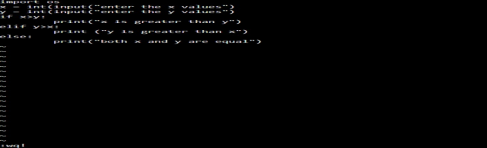

#save and quit

6. python (file name)



# to run program

7. cp (original file) (new file)



#copy data from current file to new file

8. :q!

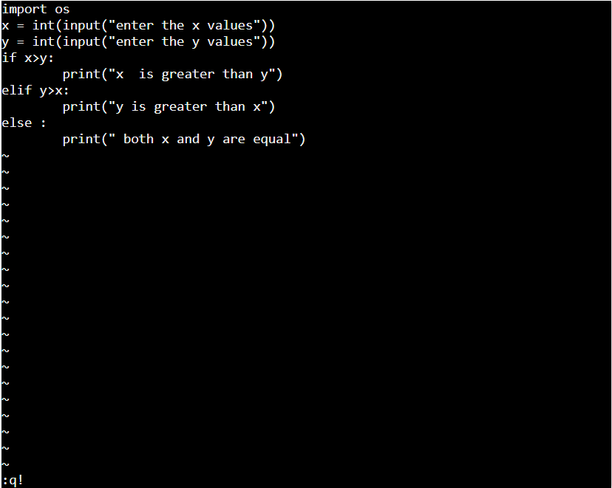

9. cat (file name)



#display file program

10. ls



#List of files

11. rmdir (folder name)



#Remove directory

12. dir



13. rm



#remove/clear file

14. mv (original file) (new file)



#move data from current file to new file

15. clear



# clear all commands

16. cd ..



1. whoami

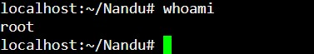

#displays the user name currently logged in terminal

1. less

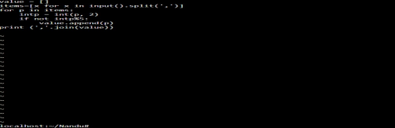

#display content on the file

#here to exist need to use ‘q’

1. echo



#displays output immediately/instantly

1. touch



# to create empty file

1. pwd



# to know current path

1. head (file name)

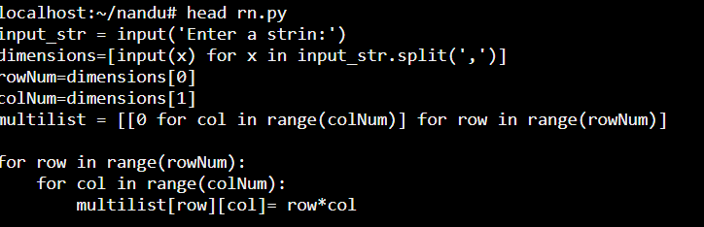

#print the first n number of data given in the input

1. tail (file name)

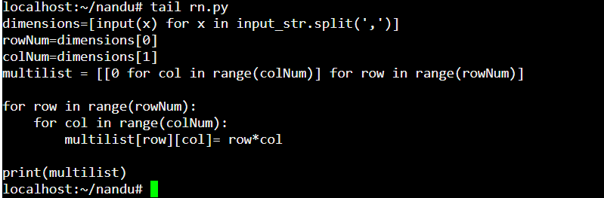

# print the last n number of data given in the input

1. gzip

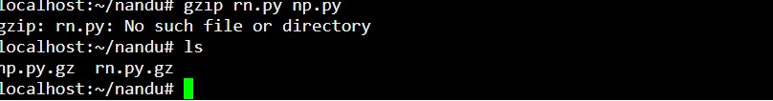

# coverts file into zip file

1. gunzip

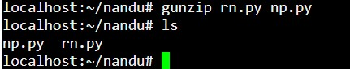

#converts zip file into original file

1. install



#Used to copy files and set attributes

1. passwd

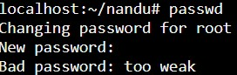

#use to change password

1. read



#Reads up the total number of bytes from the specified file descriptor into the buffer

1. script



#Used to make typescript or record all the terminal activities

1. sleep



#Used to create a dummy job

1. Slipt



#Used to split large files into smaller files

1. Userdl



#Used to delete a user account and related files

1. sudo su



#to use as super user

#to come out from that command need to click exit

1. Man



#to run system manually

1. ps (file name)

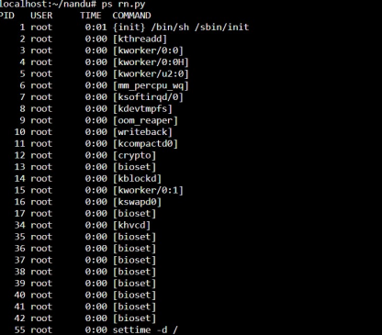

#show running process

1. Df

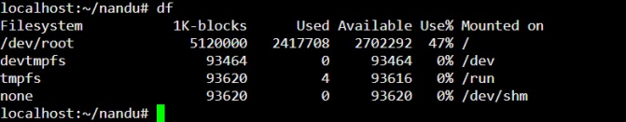

#disk usage

1. sort (file name)

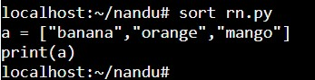

#to get data in a proper order

1. sort -r (file name)

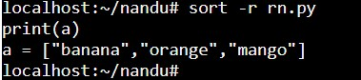

# to get data in reverse direction

1. mkdir -p (file name)

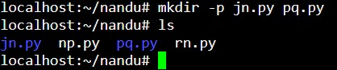

# to create multiple folders

1. vim (file name)



#to open the file or to insert the data into file

1. more (file name)

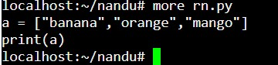

#display the data on screen

1. I

#it acts as insert command used to insert data in editor mode

1. sudo apt install(package name)



#to install particular package

1. Df -h

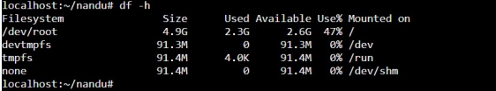

#to display the disk usage in human readable format

1. hostname

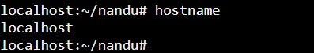

# to display hostname

1. find (file name)

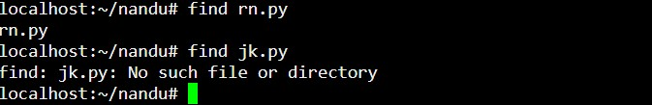

to search a file or directory

1. diff (file 1) (file2)

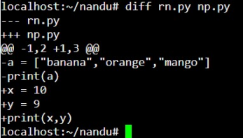

#comparison of 2 files and highlight the diff

1. Free

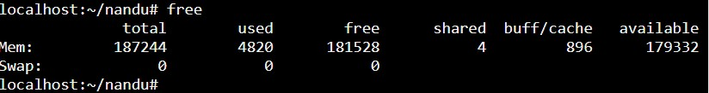

#display memory usage

1. wc (file name)

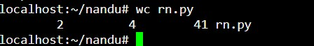

#to count no.of lines,words and characters ina file

1. Exit



#exit from super user