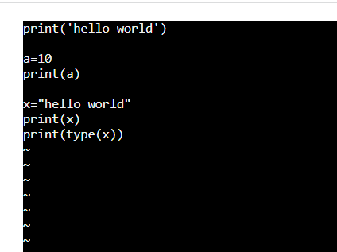

1. Sample python program in vi editor

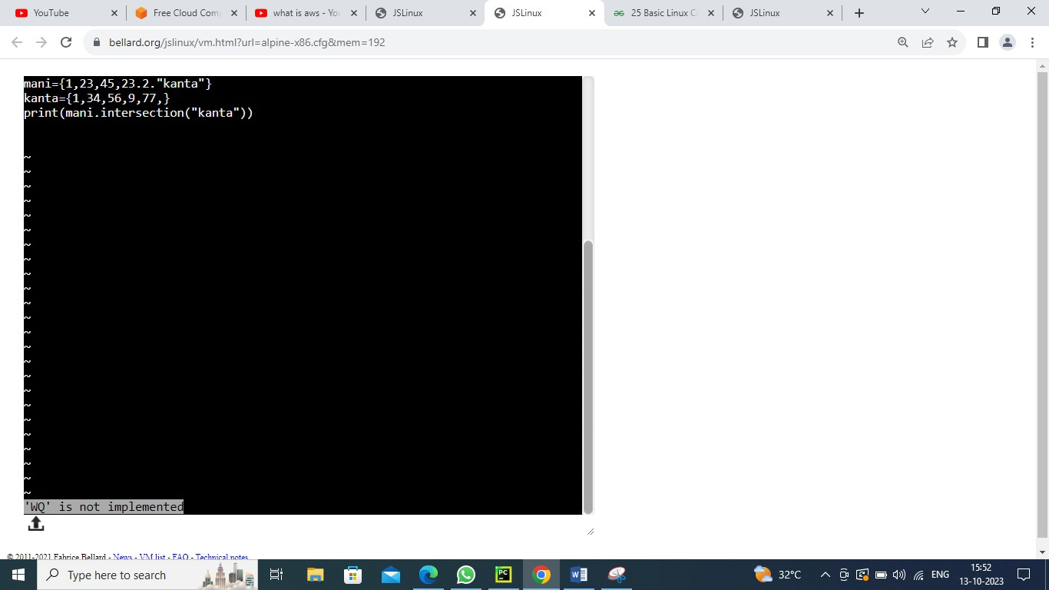

1. FILE INTO FILE SAMPLE PROGRAM IN VI EDITOR

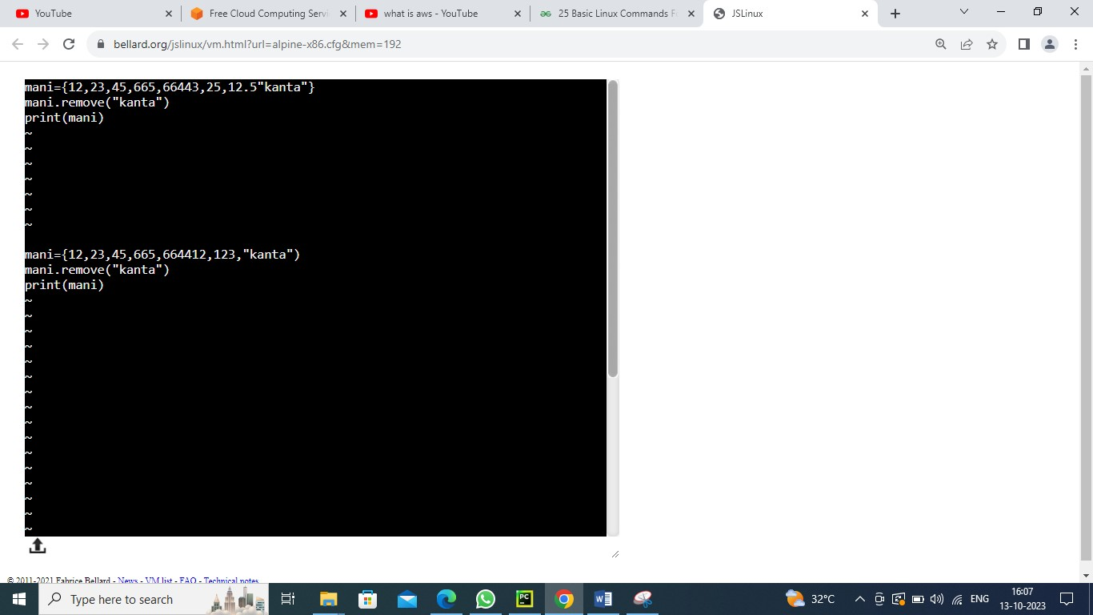

1. Error rectifying in python simple program in vi editor

V

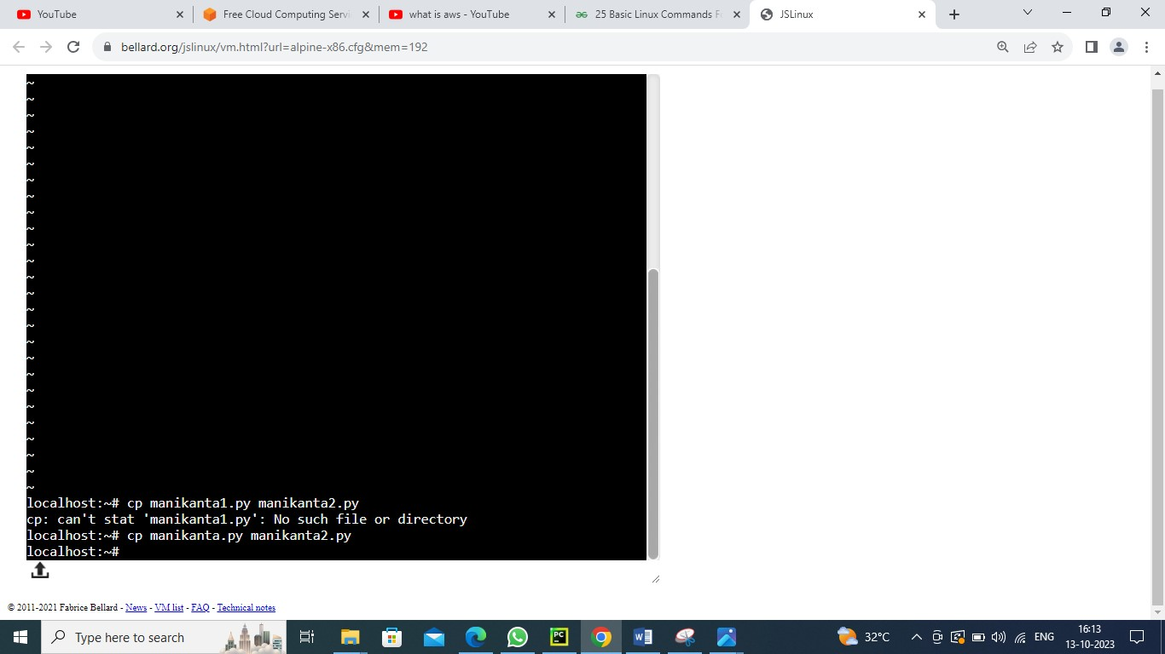

1. Copying one file date to another file simple program in vi editor

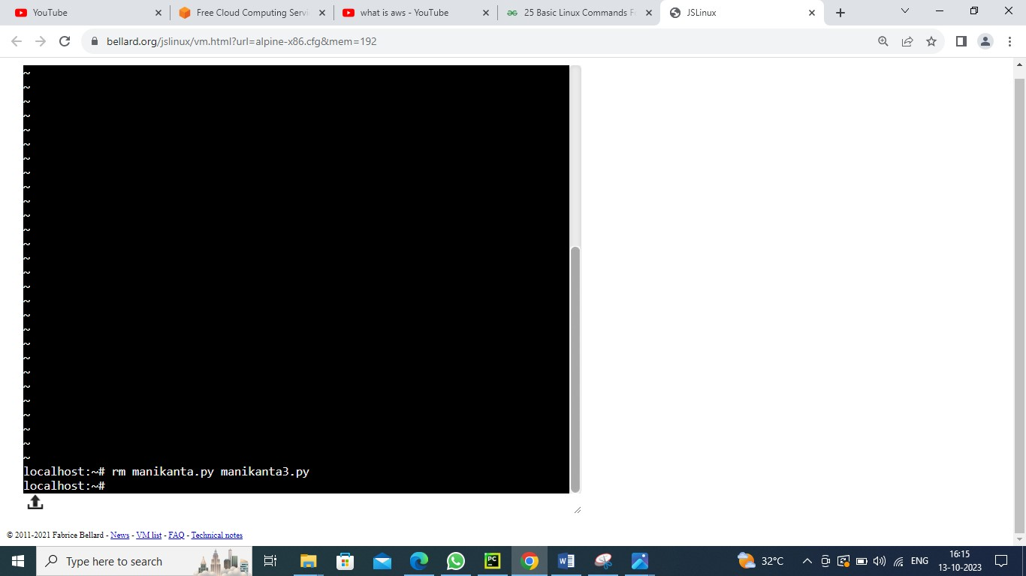

1. Moving file data into another file

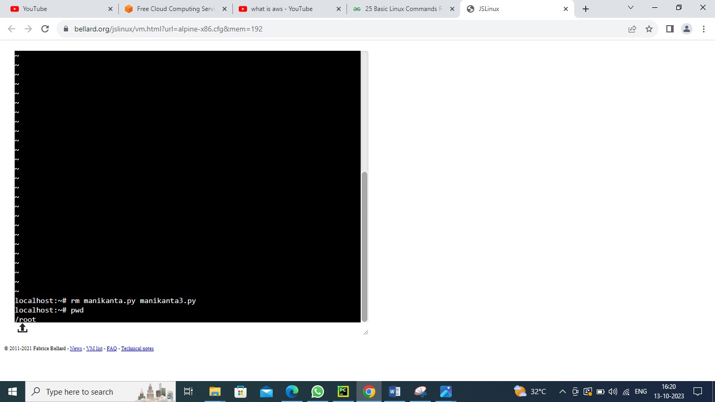

1. Using pwd command to displays the current working directory

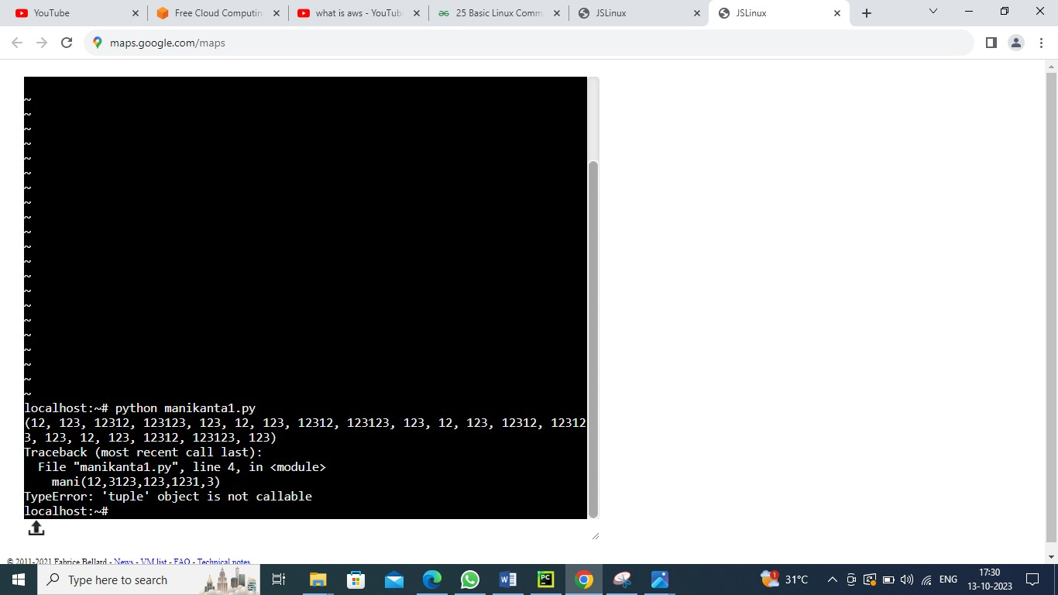

1. Code successfully executed

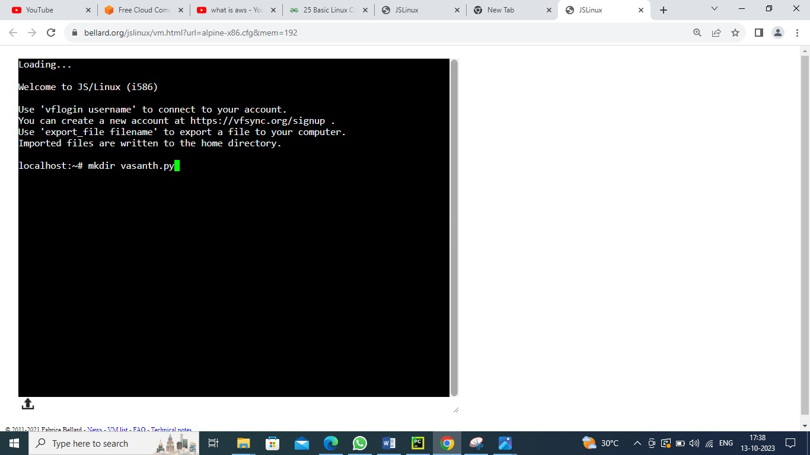

1. Creating a folder by using mkdir command

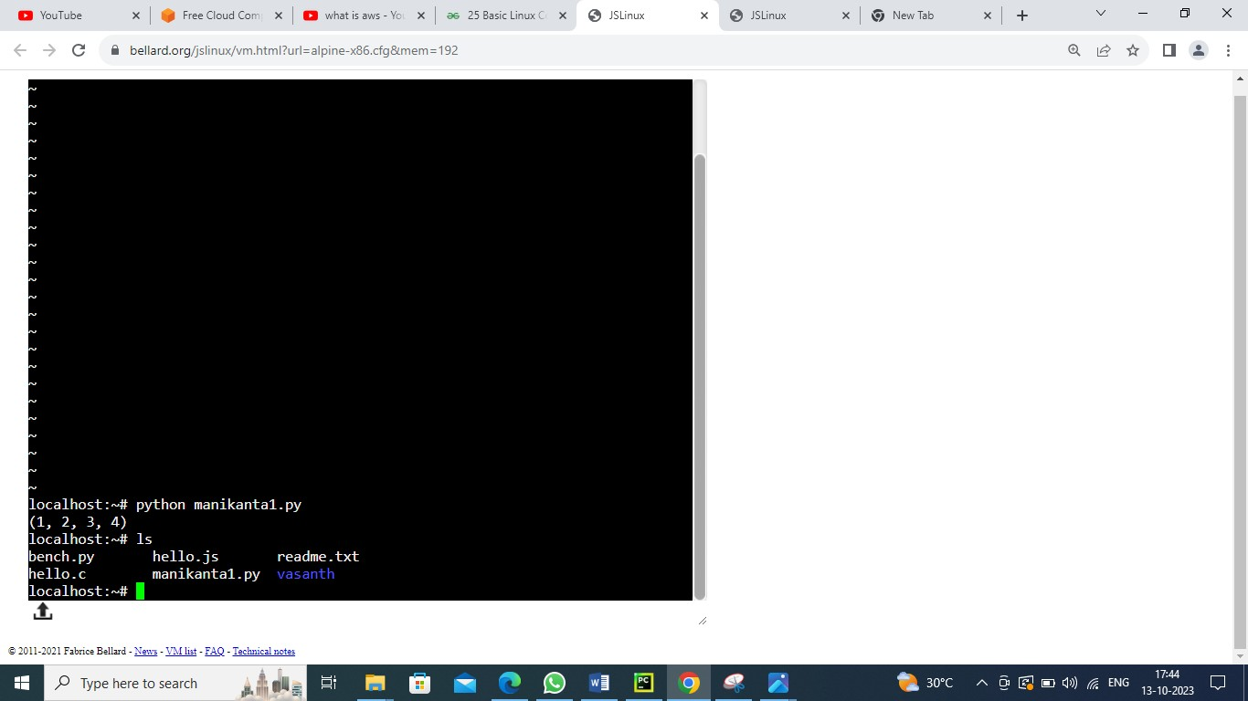

1. Using ls command to see the list of the data

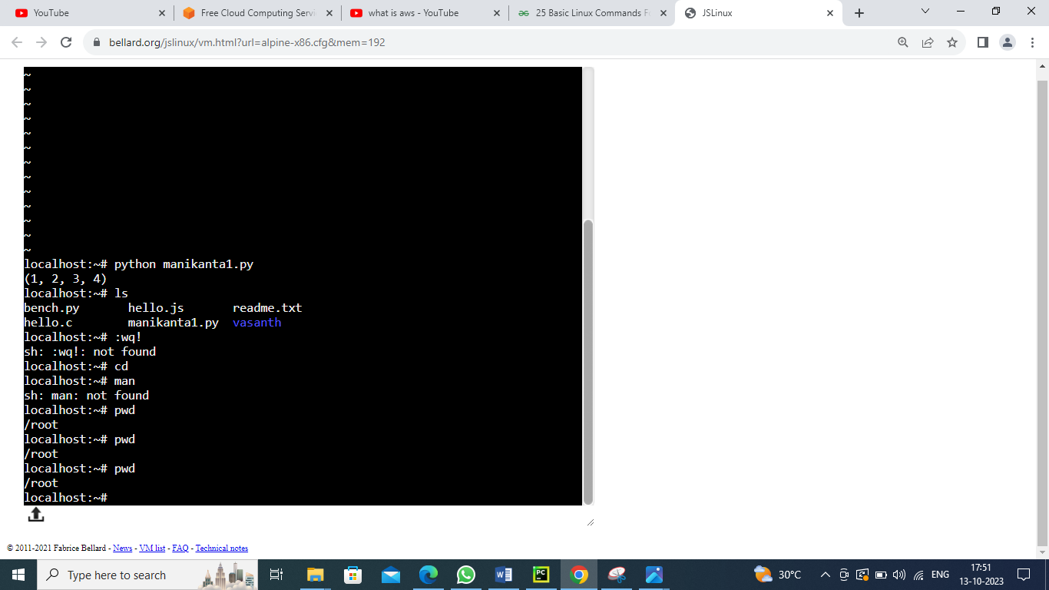

1. Using pwd command to know the path

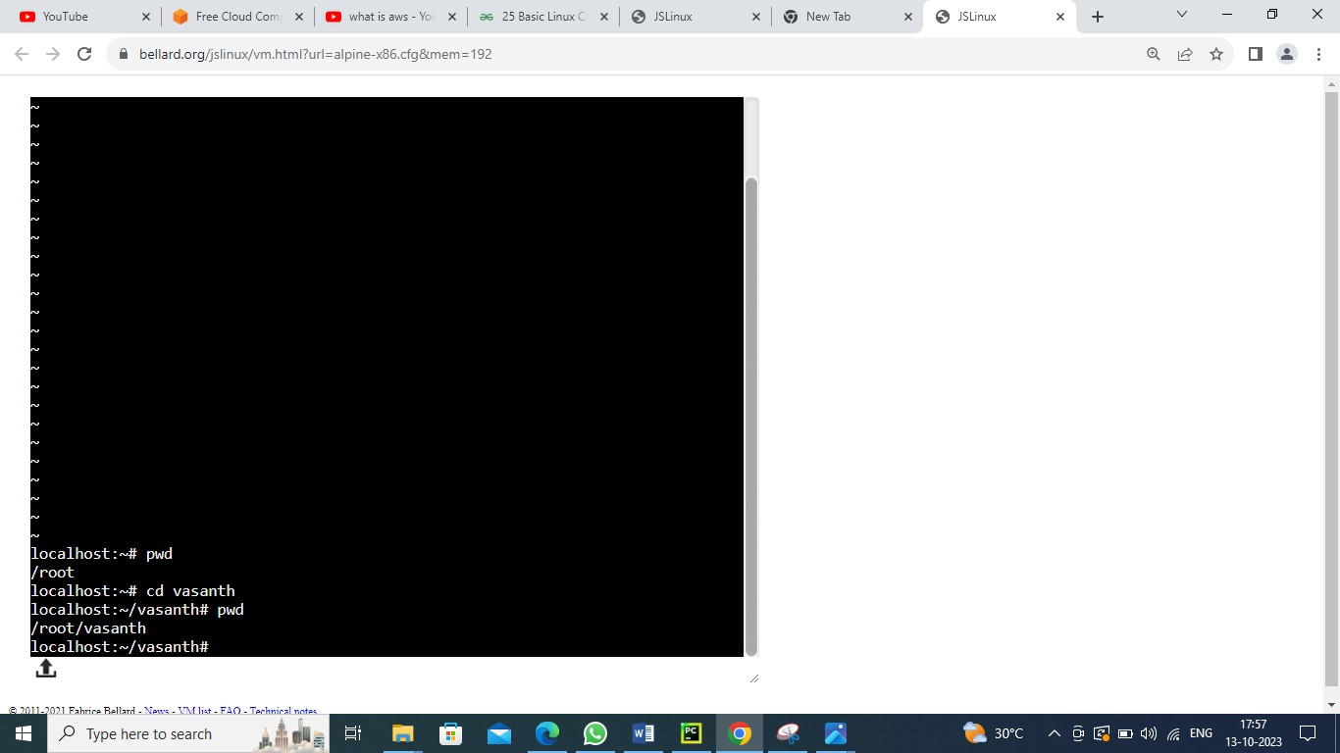



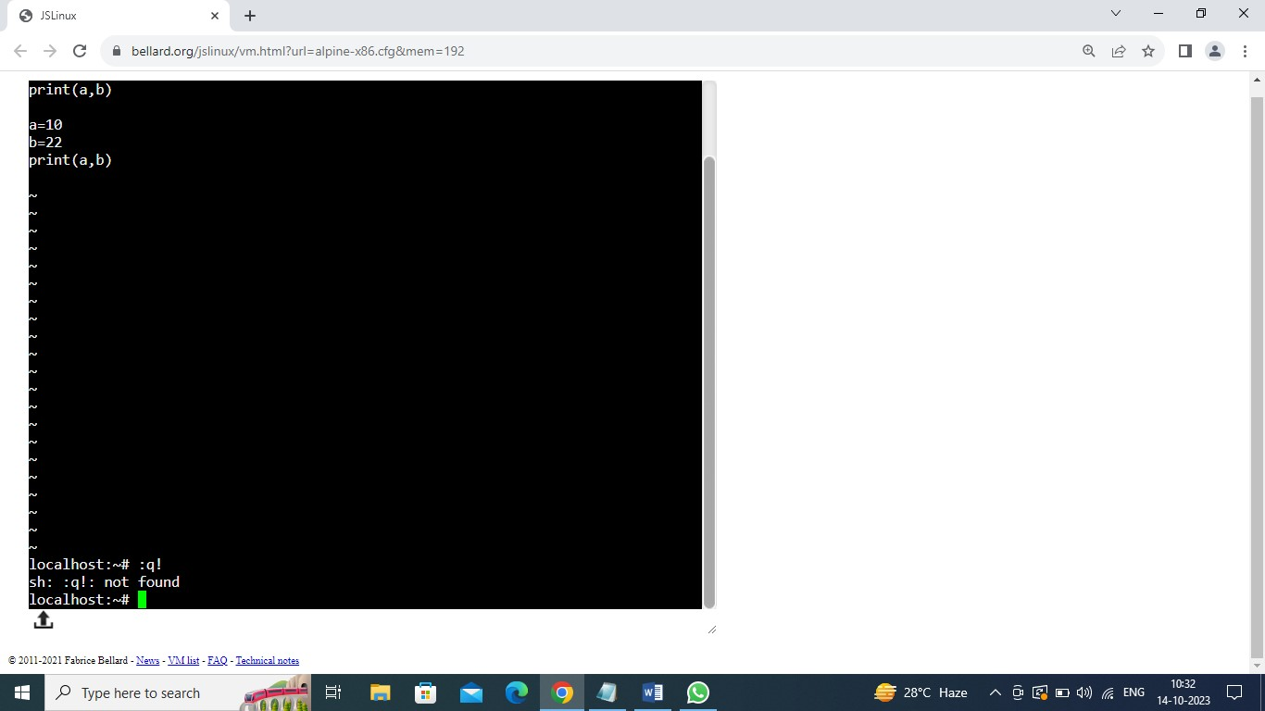

Using :q! command to don’t save recent

1. Using echo command to display some text

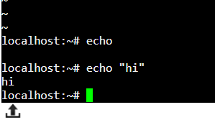

13)man command to run manually

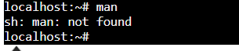

1. Using cat command to display the content on the file

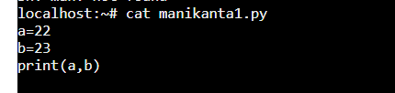

14)using unman command to user manual of any command that we can run on the terminal.



15)using call command exec command in Linux is used to execute a command from the bash itself.

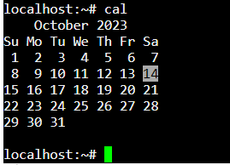

16) using top command used to show the active Linux processes.

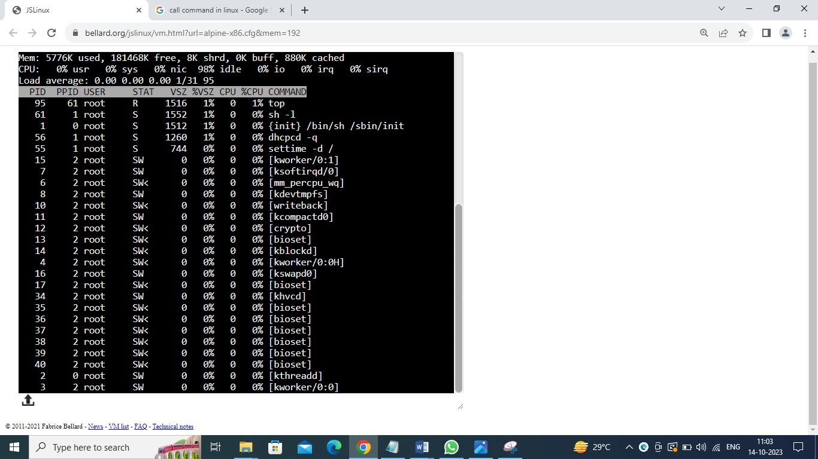

17) using tar command create and extract archive files.

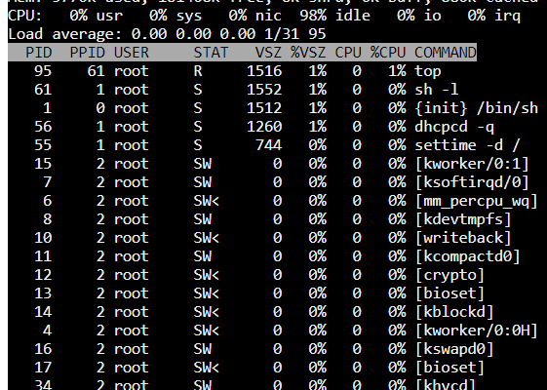

18) using grep command 'global search for the regular expression'.

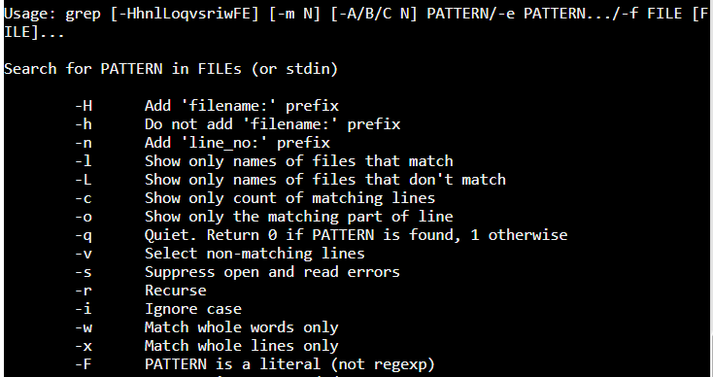

19) using service command  starts, stop and restart a daemon or services by calling the script.



20) using  to modify the permissions and access mode of files and directories.

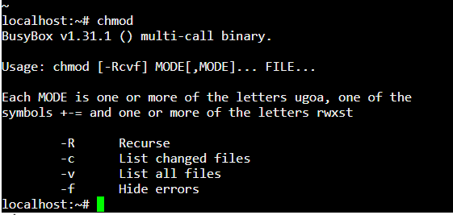

21) using ssh command provides a secure encrypted connection between two hosts over an insecure network.

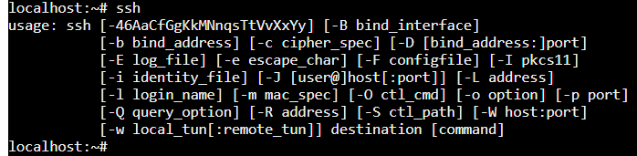

22) using wget command. download files and interact with REST APIs

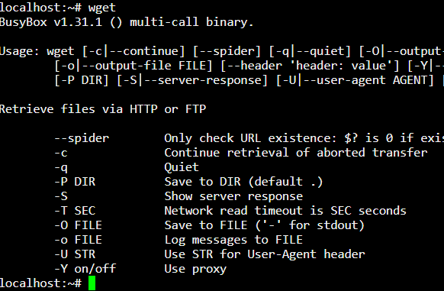

23) using unzip command The Unzip command is used to decompress or extract the content from the compressed archive.

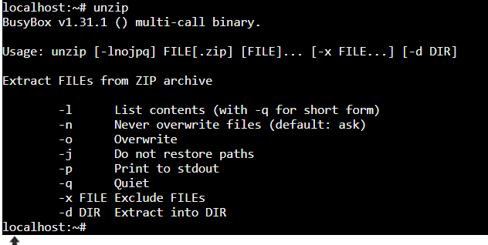

24) using cmp command to compare the two files byte by byte

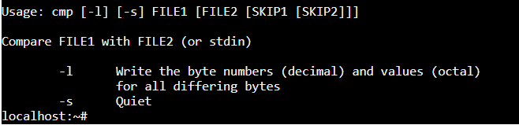

25) using whereis command   locates the source, binary, and manuals sections for specified files

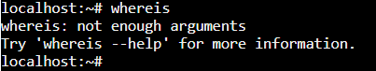

26) using mount command instructs the operating system to make a file system available for use at a specified location

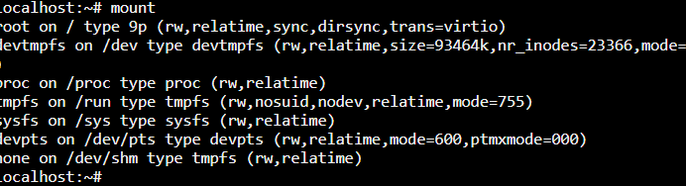

**27) using dif command** allows you to compare two files line by line

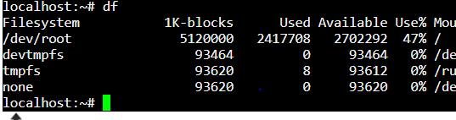

**28) using traceroute command** prints the route that a packet takes to reach the host

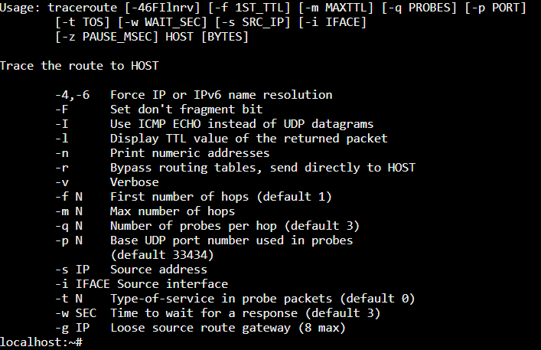

**29) using ps command**  allows you to view information about the processes running on your Linux system

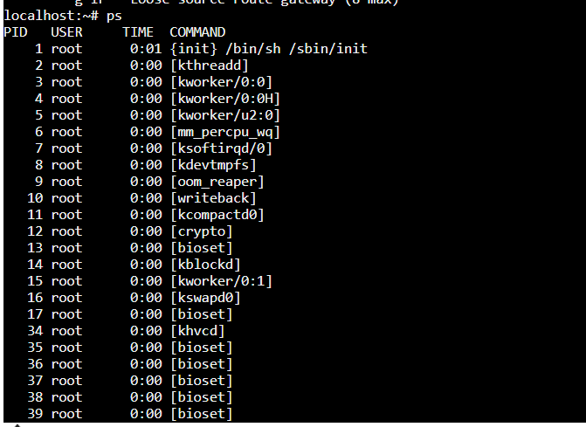

**30) using ifconfig command** to assign an address to a network interface and to configure or display the current network interface configuration information.

31) sudo

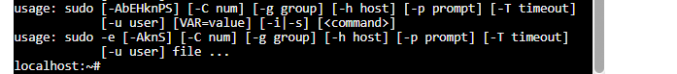

**32)**

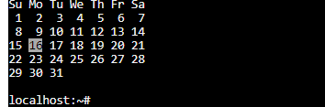

**33) top**

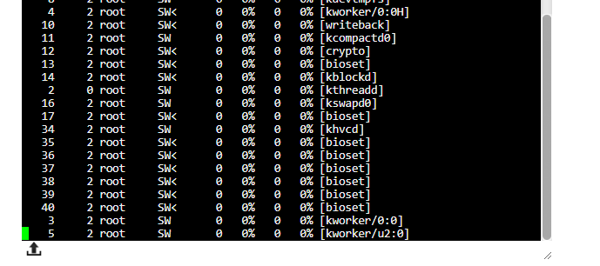

**34)grep**

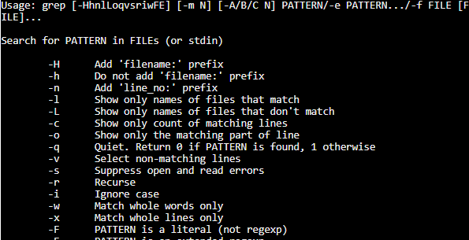

35) comm

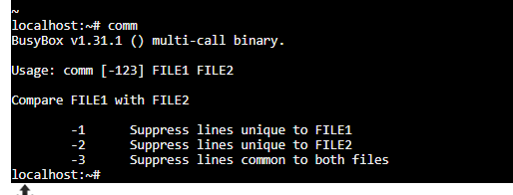

36)unzip

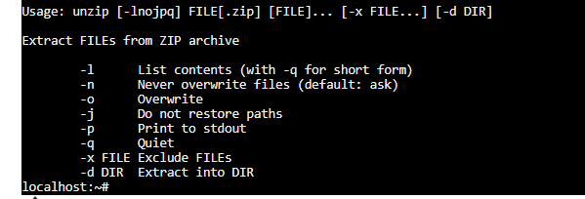

37)ssh

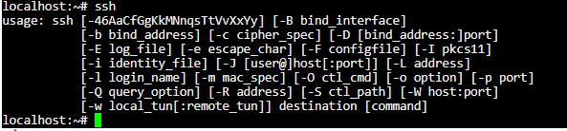

38)service

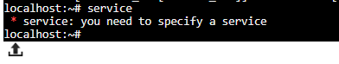

39)diff

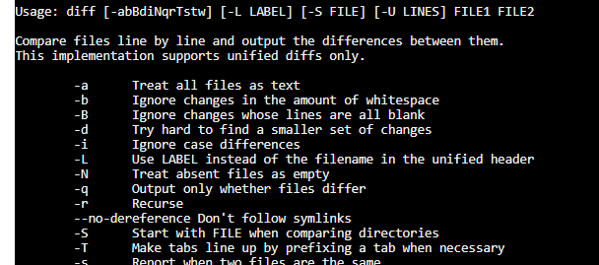

40)less

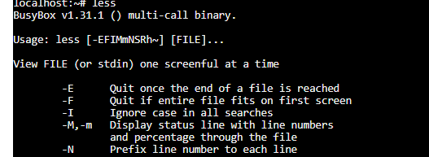

41)export

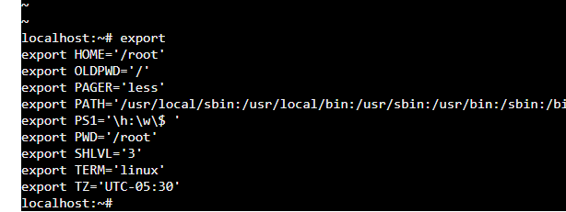

42)ifconfig

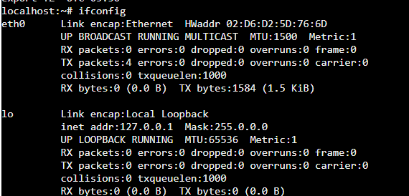

43)mount

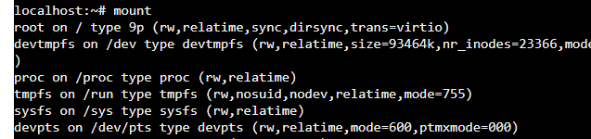

44)chmod

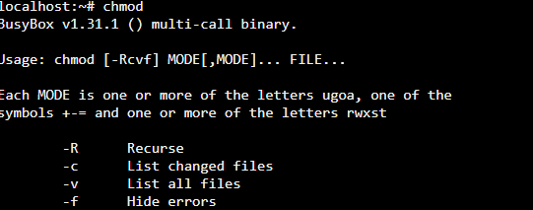

45)cmp

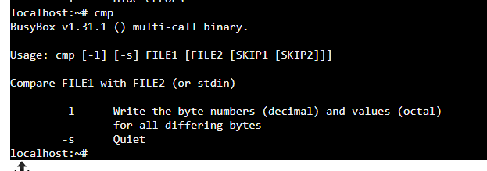

46)pwd



47)in



48)tar

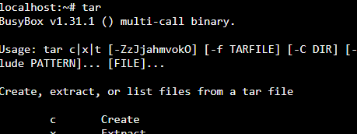

49)mv

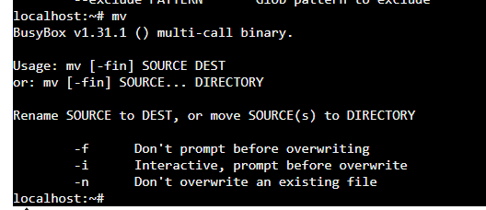

50)passwd

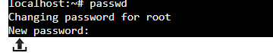

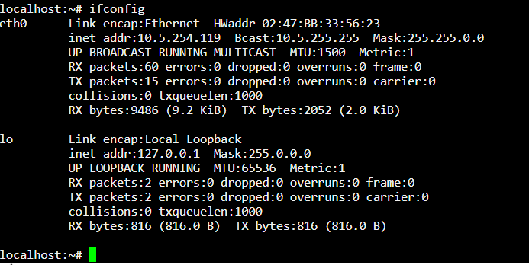

**Python programs**

**1st python program**

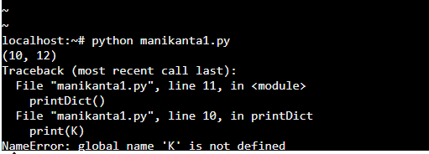

**2nd python program**

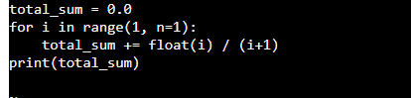

**3rd program**

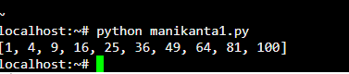

**4th program**

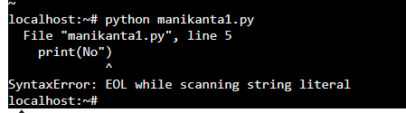

**5th program**

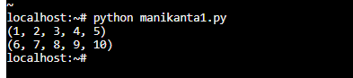

**6th program**

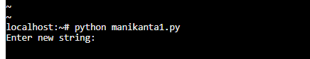

**7th program**

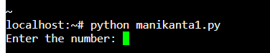

**8th program**

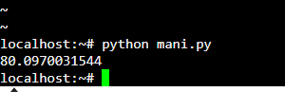

**python list methods**

**empty list**

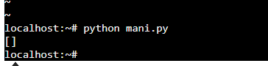

**Append method**

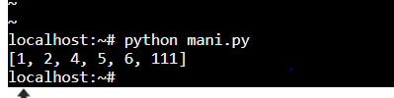

**Extend method**



**Insert method**



**Count method**

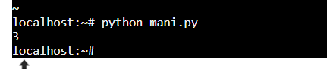

**Len method**

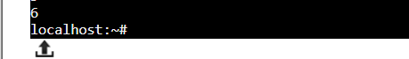

**Pop method**

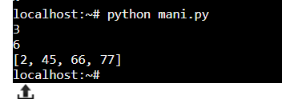

**Reverse method**

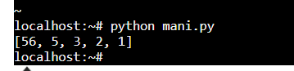

**Sort method assending to descending order**

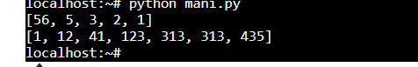

**Loop method**

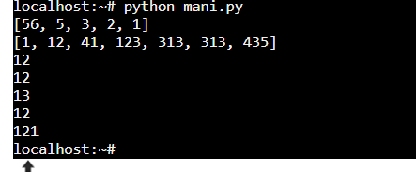

**Tuple methods**

**Repetations**

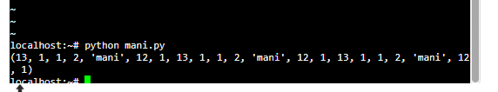

**Concadination**

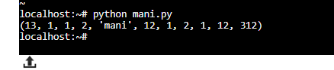

**Membership**

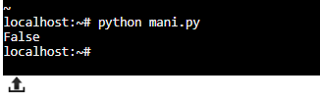

**Iterations**

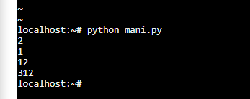

**Min method**

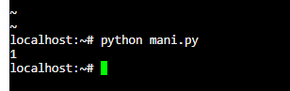

**Max method**

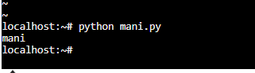

**Sum method**

