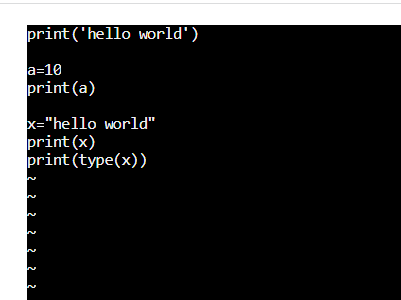

1. Sample python program in vi editor

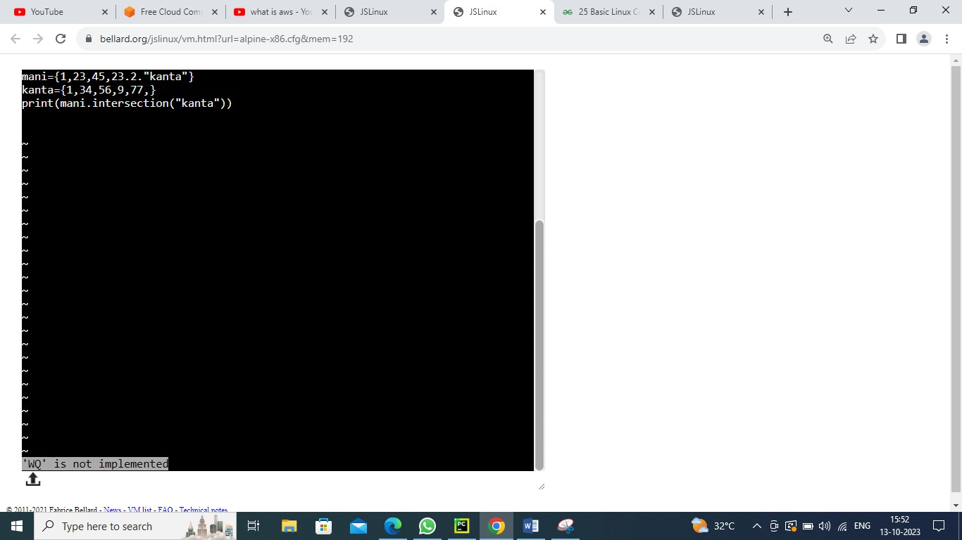

1. FILE INTO FILE SAMPLE PROGRAM IN VI EDITOR

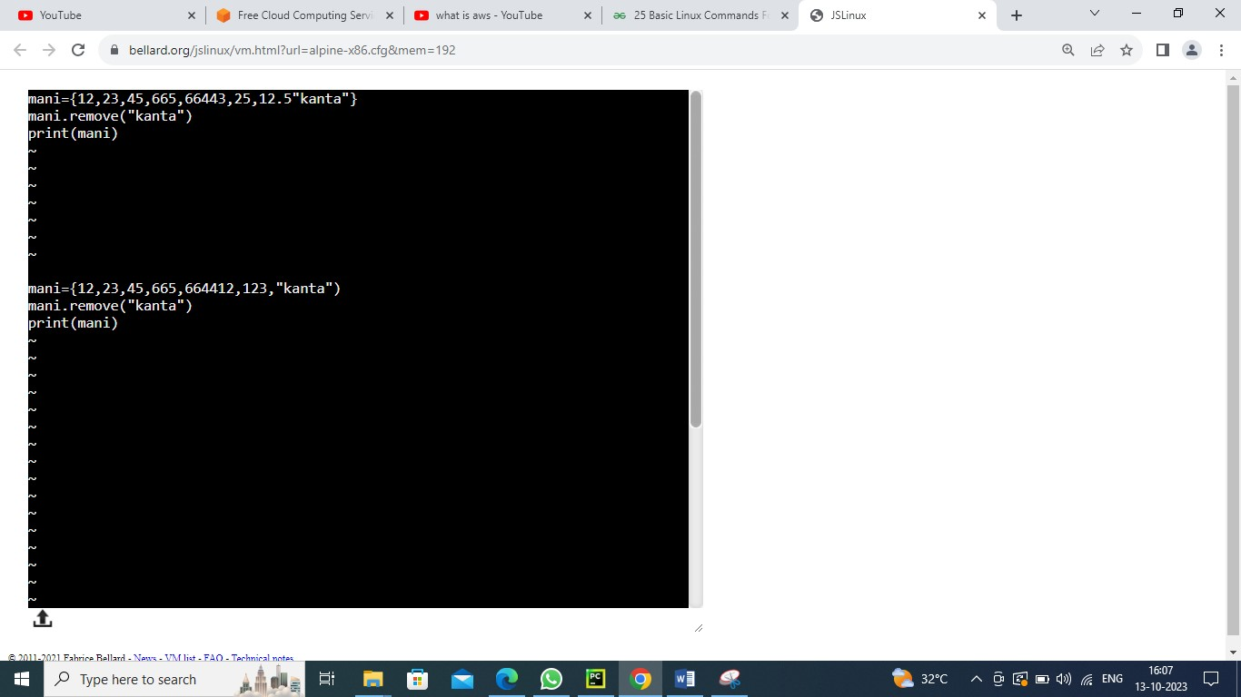

1. Error rectifying in python simple program in vi editor

V

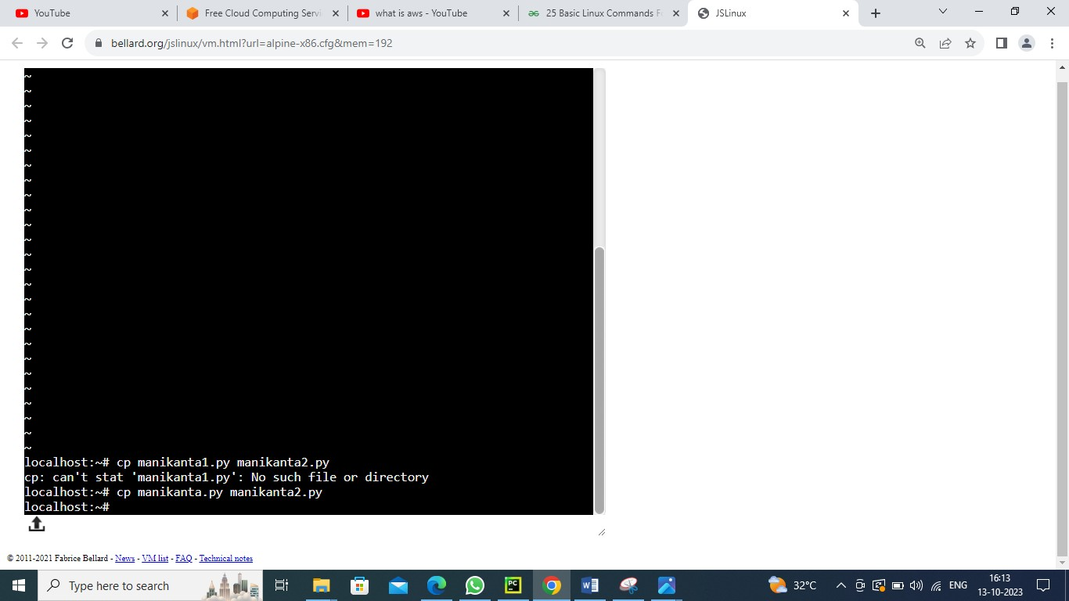

1. Copying one file date to another file simple program in vi editor

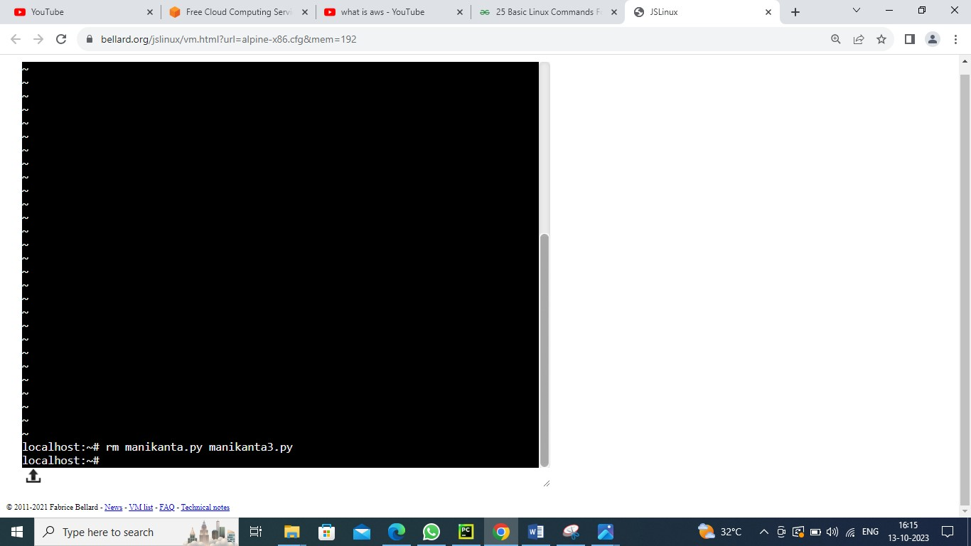

1. Moving file data into another file

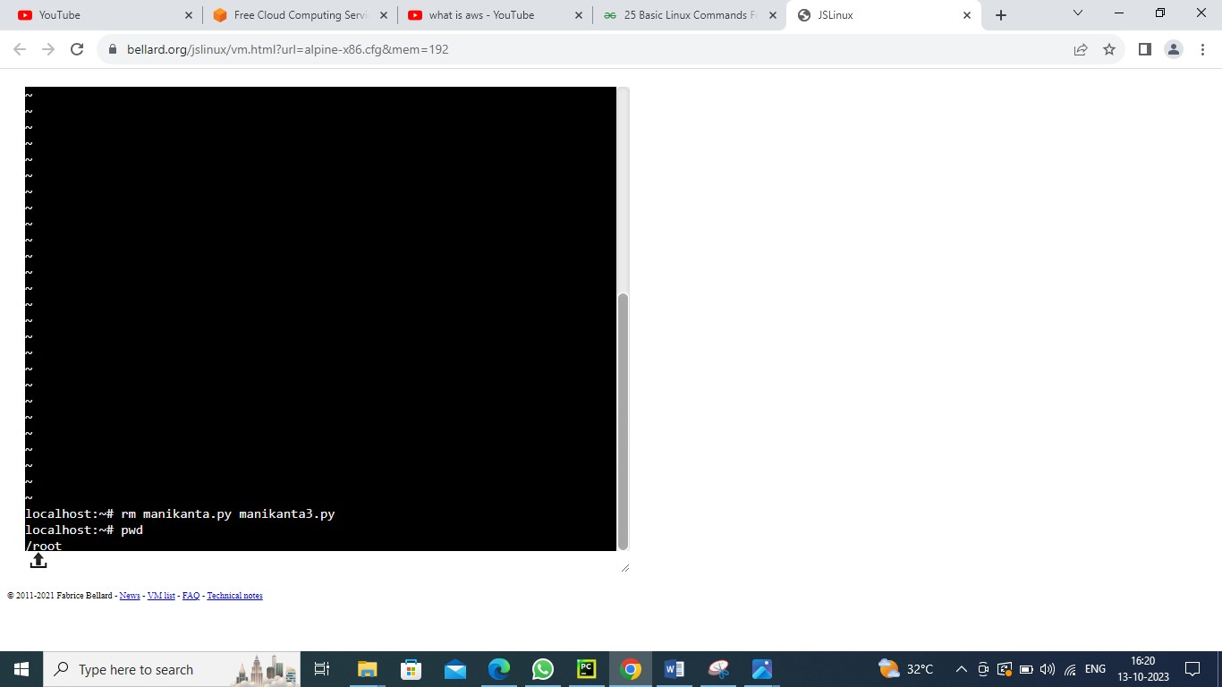

1. Using pwd command to displays the current working directory

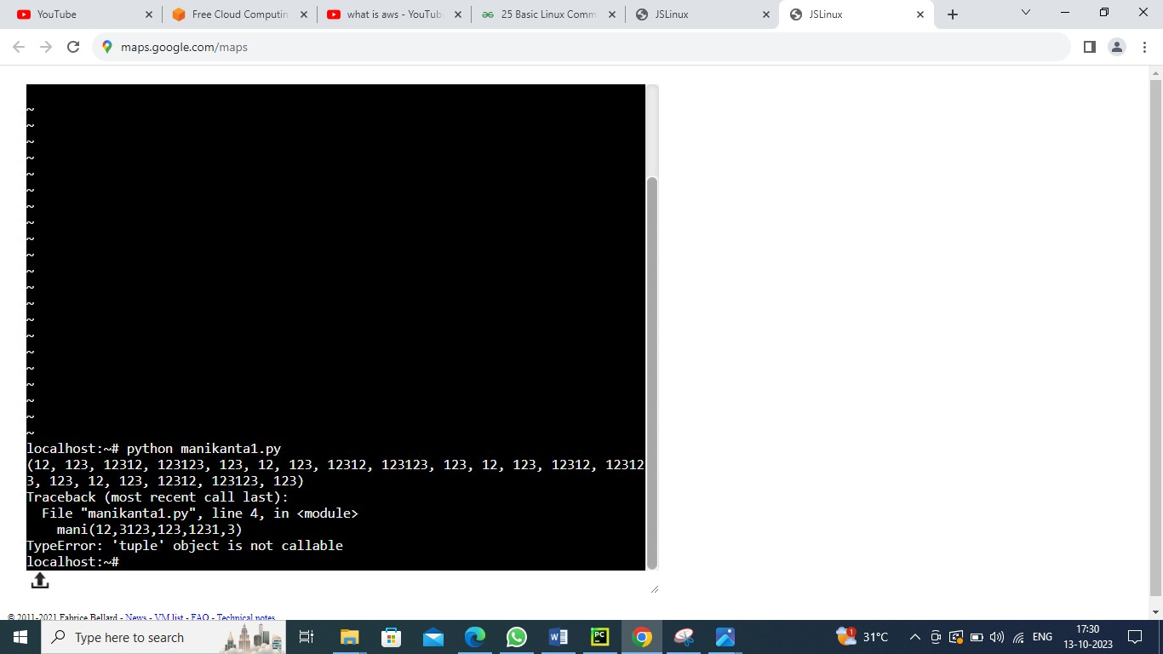

1. Code successfully executed

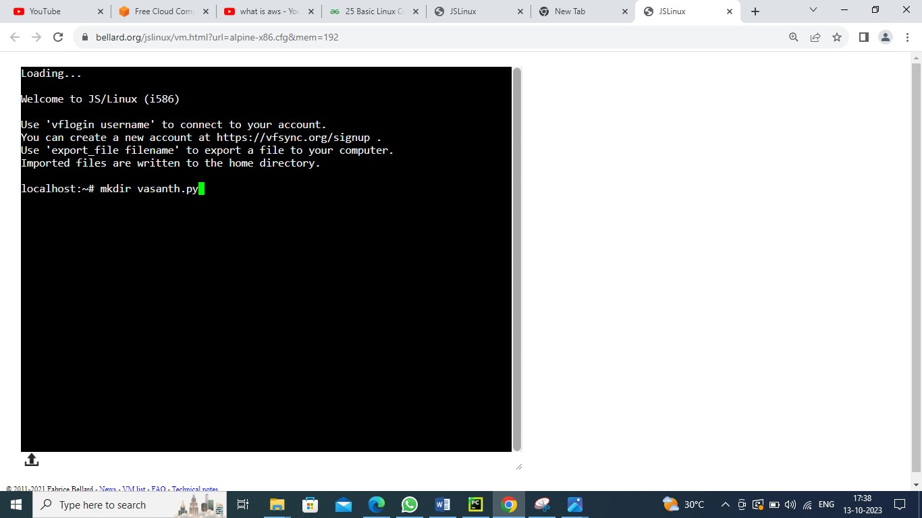

1. Creating a folder by using mkdir command

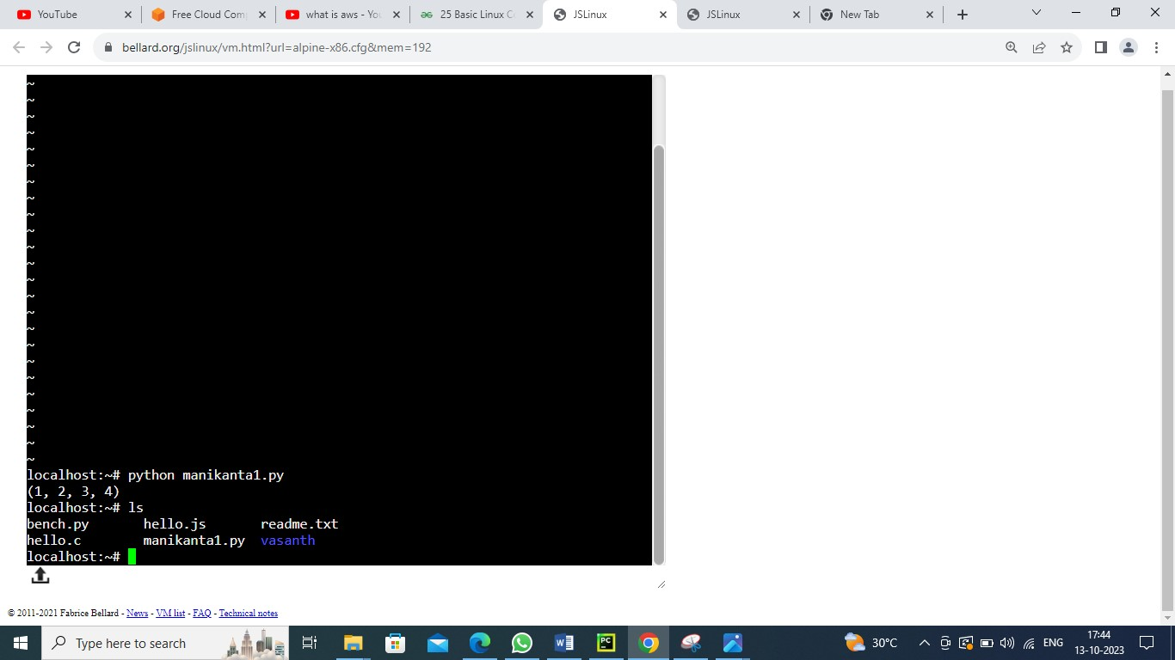

1. Using ls command to see the list of the data

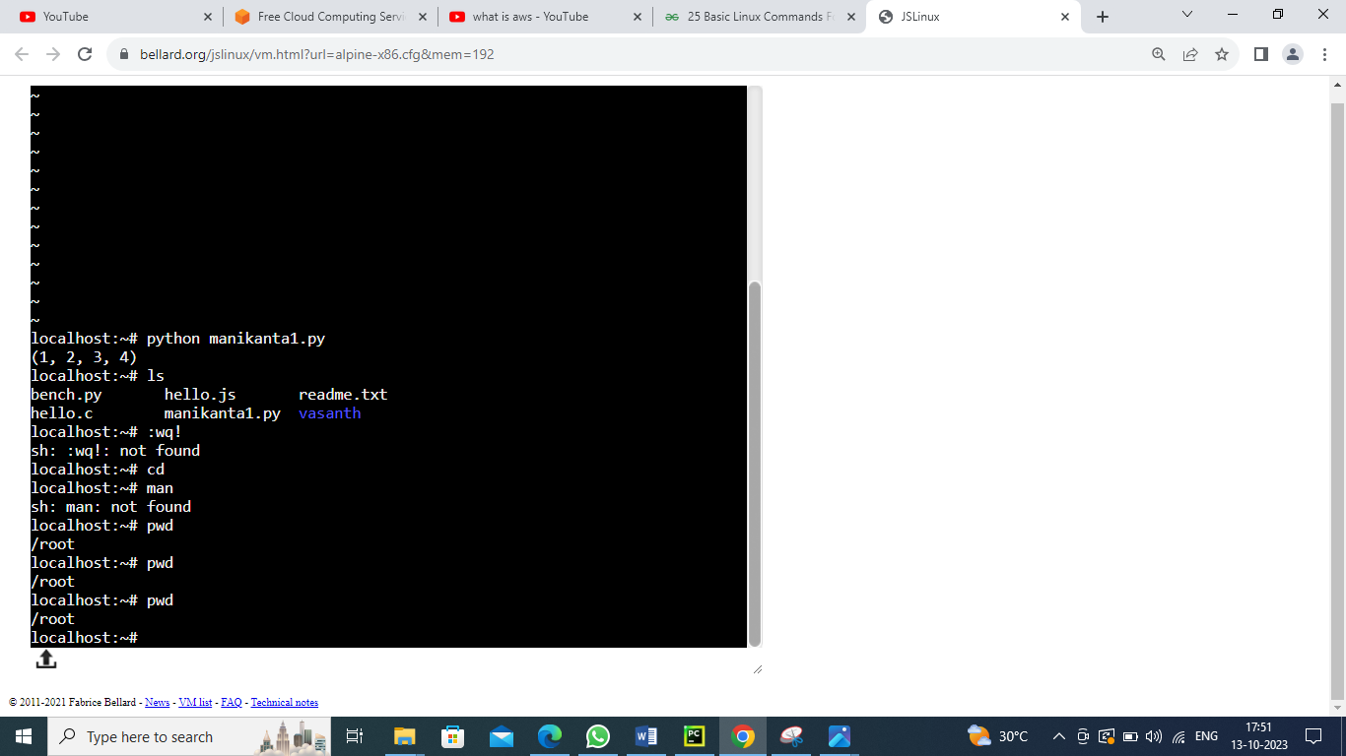

1. Using pwd command to know the path

