1. mkdir (creating new directory)

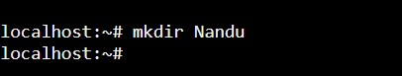

#to create new directory

2. cd (folder Name)

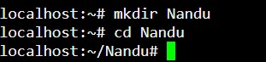

3. vi \(file name)

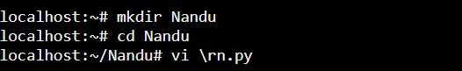

4. import os

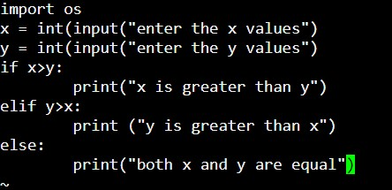

5. :wq!

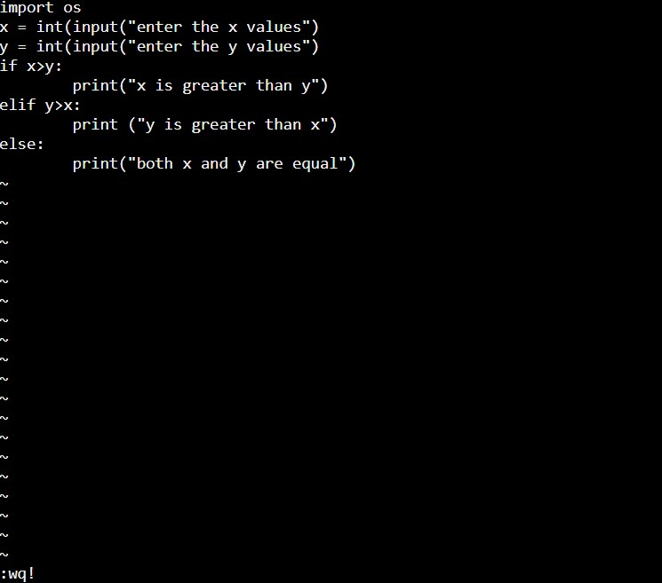

6. python (file name)

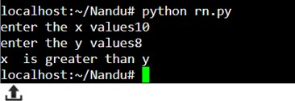

7. cp (original file) (new file)



8. :q!

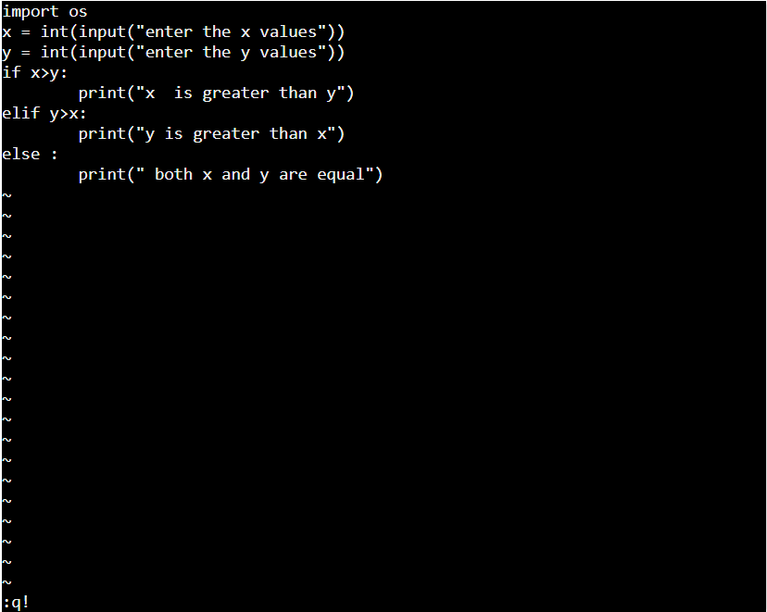

9. cat (file name)

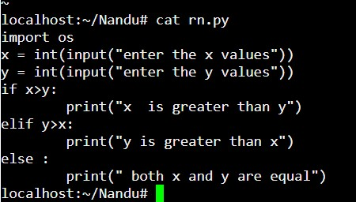

#display file program

10. ls

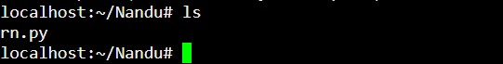

#List of files

11. rmdir (folder name)



#Remove directory

12. dir



13. rm



#remove/clear file

14. mv (original file) (new file)



15. clear

16. cd ..



17.