**Linux Commands**

**1.pwd**

**Pwd is used to show the path**



**2.mkdir**

**It is used to create a directory**

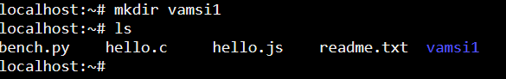

**3.rmdir**

**It is used to remove directory**

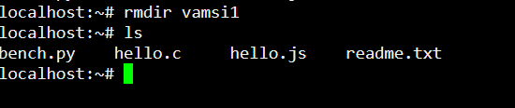

**4.ls**

**It is used to show the entire list**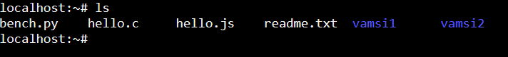

**5.cd**

**It is used to change directory of a file**



**6.touch**

**It is used to create multiple empty files**

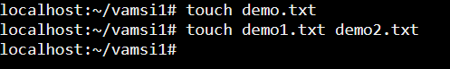

**7.cat**

**Cat is used to show the content of the file**