**Linux Commands**

# 1.pwd:

Pwd is used to show the path



# 2.mkdir:

It is used to create a directory

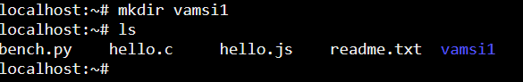

# 3.rmdir:

It is used to remove directory

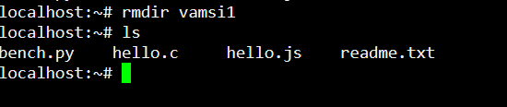

# 4.ls:

It is used to show the entire list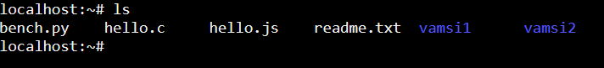

# 5.cd:

It is used to change directory of a file



# 6.touch:

It is used to create multiple empty files

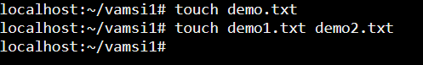

# 7.cat:

Cat is used to show the content of the file

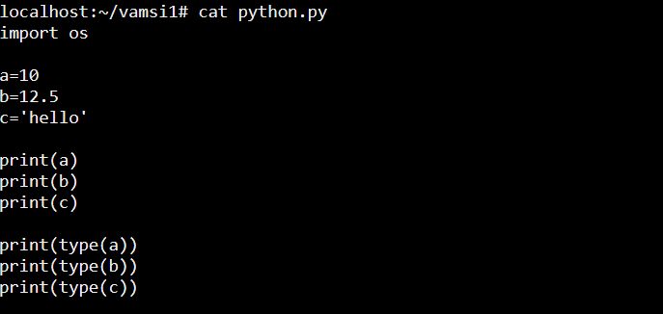

# 8.rm:

rm command is used to remove the file

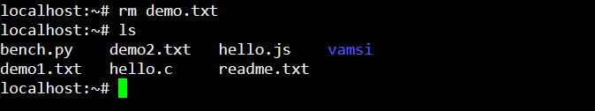

# 9.cp:

Cp is used to copy a file or directory from existing to new one

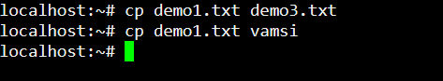

# 10.mv:

It is used to move the file or directory to one location to another

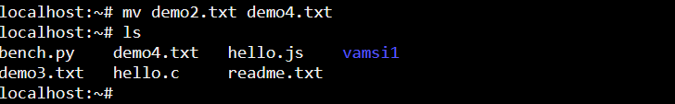

# 11.renam:

Rename command is used to rename of a file.it is very use full to rename large files.



# 12.head:

It is used to show the first 10 lines of a file

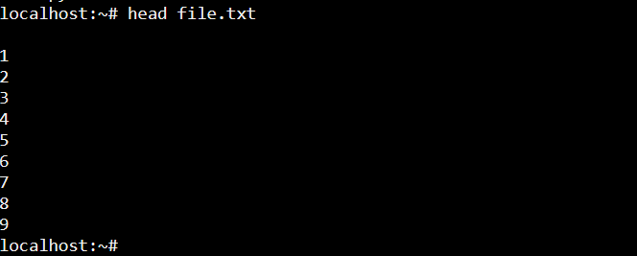

# 13.tail:

Tail command is used to show last 10 lines of a file

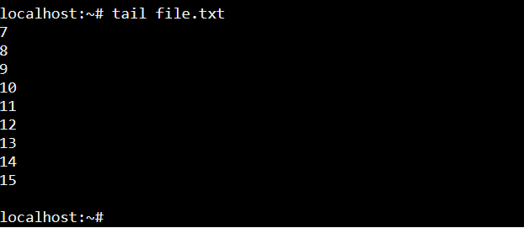

# **14. tac Command:**

The [tac](https://www.javatpoint.com/linux-tac) command is the reverse of cat command, as its name specified. It displays the file content in reverse order (from the last line)

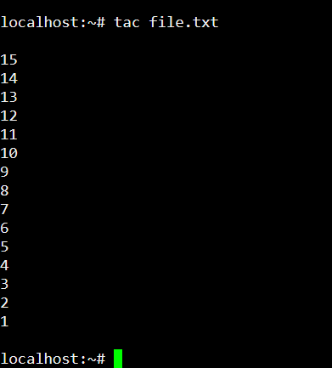

**15. more command**

The [more](https://www.javatpoint.com/linux-more) command is quite similar to the cat command, as it is used to display the file content in the same way that the cat command does. The only difference between both commands is that, in case of larger files, the more command displays screenful output at a time.

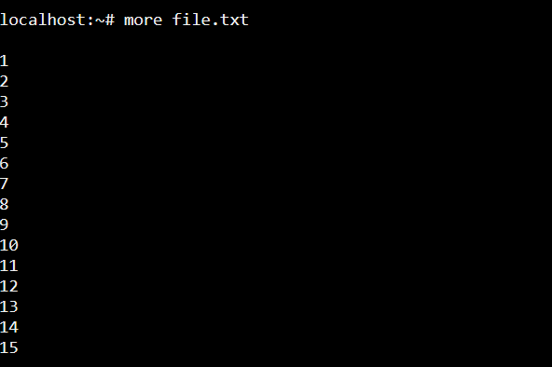

**16. less Command**

The [less](https://www.javatpoint.com/linux-less) command is similar to the more command. It also includes some extra features such as 'adjustment in width and height of the terminal.' Comparatively, the more command cuts the output in the width of the terminal.

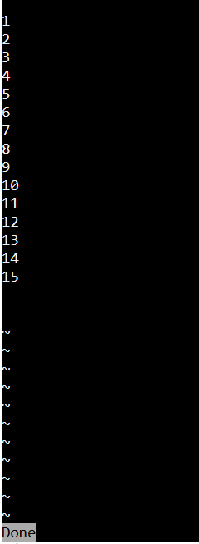

**17. cut Command**

The [cut](https://www.javatpoint.com/linux-cut) command is used to select a specific column of a file. The '-d' option is used as a delimiter, and it can be a space (' '), a slash (/), a hyphen (-), or anything else. And, the '-f' option is used to specify a column number.

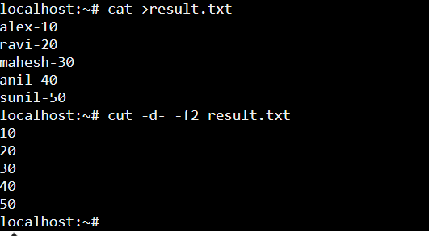

**18. grep Command**

The [grep](https://www.javatpoint.com/linux-grep) is the most powerful and used filter in a Linux system. The 'grep' stands for "**global regular expression print**." It is useful for searching the content from a file. Generally, it is used with the pipe.

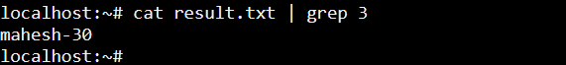

**19. comm Command**

The ['comm'](https://www.javatpoint.com/linux-comm) command is used to compare two files or streams. By default, it displays three columns, first displays non-matching items of the first file, second indicates the non-matching item of the second file, and the third column displays the matching items of both files.

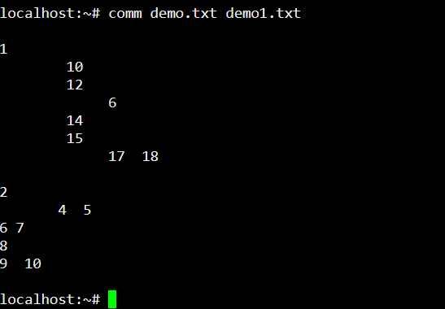

**20. tr Command**

The [tr](https://www.javatpoint.com/linux-tr) command is used to translate the file content like from lower case to upper case.

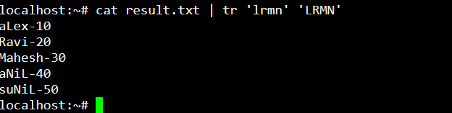

**21. wc Command**

The [wc](https://www.javatpoint.com/linux-wc) command is used to count the lines, words, and characters in a file.

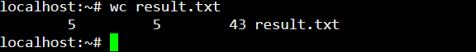

**22. od Command**

The [od](https://www.javatpoint.com/linux-od) command is used to display the content of a file in different s, such as hexadecimal, octal, and ASCII characters.

**Syntax:**

1. od -b **<fileName>**      // Octal format
2. od -t x1 **<fileName>**   // Hexa decimal format
3. od -c **<fileName>**     // ASCII character format

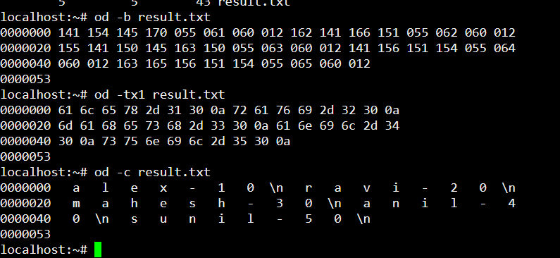

**23. sort Command**

The [sort](https://www.javatpoint.com/linux-sort) command is used to sort files in alphabetical order.

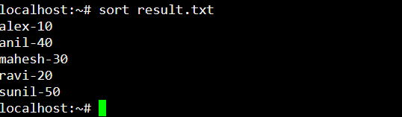

**24. gzip Command**

The [gzip](https://www.javatpoint.com/linux-gzip) command is used to truncate the file size. It is a compressing tool. It replaces the original file by the compressed file having '.gz' extension.

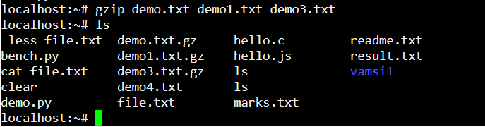

**25. gunzip Command**

The [gunzip](https://www.javatpoint.com/linux-gzip) command is used to decompress a file. It is a reverse operation of gzip command.

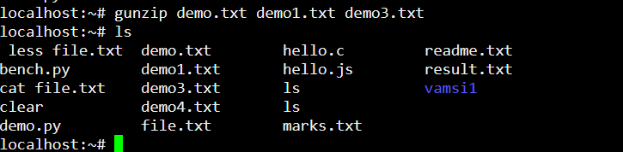

**26. find Command**

The [find](https://www.javatpoint.com/linux-find) command is used to find a particular file within a directory. It also supports various options to find a file such as byname, by type, by date, and more.

The following symbols are used after the find command:

(.) : For current directory name

(/) : For root

**Syntax:**

1. find . -name "*.pdf"

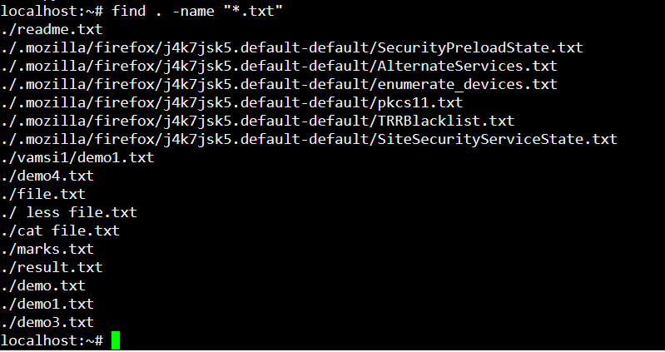

**27. date Command**

The [date](https://www.javatpoint.com/linux-date) command is used to display date, time, time zone, and more.

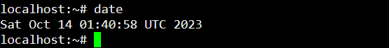

**28. cal Command**

The [cal](https://www.javatpoint.com/linux-cal) command is used to display the current month's calendar with the current date highlighted.

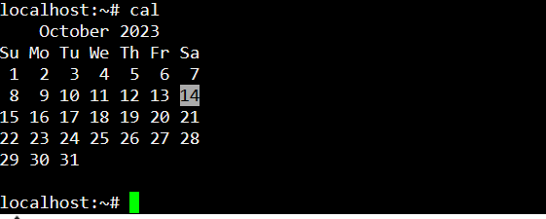

**29. time Command**

The [time](https://www.javatpoint.com/linux-time) command is used to display the time to execute a command.

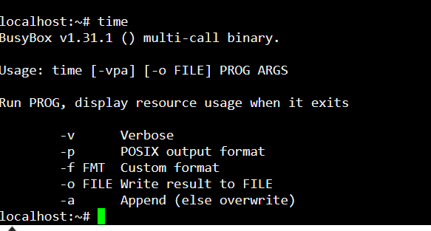

**30. sleep Command**

The [sleep](https://www.javatpoint.com/linux-sleep) command is used to hold the terminal by the specified amount of time. By default, it takes time in seconds.



**31. zcat Command**

The zcat command is used to display the compressed files.

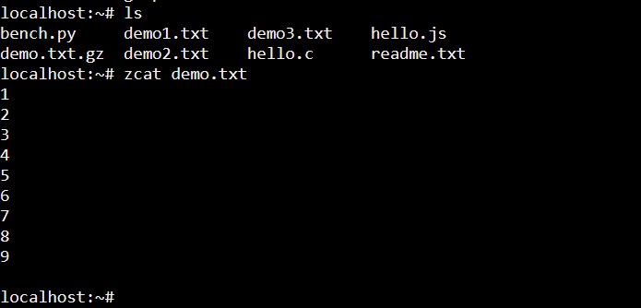

**32. df Command**

The [df](https://www.javatpoint.com/linux-df) command is used to display the disk space used in the file system. It displays the output as in the number of used blocks, available blocks, and the mounted directory.

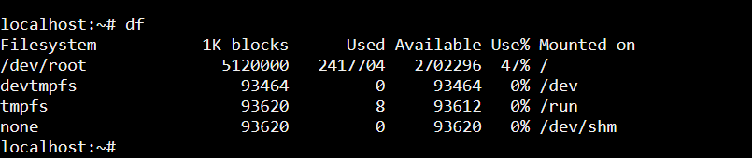

**33. mount Command**

The [mount](https://www.javatpoint.com/linux-mount) command is used to connect an external device file system to the system's file system.

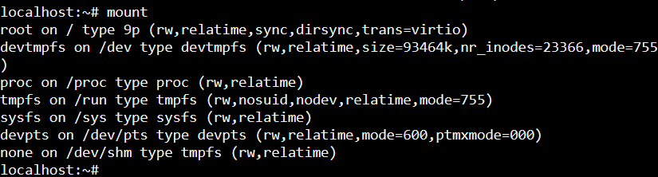

**34. ip Command**

Linux [ip](https://www.javatpoint.com/linux-ip) command is an updated version of the ipconfig command. It is used to assign an IP address, initialize an interface, disable an interface.

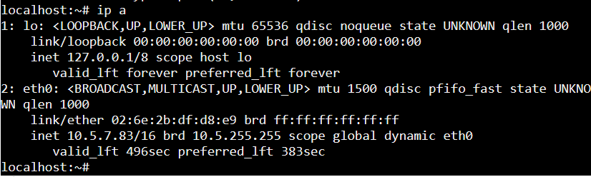

**35. ping Command**

The [ping](https://www.javatpoint.com/linux-ping) command is used to check the connectivity between two nodes, that is whether the server is connected. It is a short form of "Packet Internet Groper."

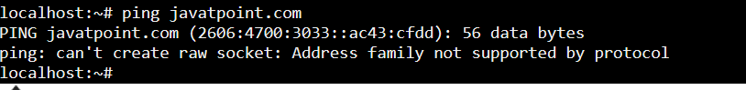**36.**[**file command**](https://www.hostinger.in/tutorials/linux-file-command/)

The file command lets you check a file type – whether it is a text, image, or binary.

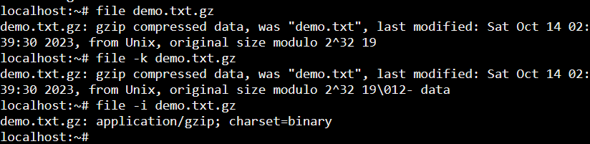

**37.uptime**

It is used to display the system time

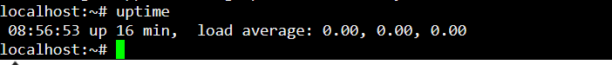**The 38.History Command**

History command shows all the basic commands in Linux that you have used in the past for the current terminal session. This can help you refer to the old commands you have entered and re-used them in your operations again.

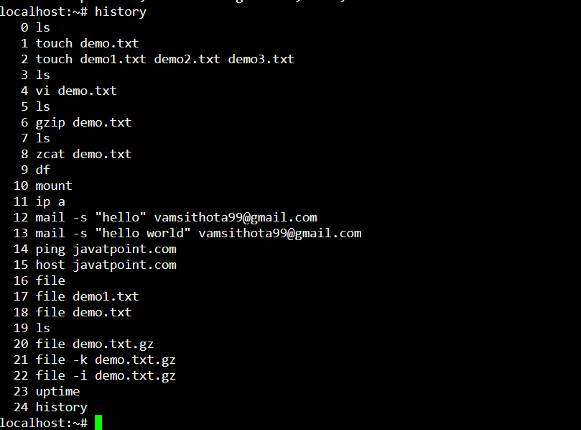

**39.uname**



**40.ln**

Create shortcuts to other files

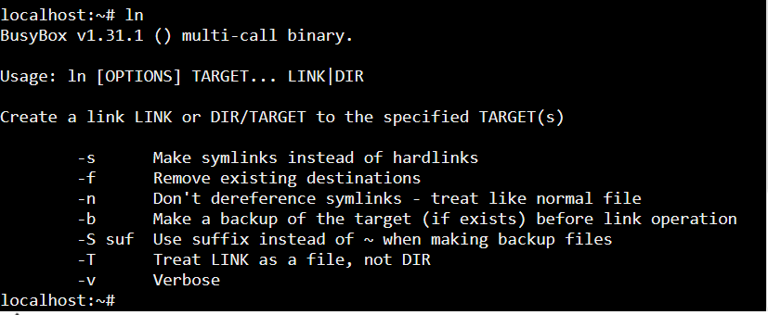

**41.ps**

Display the processes in terminal

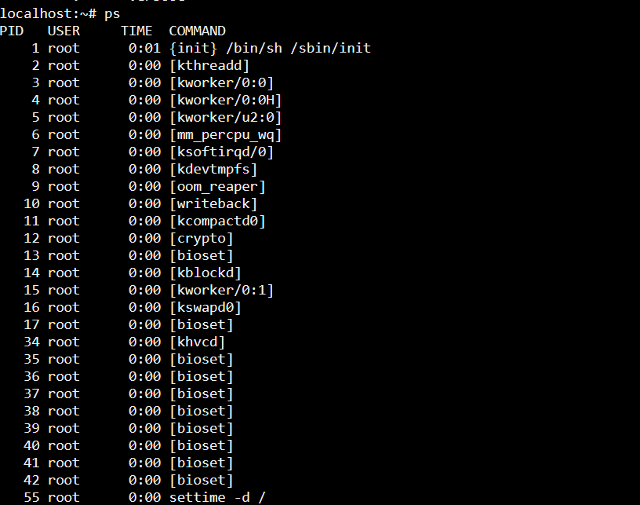

**42.wget**

download files from the internet

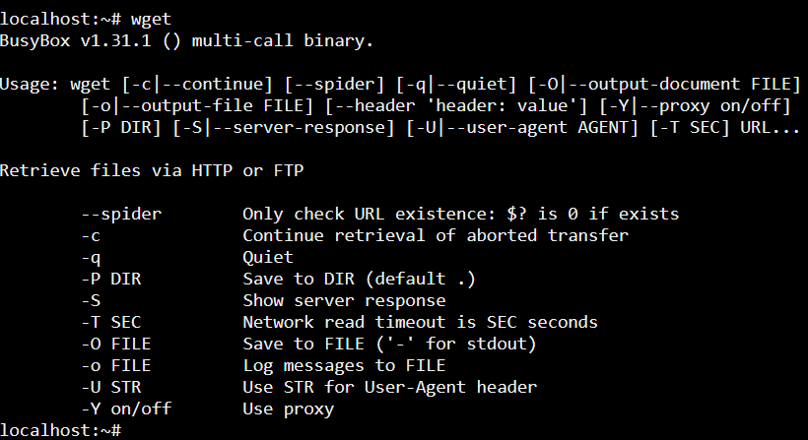

**43.wc**

Check the lines, word count, and characters in a file using different options

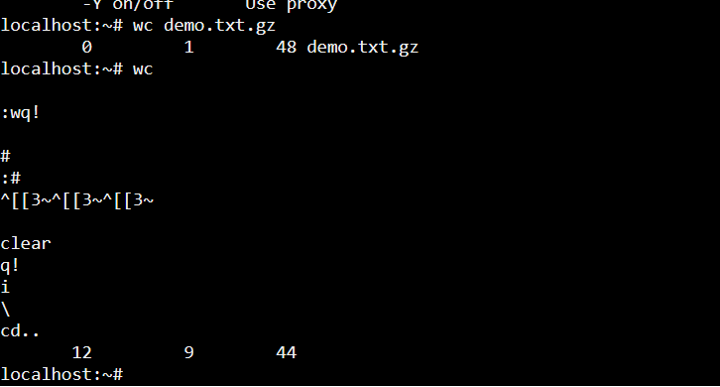

**45.wq!**

Its is used to save the data of a editor file

**46.q!**

When we use q! command it will not save the recent changes on file it will save only existing data only

**47.vi vim command**

Vi command is used to create editor of a file

**48.i command**

I means insert it will used to insert a data or text into the editor file

**49.clear**

Clear terminal

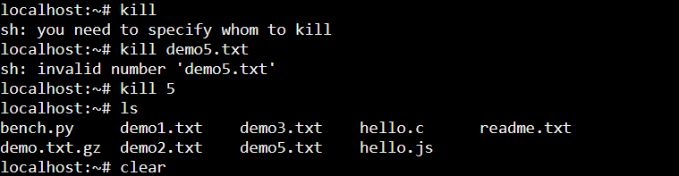



**50.exit**

Linux [exit](https://javatpoint.com/linux-exit-command) command is used to exit from the current shell. It takes a parameter as a number and exits the shell with a return of status number.

