List Methods

# 1.Append()

The python append() method is used to add the element or value to the list. the element is add to list in the last.

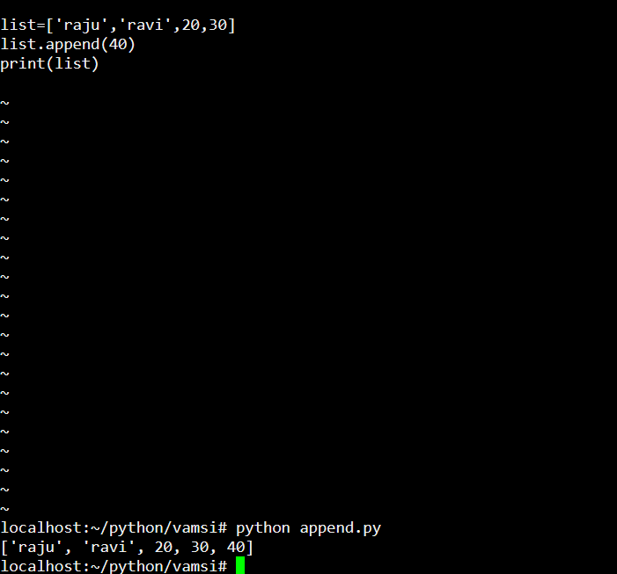

# 2.Insert()

the insert() methos is used to insert a value to the list in a given position.

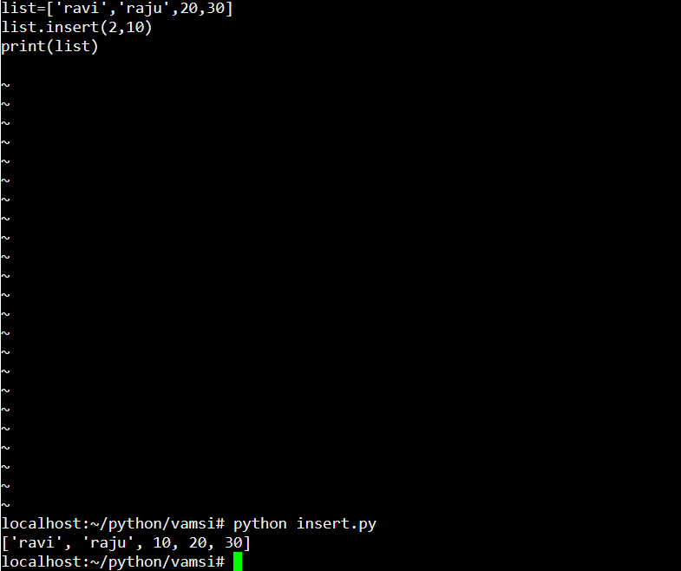

# 3.Extend()

the extend() method is used to extend the list values by adding the another list into it, the values of a list is added in the end of a list.

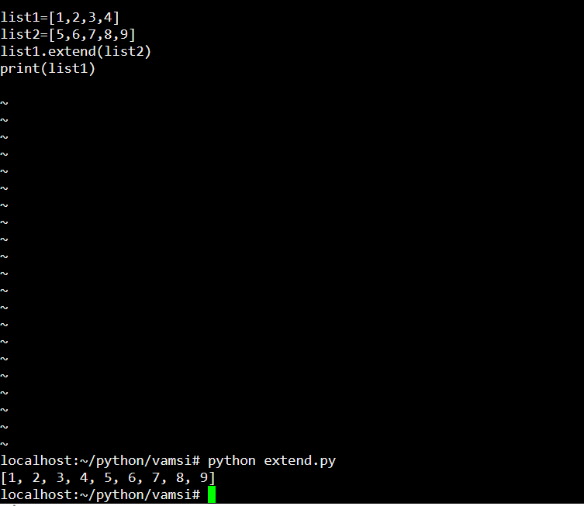

# 4.Sum()

The sum() method in python is used to calculate the total elements sum of a list.

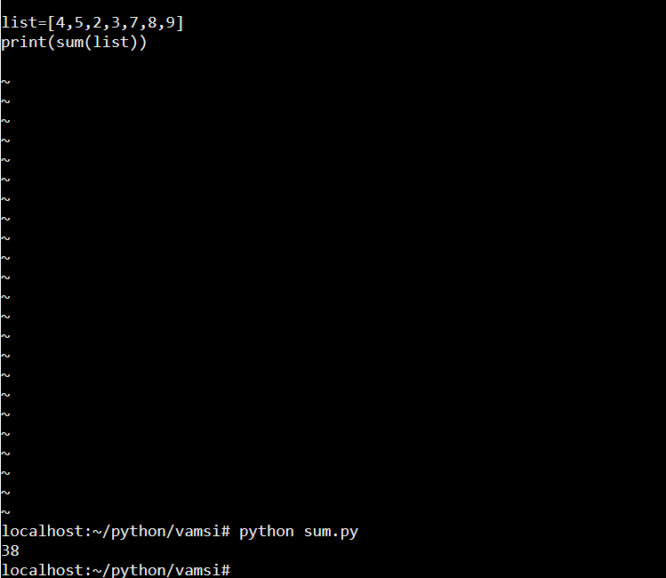

# 5.Count()

The count() method is used to calculate the number of times if a given element is appeared in a list.

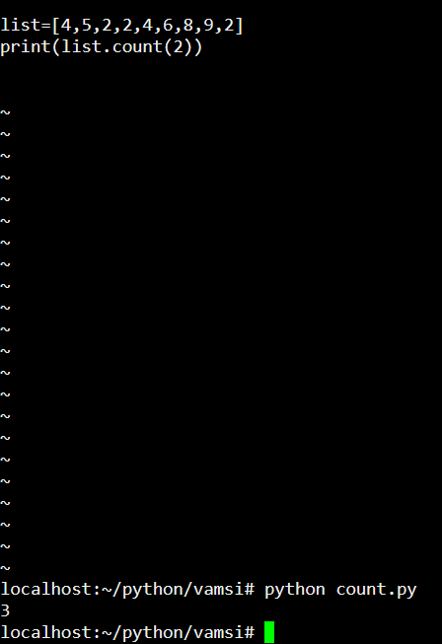

# 6.Length()

The length() method is used to calculate the length of a list.

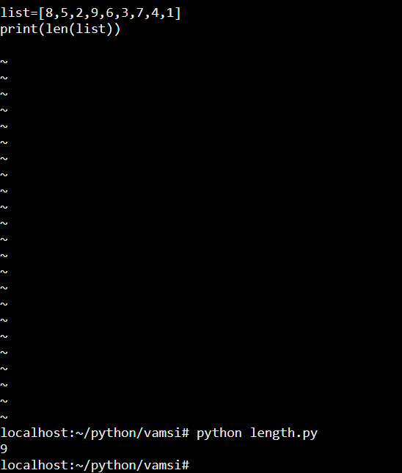

# 7.Index()

The index() method is used to identify the index position of a element in the list.

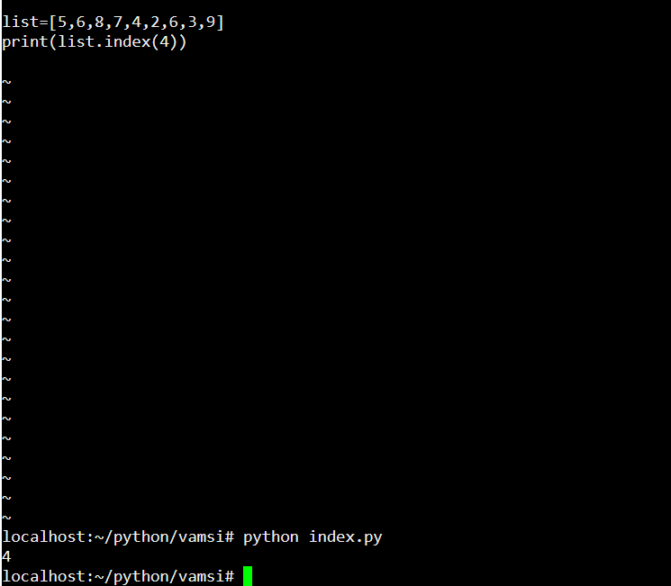

# 8.Min()

The min() method in python is used to calculate the minimum elements of all the list.

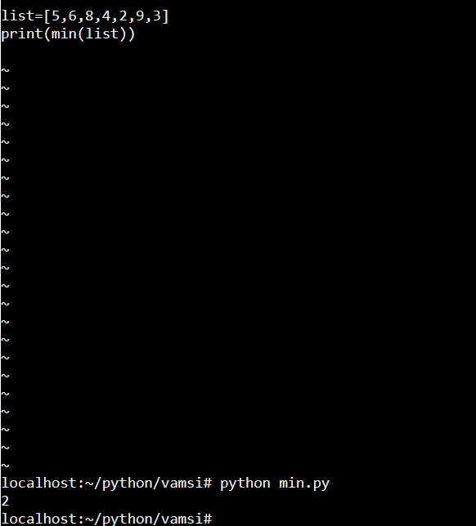

# 9.Max()

In python the max() method is used to calculate the maximum element of all the list.

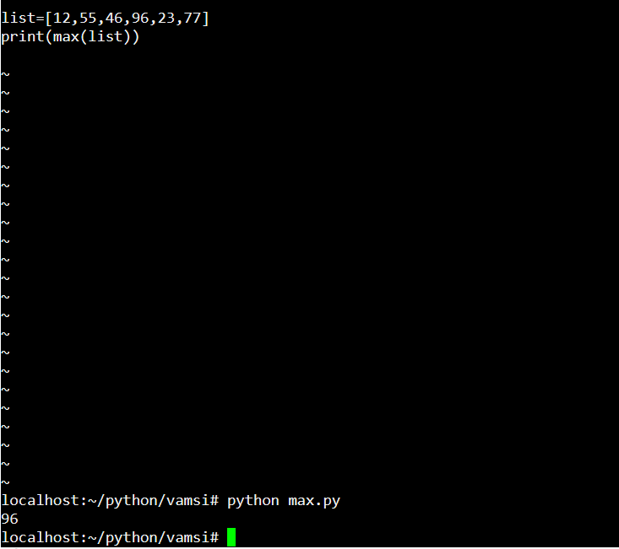

# 10.Sort()

The sort()method is used to sort the elements of a list to ascending order.

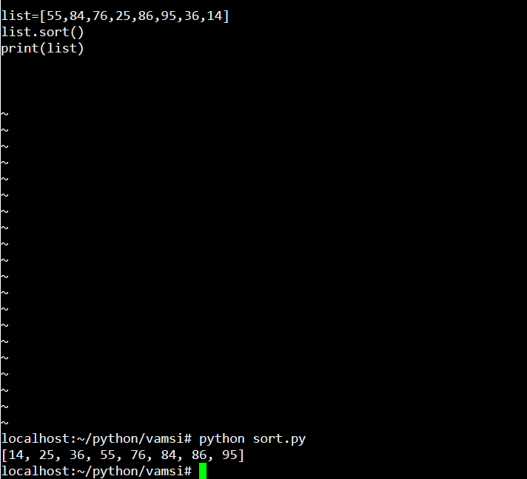

# 11.Revers()

The revers() method is used to print the elements of a list in reverse order.

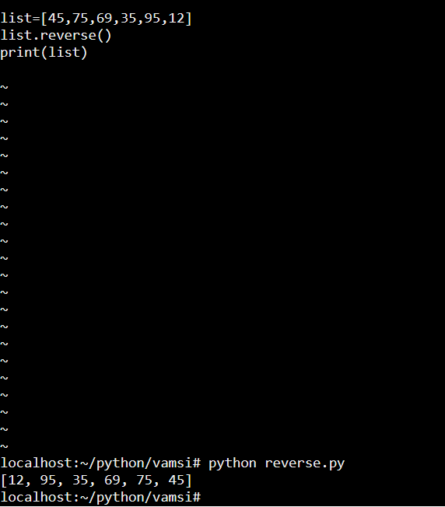

# 12.Pop()

The pop() method is used to display the element of a list if we not mention the index position of a element it will take the last element of a list.

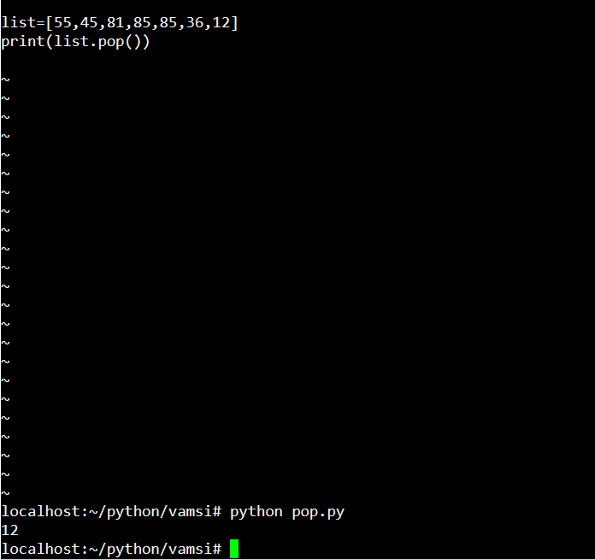

# 

# 13.Delete()

The del() method is used to delete the element of a list by giving the index position of a element.

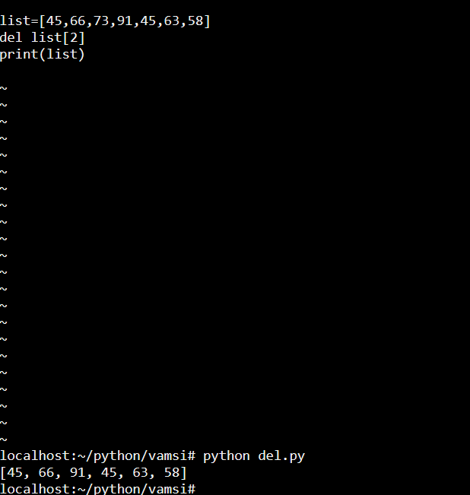

# 14.Remove()

The remove() method is used to remove the elements of a list by giving the element name.

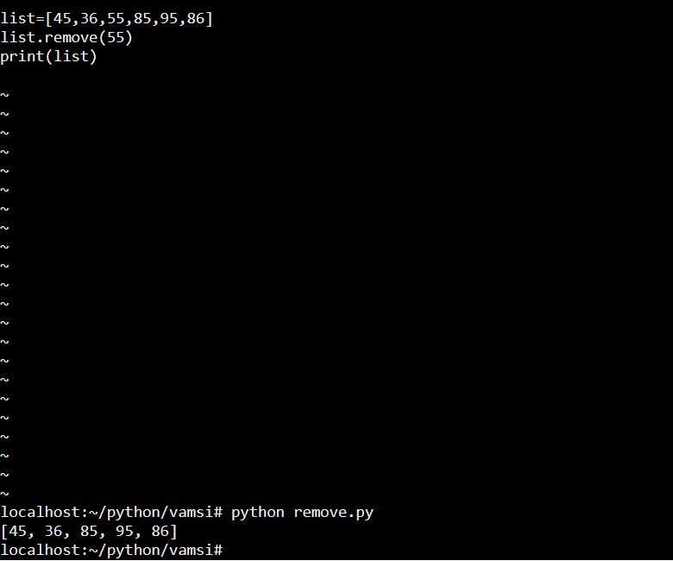

# 15.clear()

The clear() method is used to clear the all the elements of a list.

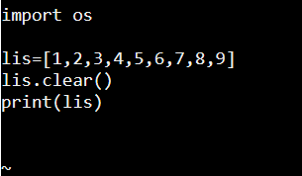

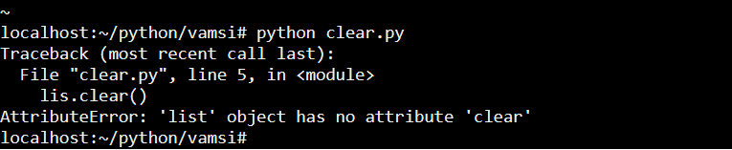

# 16.copy

The copy() method is used to copy the old list and create a one new list with same elements of old list.it cannot affect the old list.

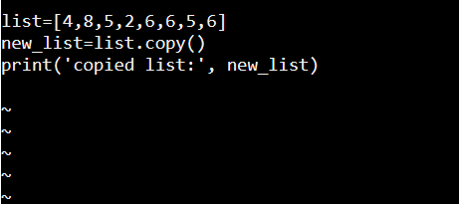

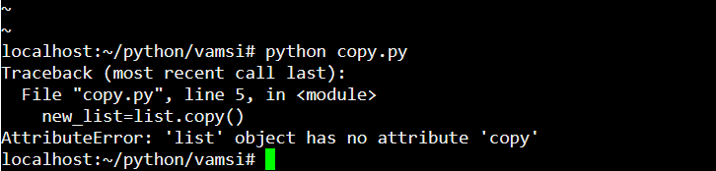

Tuple commands

# 1.count()

The count() method in tuple is used to count the given value is occurred in number of times.

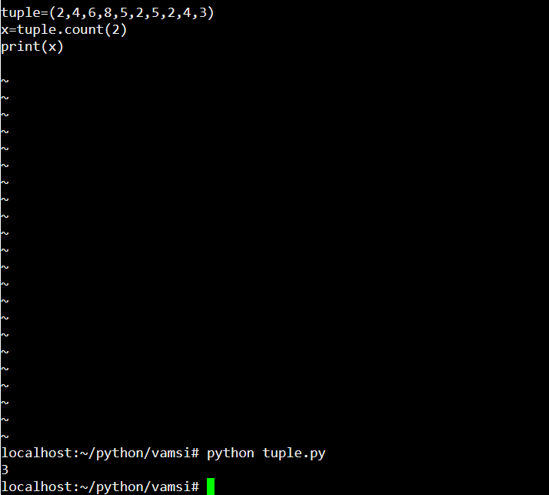

# 2.index()

The index() method in tuple is used to print the index position of a specific given value or element.it will always takes the first index position of a value.

