SQL JOINS

# 1.INNER JOIN:

An inner join returns only the rows that have matching values in both tables.

Example:

select employees.employeeid, employees.firstname, employees.lastname, department.departmentname

from employees

inner join department on employees.departmentid = department.departmentid;

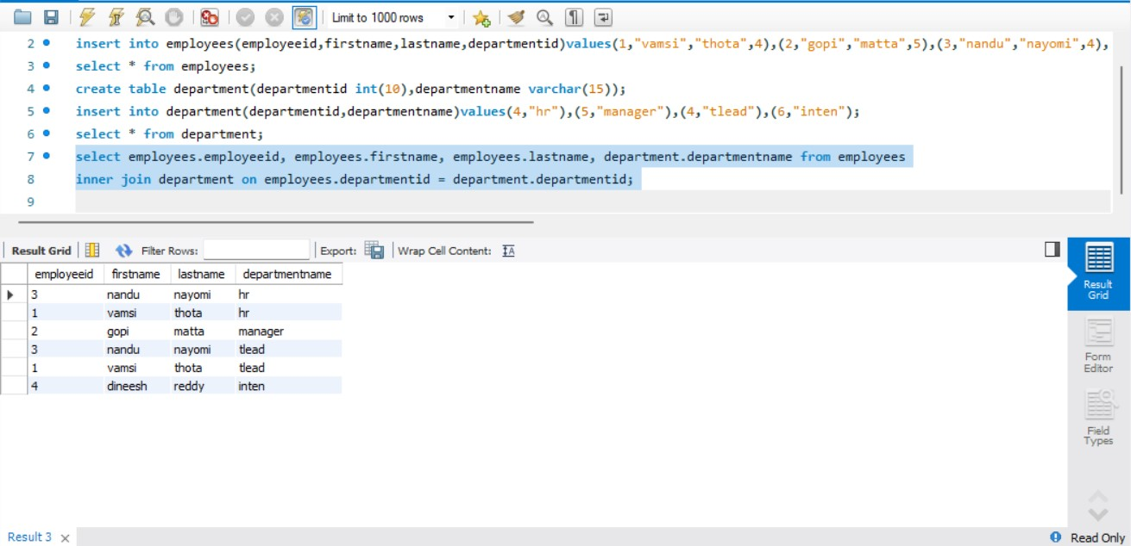

# 2. LEFT JOIN (or LEFT OUTER JOIN):

A lest join returns all rows from the left table and the matching rows from the right table. If there is no match, null values are returned from the right table.

Example:

select employees.employeeid, employees.firstname, employees.lastname, department.departmentname

from employees

left join department on employees.departmentid = department.departmentid;

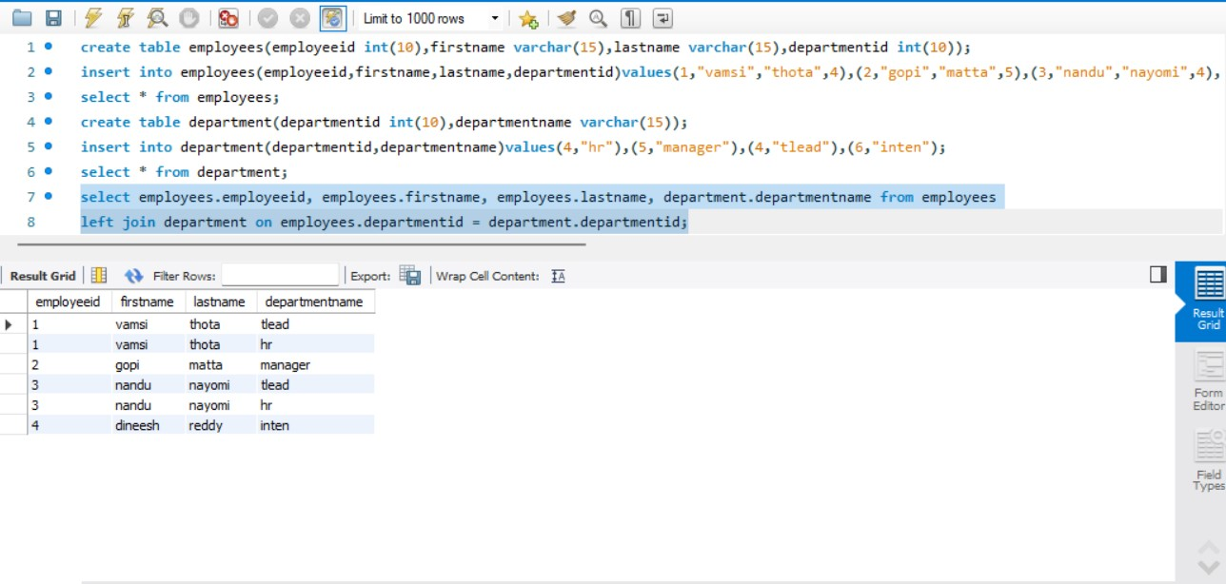

# 3. RIGHT JOIN (or RIGHT OUTER JOIN):

A right join returns all rows from the right table and the matching rows from the left table. If there is no match, null values are returned from the left table.

Example:

select employees.employeeid, employees.firstname, employees.lastname, department.departmentname

from employees

right join department on employees.departmentid = department.departmentid;

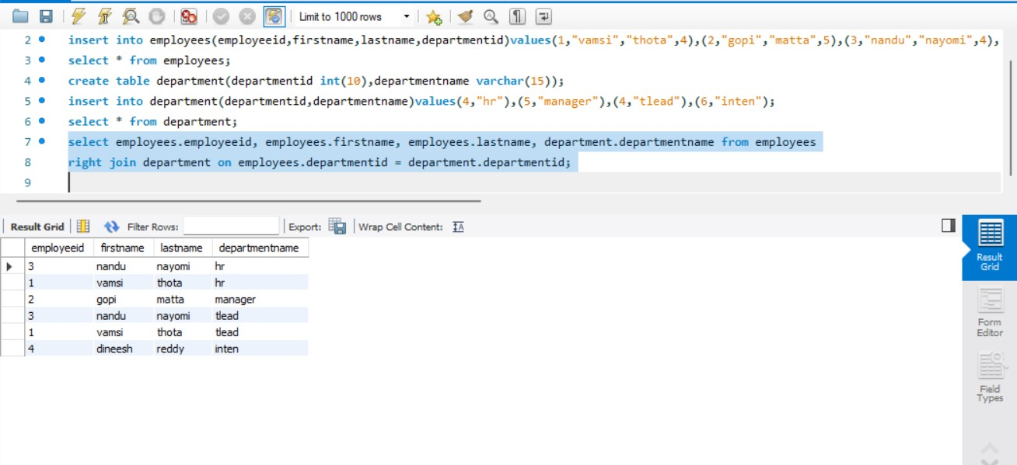

# 4. FULL JOIN (or FULL OUTER JOIN):

A full join returns all rows when there is a match in either the left or right table. If there is no match, null values are returned from the non-matching side.

Example:

select employees.employeeid, employees.firstname, employees.lastname, department.departmentname

from employees

left join department on employees.departmentid = department.departmentid union select employees.employeeid, employees.firstname, employees.lastname, department.departmentname

from employees

right join department on employees.departmentid = department.departmentid;

