**LIST METHODS**

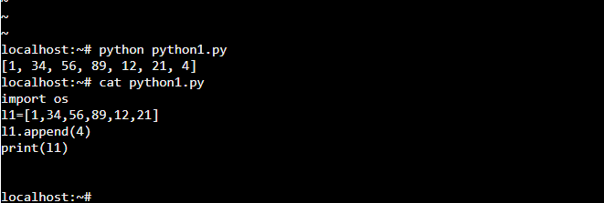

**Adding item using append method**

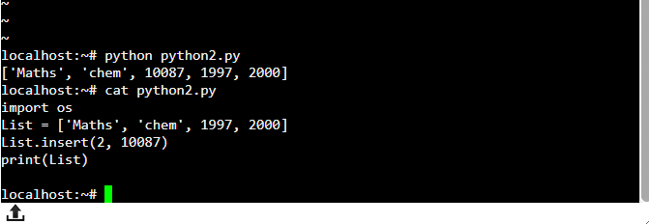

Adding multiple items using insert method

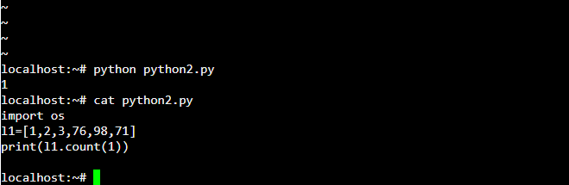

**Using count method gives total occurance of given elemet**

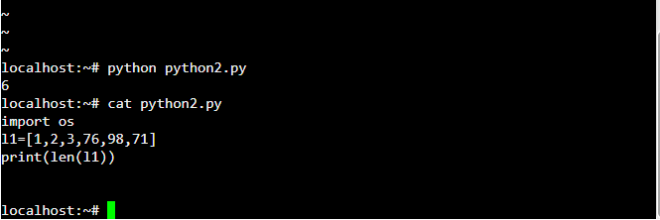

**Finding length of list using LEN method**

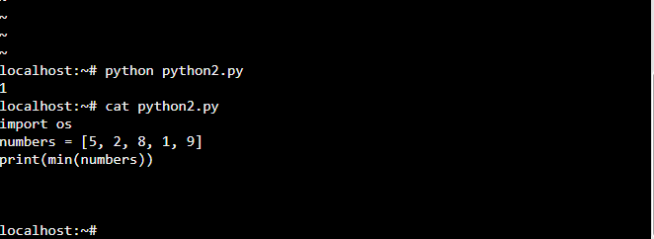

**Finding minium item item in list using MIN method**

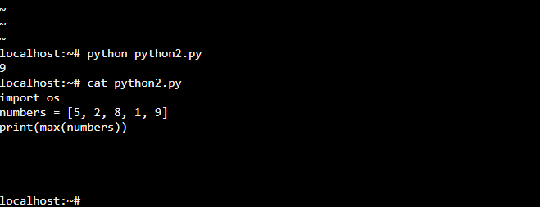

**Finding maximum item item in list using MAX method**

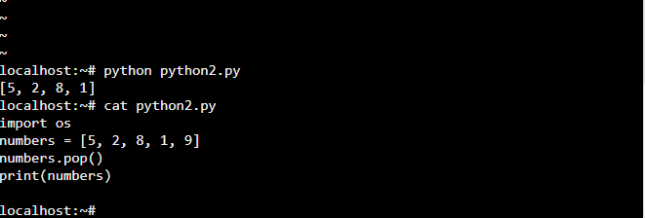

**Removing element using POP method**

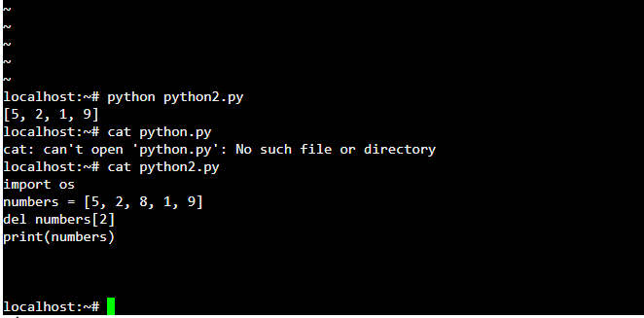

**Deleting item using DEL method**

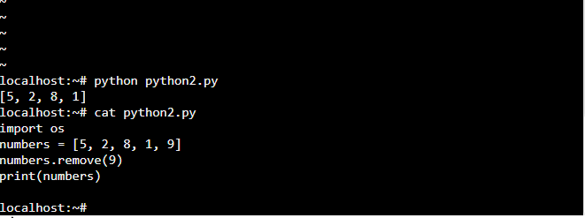

**Remove method will search the item and remove it**

**TUPLE METHODS**

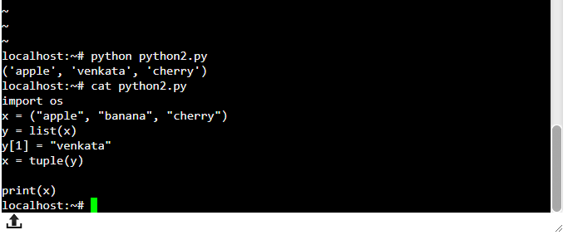

**Changing item in tuple using index**

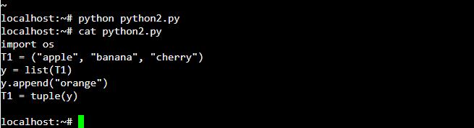

**Adding item using append method**

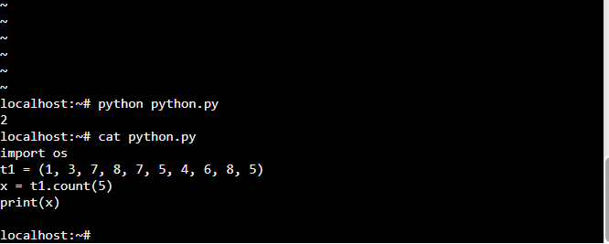

**Using count method finding occurance of a element**

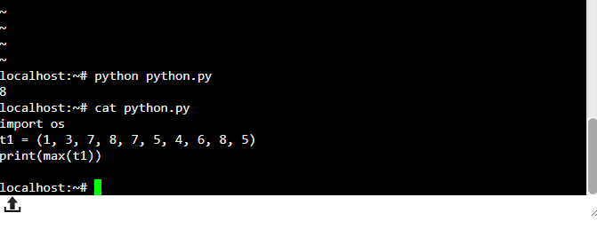

**Finding Max item in tuple using MAX**

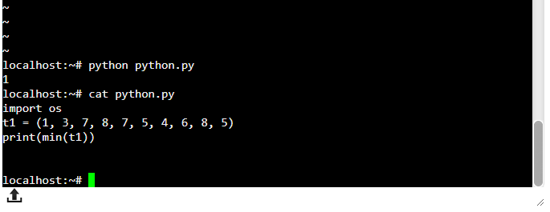

**Finding Minimum in tuple using MIN method**