Replication
net stop MongoDB
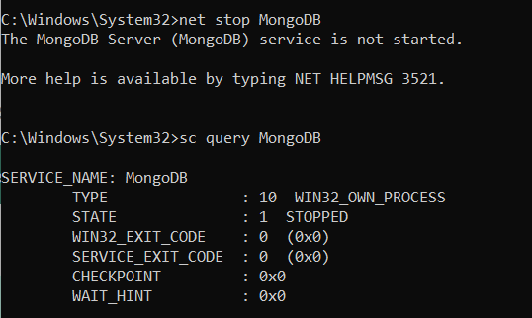
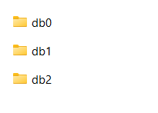
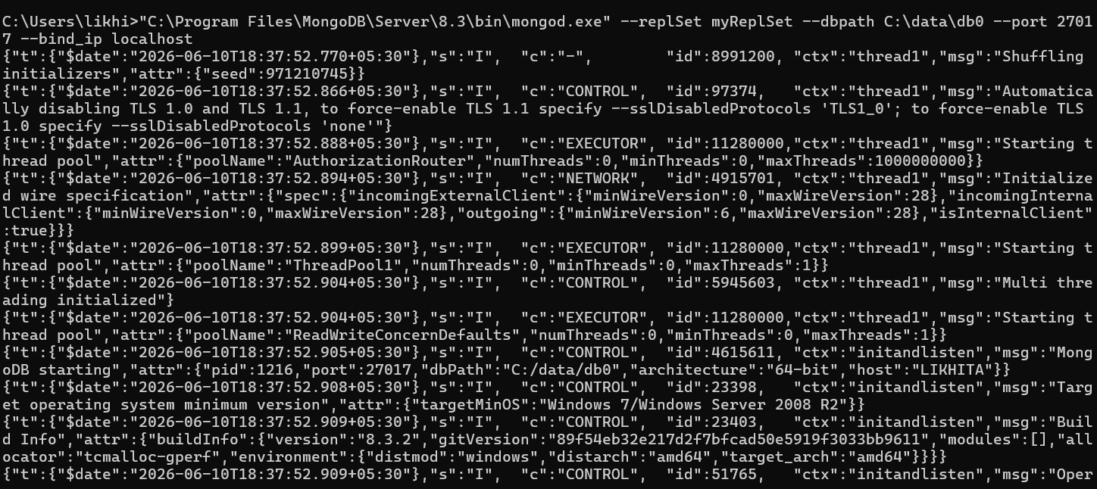
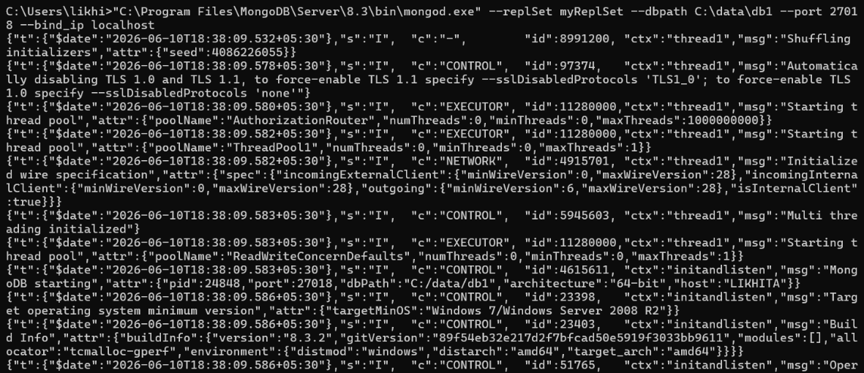
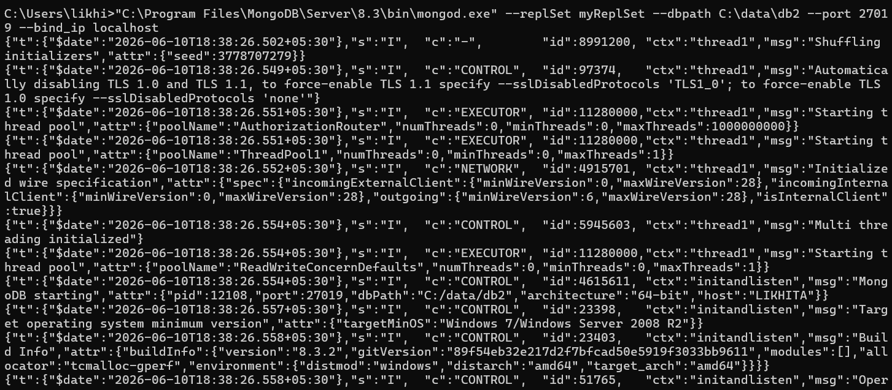
mongodb://127.0.0.1:27017/?directConnection=true

rs.initiate({
_id: "myReplSet",
members: [
{ _id: 0, host: "localhost:27017" },
{ _id: 1, host: "localhost:27018" },
{ _id: 2, host: "localhost:27019" }
]
})
{
ok: 1,
'$clusterTime': {
clusterTime: Timestamp({ t: 1781097051, i: 1 }),
signature: {
hash: Binary.createFromBase64('AAAAAAAAAAAAAAAAAAAAAAAAAAA=', 0),
keyId: Long('0')
}
},
operationTime: Timestamp({ t: 1781097051, i: 1 })
}
rs.status()
{
set: 'myReplSet',
date: 2026-06-10T13:11:34.470Z,
myState: 1,
term: Long('1'),
syncSourceHost: '',
syncSourceId: -1,
heartbeatIntervalMillis: Long('2000'),
majorityVoteCount: 2,
writeMajorityCount: 2,
votingMembersCount: 3,
writableVotingMembersCount: 3,
optimes: {
lastCommittedOpTime: { ts: Timestamp({ t: 1781097092, i: 1 }), t: Long('1') },
lastCommittedWallTime: 2026-06-10T13:11:32.812Z,
readConcernMajorityOpTime: { ts: Timestamp({ t: 1781097092, i: 1 }), t: Long('1') },
appliedOpTime: { ts: Timestamp({ t: 1781097092, i: 1 }), t: Long('1') },
durableOpTime: { ts: Timestamp({ t: 1781097092, i: 1 }), t: Long('1') },
writtenOpTime: { ts: Timestamp({ t: 1781097092, i: 1 }), t: Long('1') },
lastAppliedWallTime: 2026-06-10T13:11:32.812Z,
lastDurableWallTime: 2026-06-10T13:11:32.812Z,
lastWrittenWallTime: 2026-06-10T13:11:32.812Z
},
lastStableRecoveryTimestamp: Timestamp({ t: 1781097051, i: 1 }),
electionCandidateMetrics: {
lastElectionReason: 'electionTimeout',
lastElectionDate: 2026-06-10T13:11:02.632Z,
electionTerm: Long('1'),
lastCommittedOpTimeAtElection: { ts: Timestamp({ t: 1781097051, i: 1 }), t: Long('-1') },
lastSeenWrittenOpTimeAtElection: { ts: Timestamp({ t: 1781097051, i: 1 }), t: Long('-1') },
lastSeenOpTimeAtElection: { ts: Timestamp({ t: 1781097051, i: 1 }), t: Long('-1') },
numVotesNeeded: 2,
priorityAtElection: 1,
electionTimeoutMillis: Long('10000'),
numCatchUpOps: Long('0'),
newTermStartDate: 2026-06-10T13:11:02.746Z,
wMajorityWriteAvailabilityDate: 2026-06-10T13:11:03.212Z
},
members: [
{
_id: 0,
name: 'localhost:27017',
health: 1,
state: 1,
stateStr: 'PRIMARY',
uptime: 222,
optime: { ts: Timestamp({ t: 1781097092, i: 1 }), t: Long('1') },
optimeDate: 2026-06-10T13:11:32.000Z,
optimeWritten: { ts: Timestamp({ t: 1781097092, i: 1 }), t: Long('1') },
optimeWrittenDate: 2026-06-10T13:11:32.000Z,
lastAppliedWallTime: 2026-06-10T13:11:32.812Z,
lastDurableWallTime: 2026-06-10T13:11:32.812Z,
lastWrittenWallTime: 2026-06-10T13:11:32.812Z,
syncSourceHost: '',
syncSourceId: -1,
infoMessage: 'Could not find member to sync from',
electionTime: Timestamp({ t: 1781097062, i: 1 }),
electionDate: 2026-06-10T13:11:02.000Z,
configVersion: 1,
configTerm: 1,
self: true,
lastHeartbeatMessage: ''
},
{
_id: 1,
name: 'localhost:27018',
health: 1,
state: 2,
stateStr: 'SECONDARY',
uptime: 42,
optime: { ts: Timestamp({ t: 1781097082, i: 1 }), t: Long('1') },
optimeDurable: { ts: Timestamp({ t: 1781097082, i: 1 }), t: Long('1') },
optimeWritten: { ts: Timestamp({ t: 1781097082, i: 1 }), t: Long('1') },
optimeDate: 2026-06-10T13:11:22.000Z,
optimeDurableDate: 2026-06-10T13:11:22.000Z,
optimeWrittenDate: 2026-06-10T13:11:22.000Z,
lastAppliedWallTime: 2026-06-10T13:11:32.812Z,
lastDurableWallTime: 2026-06-10T13:11:32.812Z,
lastWrittenWallTime: 2026-06-10T13:11:32.812Z,
lastHeartbeat: 2026-06-10T13:11:32.708Z,
lastHeartbeatRecv: 2026-06-10T13:11:33.710Z,
pingMs: Long('0'),
lastHeartbeatMessage: '',
syncSourceHost: 'localhost:27017',
syncSourceId: 0,
infoMessage: '',
configVersion: 1,
configTerm: 1
},
{
_id: 2,
name: 'localhost:27019',
health: 1,
state: 2,
stateStr: 'SECONDARY',
uptime: 42,
optime: { ts: Timestamp({ t: 1781097082, i: 1 }), t: Long('1') },
optimeDurable: { ts: Timestamp({ t: 1781097082, i: 1 }), t: Long('1') },
optimeWritten: { ts: Timestamp({ t: 1781097082, i: 1 }), t: Long('1') },
optimeDate: 2026-06-10T13:11:22.000Z,
optimeDurableDate: 2026-06-10T13:11:22.000Z,
optimeWrittenDate: 2026-06-10T13:11:22.000Z,
lastAppliedWallTime: 2026-06-10T13:11:32.812Z,
lastDurableWallTime: 2026-06-10T13:11:32.812Z,
lastWrittenWallTime: 2026-06-10T13:11:32.812Z,
lastHeartbeat: 2026-06-10T13:11:32.708Z,
lastHeartbeatRecv: 2026-06-10T13:11:33.709Z,
pingMs: Long('0'),
lastHeartbeatMessage: '',
syncSourceHost: 'localhost:27017',
syncSourceId: 0,
infoMessage: '',
configVersion: 1,
configTerm: 1
}
],
ok: 1,
'$clusterTime': {
clusterTime: Timestamp({ t: 1781097092, i: 1 }),
signature: {
hash: Binary.createFromBase64('AAAAAAAAAAAAAAAAAAAAAAAAAAA=', 0),
keyId: Long('0')
}
},
operationTime: Timestamp({ t: 1781097092, i: 1 })
}
use college
switched to db college
db.students.insertOne({
name: "Uma",
course: "MongoDB"
})
{
acknowledged: true,
insertedId: ObjectId('6a2962da8a96047ed3d61d35')
}
mongodb://127.0.0.1:27018/?directConnection=true
use college
switched to db college
db.students.find()
{
_id: ObjectId('6a2962da8a96047ed3d61d35'),
name: 'Uma',
course: 'MongoDB'
}
rs.status()

Kill the primary window
{
set: 'myReplSet',
date: 2026-06-10T13:17:35.224Z,
myState: 1,
term: Long('2'),
syncSourceHost: '',
syncSourceId: -1,
heartbeatIntervalMillis: Long('2000'),
majorityVoteCount: 2,
writeMajorityCount: 2,
votingMembersCount: 3,
writableVotingMembersCount: 3,
optimes: {
lastCommittedOpTime: { ts: Timestamp({ t: 1781097447, i: 1 }), t: Long('2') },
lastCommittedWallTime: 2026-06-10T13:17:27.524Z,
readConcernMajorityOpTime: { ts: Timestamp({ t: 1781097447, i: 1 }), t: Long('2') },
appliedOpTime: { ts: Timestamp({ t: 1781097447, i: 1 }), t: Long('2') },
durableOpTime: { ts: Timestamp({ t: 1781097447, i: 1 }), t: Long('2') },
writtenOpTime: { ts: Timestamp({ t: 1781097447, i: 1 }), t: Long('2') },
lastAppliedWallTime: 2026-06-10T13:17:27.524Z,
lastDurableWallTime: 2026-06-10T13:17:27.524Z,
lastWrittenWallTime: 2026-06-10T13:17:27.524Z
},
lastStableRecoveryTimestamp: Timestamp({ t: 1781097417, i: 1 }),
electionCandidateMetrics: {
lastElectionReason: 'stepUpRequestSkipDryRun',
lastElectionDate: 2026-06-10T13:16:47.491Z,
electionTerm: Long('2'),
lastCommittedOpTimeAtElection: { ts: Timestamp({ t: 1781097402, i: 1 }), t: Long('1') },
lastSeenWrittenOpTimeAtElection: { ts: Timestamp({ t: 1781097402, i: 1 }), t: Long('1') },
lastSeenOpTimeAtElection: { ts: Timestamp({ t: 1781097402, i: 1 }), t: Long('1') },
numVotesNeeded: 2,
priorityAtElection: 1,
electionTimeoutMillis: Long('10000'),
priorPrimaryMemberId: 0,
numCatchUpOps: Long('0'),
newTermStartDate: 2026-06-10T13:16:47.515Z,
wMajorityWriteAvailabilityDate: 2026-06-10T13:16:47.535Z
},
electionParticipantMetrics: {
votedForCandidate: true,
electionTerm: Long('1'),
lastVoteDate: 2026-06-10T13:11:02.639Z,
electionCandidateMemberId: 0,
voteReason: '',
lastWrittenOpTimeAtElection: { ts: Timestamp({ t: 1781097051, i: 1 }), t: Long('-1') },
maxWrittenOpTimeInSet: { ts: Timestamp({ t: 1781097051, i: 1 }), t: Long('-1') },
lastAppliedOpTimeAtElection: { ts: Timestamp({ t: 1781097051, i: 1 }), t: Long('-1') },
maxAppliedOpTimeInSet: { ts: Timestamp({ t: 1781097051, i: 1 }), t: Long('-1') },
priorityAtElection: 1
},
members: [
{
_id: 0,
name: 'localhost:27017',
health: 0,
state: 8,
stateStr: '(not reachable/healthy)',
uptime: 0,
optime: { ts: Timestamp({ t: 0, i: 0 }), t: Long('-1') },
optimeDurable: { ts: Timestamp({ t: 0, i: 0 }), t: Long('-1') },
optimeWritten: { ts: Timestamp({ t: 0, i: 0 }), t: Long('-1') },
optimeDate: 1970-01-01T00:00:00.000Z,
optimeDurableDate: 1970-01-01T00:00:00.000Z,
optimeWrittenDate: 1970-01-01T00:00:00.000Z,
lastAppliedWallTime: 2026-06-10T13:16:57.520Z,
lastDurableWallTime: 2026-06-10T13:16:57.520Z,
lastWrittenWallTime: 2026-06-10T13:16:57.520Z,
lastHeartbeat: 2026-06-10T13:17:34.136Z,
lastHeartbeatRecv: 2026-06-10T13:17:02.024Z,
pingMs: Long('0'),
lastHeartbeatMessage: 'Error connecting to localhost:27017 (127.0.0.1:27017) :: caused by :: onInvoke :: caused by :: No connection could be made because the target machine actively refused it.',
syncSourceHost: '',
syncSourceId: -1,
infoMessage: '',
configVersion: 1,
configTerm: 2
},
{
_id: 1,
name: 'localhost:27018',
health: 1,
state: 1,
stateStr: 'PRIMARY',
uptime: 566,
optime: { ts: Timestamp({ t: 1781097447, i: 1 }), t: Long('2') },
optimeDate: 2026-06-10T13:17:27.000Z,
optimeWritten: { ts: Timestamp({ t: 1781097447, i: 1 }), t: Long('2') },
optimeWrittenDate: 2026-06-10T13:17:27.000Z,
lastAppliedWallTime: 2026-06-10T13:17:27.524Z,
lastDurableWallTime: 2026-06-10T13:17:27.524Z,
lastWrittenWallTime: 2026-06-10T13:17:27.524Z,
syncSourceHost: '',
syncSourceId: -1,
infoMessage: '',
electionTime: Timestamp({ t: 1781097407, i: 1 }),
electionDate: 2026-06-10T13:16:47.000Z,
configVersion: 1,
configTerm: 2,
self: true,
lastHeartbeatMessage: ''
},
{
_id: 2,
name: 'localhost:27019',
health: 1,
state: 2,
stateStr: 'SECONDARY',
uptime: 402,
optime: { ts: Timestamp({ t: 1781097447, i: 1 }), t: Long('2') },
optimeDurable: { ts: Timestamp({ t: 1781097447, i: 1 }), t: Long('2') },
optimeWritten: { ts: Timestamp({ t: 1781097447, i: 1 }), t: Long('2') },
optimeDate: 2026-06-10T13:17:27.000Z,
optimeDurableDate: 2026-06-10T13:17:27.000Z,
optimeWrittenDate: 2026-06-10T13:17:27.000Z,
lastAppliedWallTime: 2026-06-10T13:17:27.524Z,
lastDurableWallTime: 2026-06-10T13:17:27.524Z,
lastWrittenWallTime: 2026-06-10T13:17:27.524Z,
lastHeartbeat: 2026-06-10T13:17:33.545Z,
lastHeartbeatRecv: 2026-06-10T13:17:34.086Z,
pingMs: Long('0'),
lastHeartbeatMessage: '',
syncSourceHost: 'localhost:27018',
syncSourceId: 1,
infoMessage: '',
configVersion: 1,
configTerm: 2
}
],
ok: 1,
'$clusterTime': {
clusterTime: Timestamp({ t: 1781097447, i: 1 }),
signature: {
hash: Binary.createFromBase64('AAAAAAAAAAAAAAAAAAAAAAAAAAA=', 0),
keyId: Long('0')
}
},
operationTime: Timestamp({ t: 1781097447, i: 1 })
}
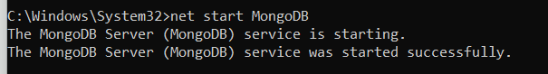

Sharding
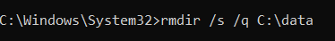
mkdir C:\data\config
"C:\Program Files\MongoDB\Server\8.3\bin\mongod.exe" --configsvr --replSet configReplSet --dbpath C:\data\config --port 27019
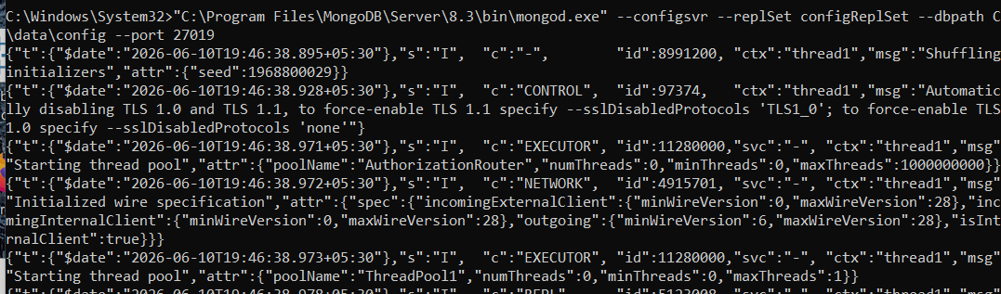
mkdir C:\data\shard1
"C:\Program Files\MongoDB\Server\8.3\bin\mongod.exe" --shardsvr --replSet shard1ReplSet --dbpath C:\data\shard1 --port 27011
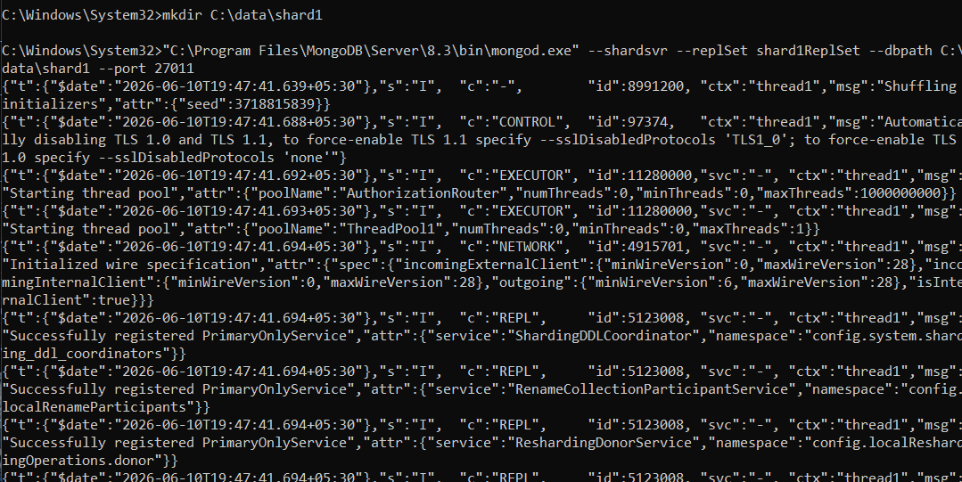
mkdir C:\data\shard2
"C:\Program Files\MongoDB\Server\8.3\bin\mongod.exe" --shardsvr --replSet shard2ReplSet --dbpath C:\data\shard2 --port 27012
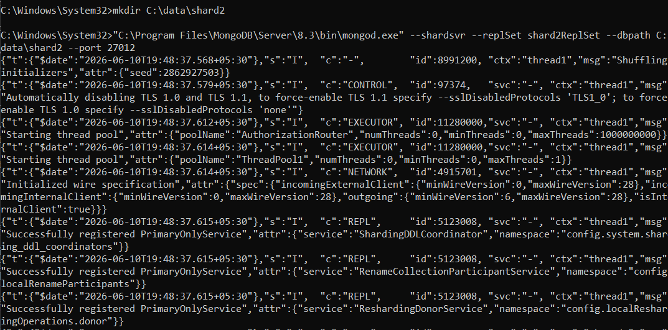
mongodb://127.0.0.1:27019/?directConnection=true
rs.initiate({ _id: "configReplSet", configsvr: true, members: [{ _id: 0, host: "127.0.0.1:27019" }] })
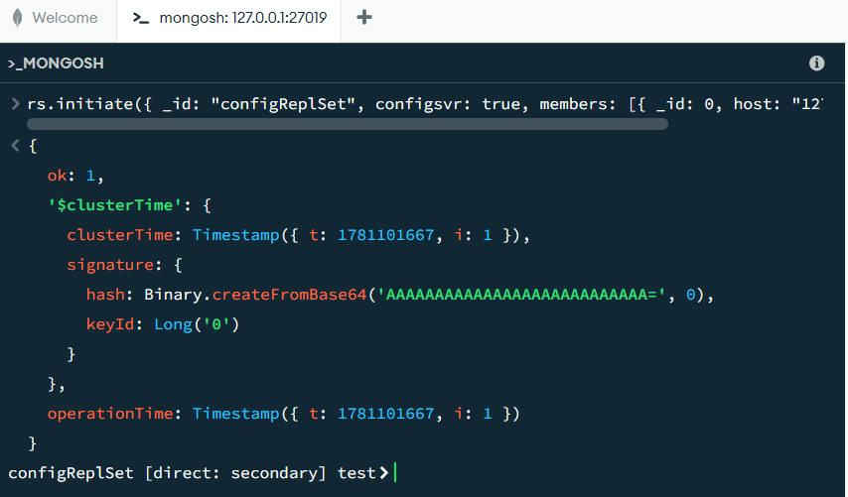
mongodb://127.0.0.1:27011/?directConnection=true
rs.initiate()
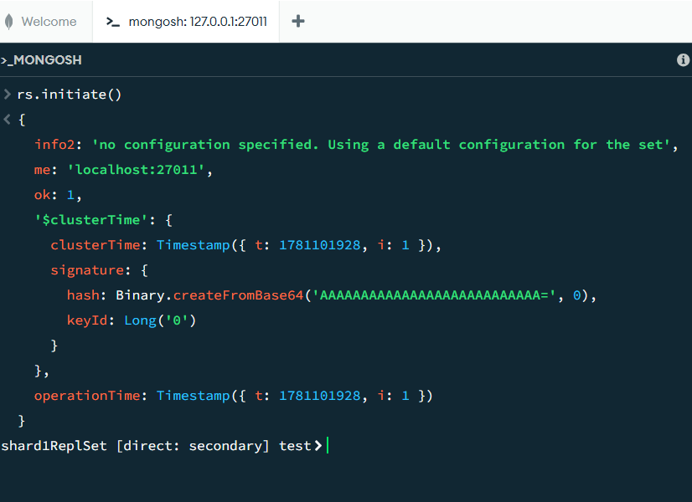
mongodb://127.0.0.1:27012/?directConnection=true
rs.initiate()
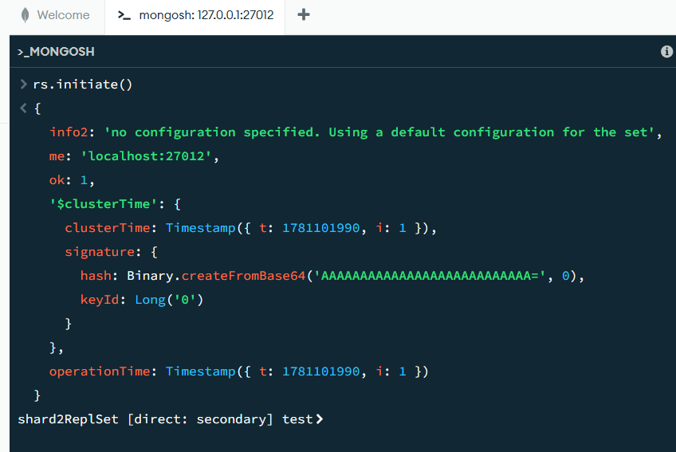
"C:\Program Files\MongoDB\Server\8.3\bin\mongos.exe" --configdb configReplSet/127.0.0.1:27019 --port 27017
