package crud_operations;
import com.mongodb.client.*;
import com.mongodb.client.model.Filters;
import com.mongodb.client.model.Updates;
import org.bson.Document;
public class MongoCRUDExample {
public static void main(String[] args) {
// Connect to MongoDB
MongoClient mongoClient = MongoClients.create("mongodb://localhost:27017");
// Access database
MongoDatabase database = mongoClient.getDatabase("vit");
// Access collection
MongoCollection<Document> collection = database.getCollection("Students"); // ==========================
// CREATE (Insert)
// ==========================
Document student = new Document("id", 101) .append("name", "John") .append("department", "CSE") .append("cgpa", 8.7); collection.insertOne(student);
System.out.println("Document Inserted Successfully");
// ========================== // READ (Find)
// ==========================
System.out.println("\nStudent RRecords:");
FindIterable<Document> students = collection.find();
for (Document doc : students) {
System.out.println(doc.toJson()); }
// ========================== // UPDATE
// ==========================
collection.updateOne( Filters.eq("id", 101), Updates.set("cgpa", 9.2) );
System.out.println("\nDocument Updated Successfully");
// ========================== // READ Updated Record
// ==========================
Document updatedStudent = collection.find(Filters.eq("id", 101)).first();
System.out.println("\nUpdated Record:");
System.out.println(updatedStudent.toJson());
// ========================== // DELETE
// ==========================
collection.deleteOne(Filters.eq("id", 101));
System.out.println("\nDocument Deleted Successfully");
// Close connection
mongoClient.close();
}
}

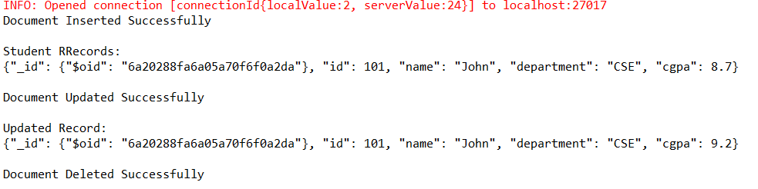
InsertMany
package crud_operations;
import com.mongodb.client.*;
import com.mongodb.client.model.Filters;
import com.mongodb.client.model.Updates;
import org.bson.Document;
public class MongoCRUDEx {
public static void main(String[] args) {
// Connect to MongoDB
MongoClient mongoClient = MongoClients.create("mongodb://localhost:27017");

// Access database
MongoDatabase database = mongoClient.getDatabase("vit");
// Access collection
MongoCollection<Document> collection = database.getCollection("Students");
// ==========================
// CREATE (Insert Many)
// ==========================
collection.insertMany(java.util.Arrays.asList(
new Document("id", 1).append("name", "Alice"),
new Document("id", 2).append("name", "Bob"),
new Document("id", 3).append("name", "Charlie")
));
System.out.println("Multiple Documents Inserted Successfully");
// ==========================
// READ (Find Specific Document)
// ==========================
System.out.println("\nFinding Specific Document (id: 2):");
Document doc = collection.find(Filters.eq("id", 2)).first();
if (doc != null) {
System.out.println(doc.toJson());
} else {
System.out.println("Document not found.");
}
// ==========================
// UPDATE Specific Document
// ==========================
collection.updateOne(
Filters.eq("id", 2),
Updates.set("name", "Bobby")
);
System.out.println("\nDocument Updated Successfully (Bob -> Bobby)");
// ==========================
// READ Updated Record
// ==========================
Document updatedStudent = collection.find(Filters.eq("id", 2)).first();
System.out.println("\nUpdated Record:");
if (updatedStudent != null) {
System.out.println(updatedStudent.toJson());
}
// ==========================
// DELETE Specific Document
// ==========================
collection.deleteOne(Filters.eq("id", 2));
System.out.println("\nDocument Deleted Successfully (id: 2)");
// Close connection
mongoClient.close();
}
}
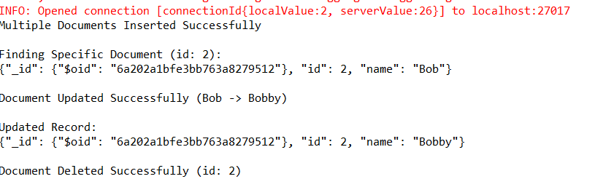

package crud_operations;
import com.mongodb.client.*;
import com.mongodb.client.model.Filters;
import com.mongodb.client.model.Updates;
import org.bson.Document;
import java.util.Arrays;
public class MongoCRUDManyEx {
public static void main(String[] args) {
// Connect to MongoDB
MongoClient mongoClient = MongoClients.create("mongodb://localhost:27017");
// Access database
MongoDatabase database = mongoClient.getDatabase("vit");
// Access collection
MongoCollection<Document> collection = database.getCollection("Students");
// ==========================
// CREATE (Insert Many)
// ==========================
Document student1 = new Document("id", 101).append("name", "John").append("department", "CSE").append("cgpa", 8.7);
Document student2 = new Document("id", 102).append("name", "Alice").append("department", "CSE").append("cgpa", 7.9);
Document student3 = new Document("id", 103).append("name", "Bob").append("department", "ECE").append("cgpa", 8.2);
// Inserting a list of documents at once
collection.insertMany(Arrays.asList(student1, student2, student3));
System.out.println("Documents Inserted Successfully using insertMany");

// ==========================
// READ (Find Many)
// ==========================
System.out.println("\nAll Student Records:");
FindIterable<Document> students = collection.find(); // Finds all documents in the collection
for (Document doc : students) {
System.out.println(doc.toJson());
}
// ==========================
// UPDATE (Update Many)
// ==========================
// Updates all students belonging to the "CSE" department
collection.updateMany(
Filters.eq("department", "CSE"),
Updates.set("cgpa", 9.2)
);
System.out.println("\nDocuments Updated Successfully using updateMany (CSE students cgpa -> 9.2)");

// ==========================
// READ Updated Records
// ==========================
System.out.println("\nUpdated Records (Filtering CSE Department):");
FindIterable<Document> updatedStudents = collection.find(Filters.eq("department", "CSE"));
for (Document doc : updatedStudents) {
System.out.println(doc.toJson());
}
// ==========================
// DELETE (Delete Many)
// ==========================
// Deletes all records matching the filter condition (e.g., all records with an ID greater than 100)
collection.deleteMany(Filters.gt("id", 100));
System.out.println("\nDocuments Deleted Successfully using deleteMany");
// Close connection
mongoClient.close();
}
}
