GIT Branching Assignment 2

Objective: Commit HTML, CSS & JavaScript assignments into GIT.

SECTION-1 (HTML assignments) - Steps to follow:

1. First take a backup of your assignments & projects. This is required because due to incorrect GIT operation you may lose your files.
2. Create an empty directory ‘Assignments’ & cd to ‘Assignments’.
3. Create a file README.txt inside ‘Assignments’ & write few lines about the contents of ‘Assignments’ folder.
4. Commit README.txt file.
5. Now create a new branch ‘html-assignments’.
6. Switch to ‘html-assignments’ branch.
7. Copy all HTML assignments inside ‘Assignments’ folder.
8. Commit HTML assignments into ‘html-assignments’ branch.
9. Make minor changes into few files belonging to ‘html-assignments’ branch.
10. Commit those changed files.
11. Switch to master branch.
12. Make minor changes into README.txt file & commit those changes into master.
13. Again switch to ‘html-assignments’ branch.
14. Make minor changes into few files belonging to ‘html-assignments’ branch.
15. Commit those changes.
16. Switch to master.
17. Merge ‘html-assignments’ branch into master. Confirm all html assignments are shown in master.
18. Finally delete the ‘html-assignments’ branch.

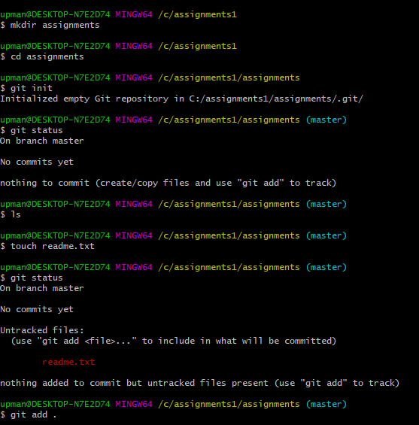

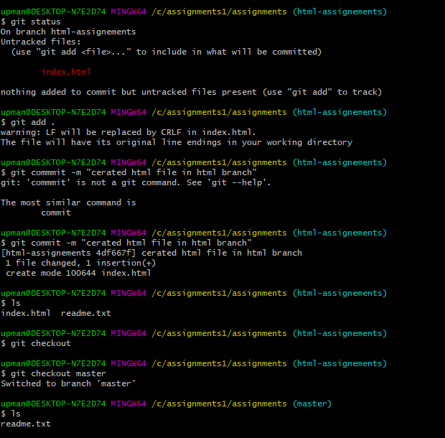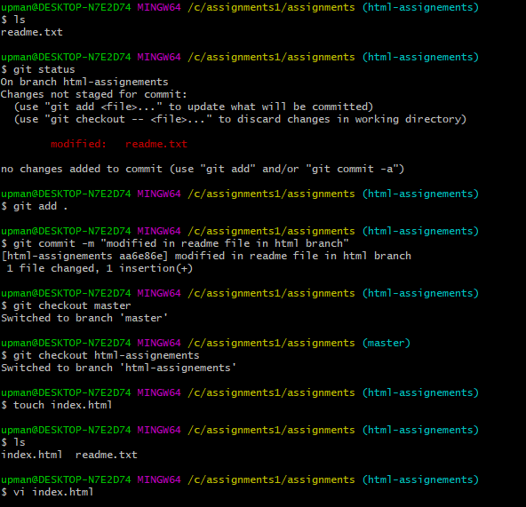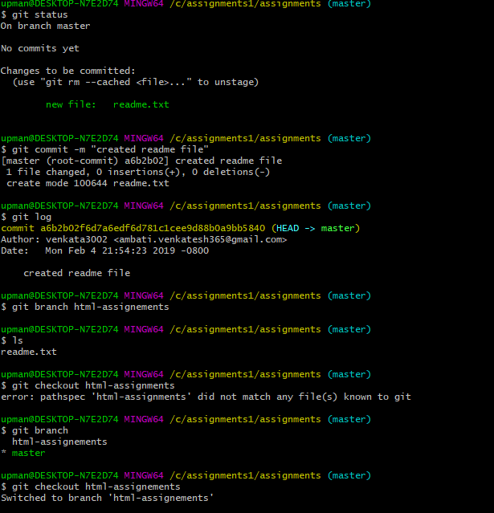

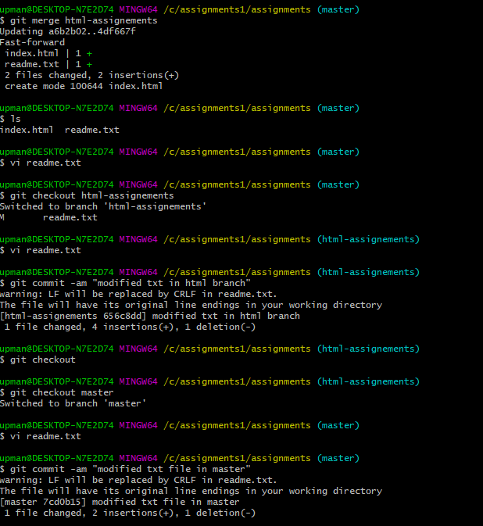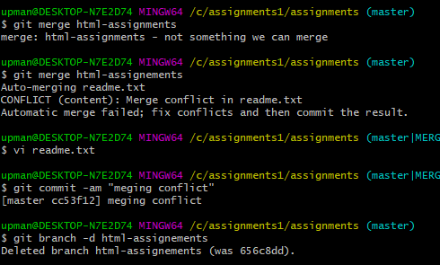

SECTION-2 - (CSS assignments) Steps to follow:

1. Create a new branch ‘css-assignments’.
2. Switch to ‘css-assignments’ branch.
3. Copy all CSS assignments inside ‘Assignments’ folder.
4. Commit CSS assignments into ‘css-assignments’ branch.
5. Make minor changes into README.txt file on line 1 belonging to ‘css-assignments’ branch.
6. Commit those changed files.
7. Switch to master branch.
8. Make minor changes into README.txt file on line 3 & commit those changes into master.
9. Again switch to ‘css-assignments’ branch.
10. Make minor changes into few files belonging to ‘css-assignments’ branch.
11. Commit those changes.
12. Switch to master.
13. Merge ‘css-assignments’ branch into master. Confirm all css assignments are shown in master.
14. Finally delete the ‘css-assignments’ branch.

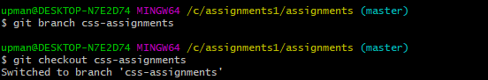

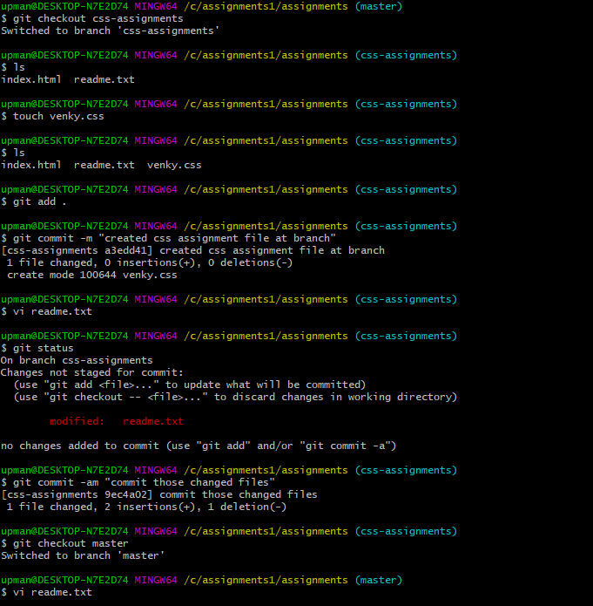

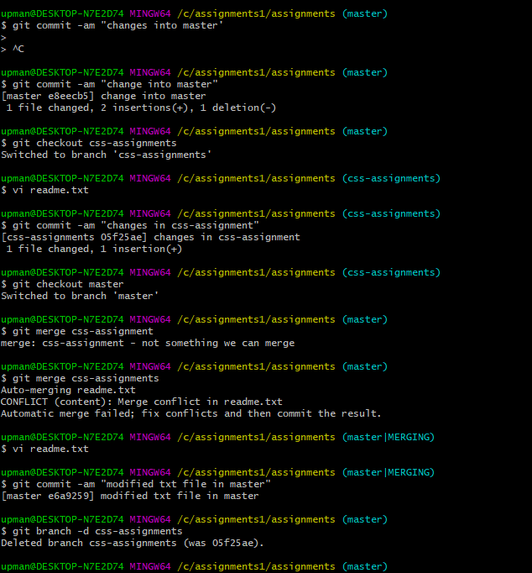

SECTION-3 - (JavaScript assignments) Steps to follow:

1. Create a new branch ‘js-assignments’.
2. Switch to ‘js-assignments’ branch.
3. Copy all JavaScript assignments inside ‘Assignments’ folder.
4. Commit JavaScript assignments into ‘js-assignments’ branch.
5. Make minor changes into README.txt file on line 1 belonging to ‘js-assignments’ branch.
6. Commit those changed files.
7. Switch to master branch.
8. Make minor changes into README.txt file on line 1 & commit those changes into master.
9. Again switch to ‘js-assignments’ branch.
10. Make minor changes into few files belonging to ‘js-assignments’ branch.
11. Commit those changes.
12. Switch to master.
13. Merge ‘js-assignments’ branch into master. Confirm all JavaScript assignments are shown in master.
14. Finally delete the ‘js-assignments’ branch.

