1_Display all departments from department table.

CREATE TABLE DEPT

(

DEPTNO NUMERIC(2) CONSTRAINT DEPTNO_DEPT_PK PRIMARY KEY,

DNAME VARCHAR(14),

LOC VARCHAR(13)

);

INSERT INTO DEPT VALUES (10,'ACCOUNTING','NEW YORK');

INSERT INTO DEPT VALUES (20,'RESEARCH','DALLAS');

INSERT INTO DEPT VALUES (30,'SALES','CHICAGO');

INSERT INTO DEPT VALUES (40,'OPERATIONS','BOSTON');

Ans-SELECT DNAME FROM DEPT;

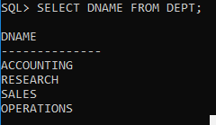

2-Display all employess from employee table.

CREATE TABLE EMP

(

EMPNO NUMERIC(4) CONSTRAINT EMPNO_EMP_PK PRIMARY KEY,

ENAME VARCHAR(10),

JOB VARCHAR(9),

MGR NUMERIC(4),

HIREDATE DATE,

SAL NUMERIC(7,2),

COMM NUMERIC(7,2),

DEPTNO NUMERIC(2) CONSTRAINT DEPTNO_DEPT_FK REFERENCES DEPT(DEPTNO)

);

INSERT INTO EMP VALUES (7369,'SMITH','CLERK',7902,'17-DEC-80',800,NULL,20);

INSERT INTO EMP VALUES (7499,'ALLEN','SALESMAN',7698,'20-FEB-81',1600,300,30);

INSERT INTO EMP VALUES (7521,'WARD','SALESMAN',7698,'22-FEB-81',1250,500,30);

INSERT INTO EMP VALUES (7566,'JONES','MANAGER',7839,'02-APR-81',2975,NULL,20);

INSERT INTO EMP VALUES (7654,'MARTIN','SALESMAN',7698,'28-SEP-81',1250,1400,30);

INSERT INTO EMP VALUES (7698,'BLAKE','MANAGER',7839,'01-MAY-81',2850,NULL,30);

INSERT INTO EMP VALUES (7782,'CLARK','MANAGER',7839,'09-JUN-81',2450,NULL,10);

INSERT INTO EMP VALUES (7788,'SCOTT','ANALYST',7566,'19-APR-87',3000,NULL,20);

INSERT INTO EMP VALUES (7839,'KING','PRESIDENT',NULL,'17-NOV-81',5000,NULL,10);

INSERT INTO EMP VALUES (7844,'TURNER','SALESMAN',7698,'08-SEP-81',1500,0,30);

INSERT INTO EMP VALUES (7876,'ADAMS','CLERK',7788,'23-MAY-87',1100,NULL,20);

INSERT INTO EMP VALUES (7900,'JAMES','CLERK',7698,'03-DEC-81','950',NULL,30);

INSERT INTO EMP VALUES (7902,'FORD','ANALYST',7566,'03-DEC-81',3000,NULL,20);

INSERT INTO EMP VALUES (7934,'MILLER','CLERK',7782,'23-JAN-82',1300,NULL,10);

Ans-SELECT ENAME FROM EMP;

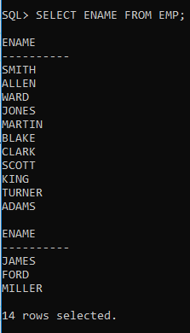

3_Select employee in dept 30.

CREATE TABLE EMP

(

EMPNO NUMERIC(4) CONSTRAINT EMPNO_EMP_PK PRIMARY KEY,

ENAME VARCHAR(10),

JOB VARCHAR(9),

MGR NUMERIC(4),

HIREDATE DATE,

SAL NUMERIC(7,2),

COMM NUMERIC(7,2),

DEPTNO NUMERIC(2) CONSTRAINT DEPTNO_DEPT_FK REFERENCES DEPT(DEPTNO)

);

INSERT INTO EMP VALUES (7369,'SMITH','CLERK',7902,'17-DEC-80',800,NULL,20);

INSERT INTO EMP VALUES (7499,'ALLEN','SALESMAN',7698,'20-FEB-81',1600,300,30);

INSERT INTO EMP VALUES (7521,'WARD','SALESMAN',7698,'22-FEB-81',1250,500,30);

INSERT INTO EMP VALUES (7566,'JONES','MANAGER',7839,'02-APR-81',2975,NULL,20);

INSERT INTO EMP VALUES (7654,'MARTIN','SALESMAN',7698,'28-SEP-81',1250,1400,30);

INSERT INTO EMP VALUES (7698,'BLAKE','MANAGER',7839,'01-MAY-81',2850,NULL,30);

INSERT INTO EMP VALUES (7782,'CLARK','MANAGER',7839,'09-JUN-81',2450,NULL,10);

INSERT INTO EMP VALUES (7788,'SCOTT','ANALYST',7566,'19-APR-87',3000,NULL,20);

INSERT INTO EMP VALUES (7839,'KING','PRESIDENT',NULL,'17-NOV-81',5000,NULL,10);

INSERT INTO EMP VALUES (7844,'TURNER','SALESMAN',7698,'08-SEP-81',1500,0,30);

INSERT INTO EMP VALUES (7876,'ADAMS','CLERK',7788,'23-MAY-87',1100,NULL,20);

INSERT INTO EMP VALUES (7900,'JAMES','CLERK',7698,'03-DEC-81','950',NULL,30);

INSERT INTO EMP VALUES (7902,'FORD','ANALYST',7566,'03-DEC-81',3000,NULL,20);

INSERT INTO EMP VALUES (7934,'MILLER','CLERK',7782,'23-JAN-82',1300,NULL,10);

Ans-SELECT ENAME FROM EMP WHERE DEPTNO=30;

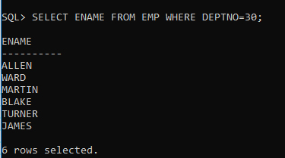

4_List the names,numbers and departmentsno of all employess.

CREATE TABLE EMP

(

EMPNO NUMERIC(4) CONSTRAINT EMPNO_EMP_PK PRIMARY KEY,

ENAME VARCHAR(10),

JOB VARCHAR(9),

MGR NUMERIC(4),

HIREDATE DATE,

SAL NUMERIC(7,2),

COMM NUMERIC(7,2),

DEPTNO NUMERIC(2) CONSTRAINT DEPTNO_DEPT_FK REFERENCES DEPT(DEPTNO)

);

INSERT INTO EMP VALUES (7369,'SMITH','CLERK',7902,'17-DEC-80',800,NULL,20);

INSERT INTO EMP VALUES (7499,'ALLEN','SALESMAN',7698,'20-FEB-81',1600,300,30);

INSERT INTO EMP VALUES (7521,'WARD','SALESMAN',7698,'22-FEB-81',1250,500,30);

INSERT INTO EMP VALUES (7566,'JONES','MANAGER',7839,'02-APR-81',2975,NULL,20);

INSERT INTO EMP VALUES (7654,'MARTIN','SALESMAN',7698,'28-SEP-81',1250,1400,30);

INSERT INTO EMP VALUES (7698,'BLAKE','MANAGER',7839,'01-MAY-81',2850,NULL,30);

INSERT INTO EMP VALUES (7782,'CLARK','MANAGER',7839,'09-JUN-81',2450,NULL,10);

INSERT INTO EMP VALUES (7788,'SCOTT','ANALYST',7566,'19-APR-87',3000,NULL,20);

INSERT INTO EMP VALUES (7839,'KING','PRESIDENT',NULL,'17-NOV-81',5000,NULL,10);

INSERT INTO EMP VALUES (7844,'TURNER','SALESMAN',7698,'08-SEP-81',1500,0,30);

INSERT INTO EMP VALUES (7876,'ADAMS','CLERK',7788,'23-MAY-87',1100,NULL,20);

INSERT INTO EMP VALUES (7900,'JAMES','CLERK',7698,'03-DEC-81','950',NULL,30);

INSERT INTO EMP VALUES (7902,'FORD','ANALYST',7566,'03-DEC-81',3000,NULL,20);

INSERT INTO EMP VALUES (7934,'MILLER','CLERK',7782,'23-JAN-82',1300,NULL,10);

Ans_SELECT ENAME,EMPNO,DEPTNO FROM EMP WHERE JOB='CLERK';

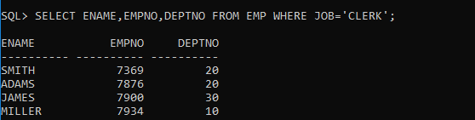

5_Find the depart numbers and the name of employee of all dept with deptno greater or equal to 20.

CREATE TABLE EMP

(

EMPNO NUMERIC(4) CONSTRAINT EMPNO_EMP_PK PRIMARY KEY,

ENAME VARCHAR(10),

JOB VARCHAR(9),

MGR NUMERIC(4),

HIREDATE DATE,

SAL NUMERIC(7,2),

COMM NUMERIC(7,2),

DEPTNO NUMERIC(2) CONSTRAINT DEPTNO_DEPT_FK REFERENCES DEPT(DEPTNO)

);

INSERT INTO EMP VALUES (7369,'SMITH','CLERK',7902,'17-DEC-80',800,NULL,20);

INSERT INTO EMP VALUES (7499,'ALLEN','SALESMAN',7698,'20-FEB-81',1600,300,30);

INSERT INTO EMP VALUES (7521,'WARD','SALESMAN',7698,'22-FEB-81',1250,500,30);

INSERT INTO EMP VALUES (7566,'JONES','MANAGER',7839,'02-APR-81',2975,NULL,20);

INSERT INTO EMP VALUES (7654,'MARTIN','SALESMAN',7698,'28-SEP-81',1250,1400,30);

INSERT INTO EMP VALUES (7698,'BLAKE','MANAGER',7839,'01-MAY-81',2850,NULL,30);

INSERT INTO EMP VALUES (7782,'CLARK','MANAGER',7839,'09-JUN-81',2450,NULL,10);

INSERT INTO EMP VALUES (7788,'SCOTT','ANALYST',7566,'19-APR-87',3000,NULL,20);

INSERT INTO EMP VALUES (7839,'KING','PRESIDENT',NULL,'17-NOV-81',5000,NULL,10);

INSERT INTO EMP VALUES (7844,'TURNER','SALESMAN',7698,'08-SEP-81',1500,0,30);

INSERT INTO EMP VALUES (7876,'ADAMS','CLERK',7788,'23-MAY-87',1100,NULL,20);

INSERT INTO EMP VALUES (7900,'JAMES','CLERK',7698,'03-DEC-81','950',NULL,30);

INSERT INTO EMP VALUES (7902,'FORD','ANALYST',7566,'03-DEC-81',3000,NULL,20);

INSERT INTO EMP VALUES (7934,'MILLER','CLERK',7782,'23-JAN-82',1300,NULL,10);

Ans_SELECT DEPTNO,EMPNO FROM EMP WHERE DEPTNO>=20;

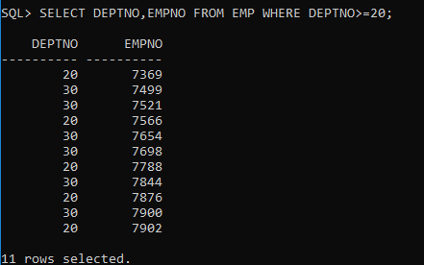

6_Find the employess whose commission is greater than salary.

CREATE TABLE EMP

(

EMPNO NUMERIC(4) CONSTRAINT EMPNO_EMP_PK PRIMARY KEY,

ENAME VARCHAR(10),

JOB VARCHAR(9),

MGR NUMERIC(4),

HIREDATE DATE,

SAL NUMERIC(7,2),

COMM NUMERIC(7,2),

DEPTNO NUMERIC(2) CONSTRAINT DEPTNO_DEPT_FK REFERENCES DEPT(DEPTNO)

);

INSERT INTO EMP VALUES (7369,'SMITH','CLERK',7902,'17-DEC-80',800,NULL,20);

INSERT INTO EMP VALUES (7499,'ALLEN','SALESMAN',7698,'20-FEB-81',1600,300,30);

INSERT INTO EMP VALUES (7521,'WARD','SALESMAN',7698,'22-FEB-81',1250,500,30);

INSERT INTO EMP VALUES (7566,'JONES','MANAGER',7839,'02-APR-81',2975,NULL,20);

INSERT INTO EMP VALUES (7654,'MARTIN','SALESMAN',7698,'28-SEP-81',1250,1400,30);

INSERT INTO EMP VALUES (7698,'BLAKE','MANAGER',7839,'01-MAY-81',2850,NULL,30);

INSERT INTO EMP VALUES (7782,'CLARK','MANAGER',7839,'09-JUN-81',2450,NULL,10);

INSERT INTO EMP VALUES (7788,'SCOTT','ANALYST',7566,'19-APR-87',3000,NULL,20);

INSERT INTO EMP VALUES (7839,'KING','PRESIDENT',NULL,'17-NOV-81',5000,NULL,10);

INSERT INTO EMP VALUES (7844,'TURNER','SALESMAN',7698,'08-SEP-81',1500,0,30);

INSERT INTO EMP VALUES (7876,'ADAMS','CLERK',7788,'23-MAY-87',1100,NULL,20);

INSERT INTO EMP VALUES (7900,'JAMES','CLERK',7698,'03-DEC-81','950',NULL,30);

INSERT INTO EMP VALUES (7902,'FORD','ANALYST',7566,'03-DEC-81',3000,NULL,20);

INSERT INTO EMP VALUES (7934,'MILLER','CLERK',7782,'23-JAN-82',1300,NULL,10);

Ans_SELECT ENAME FROM EMP WHERE COMM>SAL;

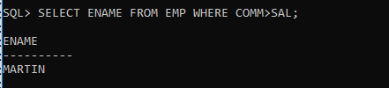

7_Find the employess whose commission is greater than 60 percent of their salary.

CREATE TABLE EMP

(

EMPNO NUMERIC(4) CONSTRAINT EMPNO_EMP_PK PRIMARY KEY,

ENAME VARCHAR(10),

JOB VARCHAR(9),

MGR NUMERIC(4),

HIREDATE DATE,

SAL NUMERIC(7,2),

COMM NUMERIC(7,2),

DEPTNO NUMERIC(2) CONSTRAINT DEPTNO_DEPT_FK REFERENCES DEPT(DEPTNO)

);

INSERT INTO EMP VALUES (7369,'SMITH','CLERK',7902,'17-DEC-80',800,NULL,20);

INSERT INTO EMP VALUES (7499,'ALLEN','SALESMAN',7698,'20-FEB-81',1600,300,30);

INSERT INTO EMP VALUES (7521,'WARD','SALESMAN',7698,'22-FEB-81',1250,500,30);

INSERT INTO EMP VALUES (7566,'JONES','MANAGER',7839,'02-APR-81',2975,NULL,20);

INSERT INTO EMP VALUES (7654,'MARTIN','SALESMAN',7698,'28-SEP-81',1250,1400,30);

INSERT INTO EMP VALUES (7698,'BLAKE','MANAGER',7839,'01-MAY-81',2850,NULL,30);

INSERT INTO EMP VALUES (7782,'CLARK','MANAGER',7839,'09-JUN-81',2450,NULL,10);

INSERT INTO EMP VALUES (7788,'SCOTT','ANALYST',7566,'19-APR-87',3000,NULL,20);

INSERT INTO EMP VALUES (7839,'KING','PRESIDENT',NULL,'17-NOV-81',5000,NULL,10);

INSERT INTO EMP VALUES (7844,'TURNER','SALESMAN',7698,'08-SEP-81',1500,0,30);

INSERT INTO EMP VALUES (7876,'ADAMS','CLERK',7788,'23-MAY-87',1100,NULL,20);

INSERT INTO EMP VALUES (7900,'JAMES','CLERK',7698,'03-DEC-81','950',NULL,30);

INSERT INTO EMP VALUES (7902,'FORD','ANALYST',7566,'03-DEC-81',3000,NULL,20);

INSERT INTO EMP VALUES (7934,'MILLER','CLERK',7782,'23-JAN-82',1300,NULL,10);

Ans_SELECT * FROM EMP WHERE COMM>(60/100)*SAL;

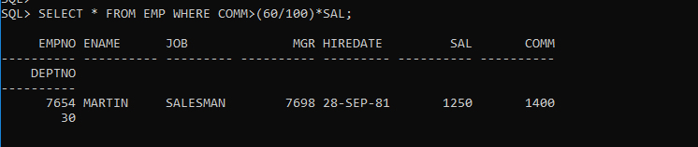

8_Find the employess whose commission is greater than 50 percent of their salary.

CREATE TABLE EMP

(

EMPNO NUMERIC(4) CONSTRAINT EMPNO_EMP_PK PRIMARY KEY,

ENAME VARCHAR(10),

JOB VARCHAR(9),

MGR NUMERIC(4),

HIREDATE DATE,

SAL NUMERIC(7,2),

COMM NUMERIC(7,2),

DEPTNO NUMERIC(2) CONSTRAINT DEPTNO_DEPT_FK REFERENCES DEPT(DEPTNO)

);

INSERT INTO EMP VALUES (7369,'SMITH','CLERK',7902,'17-DEC-80',800,NULL,20);

INSERT INTO EMP VALUES (7499,'ALLEN','SALESMAN',7698,'20-FEB-81',1600,300,30);

INSERT INTO EMP VALUES (7521,'WARD','SALESMAN',7698,'22-FEB-81',1250,500,30);

INSERT INTO EMP VALUES (7566,'JONES','MANAGER',7839,'02-APR-81',2975,NULL,20);

INSERT INTO EMP VALUES (7654,'MARTIN','SALESMAN',7698,'28-SEP-81',1250,1400,30);

INSERT INTO EMP VALUES (7698,'BLAKE','MANAGER',7839,'01-MAY-81',2850,NULL,30);

INSERT INTO EMP VALUES (7782,'CLARK','MANAGER',7839,'09-JUN-81',2450,NULL,10);

INSERT INTO EMP VALUES (7788,'SCOTT','ANALYST',7566,'19-APR-87',3000,NULL,20);

INSERT INTO EMP VALUES (7839,'KING','PRESIDENT',NULL,'17-NOV-81',5000,NULL,10);

INSERT INTO EMP VALUES (7844,'TURNER','SALESMAN',7698,'08-SEP-81',1500,0,30);

INSERT INTO EMP VALUES (7876,'ADAMS','CLERK',7788,'23-MAY-87',1100,NULL,20);

INSERT INTO EMP VALUES (7900,'JAMES','CLERK',7698,'03-DEC-81','950',NULL,30);

INSERT INTO EMP VALUES (7902,'FORD','ANALYST',7566,'03-DEC-81',3000,NULL,20);

INSERT INTO EMP VALUES (7934,'MILLER','CLERK',7782,'23-JAN-82',1300,NULL,10);

Ans_SELECT * FROM EMP WHERE COMM>(50/100)*SAL;

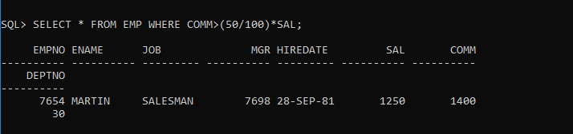

9_List the name,job and salary of all employess in dept 20 who earn more than 2000.

CREATE TABLE EMP

(

EMPNO NUMERIC(4) CONSTRAINT EMPNO_EMP_PK PRIMARY KEY,

ENAME VARCHAR(10),

JOB VARCHAR(9),

MGR NUMERIC(4),

HIREDATE DATE,

SAL NUMERIC(7,2),

COMM NUMERIC(7,2),

DEPTNO NUMERIC(2) CONSTRAINT DEPTNO_DEPT_FK REFERENCES DEPT(DEPTNO)

);

INSERT INTO EMP VALUES (7369,'SMITH','CLERK',7902,'17-DEC-80',800,NULL,20);

INSERT INTO EMP VALUES (7499,'ALLEN','SALESMAN',7698,'20-FEB-81',1600,300,30);

INSERT INTO EMP VALUES (7521,'WARD','SALESMAN',7698,'22-FEB-81',1250,500,30);

INSERT INTO EMP VALUES (7566,'JONES','MANAGER',7839,'02-APR-81',2975,NULL,20);

INSERT INTO EMP VALUES (7654,'MARTIN','SALESMAN',7698,'28-SEP-81',1250,1400,30);

INSERT INTO EMP VALUES (7698,'BLAKE','MANAGER',7839,'01-MAY-81',2850,NULL,30);

INSERT INTO EMP VALUES (7782,'CLARK','MANAGER',7839,'09-JUN-81',2450,NULL,10);

INSERT INTO EMP VALUES (7788,'SCOTT','ANALYST',7566,'19-APR-87',3000,NULL,20);

INSERT INTO EMP VALUES (7839,'KING','PRESIDENT',NULL,'17-NOV-81',5000,NULL,10);

INSERT INTO EMP VALUES (7844,'TURNER','SALESMAN',7698,'08-SEP-81',1500,0,30);

INSERT INTO EMP VALUES (7876,'ADAMS','CLERK',7788,'23-MAY-87',1100,NULL,20);

INSERT INTO EMP VALUES (7900,'JAMES','CLERK',7698,'03-DEC-81','950',NULL,30);

INSERT INTO EMP VALUES (7902,'FORD','ANALYST',7566,'03-DEC-81',3000,NULL,20);

INSERT INTO EMP VALUES (7934,'MILLER','CLERK',7782,'23-JAN-82',1300,NULL,10);

Ans_SELECT ENAME, JOB,SAL FROM EMP WHERE DEPTNO=20 AND SAL>2000;

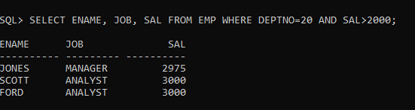

10_

CREATE TABLE EMP

(

EMPNO NUMERIC(4) CONSTRAINT EMPNO_EMP_PK PRIMARY KEY,

ENAME VARCHAR(10),

JOB VARCHAR(9),

MGR NUMERIC(4),

HIREDATE DATE,

SAL NUMERIC(7,2),

COMM NUMERIC(7,2),

DEPTNO NUMERIC(2) CONSTRAINT DEPTNO_DEPT_FK REFERENCES DEPT(DEPTNO)

);

INSERT INTO EMP VALUES (7369,'SMITH','CLERK',7902,'17-DEC-80',800,NULL,20);

INSERT INTO EMP VALUES (7499,'ALLEN','SALESMAN',7698,'20-FEB-81',1600,300,30);

INSERT INTO EMP VALUES (7521,'WARD','SALESMAN',7698,'22-FEB-81',1250,500,30);

INSERT INTO EMP VALUES (7566,'JONES','MANAGER',7839,'02-APR-81',2975,NULL,20);

INSERT INTO EMP VALUES (7654,'MARTIN','SALESMAN',7698,'28-SEP-81',1250,1400,30);

INSERT INTO EMP VALUES (7698,'BLAKE','MANAGER',7839,'01-MAY-81',2850,NULL,30);

INSERT INTO EMP VALUES (7782,'CLARK','MANAGER',7839,'09-JUN-81',2450,NULL,10);

INSERT INTO EMP VALUES (7788,'SCOTT','ANALYST',7566,'19-APR-87',3000,NULL,20);

INSERT INTO EMP VALUES (7839,'KING','PRESIDENT',NULL,'17-NOV-81',5000,NULL,10);

INSERT INTO EMP VALUES (7844,'TURNER','SALESMAN',7698,'08-SEP-81',1500,0,30);

INSERT INTO EMP VALUES (7876,'ADAMS','CLERK',7788,'23-MAY-87',1100,NULL,20);

INSERT INTO EMP VALUES (7900,'JAMES','CLERK',7698,'03-DEC-81','950',NULL,30);

INSERT INTO EMP VALUES (7902,'FORD','ANALYST',7566,'03-DEC-81',3000,NULL,20);

INSERT INTO EMP VALUES (7934,'MILLER','CLERK',7782,'23-JAN-82',1300,NULL,10);

Ans_SELECT * FROM EMP WHERE JOB='SALESMAN' AND DEPTNO=30 AND SAL>=1500;

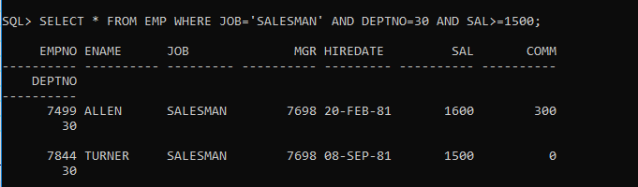

11_Find all the employess whose job is either a president or manager.

CREATE TABLE EMP

(

EMPNO NUMERIC(4) CONSTRAINT EMPNO_EMP_PK PRIMARY KEY,

ENAME VARCHAR(10),

JOB VARCHAR(9),

MGR NUMERIC(4),

HIREDATE DATE,

SAL NUMERIC(7,2),

COMM NUMERIC(7,2),

DEPTNO NUMERIC(2) CONSTRAINT DEPTNO_DEPT_FK REFERENCES DEPT(DEPTNO)

);

INSERT INTO EMP VALUES (7369,'SMITH','CLERK',7902,'17-DEC-80',800,NULL,20);

INSERT INTO EMP VALUES (7499,'ALLEN','SALESMAN',7698,'20-FEB-81',1600,300,30);

INSERT INTO EMP VALUES (7521,'WARD','SALESMAN',7698,'22-FEB-81',1250,500,30);

INSERT INTO EMP VALUES (7566,'JONES','MANAGER',7839,'02-APR-81',2975,NULL,20);

INSERT INTO EMP VALUES (7654,'MARTIN','SALESMAN',7698,'28-SEP-81',1250,1400,30);

INSERT INTO EMP VALUES (7698,'BLAKE','MANAGER',7839,'01-MAY-81',2850,NULL,30);

INSERT INTO EMP VALUES (7782,'CLARK','MANAGER',7839,'09-JUN-81',2450,NULL,10);

INSERT INTO EMP VALUES (7788,'SCOTT','ANALYST',7566,'19-APR-87',3000,NULL,20);

INSERT INTO EMP VALUES (7839,'KING','PRESIDENT',NULL,'17-NOV-81',5000,NULL,10);

INSERT INTO EMP VALUES (7844,'TURNER','SALESMAN',7698,'08-SEP-81',1500,0,30);

INSERT INTO EMP VALUES (7876,'ADAMS','CLERK',7788,'23-MAY-87',1100,NULL,20);

INSERT INTO EMP VALUES (7900,'JAMES','CLERK',7698,'03-DEC-81','950',NULL,30);

INSERT INTO EMP VALUES (7902,'FORD','ANALYST',7566,'03-DEC-81',3000,NULL,20);

INSERT INTO EMP VALUES (7934,'MILLER','CLERK',7782,'23-JAN-82',1300,NULL,10);

Ans_SELECT * FROM EMP WHERE JOB IN('PRESIDENT','MANAGER');

12_Find all managers who are not in dept 30.

CREATE TABLE EMP

(

EMPNO NUMERIC(4) CONSTRAINT EMPNO_EMP_PK PRIMARY KEY,

ENAME VARCHAR(10),

JOB VARCHAR(9),

MGR NUMERIC(4),

HIREDATE DATE,

SAL NUMERIC(7,2),

COMM NUMERIC(7,2),

DEPTNO NUMERIC(2) CONSTRAINT DEPTNO_DEPT_FK REFERENCES DEPT(DEPTNO)

);

INSERT INTO EMP VALUES (7369,'SMITH','CLERK',7902,'17-DEC-80',800,NULL,20);

INSERT INTO EMP VALUES (7499,'ALLEN','SALESMAN',7698,'20-FEB-81',1600,300,30);

INTO EMP VALUES (7566,'JONES','MANAGER',7839,'02-APR-81',2975,NULL,20);

INSERT INTO EMP VALUES (7654,'MARTIN','SALESMAN',7698,'28-SEP-81',1250,1400,30);

INSERT INTO EMP VALUES (7698,'BLAKE','MANAGER',7839,'01-MAY-81',2850,NULL,30);

INSERT INTO EMP VALUES (7782,'CLARK','MANAGER',7839,'09-JUN-81',2450,NULL,10);

INSERT INTO EMP VALUES (7788,'SCOTT','ANALYST',7566,'19-APR-87',3000,NULL,20);

INSERT INTO EMP VALUES (7839,'KING','PRESIDENT',NULL,'17-NOV-81',5000,NULL,10);

INSERT INTO EMP VALUES (7844,'TURNER','SALESMAN',7698,'08-SEP-81',1500,0,30);

INSERT INTO EMP VALUES (7876,'ADAMS','CLERK',7788,'23-MAY-87',1100,NULL,20);

INSERT INTO EMP VALUES (7900,'JAMES','CLERK',7698,'03-DEC-81','950',NULL,30);

INSERT INTO EMP VALUES (7902,'FORD','ANALYST',7566,'03-DEC-81',3000,NULL,20);

INSERT INTO EMP VALUES (7521,'WARD','SALESMAN',7698,'22-FEB-81',1250,500,30);

INSERT INTO EMP VALUES (7934,'MILLER','CLERK',7782,'23-JAN-82',1300,NULL,10);

Ans_SELECT * FROM EMP WHERE JOB='MANAGER'AND DEPTNO!=30;

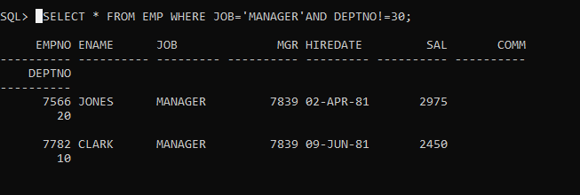

_13. Find the details of all managers and clerks in dept 10.

CREATE TABLE EMP

(

EMPNO NUMERIC(4) CONSTRAINT EMPNO_EMP_PK PRIMARY KEY,

ENAME VARCHAR(10),

JOB VARCHAR(9),

MGR NUMERIC(4),

HIREDATE DATE,

SAL NUMERIC(7,2),

COMM NUMERIC(7,2),

DEPTNO NUMERIC(2) CONSTRAINT DEPTNO_DEPT_FK REFERENCES DEPT(DEPTNO)

);

INSERT INTO EMP VALUES (7369,'SMITH','CLERK',7902,'17-DEC-80',800,NULL,20);

INSERT INTO EMP VALUES (7499,'ALLEN','SALESMAN',7698,'20-FEB-81',1600,300,30);

INTO EMP VALUES (7566,'JONES','MANAGER',7839,'02-APR-81',2975,NULL,20);

INSERT INTO EMP VALUES (7654,'MARTIN','SALESMAN',7698,'28-SEP-81',1250,1400,30);

INSERT INTO EMP VALUES (7698,'BLAKE','MANAGER',7839,'01-MAY-81',2850,NULL,30);

INSERT INTO EMP VALUES (7782,'CLARK','MANAGER',7839,'09-JUN-81',2450,NULL,10);

INSERT INTO EMP VALUES (7788,'SCOTT','ANALYST',7566,'19-APR-87',3000,NULL,20);

INSERT INTO EMP VALUES (7839,'KING','PRESIDENT',NULL,'17-NOV-81',5000,NULL,10);

INSERT INTO EMP VALUES (7844,'TURNER','SALESMAN',7698,'08-SEP-81',1500,0,30);

INSERT INTO EMP VALUES (7876,'ADAMS','CLERK',7788,'23-MAY-87',1100,NULL,20);

INSERT INTO EMP VALUES (7900,'JAMES','CLERK',7698,'03-DEC-81','950',NULL,30);

INSERT INTO EMP VALUES (7902,'FORD','ANALYST',7566,'03-DEC-81',3000,NULL,20);

INSERT INTO EMP VALUES (7521,'WARD','SALESMAN',7698,'22-FEB-81',1250,500,30);

INSERT INTO EMP VALUES (7934,'MILLER','CLERK',7782,'23-JAN-82',1300,NULL,10);

Ans_SELECT ENAME,JOB,DEPTNO FROM EMP WHERE (JOB='MANAGER' OR JOB='CLERK') AND DEPTNO=10;

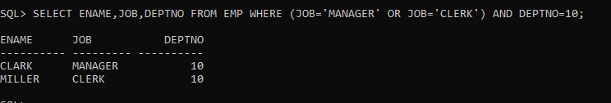

14.Find the details of all manager (in any dept) and all clerks in dept 10.

CREATE TABLE EMP

(

EMPNO NUMERIC(4) CONSTRAINT EMPNO_EMP_PK PRIMARY KEY,

ENAME VARCHAR(10),

JOB VARCHAR(9),

MGR NUMERIC(4),

HIREDATE DATE,

SAL NUMERIC(7,2),

COMM NUMERIC(7,2),

DEPTNO NUMERIC(2) CONSTRAINT DEPTNO_DEPT_FK REFERENCES DEPT(DEPTNO)

);

INSERT INTO EMP VALUES (7369,'SMITH','CLERK',7902,'17-DEC-80',800,NULL,20);

INSERT INTO EMP VALUES (7499,'ALLEN','SALESMAN',7698,'20-FEB-81',1600,300,30);

INTO EMP VALUES (7566,'JONES','MANAGER',7839,'02-APR-81',2975,NULL,20);

INSERT INTO EMP VALUES (7654,'MARTIN','SALESMAN',7698,'28-SEP-81',1250,1400,30);

INSERT INTO EMP VALUES (7698,'BLAKE','MANAGER',7839,'01-MAY-81',2850,NULL,30);

INSERT INTO EMP VALUES (7782,'CLARK','MANAGER',7839,'09-JUN-81',2450,NULL,10);

INSERT INTO EMP VALUES (7788,'SCOTT','ANALYST',7566,'19-APR-87',3000,NULL,20);

INSERT INTO EMP VALUES (7839,'KING','PRESIDENT',NULL,'17-NOV-81',5000,NULL,10);

INSERT INTO EMP VALUES (7844,'TURNER','SALESMAN',7698,'08-SEP-81',1500,0,30);

INSERT INTO EMP VALUES (7876,'ADAMS','CLERK',7788,'23-MAY-87',1100,NULL,20);

INSERT INTO EMP VALUES (7900,'JAMES','CLERK',7698,'03-DEC-81','950',NULL,30);

INSERT INTO EMP VALUES (7902,'FORD','ANALYST',7566,'03-DEC-81',3000,NULL,20);

INSERT INTO EMP VALUES (7521,'WARD','SALESMAN',7698,'22-FEB-81',1250,500,30);

INSERT INTO EMP VALUES (7934,'MILLER','CLERK',7782,'23-JAN-82',1300,NULL,10);

Ans_SELECT ENAME,JOB,DEPTNO FROM EMP WHERE (JOB='MANAGER') OR (JOB='CLERK' AND DEPTNO=10);

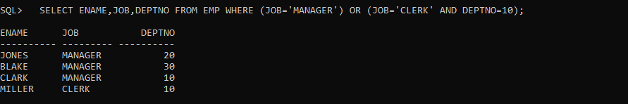

15.Find the details of all managers in dept 10 and all clerks in dept 20.

CREATE TABLE EMP

(

EMPNO NUMERIC(4) CONSTRAINT EMPNO_EMP_PK PRIMARY KEY,

ENAME VARCHAR(10),

JOB VARCHAR(9),

MGR NUMERIC(4),

HIREDATE DATE,

SAL NUMERIC(7,2),

COMM NUMERIC(7,2),

DEPTNO NUMERIC(2) CONSTRAINT DEPTNO_DEPT_FK REFERENCES DEPT(DEPTNO)

);

INSERT INTO EMP VALUES (7369,'SMITH','CLERK',7902,'17-DEC-80',800,NULL,20);

INSERT INTO EMP VALUES (7499,'ALLEN','SALESMAN',7698,'20-FEB-81',1600,300,30);

INTO EMP VALUES (7566,'JONES','MANAGER',7839,'02-APR-81',2975,NULL,20);

INSERT INTO EMP VALUES (7654,'MARTIN','SALESMAN',7698,'28-SEP-81',1250,1400,30);

INSERT INTO EMP VALUES (7698,'BLAKE','MANAGER',7839,'01-MAY-81',2850,NULL,30);

INSERT INTO EMP VALUES (7782,'CLARK','MANAGER',7839,'09-JUN-81',2450,NULL,10);

INSERT INTO EMP VALUES (7788,'SCOTT','ANALYST',7566,'19-APR-87',3000,NULL,20);

INSERT INTO EMP VALUES (7839,'KING','PRESIDENT',NULL,'17-NOV-81',5000,NULL,10);

INSERT INTO EMP VALUES (7844,'TURNER','SALESMAN',7698,'08-SEP-81',1500,0,30);

INSERT INTO EMP VALUES (7876,'ADAMS','CLERK',7788,'23-MAY-87',1100,NULL,20);

INSERT INTO EMP VALUES (7900,'JAMES','CLERK',7698,'03-DEC-81','950',NULL,30);

INSERT INTO EMP VALUES (7902,'FORD','ANALYST',7566,'03-DEC-81',3000,NULL,20);

INSERT INTO EMP VALUES (7521,'WARD','SALESMAN',7698,'22-FEB-81',1250,500,30);

INSERT INTO EMP VALUES (7934,'MILLER','CLERK',7782,'23-JAN-82',1300,NULL,10);

Ans_SELECT ENAME,JOB,DEPTNO FROM EMP WHERE (JOB='MANAGER' AND DEPTNO=10 ) OR (JOB='CLERK' AND DEPTNO=20);

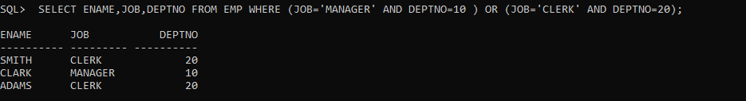

16.Find all employees who are neither clerks nor manager but whose salary is greater than or equal to Rs. 2000.

CREATE TABLE EMP

(

EMPNO NUMERIC(4) CONSTRAINT EMPNO_EMP_PK PRIMARY KEY,

ENAME VARCHAR(10),

JOB VARCHAR(9),

MGR NUMERIC(4),

HIREDATE DATE,

SAL NUMERIC(7,2),

COMM NUMERIC(7,2),

DEPTNO NUMERIC(2) CONSTRAINT DEPTNO_DEPT_FK REFERENCES DEPT(DEPTNO)

);

INSERT INTO EMP VALUES (7369,'SMITH','CLERK',7902,'17-DEC-80',800,NULL,20);

INSERT INTO EMP VALUES (7499,'ALLEN','SALESMAN',7698,'20-FEB-81',1600,300,30);

INTO EMP VALUES (7566,'JONES','MANAGER',7839,'02-APR-81',2975,NULL,20);

INSERT INTO EMP VALUES (7654,'MARTIN','SALESMAN',7698,'28-SEP-81',1250,1400,30);

INSERT INTO EMP VALUES (7698,'BLAKE','MANAGER',7839,'01-MAY-81',2850,NULL,30);

INSERT INTO EMP VALUES (7782,'CLARK','MANAGER',7839,'09-JUN-81',2450,NULL,10);

INSERT INTO EMP VALUES (7788,'SCOTT','ANALYST',7566,'19-APR-87',3000,NULL,20);

INSERT INTO EMP VALUES (7839,'KING','PRESIDENT',NULL,'17-NOV-81',5000,NULL,10);

INSERT INTO EMP VALUES (7844,'TURNER','SALESMAN',7698,'08-SEP-81',1500,0,30);

INSERT INTO EMP VALUES (7876,'ADAMS','CLERK',7788,'23-MAY-87',1100,NULL,20);

INSERT INTO EMP VALUES (7900,'JAMES','CLERK',7698,'03-DEC-81','950',NULL,30);

INSERT INTO EMP VALUES (7902,'FORD','ANALYST',7566,'03-DEC-81',3000,NULL,20);

INSERT INTO EMP VALUES (7521,'WARD','SALESMAN',7698,'22-FEB-81',1250,500,30);

INSERT INTO EMP VALUES (7934,'MILLER','CLERK',7782,'23-JAN-82',1300,NULL,10);

Ans_SELECT * FROM EMP WHERE (JOB!='MANAGER'AND JOB!='CLERK') AND SAL>=2000;

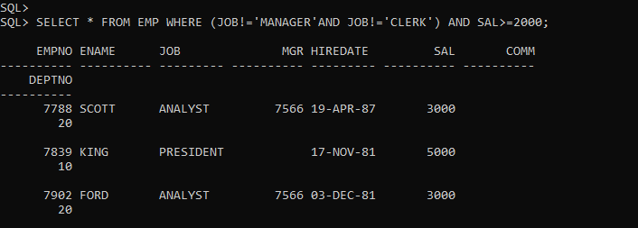

17. Find the employees who earns between Rs. 1200 and Rs.1400.

CREATE TABLE EMP

(

EMPNO NUMERIC(4) CONSTRAINT EMPNO_EMP_PK PRIMARY KEY,

ENAME VARCHAR(10),

JOB VARCHAR(9),

MGR NUMERIC(4),

HIREDATE DATE,

SAL NUMERIC(7,2),

COMM NUMERIC(7,2),

DEPTNO NUMERIC(2) CONSTRAINT DEPTNO_DEPT_FK REFERENCES DEPT(DEPTNO)

);

INSERT INTO EMP VALUES (7369,'SMITH','CLERK',7902,'17-DEC-80',800,NULL,20);

INSERT INTO EMP VALUES (7499,'ALLEN','SALESMAN',7698,'20-FEB-81',1600,300,30);

INTO EMP VALUES (7566,'JONES','MANAGER',7839,'02-APR-81',2975,NULL,20);

INSERT INTO EMP VALUES (7654,'MARTIN','SALESMAN',7698,'28-SEP-81',1250,1400,30);

INSERT INTO EMP VALUES (7698,'BLAKE','MANAGER',7839,'01-MAY-81',2850,NULL,30);

INSERT INTO EMP VALUES (7782,'CLARK','MANAGER',7839,'09-JUN-81',2450,NULL,10);

INSERT INTO EMP VALUES (7788,'SCOTT','ANALYST',7566,'19-APR-87',3000,NULL,20);

INSERT INTO EMP VALUES (7839,'KING','PRESIDENT',NULL,'17-NOV-81',5000,NULL,10);

INSERT INTO EMP VALUES (7844,'TURNER','SALESMAN',7698,'08-SEP-81',1500,0,30);

INSERT INTO EMP VALUES (7876,'ADAMS','CLERK',7788,'23-MAY-87',1100,NULL,20);

INSERT INTO EMP VALUES (7900,'JAMES','CLERK',7698,'03-DEC-81','950',NULL,30);

INSERT INTO EMP VALUES (7902,'FORD','ANALYST',7566,'03-DEC-81',3000,NULL,20);

INSERT INTO EMP VALUES (7521,'WARD','SALESMAN',7698,'22-FEB-81',1250,500,30);

INSERT INTO EMP VALUES (7934,'MILLER','CLERK',7782,'23-JAN-82',1300,NULL,10);

Ans_SELECT * FROM EMP WHERE SAL BETWEEN 1200 AND 1400;

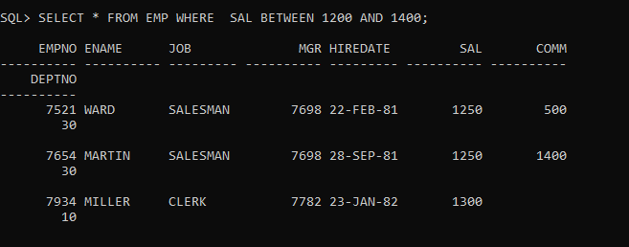

18. Find the employees who are clerks, analysts or salesman.

CREATE TABLE EMP

(

EMPNO NUMERIC(4) CONSTRAINT EMPNO_EMP_PK PRIMARY KEY,

ENAME VARCHAR(10),

JOB VARCHAR(9),

MGR NUMERIC(4),

HIREDATE DATE,

SAL NUMERIC(7,2),

COMM NUMERIC(7,2),

DEPTNO NUMERIC(2) CONSTRAINT DEPTNO_DEPT_FK REFERENCES DEPT(DEPTNO)

);

INSERT INTO EMP VALUES (7369,'SMITH','CLERK',7902,'17-DEC-80',800,NULL,20);

INSERT INTO EMP VALUES (7499,'ALLEN','SALESMAN',7698,'20-FEB-81',1600,300,30);

INTO EMP VALUES (7566,'JONES','MANAGER',7839,'02-APR-81',2975,NULL,20);

INSERT INTO EMP VALUES (7654,'MARTIN','SALESMAN',7698,'28-SEP-81',1250,1400,30);

INSERT INTO EMP VALUES (7698,'BLAKE','MANAGER',7839,'01-MAY-81',2850,NULL,30);

INSERT INTO EMP VALUES (7782,'CLARK','MANAGER',7839,'09-JUN-81',2450,NULL,10);

INSERT INTO EMP VALUES (7788,'SCOTT','ANALYST',7566,'19-APR-87',3000,NULL,20);

INSERT INTO EMP VALUES (7839,'KING','PRESIDENT',NULL,'17-NOV-81',5000,NULL,10);

INSERT INTO EMP VALUES (7844,'TURNER','SALESMAN',7698,'08-SEP-81',1500,0,30);

INSERT INTO EMP VALUES (7876,'ADAMS','CLERK',7788,'23-MAY-87',1100,NULL,20);

INSERT INTO EMP VALUES (7900,'JAMES','CLERK',7698,'03-DEC-81','950',NULL,30);

INSERT INTO EMP VALUES (7902,'FORD','ANALYST',7566,'03-DEC-81',3000,NULL,20);

INSERT INTO EMP VALUES (7521,'WARD','SALESMAN',7698,'22-FEB-81',1250,500,30);

INSERT INTO EMP VALUES (7934,'MILLER','CLERK',7782,'23-JAN-82',1300,NULL,10);

Ans_SELECT * FROM EMP WHERE (JOB!='MANAGER'AND JOB!='CLERK') AND SAL>=2000;

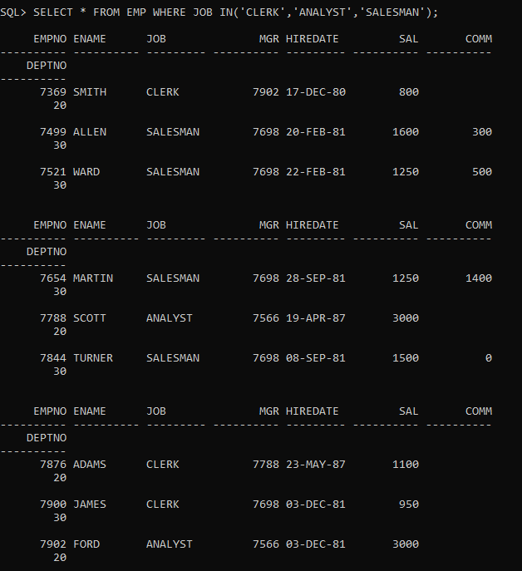

19. Find the employees who are not clerks, analyst or salesman.

CREATE TABLE EMP

(

EMPNO NUMERIC(4) CONSTRAINT EMPNO_EMP_PK PRIMARY KEY,

ENAME VARCHAR(10),

JOB VARCHAR(9),

MGR NUMERIC(4),

HIREDATE DATE,

SAL NUMERIC(7,2),

COMM NUMERIC(7,2),

DEPTNO NUMERIC(2) CONSTRAINT DEPTNO_DEPT_FK REFERENCES DEPT(DEPTNO)

);

INSERT INTO EMP VALUES (7369,'SMITH','CLERK',7902,'17-DEC-80',800,NULL,20);

INSERT INTO EMP VALUES (7499,'ALLEN','SALESMAN',7698,'20-FEB-81',1600,300,30);

INTO EMP VALUES (7566,'JONES','MANAGER',7839,'02-APR-81',2975,NULL,20);

INSERT INTO EMP VALUES (7654,'MARTIN','SALESMAN',7698,'28-SEP-81',1250,1400,30);

INSERT INTO EMP VALUES (7698,'BLAKE','MANAGER',7839,'01-MAY-81',2850,NULL,30);

INSERT INTO EMP VALUES (7782,'CLARK','MANAGER',7839,'09-JUN-81',2450,NULL,10);

INSERT INTO EMP VALUES (7788,'SCOTT','ANALYST',7566,'19-APR-87',3000,NULL,20);

INSERT INTO EMP VALUES (7839,'KING','PRESIDENT',NULL,'17-NOV-81',5000,NULL,10);

INSERT INTO EMP VALUES (7844,'TURNER','SALESMAN',7698,'08-SEP-81',1500,0,30);

INSERT INTO EMP VALUES (7876,'ADAMS','CLERK',7788,'23-MAY-87',1100,NULL,20);

INSERT INTO EMP VALUES (7900,'JAMES','CLERK',7698,'03-DEC-81','950',NULL,30);

INSERT INTO EMP VALUES (7902,'FORD','ANALYST',7566,'03-DEC-81',3000,NULL,20);

INSERT INTO EMP VALUES (7521,'WARD','SALESMAN',7698,'22-FEB-81',1250,500,30);

INSERT INTO EMP VALUES (7934,'MILLER','CLERK',7782,'23-JAN-82',1300,NULL,10);

Ans_SELECT * FROM EMP WHERE JOB NOT IN('CLERK','ANALYST','SALESMAN');

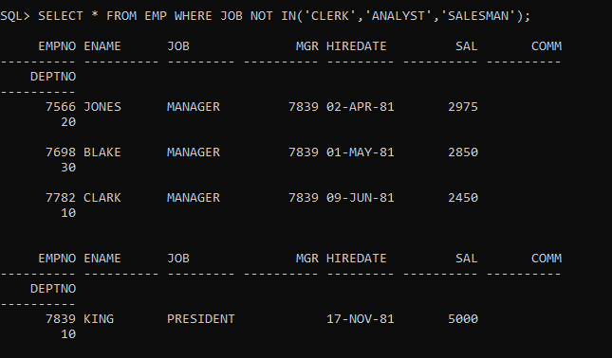

20.Find the employees who do not receive a commission i.e. commission is NULL.

CREATE TABLE EMP

(

EMPNO NUMERIC(4) CONSTRAINT EMPNO_EMP_PK PRIMARY KEY,

ENAME VARCHAR(10),

JOB VARCHAR(9),

MGR NUMERIC(4),

HIREDATE DATE,

SAL NUMERIC(7,2),

COMM NUMERIC(7,2),

DEPTNO NUMERIC(2) CONSTRAINT DEPTNO_DEPT_FK REFERENCES DEPT(DEPTNO)

);

INSERT INTO EMP VALUES (7369,'SMITH','CLERK',7902,'17-DEC-80',800,NULL,20);

INSERT INTO EMP VALUES (7499,'ALLEN','SALESMAN',7698,'20-FEB-81',1600,300,30);

INTO EMP VALUES (7566,'JONES','MANAGER',7839,'02-APR-81',2975,NULL,20);

INSERT INTO EMP VALUES (7654,'MARTIN','SALESMAN',7698,'28-SEP-81',1250,1400,30);

INSERT INTO EMP VALUES (7698,'BLAKE','MANAGER',7839,'01-MAY-81',2850,NULL,30);

INSERT INTO EMP VALUES (7782,'CLARK','MANAGER',7839,'09-JUN-81',2450,NULL,10);

INSERT INTO EMP VALUES (7788,'SCOTT','ANALYST',7566,'19-APR-87',3000,NULL,20);

INSERT INTO EMP VALUES (7839,'KING','PRESIDENT',NULL,'17-NOV-81',5000,NULL,10);

INSERT INTO EMP VALUES (7844,'TURNER','SALESMAN',7698,'08-SEP-81',1500,0,30);

INSERT INTO EMP VALUES (7876,'ADAMS','CLERK',7788,'23-MAY-87',1100,NULL,20);

INSERT INTO EMP VALUES (7900,'JAMES','CLERK',7698,'03-DEC-81','950',NULL,30);

INSERT INTO EMP VALUES (7902,'FORD','ANALYST',7566,'03-DEC-81',3000,NULL,20);

INSERT INTO EMP VALUES (7521,'WARD','SALESMAN',7698,'22-FEB-81',1250,500,30);

INSERT INTO EMP VALUES (7934,'MILLER','CLERK',7782,'23-JAN-82',1300,NULL,10);

Ans_

SELECT ENAME ,DEPTNO FROM EMP WHERE COMM IS NULL;

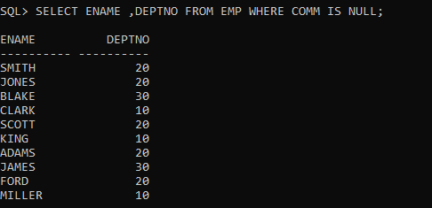

21_Find the employee whose commission is Rs. 0.

CREATE TABLE EMP

(

EMPNO NUMERIC(4) CONSTRAINT EMPNO_EMP_PK PRIMARY KEY,

ENAME VARCHAR(10),

JOB VARCHAR(9),

MGR NUMERIC(4),

HIREDATE DATE,

SAL NUMERIC(7,2),

COMM NUMERIC(7,2),

DEPTNO NUMERIC(2) CONSTRAINT DEPTNO_DEPT_FK REFERENCES DEPT(DEPTNO)

);

INSERT INTO EMP VALUES (7369,'SMITH','CLERK',7902,'17-DEC-80',800,NULL,20);

INSERT INTO EMP VALUES (7499,'ALLEN','SALESMAN',7698,'20-FEB-81',1600,300,30);

INTO EMP VALUES (7566,'JONES','MANAGER',7839,'02-APR-81',2975,NULL,20);

INSERT INTO EMP VALUES (7654,'MARTIN','SALESMAN',7698,'28-SEP-81',1250,1400,30);

INSERT INTO EMP VALUES (7698,'BLAKE','MANAGER',7839,'01-MAY-81',2850,NULL,30);

INSERT INTO EMP VALUES (7782,'CLARK','MANAGER',7839,'09-JUN-81',2450,NULL,10);

INSERT INTO EMP VALUES (7788,'SCOTT','ANALYST',7566,'19-APR-87',3000,NULL,20);

INSERT INTO EMP VALUES (7839,'KING','PRESIDENT',NULL,'17-NOV-81',5000,NULL,10);

INSERT INTO EMP VALUES (7844,'TURNER','SALESMAN',7698,'08-SEP-81',1500,0,30);

INSERT INTO EMP VALUES (7876,'ADAMS','CLERK',7788,'23-MAY-87',1100,NULL,20);

INSERT INTO EMP VALUES (7900,'JAMES','CLERK',7698,'03-DEC-81','950',NULL,30);

INSERT INTO EMP VALUES (7902,'FORD','ANALYST',7566,'03-DEC-81',3000,NULL,20);

INSERT INTO EMP VALUES (7521,'WARD','SALESMAN',7698,'22-FEB-81',1250,500,30);

INSERT INTO EMP VALUES (7934,'MILLER','CLERK',7782,'23-JAN-82',1300,NULL,10);

Ans_SELECT ENAME FROM EMP WHERE COMM=0;

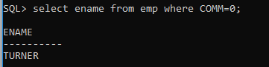

22_Find the different jobs of the employees receiving commission.

CREATE TABLE EMP

(

EMPNO NUMERIC(4) CONSTRAINT EMPNO_EMP_PK PRIMARY KEY,

ENAME VARCHAR(10),

JOB VARCHAR(9),

MGR NUMERIC(4),

HIREDATE DATE,

SAL NUMERIC(7,2),

COMM NUMERIC(7,2),

DEPTNO NUMERIC(2) CONSTRAINT DEPTNO_DEPT_FK REFERENCES DEPT(DEPTNO)

);

INSERT INTO EMP VALUES (7369,'SMITH','CLERK',7902,'17-DEC-80',800,NULL,20);

INSERT INTO EMP VALUES (7499,'ALLEN','SALESMAN',7698,'20-FEB-81',1600,300,30);

INTO EMP VALUES (7566,'JONES','MANAGER',7839,'02-APR-81',2975,NULL,20);

INSERT INTO EMP VALUES (7654,'MARTIN','SALESMAN',7698,'28-SEP-81',1250,1400,30);

INSERT INTO EMP VALUES (7698,'BLAKE','MANAGER',7839,'01-MAY-81',2850,NULL,30);

INSERT INTO EMP VALUES (7782,'CLARK','MANAGER',7839,'09-JUN-81',2450,NULL,10);

INSERT INTO EMP VALUES (7788,'SCOTT','ANALYST',7566,'19-APR-87',3000,NULL,20);

INSERT INTO EMP VALUES (7839,'KING','PRESIDENT',NULL,'17-NOV-81',5000,NULL,10);

INSERT INTO EMP VALUES (7844,'TURNER','SALESMAN',7698,'08-SEP-81',1500,0,30);

INSERT INTO EMP VALUES (7876,'ADAMS','CLERK',7788,'23-MAY-87',1100,NULL,20);

INSERT INTO EMP VALUES (7900,'JAMES','CLERK',7698,'03-DEC-81','950',NULL,30);

INSERT INTO EMP VALUES (7902,'FORD','ANALYST',7566,'03-DEC-81',3000,NULL,20);

INSERT INTO EMP VALUES (7521,'WARD','SALESMAN',7698,'22-FEB-81',1250,500,30);

INSERT INTO EMP VALUES (7934,'MILLER','CLERK',7782,'23-JAN-82',1300,NULL,10);

Ans_SELECT DISTINCT JOB FROM EMP WHERE COM IS NOT NULL;

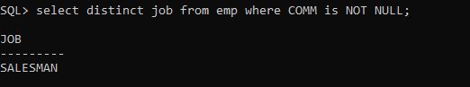

23_Find all employees who do not receive a commission or whose Commission is less than Rs. 100.

CREATE TABLE EMP

(

EMPNO NUMERIC(4) CONSTRAINT EMPNO_EMP_PK PRIMARY KEY,

ENAME VARCHAR(10),

JOB VARCHAR(9),

MGR NUMERIC(4),

HIREDATE DATE,

SAL NUMERIC(7,2),

COMM NUMERIC(7,2),

DEPTNO NUMERIC(2) CONSTRAINT DEPTNO_DEPT_FK REFERENCES DEPT(DEPTNO)

);

INSERT INTO EMP VALUES (7369,'SMITH','CLERK',7902,'17-DEC-80',800,NULL,20);

INSERT INTO EMP VALUES (7499,'ALLEN','SALESMAN',7698,'20-FEB-81',1600,300,30);

INTO EMP VALUES (7566,'JONES','MANAGER',7839,'02-APR-81',2975,NULL,20);

INSERT INTO EMP VALUES (7654,'MARTIN','SALESMAN',7698,'28-SEP-81',1250,1400,30);

INSERT INTO EMP VALUES (7698,'BLAKE','MANAGER',7839,'01-MAY-81',2850,NULL,30);

INSERT INTO EMP VALUES (7782,'CLARK','MANAGER',7839,'09-JUN-81',2450,NULL,10);

INSERT INTO EMP VALUES (7788,'SCOTT','ANALYST',7566,'19-APR-87',3000,NULL,20);

INSERT INTO EMP VALUES (7839,'KING','PRESIDENT',NULL,'17-NOV-81',5000,NULL,10);

INSERT INTO EMP VALUES (7844,'TURNER','SALESMAN',7698,'08-SEP-81',1500,0,30);

INSERT INTO EMP VALUES (7876,'ADAMS','CLERK',7788,'23-MAY-87',1100,NULL,20);

INSERT INTO EMP VALUES (7900,'JAMES','CLERK',7698,'03-DEC-81','950',NULL,30);

INSERT INTO EMP VALUES (7902,'FORD','ANALYST',7566,'03-DEC-81',3000,NULL,20);

INSERT INTO EMP VALUES (7521,'WARD','SALESMAN',7698,'22-FEB-81',1250,500,30);

INSERT INTO EMP VALUES (7934,'MILLER','CLERK',7782,'23-JAN-82',1300,NULL,10);

Ans_SELECT ENAME FROM EMP WHERE COMM IS NULL OR COMM<100;

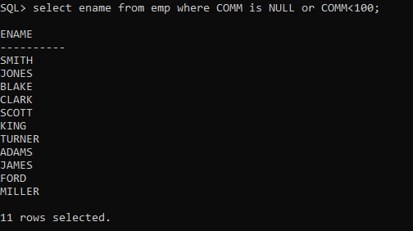

24_The employees who not receiving commission are entailed to Rs. 250, Show the net earnings of all employees. (find about **nvl()**

CREATE TABLE EMP

(

EMPNO NUMERIC(4) CONSTRAINT EMPNO_EMP_PK PRIMARY KEY,

ENAME VARCHAR(10),

JOB VARCHAR(9),

MGR NUMERIC(4),

HIREDATE DATE,

SAL NUMERIC(7,2),

COMM NUMERIC(7,2),

DEPTNO NUMERIC(2) CONSTRAINT DEPTNO_DEPT_FK REFERENCES DEPT(DEPTNO)

);

INSERT INTO EMP VALUES (7369,'SMITH','CLERK',7902,'17-DEC-80',800,NULL,20);

INSERT INTO EMP VALUES (7499,'ALLEN','SALESMAN',7698,'20-FEB-81',1600,300,30);

INTO EMP VALUES (7566,'JONES','MANAGER',7839,'02-APR-81',2975,NULL,20);

INSERT INTO EMP VALUES (7654,'MARTIN','SALESMAN',7698,'28-SEP-81',1250,1400,30);

INSERT INTO EMP VALUES (7698,'BLAKE','MANAGER',7839,'01-MAY-81',2850,NULL,30);

INSERT INTO EMP VALUES (7782,'CLARK','MANAGER',7839,'09-JUN-81',2450,NULL,10);

INSERT INTO EMP VALUES (7788,'SCOTT','ANALYST',7566,'19-APR-87',3000,NULL,20);

INSERT INTO EMP VALUES (7839,'KING','PRESIDENT',NULL,'17-NOV-81',5000,NULL,10);

INSERT INTO EMP VALUES (7844,'TURNER','SALESMAN',7698,'08-SEP-81',1500,0,30);

INSERT INTO EMP VALUES (7876,'ADAMS','CLERK',7788,'23-MAY-87',1100,NULL,20);

INSERT INTO EMP VALUES (7900,'JAMES','CLERK',7698,'03-DEC-81','950',NULL,30);

INSERT INTO EMP VALUES (7902,'FORD','ANALYST',7566,'03-DEC-81',3000,NULL,20);

INSERT INTO EMP VALUES (7521,'WARD','SALESMAN',7698,'22-FEB-81',1250,500,30);

INSERT INTO EMP VALUES (7934,'MILLER','CLERK',7782,'23-JAN-82',1300,NULL,10);

Ans_SELECT ENAME,(SAL+NVL(COMM,250)) AS NETSAL FROM EMP;

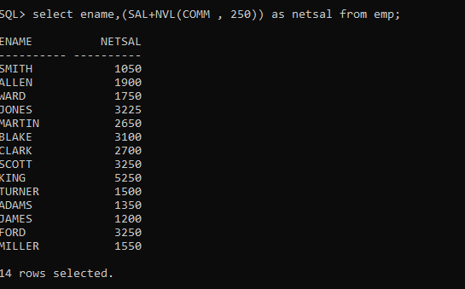

25_Find all employees whose total earnings are greater than Rs. 2000.

CREATE TABLE EMP

(

EMPNO NUMERIC(4) CONSTRAINT EMPNO_EMP_PK PRIMARY KEY,

ENAME VARCHAR(10),

JOB VARCHAR(9),

MGR NUMERIC(4),

HIREDATE DATE,

SAL NUMERIC(7,2),

COMM NUMERIC(7,2),

DEPTNO NUMERIC(2) CONSTRAINT DEPTNO_DEPT_FK REFERENCES DEPT(DEPTNO)

);

INSERT INTO EMP VALUES (7369,'SMITH','CLERK',7902,'17-DEC-80',800,NULL,20);

INSERT INTO EMP VALUES (7499,'ALLEN','SALESMAN',7698,'20-FEB-81',1600,300,30);

INTO EMP VALUES (7566,'JONES','MANAGER',7839,'02-APR-81',2975,NULL,20);

INSERT INTO EMP VALUES (7654,'MARTIN','SALESMAN',7698,'28-SEP-81',1250,1400,30);

INSERT INTO EMP VALUES (7698,'BLAKE','MANAGER',7839,'01-MAY-81',2850,NULL,30);

INSERT INTO EMP VALUES (7782,'CLARK','MANAGER',7839,'09-JUN-81',2450,NULL,10);

INSERT INTO EMP VALUES (7788,'SCOTT','ANALYST',7566,'19-APR-87',3000,NULL,20);

INSERT INTO EMP VALUES (7839,'KING','PRESIDENT',NULL,'17-NOV-81',5000,NULL,10);

INSERT INTO EMP VALUES (7844,'TURNER','SALESMAN',7698,'08-SEP-81',1500,0,30);

INSERT INTO EMP VALUES (7876,'ADAMS','CLERK',7788,'23-MAY-87',1100,NULL,20);

INSERT INTO EMP VALUES (7900,'JAMES','CLERK',7698,'03-DEC-81','950',NULL,30);

INSERT INTO EMP VALUES (7902,'FORD','ANALYST',7566,'03-DEC-81',3000,NULL,20);

INSERT INTO EMP VALUES (7521,'WARD','SALESMAN',7698,'22-FEB-81',1250,500,30);

INSERT INTO EMP VALUES (7934,'MILLER','CLERK',7782,'23-JAN-82',1300,NULL,10);

Ans_SELECT ENAME,(SAL+NVL(COMM,0)) FROM EMP WHERE (SAL+NVL(COMM,0))>2000;

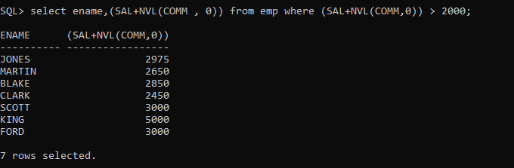

26_ Find all employees whose names begin with m.

CREATE TABLE EMP

(

EMPNO NUMERIC(4) CONSTRAINT EMPNO_EMP_PK PRIMARY KEY,

ENAME VARCHAR(10),

JOB VARCHAR(9),

MGR NUMERIC(4),

HIREDATE DATE,

SAL NUMERIC(7,2),

COMM NUMERIC(7,2),

DEPTNO NUMERIC(2) CONSTRAINT DEPTNO_DEPT_FK REFERENCES DEPT(DEPTNO)

);

INSERT INTO EMP VALUES (7369,'SMITH','CLERK',7902,'17-DEC-80',800,NULL,20);

INSERT INTO EMP VALUES (7499,'ALLEN','SALESMAN',7698,'20-FEB-81',1600,300,30);

INTO EMP VALUES (7566,'JONES','MANAGER',7839,'02-APR-81',2975,NULL,20);

INSERT INTO EMP VALUES (7654,'MARTIN','SALESMAN',7698,'28-SEP-81',1250,1400,30);

INSERT INTO EMP VALUES (7698,'BLAKE','MANAGER',7839,'01-MAY-81',2850,NULL,30);

INSERT INTO EMP VALUES (7782,'CLARK','MANAGER',7839,'09-JUN-81',2450,NULL,10);

INSERT INTO EMP VALUES (7788,'SCOTT','ANALYST',7566,'19-APR-87',3000,NULL,20);

INSERT INTO EMP VALUES (7839,'KING','PRESIDENT',NULL,'17-NOV-81',5000,NULL,10);

INSERT INTO EMP VALUES (7844,'TURNER','SALESMAN',7698,'08-SEP-81',1500,0,30);

INSERT INTO EMP VALUES (7876,'ADAMS','CLERK',7788,'23-MAY-87',1100,NULL,20);

INSERT INTO EMP VALUES (7900,'JAMES','CLERK',7698,'03-DEC-81','950',NULL,30);

INSERT INTO EMP VALUES (7902,'FORD','ANALYST',7566,'03-DEC-81',3000,NULL,20);

INSERT INTO EMP VALUES (7521,'WARD','SALESMAN',7698,'22-FEB-81',1250,500,30);

INSERT INTO EMP VALUES (7934,'MILLER','CLERK',7782,'23-JAN-82',1300,NULL,10);

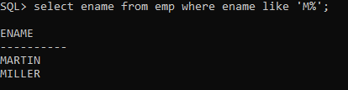

27_ Find all employees whose names end with m.

CREATE TABLE EMP

(

EMPNO NUMERIC(4) CONSTRAINT EMPNO_EMP_PK PRIMARY KEY,

ENAME VARCHAR(10),

JOB VARCHAR(9),

MGR NUMERIC(4),

HIREDATE DATE,

SAL NUMERIC(7,2),

COMM NUMERIC(7,2),

DEPTNO NUMERIC(2) CONSTRAINT DEPTNO_DEPT_FK REFERENCES DEPT(DEPTNO)

);

INSERT INTO EMP VALUES (7369,'SMITH','CLERK',7902,'17-DEC-80',800,NULL,20);

INSERT INTO EMP VALUES (7499,'ALLEN','SALESMAN',7698,'20-FEB-81',1600,300,30);

INTO EMP VALUES (7566,'JONES','MANAGER',7839,'02-APR-81',2975,NULL,20);

INSERT INTO EMP VALUES (7654,'MARTIN','SALESMAN',7698,'28-SEP-81',1250,1400,30);

INSERT INTO EMP VALUES (7698,'BLAKE','MANAGER',7839,'01-MAY-81',2850,NULL,30);

INSERT INTO EMP VALUES (7782,'CLARK','MANAGER',7839,'09-JUN-81',2450,NULL,10);

INSERT INTO EMP VALUES (7788,'SCOTT','ANALYST',7566,'19-APR-87',3000,NULL,20);

INSERT INTO EMP VALUES (7839,'KING','PRESIDENT',NULL,'17-NOV-81',5000,NULL,10);

INSERT INTO EMP VALUES (7844,'TURNER','SALESMAN',7698,'08-SEP-81',1500,0,30);

INSERT INTO EMP VALUES (7876,'ADAMS','CLERK',7788,'23-MAY-87',1100,NULL,20);

INSERT INTO EMP VALUES (7900,'JAMES','CLERK',7698,'03-DEC-81','950',NULL,30);

INSERT INTO EMP VALUES (7902,'FORD','ANALYST',7566,'03-DEC-81',3000,NULL,20);

INSERT INTO EMP VALUES (7521,'WARD','SALESMAN',7698,'22-FEB-81',1250,500,30);

INSERT INTO EMP VALUES (7934,'MILLER','CLERK',7782,'23-JAN-82',1300,NULL,10);

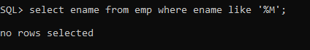

28_ Find all employees whose names contain the letter m.

CREATE TABLE EMP

(

EMPNO NUMERIC(4) CONSTRAINT EMPNO_EMP_PK PRIMARY KEY,

ENAME VARCHAR(10),

JOB VARCHAR(9),

MGR NUMERIC(4),

HIREDATE DATE,

SAL NUMERIC(7,2),

COMM NUMERIC(7,2),

DEPTNO NUMERIC(2) CONSTRAINT DEPTNO_DEPT_FK REFERENCES DEPT(DEPTNO)

);

INSERT INTO EMP VALUES (7369,'SMITH','CLERK',7902,'17-DEC-80',800,NULL,20);

INSERT INTO EMP VALUES (7499,'ALLEN','SALESMAN',7698,'20-FEB-81',1600,300,30);

INTO EMP VALUES (7566,'JONES','MANAGER',7839,'02-APR-81',2975,NULL,20);

INSERT INTO EMP VALUES (7654,'MARTIN','SALESMAN',7698,'28-SEP-81',1250,1400,30);

INSERT INTO EMP VALUES (7698,'BLAKE','MANAGER',7839,'01-MAY-81',2850,NULL,30);

INSERT INTO EMP VALUES (7782,'CLARK','MANAGER',7839,'09-JUN-81',2450,NULL,10);

INSERT INTO EMP VALUES (7788,'SCOTT','ANALYST',7566,'19-APR-87',3000,NULL,20);

INSERT INTO EMP VALUES (7839,'KING','PRESIDENT',NULL,'17-NOV-81',5000,NULL,10);

INSERT INTO EMP VALUES (7844,'TURNER','SALESMAN',7698,'08-SEP-81',1500,0,30);

INSERT INTO EMP VALUES (7876,'ADAMS','CLERK',7788,'23-MAY-87',1100,NULL,20);

INSERT INTO EMP VALUES (7900,'JAMES','CLERK',7698,'03-DEC-81','950',NULL,30);

INSERT INTO EMP VALUES (7902,'FORD','ANALYST',7566,'03-DEC-81',3000,NULL,20);

INSERT INTO EMP VALUES (7521,'WARD','SALESMAN',7698,'22-FEB-81',1250,500,30);

INSERT INTO EMP VALUES (7934,'MILLER','CLERK',7782,'23-JAN-82',1300,NULL,10);

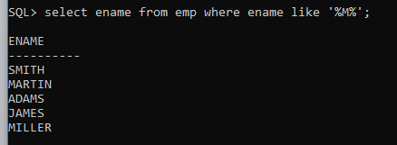

29_ Find the employees whose names are 5 characters long and end with n.

CREATE TABLE EMP

(

EMPNO NUMERIC(4) CONSTRAINT EMPNO_EMP_PK PRIMARY KEY,

ENAME VARCHAR(10),

JOB VARCHAR(9),

MGR NUMERIC(4),

HIREDATE DATE,

SAL NUMERIC(7,2),

COMM NUMERIC(7,2),

DEPTNO NUMERIC(2) CONSTRAINT DEPTNO_DEPT_FK REFERENCES DEPT(DEPTNO)

);

INSERT INTO EMP VALUES (7369,'SMITH','CLERK',7902,'17-DEC-80',800,NULL,20);

INSERT INTO EMP VALUES (7499,'ALLEN','SALESMAN',7698,'20-FEB-81',1600,300,30);

INTO EMP VALUES (7566,'JONES','MANAGER',7839,'02-APR-81',2975,NULL,20);

INSERT INTO EMP VALUES (7654,'MARTIN','SALESMAN',7698,'28-SEP-81',1250,1400,30);

INSERT INTO EMP VALUES (7698,'BLAKE','MANAGER',7839,'01-MAY-81',2850,NULL,30);

INSERT INTO EMP VALUES (7782,'CLARK','MANAGER',7839,'09-JUN-81',2450,NULL,10);

INSERT INTO EMP VALUES (7788,'SCOTT','ANALYST',7566,'19-APR-87',3000,NULL,20);

INSERT INTO EMP VALUES (7839,'KING','PRESIDENT',NULL,'17-NOV-81',5000,NULL,10);

INSERT INTO EMP VALUES (7844,'TURNER','SALESMAN',7698,'08-SEP-81',1500,0,30);

INSERT INTO EMP VALUES (7876,'ADAMS','CLERK',7788,'23-MAY-87',1100,NULL,20);

INSERT INTO EMP VALUES (7900,'JAMES','CLERK',7698,'03-DEC-81','950',NULL,30);

INSERT INTO EMP VALUES (7902,'FORD','ANALYST',7566,'03-DEC-81',3000,NULL,20);

INSERT INTO EMP VALUES (7521,'WARD','SALESMAN',7698,'22-FEB-81',1250,500,30);

INSERT INTO EMP VALUES (7934,'MILLER','CLERK',7782,'23-JAN-82',1300,NULL,10);

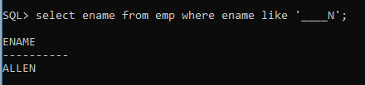

30_ Find the employees who have the letter r as the third letter in their name.

CREATE TABLE EMP

(

EMPNO NUMERIC(4) CONSTRAINT EMPNO_EMP_PK PRIMARY KEY,

ENAME VARCHAR(10),

JOB VARCHAR(9),

MGR NUMERIC(4),

HIREDATE DATE,

SAL NUMERIC(7,2),

COMM NUMERIC(7,2),

DEPTNO NUMERIC(2) CONSTRAINT DEPTNO_DEPT_FK REFERENCES DEPT(DEPTNO)

);

INSERT INTO EMP VALUES (7369,'SMITH','CLERK',7902,'17-DEC-80',800,NULL,20);

INSERT INTO EMP VALUES (7499,'ALLEN','SALESMAN',7698,'20-FEB-81',1600,300,30);

INTO EMP VALUES (7566,'JONES','MANAGER',7839,'02-APR-81',2975,NULL,20);

INSERT INTO EMP VALUES (7654,'MARTIN','SALESMAN',7698,'28-SEP-81',1250,1400,30);

INSERT INTO EMP VALUES (7698,'BLAKE','MANAGER',7839,'01-MAY-81',2850,NULL,30);

INSERT INTO EMP VALUES (7782,'CLARK','MANAGER',7839,'09-JUN-81',2450,NULL,10);

INSERT INTO EMP VALUES (7788,'SCOTT','ANALYST',7566,'19-APR-87',3000,NULL,20);

INSERT INTO EMP VALUES (7839,'KING','PRESIDENT',NULL,'17-NOV-81',5000,NULL,10);

INSERT INTO EMP VALUES (7844,'TURNER','SALESMAN',7698,'08-SEP-81',1500,0,30);

INSERT INTO EMP VALUES (7876,'ADAMS','CLERK',7788,'23-MAY-87',1100,NULL,20);

INSERT INTO EMP VALUES (7900,'JAMES','CLERK',7698,'03-DEC-81','950',NULL,30);

INSERT INTO EMP VALUES (7902,'FORD','ANALYST',7566,'03-DEC-81',3000,NULL,20);

INSERT INTO EMP VALUES (7521,'WARD','SALESMAN',7698,'22-FEB-81',1250,500,30);

INSERT INTO EMP VALUES (7934,'MILLER','CLERK',7782,'23-JAN-82',1300,NULL,10);

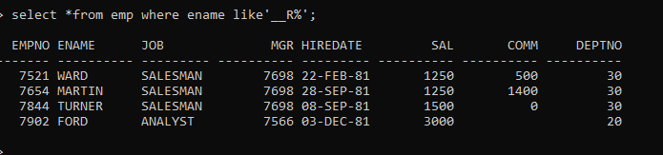

31_ Find all employees hired in month of February (of any year).

CREATE TABLE EMP

(

EMPNO NUMERIC(4) CONSTRAINT EMPNO_EMP_PK PRIMARY KEY,

ENAME VARCHAR(10),

JOB VARCHAR(9),

MGR NUMERIC(4),

HIREDATE DATE,

SAL NUMERIC(7,2),

COMM NUMERIC(7,2),

DEPTNO NUMERIC(2) CONSTRAINT DEPTNO_DEPT_FK REFERENCES DEPT(DEPTNO)

);

INSERT INTO EMP VALUES (7369,'SMITH','CLERK',7902,'17-DEC-80',800,NULL,20);

INSERT INTO EMP VALUES (7499,'ALLEN','SALESMAN',7698,'20-FEB-81',1600,300,30);

INTO EMP VALUES (7566,'JONES','MANAGER',7839,'02-APR-81',2975,NULL,20);

INSERT INTO EMP VALUES (7654,'MARTIN','SALESMAN',7698,'28-SEP-81',1250,1400,30);

INSERT INTO EMP VALUES (7698,'BLAKE','MANAGER',7839,'01-MAY-81',2850,NULL,30);

INSERT INTO EMP VALUES (7782,'CLARK','MANAGER',7839,'09-JUN-81',2450,NULL,10);

INSERT INTO EMP VALUES (7788,'SCOTT','ANALYST',7566,'19-APR-87',3000,NULL,20);

INSERT INTO EMP VALUES (7839,'KING','PRESIDENT',NULL,'17-NOV-81',5000,NULL,10);

INSERT INTO EMP VALUES (7844,'TURNER','SALESMAN',7698,'08-SEP-81',1500,0,30);

INSERT INTO EMP VALUES (7876,'ADAMS','CLERK',7788,'23-MAY-87',1100,NULL,20);

INSERT INTO EMP VALUES (7900,'JAMES','CLERK',7698,'03-DEC-81','950',NULL,30);

INSERT INTO EMP VALUES (7902,'FORD','ANALYST',7566,'03-DEC-81',3000,NULL,20);

INSERT INTO EMP VALUES (7521,'WARD','SALESMAN',7698,'22-FEB-81',1250,500,30);

INSERT INTO EMP VALUES (7934,'MILLER','CLERK',7782,'23-JAN-82',1300,NULL,10);

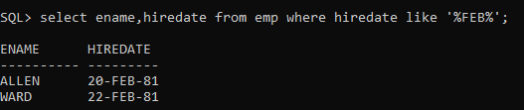

32_ ***Find all employees who were hired on the last day of the month.***

CREATE TABLE EMP

(

EMPNO NUMERIC(4) CONSTRAINT EMPNO_EMP_PK PRIMARY KEY,

ENAME VARCHAR(10),

JOB VARCHAR(9),

MGR NUMERIC(4),

HIREDATE DATE,

SAL NUMERIC(7,2),

COMM NUMERIC(7,2),

DEPTNO NUMERIC(2) CONSTRAINT DEPTNO_DEPT_FK REFERENCES DEPT(DEPTNO)

);

INSERT INTO EMP VALUES (7369,'SMITH','CLERK',7902,'17-DEC-80',800,NULL,20);

INSERT INTO EMP VALUES (7499,'ALLEN','SALESMAN',7698,'20-FEB-81',1600,300,30);

INTO EMP VALUES (7566,'JONES','MANAGER',7839,'02-APR-81',2975,NULL,20);

INSERT INTO EMP VALUES (7654,'MARTIN','SALESMAN',7698,'28-SEP-81',1250,1400,30);

INSERT INTO EMP VALUES (7698,'BLAKE','MANAGER',7839,'01-MAY-81',2850,NULL,30);

INSERT INTO EMP VALUES (7782,'CLARK','MANAGER',7839,'09-JUN-81',2450,NULL,10);

INSERT INTO EMP VALUES (7788,'SCOTT','ANALYST',7566,'19-APR-87',3000,NULL,20);

INSERT INTO EMP VALUES (7839,'KING','PRESIDENT',NULL,'17-NOV-81',5000,NULL,10);

INSERT INTO EMP VALUES (7844,'TURNER','SALESMAN',7698,'08-SEP-81',1500,0,30);

INSERT INTO EMP VALUES (7876,'ADAMS','CLERK',7788,'23-MAY-87',1100,NULL,20);

INSERT INTO EMP VALUES (7900,'JAMES','CLERK',7698,'03-DEC-81','950',NULL,30);

INSERT INTO EMP VALUES (7902,'FORD','ANALYST',7566,'03-DEC-81',3000,NULL,20);

INSERT INTO EMP VALUES (7521,'WARD','SALESMAN',7698,'22-FEB-81',1250,500,30);

INSERT INTO EMP VALUES (7934,'MILLER','CLERK',7782,'23-JAN-82',1300,NULL,10);

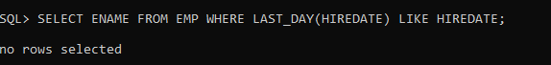

33_ Find the employees who were hired more than 12 years ago.

CREATE TABLE EMP

(

EMPNO NUMERIC(4) CONSTRAINT EMPNO_EMP_PK PRIMARY KEY,

ENAME VARCHAR(10),

JOB VARCHAR(9),

MGR NUMERIC(4),

HIREDATE DATE,

SAL NUMERIC(7,2),

COMM NUMERIC(7,2),

DEPTNO NUMERIC(2) CONSTRAINT DEPTNO_DEPT_FK REFERENCES DEPT(DEPTNO)

);

INSERT INTO EMP VALUES (7369,'SMITH','CLERK',7902,'17-DEC-80',800,NULL,20);

INSERT INTO EMP VALUES (7499,'ALLEN','SALESMAN',7698,'20-FEB-81',1600,300,30);

INTO EMP VALUES (7566,'JONES','MANAGER',7839,'02-APR-81',2975,NULL,20);

INSERT INTO EMP VALUES (7654,'MARTIN','SALESMAN',7698,'28-SEP-81',1250,1400,30);

INSERT INTO EMP VALUES (7698,'BLAKE','MANAGER',7839,'01-MAY-81',2850,NULL,30);

INSERT INTO EMP VALUES (7782,'CLARK','MANAGER',7839,'09-JUN-81',2450,NULL,10);

INSERT INTO EMP VALUES (7788,'SCOTT','ANALYST',7566,'19-APR-87',3000,NULL,20);

INSERT INTO EMP VALUES (7839,'KING','PRESIDENT',NULL,'17-NOV-81',5000,NULL,10);

INSERT INTO EMP VALUES (7844,'TURNER','SALESMAN',7698,'08-SEP-81',1500,0,30);

INSERT INTO EMP VALUES (7876,'ADAMS','CLERK',7788,'23-MAY-87',1100,NULL,20);

INSERT INTO EMP VALUES (7900,'JAMES','CLERK',7698,'03-DEC-81','950',NULL,30);

INSERT INTO EMP VALUES (7902,'FORD','ANALYST',7566,'03-DEC-81',3000,NULL,20);

INSERT INTO EMP VALUES (7521,'WARD','SALESMAN',7698,'22-FEB-81',1250,500,30);

INSERT INTO EMP VALUES (7934,'MILLER','CLERK',7782,'23-JAN-82',1300,NULL,10);

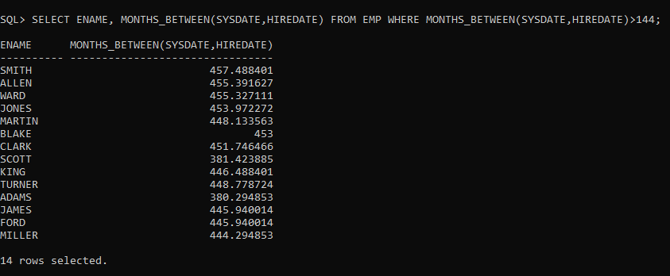

34_ Find the managers hired in the year 2007.

CREATE TABLE EMP

(

EMPNO NUMERIC(4) CONSTRAINT EMPNO_EMP_PK PRIMARY KEY,

ENAME VARCHAR(10),

JOB VARCHAR(9),

MGR NUMERIC(4),

HIREDATE DATE,

SAL NUMERIC(7,2),

COMM NUMERIC(7,2),

DEPTNO NUMERIC(2) CONSTRAINT DEPTNO_DEPT_FK REFERENCES DEPT(DEPTNO)

);

INSERT INTO EMP VALUES (7369,'SMITH','CLERK',7902,'17-DEC-80',800,NULL,20);

INSERT INTO EMP VALUES (7499,'ALLEN','SALESMAN',7698,'20-FEB-81',1600,300,30);

INTO EMP VALUES (7566,'JONES','MANAGER',7839,'02-APR-81',2975,NULL,20);

INSERT INTO EMP VALUES (7654,'MARTIN','SALESMAN',7698,'28-SEP-81',1250,1400,30);

INSERT INTO EMP VALUES (7698,'BLAKE','MANAGER',7839,'01-MAY-81',2850,NULL,30);

INSERT INTO EMP VALUES (7782,'CLARK','MANAGER',7839,'09-JUN-81',2450,NULL,10);

INSERT INTO EMP VALUES (7788,'SCOTT','ANALYST',7566,'19-APR-87',3000,NULL,20);

INSERT INTO EMP VALUES (7839,'KING','PRESIDENT',NULL,'17-NOV-81',5000,NULL,10);

INSERT INTO EMP VALUES (7844,'TURNER','SALESMAN',7698,'08-SEP-81',1500,0,30);

INSERT INTO EMP VALUES (7876,'ADAMS','CLERK',7788,'23-MAY-87',1100,NULL,20);

INSERT INTO EMP VALUES (7900,'JAMES','CLERK',7698,'03-DEC-81','950',NULL,30);

INSERT INTO EMP VALUES (7902,'FORD','ANALYST',7566,'03-DEC-81',3000,NULL,20);

INSERT INTO EMP VALUES (7521,'WARD','SALESMAN',7698,'22-FEB-81',1250,500,30);

INSERT INTO EMP VALUES (7934,'MILLER','CLERK',7782,'23-JAN-82',1300,NULL,10);

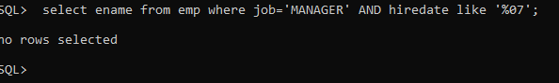

35_ ***Display the names and the jobs of all employees, separated by ‘,’(comma). For example***

(smith, clerk).

CREATE TABLE EMP

(

EMPNO NUMERIC(4) CONSTRAINT EMPNO_EMP_PK PRIMARY KEY,

ENAME VARCHAR(10),

JOB VARCHAR(9),

MGR NUMERIC(4),

HIREDATE DATE,

SAL NUMERIC(7,2),

COMM NUMERIC(7,2),

DEPTNO NUMERIC(2) CONSTRAINT DEPTNO_DEPT_FK REFERENCES DEPT(DEPTNO)

);

INSERT INTO EMP VALUES (7369,'SMITH','CLERK',7902,'17-DEC-80',800,NULL,20);

INSERT INTO EMP VALUES (7499,'ALLEN','SALESMAN',7698,'20-FEB-81',1600,300,30);

INTO EMP VALUES (7566,'JONES','MANAGER',7839,'02-APR-81',2975,NULL,20);

INSERT INTO EMP VALUES (7654,'MARTIN','SALESMAN',7698,'28-SEP-81',1250,1400,30);

INSERT INTO EMP VALUES (7698,'BLAKE','MANAGER',7839,'01-MAY-81',2850,NULL,30);

INSERT INTO EMP VALUES (7782,'CLARK','MANAGER',7839,'09-JUN-81',2450,NULL,10);

INSERT INTO EMP VALUES (7788,'SCOTT','ANALYST',7566,'19-APR-87',3000,NULL,20);

INSERT INTO EMP VALUES (7839,'KING','PRESIDENT',NULL,'17-NOV-81',5000,NULL,10);

INSERT INTO EMP VALUES (7844,'TURNER','SALESMAN',7698,'08-SEP-81',1500,0,30);

INSERT INTO EMP VALUES (7876,'ADAMS','CLERK',7788,'23-MAY-87',1100,NULL,20);

INSERT INTO EMP VALUES (7900,'JAMES','CLERK',7698,'03-DEC-81','950',NULL,30);

INSERT INTO EMP VALUES (7902,'FORD','ANALYST',7566,'03-DEC-81',3000,NULL,20);

INSERT INTO EMP VALUES (7521,'WARD','SALESMAN',7698,'22-FEB-81',1250,500,30);

INSERT INTO EMP VALUES (7934,'MILLER','CLERK',7782,'23-JAN-82',1300,NULL,10);

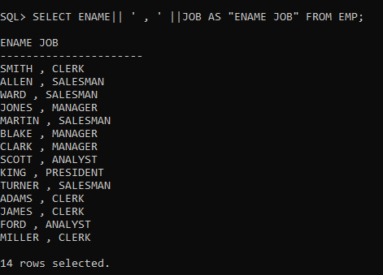

36_ ***Display the names of all employees with the initial letter only in capitals.***

CREATE TABLE EMP

(

EMPNO NUMERIC(4) CONSTRAINT EMPNO_EMP_PK PRIMARY KEY,

ENAME VARCHAR(10),

JOB VARCHAR(9),

MGR NUMERIC(4),

HIREDATE DATE,

SAL NUMERIC(7,2),

COMM NUMERIC(7,2),

DEPTNO NUMERIC(2) CONSTRAINT DEPTNO_DEPT_FK REFERENCES DEPT(DEPTNO)

);

INSERT INTO EMP VALUES (7369,'SMITH','CLERK',7902,'17-DEC-80',800,NULL,20);

INSERT INTO EMP VALUES (7499,'ALLEN','SALESMAN',7698,'20-FEB-81',1600,300,30);

INTO EMP VALUES (7566,'JONES','MANAGER',7839,'02-APR-81',2975,NULL,20);

INSERT INTO EMP VALUES (7654,'MARTIN','SALESMAN',7698,'28-SEP-81',1250,1400,30);

INSERT INTO EMP VALUES (7698,'BLAKE','MANAGER',7839,'01-MAY-81',2850,NULL,30);

INSERT INTO EMP VALUES (7782,'CLARK','MANAGER',7839,'09-JUN-81',2450,NULL,10);

INSERT INTO EMP VALUES (7788,'SCOTT','ANALYST',7566,'19-APR-87',3000,NULL,20);

INSERT INTO EMP VALUES (7839,'KING','PRESIDENT',NULL,'17-NOV-81',5000,NULL,10);

INSERT INTO EMP VALUES (7844,'TURNER','SALESMAN',7698,'08-SEP-81',1500,0,30);

INSERT INTO EMP VALUES (7876,'ADAMS','CLERK',7788,'23-MAY-87',1100,NULL,20);

INSERT INTO EMP VALUES (7900,'JAMES','CLERK',7698,'03-DEC-81','950',NULL,30);

INSERT INTO EMP VALUES (7902,'FORD','ANALYST',7566,'03-DEC-81',3000,NULL,20);

INSERT INTO EMP VALUES (7521,'WARD','SALESMAN',7698,'22-FEB-81',1250,500,30);

INSERT INTO EMP VALUES (7934,'MILLER','CLERK',7782,'23-JAN-82',1300,NULL,10);

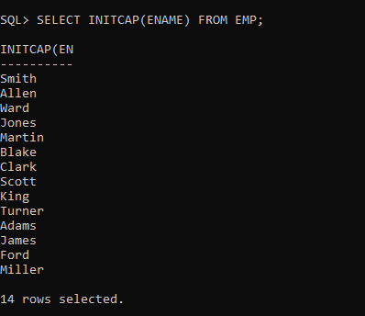

37_ ***Display the names of all employees, right aligning them to 15 characters.***

CREATE TABLE EMP

(

EMPNO NUMERIC(4) CONSTRAINT EMPNO_EMP_PK PRIMARY KEY,

ENAME VARCHAR(10),

JOB VARCHAR(9),

MGR NUMERIC(4),

HIREDATE DATE,

SAL NUMERIC(7,2),

COMM NUMERIC(7,2),

DEPTNO NUMERIC(2) CONSTRAINT DEPTNO_DEPT_FK REFERENCES DEPT(DEPTNO)

);

INSERT INTO EMP VALUES (7369,'SMITH','CLERK',7902,'17-DEC-80',800,NULL,20);

INSERT INTO EMP VALUES (7499,'ALLEN','SALESMAN',7698,'20-FEB-81',1600,300,30);

INTO EMP VALUES (7566,'JONES','MANAGER',7839,'02-APR-81',2975,NULL,20);

INSERT INTO EMP VALUES (7654,'MARTIN','SALESMAN',7698,'28-SEP-81',1250,1400,30);

INSERT INTO EMP VALUES (7698,'BLAKE','MANAGER',7839,'01-MAY-81',2850,NULL,30);

INSERT INTO EMP VALUES (7782,'CLARK','MANAGER',7839,'09-JUN-81',2450,NULL,10);

INSERT INTO EMP VALUES (7788,'SCOTT','ANALYST',7566,'19-APR-87',3000,NULL,20);

INSERT INTO EMP VALUES (7839,'KING','PRESIDENT',NULL,'17-NOV-81',5000,NULL,10);

INSERT INTO EMP VALUES (7844,'TURNER','SALESMAN',7698,'08-SEP-81',1500,0,30);

INSERT INTO EMP VALUES (7876,'ADAMS','CLERK',7788,'23-MAY-87',1100,NULL,20);

INSERT INTO EMP VALUES (7900,'JAMES','CLERK',7698,'03-DEC-81','950',NULL,30);

INSERT INTO EMP VALUES (7902,'FORD','ANALYST',7566,'03-DEC-81',3000,NULL,20);

INSERT INTO EMP VALUES (7521,'WARD','SALESMAN',7698,'22-FEB-81',1250,500,30);

INSERT INTO EMP VALUES (7934,'MILLER','CLERK',7782,'23-JAN-82',1300,NULL,10);

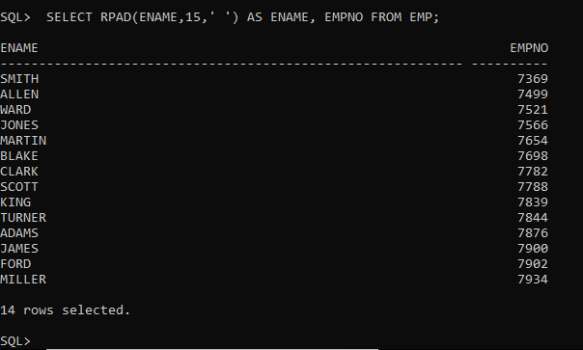

38. Display the names of all employees, padding them to right up-to 15 characters with ‘-‘ (using lpad)

CREATE TABLE EMP

(

EMPNO NUMERIC(4) CONSTRAINT EMPNO_EMP_PK PRIMARY KEY,

ENAME VARCHAR(10),

JOB VARCHAR(9),

MGR NUMERIC(4),

HIREDATE DATE,

SAL NUMERIC(7,2),

COMM NUMERIC(7,2),

DEPTNO NUMERIC(2) CONSTRAINT DEPTNO_DEPT_FK REFERENCES DEPT(DEPTNO)

);

INSERT INTO EMP VALUES (7369,'SMITH','CLERK',7902,'17-DEC-80',800,NULL,20);

INSERT INTO EMP VALUES (7499,'ALLEN','SALESMAN',7698,'20-FEB-81',1600,300,30);

INTO EMP VALUES (7566,'JONES','MANAGER',7839,'02-APR-81',2975,NULL,20);

INSERT INTO EMP VALUES (7654,'MARTIN','SALESMAN',7698,'28-SEP-81',1250,1400,30);

INSERT INTO EMP VALUES (7698,'BLAKE','MANAGER',7839,'01-MAY-81',2850,NULL,30);

INSERT INTO EMP VALUES (7782,'CLARK','MANAGER',7839,'09-JUN-81',2450,NULL,10);

INSERT INTO EMP VALUES (7788,'SCOTT','ANALYST',7566,'19-APR-87',3000,NULL,20);

INSERT INTO EMP VALUES (7839,'KING','PRESIDENT',NULL,'17-NOV-81',5000,NULL,10);

INSERT INTO EMP VALUES (7844,'TURNER','SALESMAN',7698,'08-SEP-81',1500,0,30);

INSERT INTO EMP VALUES (7876,'ADAMS','CLERK',7788,'23-MAY-87',1100,NULL,20);

INSERT INTO EMP VALUES (7900,'JAMES','CLERK',7698,'03-DEC-81','950',NULL,30);

INSERT INTO EMP VALUES (7902,'FORD','ANALYST',7566,'03-DEC-81',3000,NULL,20);

INSERT INTO EMP VALUES (7521,'WARD','SALESMAN',7698,'22-FEB-81',1250,500,30);

INSERT INTO EMP VALUES (7934,'MILLER','CLERK',7782,'23-JAN-82',1300,NULL,10);

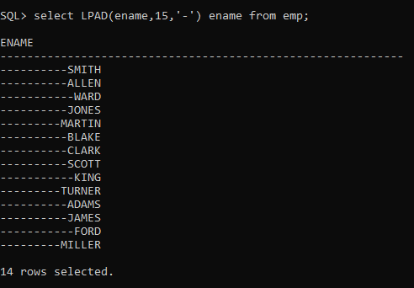

39.Display the length of the name of all employees.

CREATE TABLE EMP

(

EMPNO NUMERIC(4) CONSTRAINT EMPNO_EMP_PK PRIMARY KEY,

ENAME VARCHAR(10),

JOB VARCHAR(9),

MGR NUMERIC(4),

HIREDATE DATE,

SAL NUMERIC(7,2),

COMM NUMERIC(7,2),

DEPTNO NUMERIC(2) CONSTRAINT DEPTNO_DEPT_FK REFERENCES DEPT(DEPTNO)

);

INSERT INTO EMP VALUES (7369,'SMITH','CLERK',7902,'17-DEC-80',800,NULL,20);

INSERT INTO EMP VALUES (7499,'ALLEN','SALESMAN',7698,'20-FEB-81',1600,300,30);

INTO EMP VALUES (7566,'JONES','MANAGER',7839,'02-APR-81',2975,NULL,20);

INSERT INTO EMP VALUES (7654,'MARTIN','SALESMAN',7698,'28-SEP-81',1250,1400,30);

INSERT INTO EMP VALUES (7698,'BLAKE','MANAGER',7839,'01-MAY-81',2850,NULL,30);

INSERT INTO EMP VALUES (7782,'CLARK','MANAGER',7839,'09-JUN-81',2450,NULL,10);

INSERT INTO EMP VALUES (7788,'SCOTT','ANALYST',7566,'19-APR-87',3000,NULL,20);

INSERT INTO EMP VALUES (7839,'KING','PRESIDENT',NULL,'17-NOV-81',5000,NULL,10);

INSERT INTO EMP VALUES (7844,'TURNER','SALESMAN',7698,'08-SEP-81',1500,0,30);

INSERT INTO EMP VALUES (7876,'ADAMS','CLERK',7788,'23-MAY-87',1100,NULL,20);

INSERT INTO EMP VALUES (7900,'JAMES','CLERK',7698,'03-DEC-81','950',NULL,30);

INSERT INTO EMP VALUES (7902,'FORD','ANALYST',7566,'03-DEC-81',3000,NULL,20);

INSERT INTO EMP VALUES (7521,'WARD','SALESMAN',7698,'22-FEB-81',1250,500,30);

INSERT INTO EMP VALUES (7934,'MILLER','CLERK',7782,'23-JAN-82',1300,NULL,10);

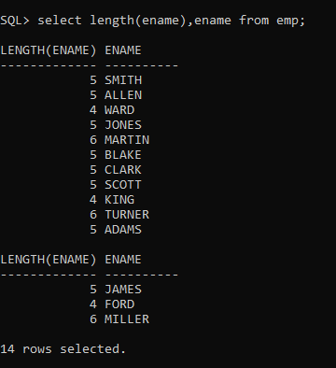

***40. Display the names of all employees centering them with 20 characters.***

CREATE TABLE EMP

(

EMPNO NUMERIC(4) CONSTRAINT EMPNO_EMP_PK PRIMARY KEY,

ENAME VARCHAR(10),

JOB VARCHAR(9),

MGR NUMERIC(4),

HIREDATE DATE,

SAL NUMERIC(7,2),

COMM NUMERIC(7,2),

DEPTNO NUMERIC(2) CONSTRAINT DEPTNO_DEPT_FK REFERENCES DEPT(DEPTNO)

);

INSERT INTO EMP VALUES (7369,'SMITH','CLERK',7902,'17-DEC-80',800,NULL,20);

INSERT INTO EMP VALUES (7499,'ALLEN','SALESMAN',7698,'20-FEB-81',1600,300,30);

INTO EMP VALUES (7566,'JONES','MANAGER',7839,'02-APR-81',2975,NULL,20);

INSERT INTO EMP VALUES (7654,'MARTIN','SALESMAN',7698,'28-SEP-81',1250,1400,30);

INSERT INTO EMP VALUES (7698,'BLAKE','MANAGER',7839,'01-MAY-81',2850,NULL,30);

INSERT INTO EMP VALUES (7782,'CLARK','MANAGER',7839,'09-JUN-81',2450,NULL,10);

INSERT INTO EMP VALUES (7788,'SCOTT','ANALYST',7566,'19-APR-87',3000,NULL,20);

INSERT INTO EMP VALUES (7839,'KING','PRESIDENT',NULL,'17-NOV-81',5000,NULL,10);

INSERT INTO EMP VALUES (7844,'TURNER','SALESMAN',7698,'08-SEP-81',1500,0,30);

INSERT INTO EMP VALUES (7876,'ADAMS','CLERK',7788,'23-MAY-87',1100,NULL,20);

INSERT INTO EMP VALUES (7900,'JAMES','CLERK',7698,'03-DEC-81','950',NULL,30);

INSERT INTO EMP VALUES (7902,'FORD','ANALYST',7566,'03-DEC-81',3000,NULL,20);

INSERT INTO EMP VALUES (7521,'WARD','SALESMAN',7698,'22-FEB-81',1250,500,30);

INSERT INTO EMP VALUES (7934,'MILLER','CLERK',7782,'23-JAN-82',1300,NULL,10);

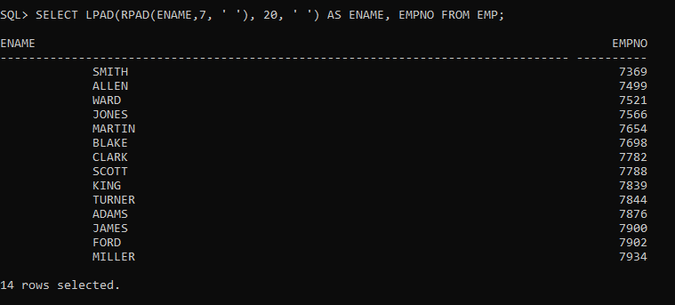

41.Display the names of all employees without any leading 'a'.

CREATE TABLE EMP

(

EMPNO NUMERIC(4) CONSTRAINT EMPNO_EMP_PK PRIMARY KEY,

ENAME VARCHAR(10),

JOB VARCHAR(9),

MGR NUMERIC(4),

HIREDATE DATE,

SAL NUMERIC(7,2),

COMM NUMERIC(7,2),

DEPTNO NUMERIC(2) CONSTRAINT DEPTNO_DEPT_FK REFERENCES DEPT(DEPTNO)

);

INSERT INTO EMP VALUES (7369,'SMITH','CLERK',7902,'17-DEC-80',800,NULL,20);

INSERT INTO EMP VALUES (7499,'ALLEN','SALESMAN',7698,'20-FEB-81',1600,300,30);

INTO EMP VALUES (7566,'JONES','MANAGER',7839,'02-APR-81',2975,NULL,20);

INSERT INTO EMP VALUES (7654,'MARTIN','SALESMAN',7698,'28-SEP-81',1250,1400,30);

INSERT INTO EMP VALUES (7698,'BLAKE','MANAGER',7839,'01-MAY-81',2850,NULL,30);

INSERT INTO EMP VALUES (7782,'CLARK','MANAGER',7839,'09-JUN-81',2450,NULL,10);

INSERT INTO EMP VALUES (7788,'SCOTT','ANALYST',7566,'19-APR-87',3000,NULL,20);

INSERT INTO EMP VALUES (7839,'KING','PRESIDENT',NULL,'17-NOV-81',5000,NULL,10);

INSERT INTO EMP VALUES (7844,'TURNER','SALESMAN',7698,'08-SEP-81',1500,0,30);

INSERT INTO EMP VALUES (7876,'ADAMS','CLERK',7788,'23-MAY-87',1100,NULL,20);

INSERT INTO EMP VALUES (7900,'JAMES','CLERK',7698,'03-DEC-81','950',NULL,30);

INSERT INTO EMP VALUES (7902,'FORD','ANALYST',7566,'03-DEC-81',3000,NULL,20);

INSERT INTO EMP VALUES (7521,'WARD','SALESMAN',7698,'22-FEB-81',1250,500,30);

INSERT INTO EMP VALUES (7934,'MILLER','CLERK',7782,'23-JAN-82',1300,NULL,10);

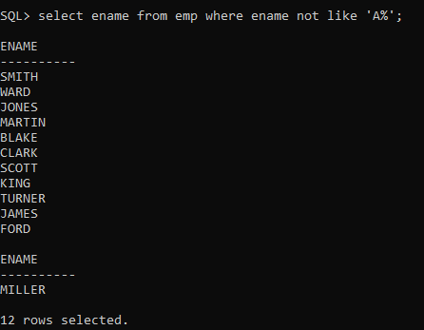

42.Display the names of all employees without any trailing 'r'.

CREATE TABLE EMP

(

EMPNO NUMERIC(4) CONSTRAINT EMPNO_EMP_PK PRIMARY KEY,

ENAME VARCHAR(10),

JOB VARCHAR(9),

MGR NUMERIC(4),

HIREDATE DATE,

SAL NUMERIC(7,2),

COMM NUMERIC(7,2),

DEPTNO NUMERIC(2) CONSTRAINT DEPTNO_DEPT_FK REFERENCES DEPT(DEPTNO)

);

INSERT INTO EMP VALUES (7369,'SMITH','CLERK',7902,'17-DEC-80',800,NULL,20);

INSERT INTO EMP VALUES (7499,'ALLEN','SALESMAN',7698,'20-FEB-81',1600,300,30);

INTO EMP VALUES (7566,'JONES','MANAGER',7839,'02-APR-81',2975,NULL,20);

INSERT INTO EMP VALUES (7654,'MARTIN','SALESMAN',7698,'28-SEP-81',1250,1400,30);

INSERT INTO EMP VALUES (7698,'BLAKE','MANAGER',7839,'01-MAY-81',2850,NULL,30);

INSERT INTO EMP VALUES (7782,'CLARK','MANAGER',7839,'09-JUN-81',2450,NULL,10);

INSERT INTO EMP VALUES (7788,'SCOTT','ANALYST',7566,'19-APR-87',3000,NULL,20);

INSERT INTO EMP VALUES (7839,'KING','PRESIDENT',NULL,'17-NOV-81',5000,NULL,10);

INSERT INTO EMP VALUES (7844,'TURNER','SALESMAN',7698,'08-SEP-81',1500,0,30);

INSERT INTO EMP VALUES (7876,'ADAMS','CLERK',7788,'23-MAY-87',1100,NULL,20);

INSERT INTO EMP VALUES (7900,'JAMES','CLERK',7698,'03-DEC-81','950',NULL,30);

INSERT INTO EMP VALUES (7902,'FORD','ANALYST',7566,'03-DEC-81',3000,NULL,20);

INSERT INTO EMP VALUES (7521,'WARD','SALESMAN',7698,'22-FEB-81',1250,500,30);

INSERT INTO EMP VALUES (7934,'MILLER','CLERK',7782,'23-JAN-82',1300,NULL,10);

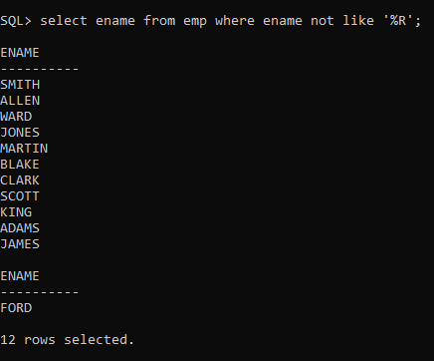

43.Show the first three characters of the names of all employees.

CREATE TABLE EMP

(

EMPNO NUMERIC(4) CONSTRAINT EMPNO_EMP_PK PRIMARY KEY,

ENAME VARCHAR(10),

JOB VARCHAR(9),

MGR NUMERIC(4),

HIREDATE DATE,

SAL NUMERIC(7,2),

COMM NUMERIC(7,2),

DEPTNO NUMERIC(2) CONSTRAINT DEPTNO_DEPT_FK REFERENCES DEPT(DEPTNO)

);

INSERT INTO EMP VALUES (7369,'SMITH','CLERK',7902,'17-DEC-80',800,NULL,20);

INSERT INTO EMP VALUES (7499,'ALLEN','SALESMAN',7698,'20-FEB-81',1600,300,30);

INTO EMP VALUES (7566,'JONES','MANAGER',7839,'02-APR-81',2975,NULL,20);

INSERT INTO EMP VALUES (7654,'MARTIN','SALESMAN',7698,'28-SEP-81',1250,1400,30);

INSERT INTO EMP VALUES (7698,'BLAKE','MANAGER',7839,'01-MAY-81',2850,NULL,30);

INSERT INTO EMP VALUES (7782,'CLARK','MANAGER',7839,'09-JUN-81',2450,NULL,10);

INSERT INTO EMP VALUES (7788,'SCOTT','ANALYST',7566,'19-APR-87',3000,NULL,20);

INSERT INTO EMP VALUES (7839,'KING','PRESIDENT',NULL,'17-NOV-81',5000,NULL,10);

INSERT INTO EMP VALUES (7844,'TURNER','SALESMAN',7698,'08-SEP-81',1500,0,30);

INSERT INTO EMP VALUES (7876,'ADAMS','CLERK',7788,'23-MAY-87',1100,NULL,20);

INSERT INTO EMP VALUES (7900,'JAMES','CLERK',7698,'03-DEC-81','950',NULL,30);

INSERT INTO EMP VALUES (7902,'FORD','ANALYST',7566,'03-DEC-81',3000,NULL,20);

INSERT INTO EMP VALUES (7521,'WARD','SALESMAN',7698,'22-FEB-81',1250,500,30);

INSERT INTO EMP VALUES (7934,'MILLER','CLERK',7782,'23-JAN-82',1300,NULL,10);

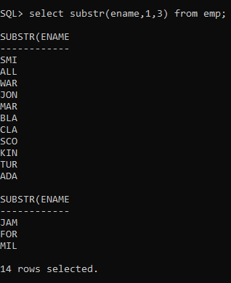

44..Show the last three characters of the names of all employees.

CREATE TABLE EMP

(

EMPNO NUMERIC(4) CONSTRAINT EMPNO_EMP_PK PRIMARY KEY,

ENAME VARCHAR(10),

JOB VARCHAR(9),

MGR NUMERIC(4),

HIREDATE DATE,

SAL NUMERIC(7,2),

COMM NUMERIC(7,2),

DEPTNO NUMERIC(2) CONSTRAINT DEPTNO_DEPT_FK REFERENCES DEPT(DEPTNO)

);

INSERT INTO EMP VALUES (7369,'SMITH','CLERK',7902,'17-DEC-80',800,NULL,20);

INSERT INTO EMP VALUES (7499,'ALLEN','SALESMAN',7698,'20-FEB-81',1600,300,30);

INTO EMP VALUES (7566,'JONES','MANAGER',7839,'02-APR-81',2975,NULL,20);

INSERT INTO EMP VALUES (7654,'MARTIN','SALESMAN',7698,'28-SEP-81',1250,1400,30);

INSERT INTO EMP VALUES (7698,'BLAKE','MANAGER',7839,'01-MAY-81',2850,NULL,30);

INSERT INTO EMP VALUES (7782,'CLARK','MANAGER',7839,'09-JUN-81',2450,NULL,10);

INSERT INTO EMP VALUES (7788,'SCOTT','ANALYST',7566,'19-APR-87',3000,NULL,20);

INSERT INTO EMP VALUES (7839,'KING','PRESIDENT',NULL,'17-NOV-81',5000,NULL,10);

INSERT INTO EMP VALUES (7844,'TURNER','SALESMAN',7698,'08-SEP-81',1500,0,30);

INSERT INTO EMP VALUES (7876,'ADAMS','CLERK',7788,'23-MAY-87',1100,NULL,20);

INSERT INTO EMP VALUES (7900,'JAMES','CLERK',7698,'03-DEC-81','950',NULL,30);

INSERT INTO EMP VALUES (7902,'FORD','ANALYST',7566,'03-DEC-81',3000,NULL,20);

INSERT INTO EMP VALUES (7521,'WARD','SALESMAN',7698,'22-FEB-81',1250,500,30);

INSERT INTO EMP VALUES (7934,'MILLER','CLERK',7782,'23-JAN-82',1300,NULL,10);

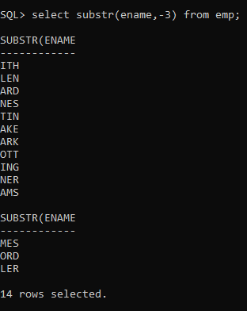

45.Display the names of all employees replacing any 'a' with 'e'.

CREATE TABLE EMP

(

EMPNO NUMERIC(4) CONSTRAINT EMPNO_EMP_PK PRIMARY KEY,

ENAME VARCHAR(10),

JOB VARCHAR(9),

MGR NUMERIC(4),

HIREDATE DATE,

SAL NUMERIC(7,2),

COMM NUMERIC(7,2),

DEPTNO NUMERIC(2) CONSTRAINT DEPTNO_DEPT_FK REFERENCES DEPT(DEPTNO)

);

INSERT INTO EMP VALUES (7369,'SMITH','CLERK',7902,'17-DEC-80',800,NULL,20);

INSERT INTO EMP VALUES (7499,'ALLEN','SALESMAN',7698,'20-FEB-81',1600,300,30);

INTO EMP VALUES (7566,'JONES','MANAGER',7839,'02-APR-81',2975,NULL,20);

INSERT INTO EMP VALUES (7654,'MARTIN','SALESMAN',7698,'28-SEP-81',1250,1400,30);

INSERT INTO EMP VALUES (7698,'BLAKE','MANAGER',7839,'01-MAY-81',2850,NULL,30);

INSERT INTO EMP VALUES (7782,'CLARK','MANAGER',7839,'09-JUN-81',2450,NULL,10);

INSERT INTO EMP VALUES (7788,'SCOTT','ANALYST',7566,'19-APR-87',3000,NULL,20);

INSERT INTO EMP VALUES (7839,'KING','PRESIDENT',NULL,'17-NOV-81',5000,NULL,10);

INSERT INTO EMP VALUES (7844,'TURNER','SALESMAN',7698,'08-SEP-81',1500,0,30);

INSERT INTO EMP VALUES (7876,'ADAMS','CLERK',7788,'23-MAY-87',1100,NULL,20);

INSERT INTO EMP VALUES (7900,'JAMES','CLERK',7698,'03-DEC-81','950',NULL,30);

INSERT INTO EMP VALUES (7902,'FORD','ANALYST',7566,'03-DEC-81',3000,NULL,20);

INSERT INTO EMP VALUES (7521,'WARD','SALESMAN',7698,'22-FEB-81',1250,500,30);

INSERT INTO EMP VALUES (7934,'MILLER','CLERK',7782,'23-JAN-82',1300,NULL,10);

46.Display the names of all employees and the position at which the string 'ar' occurs in the name.

CREATE TABLE EMP

(

EMPNO NUMERIC(4) CONSTRAINT EMPNO_EMP_PK PRIMARY KEY,

ENAME VARCHAR(10),

JOB VARCHAR(9),

MGR NUMERIC(4),

HIREDATE DATE,

SAL NUMERIC(7,2),

COMM NUMERIC(7,2),

DEPTNO NUMERIC(2) CONSTRAINT DEPTNO_DEPT_FK REFERENCES DEPT(DEPTNO)

);

INSERT INTO EMP VALUES (7369,'SMITH','CLERK',7902,'17-DEC-80',800,NULL,20);

INSERT INTO EMP VALUES (7499,'ALLEN','SALESMAN',7698,'20-FEB-81',1600,300,30);

INTO EMP VALUES (7566,'JONES','MANAGER',7839,'02-APR-81',2975,NULL,20);

INSERT INTO EMP VALUES (7654,'MARTIN','SALESMAN',7698,'28-SEP-81',1250,1400,30);

INSERT INTO EMP VALUES (7698,'BLAKE','MANAGER',7839,'01-MAY-81',2850,NULL,30);

INSERT INTO EMP VALUES (7782,'CLARK','MANAGER',7839,'09-JUN-81',2450,NULL,10);

INSERT INTO EMP VALUES (7788,'SCOTT','ANALYST',7566,'19-APR-87',3000,NULL,20);

INSERT INTO EMP VALUES (7839,'KING','PRESIDENT',NULL,'17-NOV-81',5000,NULL,10);

INSERT INTO EMP VALUES (7844,'TURNER','SALESMAN',7698,'08-SEP-81',1500,0,30);

INSERT INTO EMP VALUES (7876,'ADAMS','CLERK',7788,'23-MAY-87',1100,NULL,20);

INSERT INTO EMP VALUES (7900,'JAMES','CLERK',7698,'03-DEC-81','950',NULL,30);

INSERT INTO EMP VALUES (7902,'FORD','ANALYST',7566,'03-DEC-81',3000,NULL,20);

INSERT INTO EMP VALUES (7521,'WARD','SALESMAN',7698,'22-FEB-81',1250,500,30);

INSERT INTO EMP VALUES (7934,'MILLER','CLERK',7782,'23-JAN-82',1300,NULL,10);

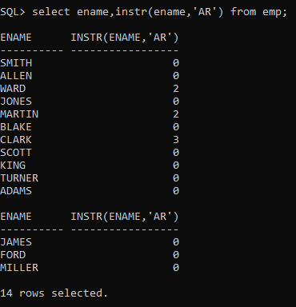

47.Show the salary of all employees rounding it to the nearest Rs. 1000. For example (3790 will be 4000)

CREATE TABLE EMP

(

EMPNO NUMERIC(4) CONSTRAINT EMPNO_EMP_PK PRIMARY KEY,

ENAME VARCHAR(10),

JOB VARCHAR(9),

MGR NUMERIC(4),

HIREDATE DATE,

SAL NUMERIC(7,2),

COMM NUMERIC(7,2),

DEPTNO NUMERIC(2) CONSTRAINT DEPTNO_DEPT_FK REFERENCES DEPT(DEPTNO)

);

INSERT INTO EMP VALUES (7369,'SMITH','CLERK',7902,'17-DEC-80',800,NULL,20);

INSERT INTO EMP VALUES (7499,'ALLEN','SALESMAN',7698,'20-FEB-81',1600,300,30);

INTO EMP VALUES (7566,'JONES','MANAGER',7839,'02-APR-81',2975,NULL,20);

INSERT INTO EMP VALUES (7654,'MARTIN','SALESMAN',7698,'28-SEP-81',1250,1400,30);

INSERT INTO EMP VALUES (7698,'BLAKE','MANAGER',7839,'01-MAY-81',2850,NULL,30);

INSERT INTO EMP VALUES (7782,'CLARK','MANAGER',7839,'09-JUN-81',2450,NULL,10);

INSERT INTO EMP VALUES (7788,'SCOTT','ANALYST',7566,'19-APR-87',3000,NULL,20);

INSERT INTO EMP VALUES (7839,'KING','PRESIDENT',NULL,'17-NOV-81',5000,NULL,10);

INSERT INTO EMP VALUES (7844,'TURNER','SALESMAN',7698,'08-SEP-81',1500,0,30);

INSERT INTO EMP VALUES (7876,'ADAMS','CLERK',7788,'23-MAY-87',1100,NULL,20);

INSERT INTO EMP VALUES (7900,'JAMES','CLERK',7698,'03-DEC-81','950',NULL,30);

INSERT INTO EMP VALUES (7902,'FORD','ANALYST',7566,'03-DEC-81',3000,NULL,20);

INSERT INTO EMP VALUES (7521,'WARD','SALESMAN',7698,'22-FEB-81',1250,500,30);

INSERT INTO EMP VALUES (7934,'MILLER','CLERK',7782,'23-JAN-82',1300,NULL,10);

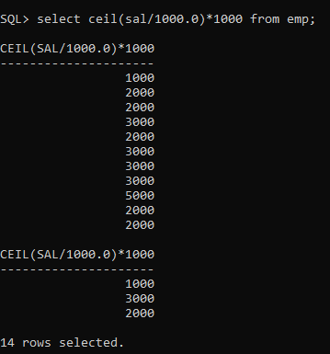

48.Show the daily salary of all employees assuming a month has 30 days.

CREATE TABLE EMP

(

EMPNO NUMERIC(4) CONSTRAINT EMPNO_EMP_PK PRIMARY KEY,

ENAME VARCHAR(10),

JOB VARCHAR(9),

MGR NUMERIC(4),

HIREDATE DATE,

SAL NUMERIC(7,2),

COMM NUMERIC(7,2),

DEPTNO NUMERIC(2) CONSTRAINT DEPTNO_DEPT_FK REFERENCES DEPT(DEPTNO)

);

INSERT INTO EMP VALUES (7369,'SMITH','CLERK',7902,'17-DEC-80',800,NULL,20);

INSERT INTO EMP VALUES (7499,'ALLEN','SALESMAN',7698,'20-FEB-81',1600,300,30);

INTO EMP VALUES (7566,'JONES','MANAGER',7839,'02-APR-81',2975,NULL,20);

INSERT INTO EMP VALUES (7654,'MARTIN','SALESMAN',7698,'28-SEP-81',1250,1400,30);

INSERT INTO EMP VALUES (7698,'BLAKE','MANAGER',7839,'01-MAY-81',2850,NULL,30);

INSERT INTO EMP VALUES (7782,'CLARK','MANAGER',7839,'09-JUN-81',2450,NULL,10);

INSERT INTO EMP VALUES (7788,'SCOTT','ANALYST',7566,'19-APR-87',3000,NULL,20);

INSERT INTO EMP VALUES (7839,'KING','PRESIDENT',NULL,'17-NOV-81',5000,NULL,10);

INSERT INTO EMP VALUES (7844,'TURNER','SALESMAN',7698,'08-SEP-81',1500,0,30);

INSERT INTO EMP VALUES (7876,'ADAMS','CLERK',7788,'23-MAY-87',1100,NULL,20);

INSERT INTO EMP VALUES (7900,'JAMES','CLERK',7698,'03-DEC-81','950',NULL,30);

INSERT INTO EMP VALUES (7902,'FORD','ANALYST',7566,'03-DEC-81',3000,NULL,20);

INSERT INTO EMP VALUES (7521,'WARD','SALESMAN',7698,'22-FEB-81',1250,500,30);

INSERT INTO EMP VALUES (7934,'MILLER','CLERK',7782,'23-JAN-82',1300,NULL,10);

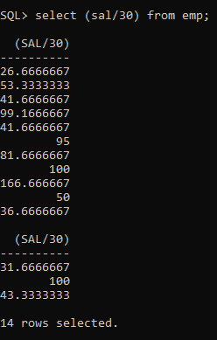

49.Display the name of all employees, and their bonus. Assume each Employee gets a bonus of 20 percent of his salary subject to the Maximum of Rs. 500.

CREATE TABLE EMP

(

EMPNO NUMERIC(4) CONSTRAINT EMPNO_EMP_PK PRIMARY KEY,

ENAME VARCHAR(10),

JOB VARCHAR(9),

MGR NUMERIC(4),

HIREDATE DATE,

SAL NUMERIC(7,2),

COMM NUMERIC(7,2),

DEPTNO NUMERIC(2) CONSTRAINT DEPTNO_DEPT_FK REFERENCES DEPT(DEPTNO)

);

INSERT INTO EMP VALUES (7369,'SMITH','CLERK',7902,'17-DEC-80',800,NULL,20);

INSERT INTO EMP VALUES (7499,'ALLEN','SALESMAN',7698,'20-FEB-81',1600,300,30);

INTO EMP VALUES (7566,'JONES','MANAGER',7839,'02-APR-81',2975,NULL,20);

INSERT INTO EMP VALUES (7654,'MARTIN','SALESMAN',7698,'28-SEP-81',1250,1400,30);

INSERT INTO EMP VALUES (7698,'BLAKE','MANAGER',7839,'01-MAY-81',2850,NULL,30);

INSERT INTO EMP VALUES (7782,'CLARK','MANAGER',7839,'09-JUN-81',2450,NULL,10);

INSERT INTO EMP VALUES (7788,'SCOTT','ANALYST',7566,'19-APR-87',3000,NULL,20);

INSERT INTO EMP VALUES (7839,'KING','PRESIDENT',NULL,'17-NOV-81',5000,NULL,10);

INSERT INTO EMP VALUES (7844,'TURNER','SALESMAN',7698,'08-SEP-81',1500,0,30);

INSERT INTO EMP VALUES (7876,'ADAMS','CLERK',7788,'23-MAY-87',1100,NULL,20);

INSERT INTO EMP VALUES (7900,'JAMES','CLERK',7698,'03-DEC-81','950',NULL,30);

INSERT INTO EMP VALUES (7902,'FORD','ANALYST',7566,'03-DEC-81',3000,NULL,20);

INSERT INTO EMP VALUES (7521,'WARD','SALESMAN',7698,'22-FEB-81',1250,500,30);

INSERT INTO EMP VALUES (7934,'MILLER','CLERK',7782,'23-JAN-82',1300,NULL,10);

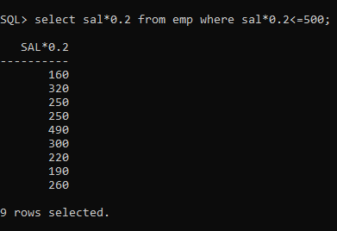

50.Display the name of all employees, and their bonus. Assume each employee gets a bonus of 20 percent of his salary subject to the Maximum of Rs. 200.

CREATE TABLE EMP

(

EMPNO NUMERIC(4) CONSTRAINT EMPNO_EMP_PK PRIMARY KEY,

ENAME VARCHAR(10),

JOB VARCHAR(9),

MGR NUMERIC(4),

HIREDATE DATE,

SAL NUMERIC(7,2),

COMM NUMERIC(7,2),

DEPTNO NUMERIC(2) CONSTRAINT DEPTNO_DEPT_FK REFERENCES DEPT(DEPTNO)

);

INSERT INTO EMP VALUES (7369,'SMITH','CLERK',7902,'17-DEC-80',800,NULL,20);

INSERT INTO EMP VALUES (7499,'ALLEN','SALESMAN',7698,'20-FEB-81',1600,300,30);

INTO EMP VALUES (7566,'JONES','MANAGER',7839,'02-APR-81',2975,NULL,20);

INSERT INTO EMP VALUES (7654,'MARTIN','SALESMAN',7698,'28-SEP-81',1250,1400,30);

INSERT INTO EMP VALUES (7698,'BLAKE','MANAGER',7839,'01-MAY-81',2850,NULL,30);

INSERT INTO EMP VALUES (7782,'CLARK','MANAGER',7839,'09-JUN-81',2450,NULL,10);

INSERT INTO EMP VALUES (7788,'SCOTT','ANALYST',7566,'19-APR-87',3000,NULL,20);

INSERT INTO EMP VALUES (7839,'KING','PRESIDENT',NULL,'17-NOV-81',5000,NULL,10);

INSERT INTO EMP VALUES (7844,'TURNER','SALESMAN',7698,'08-SEP-81',1500,0,30);

INSERT INTO EMP VALUES (7876,'ADAMS','CLERK',7788,'23-MAY-87',1100,NULL,20);

INSERT INTO EMP VALUES (7900,'JAMES','CLERK',7698,'03-DEC-81','950',NULL,30);

INSERT INTO EMP VALUES (7902,'FORD','ANALYST',7566,'03-DEC-81',3000,NULL,20);

INSERT INTO EMP VALUES (7521,'WARD','SALESMAN',7698,'22-FEB-81',1250,500,30);

INSERT INTO EMP VALUES (7934,'MILLER','CLERK',7782,'23-JAN-82',1300,NULL,10);

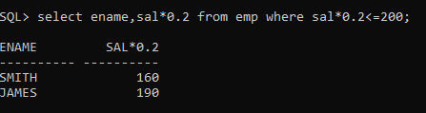

51_For each employee display the number of days passed since the employee joined the company.

CREATE TABLE EMP

(

EMPNO NUMERIC(4) CONSTRAINT EMPNO_EMP_PK PRIMARY KEY,

ENAME VARCHAR(10),

JOB VARCHAR(9),

MGR NUMERIC(4),

HIREDATE DATE,

SAL NUMERIC(7,2),

COMM NUMERIC(7,2),

DEPTNO NUMERIC(2) CONSTRAINT DEPTNO_DEPT_FK REFERENCES DEPT(DEPTNO)

);

INSERT INTO EMP VALUES (7369,'SMITH','CLERK',7902,'17-DEC-80',800,NULL,20);

INSERT INTO EMP VALUES (7499,'ALLEN','SALESMAN',7698,'20-FEB-81',1600,300,30);

INTO EMP VALUES (7566,'JONES','MANAGER',7839,'02-APR-81',2975,NULL,20);

INSERT INTO EMP VALUES (7654,'MARTIN','SALESMAN',7698,'28-SEP-81',1250,1400,30);

INSERT INTO EMP VALUES (7698,'BLAKE','MANAGER',7839,'01-MAY-81',2850,NULL,30);

INSERT INTO EMP VALUES (7782,'CLARK','MANAGER',7839,'09-JUN-81',2450,NULL,10);

INSERT INTO EMP VALUES (7788,'SCOTT','ANALYST',7566,'19-APR-87',3000,NULL,20);

INSERT INTO EMP VALUES (7839,'KING','PRESIDENT',NULL,'17-NOV-81',5000,NULL,10);

INSERT INTO EMP VALUES (7844,'TURNER','SALESMAN',7698,'08-SEP-81',1500,0,30);

INSERT INTO EMP VALUES (7876,'ADAMS','CLERK',7788,'23-MAY-87',1100,NULL,20);

INSERT INTO EMP VALUES (7900,'JAMES','CLERK',7698,'03-DEC-81','950',NULL,30);

INSERT INTO EMP VALUES (7902,'FORD','ANALYST',7566,'03-DEC-81',3000,NULL,20);

INSERT INTO EMP VALUES (7521,'WARD','SALESMAN',7698,'22-FEB-81',1250,500,30);

INSERT INTO EMP VALUES (7934,'MILLER','CLERK',7782,'23-JAN-82',1300,NULL,10);

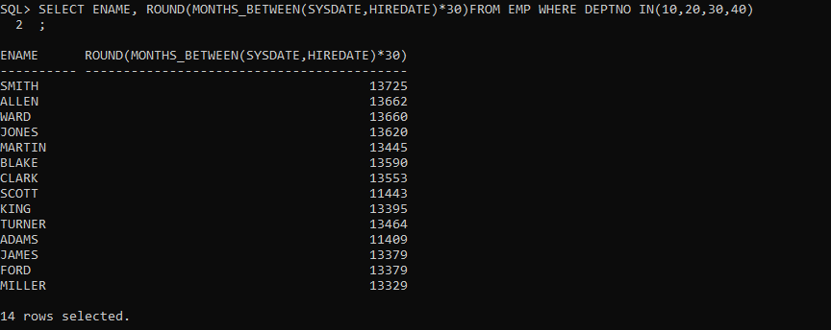

52_For each employee display the number of months passed since the employee joined the company.

CREATE TABLE EMP

(

EMPNO NUMERIC(4) CONSTRAINT EMPNO_EMP_PK PRIMARY KEY,

ENAME VARCHAR(10),

JOB VARCHAR(9),

MGR NUMERIC(4),

HIREDATE DATE,

SAL NUMERIC(7,2),

COMM NUMERIC(7,2),

DEPTNO NUMERIC(2) CONSTRAINT DEPTNO_DEPT_FK REFERENCES DEPT(DEPTNO)

);

INSERT INTO EMP VALUES (7369,'SMITH','CLERK',7902,'17-DEC-80',800,NULL,20);

INSERT INTO EMP VALUES (7499,'ALLEN','SALESMAN',7698,'20-FEB-81',1600,300,30);

INTO EMP VALUES (7566,'JONES','MANAGER',7839,'02-APR-81',2975,NULL,20);

INSERT INTO EMP VALUES (7654,'MARTIN','SALESMAN',7698,'28-SEP-81',1250,1400,30);

INSERT INTO EMP VALUES (7698,'BLAKE','MANAGER',7839,'01-MAY-81',2850,NULL,30);

INSERT INTO EMP VALUES (7782,'CLARK','MANAGER',7839,'09-JUN-81',2450,NULL,10);

INSERT INTO EMP VALUES (7788,'SCOTT','ANALYST',7566,'19-APR-87',3000,NULL,20);

INSERT INTO EMP VALUES (7839,'KING','PRESIDENT',NULL,'17-NOV-81',5000,NULL,10);

INSERT INTO EMP VALUES (7844,'TURNER','SALESMAN',7698,'08-SEP-81',1500,0,30);

INSERT INTO EMP VALUES (7876,'ADAMS','CLERK',7788,'23-MAY-87',1100,NULL,20);

INSERT INTO EMP VALUES (7900,'JAMES','CLERK',7698,'03-DEC-81','950',NULL,30);

INSERT INTO EMP VALUES (7902,'FORD','ANALYST',7566,'03-DEC-81',3000,NULL,20);

INSERT INTO EMP VALUES (7521,'WARD','SALESMAN',7698,'22-FEB-81',1250,500,30);

INSERT INTO EMP VALUES (7934,'MILLER','CLERK',7782,'23-JAN-82',1300,NULL,

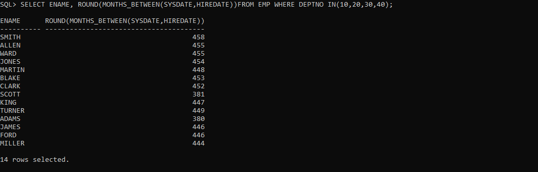

53_Display the tenure of service in the years,months and days for all employess in character format .Assume every month has 30 days.

CREATE TABLE EMP

(

EMPNO NUMERIC(4) CONSTRAINT EMPNO_EMP_PK PRIMARY KEY,

ENAME VARCHAR(10),

JOB VARCHAR(9),

MGR NUMERIC(4),

HIREDATE DATE,

SAL NUMERIC(7,2),

COMM NUMERIC(7,2),

DEPTNO NUMERIC(2) CONSTRAINT DEPTNO_DEPT_FK REFERENCES DEPT(DEPTNO)

);

INSERT INTO EMP VALUES (7369,'SMITH','CLERK',7902,'17-DEC-80',800,NULL,20);

INSERT INTO EMP VALUES (7499,'ALLEN','SALESMAN',7698,'20-FEB-81',1600,300,30);

INTO EMP VALUES (7566,'JONES','MANAGER',7839,'02-APR-81',2975,NULL,20);

INSERT INTO EMP VALUES (7654,'MARTIN','SALESMAN',7698,'28-SEP-81',1250,1400,30);

INSERT INTO EMP VALUES (7698,'BLAKE','MANAGER',7839,'01-MAY-81',2850,NULL,30);

INSERT INTO EMP VALUES (7782,'CLARK','MANAGER',7839,'09-JUN-81',2450,NULL,10);

INSERT INTO EMP VALUES (7788,'SCOTT','ANALYST',7566,'19-APR-87',3000,NULL,20);

INSERT INTO EMP VALUES (7839,'KING','PRESIDENT',NULL,'17-NOV-81',5000,NULL,10);

INSERT INTO EMP VALUES (7844,'TURNER','SALESMAN',7698,'08-SEP-81',1500,0,30);

INSERT INTO EMP VALUES (7876,'ADAMS','CLERK',7788,'23-MAY-87',1100,NULL,20);

INSERT INTO EMP VALUES (7900,'JAMES','CLERK',7698,'03-DEC-81','950',NULL,30);

INSERT INTO EMP VALUES (7902,'FORD','ANALYST',7566,'03-DEC-81',3000,NULL,20);

INSERT INTO EMP VALUES (7521,'WARD','SALESMAN',7698,'22-FEB-81',1250,500,30);

INSERT INTO EMP VALUES (7934,'MILLER','CLERK',7782,'23-JAN-82',1300,NULL,10);

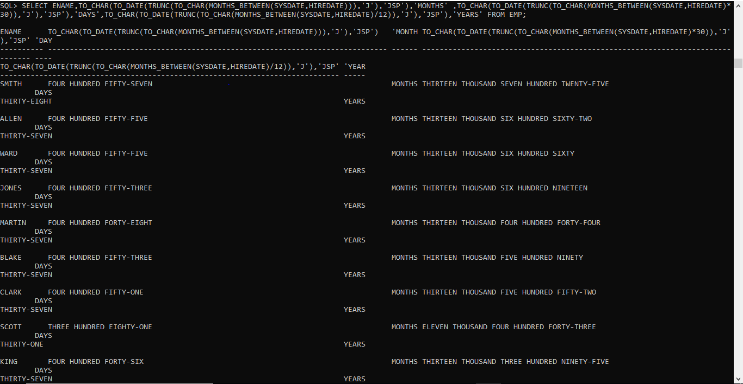

54_Display the employee details in the following manner. ‘Miler joined on the twenty third of January of the year nineteen hundred and eighty two’.

CREATE TABLE EMP

(

EMPNO NUMERIC(4) CONSTRAINT EMPNO_EMP_PK PRIMARY KEY,

ENAME VARCHAR(10),

JOB VARCHAR(9),

MGR NUMERIC(4),

HIREDATE DATE,

SAL NUMERIC(7,2),

COMM NUMERIC(7,2),

DEPTNO NUMERIC(2) CONSTRAINT DEPTNO_DEPT_FK REFERENCES DEPT(DEPTNO)

);

INSERT INTO EMP VALUES (7369,'SMITH','CLERK',7902,'17-DEC-80',800,NULL,20);

INSERT INTO EMP VALUES (7499,'ALLEN','SALESMAN',7698,'20-FEB-81',1600,300,30);

INTO EMP VALUES (7566,'JONES','MANAGER',7839,'02-APR-81',2975,NULL,20);

INSERT INTO EMP VALUES (7654,'MARTIN','SALESMAN',7698,'28-SEP-81',1250,1400,30);

INSERT INTO EMP VALUES (7698,'BLAKE','MANAGER',7839,'01-MAY-81',2850,NULL,30);

INSERT INTO EMP VALUES (7782,'CLARK','MANAGER',7839,'09-JUN-81',2450,NULL,10);

INSERT INTO EMP VALUES (7788,'SCOTT','ANALYST',7566,'19-APR-87',3000,NULL,20);

INSERT INTO EMP VALUES (7839,'KING','PRESIDENT',NULL,'17-NOV-81',5000,NULL,10);

INSERT INTO EMP VALUES (7844,'TURNER','SALESMAN',7698,'08-SEP-81',1500,0,30);

INSERT INTO EMP VALUES (7876,'ADAMS','CLERK',7788,'23-MAY-87',1100,NULL,20);

INSERT INTO EMP VALUES (7900,'JAMES','CLERK',7698,'03-DEC-81','950',NULL,30);

INSERT INTO EMP VALUES (7902,'FORD','ANALYST',7566,'03-DEC-81',3000,NULL,20);

INSERT INTO EMP VALUES (7521,'WARD','SALESMAN',7698,'22-FEB-81',1250,500,30);

INSERT INTO EMP VALUES (7934,'MILLER','CLERK',7782,'23-JAN-82',1300,NULL,10);

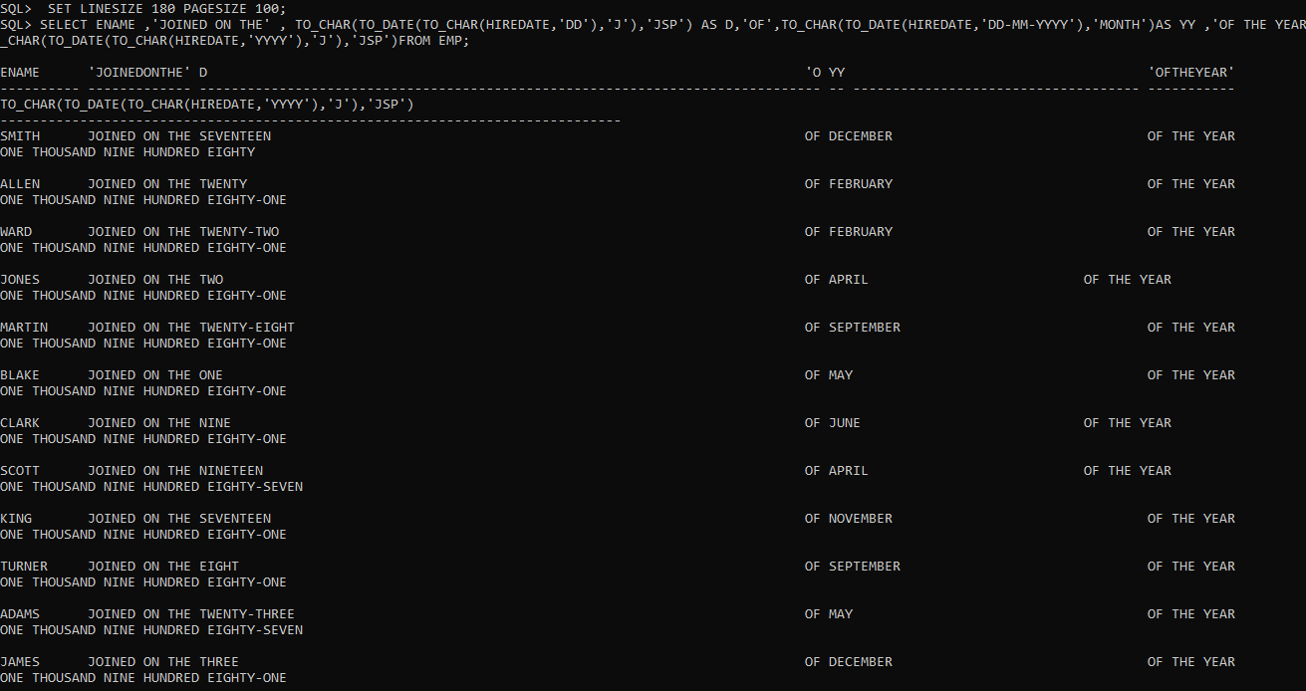

55_ Display the details of all employees ,sorted on the names.

CREATE TABLE EMP

(

EMPNO NUMERIC(4) CONSTRAINT EMPNO_EMP_PK PRIMARY KEY,

ENAME VARCHAR(10),

JOB VARCHAR(9),

MGR NUMERIC(4),

HIREDATE DATE,

SAL NUMERIC(7,2),

COMM NUMERIC(7,2),

DEPTNO NUMERIC(2) CONSTRAINT DEPTNO_DEPT_FK REFERENCES DEPT(DEPTNO)

);

INSERT INTO EMP VALUES (7369,'SMITH','CLERK',7902,'17-DEC-80',800,NULL,20);

INSERT INTO EMP VALUES (7499,'ALLEN','SALESMAN',7698,'20-FEB-81',1600,300,30);

INTO EMP VALUES (7566,'JONES','MANAGER',7839,'02-APR-81',2975,NULL,20);

INSERT INTO EMP VALUES (7654,'MARTIN','SALESMAN',7698,'28-SEP-81',1250,1400,30);

INSERT INTO EMP VALUES (7698,'BLAKE','MANAGER',7839,'01-MAY-81',2850,NULL,30);

INSERT INTO EMP VALUES (7782,'CLARK','MANAGER',7839,'09-JUN-81',2450,NULL,10);

INSERT INTO EMP VALUES (7788,'SCOTT','ANALYST',7566,'19-APR-87',3000,NULL,20);

INSERT INTO EMP VALUES (7839,'KING','PRESIDENT',NULL,'17-NOV-81',5000,NULL,10);

INSERT INTO EMP VALUES (7844,'TURNER','SALESMAN',7698,'08-SEP-81',1500,0,30);

INSERT INTO EMP VALUES (7876,'ADAMS','CLERK',7788,'23-MAY-87',1100,NULL,20);

INSERT INTO EMP VALUES (7900,'JAMES','CLERK',7698,'03-DEC-81','950',NULL,30);

INSERT INTO EMP VALUES (7902,'FORD','ANALYST',7566,'03-DEC-81',3000,NULL,20);

INSERT INTO EMP VALUES (7521,'WARD','SALESMAN',7698,'22-FEB-81',1250,500,30);

INSERT INTO EMP VALUES (7934,'MILLER','CLERK',7782,'23-JAN-82',1300,NULL,10);



56_Display the name of all employees,based on their tenure,with the oldest employee coming first.

CREATE TABLE EMP

(

EMPNO NUMERIC(4) CONSTRAINT EMPNO_EMP_PK PRIMARY KEY,

ENAME VARCHAR(10),

JOB VARCHAR(9),

MGR NUMERIC(4),

HIREDATE DATE,

SAL NUMERIC(7,2),

COMM NUMERIC(7,2),

DEPTNO NUMERIC(2) CONSTRAINT DEPTNO_DEPT_FK REFERENCES DEPT(DEPTNO)

);

INSERT INTO EMP VALUES (7369,'SMITH','CLERK',7902,'17-DEC-80',800,NULL,20);

INSERT INTO EMP VALUES (7499,'ALLEN','SALESMAN',7698,'20-FEB-81',1600,300,30);

INTO EMP VALUES (7566,'JONES','MANAGER',7839,'02-APR-81',2975,NULL,20);

INSERT INTO EMP VALUES (7654,'MARTIN','SALESMAN',7698,'28-SEP-81',1250,1400,30);

INSERT INTO EMP VALUES (7698,'BLAKE','MANAGER',7839,'01-MAY-81',2850,NULL,30);

INSERT INTO EMP VALUES (7782,'CLARK','MANAGER',7839,'09-JUN-81',2450,NULL,10);

INSERT INTO EMP VALUES (7788,'SCOTT','ANALYST',7566,'19-APR-87',3000,NULL,20);

INSERT INTO EMP VALUES (7839,'KING','PRESIDENT',NULL,'17-NOV-81',5000,NULL,10);

INSERT INTO EMP VALUES (7844,'TURNER','SALESMAN',7698,'08-SEP-81',1500,0,30);

INSERT INTO EMP VALUES (7876,'ADAMS','CLERK',7788,'23-MAY-87',1100,NULL,20);

INSERT INTO EMP VALUES (7900,'JAMES','CLERK',7698,'03-DEC-81','950',NULL,30);

INSERT INTO EMP VALUES (7902,'FORD','ANALYST',7566,'03-DEC-81',3000,NULL,20);

INSERT INTO EMP VALUES (7521,'WARD','SALESMAN',7698,'22-FEB-81',1250,500,30);

INSERT INTO EMP VALUES (7934,'MILLER','CLERK',7782,'23-JAN-82',1300,NULL,10);



57_Display the names ,job and salary of all employees sorted on jobs and salary.

CREATE TABLE EMP

(

EMPNO NUMERIC(4) CONSTRAINT EMPNO_EMP_PK PRIMARY KEY,

ENAME VARCHAR(10),

JOB VARCHAR(9),

MGR NUMERIC(4),

HIREDATE DATE,

SAL NUMERIC(7,2),

COMM NUMERIC(7,2),

DEPTNO NUMERIC(2) CONSTRAINT DEPTNO_DEPT_FK REFERENCES DEPT(DEPTNO)

);

INSERT INTO EMP VALUES (7369,'SMITH','CLERK',7902,'17-DEC-80',800,NULL,20);

INSERT INTO EMP VALUES (7499,'ALLEN','SALESMAN',7698,'20-FEB-81',1600,300,30);

INTO EMP VALUES (7566,'JONES','MANAGER',7839,'02-APR-81',2975,NULL,20);

INSERT INTO EMP VALUES (7654,'MARTIN','SALESMAN',7698,'28-SEP-81',1250,1400,30);

INSERT INTO EMP VALUES (7698,'BLAKE','MANAGER',7839,'01-MAY-81',2850,NULL,30);

INSERT INTO EMP VALUES (7782,'CLARK','MANAGER',7839,'09-JUN-81',2450,NULL,10);

INSERT INTO EMP VALUES (7788,'SCOTT','ANALYST',7566,'19-APR-87',3000,NULL,20);

INSERT INTO EMP VALUES (7839,'KING','PRESIDENT',NULL,'17-NOV-81',5000,NULL,10);

INSERT INTO EMP VALUES (7844,'TURNER','SALESMAN',7698,'08-SEP-81',1500,0,30);

INSERT INTO EMP VALUES (7876,'ADAMS','CLERK',7788,'23-MAY-87',1100,NULL,20);

INSERT INTO EMP VALUES (7900,'JAMES','CLERK',7698,'03-DEC-81','950',NULL,30);

INSERT INTO EMP VALUES (7902,'FORD','ANALYST',7566,'03-DEC-81',3000,NULL,20);

INSERT INTO EMP VALUES (7521,'WARD','SALESMAN',7698,'22-FEB-81',1250,500,30);

INSERT INTO EMP VALUES (7934,'MILLER','CLERK',7782,'23-JAN-82',1300,NULL,10);

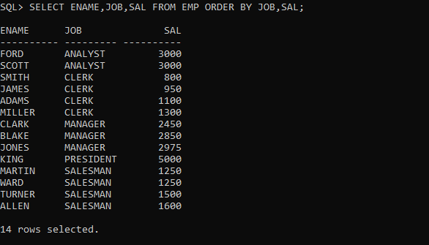

58_Display the names,job and salary of all employees ,sorted on jobs and within job,sorted on the descending order of salary.

CREATE TABLE EMP

(

EMPNO NUMERIC(4) CONSTRAINT EMPNO_EMP_PK PRIMARY KEY,

ENAME VARCHAR(10),

JOB VARCHAR(9),

MGR NUMERIC(4),

HIREDATE DATE,

SAL NUMERIC(7,2),

COMM NUMERIC(7,2),

DEPTNO NUMERIC(2) CONSTRAINT DEPTNO_DEPT_FK REFERENCES DEPT(DEPTNO)

);

INSERT INTO EMP VALUES (7369,'SMITH','CLERK',7902,'17-DEC-80',800,NULL,20);

INSERT INTO EMP VALUES (7499,'ALLEN','SALESMAN',7698,'20-FEB-81',1600,300,30);

INTO EMP VALUES (7566,'JONES','MANAGER',7839,'02-APR-81',2975,NULL,20);

INSERT INTO EMP VALUES (7654,'MARTIN','SALESMAN',7698,'28-SEP-81',1250,1400,30);

INSERT INTO EMP VALUES (7698,'BLAKE','MANAGER',7839,'01-MAY-81',2850,NULL,30);

INSERT INTO EMP VALUES (7782,'CLARK','MANAGER',7839,'09-JUN-81',2450,NULL,10);

INSERT INTO EMP VALUES (7788,'SCOTT','ANALYST',7566,'19-APR-87',3000,NULL,20);

INSERT INTO EMP VALUES (7839,'KING','PRESIDENT',NULL,'17-NOV-81',5000,NULL,10);

INSERT INTO EMP VALUES (7844,'TURNER','SALESMAN',7698,'08-SEP-81',1500,0,30);

INSERT INTO EMP VALUES (7876,'ADAMS','CLERK',7788,'23-MAY-87',1100,NULL,20);

INSERT INTO EMP VALUES (7900,'JAMES','CLERK',7698,'03-DEC-81','950',NULL,30);

INSERT INTO EMP VALUES (7902,'FORD','ANALYST',7566,'03-DEC-81',3000,NULL,20);

INSERT INTO EMP VALUES (7521,'WARD','SALESMAN',7698,'22-FEB-81',1250,500,30);

INSERT INTO EMP VALUES (7934,'MILLER','CLERK',7782,'23-JAN-82',1300,NULL,10);

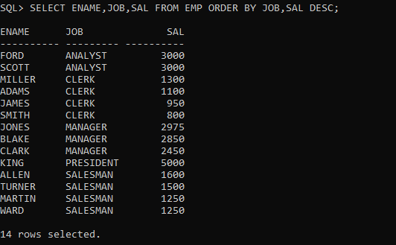

59_Display the names ,job and salary of all employees,sorted on descending order of job and within job ,sorted on the descending order of salary.

CREATE TABLE EMP

(

EMPNO NUMERIC(4) CONSTRAINT EMPNO_EMP_PK PRIMARY KEY,

ENAME VARCHAR(10),

JOB VARCHAR(9),

MGR NUMERIC(4),

HIREDATE DATE,

SAL NUMERIC(7,2),

COMM NUMERIC(7,2),

DEPTNO NUMERIC(2) CONSTRAINT DEPTNO_DEPT_FK REFERENCES DEPT(DEPTNO)

);

INSERT INTO EMP VALUES (7369,'SMITH','CLERK',7902,'17-DEC-80',800,NULL,20);

INSERT INTO EMP VALUES (7499,'ALLEN','SALESMAN',7698,'20-FEB-81',1600,300,30);

INTO EMP VALUES (7566,'JONES','MANAGER',7839,'02-APR-81',2975,NULL,20);

INSERT INTO EMP VALUES (7654,'MARTIN','SALESMAN',7698,'28-SEP-81',1250,1400,30);

INSERT INTO EMP VALUES (7698,'BLAKE','MANAGER',7839,'01-MAY-81',2850,NULL,30);

INSERT INTO EMP VALUES (7782,'CLARK','MANAGER',7839,'09-JUN-81',2450,NULL,10);

INSERT INTO EMP VALUES (7788,'SCOTT','ANALYST',7566,'19-APR-87',3000,NULL,20);

INSERT INTO EMP VALUES (7839,'KING','PRESIDENT',NULL,'17-NOV-81',5000,NULL,10);

INSERT INTO EMP VALUES (7844,'TURNER','SALESMAN',7698,'08-SEP-81',1500,0,30);

INSERT INTO EMP VALUES (7876,'ADAMS','CLERK',7788,'23-MAY-87',1100,NULL,20);

INSERT INTO EMP VALUES (7900,'JAMES','CLERK',7698,'03-DEC-81','950',NULL,30);

INSERT INTO EMP VALUES (7902,'FORD','ANALYST',7566,'03-DEC-81',3000,NULL,20);

INSERT INTO EMP VALUES (7521,'WARD','SALESMAN',7698,'22-FEB-81',1250,500,30);

INSERT INTO EMP VALUES (7934,'MILLER','CLERK',7782,'23-JAN-82',1300,NULL,10);

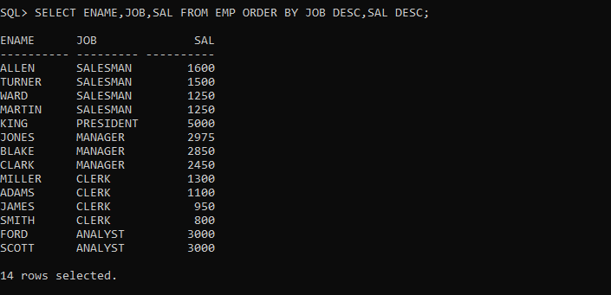

60_Display the name ,month and year of all employees ,sorted on the month of their hire date irrespective of the year.

CREATE TABLE EMP

(

EMPNO NUMERIC(4) CONSTRAINT EMPNO_EMP_PK PRIMARY KEY,

ENAME VARCHAR(10),

JOB VARCHAR(9),

MGR NUMERIC(4),

HIREDATE DATE,

SAL NUMERIC(7,2),

COMM NUMERIC(7,2),

DEPTNO NUMERIC(2) CONSTRAINT DEPTNO_DEPT_FK REFERENCES DEPT(DEPTNO)

);

INSERT INTO EMP VALUES (7369,'SMITH','CLERK',7902,'17-DEC-80',800,NULL,20);

INSERT INTO EMP VALUES (7499,'ALLEN','SALESMAN',7698,'20-FEB-81',1600,300,30);

INTO EMP VALUES (7566,'JONES','MANAGER',7839,'02-APR-81',2975,NULL,20);

INSERT INTO EMP VALUES (7654,'MARTIN','SALESMAN',7698,'28-SEP-81',1250,1400,30);

INSERT INTO EMP VALUES (7698,'BLAKE','MANAGER',7839,'01-MAY-81',2850,NULL,30);

INSERT INTO EMP VALUES (7782,'CLARK','MANAGER',7839,'09-JUN-81',2450,NULL,10);

INSERT INTO EMP VALUES (7788,'SCOTT','ANALYST',7566,'19-APR-87',3000,NULL,20);

INSERT INTO EMP VALUES (7839,'KING','PRESIDENT',NULL,'17-NOV-81',5000,NULL,10);

INSERT INTO EMP VALUES (7844,'TURNER','SALESMAN',7698,'08-SEP-81',1500,0,30);

INSERT INTO EMP VALUES (7876,'ADAMS','CLERK',7788,'23-MAY-87',1100,NULL,20);

INSERT INTO EMP VALUES (7900,'JAMES','CLERK',7698,'03-DEC-81','950',NULL,30);

INSERT INTO EMP VALUES (7902,'FORD','ANALYST',7566,'03-DEC-81',3000,NULL,20);

INSERT INTO EMP VALUES (7521,'WARD','SALESMAN',7698,'22-FEB-81',1250,500,30);

INSERT INTO EMP VALUES (7934,'MILLER','CLERK',7782,'23-JAN-82',1300,NULL,10);

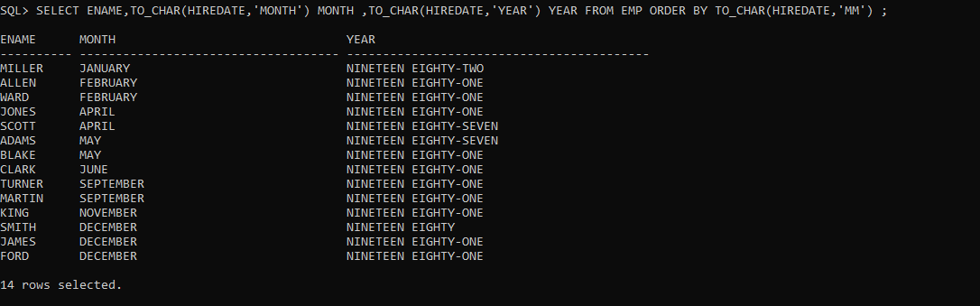

61_Display the name ,month and year of joining of all employees ,sorted on the month of their hire date, and within that on the year ,with the earliest year appearing first.

CREATE TABLE EMP

(

EMPNO NUMERIC(4) CONSTRAINT EMPNO_EMP_PK PRIMARY KEY,

ENAME VARCHAR(10),

JOB VARCHAR(9),

MGR NUMERIC(4),

HIREDATE DATE,

SAL NUMERIC(7,2),

COMM NUMERIC(7,2),

DEPTNO NUMERIC(2) CONSTRAINT DEPTNO_DEPT_FK REFERENCES DEPT(DEPTNO)

);

INSERT INTO EMP VALUES (7369,'SMITH','CLERK',7902,'17-DEC-80',800,NULL,20);

INSERT INTO EMP VALUES (7499,'ALLEN','SALESMAN',7698,'20-FEB-81',1600,300,30);

INTO EMP VALUES (7566,'JONES','MANAGER',7839,'02-APR-81',2975,NULL,20);

INSERT INTO EMP VALUES (7654,'MARTIN','SALESMAN',7698,'28-SEP-81',1250,1400,30);

INSERT INTO EMP VALUES (7698,'BLAKE','MANAGER',7839,'01-MAY-81',2850,NULL,30);

INSERT INTO EMP VALUES (7782,'CLARK','MANAGER',7839,'09-JUN-81',2450,NULL,10);

INSERT INTO EMP VALUES (7788,'SCOTT','ANALYST',7566,'19-APR-87',3000,NULL,20);

INSERT INTO EMP VALUES (7839,'KING','PRESIDENT',NULL,'17-NOV-81',5000,NULL,10);

INSERT INTO EMP VALUES (7844,'TURNER','SALESMAN',7698,'08-SEP-81',1500,0,30);

INSERT INTO EMP VALUES (7876,'ADAMS','CLERK',7788,'23-MAY-87',1100,NULL,20);

INSERT INTO EMP VALUES (7900,'JAMES','CLERK',7698,'03-DEC-81','950',NULL,30);

INSERT INTO EMP VALUES (7902,'FORD','ANALYST',7566,'03-DEC-81',3000,NULL,20);

INSERT INTO EMP VALUES (7521,'WARD','SALESMAN',7698,'22-FEB-81',1250,500,30);

INSERT INTO EMP VALUES (7934,'MILLER','CLERK',7782,'23-JAN-82',1300,NULL,10);

