(day-13 Assignment)

1. Create an arraylist of user-defined data type Book. it should have:- i)Name of the Book
2. Author of the book
3. year of publication of the book iV)number of copies sold.

sort the array list based on the year of publication.

//code

import java.util.ArrayList;

import java.util.Collections; import java.util.Comparator;

class Pbook{

private String name,author; private Integer cpy,year;

public Pbook(String name,String author,Integer cpy, Integer year) { this.name=name;

this.author=author; this.cpy=cpy; this.year=year;

}

public Integer getYear() { return year;

}

@Override

public String toString() {

return " date="+year+", name="+name+", author="+author+", cpy="+cpy+"\n";

}

}

public class Question1 {

public static void main(String[] args) { ArrayList<Pbook> bk=new ArrayList<Pbook>();

bk.add(new Pbook("wings of fire","APJ ABDUL kALAM",400,2000)); bk.add(new Pbook("an i deniel","ashlin",120,1997)); bk.add(new Pbook("Tw States","Chethan Bhagat",500,2003)); bk.add(new Pbook("The Alchemist","Paulo Coelho",1500,1988));

System.*out*.println(" beforesorting:\n"+bk); bk.sort((source,target) -> {return (source.getYear() -

target.getYear());});

bk.sort(Comparator.*comparingInt*(Pbook::getYear)); System.*out*.println(bk);

}

}

//output

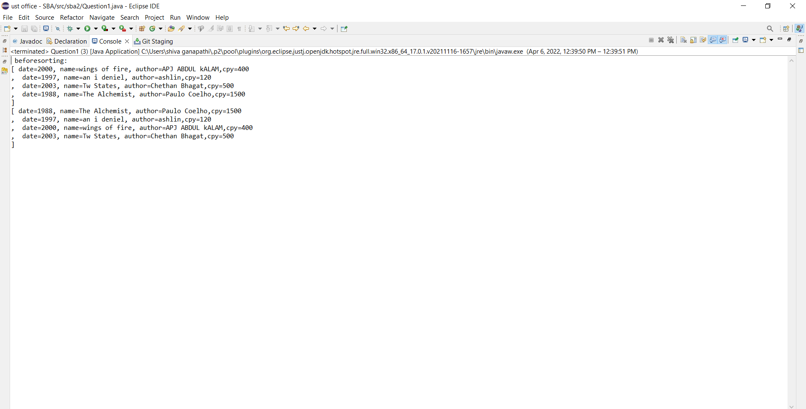

(day-14 assignment)

1. Write a program to create, write and read from a file.

//code

import java.io.File; import java.io.IOException; import java.io.PrintWriter; import java.io.FileReader; import java.io.*;

public class Question2 {

public static void main(String[] args) { try

{

File file=new File("SBA2_2.txt");

if(!file.exists())

{

file.createNewFile();

}

//content for file

PrintWriter pw= new PrintWriter(file); pw.println("'this is the content'"); pw.println("file exists"); pw.close();

System.*out*.println("file created and adding content = Done");

System.*out*.println(); System.*out*.println("****Reading from the file****");

try{

FileReader fr = new FileReader("SBA2_2.txt"

);

int i;

while ((i = fr.read()) != -1)

System.*out*.print((char)i);

}

catch (IOException e) {

e.printStackTrace();

}

}

catch (IOException e) {

e.printStackTrace();

}

}

}

//output

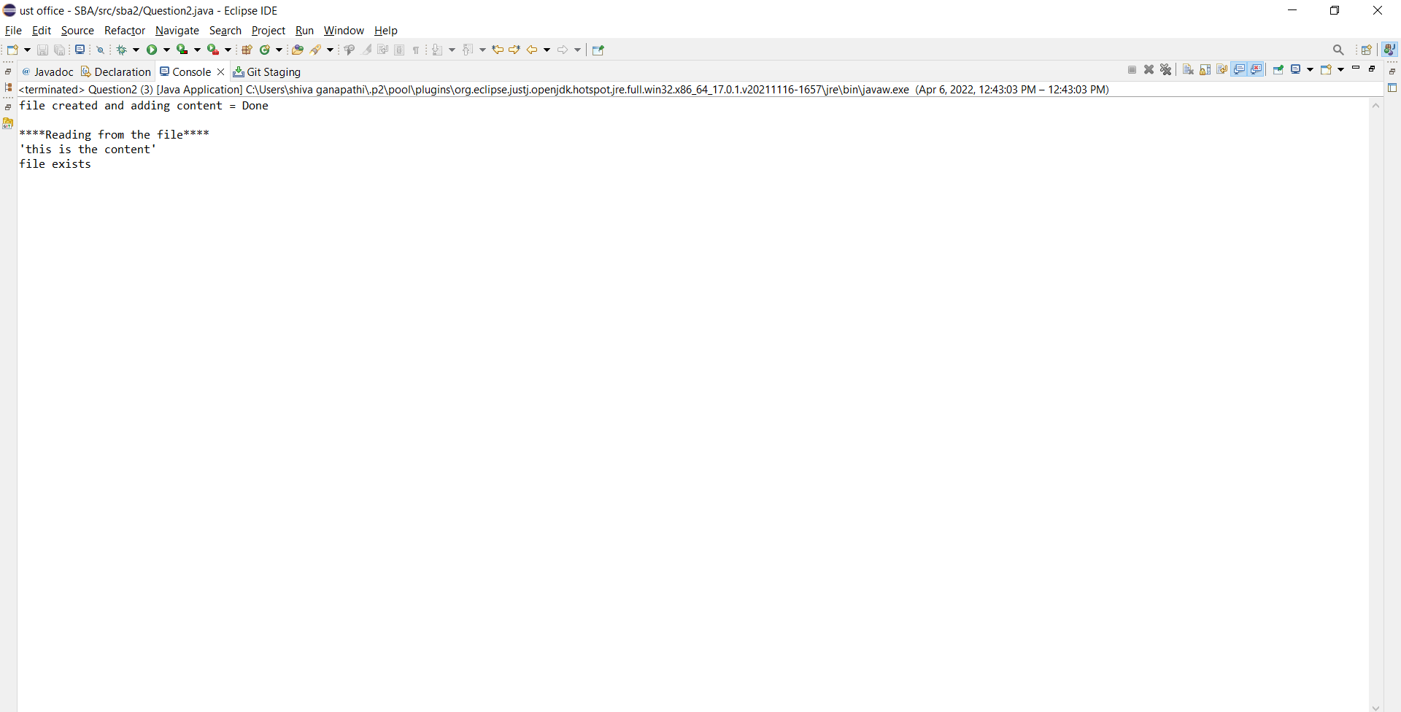

1. Write a program to get the information about the file.

//code

import java.io.*; public class Question3 {

public static void main(String[] args) {

File f=new File("SBA2_2.txt"); if(f.exists())

{

System.*out*.println("File Name :"+f.getName()); System.*out*.println("File Path :"+f.getAbsolutePath()); System.*out*.println("File Free Space :"+f.getFreeSpace()); System.*out*.println("File Writable :"+f.canRead()); System.*out*.println("File Readable :"+f.canWrite()); System.*out*.println("File useSpace :"+f.getUsableSpace());

System.*out*.println("File TotalSpace :"+f.getTotalSpace());

}

else

{

System.*out*.println("file doesn exists");

}

}

}

//output

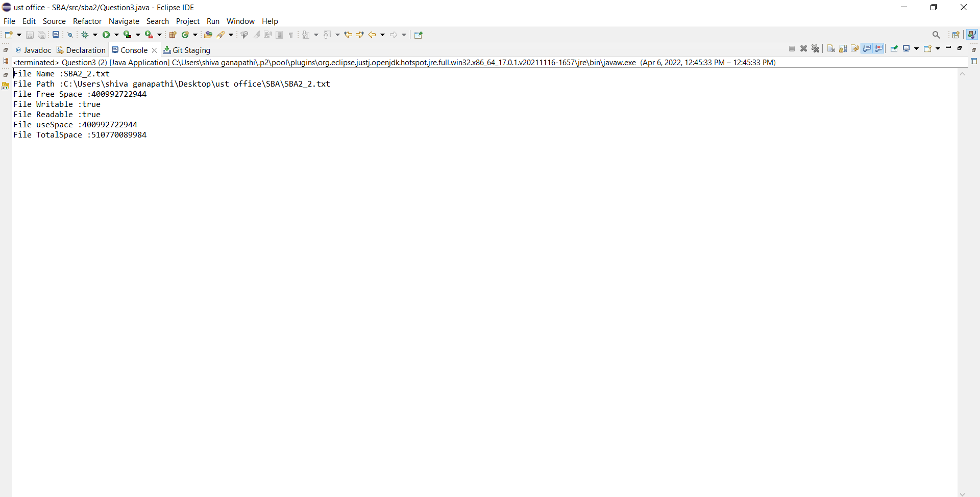

1. Write a program Implement the filereader until the file ending character is “-1” and print all the data of the file.

//code

import java.io.*;

import java.io.FileReader; public class Question4{

public static void main(String[] args) throws IOException

{

try {

FileReader file=new FileReader("SBA2_2.txt"); int data=file.read();

while(data!=-1) { System.*out*.print((char)data); data=file.read();

}

file.close();

}

catch (FileNotFoundException e)

{

e.printStackTrace();

}

}

}

//output

