package SBA3;

/*  
* Implement an ArrayDequeue and all of its methods such as add(), addFirst(), addLast(), element(), poll(), push(), remove.  
*/  
import java.util.*;

public class Question1 {  
// Java program to Implement ArrayDeque in Java  
public static void main(String[] args) {  
// Creating and initializing deque  
// Declaring object of integer type  
Deque<Integer> de_que = new ArrayDeque<Integer>(10);  
// Operations 1  
// add() method  
// Adding custom elements  
// using add() method to insert  
de_que.add(10);// 10,20,30,40,50  
de_que.add(20);  
de_que.add(30);  
de_que.add(40);  
de_que.add(50);  
System.out.println("After add method " + de_que);  
// Operations 2  
// addFirst() method  
// Inserting at the start  
de_que.addFirst(564);  
System.out.println("After addFirst method"+de_que);  
de_que.addFirst(291);  
System.out.println("After add first method()" + de_que);  
// Operation 3  
// addLast() method  
// Inserting at end  
de_que.addLast(24);  
System.out.println("After addLast method()" + de_que);  
de_que.addLast(14);  
System.out.println("After addLast method()" + de_que);  
// Operation 4  
// element() method : to get Head element  
System.out.println("Element using element(): " + de_que.element());  
// Operation 5  
// poll() method : to get head  
System.out.println("Head element poll : " + de_que.poll());  
// Operation 6  
// push() method  
de_que.push(265);  
System.out.println("After first push"+de_que);  
de_que.push(984);  
System.out.println("After second push"+de_que);  
de_que.push(2365);  
System.out.println("After third push"+de_que);  
// Operation 7  
// remove() method : to get head  
System.out.println("Head element remove : " + de_que.remove());  
System.out.println("The final array is: " + de_que);  
}  
}

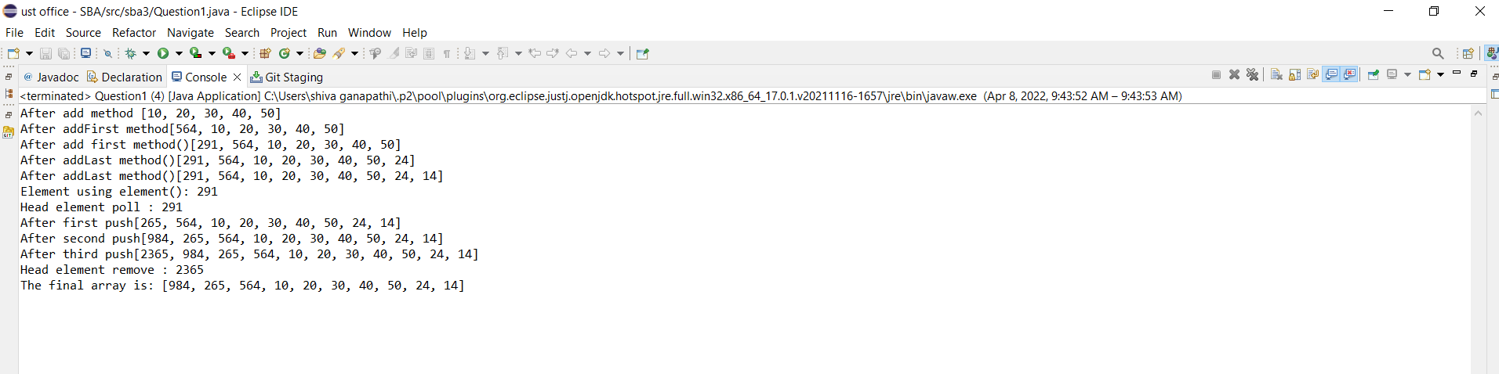

**package** sba3;

**import** java.util.*;

**public** **class** Question2 {

**public** **static** **void** main(String[] args) {

PriorityQueue<String> pq = **new** PriorityQueue<>();

pq.add("ajay");

pq.add("vijay");

pq.add("raj");

pq.add("gagan");

System.***out***.println("head:" + pq.element()); // returns 1st element

System.***out***.println("head:" + pq.peek()); // returns 1st element

System.***out***.println("iterating queue elements");

Iterator itr = pq.iterator();

**while** (itr.hasNext()) {

System.***out***.println(itr.next());

}

pq.remove(); // deletes head element

pq.poll(); // removes head

System.***out***.println("after removing 2 elements");

Iterator itr2 = pq.iterator();

**while** (itr2.hasNext()) {

System.***out***.println(itr2.next());

}

}

}

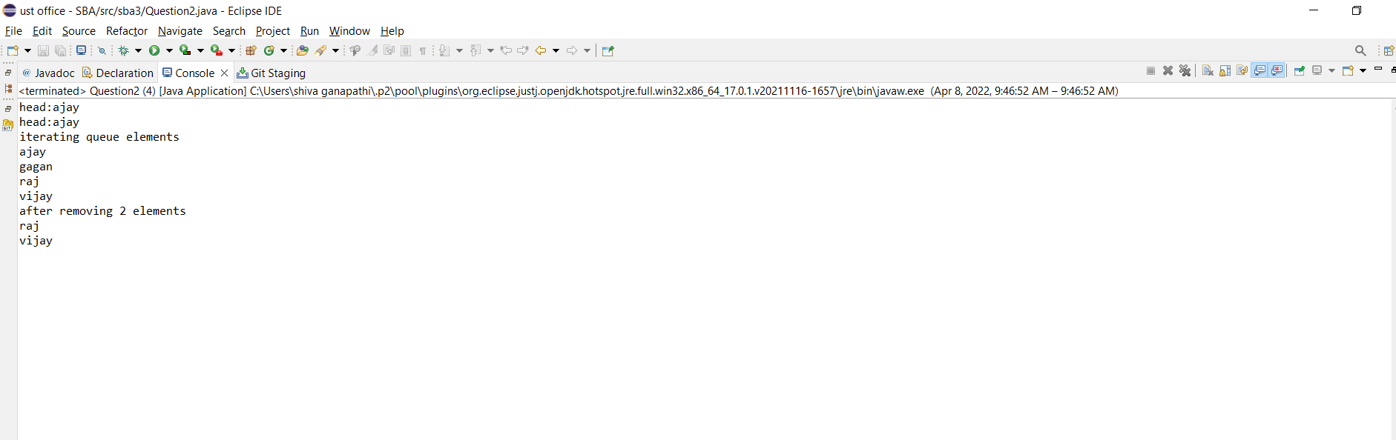

**package** sba3;

**import** java.util.Stack;

**public** **class** Question3 {

**public** **static** **void** main(String[] args) {

Stack<String> animal = **new** Stack<String>();

animal.push("dog");

animal.push("cat");

animal.push("tiger");

animal.push("lion");

animal.push("bear");

animal.push("panda");

System.***out***.println("stack:" + animal);

animal.pop();

animal.pop();

System.***out***.println("stack:" + animal);

String top = animal.peek();

System.***out***.println("topmost element of stack:" + top);

**boolean** result = animal.empty();

System.***out***.println("is stack empty:" + result);

System.***out***.println("stack size:" + animal.size());

**int** location = animal.search("tiger");

System.***out***.println("tiger is present at position:" + location);

}

}

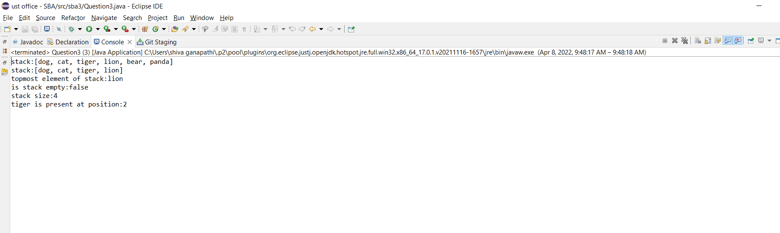

**package** sba3;

**public** **class** Question4 {

**void** sort(**int** arr[]) {

**int** n = arr.length;

**for** (**int** i = 0; i < n; ++i) {

**int** temp = arr[i];

**int** j = i - 1;

/*

* Move elements of arr[0..i-1], that are greater than key, to one position

* ahead of their current position

*/

**while** (j >= 0 && arr[j] > temp) {

arr[j + 1] = arr[j];

j = j - 1;

}

arr[j + 1] = temp;

}

}

/* A utility function to print array of size n */

**static** **void** printArray(**int** arr[]) {

**int** n = arr.length;

**for** (**int** i = 0; i < n; ++i)

System.***out***.print(arr[i] + " ");

System.***out***.println();

}

// Driver method

**public** **static** **void** main(String args[]) {

**int** arr[] = { 12, 11, 13, 5, 6 };

Question4 ob = **new** Question4();

ob.sort(arr);

System.***out***.println("Sorted array is");

*printArray*(arr);

}

}

