# Create Database project_movie_data and deploy table data according to ER diagram.

create database project_movie_data; use project_movie_data;

show tables;

# Create 9 tables which are presented in ER model and load the data with their foreign key and primary key values.

create table actor( act_id int primary key, act_fname char(20), act_lname char(20), act_gender char(1));

insert into actor(act_id,act_fname,act_lname,act_gender) values(101,'James','Stewart','M'),(102,'Deborah','Kerr','F'),

(103,'Peter','OToole','M'),(104,'Robert','De

Niro','M'),(105,'F.Murray','Abraham','M'),

(106,'Harrison','Ford','M'),(107,'Nicole','Kidman','F'),(108,'Stephen','Baldwin ','M'),

(109,'Jack','Nicholson','M'),(110,'Mark','Wahlberg','M'),(111,'Woody','Allen',' M'),

(112,'Claire','Danes','F'),(113,'Tim','Robbins','M'),(114,'Kevin','Spacey','M')

,

(115,'Kate','Winslet','F'),(116,'Robin','Williams','M'),(117,'Jon','Voight','M'

),

(118,'Ewan','McGregor','M'),(119,'Christian','Bale','M'),(120,'Maggie','Gyllenh aal','F'),

(121,'Dev','Patel','M'),(122,'Sigourney','Weaver','F'),(123,'David','Aston','M'

), (124,'Ali','Astin','F');

select*from actor;

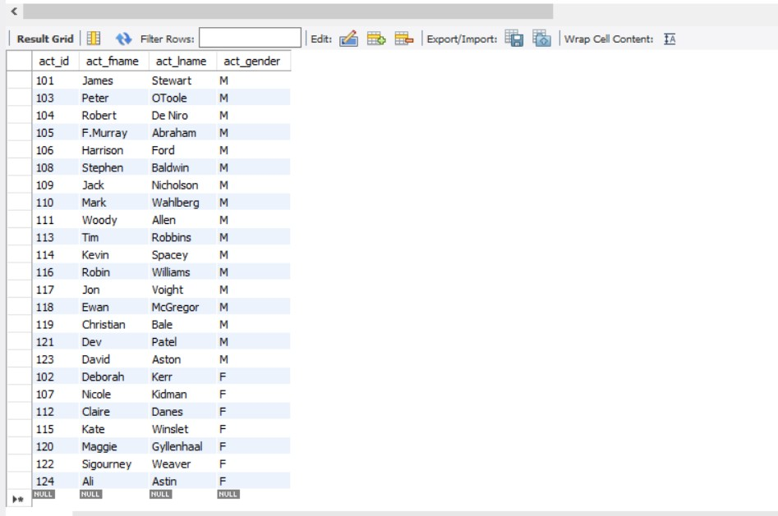

******************************************************************************* create table director(

dir_id int primary key, dir_fname char(20), dir_lname char(20));

insert into director(dir_id,dir_fname,dir_lname)

values(201,'Alfred','Hitchcock'),(202,'Jack','Clayton'),(203,'David','Lean'),(2 04,'Michael','Cimino'),

(205,'Milos','Forman'),(206,'Ridley','Scott'),(207,'Stanley','Kubrick'),

(208,'Bryan','Singer'),(209,'Roman','Polanski'),(210,'Paul','Thomas Anderson'),

(211,'Woody','Allen'),(212,'Hayo','Miyazaki'),(213,'Frank','Darabont'),

(214,'Sam','Mendes'),(215,'James','Cameron'),(216,'Gus','Van Sant'),

(217,'John','Boorman'),(218,'Danny','Boyle'),(219,'Christopher','Nolan'),

(220,'Richard','Kelly'),(221,'Kevin','Spacey'),(222,'Andrei','Tarkovsky'), (223,'Peter','Jackson');

select*from director;

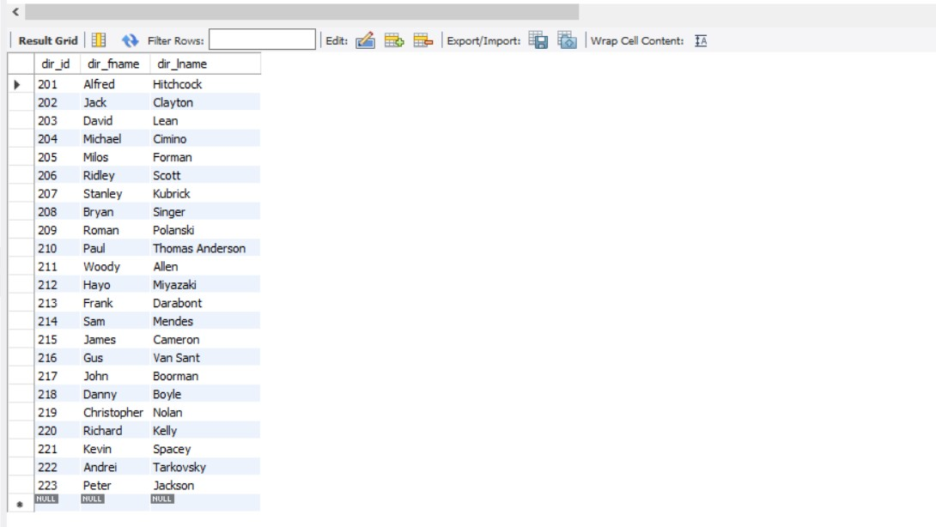

******************************************************************************* create table movie(

mov_id int primary key, mov_title char(50), mov_year int,

mov_time int, mov_lang char(50), mov_dt_rel date,

mov_rel_country char(5));

insert into movie(mov_id,mov_title,mov_year,mov_time,mov_lang,mov_dt_rel,mov_rel_country)

values(901,'Vertigo',1958,128,'English','1958-08-24','UK'),

(902,'The Innocents',1961,100,'English','1962-02-19','SW'),

(903,'Lawrence of Arabia',1962,216,'English','1962-12-11','UK'),

(904,'The Deer Hunter',1978,183,'English','1979-03-08','UK'),

(905,'Amadeus',1984,160,'English','1985-01-07','UK'),

(906,'Blade Runner',1982,117,'English','1982-09-09','UK'),

(907,'Eyes Wide Shut',1999,159,'English',null,'UK'),

(908,'The Usual Suspects',1995,106,'English','1995-08-25','UK'),

(909,'Chinatown',1974,130,'English','1974-08-09','UK'),

(910,'Boogie Nights',1997,155,'English','1998-02-16','UK'),

(911,'Annie Hall',1977,93,'English','1977-04-20','USA'),

(912,'Princess Mononoke',1997,134,'Japanese','2001-10-19','UK'), (913,'The Shawshank Redemption',1994,142,'English','1995-02-17','UK'), (914,'American Beauty',1999,122,'English',null,'UK'), (915,'Titanic',1997,194,'English','1998-01-23','UK'),

(916,'Good Will Hunting',1997,126,'English','1998-06-03','UK'),

(917,'Deliverance',1972,109,'English','1982-10-05','UK'),

(918,'Trainspotting',1996,94,'English','1996-02-23','UK'),

(919,'The Prestige',2006,130,'English','2006-11-10','UK'),

(920,'Donnie Darko',2001,113,'English',null,'UK'),

(921,'Slumdog Millionaire',2008,120,'English','2009-01-09','UK'), (922,'Aliens',1986,137,'English','1986-08-29','UK'),

(923,'Beyond the Sea',2004,118,'English','2004-11-26','UK'),

(924,'Avatar',2009,162,'English','2009-12-17','UK'),

(926,'Seven Samurai',1954,207,'Japanese','1954-04-26','JP'),

(927,'Spirited Away',2001,125,'Japanese','2003-09-12','UK'),

(928,'Back to Future',1985,116,'English','1985-12-04','UK'),

(925,'Braveheart',1995,178,'English','1995-09-08','UK');

select*from movie;

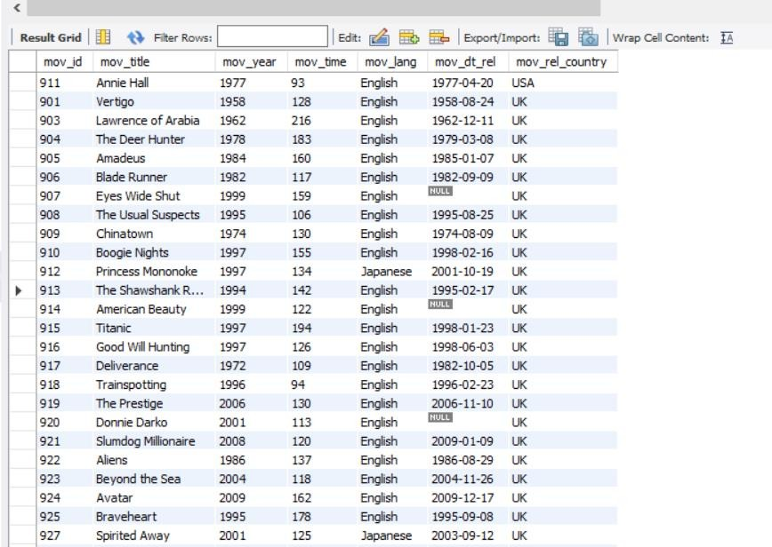

******************************************************************************* create table movie_cast(

act_id int , mov_id int, role char(30),

foreign key(act_id) references actor(act_id), foreign key(mov_id) references movie(mov_id));

insert into movie_cast values(101,901,'John Scottie Ferguson'), (102,902,'Miss Giddens'),

(103,903,'T E Lawrence'),(104,904,'Michael'),(105,905,'Antonio Salieri'), (106,906,'Rick Deckard'),(107,907,'Alice Harford'), (108,908,'McManus'),(110,910,'Eddie Adams'),(111,911,'Alvy Singer'),

(112,912,'San'),(113,913,'Andy Dufresne'),(114,914,'Lester Burnham'), (115,915,'Rose Dewitt Bukater'),(116,916,'Sean Maguire'), (117,917,'Ed'),(118,918,'Renton'),(120,920,'Elizabeth Darko'),

(121,921,'Older Jamal'),(122,922,'Ripley'),(114,923,'Bobby Darin'),

(109,909,'J.J Gittes'),(119,919,'Alfred Borden');

select*from movie_cast;

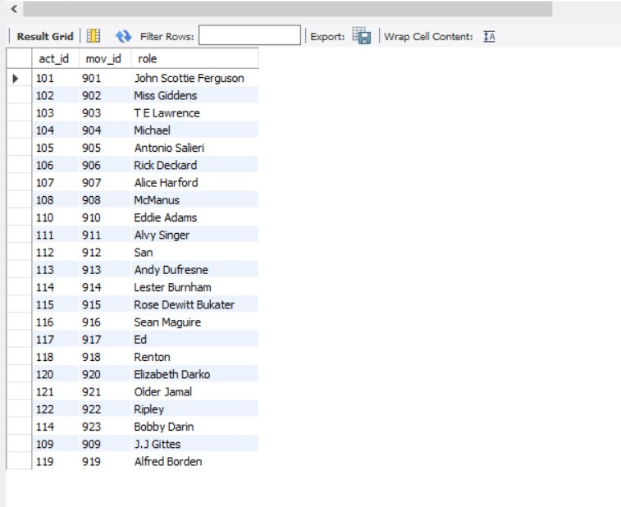

******************************************************************************* create table reviewer(

rev_id int primary key, rev_name char(30));

insert into reviewer(rev_id,rev_name) values(9001,'Righty Sock'),

(9002,'Jack Malvern'),(9003,'Flagrant Baronessa'),(9004,'Alec Shaw'), (9005,null),(9006,'Victor Woeltjen'),(9007,'Simon Wright'),(9008,'Neal Wruck'), (9009,'Paul Monks'),(9010,'Mike Salvati'),(9011,null),(9012,'Wesley S.Walker'), (9013,'Sasha Goldshtein'),(9014,'Josh Cates'),(9015,'Krug Stillo'), (9016,'Scott LeBrun'),(9017,'Hannah Steele'),(9018,'Vincent Cadena'), (9019,'Brandt Sponseller'),(9020,'Richard Adams');

select*from reviewer;

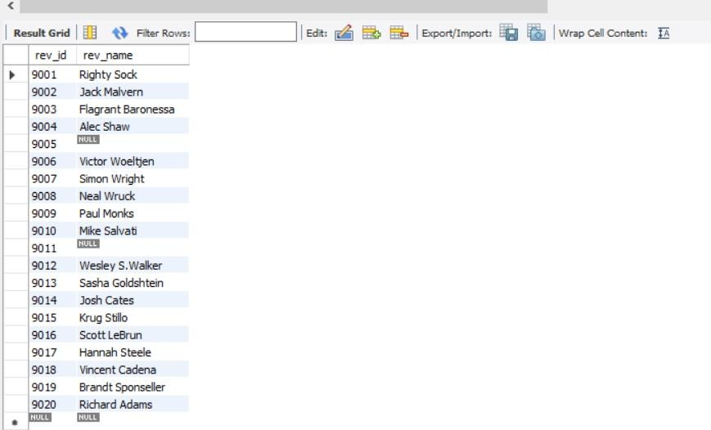

******************************************************************************* create table genres(

gen_id int primary key, gen_title char(20));

insert into genres(gen_id,gen_title) values(1001,'Action'),

(1002,'Adventure'),(1003,'Animation'),(1004,'Biography'),(1005,'Comedy'),

(1006,'Crime'),(1007,'Drama'),(1008,'Horro'),(1009,'Music'),

(1010,'Mystery'),(1011,'Romance'),(1012,'Thriller'),(1013,'War');

select*from genres;

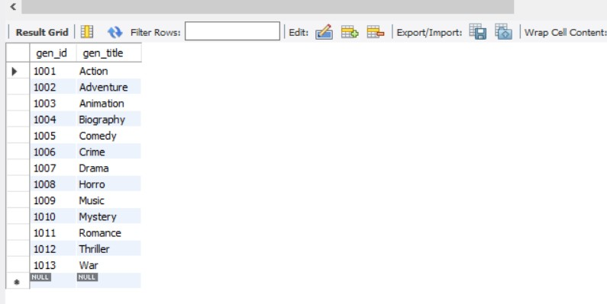

******************************************************************************* create table movie_direction(

dir_id int, mov_id int,

foreign key (dir_id)references director(dir_id), foreign key(mov_id) references movie(mov_id));

insert into movie_direction values(201,901),(202,902),(203,903),

(204,904),(205,905),(206,906),(207,907),

(208,908),(209,909),(210,910),(211,911),

(212,912),(213,913),(214,914),(215,915),

(216,916),(217,917),(218,918),(219,919),

(220,920),(218,921),(215,922),(221,923);

select*from movie_direction;

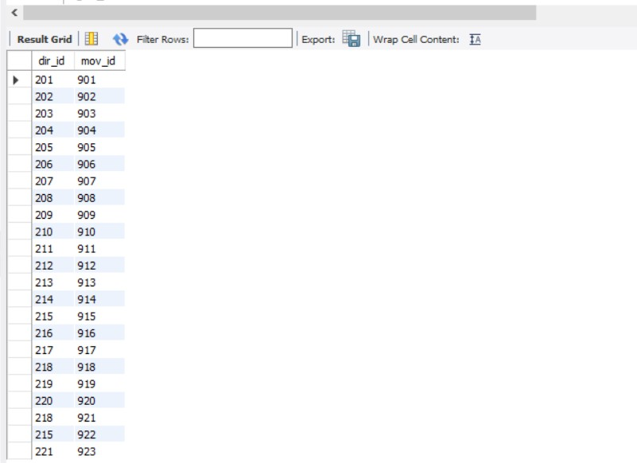

******************************************************************************* create table movie_genres(

mov_id int, gen_id int,

foreign key(mov_id) references movie(mov_id), foreign key(gen_id) references genres(gen_id));

insert into movie_genres values(922,1001),(917,1002),(903,1002),

(912,1003),(911,1005),(908,1006),(913,1006),

(926,1007),(928,1007),(918,1007),(921,1007),

(902,1008),(923,1009),(907,1010),

(927,1010),(901,1010),(914,1011),(906,1012),

(904,1013);

select*from movie_genres;

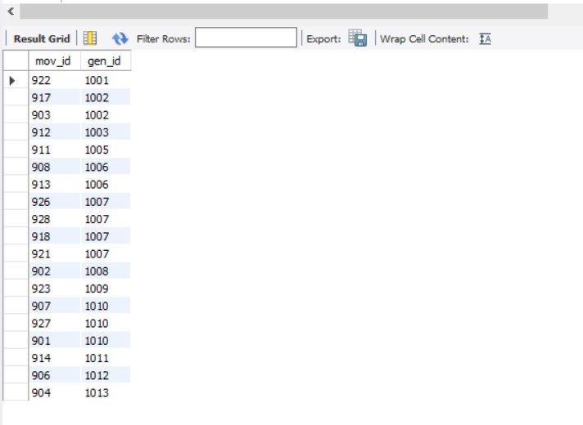

******************************************************************************* create table rating(

mov_id int, rev_id int, rev_stars int,

num_o_ratings int,

foreign key (mov_id)references movie(mov_id), foreign key(rev_id) references reviewer(rev_id));

insert into rating values(901,9001,8.4,263575),(902,9002,7.9,20207), (903,9003,8.3,202778),(906,9005,8.2,484746),(924,9006,7.3,null), (908,9007,8.6,779489),(909,9008,null,227235), (910,9009,3,195961),(911,9010,8.1,203875),(912,9011,8.4,null), (914,9013,7,862618),(915,9001,7.7,830095), (916,9014,4,642132),(925,9015,7.7,81328),(918,9016,null,580301), (920,9017,8.1,609451),(921,9018,8,667758),(922,9019,8.4,511613),

(923,9020,6.7,13091);

select*from rating;

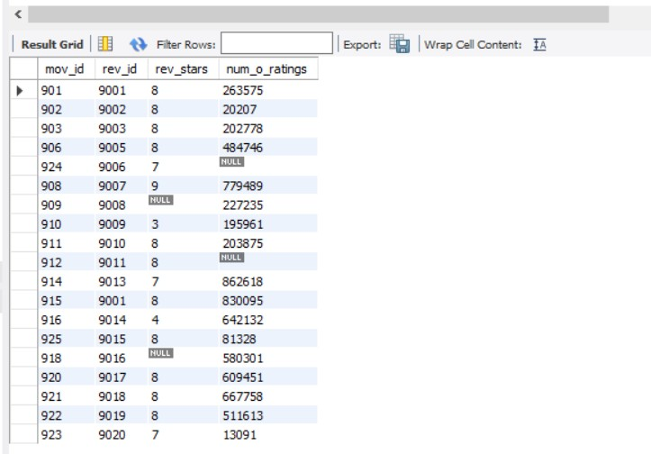

*******************************************************************************

# Write a query in SQL to list the Horror movies?

select mov_id,gen_id from movie_genres where gen_id in

(select gen_id from genres where gen_id=1008);

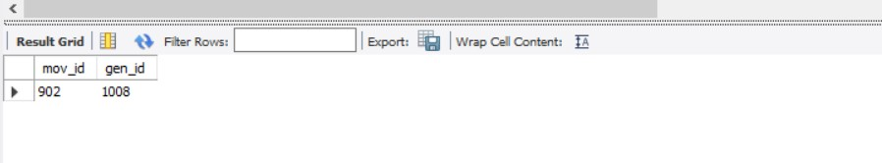

# Write a query in SQL to find the name of all reviewers who have rated 8 or more stars?

select rev_name from reviewer where rev_id in

(select rev_id from rating where rev_stars >= 8);

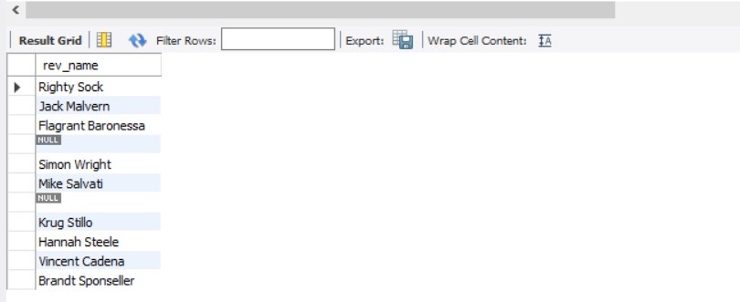

# Write a query in SQL to list all the information of the actors who played a role in the movie ‘Deliverance’

SELECT * FROM actor WHERE act_id IN( SELECT act_id

FROM movie_cast WHERE mov_id IN ( SELECT mov_id FROM movie

WHERE mov_title='Deliverance'

));

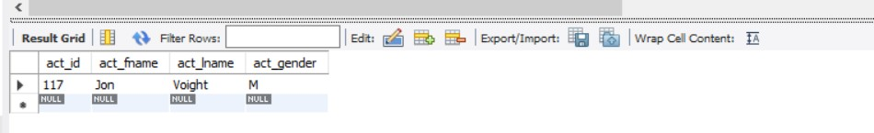

# Write a query in SQL to find the name of the director (first and last names) who directed a movie that casted a role for ‘Eyes Wide Shut’. (using subquery)

select * from director where dir_id in

(select dir_id from movie_direction where mov_id=907);

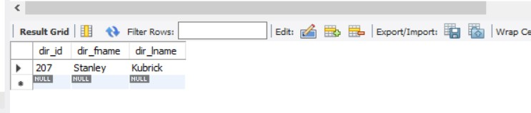

# 8. Write a query in SQL to find all the years which produced at least one movie and that received a rating of more than 4 stars.

SELECT DISTINCT mov_year FROM movie

WHERE mov_id IN ( SELECT mov_id FROM rating

WHERE rev_stars>4);

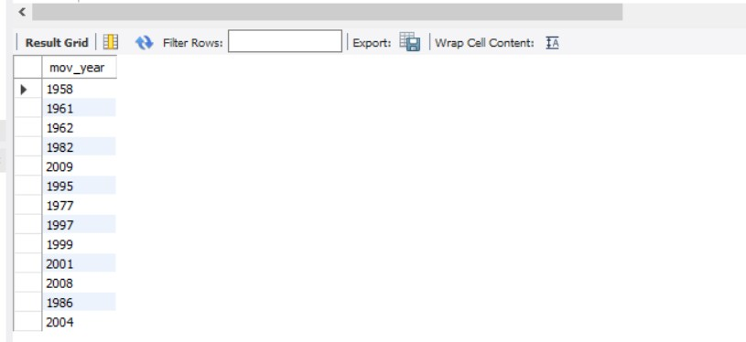

# 10. Write a query in SQL to find the name of movies who were directed by ‘David’

select mov_id,mov_title from movie where mov_id in

(select mov_id from movie_direction where dir_id=203);

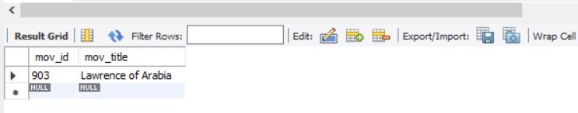

# 12. Find the name of the actor who have worked in more than one movie.

SELECT mov_title, act_fname, act_lname, role FROM movie

JOIN movie_cast

ON movie_cast.mov_id=movie.mov_id JOIN actor

ON movie_cast.act_id=actor.act_id WHERE actor.act_id IN (

SELECT act_id FROM movie_cast

GROUP BY act_id HAVING COUNT(*)>1);

