Channel size calculation formula

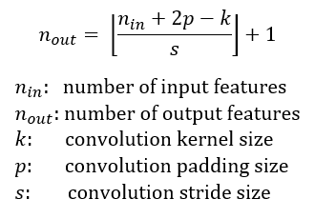

Receptive Field size calculation formula

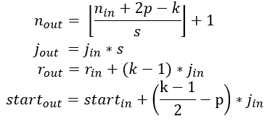

J-out ==> Jump calculated for next operation

J-in ==> Jump of the current operation

r-in ==> incoming receptive field size

r-out ==> outgoing receptive field size

|  |  |  |  |  |
| --- | --- | --- | --- | --- |
| Operation | Input | output | Receptive field | jump |
| Input | 112 | 112 | 1 | 1 |
| Convolution k=7, s=2, p=0 | 112 | 53 | 7 | 1 |
| Maxpooling k=3, s=2 | 53 | 26 | 11 | 2 |
| Convolution k=3, s=1 | 26 | 24 | 19 | 4 |
| Maxpooling k=3, s=2 | 24 | 12 | 27 | 4 |
| Inception 3a, k=1 | 12 | 12 | 27 | 8 |
| Inception 3b, k=1 | 12 | 12 | 27 | 8 |
| Maxpooling k=3, s=2 | 12 | 6 | 43 | 8 |
| Inception 4a, k=1 | 6 | 6 | 43 | 16 |
| Inception 4b, k=1 | 6 | 6 | 43 | 16 |
| Inception 4c, k=1 | 6 | 6 | 43 | 16 |
| Inception 4d, k=1 | 6 | 6 | 43 | 16 |
| Inception 4e, k=1 | 6 | 6 | 43 | 16 |
| Maxpooling k=3, s=2 | 6 | 3 | 75 | 16 |
| Inception 5a, k=1 | 6 | 3 | 75 | 32 |
| Inception 5b, k=1 | 6 | 3 | 75 | 32 |
| Average pool | 3 | 0 | 267 | 32 |
|  |  |  |  |  |
|  |  |  |  |  |