**WEEK - 2**

**Use Git to perform the following tasks**

a) Setup and configuration(config etc.)

b) Repository Management(init,clone etc.)

c) Basic Snapshotting(status, commit,log etc.)

**Configured global Git username and email using git config.**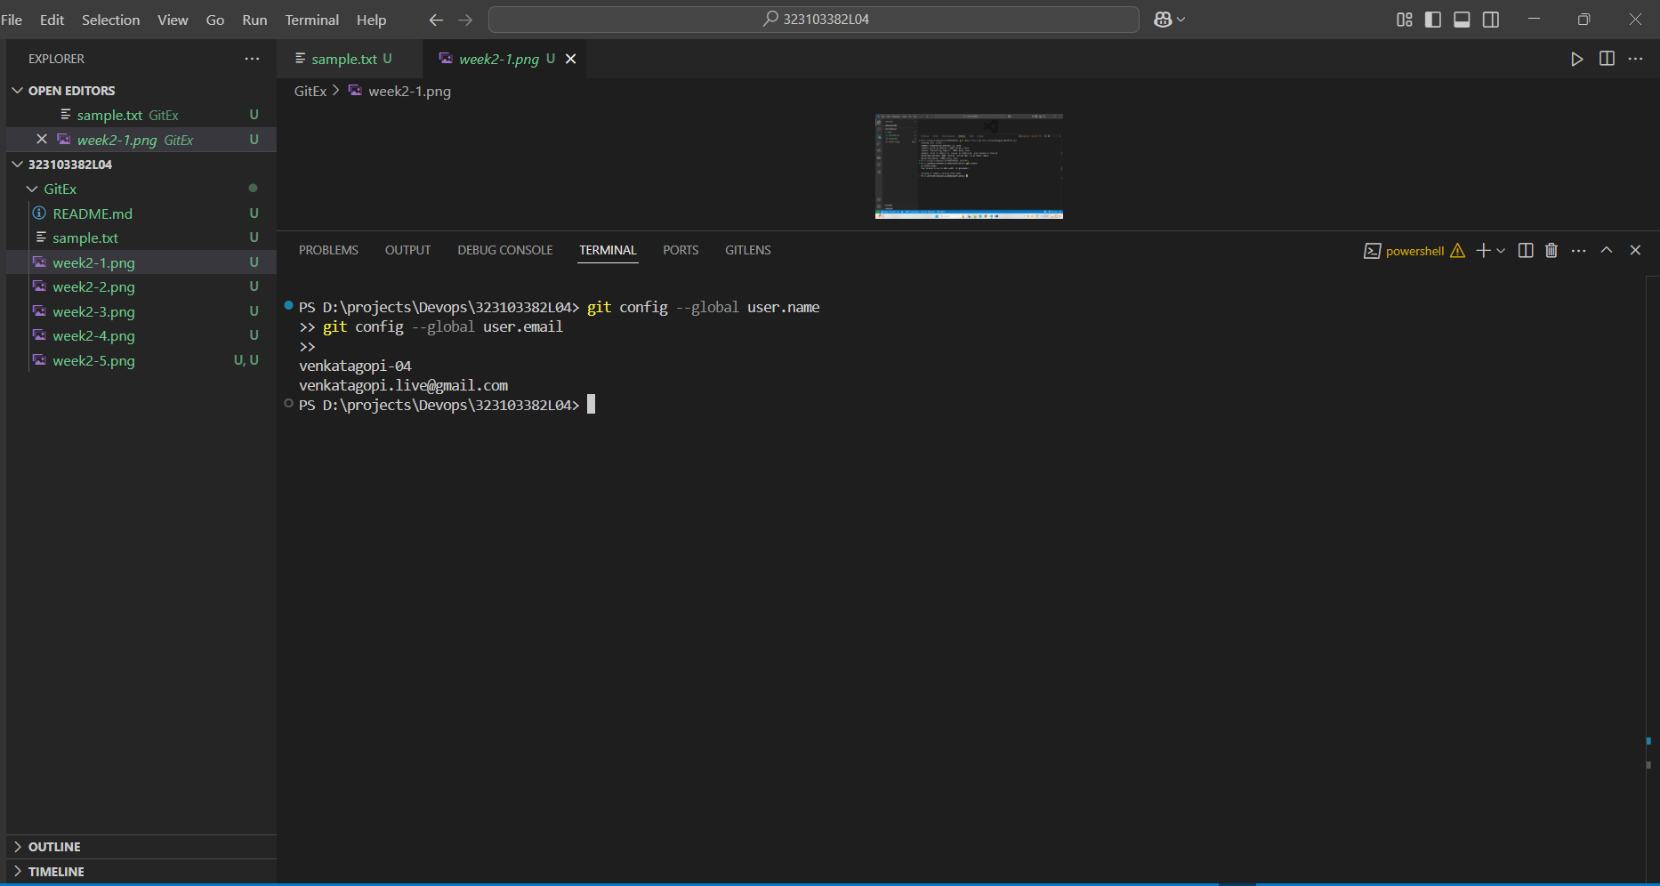

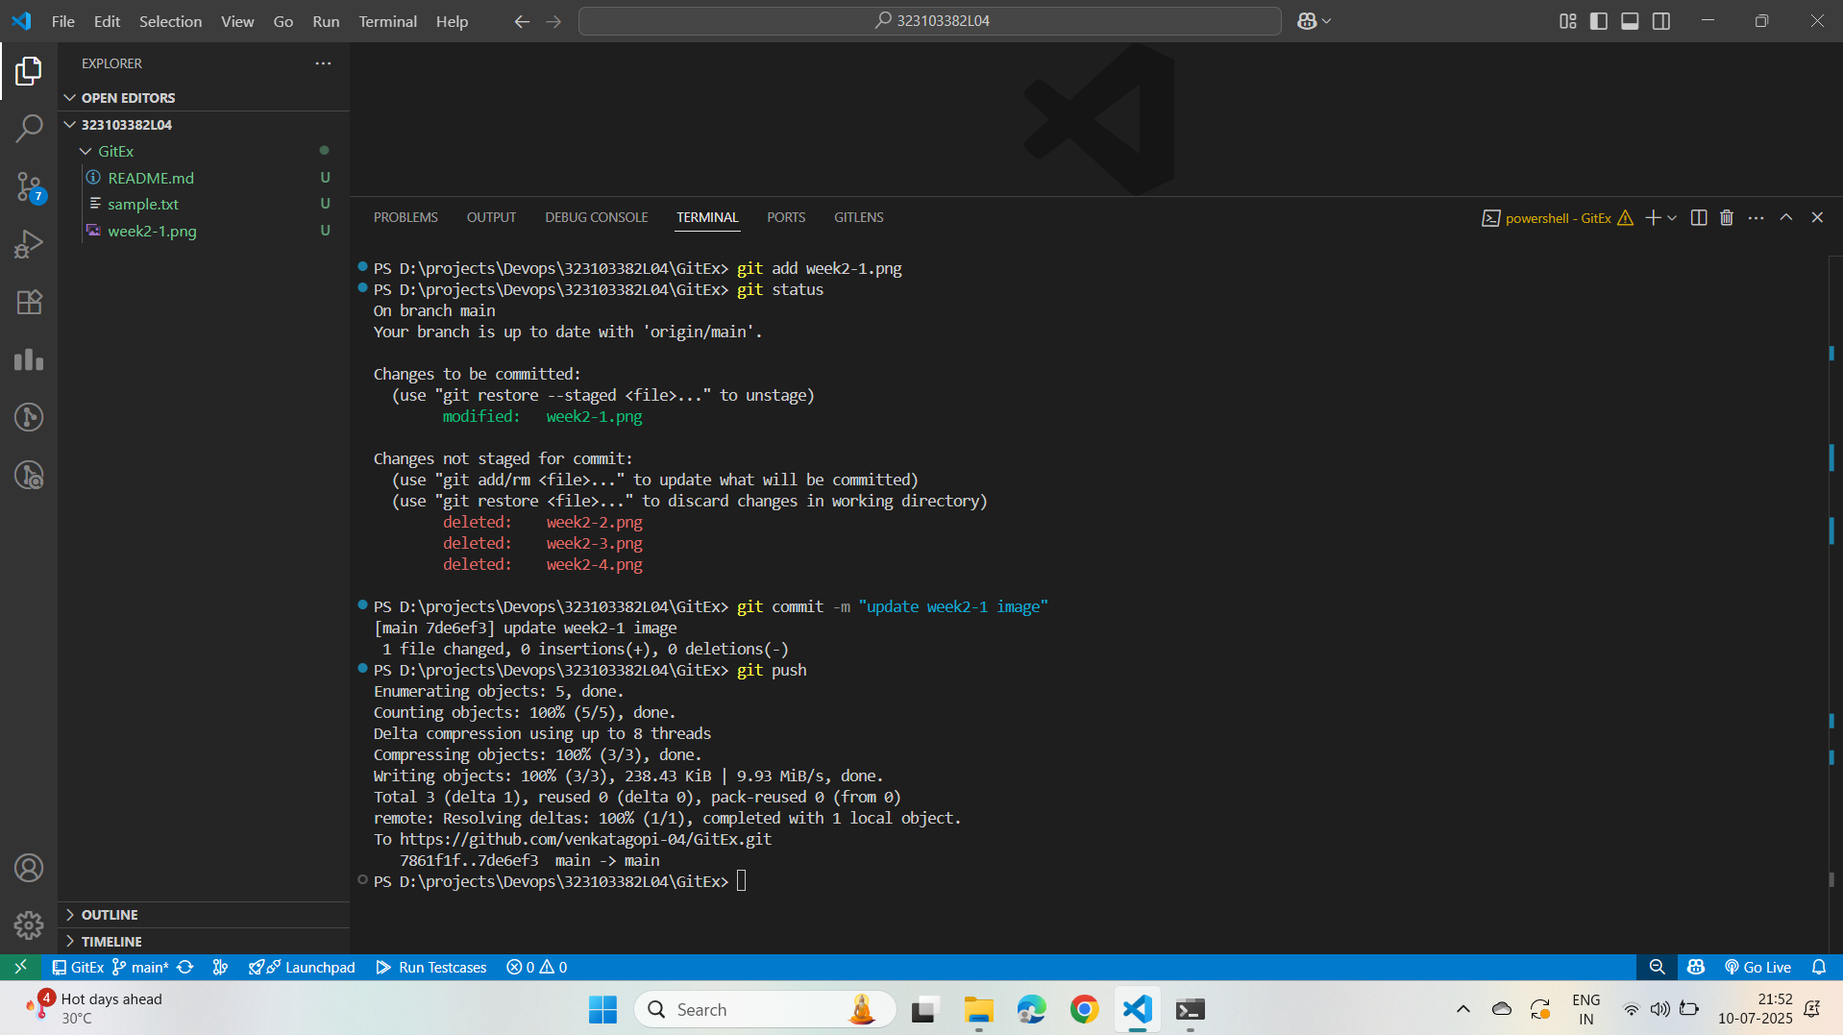

**Cloned remote repository from GitHub and verified status with git status**

**Staged changes to week2-1.png, committed with a message, and pushed to GitHub.**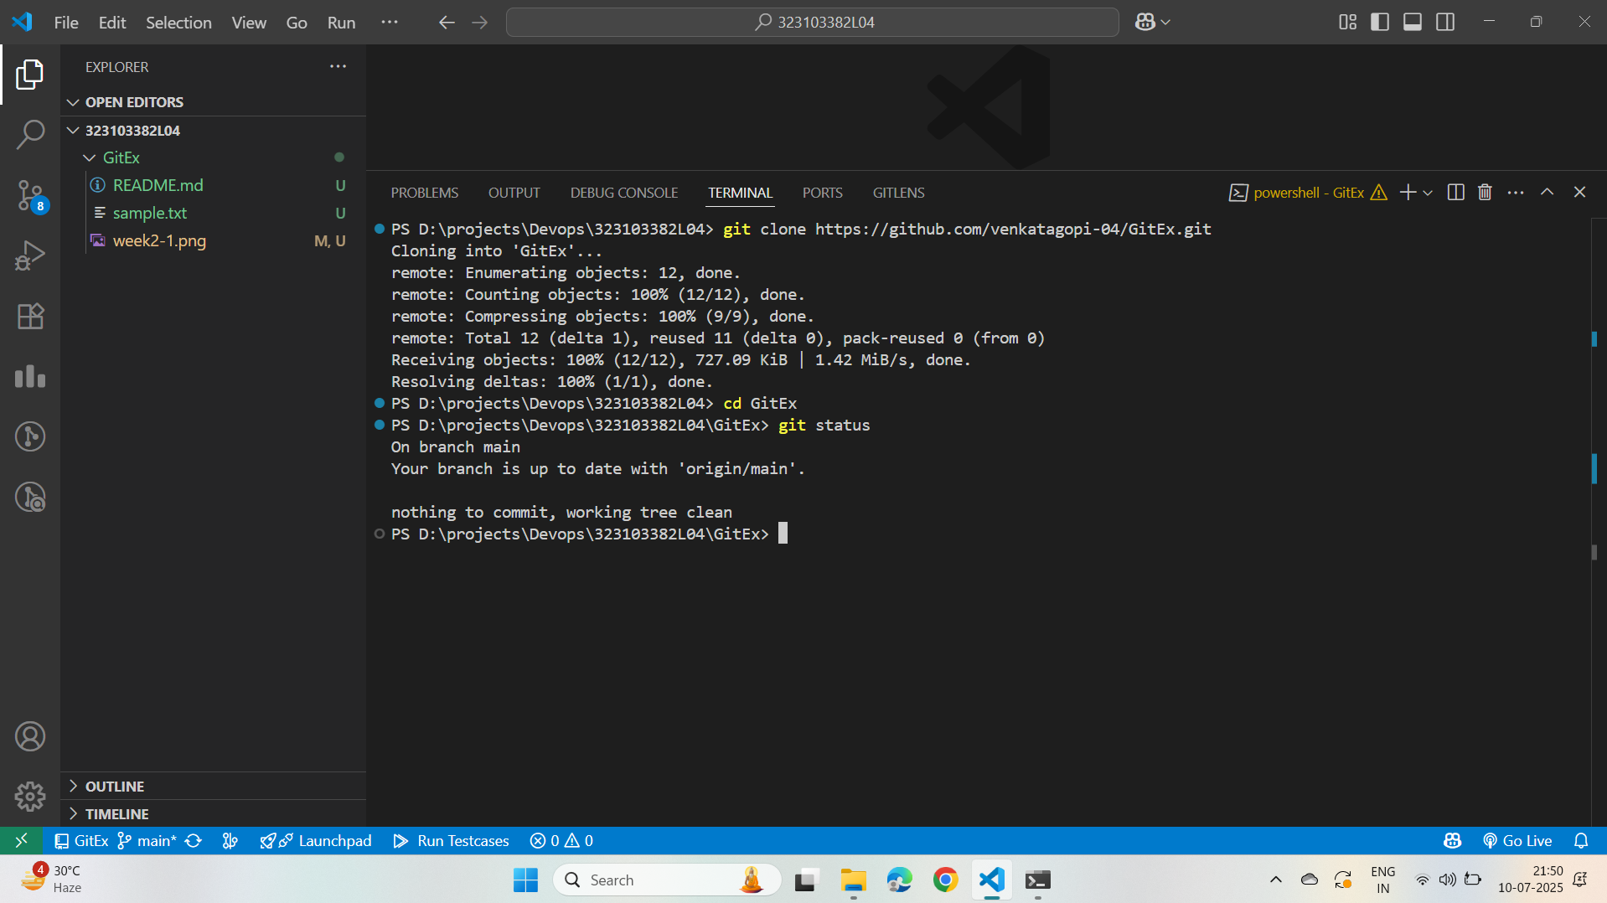

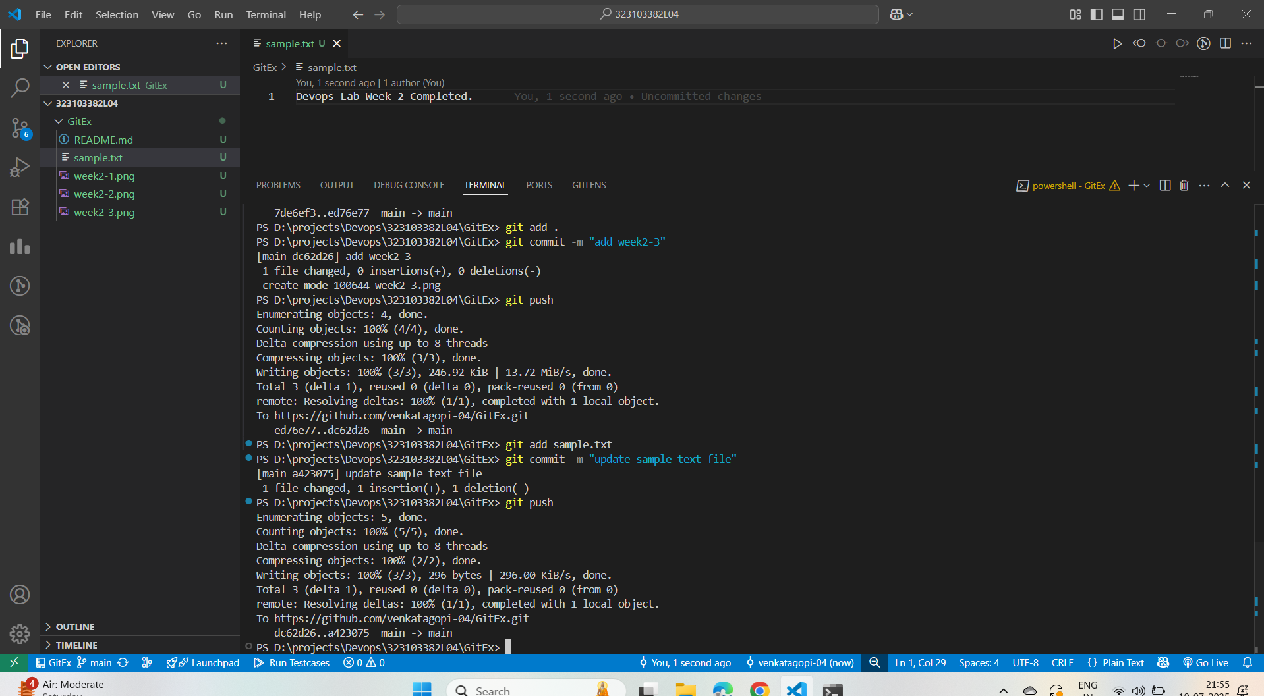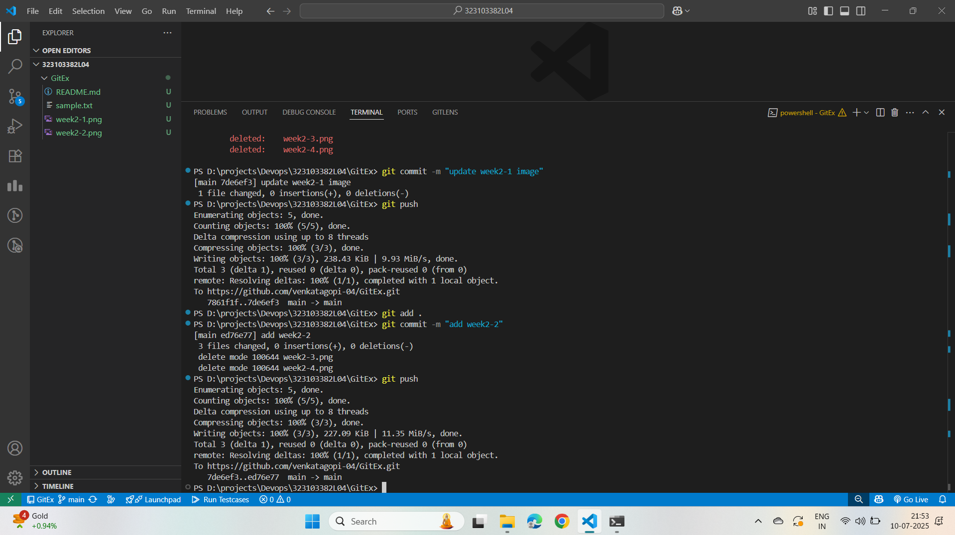

**I added week2-2.png, committed it, and pushed it to the remote repository.**

**I added week2-3.png, committed it, and pushed it to the remote repository.**

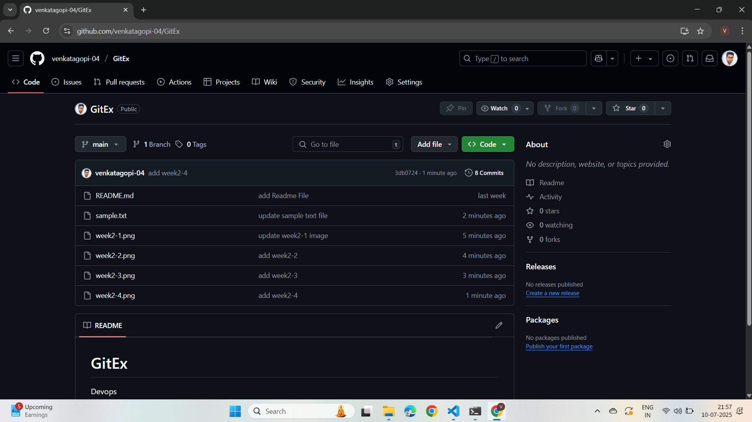

**I updated the sample.txt file, committed the change, and pushed it to GitHub.**