R programming basics

K Sandhya Susmistha

2020503541

1) Branching statements in R programming.

x <- 5

y <- 6

if (x>y) {

print("x is greater than y")

} else if(x==y){

print("x and y are equal")

}else{

print("x is less than y")

}

Output:

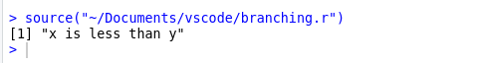

2) Looping statements in R

#while

i<-1

print("while loop")

while(i<6){

print(i)

i<-i+1

}

#for

print("for loop")

for(i in 1:5){

print(i)

}

#repeat

i<-1

print("repeat")

repeat{

print(i)

i<-i+1

if(i>5){

break

}

}

Output:

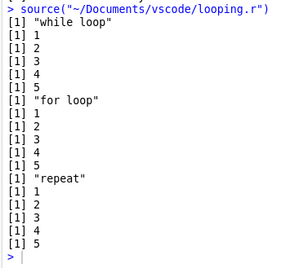

3) Create two dataframes for Batch 1 and Batch 2 with reg.no, grade, name and cgpa and combine them

* Append one more field class as categorial value

batch1 <- data.frame(

reg_no = c(3001,3002,3003,3004,3005),

stu_name = c("a","b","c","d","e"),

cgpa = c(9.1,9.3,9.2,9.2,9.5)

)

# batch1

print("batch1")

print(batch1)

grades <- c("a","a+","a","a","o")

batch1 <- cbind(batch1,grades)

print("Adding grades column")

print(batch1)

print("batch2")

batch2 <- data.frame(

reg_no = c(3501,3502,3503,3504,3505),

stu_name = c("a","b","c","d","e"),

cgpa = c(9.1,9.3,5.2,9.2,9.5)

)

#batch2

print(batch2)

grades <- c("a","a+","a","a","o")

batch2 <- cbind(batch2,grades)

print(batch2)

batch_info <- rbind(batch1,batch2)

batch_info

batch_info$class <- as.factor(ifelse(batch_info$cgpa>=6.0,"pass"

,"fail"))

print("Combining two batches")

print(batch_info)

Output:

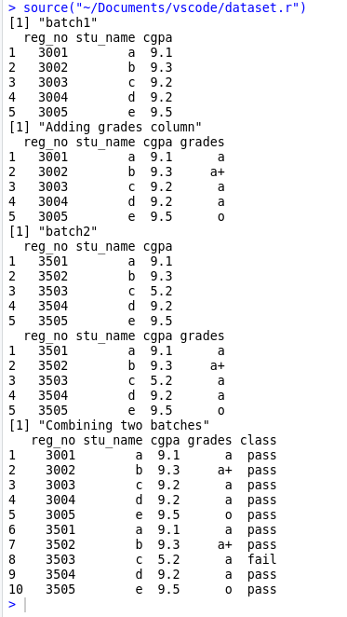

4) Create a list of string, numeric with sid, sname, project domain

* Extract only project domain

stu_list <- list(c("A","B","C"),c(3001,3002,3003),c("web_dev","app_dev","ML"))

print(stu_list)

names(stu_list) <- c("stu_names","stu_id","proj_domain")

print("project domain")

print(stu_list$proj_domain)

Output:

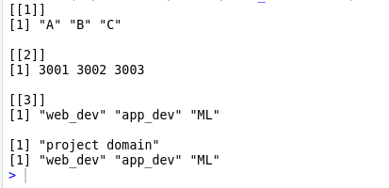

5) Create a list for eid, ename, designation, salary and company location

* Change designation from manager to ceo
* Append project details between designation and salary
* Remove location information

emp_data <- list(c(1,2,3),c("a","b","c"),c("Manager","Team_Lead","Worker"),c(1000,2000,1500),c("Chennai","Banglore","Chennai"))

names(emp_data) <- c("emp_id","emp_name","emp_desig","emp_sal","emp_loc")

print(emp_data)

# emp_data

emp_data <- lapply(emp_data,function(x) replace(x,x=="Manager","CEO"))

print("changing manger to ceo")

print(emp_data)

append(emp_data,c("web","app","ml"),after=3)

print("appending projects")

print(emp_data)

emp_data[["emp_loc"]] = NULL

print("removing employee work location")

print(emp_data)

Output:

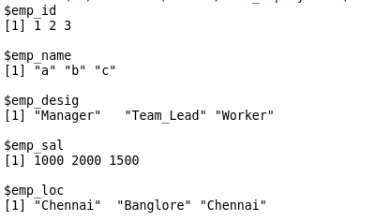

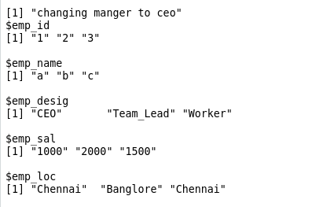

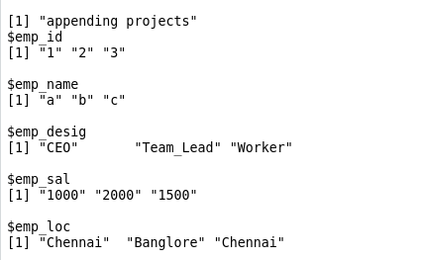

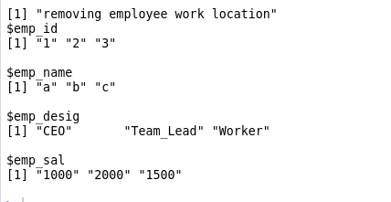

6) create a vector with string values, numeric values and find vector length, extract 3rd element, extract 1,4,6 elements, remove 1st element, remove 1,3,6 elements and change item at 5th index

#string values

sports <- c("cricket","football","badminton")

print("string vector")

print(sports)

#numbers

a <- 1:10

print("number vector")

print(a)

#length

print("vector length - sports")

print(length(sports))

#indexing

print("indexing of vectors")

print(sports[3])

#multi indexing

print("multi indexing of vectors")

print(a[c(1,4,6)])

#remove first ele

print("removing elements")

a <- a[! a%in% c(1)]

print(a)

a <- a[! a%in% c(1,4,6)]

print(a)

print("assigning values to specific location")

a[5]<-10

print(a)

output:

