Graph Neural Networks for Social Network Analysis in India: Detecting Fake Profiles & Botnets
In propose project as per your request we have used all features from dataset except Location features and then process this features for normalization and converting all non-numeric values to numeric values using Label Encoder class. All processed data will be split to train and test where application using 80% data for training and 20% for testing.
In below screen showing GNN code which is getting trained on training features and then performing prediction on test data.
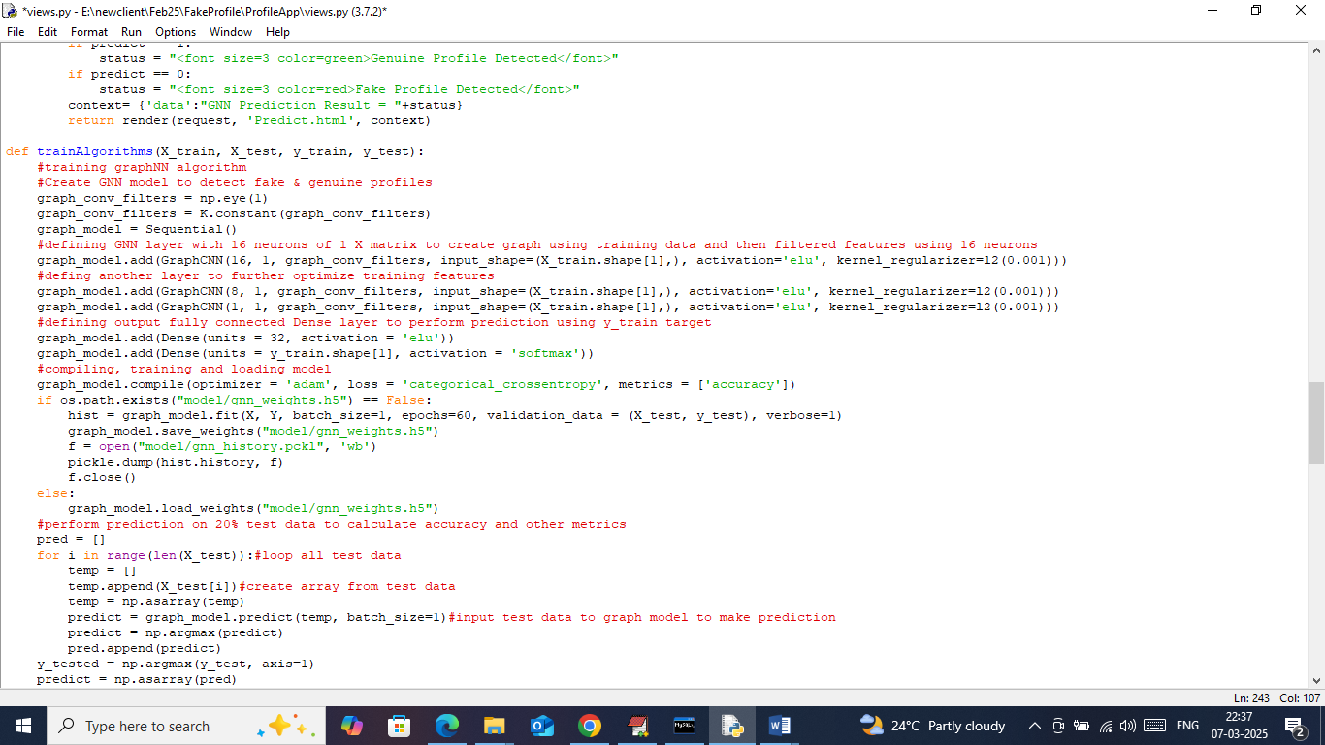
In above screen you can read red colour comments to know about Graph Neural Network (GNN) training.
To implement this project we have designed following modules
- Admin Login: admin can login to system using username and password as ‘admin and admin’. After login admin will perform below operations
- Load Dataset: using this module admin can upload ‘Profile’ dataset to application and this module will read dataset and then clean dataset by converting all non-numeric values to numeric values. This module will remove all missing values and then normalize and shuffle entire dataset. Processed dataset will be split to train and test where application using 80% dataset for training and 20% for testing
- Run GNN Algorithm: admin will run this module to train GNN algorithm on training data and then input test data to perform prediction and then calculate prediction accuracy
- View Fake Profiles: using this module admin can view all tested profiles with prediction
- New User Sign up: user can sign up with the application
- User Login: user can login to system
- Fake Profile Prediction: using this module user can input profile data and then system will employ GNN algorithm to predict weather profile is fake or genuine.
SCREEN SHOTS
To run project install MYSQL database and give MYSQL password as ‘root’ and then copy content from ‘database.txt’ file and paste in MYSQL console to create database.
Now install python3.7.2 and then copy content from requirements.txt file and paste in Command Prompt to install required packages.
Now double click on ‘runWebServer.bat’ file to start python server and then will get below page
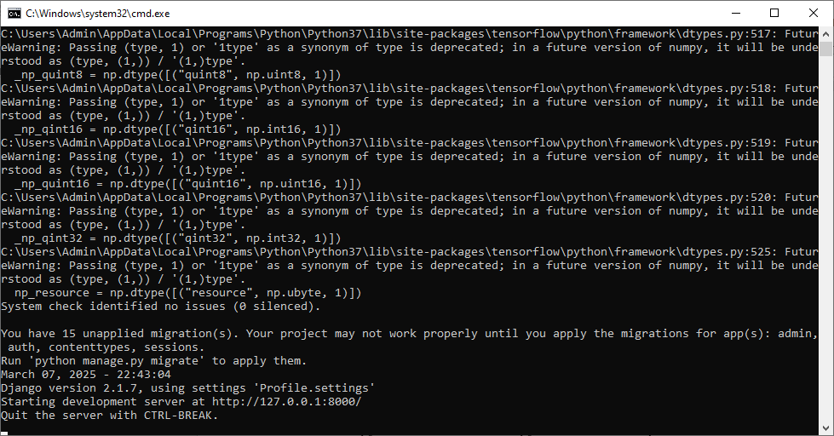
In above screen python server started and now open browser and enter URL as http://127.0.0.1:8000/index.html and then press enter key to get below page
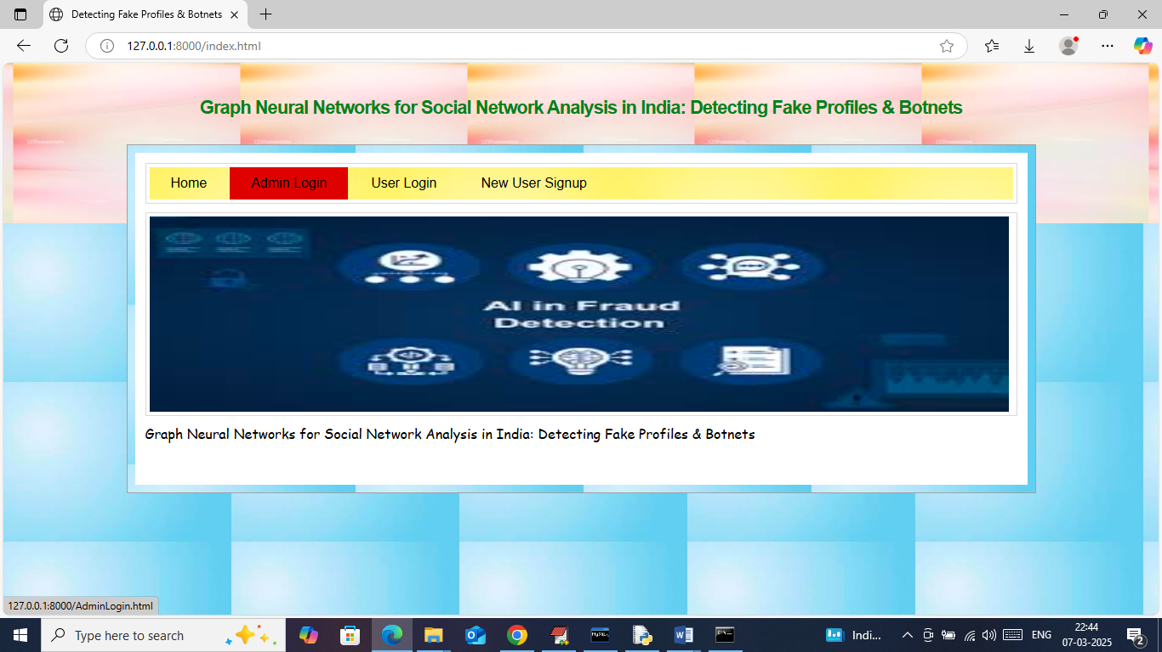
In above screen click on ‘Admin Login’ link to get below page
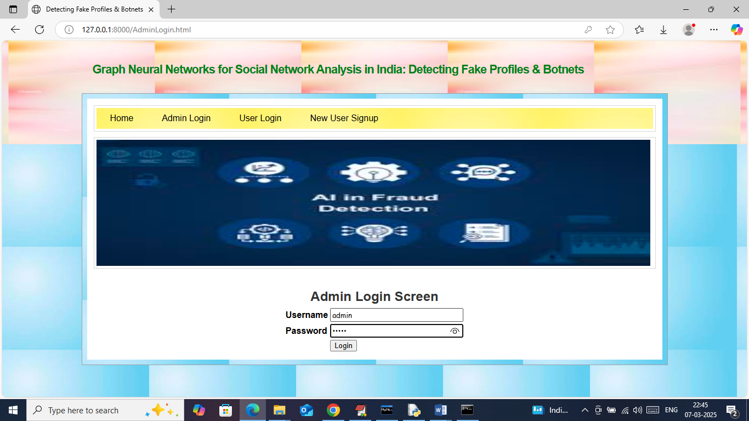
In above screen admin is login and after login will get below page
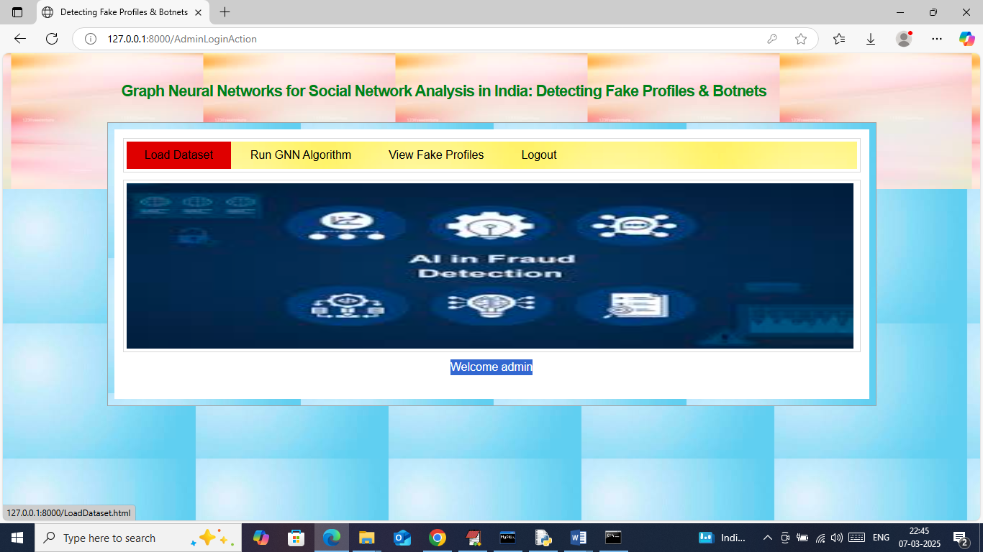
In above screen click on ‘Load Dataset’ link to get below page
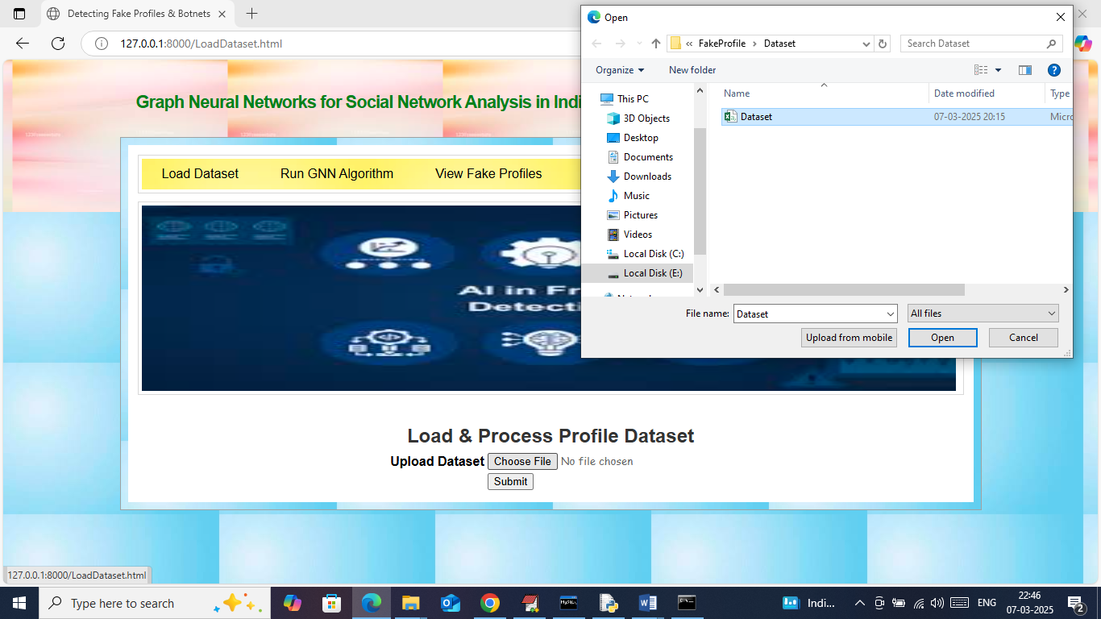
In above screen selecting and uploading ‘Dataset.csv’ file and then click on ‘Open and Submit’ button to get below page
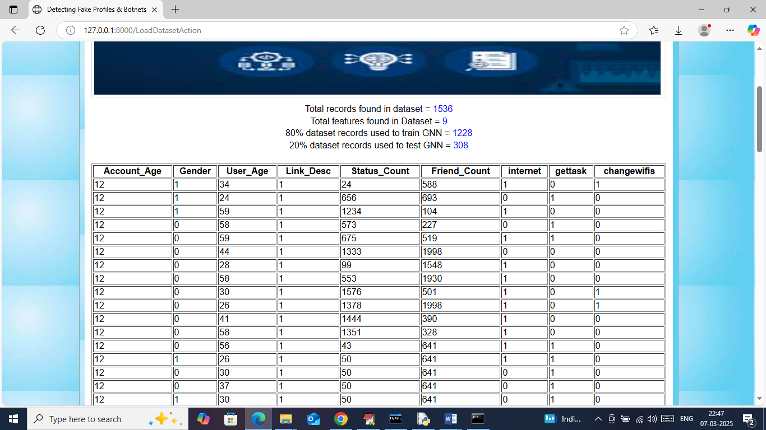
In above screen in first 4 lines can see dataset details like number of records, features and then can see train and test data size. In table format can see processed data where all values are cleaned and converted to numeric format and now scroll down above page to see class label graph
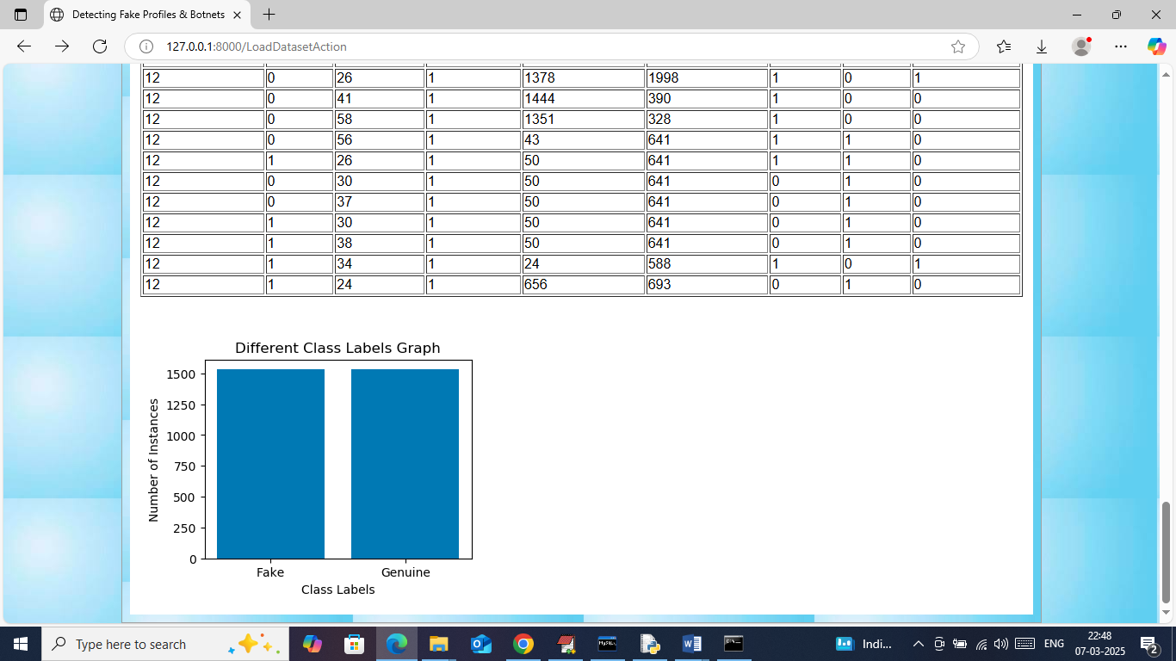
In above graph x-axis represents ‘class labels’ as ‘Fake or Genuine’ and y-axis represents number of records under that class labels and now click on ‘Run GNN Algorithm’ link to train GNN and then will get below output

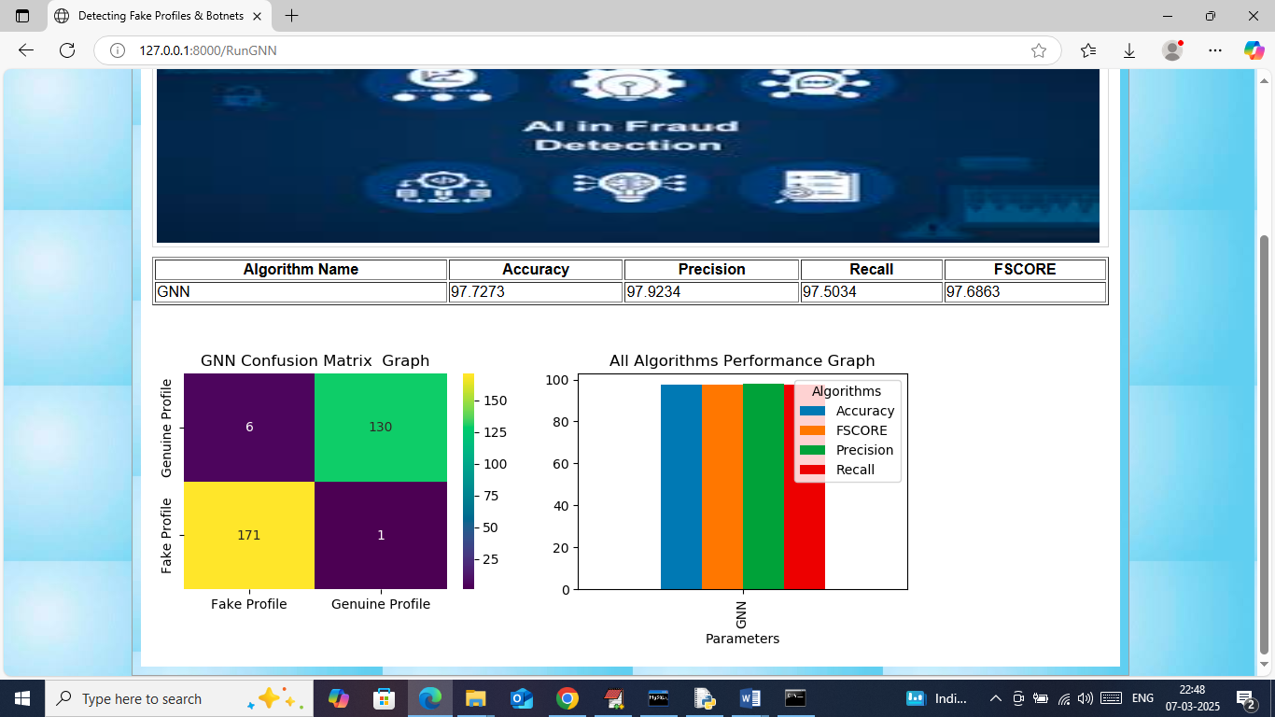
In above screen in tabular format can see accuracy and other metrics for GNN algorithms and can see other metrics like precision, recall and FSCORE. In Confusion matrix graph x-axis represents Predicted Labels and y-axis represents True Labels and then yellow and green colour boxes in diagonal represents correct prediction count and remaining blue boxes represents incorrect prediction count which are very few. In above bar graph x-axis represents algorithm name and y-axis represents accuracy and other metrics in different colour. Now logout and sign up new user like below page
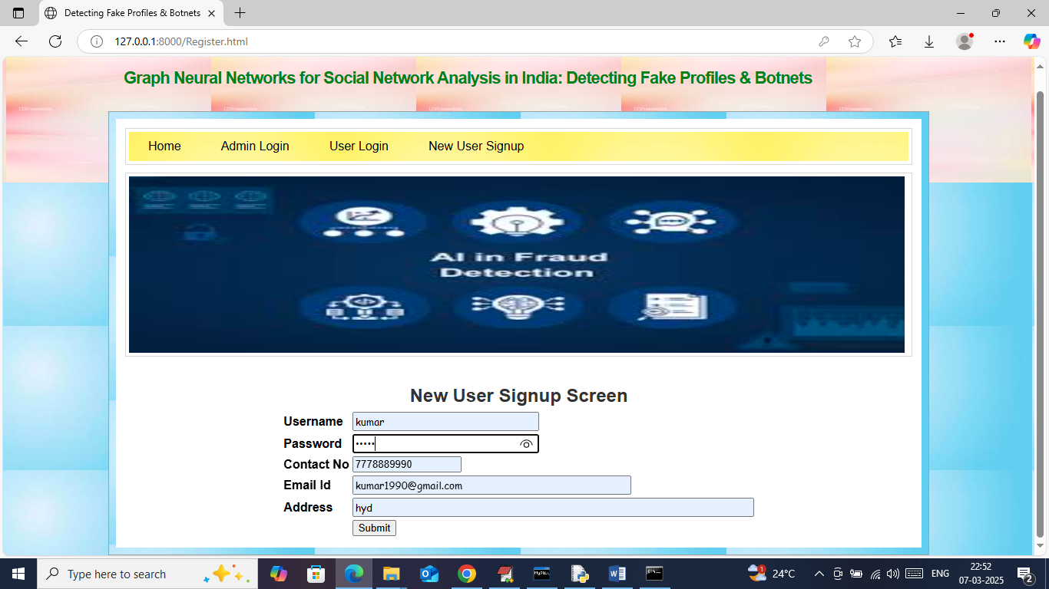
In above screen user is entering sign up details and then press button to get below page
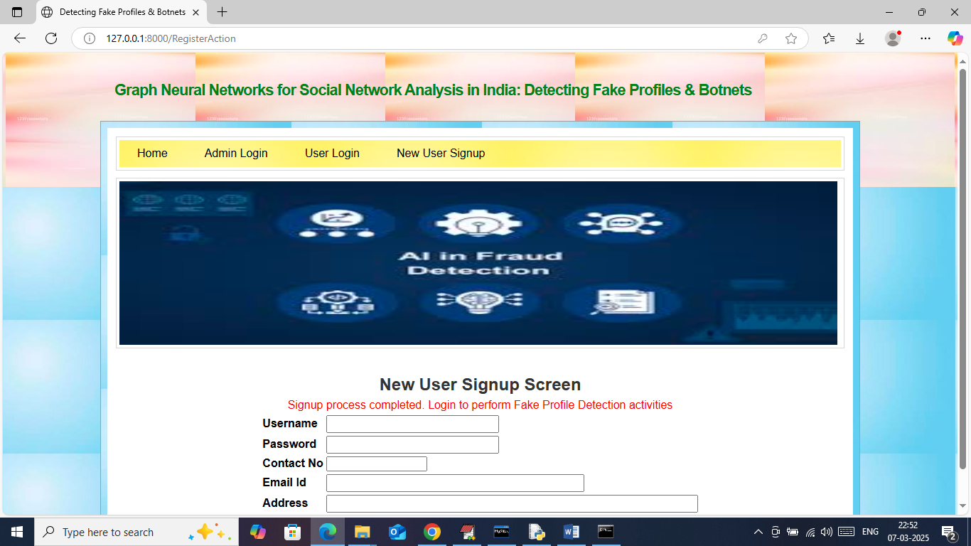
In above screen sign up completed and now click on ‘User Login’ link to get below page
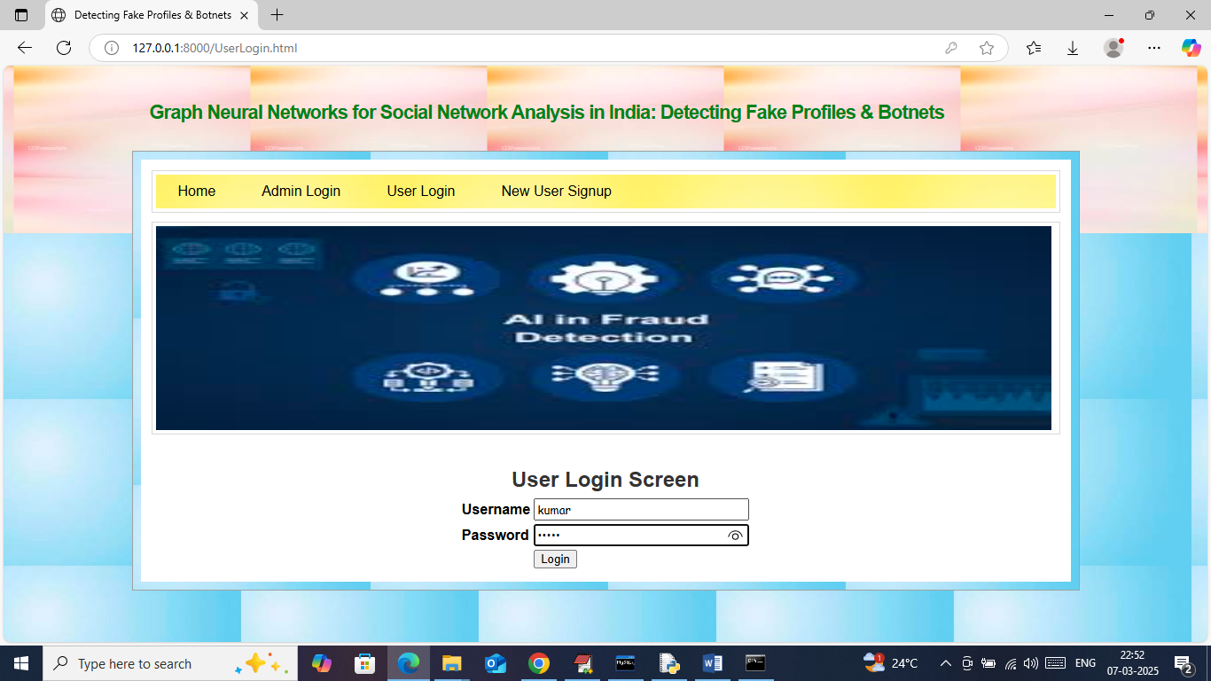
In above screen user is login and after login will get below page
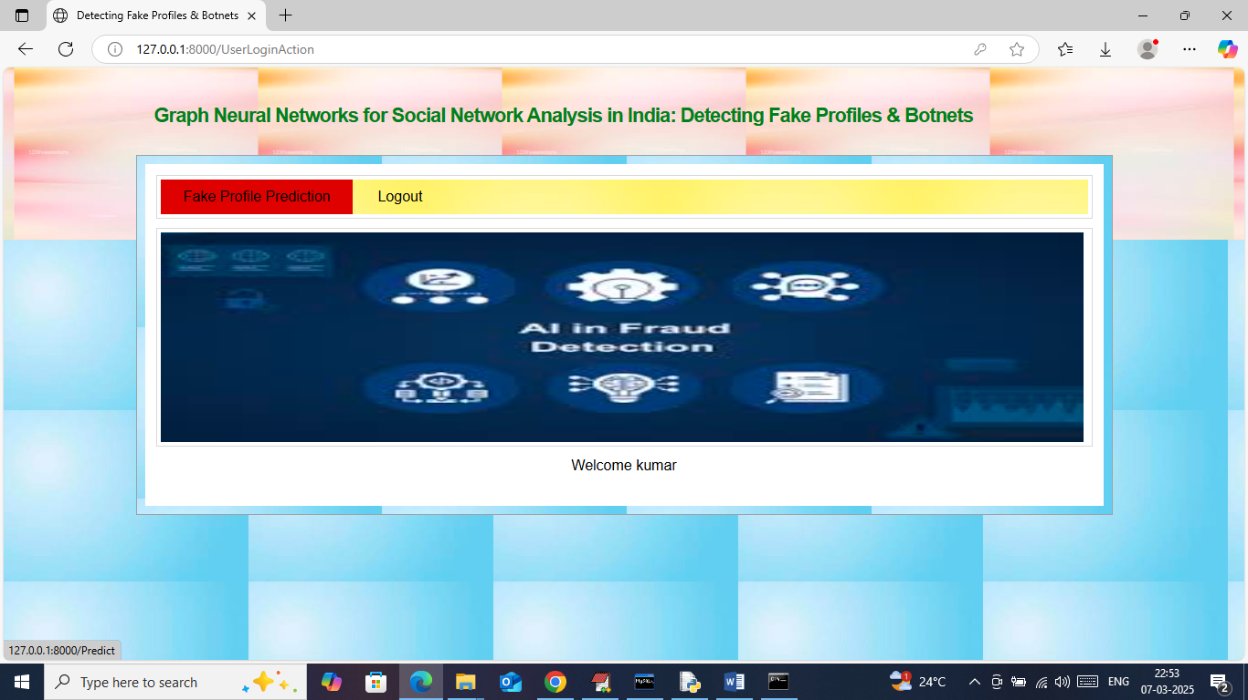
In above screen click on ‘Fake Profile Detection’ link to get below page
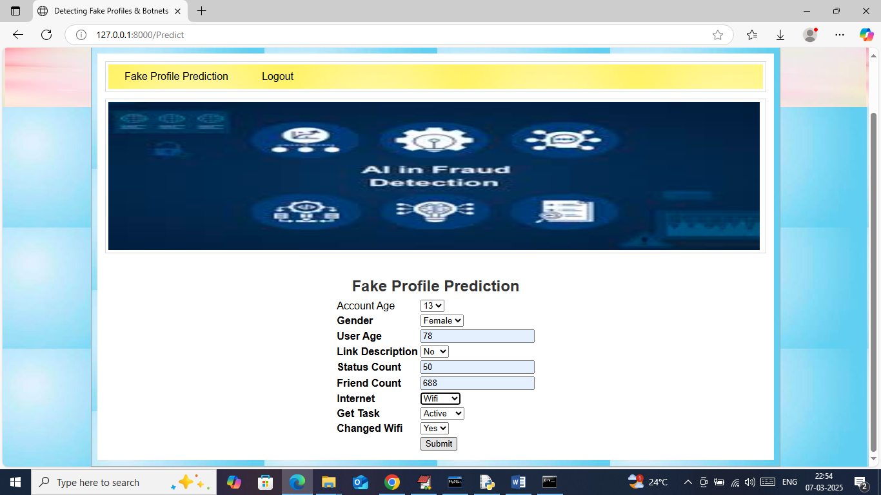
In above screen you can enter input values and then press button to get below page
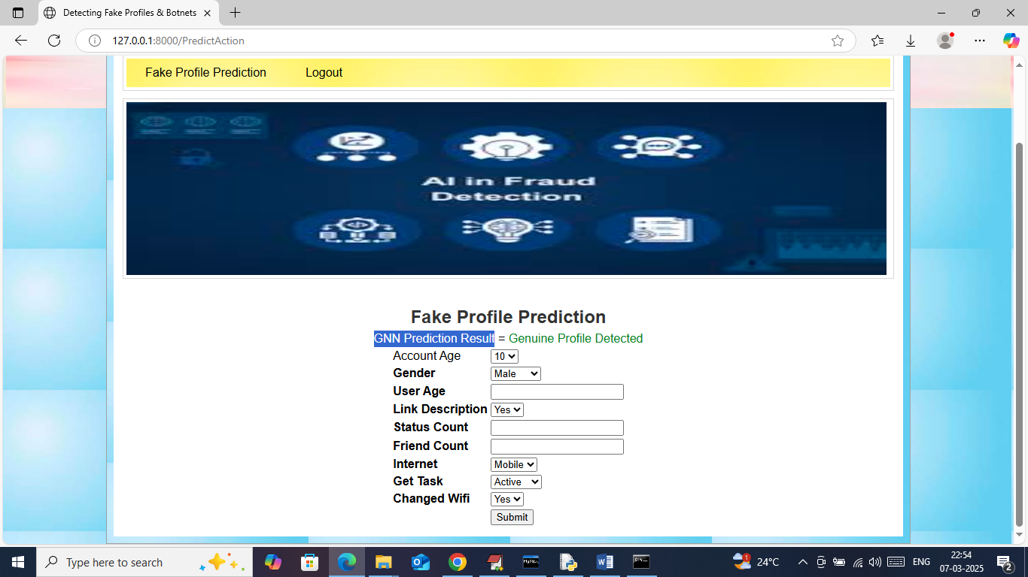
In above screen in green colour text can see given input predicted as ‘Genuine Profile’ and now test another input
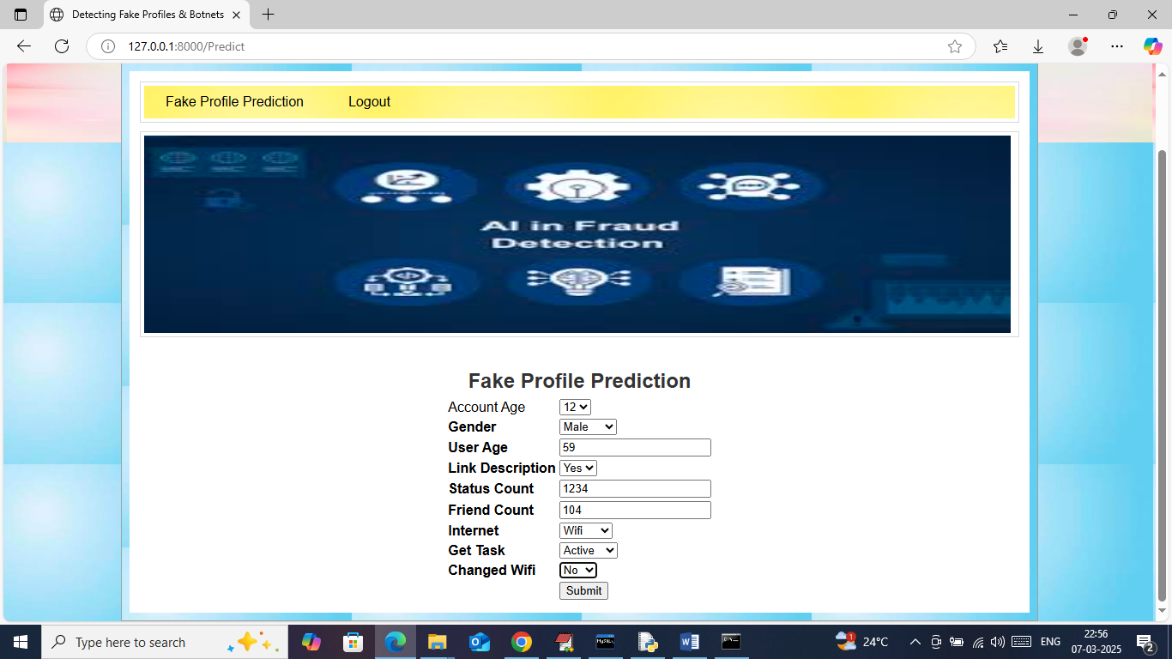
In above screen I am entering new test data and then press button to get below page
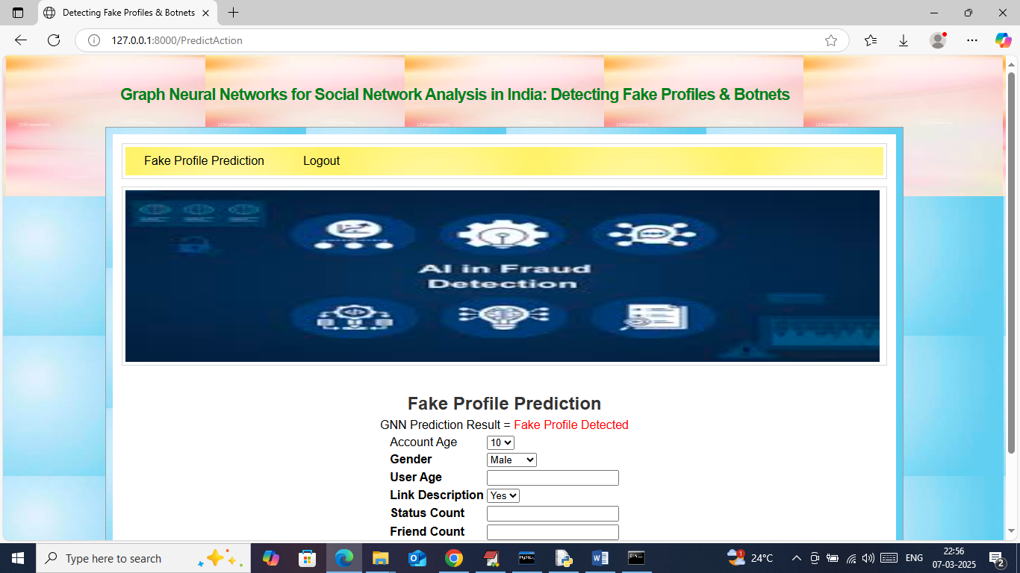
In above screen in red text can see given input predicted as ‘Fake’ and similarly you can input and get predicted output. Now logout and login as admin to view profiles
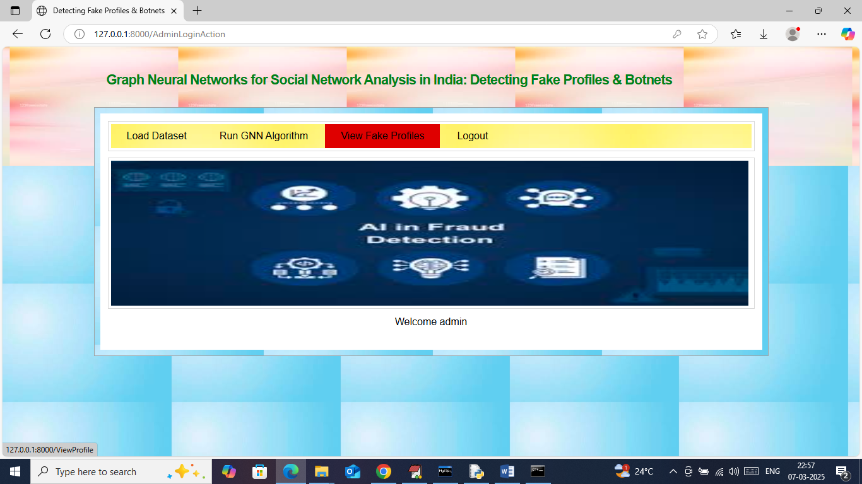
In above screen admin can click on ‘View Fake Profiles’ link to get below page
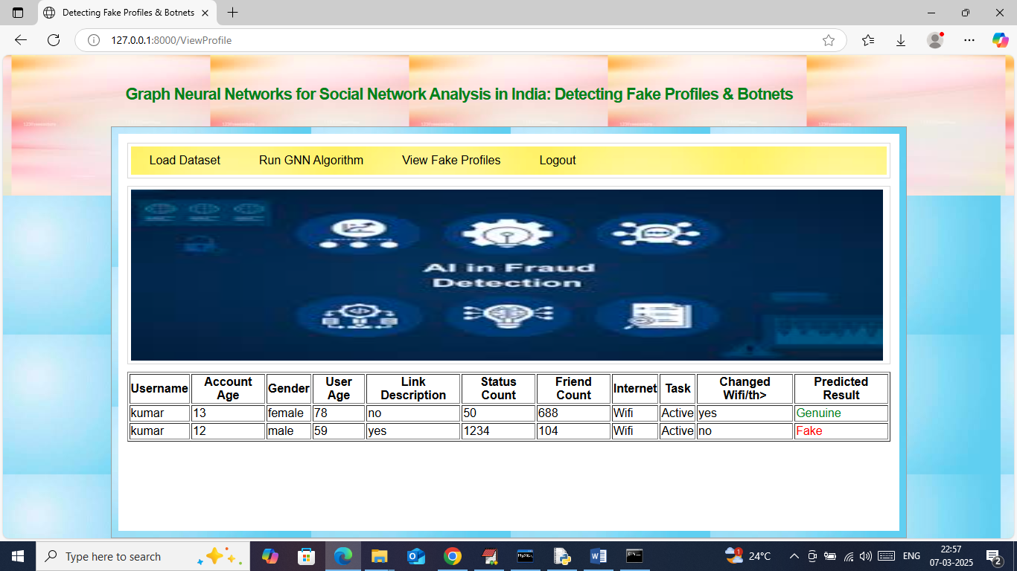
In above screen admin can view all profile details along with predicted result showing in last column as ‘fake or genuine’.

