https://awesomeopensource.com/projects/kubectl-plugins

<https://krew.sigs.k8s.io/docs/user-guide/setup/install/>

KREW Installation:

(

*set* -x; *cd* "$(mktemp -d)" &&

curl -fsSLO "https://github.com/kubernetes-sigs/krew/releases/latest/download/krew.tar.gz" &&

tar zxvf krew.tar.gz &&

*KREW*=./krew-"$(uname | tr '[:upper:]' '[:lower:]')_$(uname -m | sed -e 's/x86_64/amd64/' -e 's/arm.*$/arm/')" &&

"*$KREW*" install krew

)

Add following in ~/.bashrc and reboot.

export PATH="${PATH}:${HOME}/.krew/bin"

root@ip-192-168-1-100:~# kubectl krew

krew is the kubectl plugin manager.

You can invoke krew through kubectl: "kubectl krew [command]..."

https://krew.sigs.k8s.io/plugins/

alias kk='kubectl krew'

ku krew install view-utilization

ku view-utilization -n default

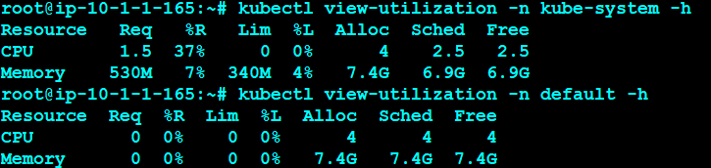

ku krew install tree

ku run hello --image=sreeharshav/rollingupdate:v5 --replicas 3

ku tree deployment hello

ku krew install example

ku example deployment

kk install iexec

ku krew install topology

ku topology pod node

ku krew install rbac-view

kubectl rbac-view

http://ec2-18-206-64-91.compute-1.amazonaws.com:8800/index.html

ku krew install tail

ku krew install service-tree

ku expose deployment hello --port=8300 --target-port=80 --type=NodePort --name hello3

kubectl service-tree

kk install popeye

kubectl popeye

kk install pod-logs

kubectl pod-logs

kk install iexec

ku iexec hello-d4d6db749-bmzht bash

alias exec='kubectl iexec'

exec hello-d4d6db749-fzdff bash

kk install deprecations

kubectl deprecations

alias ku='kubectl'

alias deps='kubectl get deploy'

alias pods='kubectl get pods'

alias allpods='kubectl get pods --all-namespaces'

alias svcs='kubectl get svc'

alias nodes='kubectl get nodes'

alias all='kubectl get pods,deploy,svc'

alias des='kubectl describe'

alias ns='kubectl get ns'

alias clustercreate='kops create cluster --name=sreek8s.xyz --state=s3://sreek8s --zones=us-east-1a --node-co$

alias clusterdelete='kops delete cluster --name sreek8s.xyz --yes --state s3://sreek8s'

export KOPS_STATE_STORE=s3://sreek8s

export CLUSTER_NAME=sreek8s.xyz

export EDITOR=nano