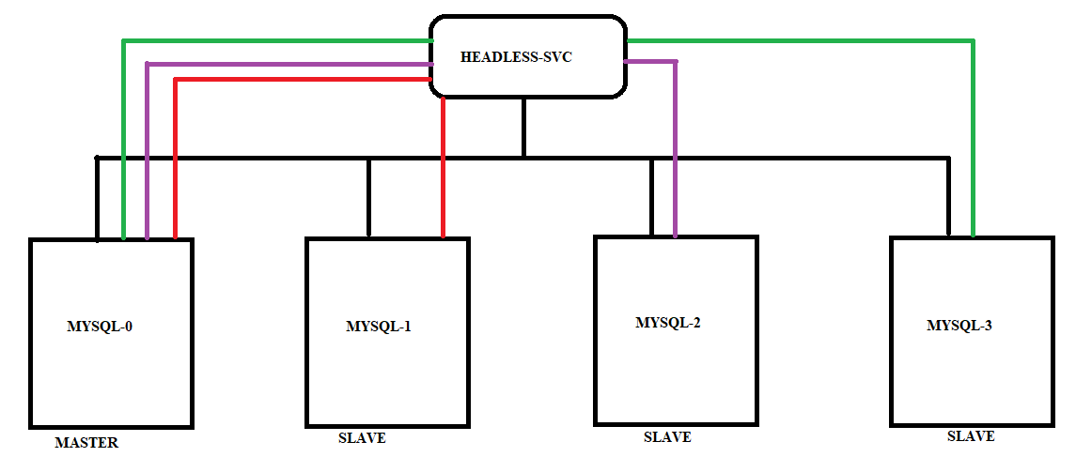

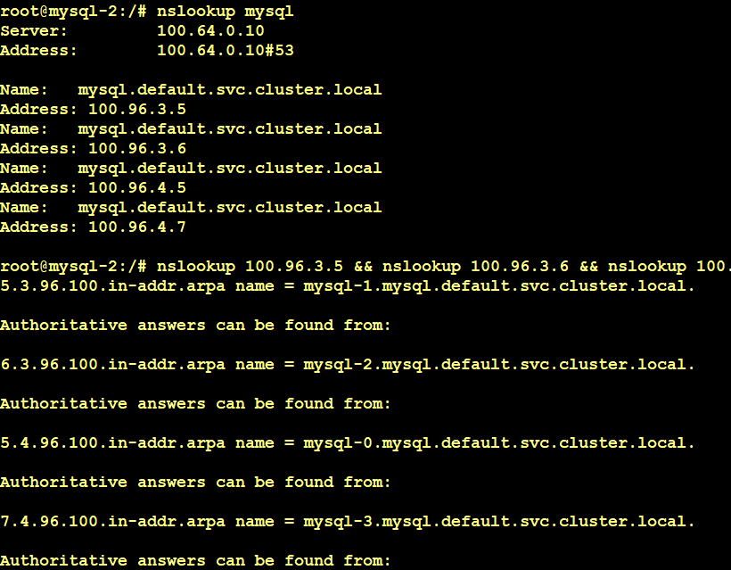

Headless services are used by the PODs of the sattefull sets to reach to the master. Since the PODS names of the statefullsets wont changes, the slaves will perform nslookup of the headless service and find the all PODS which are part of the headless service and then find the master.

In mysql scenario, mysql-0 is the master and others are the slaves. Using headless service the slaves can reach to the master.