PRACTICAL 3
Process Creation and Process Information in Linux

1. Objective
To create a child process using fork(), display the PID and PPID of the parent and child processes, and inspect process information using Linux commands such as ps, top, and /proc/<PID>/status.

2. C Program
#include <stdio.h>
#include <unistd.h>
int main()
{
int pro;
pro = fork();
if (pro < 0)
{
printf("Fork failed\n");
}
else if (pro == 0)
{
printf("Child Process\n");
printf("PID: %d\n", getpid());
printf("PPID: %d\n", getppid());
}
else
{
printf("Parent Process\n");
printf("PID: %d\n", getpid());
printf("PPID: %d\n", getppid());
}
return 0;
}

3. Compilation and Execution
nano practical3.c
gcc practical3.c
./a.out

4. Program Output
Parent Process
PID: 684
PPID: 346
Child Process
PID: 685
PPID: 684
The output shows that fork() created a child process. The child process has PID 685 and its parent process ID (PPID) is 684.

5. Process Listing using ps
The ps command is used to display currently running processes. The practical session shows the bash shell and the ps command with their corresponding process IDs.
PID TTY TIME CMD
346 pts/0 00:00:00 bash
698 pts/0 00:00:00 ps

6. Process Monitoring using top
The top command provides a real-time view of running processes, CPU and memory usage, system load, and process states. In the captured output, process 708 is the running top command, while the bash process has PID 346.
Tasks: 24 total, 1 running, 23 sleeping, 0 stopped, 0 zombie
Memory: 7827.6 MiB total, 7264.4 MiB free, 512.4 MiB used
Swap: 2048.0 MiB total, 2048.0 MiB free, 0.0 MiB used
Shell: bash, PID 346
top: PID 708

7. Process Information using /proc
The /proc filesystem contains information about running Linux processes. The command cat /proc/453/status displays detailed information for process 453.
Name: bash
State: S (sleeping)
Pid: 453
PPid: 349
Uid: 1000 1000 1000 1000
Gid: 1000 1000 1000 1000
Threads: 1
VmPeak: 6136 kB
VmSize: 6136 kB
VmRSS: 5436 kB
RssAnon: 1580 kB
RssFile: 3856 kB
VmData: 1496 kB
VmStk: 132 kB
VmExe: 1036 kB
VmLib: 1908 kB
VmPTE: 48 kB
VmSwap: 0 kB
Cpus_allowed_list: 0-7
voluntary_ctxt_switches: 51
nonvoluntary_ctxt_switches: 2

8. Screenshots
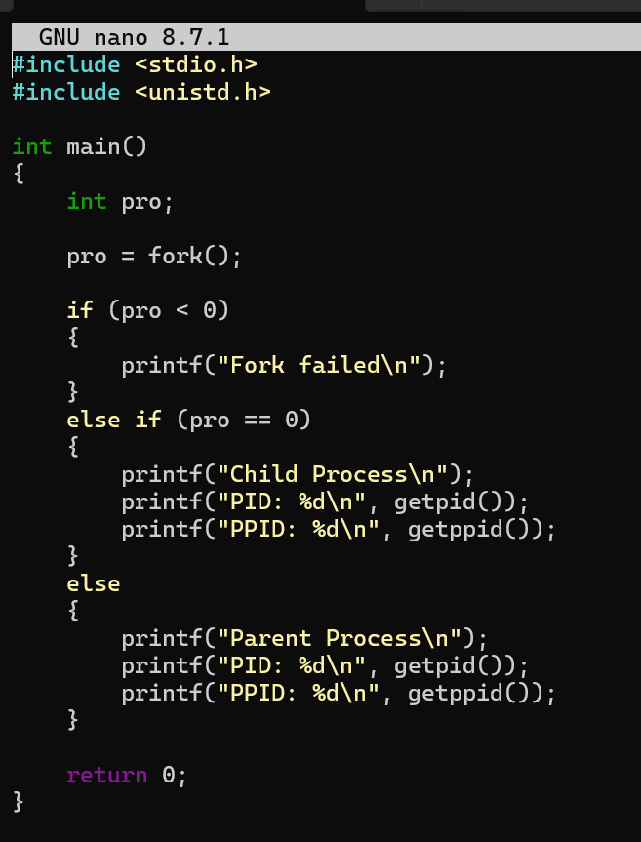
Screenshot 1: C program in GNU nano
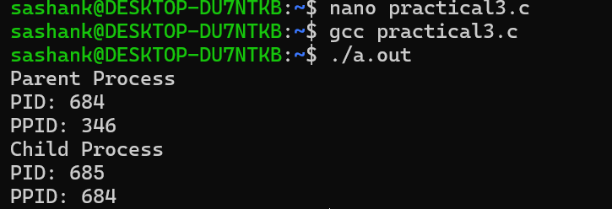
Screenshot 2: Compilation and program output
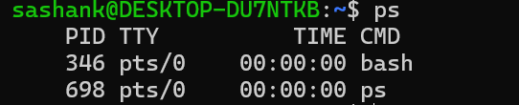
Screenshot 3: ps command output
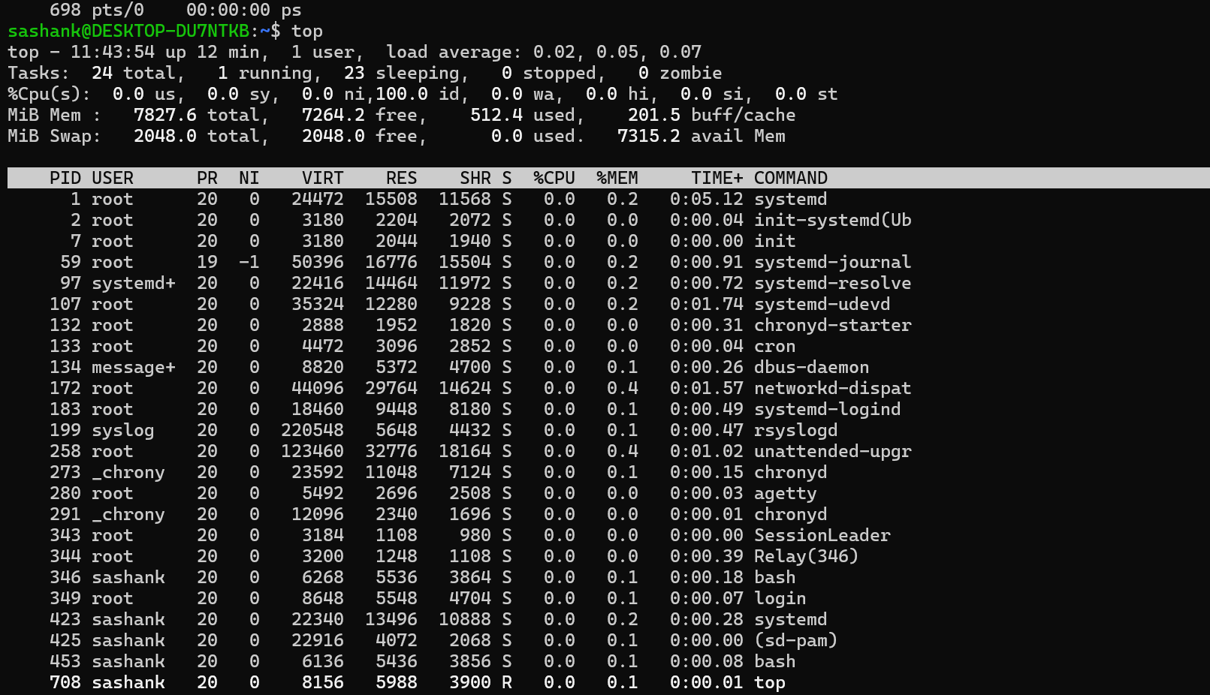
Screenshot 4: top command output
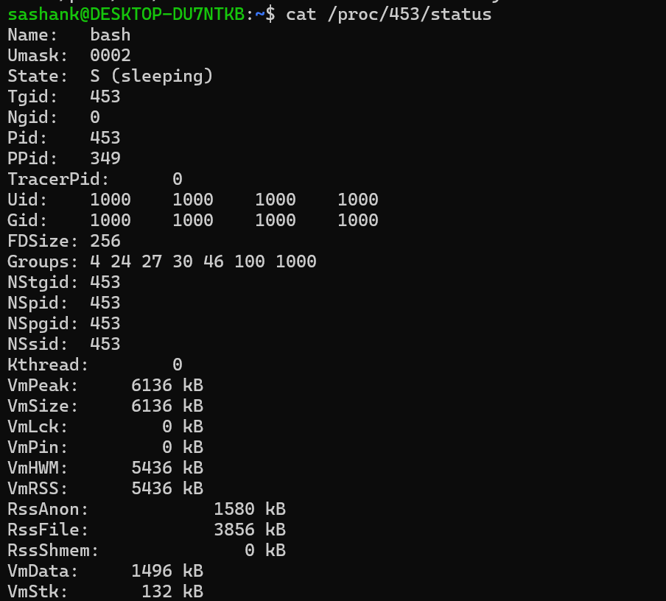
Screenshot 5: /proc/453/status output - part 1
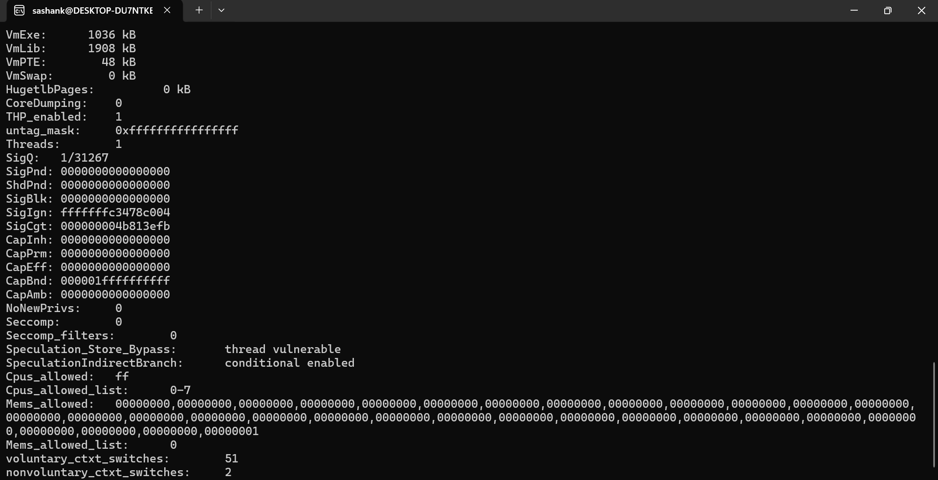
Screenshot 6: /proc/453/status output - part 2

9. Result
The C program was successfully compiled and executed. A child process was created using fork(), and the PID and PPID of the parent and child processes were displayed. Linux process information was also examined using ps, top, and the /proc filesystem.

