Placement Mangement System Report

Student’s Name

Date of Submission

**Executive Summary**

Python, Django, React, and Node were the other four components that went into making the placement management system. This strategy aims to make it simpler, more time- and cost effective for companies to find and recruit recent college graduates. Due to the user-friendly nature of the system's interface, both educational institutions and commercial enterprises may quickly and easily publish job vacancies, collect applications, organize interviews, and make hiring choices. The system is versatile, safe, and able to be customized to meet the requirements of different enterprises and educational institutions.

Using an automated placement management system, the school can place and coordinate its students as well as is humanly possible. It lets the students combine their knowledge into a "hive mind," which can improve the selection rate and make it easier for management data to be made automatically. We have automated the placement cell as part of our online training and job placement program. Tasks include approving the curriculum vitae, telling students about open positions, working with businesses to invite students for internships and other experiences, keeping an eye on the selection process, and connecting with a wide range of users. Other responsibilities include inviting students for internships and other experiences.

**Introduction**

The Placement Management System is an online platform that aims to connect students with possible employers and speed up finding a job. Its primary objective is to connect students with future employers. Python is the primary programming language used in constructing this system, which also uses the Django framework, React for the front end, Node for the back end, and more. This study provides an overview of the primary features, functions, and advantages of the placement management system and discusses the technologies utilized in its development.

Among educational institutions, the implementation of software technologies referred to as "placement management systems" is intended to simplify and expedite the process of student job placement. Because they provide a centralized focus for communication and collaboration, these platforms are helpful for placement coordinators, companies, and students. As a result of the growing popularity of the use of technology in placement management over the past few years, a great deal of software and online platforms have been designed to simplify and improve the placement process. They have been produced to capitalize on this trend.

In this section, we will go over the process of developing a placement management system with the assistance of the Django framework, Python, React JS, and Node JS. Specifically, we will focus on how these four technologies may be used. *Django* is a popular web framework that was developed using the Python programming language. It is utilized frequently in the process of developing dynamic web applications. Whereas React JS is a JavaScript framework used to create user interfaces, Node JS is a runtime environment that enables developers to execute JavaScript on the server. Node JS is known as "Node JS."

Our in-house developed system for managing placements comprises several subsystems, such as user registration, employer registration, job posting, and placement coordination. Students can create an account and establish a profile highlighting their credentials, hobbies, and achievements. Businesses also have the option to register for the website and post open positions; students can then use their profiles to apply for the employment that interests them.

Using each student's unique set of skills and areas of interest, our placement management system can successfully match students with internships and full-time jobs that are a good fit for them. Students and business owners alike can benefit from the recommendations generated by the system. Machine learning algorithms derive these recommendations from analyzing individual profiles and particular work requirements.

Not only does our placement management system match students with possible companies, but it also provides placement coordinators with the tools they need to handle the entirety of the placement process. This allows us to serve both the students and the employers better. Through the portal, placement coordinators can keep track of and manage student applications, coordinate the scheduling of interviews, and communicate in two directions with both students and companies.

Our system for administering placements was constructed piece by piece over time. To get things started, we devised a framework for the system's overall architecture and constructed a database to store information on students and prospective employers. After that, we built the application's backend with Django and Python, including user authentication, data models, and API endpoints.

Following that, we constructed the front end with the help of React JS, which provides a slick and intuitive interface for our audience, which includes students, corporations, and placement officials. The front and back ends can connect through REST APIs, which enables the interchange of data and the creation of real-time updates. We implement ML algorithms in order to make career advising accessible to students as well as enterprises. Using the sci-kit-learn module of Python, we built a recommendation engine to provide individualized recommendations to students and potential employers.

**Features and Functionalities**

The placement management system is loaded with various features and functionalities, which combine to make it an all-encompassing and simple-to-navigate platform for students and businesses. The following are some of the essential features and functionalities:

1. Registration Forms for Students and Employers, as well as the Creation of Their Profiles The system includes registration forms for both students and employers and the creation of their profiles. This form has sections for gathering information such as a user's name, email address, phone number, academic credentials, employment experience, and other data that may be pertinent.
2. Job Posting and Application: Employers can establish job postings that include data such as the job title, work description, job location, and needed credentials. Applicants may then submit their resumes to the employer. Students can apply for these employment openings by delivering their curriculum vitae and cover letters.
3. Scheduling of Interviews: The system has a calendar function that allows both students and employers to arrange interviews with one another. Because of this functionality, both parties can check the available time slots and arrange interviews according to the parameters that best suit their needs.
4. Acceptance or rejection of an employment offer Employers can extend job offers to students when they have determined that the student has successfully completed the interview procedure. Students can take these employment offers or turn them down, depending on their choices.
5. Messaging System: The system has a messaging feature that lets students and possible employers talk to each other in real-time. Students can clarify any questions or concerns while allowing potential employers to ask further questions.
6. Reporting and analytics: The system has a reporting and analytics module that lets users see how well the job placement process is going. Reports on the number of job advertisements, applications, interviews, job offers, and rejections are generated by this module.

**Technologies Used**

The development of the placement management system uses various technologies, which together make possible the system's comprehensive functionality and intuitive user experience. Among these technological advancements are:

1. Django: Django is a high-level Python web framework that provides a clean and pragmatic architecture for the development of online applications. The Django Software Foundation created Django. It is well-known for the user-friendliness and built-in security measures that it offers.
2. React: React is a library written in JavaScript that makes it possible to create user interfaces that are both dynamic and interactive. It is commonly used for the construction of web applications and offers a wide variety of tools and components that have already been pre-built.
3. Node: Node is a back-end JavaScript run-time that makes it possible for developers to create web applications that are both scalable and efficient. It is designed to handle enormous amounts of data and delivers data processing capabilities at a fast speed.
4. Python: Python is a flexible programming language that is extensively used for a variety of purposes, including the building of websites, the analysis of data, and the training of machines. It is well-known for being easy to comprehend and use, as well as having a large number of libraries and frameworks.

The creation of the placement management system made use of a wide variety of different technologies, some of which include Django, Python, React JS, and Node JS. In this section, we will discuss each of these technologies in further detail and show how the placement management platform was modified to accommodate their incorporation.

While developing Python-based web applications, the popular Django web framework is typically utilized. Developers can create web apps using Django without being concerned about the nitty-gritty details and instead focusing on establishing the business logic.

The back end of the placement management system was built with Django and includes the application's data models, user authentication, and API endpoints. Django was utilized in the construction of the back end. The built-in admin interface with Django and its robust Object-Relational Mapping (ORM) make it easy to manage data and databases.

The built-in security features of Django are a significant strength of the framework. Common security flaws, such as Cross-Site Request Forgery (CSRF) and Cross-Site Scripting (XSS), are mitigated by Django's built-in safeguards (Cross-Site Scripting). Developing web applications that are protected from these vulnerabilities is made more accessible due to this.

Python is a high-level programming language that is widely used in many industries, including but not limited to web development, data analysis, and machine learning. Python is praised as an approachable, transparent, and straightforward programming language.

Python and Django were utilized to develop the system's back end for placement management. Python was utilized throughout this project to create API endpoints, data models, and user authentication.

Python is also widely used in machine learning and data science. It was incorporated into the placement management system to facilitate the development of machine learning algorithms that improved the system's ability to make employment recommendations to students and companies.

Developers can utilize the JavaScript library known as React JS in constructing user interfaces. Because it possesses these characteristics, React JS has garnered much attention recently. The development of modular and reusable components is actively encouraged by the React JS framework, which makes the process of developing and maintaining complex online applications more manageable.

React JS created the placement management system's graphical user interface. The user interface that can be interacted with by students, companies, and placement coordinators was developed with React JS, which makes it cutting-edge and straightforward to use. The front and back ends can connect through REST APIs, which enables the interchange of data and the creation of real-time updates.

Modifications to the user interface can be made more quickly with the help of React JS's virtual Document Object Model (DOM). Because of this, applications that are created in React JS can make modifications to the user interfaces of their applications without having to refresh the entire page.

To put it another way, Node JS is an environment for running JavaScript located on the server. Node JS is ideally suited for developing large-scale web applications thanks to the asynchronous I/O approach it takes.

Node.js was used to develop many of the server-side components of the placement management system. One example is the recommendation engine, which provides employment recommendations to students and companies. Node JS was utilized to develop the API endpoints, which link the application's front- and back ends.

Node JS is a popular choice for developing enterprise-level online applications because it is both quick and scalable. Because it can manage multiple connections at once without experiencing a performance hit, Node JS is an excellent choice for building highly scalable web applications.

**Problem definition and scope of the project**

When students select a specific institution where the placement will take place, saving all of these papers is necessary, which consumes a significant quantity of storage space. It must be done manually; there is a possibility of missing something, and it is challenging to manage the data of each pupil.

Objects of the project: Our project has a vast scope. Students have access to information regarding their past placements. We are able to save the information of each and every student. There are a variety of businesses that have access to their data. Students get informational communications on various businesses. The data about the students is simple to obtain and manage. To improve the placement procedure's accuracy while maintaining its high-efficiency level.

**Analysis of the placement processes**

Upgraded versions may have additional functions, such as notifying students about employment, accessible both on and off campus. This type of notice may be among the additional features offered. The system cannot provide SMS integration at this time. As a result, it may be altered such that SMS integration is provided. In the future, more capabilities, such as analytics, could be added to this site for tracking students' development in various subject areas. Following analysis, this method will inform pupils of the areas in which they have deficiencies.

**Justification of the problem**

**Existing System**

Manual labor is required to complete every step in the current system. Human interaction is required for any activity to be accomplished within the framework of the current system. There was much work for the placement officer to perform because all of the work had to be done manually, increasing the maximum potential for errors and the burden. This is sluggish and takes up much time. As the number of users rises, the procedure will become increasingly challenging. The following is a list of problems that are encountered when using the current system: The search for suitable students is performed manually by TPO according to the corporate requirements.

Because the records were saved in customized Excel sheets, there was an issue with the sorting. It was common practice to duplicate records, which resulted in redundant data.

TPOs are required to gather all of the information and resumes of students, manually arrange the information and resumes, and then categorize the information according to the different streams.

Collecting the curriculum vitae of such a large number of students is laborious and time-consuming. Managing such a large volume of CVs creates significant overhead.

Maintaining, updating, and notifying individual students about specific corporate criteria consumes excessive time.

**Proposed System**

The primary goal of the web-based placement management portal that has been developed is to make it easier for TPOs, placement coordinators, and students to alter and access information promptly. The system offers an improved method for maintaining information on students in the database and guarantees the data's correctness and integrity. Additionally, the system cuts down on the amount of time spent on paperwork and ensures a smooth flow of information across the various system components.

Our system is made up of a variety of modules that may be interacted with. When you first visit the online portal, you will be sent to the site's homepage, which provides information about the college. Second, three tabs are available in the gateway, labeled T&P, Student, and Company, respectively. When logging into the system, each module uses the same login screen, which includes a user ID and password field, to access the system's various capabilities. The three categories within the site are T&P, student, and Company. The user can access the module's functionality by entering data into the user ID and password fields on the login page, which all modules share. This page has a user ID and password fields.

**The necessity of adopting the new system**

The Placement Management System Offers Modules Such As:

* Student
* Admin
* Student Can Access Corporate Data
* Admin dashboard has overall functional rights
* Appropriate data processing and handling
* Students can view company data.

**Student Dashboard**

This module has a login option and a registration window for students who still need to register. The students will log in using a username and a password with the appropriate length requirements. Students get access to all of the information relevant to their placement activities through the dashboard specifically designed for them. This contains advertisements for jobs, profiles of firms, updates on the progress of applications, timetables for interviews, and comments from employers.

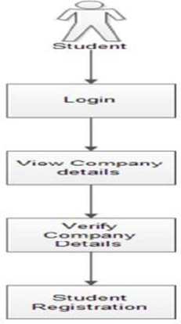

Job Postings: This website offers a list of all the available job vacancies that various firms have listed. Students can peruse the available job descriptions, as well as the necessary credentials and application deadlines. They can submit applications for several job openings, and the application status area will keep track of all of their submissions.

Students get access to a wealth of information on the firms that pique their interest in the "Company Profiles" part of the course. This contains the history of the organization, its goal, vision, and values, as well as information about the culture of the Company, the working environment, and the perks available to employees. Students have access to the Company's website as well as its social media pages and can see them at any time.

Application Status: This portion of the website displays the current status of each job application sent in by the student. This contains the status of the application, such as whether it is pending, being reviewed, or has been denied. Students can read the possible reasons for their application being denied and reapply if they continue to satisfy all of the requirements. Possesses the authority necessary to administer a variety of the system's operations. This module will be managed by an Admin (Placement Officer), who can:

• Add company data

• Provide authentication for enrolled students

• Add a news feed, and Keep the information about the firm up-to-date.

The overall records of the students, such as the data of all placed and unplaced students, will be provided on the portal. This would eliminate the bottleneck that causes misunderstanding among the students.

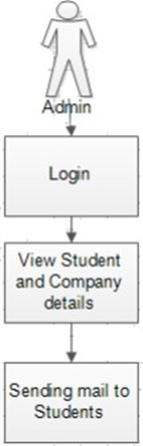

Interview Schedules: This portion of the application provides information regarding the date, time, and place of the planned interviews for the student. Students can view the interview's specifics, at which point they can accept or refuse the invitation.

In the section labeled "Feedback," you will see a representation of the feedback that the firms gave following the interview. This provides feedback on the student's performance, including remarks on their strengths and flaws and ideas for how they might improve. Students may use this criticism to enhance their abilities and better prepare for future interviews by remembering this information.

**Placement Officer Dashboard**

The purpose of the placement officer dashboard is to give the officer an all-encompassing perspective of the placement activity. This comprises advertisements for jobs, profiles of companies, applications from students, timetables for interviews, and placement reports.

Job Postings: This website offers a list of all the available job vacancies that various firms have listed. The placement officer can go through the job postings, evaluate them based on the job descriptions, needed requirements, and application deadlines, and either accept or reject the listings.

Company Profiles This portion of the document gives the placement officer in-depth information regarding the firms being considered for placement. This contains the history of the organization, its goal, vision, and values, as well as information about the culture of the Company, the working environment, and the perks available to employees. In addition, the placement officer has access to the links and profiles of the Company's various social media platforms.

Applications Submitted by Students: This portion of the website displays all student applications that have been sent in. The placement officer can review the applications, create a shortlist of potential applicants, and set up interviews.

Interview Schedules This portion of the page presents the date, time, and place of the interviews that have been planned for the students.

**Project Plan**

The purpose of the system that is being proposed is to create a system that has facilities that have been upgraded. It gives more security to data, ensures data accuracy, reduces paperwork, and saves time; only eligible students get a chance; makes information flow efficient and paves the way for easy report generation; and reduces space. These are some of the limitations of the existing system that can be overcome by the proposed system, which includes: maintaining student information in a database, giving more security to data, and ensuring data accuracy. The proposed system has a reasonable price.

**Project estimate**

An accurate estimation of the many resources needed to finish the project is the first step in ensuring that the project will be successful. In every software development project, one of the most crucial activities is developing an accurate estimate of the software project. Our failure to appropriately estimate the size of the software is one of the primary reasons software programs are unsuccessful. We nearly never make accurate size estimates, which results in inadequate funding and insufficient time allotted for the development process. Inaccurate size estimations are typically the root cause of cost and schedule overruns.

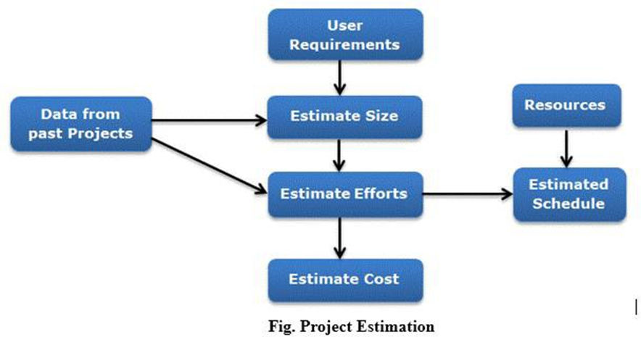

Step 1: The first step is to collect and examine the software's functional and programmatic requirements. At this stage, we analyze the software requirements, architecture, and programming limitations, then make any necessary adjustments.

A software manager, system engineers, and engineers are accountable for this.

Step 2: Specify the Work Components and Purchasing Requirements

In this stage, we will specify the work parts and procurements for the software project that will be included in the software estimate. This step's objective is to ensure that the software estimate is accurate. Software managers, system engineers, and engineers are responsible for this project.

Step 3: Estimating the scope of the project. The first thing that must be done to provide a reliable estimate of the project is to establish a rough estimate of the size of the software that will be built. The needs of a client and the system specification serve as a foundation for determining how much space software will take up. In a later phase of the project, when an estimate of the total size of the program is being developed, a system design document may include additional details that are needed.

One of the methods to estimate the size of a project is by using historical data from a system that was established in the past. This method of estimating is known as estimation by analogy. The other estimation method is based on the characteristics and capabilities of the product. The system is partitioned into the number of subsystems determined by the functionality, and the dimensions of each subsystem are determined.

Persons Responsible: the manager of the software and the engineers.

Step 4: Estimating the Level of Effort Required. As soon as we have completed estimating the size, the following step will be to estimate the amount of work depending on the size. The organizational nuances of the software development life cycle can provide the foundation for an accurate calculation of the amount of work required. There is more to creating any application software system than simply coding the system.

The estimation of how much work will go into the project will change depending on the needs for the deliverables. Estimations of the amount of work are made in terms of person-months: The organization's historical data on the development process provides the most accurate basis for estimating the amount of work that will be required. When building a variety of apps, businesses typically follow a development life cycle that is comparable.

Suppose the project is of a different type than expected, which necessitates the organization to adopt a new strategy for development. In that case, the organization might come up with alternative models based on algorithmic approaches to estimate the amount of work that will be required. Personnel accountable for this include a manager for the software, engineers, and software estimators.

Step 5: Estimating Schedule. Estimating the project timeline based on the projected amount of work that has to be done is the following stage in the estimation process, which follows the step of estimating the efforts. In most cases, the number of human resources engaged in a process will determine the timeline for a project. The work done is measured in calendar months rather than personal months. The timetable expressed in calendar months is 3.0 times (person-months) multiplied by 1/3. The value of parameter 3.0 can be changed based on the circumstances and what the organization finds most compelling.

Managers of the software, software engineers, and software estimators are the people responsible.

Step 6: Estimating the cost. The goal of this phase is to come up with a rough estimate of how much the software project will cost. The cost of a project is not only generated from the estimations of effort and size but also from other criteria such as the cost of the hardware, travel expenses, communications costs, training costs, etc., all of which should be considered.

Estimating the total price may be done as follows:

Find out how much the acquisitions will cost: Please find out how much it will cost for the various types of support and services, such as ground support equipment, workstations, test-bed boards, and simulators, as well as network and phone expenses.

Find out how much money will be spent purchasing software such as operating systems, compilers, licenses, and development tools. Find out how much money will be spent on travel and trips associated with student evaluations and interfaces, corporate visits, and attendance at project-related conferences. Determine the cost of the training that will be scheduled for the software project, as well as the labor force's compensation and skill level.

To calculate the total cost, you must use a budgeting tool supported by the institution. You will need to input the amount of effort, the wage levels, and the cost of procurements. All estimations must consider all applicable rates and components, including institutional standard inflation rates and median salary levels.

During the process of determining the cost, there is a possibility that errors and gaps in the estimates will surface. This is especially true when attempting to accommodate the cost within the financial constraints placed on the software development project. Consequently, it may be required to restate the estimates of the other phases many times, lower the amount of effort and procurements, or accept a higher level of risk to stay within the budget that has been set. If the timeline is pushed back, expenditures will increase since the work will be spread out across more expensive years. Reviewing the estimations in comparison to the budget and the timetable can be found in the following phases.

Managers of the software, software engineers, and software estimators are the people responsible.

**Project resources**

To maintain the smooth operation of a Placement Management System (PMS), it is necessary to invest in both software and hardware components. In this piece, we'll go through what kind of computer setup is needed to run a PMS smoothly.

**Software Requirements**

The PMS is cross-platform and will function on Windows, Mac OS, and Linux computers. An organization can use whichever OS it likes, but it should check to make sure it is compatible with the PMS program before making a final decision.

The PMS can't function without a web server. The PMS is often hosted on either Apache or Nginx. The PMS program requires a properly configured web server in order to function.

The PMS can't function without a database management system for storing and organizing information. PMS databases are typically managed using MySQL, PostgreSQL, or Oracle. To guarantee the PMS's access to and storage of data, the DBMS must be set up properly.

**Hardware Requirements:**

The PMS calls for a processor with a speed of at least 2.4 GHz. The CPU should be robust enough to process several user requests simultaneously.

Memory (RAM): The PMS needs at least 4 GB of RAM. However, 8 GB of RAM or more is suggested for maximum performance.

The PMS itself, along with the OS, the database management system, and the PMS software, all need storage space. For the PMS to run smoothly, you should have at least 20 GB available.

The PMS can't function without a reliable network connection to the internet and user terminals. To prevent delays in the placement procedure, it is important that the network connection is fast and stable.The most significant advantage brought about by automation is the reduction of the need for human labor. With the assistance of this site, our primary goal was to reduce our consumption of energy and resources while simultaneously achieving improvements in quality, accuracy, and precision. According to the results of a survey that we conducted with TnP coordinators (TPCs) about the most challenging and annoying tasks that they have to perform while working for the TnP department and what features they would like to see included in the TnP web portal, the most challenging and annoying tasks that they have to perform are the following:

* According to the survey that was carried out, the following are some of the issues that are currently present in the system:
* Informing the students of the situation
* Composing Invitations to be sent to the companies
* Sending a letter to every student with information on the firm and other specifics.
* Providing a list of pupils who are suitable according to the format of the firm, which varies depending on the type of business.

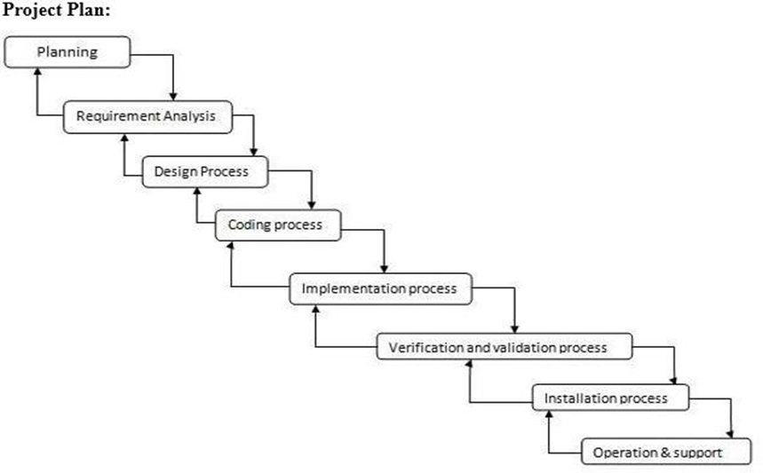

**Project breakdown**

The work breakdown structure of a project is referred to as a task. No task is suitable for all process models and projects; instead, tasks differ in accordance with the nature of the project and the level of rigor (determined by the influential actors) with which the team intends to work.

The job that has been assigned should give sufficient discipline to accomplish the goal of producing high-quality software; nevertheless, it must be a burden on the project team in the form of superfluous labor. The project's work set is specified by the conditions that are provided below:

* Outline every project job.
* Construct a task network that illustrates their mutual dependencies on one another.
* Determine which tasks inside the network are of the utmost importance and construct a timeline that illustrates the time and progress that has been made on each activity.
* Keep track of the assignment by finishing the milestones and recording it as finished. Keep track of how far along a task you are so that any delays may be identified "one day at a time."
* In order to do this, the timetable should provide a means through which the progress can be observed, and the project can be managed.

**Task network**

The reason behind a Task Network An activity network is another name for this. It is a graphical depiction of the progression of the tasks involved in a particular project. It illustrates the duration of tasks, the order of tasks, the concurrent tasks, and the dependent tasks. Identifies relationships between tasks to assist the management in ensuring that the project progresses consistently toward completion.

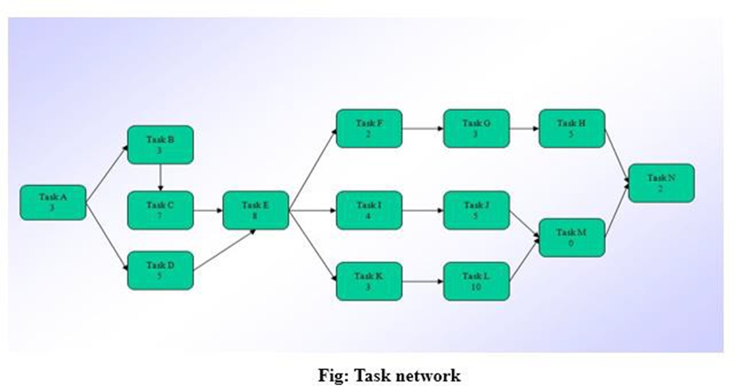

System Design & Specification

**Software Requirements**

Java/Node JS/React JS

Operating System: Windows / Linux

Django

Python

Android Studio

**System Design**

The Placement Management System (PMS) is an advanced web application that streamlines and automates hiring new staff members. The system's design comprises three distinct tiers: the display layer, the application layer, and the data storage layer. The system's three-tier architecture contributes to its scalability, dependability, and overall effectiveness.

In order to create its presentation layer, the PMS relies on the well-known open-source JavaScript framework known as React JS. Because it is built with React JS, the system's user interface is both responsive and adaptable, enabling fluid interaction on the user's part. The presentation layer's responsibilities include the user interface, the collection of input, and the transmission of requests to the application layer.

The application layer of the PMS was developed with Django, which is an advanced web framework written in Python. Django is a framework for developing web applications that is safe and dependable. It has features such as authentication, authorization, and session management. The application layer is responsible for handling user requests and executing the business logic. The application layer interacts with the data storage layer.

The data storage layer of the PMS is crafted with the assistance of a relational database management system (RDBMS), such as PostgreSQL. The data storage layer is responsible for supplying the application layer with the information it requires. In addition, the data storage layer is responsible for the enforcement of data limitations and the implementation of transaction management in order to ensure the consistency and integrity of the data.

The PMS framework was designed to be easily customizable from the beginning. Due to the system's modular, three-tier architecture, it is simple to update and enhance its functionality. If new functionality is required, for example, the application layer can be modified independently of the display and data store layers. When a Relational Database Management System (RDBMS) is used, applications that share the same database can easily combine their functionality.

The PMS framework incorporates several measures to guarantee all data's complete confidentiality. Authentication and authorization are two of the built-in security features that are included in the application layer. These two elements collaborate to prevent bad actors from accessing the system. The data storage layer is responsible for implementing data encryption and access control mechanisms to protect data from unauthorized access and preserve data privacy.

The PMS design offers a dependable, scalable, and efficient way to control the hiring of new employees. The system's three-tiered architecture protects both the security functions and the system's modularity. Innovative technologies like React JS, Django, and PostgreSQL are utilized to construct a stable and scalable system. The PMS framework was developed to handle the requirements of the recruiting industry, which are constantly shifting, and it can be adjusted to meet the particular requirements of unique organizations.

Architecture Diagram :

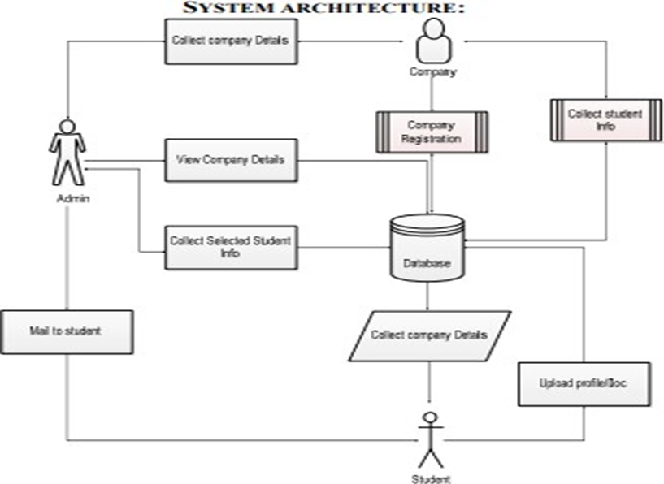

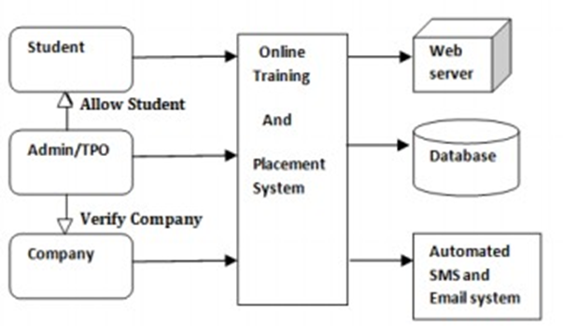

**DFD Level 0:**

It is also known as a Context Diagram in some circles. It is a high-level summary of everything being examined or modeled, a system, or a process. This view provides an overview at a glance, presenting the system as a single high-level process and illustrating its connections to other entities in the environment. Occasionally, people will refer to it as a Context Diagram.

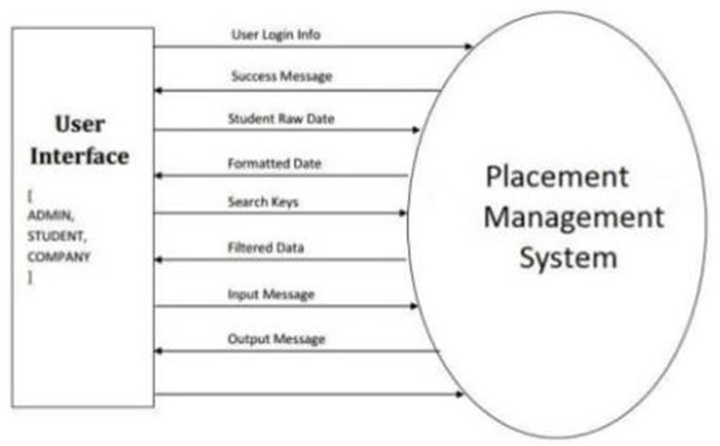

Event Management :

* Students' login and registration process
* Admin can view details of students

**DFD Level- 1**

Context diagrams, also known as level 0 data flow diagrams, are diagrams in which the entire system is represented as a single process, as was said before. A DFD with level 1 notation describes each of the primary subprocesses that, when combined, make up the entire system. An "exploded perspective" of the context diagram is how we might conceptualize a level 1 data flow diagram.

A data flow diagram (DFD) of level 1 is more detailed than a data flow diagram (DFD) of level 0 for the following reasons:

* + It gives a more detailed perspective of the context level diagram.
  + In this section, the system's primary tasks are emphasized, and we next proceed to examine its subprocesses.

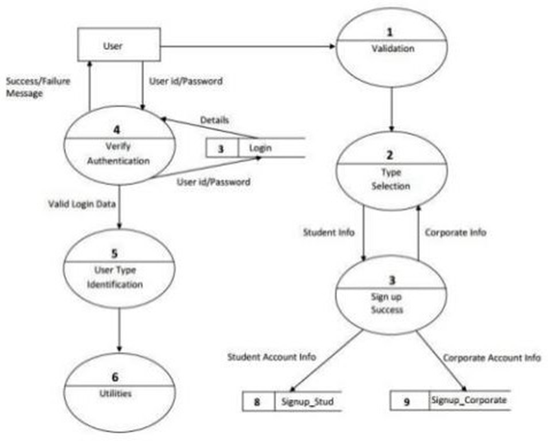

**DFD Level 2: For Student:**

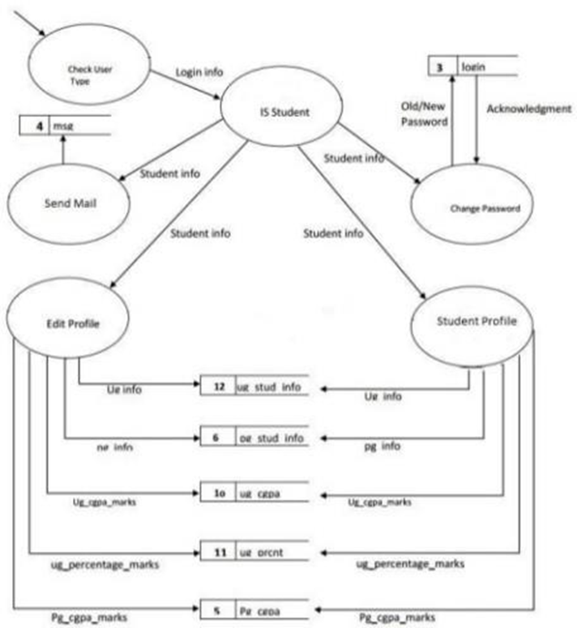

**DFD Level 2:For Admin:**

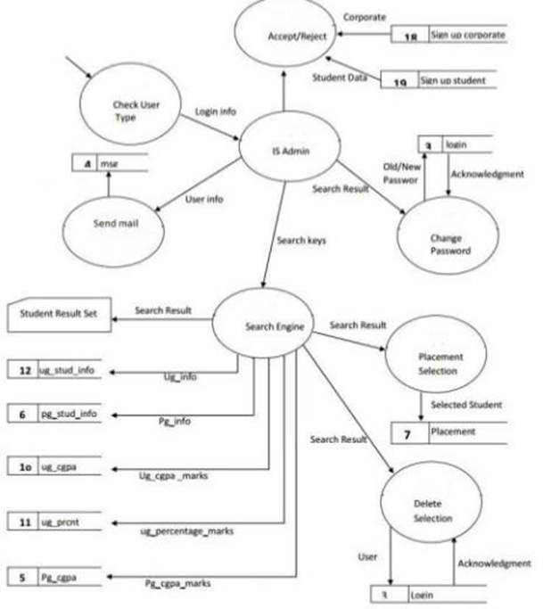

**Sequence Diagram**

The reason that sequence diagrams are such a standard dynamic modeling solution in UML is that they concentrate solely on the lifeline, which consists of the processes and objects that are active at the same time, as well as the messages that are passed back and forth between them in order to carry out a task before the lifeline comes to an end.

For Student:

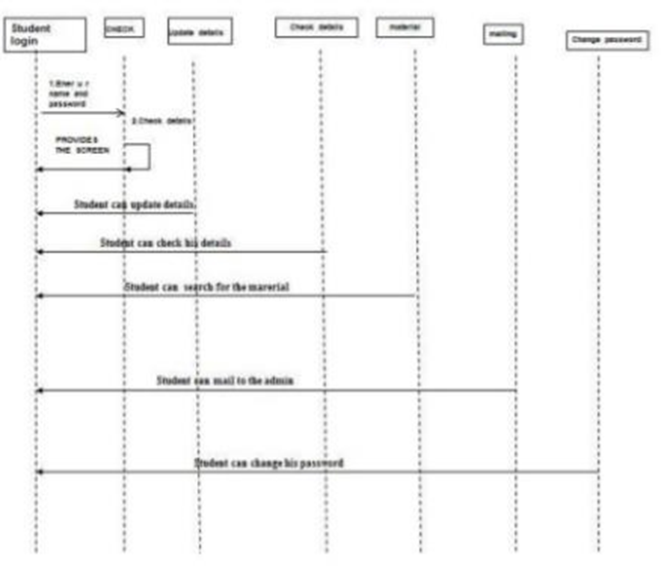

**Event Management:**

1. The sign-in and registration procedure for students
2. Students can review and make changes to their personal information and data
3. Students can alter both their login and their password at any time.
4. Students can send mail to the administration

**For Admin:**

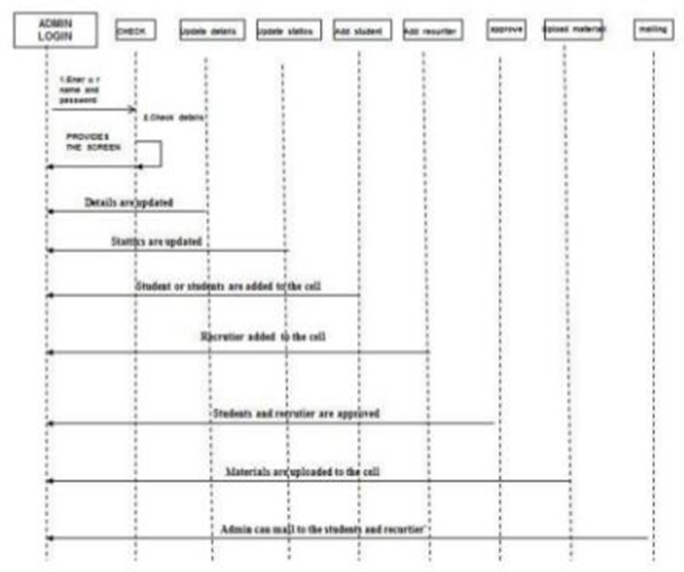

**Event Management :**

* Admin login & registration process
* The administrator will enter the pupils and receivers into the cell.
* Administrators have access to detailed information on students and recipients
* The administration can send out mailings to the students and receivers

**Class Diagram**

Class diagrams are one of the most helpful diagrams in UML because they map out the structure of a specific system by modeling the system's classes, attributes, operations, and relationships between objects. This makes class diagrams one of the most useful diagrams in UML. The use of class diagrams may provide a variety of advantages to any organization. Illustration of data models for information systems, regardless of how basic or sophisticated they may be, may be accomplished with the help of UML class diagrams. Gain a deeper comprehension of the application's overall architecture by studying its diagrams.

Class diagrams are UML (Unified Modeling Language) diagrams used to illustrate information about the classes that make up a system and the connections between those classes. A *class diagram* is a graphical representation that can convey information regarding the classes, characteristics, and relationships within a Placement Management System (PMS).

The Student, Employer, and Placement sections are the three most essential parts of the Placement Management System (PMS). The functionality of the PMS is delivered through the interaction of several modules, each capable of being represented as a class in the class diagram.

The Student class is what is used to represent the student module of the PMS. Attributes of the class are used to save information about students, such as their IDs, names, email addresses, phone numbers, and physical addresses. In a similar vein, the placement module, which is embodied by the Placement class, is connected to this one. As seen by the one-to-many link between the Student and Placement classes, a student can be enrolled in more than one placement.

The Employer class is intended to serve as a replacement for the employer part of the PMS. This class has several properties, including the employer identification number, name, email address, phone number, and physical address. In a similar vein, the placement module, which is embodied by the Placement class, is connected to this one. Because there is a link between the Employer and Placement classes that goes one way too many, an employer might have many different placements.

The Placement class fills in for the placement function the PMS provides. This course includes a Placement ID, start and finish dates, salary information, and job descriptions for available positions. The Student and Worker classes communicate with one another through this class. According to the many-to-one relationship between the Placement class and the Student class and the Placement class and the Employer class, it is possible to relate multiple placements to the same student or company.

The User class will be used for logging in to the PMS's many functionalities. The attributes of the class include the username and the password. There is a connection between this class, the Student class, and the Employer class (Katwa et al., 2016). Because of the one-to-one relationship between the User and Student and the User and Employer classes, every student and every employer only has one account in the system.

The Admin class serves as a stand-in for the PMS administrator. Characteristics of the class include the Admin ID, name, email address, and phone number, among other information. This one class is the hub around which the rest of the PMS classes revolve. Because of the many-to-one link between the Admin class and the Placement class, a single administrator can supervise many assignments.

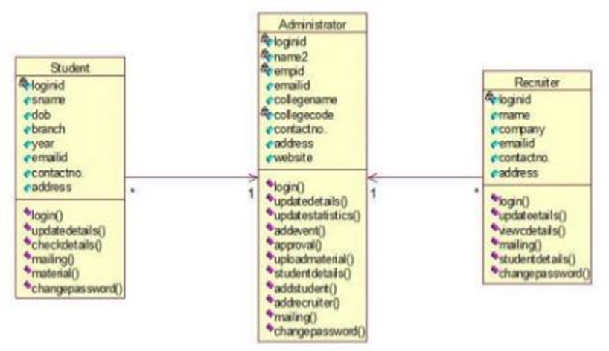

**Event Management:**

Login for the Admin. Admin can examine and update student and receiver information, create events, issue approvals, upload materials, view student information, create new students and receivers (recruiters), and send mail to students and receivers. Admin also can grant approvals.

Student' login. Students can edit and update their information, as well as their passwords and usernames, and they can send emails to the system administrator.

The login for the receiver. The receiver examines the students' profiles and can send messages to the administrator.

**Activity Diagram**

The activity diagram is yet another crucial diagram in the UML, and its purpose is to explain the system's dynamic features. An activity diagram is a flowchart illustrating the transition from one activity to another. An operation of the system is what this action is. Thus, it is an example of that. From one operation to the next, the control flow is transferred. This flow may be sequential, it may take branches, or it may go in parallel.

It is possible to summarize the function of an activity diagram as follows:

* + You are to draw out the process flow of a system.
  + Specify the order in which the various activities will take place.
  + Explain the system's parallel, branching, and concurrent flow.

**Event Management:**

* + - Admin can change permissions, maintain records about placement and training, manage records about colleges, and manage corporate records.

**Deployment Diagram**

A UML deployment diagram is a type of diagram that illustrates the setup of run-time processing nodes as well as the components that reside on those nodes. In modeling the physical features of an object-oriented system, structure diagrams of the kind known as deployment diagrams are utilized. They are frequently utilized in modeling the static deployment perspective of a system (topology of the hardware). Deployment Diagrams Serve What Purpose?

* + They illustrate the composition of the run-time system.
  + They record the hardware that will be utilized to construct the system and the connections between the various pieces of hardware.
  + They model the physical components of the hardware as well as the communication channels that connect them.

**Collaboration Diagram**

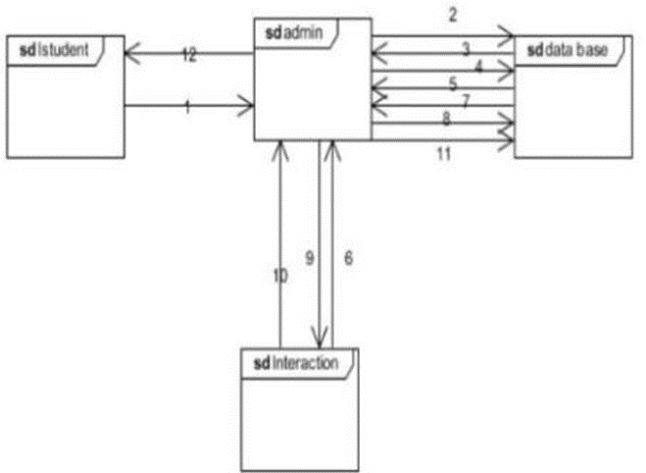

**Component Diagram**

* + In both their nature and their behavior, component diagrams are distinct from one another. Modeling the physical features of a system may be done with the use of component diagrams.
  + It is possible to summarize the function of the component diagram as follows:
  + Have a mental image of the parts that make up a system.
  + Develop an executable by utilizing both forward and reverse engineering.
  + Explain how the components are organized and their connections to one another.

**Methodology Used for Implementation**

A successful installation of a PMS (Placement Management System) requires careful planning and execution on the part of the organization. The process of developing a PMS consists of many stages, including the gathering of requirements, the designing of the system, the building of the system, the testing of the system, the deployment of the system, and the maintenance of the system. In this post, we will provide a step-by-step breakdown of the processes that are required while deploying a PMS.

Requirements The first thing to be done to establish a PMS is to collect requirements from the organization's key actors. You first need to conduct research to determine what students, educators, and potential employers want. Following these standards' completion, the PMS's design and development can continue. At this juncture, stakeholders need to be questioned to discover their requirements for the PMS.

After the requirements phase of the PMS has been finished, the design phase can start being worked on. The next thing to do is to make some rough sketches of the system's components, as well as its structure and interfaces. The design phase is also responsible for detailing the capabilities and features of the system, as well as demonstrating how those features and capabilities will fulfill the requirements determined in the analysis phase. It is vital to have a layout that is both user-friendly and straightforward in order to achieve optimal use.

The development phase entails starting from scratch with the PMS's construction after creating a detailed design. At this point, both the system's front and back ends are being constructed using the selected programming languages and frameworks. During development, one needs to be skilled in programming and database management to attain the highest possible level of performance from the PMS.

During this step, we test the PMS to ensure that it operates by the plans. At this point, we thoroughly examine the PMS to ensure it is devoid of any defects. Testing is necessary since the PMS has to function as designed, and any existing bugs must be located and repaired before they can be put into production.

After PMS testing is complete, the deployment process can begin. The Project Management System (PMS) is currently being deployed on a server and configured for optimal performance. Verify that all required hardware and software are installed before the deployment if you want everything to go off without a hitch.

Maintenance is always the last step in any PMS deployment strategy. At this phase, the PMS is tested for any issues and updated as required to ensure it continues functioning without any hitches. A PMS that is regularly maintained appropriately is dependable, current, and works to the advantage of all parties concerned.

**System Implementation plan:**

The most significant advantage brought about by automation is the reduction of the need for human labor. With the assistance of this site, our primary goal was to reduce our consumption of energy and resources while simultaneously achieving improvements in quality, accuracy, and precision. According to the results of a survey that we conducted with the TnP coordinators (TPCs) on the most challenging and annoying job that they have to do while working for the TnP department and what features they would like to see included in the TnP web portal, we found that the TnP coordinators want the TnP web portal to have more of. According to the survey that was carried out, the following are some of the issues that are currently present in the system:

• Informing the pupils in question

• Composing Invitations to be sent to the businesses

• Sending information about the firm as well as other information to each and every student via mail.

• Provide a list of students eligible to work for the firm per the Company's format, which is unique to each business.

According to the poll, seventy percent of TPC believe corporate formatting is a tough job, and twenty percent believe contacting students is an onerous duty. The remaining ten percent believe that writing invites to firms is irritating. The following are some potential solutions to the issues that have been raised with the current system:

Automation

The TPO and the TPCs have access to the automated mailers function of the platform. Mailing every student and Company is a laborious task; however, with the assistance of an automated mailer, TPO and TPCs will be able to invite corporations effortlessly, and sending mass emails to students will be a far less arduous task.

According to the survey results, the most annoying task is to create a list of all the unplaced students who meet the requirements of the Company. This is because each Company requires a unique set of parameters and a unique format; therefore, formatting must be done repeatedly, which is a time-consuming job; therefore, in order to reduce this problem and save time, a feature that automates the company format has been added to the web portal. It is a win-win situation for both TPCs and Companies because they can do their work much more efficiently.

This feature enables the Company to filter the students according to their requirements and basic eligibility. Informing the Students of the Changes Students generally have a problem in which they need to be appropriately notified. This may be because some students do not use WhatsApp or because they need to receive proper mail from the department that handles training and placement. Therefore, in order to solve this issue, a notification system has been implemented. Students will receive alerts thanks to the implementation of this feature. Because a notification window will automatically appear on their desktop, informing them of upcoming seminars, events, and companies.

When we talk about an implementation methodology, we mean a set of practices, processes, and regulations that must be implemented to carry out a particular operation to offer deliverables at the conclusion of each step. The framework for an efficient implementation methodology is developed from a collection of procedures, which are then used to build the eight principles listed below. This framework allows for flexibility to respond and adapt to the specific requirements of each project, and it incorporates the guiding principles of:

**Scope Requirements Specification**

**Risk Management**

The art and science of communicating effectively between individuals with distinct responsibilities, points of view, and expectations are at the heart of project management. This is done to ensure that the project team and the organization sponsoring the project perceive value and quality in the final product. The implementation process should be guided by sound project management principles and the idea that individuals should collaborate. The project manager is responsible for driving the collaborative process to ensure that members of the team work together to achieve the goals that have been agreed upon.

**Purpose and Requirements Specification**

The implementation strategy should center on the results to be achieved. This indicates that the process places a significant emphasis on determining the business needs that are aimed at a company's particular aims and objectives. This is accomplished methodically, laying out a solution road map that converts goals and objectives into functional requirements (critical success factors).

**Risk management process**

Risk is involved in almost everything we do, and it is unavoidably involved in the projects that involve software implementation. A possibility with a lower than one hundred percent chance of occurring is a risk. If the risk does materialize, it will negatively influence the project if it does occur. If something has a likelihood of one hundred percent, or if, in other words, it happens, then that thing becomes a problem. In contrast to risk, this kind of problem is approached differently. An efficient methodology approach to the topic of risk management covers four stages of risk management:

Stage 1: Identification

Stage 2: Quantification

Stage 3: Response Control of the Stage.

Issue management Problems can be thought of as issues. In order to find a solution to the issue, an action must be delegated to a person responsible for completing something by a specific time. Keeping track of issues according to type, status, and priority is essential. When it comes to the management of issues, the methodology should encompass the following steps:

When it comes to the management of issues, the methodology should encompass the following steps:

Stage 4: Clarify the nature of the problem.

Maintain a log of issues that everyone working on the project can quickly and easily accessible. Determine the order of importance for issues based on their potential impact on project completion. Put someone in charge of dealing with the problem.

The most important thing to do is regularly monitor the situation and report its status—communication Training. Communication Maintain regular, as well as formal and informal, communication. It is essential to keep people informed to support the project's outcome, understand what they need to do and the implications, and alert the project team to any problems that may arise. Communication should be directed at two primary groups: the project team and the stakeholders, which include staff, management, regulators, and contractors.

Training is necessary for the successful implementation of the system by end users. The following are some critical considerations: Organizing the training schedule. Too soon, and everything will be forgotten; the people involved in the audience. The training plan used for management will be different from the training strategy used for staff members who will be obliged to utilize the system as part of their day-to-day operations.

The management of quality ensures that the product satisfies or exceeds the requirements set forth by the customer. It is a strategy for ensuring that all of the activities, procedures, and documentation needed to put a project into action are practical and efficient for the system's operation as a whole. The emphasis is placed not only on the result but also on the process of getting there. Examining the Results of the Implementation In this stage, learning from past errors and determining where improvements are needed is initiated. Within the quality management framework, we are currently in the review stage.

A meeting to wrap up the project should be held with all project team members, including any stakeholders, before the project is officially signed off. Project team members and stakeholders discuss and document lessons learned through project outcomes, significant issues, benefits, and risks. This discussion and documentation are typically carried out in a workshop setting.

**Documentation**

A comprehensive documentation phase is required to complete the software development process successfully. Throughout any one of several phases, such as design, implementation, or testing, documentation for the Placement Management System (PMS) might be created. The following is a list of important information that may be found in the PMS manual:

The PMS Functional Requirements Specification (FRS) is a document that lays out the requirements that must be met for the system to function as intended. This document includes the system's objectives, its capabilities, and some instances of how it is meant to be applied. This piece of writing provides, in addition to a description of the outcomes sought from the system, specifics of the information that must be supplied to it. The FRS document is essential because it acts as the foundation for the entire project and directs the development team as they work to build a system that satisfies the customer's requirements.

The Technical Design

The document provides a comprehensive analysis of the technical architecture of the PMS (TDD). This process includes the design of the user interface (UI), the architecture, and the database. The document describes in great detail the technologies used in the implementation of the system and explains the decisions made. The TDD document comprehensively explains the system, which the development team can use to create the system in the most effective way possible.

For further assistance, users of the PMS can consult the accompanying user manual. It walks you through everything you need to know to use the site, from creating an account to posting jobs and applying for them to using the platform. In addition to text descriptions, the user manual contains drawings and screenshots that better illustrate the functions and capabilities of the system.

The document that serves as the test plan outlines the testing strategy for the PMS. It explains in detail the many forms of testing that need to be carried out, such as individual unit testing, integration testing, and full-scale system testing. The methods and processes that will be used during the testing process, as well as the results that will be collected, are outlined in the document as well. The testing plan ensures that the product is up to par and meets the requirements set out by the client.

The PMS deployment and maintenance guide covers installing the software in a live environment and maintaining it functioning smoothly after it has been set up. This package includes instructions for rolling out the system, setting up the server, and installing any necessary apps. The troubleshooting and repair procedures, as well as preventative maintenance for the system, are outlined in depth in the maintenance manual.

Every step of the implementation methodology needs to be documented thoroughly. The documentation should be tailored to the subject matter and the individuals who will be reading it. It typically takes the following forms: Procedure, an overview of the methodology, including its phases, milestones, and deliverables. Templates are also included in this type of documentation, and they contribute to promoting efficiencies and streamlining the implementation process. The project team is the intended audience for this kind of documentation.

Technical Specifies the technical requirements that must be met in order to install the information system. This kind of documentation is meant to be read by people with technical backgrounds (Divyashree & KS, 2022). End-User Manuals for the end user, the system administrator, and the support staff are referred to here. These resources include training manuals, aides (like PowerPoint slides), and automated training material (such as animations).

**Non-functional requirement:**

Performance Requirements:

High Velocity: The system should perform the requested task in parallel with a variety of actions in order to provide a prompt response. The system must then wait for the completion of the process.

Accuracy: The system's execution of the process should be correct, and the result should be displayed accurately.

The system's output should be in the format that the user requires.

Safety Requirements: A safe and dependable transmission medium is required, and this must be arranged in order to guarantee the data's integrity. In order to prevent any improper use or malfunctioning, the information regarding the source and the destination must be entered accurately. User-generated passwords typically consist of letters, numbers, and special characters, making them more challenging for hackers to crack. Therefore, no harm will come to that user account.

Specifications for Required Safety: Secure access to confidential data (user's details). The protection of information and information systems against illegal access, use, disclosure, interruption, alteration, or destruction is what we mean when discussing information security. There is a common misconception that information security, computer security, and information assurance are all synonymous terms that can be used interchangeably.

Even though these areas frequently overlap and work toward the same overarching objectives of maintaining the confidentiality, integrity, and accessibility of information, some subtle distinctions exist between them. For safety and security reasons, the user password must always be stored in an encrypted form. Only those with a high level of authority should be able to access any user details. Usernames and passwords will be used to control who can access the system.

**Result and Discussion**

The advancement of this project opens up a wide variety of previously unexplored areas. This project has much potential and could be implemented at any university or other institution.

Objectives: • To get students ready for jobs in the industry; • To give students chances for training and employment; • To get industrial institutes to interact with students; • To prepare students to work in the industry.

**Testing**

The Project Management System (PMS) is like any other piece of software in that it must undergo rigorous testing at multiple stages during development. The purpose of testing is to ensure that the system in question is error-free, operates as specified, and is by the requirements set by the client. The PMS comprises many modules, some of which allow for the posting of positions, the tracking of applicants, and the generation of reports. Several different kinds of testing, including acceptance testing, system testing, integration testing, and unit testing, must be carried out on the PMS to guarantee the system's quality.

"unit testing" refers to testing performed on individual components or modules of a more extensive system. By testing each module, we can ensure that the overall system functions as intended and is by the specifications. When doing quality assurance on a system, "integration" refers to ensuring that all its components function in concert. It ensures that all of the components of the system may be assembled correctly. The process of putting an entire system through its paces in order to determine whether or not it satisfies the requirements set out by the customer and operates as anticipated is known as system testing. At long last, the software is put through acceptance testing to ensure that it satisfies the requirements outlined by the customer and is prepared for distribution.

Other testing methodologies that may be utilized include but are not limited to, load testing, performance testing, and security testing, just a few examples. During load testing, a system is put through its paces to see how well it can manage an overwhelming number of users and data. Putting the system's security mechanisms through their paces ensures that they will prevent hackers. It is necessary, in order to ensure the system's reliability, to test the performance of the system under a variety of loads.

Developing a comprehensive test plan that outlines the testing strategy, the test cases, and the intended outcomes is essential to ensure that the testing is carried out effectively. If you want to be sure that your system has been put through all of the necessary tests, you should devise a testing strategy based on the requirements specification and the design documents. Testing should occur at several stages throughout the process, including while the system is still being constructed, when each module is complete, and right before deployment.

In order to ensure that the PMS has a high level of quality, it is necessary to perform exhaustive testing on it during the development phase. Spending more time and money on testing early on in the process, detecting and correcting more defects, and saving more money on bug fixes is one way for the development team to save money. Both the client's and end users' needs may be addressed with a PMS that has been thoroughly tested, which can lead to increased productivity and output.

UNIT TESTING: This method concentrates verification efforts on the module, a minor software component being tested, utilizing both the comprehensive design and the procedure. Testing to the specification is carried out to locate errors within the confines of the module. Before moving on to the integration testing phase, the unit tests for each module must be completed successfully.

INTEGRATION TESTING: - Following the completion of the unit testing, we will move on to the integration testing. This testing activity can be considered testing the design, so the emphasis is placed on testing module interaction. The objective is to determine whether or not the modules can be appropriately integrated into the system.

SYSTEM TESTING: This part involves testing the whole software system. The requirement document serves as the point of reference for this process. The operating system's objective is to determine whether or not the software satisfies its requirements.

ACCEPTANCE TESTING: This type of testing is carried out with a data representative of the client to demonstrate that the software is functioning adequately. In this context, testing concentrates on the system's behavior in the outside world; the program's internal logic receives less attention.

WHITE BOX TESTING: - This is the unit testing method in which a unit will be taken at a time and tested thoroughly at a statement level to find the maximum possible error.

BLACK BOX TESTING: This testing method treats a module like a single unit. It examines the module's interface and communication with other modules rather than delving into the specifics at the statement level. In this context, the module will be seen as a black box that will produce output after receiving some input. The output for a particular set of input combinations is sent to the other module.

**Testing Plan**

Software testing is an essential part of the quality assurance process for a product and is the last assessment of the software's specifications, designs, and codes. The software engineer is faced with a fascinating anomaly when testing is performed.

* + The scope of the test includes the following:

In software development, testing entails running a program to locate and fix bugs. A good test case has a probability of locating an error that has yet to be found. A practical test reveals an error that had previously gone undetected.

* + Testing Principles: Every test ought to be able to be linked back to the requirements of the end-user

The tests should start on a small scale and work their way up to testing on a large scale. -The tests should be planned well in advance of their actual execution. It is not possible to conduct exhaustive testing. For testing to be as helpful as possible, it should be done by an impartial third party.

**Test cases**

|  |  |  |  |
| --- | --- | --- | --- |
| TEST CASE | EXPECTED RESULT | ACTUAL RESULT | RESULT STATUS |
| 1 | Login | Admin Login, Student Login,  And Company Login | PASS |
| 2 | Registration | Registration Of  Students And Various Companies. | PASS |
| 3 | Check Details | Admin can check the details of every registered student and Company. The Company can check the details of Students. | PASS |
| 4 | Schedule the dates | Companies will schedule the date and time for the interviews of the students from various colleges.  For that, students can send their CVs to that Company. | PASS |
| 5 | Notification To Students | The Company sends the email or the message to the students whenever the  interview is conducted. | PASS |

**Test results**

The software testing method known as "WHITE BOX TESTING" (also known as "Clear Box Testing," "Open Box Testing," "Glass Box Testing," "Transparent Box Testing," "Code-Based Testing," or "Structural Testing") is one in which the tester is aware of the internal structure, design, and implementation of the item that is being tested. Other names for this method include: "Open Box Testing," "Clear Box Testing," "Open Box Testing," and "Transparent Box Testing,"

The tester will select the proper inputs to exercise several pathways through the code and will decide whether outputs are appropriate. An understanding of programming as well as knowledge of implementation is required. Testing that goes beyond the user interface and investigates the inner workings of a system is known as white box testing. This technique was given its name because, from the software tester's perspective, the application is analogous to a white or transparent box, the contents of which are visible to everybody.

The software testing approach known as "Black Box Testing," which is sometimes referred to as "Behavioral Testing," is one in which the tester is unaware of the internal structure, design, or implementation of the item being tested. These tests could be functional, or they might be non-functional-functional, but most of the time, they are functional. This technique was given its name because, from the software tester's perspective, the application is like a black box, the contents of which are hidden from view. The Black Box testing approach may be applied to the following stages of the software testing process:

* + - Tests of System Integration
    - Tests of the Whole System
    - Acceptance Testing

Unit testing is a type of testing that focuses the verification process on the module, which is the smallest component of the program. With the help of the complete design description, critical control routes are put through a series of tests to determine whether or not there are faults within the parameters of the module.

Each sub-module in this system, such as campaigns, leads, contacts, and so on, is subjected to individual testing as part of the system's unit testing protocol. The validations of their input fields are being tested.

INTEGRATION TESTING Once all of the individual units have been tested, the next step is to test how they were put together. This ensures that no data is lost across interfaces, that one module does not hurt another, and that a function is not performed incorrectly. After the unit tests for every sub-module, the modules are then integrated with one another and tested.

Modules of the project will be tested as part of system testing for the current system. Currently, we are conducting tests to determine whether or not the system generates the correct output. The integration of all of the modules took place, after which the flow of information between the various modules was examined.

In addition, it was examined to see if the flow of data conformed to the standards. When the integration was finished, every module was analyzed to see whether or not it was operating correctly as a whole. This meant it was examined to see whether or not any particular module was not functioning correctly. During this testing stage, we checked, among other things: - to see whether all the forms functioned appropriately. Whether or whether all of the forms have been connected correctly. Whether or not all of the photographs are shown correctly. Whether or not the transit of data is appropriate.

**Future Scope**

The Placement Management System (PMS) is an online platform that automates and centralizes processes such as posting jobs, keeping track of candidates, and creating reports. Other duties that may be performed on the PMS include searching for applicants. The construction of the system used the programming languages Django, Python, React JS, and Node JS to guarantee that it was safe, scalable, and efficient. Because of the increasing digitization of our world, the PMS has the potential to become an indispensable tool in the recruitment procedures of various companies.

There is room for the PMS to undergo additional development in the direction of the incorporation of AI and ML algorithms. With these technologies, organizations can automate repetitive tasks, analyze large amounts of data, and base decisions on the analysis of that data. For instance, they employ machine learning algorithms to analyze application data to find the best matches based on variables like education, experience, and talent. Moreover, chatbots driven by AI could be added to the system to provide timely and correct responses to the inquiries posed by candidates.

Additionally, the PMS plans to use blockchain technology in the not-too-distant future. Blockchain technology can make the recruiting process more secure and transparent. This is accomplished by producing an immutable record of all transactions. Applying blockchain technology in the employment process allows for establishing accountability for all parties involved, reducing the likelihood of fraudulent activity.

The PMS can be expanded to include additional features such as the incorporation of social media, video interviews, and gamification. With the help of social media integration, businesses may expand their application pool and fortify their reputation as an employer, all while doing the same thing. Video interviews allow organizations to conduct interviews remotely, which results in time and cost savings for the organization. If the application process is more like a game, more people will be interested in applying, and those who do apply will have a more positive experience.

The PMS offers many possible uses in the foreseeable future and many possibilities for expansion and improvement. By implementing cutting-edge technology and cutting-edge functionality, the PMS enables organizations to realize time and cost savings while upgrading their hiring processes. As a result of changes like employment, the PMS has the potential to develop into a resource that is necessary for businesses to win the war for talent.

To minimize the potential for making mistakes while performing manual labor was the primary motivation behind the creation of this website. Put aside some time for the procedure. In addition, students are immediately notified by SMS of the change.

Upgraded versions may have additional functions, such as notifying students about employment that are accessible both on and off campus. This type of notice may be among the additional features offered. The system cannot provide SMS integration at this time. As a result, it may be altered such that the SMS integration is provided. In the future, more capabilities, such as analytics, could be added to this site for tracking students' development in various subject areas. Following analysis, this method will inform pupils of the areas in which they have deficiencies.

**Conclusion**

To summarize, the Placement Management System, often known as PMS, is a solution that encompasses everything and simplifies and automates the entire hiring process. The Project Management System (PMS) was built with cutting-edge technologies such as Django, Python, React JS, and Node JS, which accounts for its power, scalability, and efficiency. We have discussed the software and hardware requirements of the PMS, as well as the implementation strategy, class diagram, and documentation. The importance of testing has been highlighted, and the many types necessary for the PMS have been outlined.

There is significant room for development and improvement in the potential future uses of the PMS. Several additional features, such as artificial intelligence and machine learning algorithms, blockchain technology, social media integration, video interviews, and gamification, could be added to the PMS to improve the hiring process's efficiency.

The PMS has the potential to become a vital instrument for organizations of all kinds when it comes to luring, recruiting, and maintaining top-tier talent. By implementing cutting-edge technology and cutting-edge functionality, the PMS enables organizations to realize time and cost savings while upgrading their hiring processes. Because of its adaptability and scalability, the PMS is an excellent choice for organizations' often changing requirements, making it a natural fit for the competitive nature of the recruiting industry. The PMS is an excellent tool that companies may utilize in their search for the most talented individuals and to keep a competitive edge in their operations.

The IEEE publication validates the functionality of our suggested solution. It can successfully log an authorized user into the system and register them. In our system, the Admin can check the Student list to see which ones are eligible based on the criteria provided by the Company, instantly notify them of their eligibility, and successfully update their information at any time. All three components of our system, including security and usability, are top-notch.

The rising demand for convenience and the consolidation of all relevant information into a single location has always been difficult for everyone. Implementing this web-based placement management system will simplify the lives of students and administration personnel by presenting an alternative to the system currently being utilized. During the placement period, simple management of the allocation process will be made possible thanks to the straightforward accessibility and operation of this portal.

Because of the growing demand for digitalization in every facet of day-to-day activities, we predict that there will be a significant demand for online portals in the not-too-distant future. The increased convenience will drive this demand that digitalization will bring to the lives of everyone. Also, the rapidly growing worries about global warming are due to the increase in deforestation for a large amount of paper required. Here at this location, we have a small role in saving Mother Nature. Therefore, we hope each of you can appreciate the opulence of the digitalization process. Especially in this hectic and draining life that we lead, we are conserving one of the most critical factors that keep us going: human energy.

References

Divyashree, N. and KS, N.P., 2022. Design and Development of We-CDSS Using Django Framework: Conducing Predictive and Prescriptive Analytics for Coronary Artery Disease. *IEEE Access*, *10*, pp.119575-119592.

Katwa, C., Sanjana, K. and Parmar, P., 2016. Final Year Placement Management System. *International Journal of Scientific and Technical Advancements*, *2*(1), pp.233-234.