CSCE 876 FALL 2017

Venkata Krishna Mohan Sunkara

65528957

**HOMEWORK 4**

**3. a.**

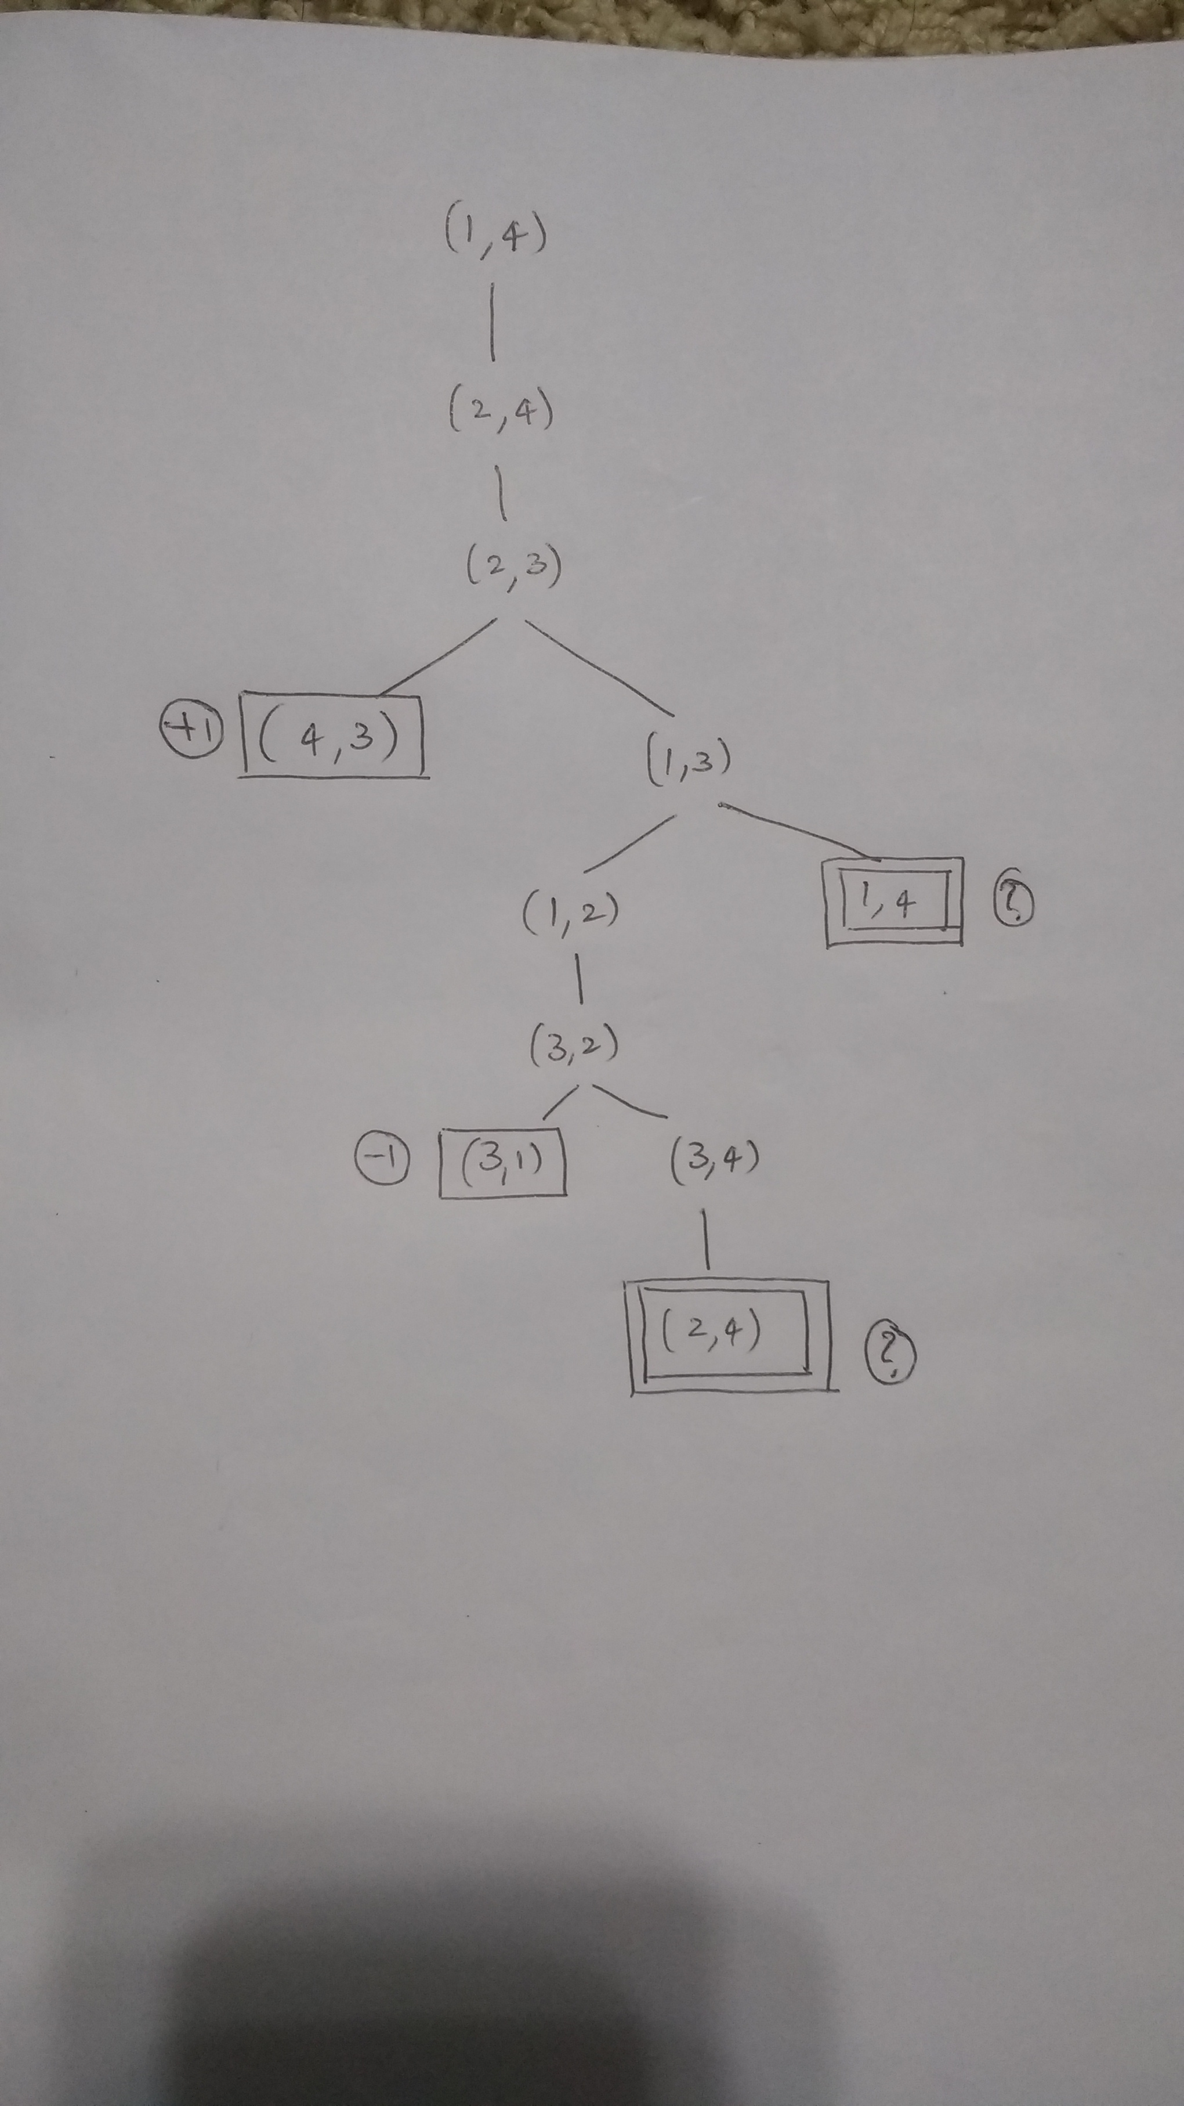

Each state is represented as (Sa, Sb) where Sa and Sb denote the token locations. The game values for player A are represented in circles.

**b.**

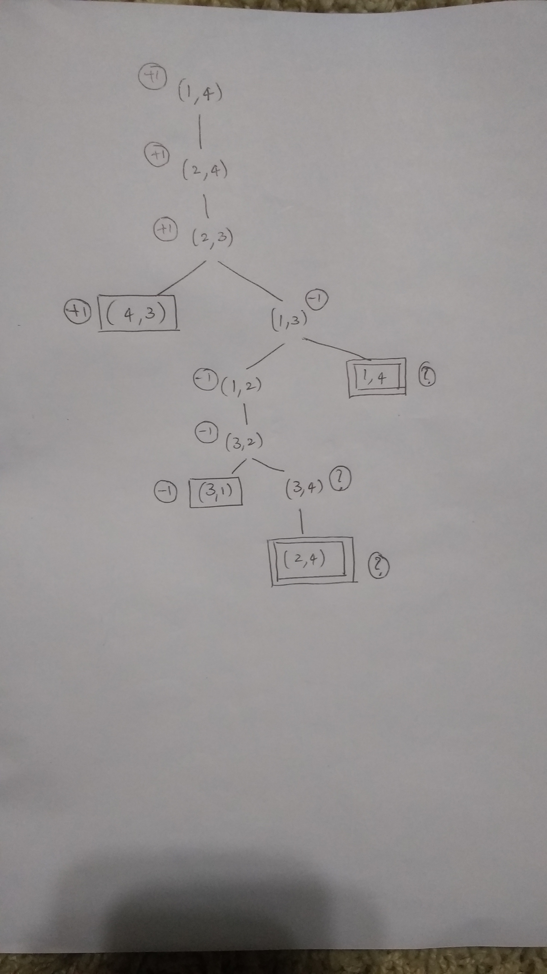

The “?” values are handled by assuming that each player plays his best choice possible to win the game. If a player enters a ”?” state, he will always choose the win. For example, if min(-1,?) occurs then min chooses -1 and if max(+1,?) occurs then max chooses +1. If all the successors of a state have value “?” then “?” is backed-up.

**c.**

The standard minimax is depth first and would go into an infinite loop. It can be fixed by comparing the current state against the stack, same as that of a graph search technique. If a state is repeated then denote its game value with a “?” and propagated to above nodes as described above. Although this technique works for this case, it doesn’t always work because it is unclear about how to compare “?” with another positions game value where the game value is not a zero-sum game.

**d.** The notion that A wins if n is even and B wins if n is odd can be proved by induction. The base case of n=3 is a loss for A and the base case of n=4 is a win for A. Now consider any game scenario for n>4, the initial moves are same. A, B move one step towards each other and now the game is reduced to size n-2, if we ignore the extra choice of moves on squares 2 and n-1 as every player tries to win the game. If we continue reducing the game size until a base case is reached we can say that if n is odd, B wins the game and if n is even A wins the game.