**SOLIDWORKS INSTALLATION GUIDE**

# STEP 1: LICENSE REQUEST

Before Install kindly copy the below link and paste it in the browser and fill the form to use this software. [**http://web.iitm.ac.in/licenserequest/**](http://web.iitm.ac.in/licenserequest/)

**STEP 2:**

**License Server activation**

**For Windows:**

For communicating with License Manager, host file is to be edited.

Right click on and open **Notepad** via run as an administrator.

In that, **File** 🡪**open**, then **C:** 🡪 **windows** 🡪 **system32** 🡪 **drivers** 🡪 **etc**, then select file type as “**All**” to view the files in it and open the **hosts** file and add last line as below and save the file.

**10.21.202.41(one tab space) WIN-6UJVIVC87K0**

**Installation**

**STEP 1** : Extract the files and run the setup as run as administrator. Then click **OK** to continue the installation.

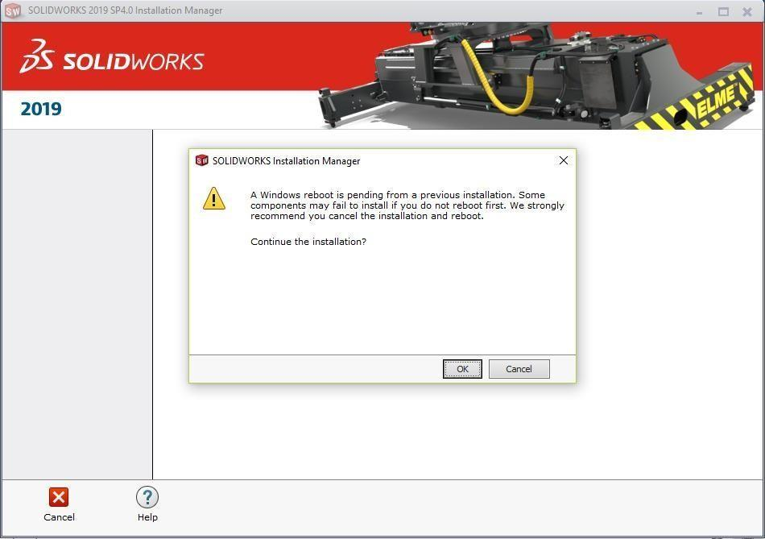

**STEP 2** : Select individual to continue the installation and click **Next**.

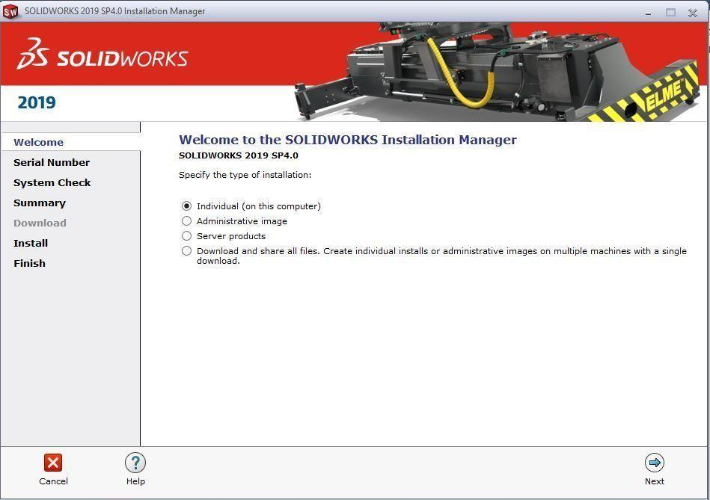

**STEP 3** : Select the required modules and enter the license serial number of given below.

Serial number : **9710 - 0244 - 3863 - 3705 - 45JF - C75C**

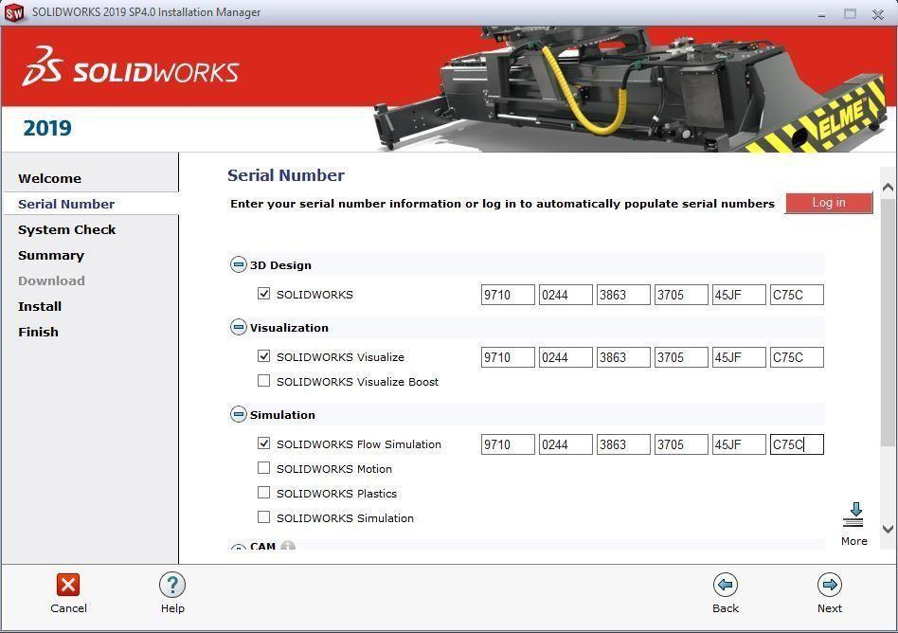

**STEP 4** : Click on the check box for accepting the terms and click “**Install now**”.

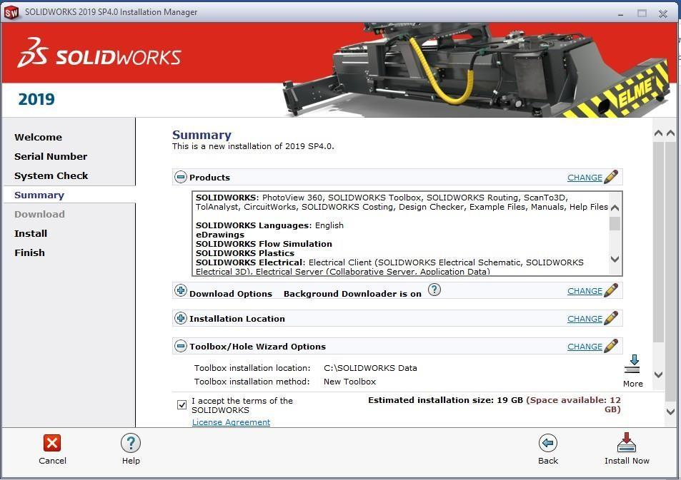

**STEP 5** : Enter the **port@server** info as given below & then click **OK.**

port@server : **25734@10.21.202.41**

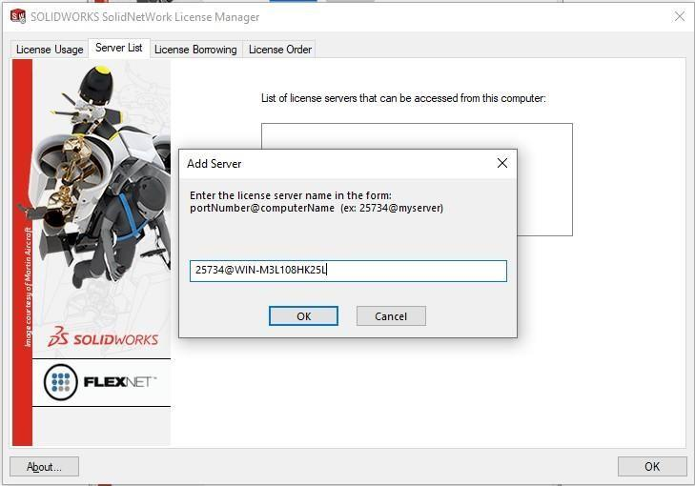

**STEP 6 :** Then the installation will start and it will take time to install.

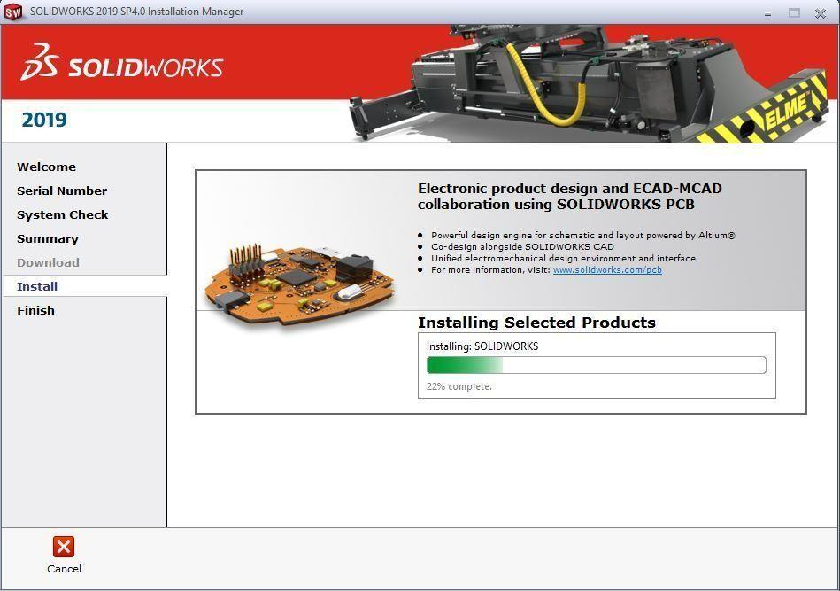

**STEP 7** : Choose “**No, thank you”** and click **Finish** button to complete the installation.

