Question 1 : Create a new HDFS file structure data/dev/analysis in the HDFS home directory. Copy the covid-19 folder in to it



Question 2 :

Change the permission of Covid_patient_Apr26.csv file to have only read/write/execute for the owner/ group and read/write permission for others.

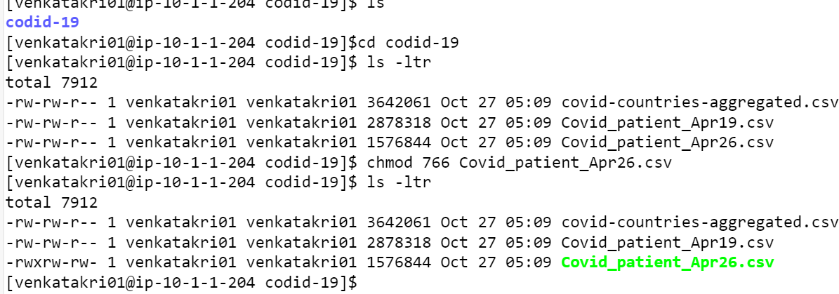

Question 3 :

copy covid-19 folder in to another hdfs directory data/prod/analysis

Question 4 :

Read the contents of the file Covid_patient_Apr19.csv and print the contents on the screen

Question 5 :

Print the no of lines present in the HDFS file Covid_patient_Apr19.csv



Question 6 :

Count the no of records present in the HDFS file Covid_patient_Apr19.csv for the state “UP”

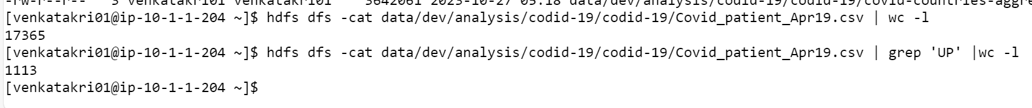

7. Delete the file Covid_patient_Apr19.csv from the data/prod/analysis folder in HDFS

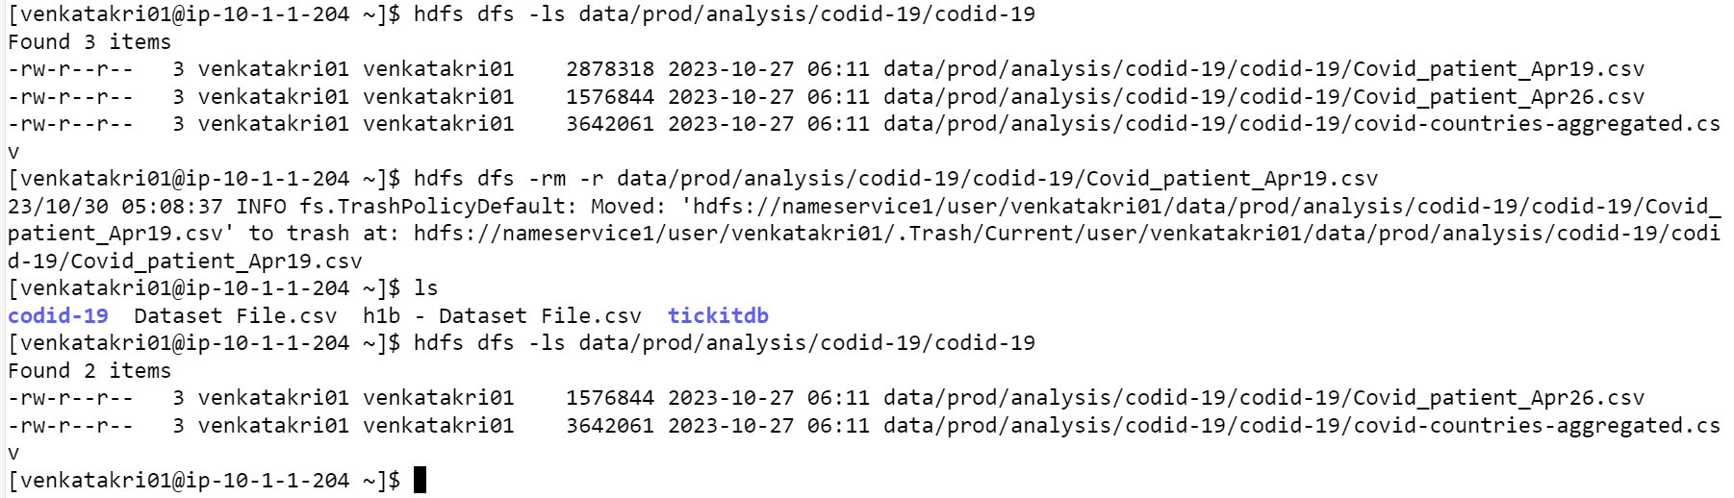

8. Delete the covid-19 folder from both the dev and prod folders created above

9. Copy the tickitdb folder(in the local file system) in to HDFS home directory. How many blocks will be created for the files in this directory?

10. Find all the file names which has the word “pipe” in their names

11. Copy the h1b.csv file to hdfs home directory. How many blocks will be created for this file?

12. Move the h1b.csv file (in the HDFS) to the tickitdb folder in hdfs. How many blocks will be there for the tickitdb folder?

13. Calculate the total storage space occupied by the files directory and its contents.

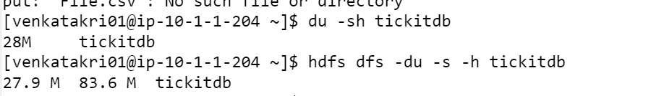

14. Check the storage quota for the file directory.

15. Delete a specific snapshot 'snapshot1' from the file directory.

16. Create a snapshot of the file directory in HDFS.

17. Set a replication factor of 3 for all files within the file directory.

18. Rename the 'file name' file to 'new file name' within the file directory in HDFS.

19. List all the files and directories in the files directory in HDFS.

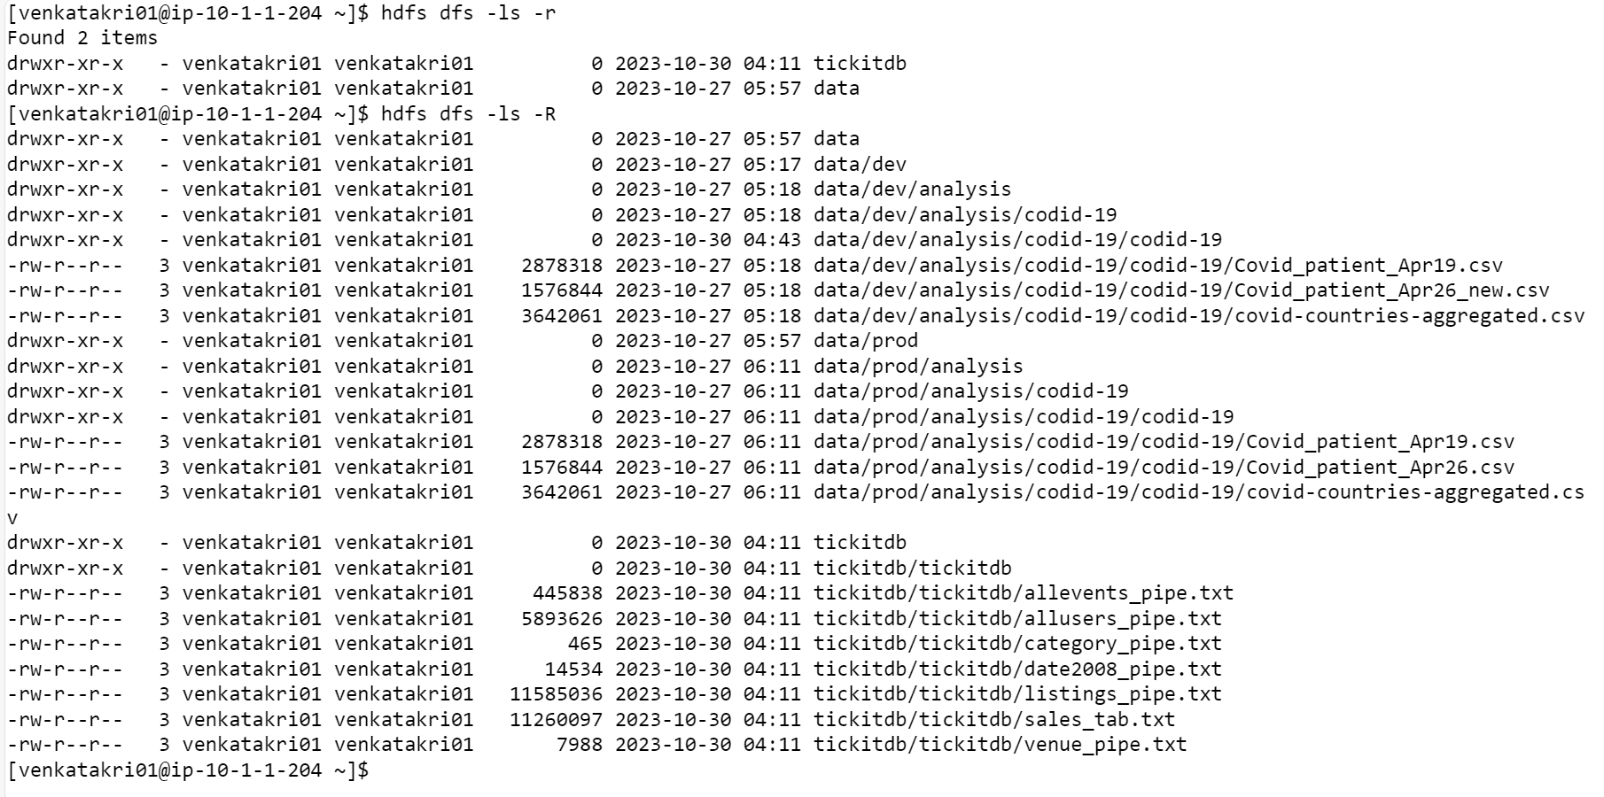

20. Create an HDFS directory file names in your home directory and upload a local file 'test.txt' to i

