**Online Air ticket Booking system**

**PROBLEM STATEMENT**

The new airline “King Flyer” is looking to have a strong start in the market and have requested for a dynamic online flight booking system. We are going to help them do exactly do that with our system.

Our online flight booking system provides users the freedom to browse for flights across the globe, view the timings, flight fares and the duration of journey before booking the tickets. Once the customer has registered, he will be able to proceed with the booking and payment process of the flight tickets .The users also have the provision to book tickets for multiple passengers by providing their details. The administrator will be responsible for updating the flight schedule and prices.

This Software Requirements Specification (SRS) document outlines the steps taken to create a working solution for the initial deployment of the online booking system for King Flyer Airlines.

**Acronyms and Abbreviations:**

SRS – Software Requirements Specification

GUI – Graphical User Interface

**Functional Requirements:**

1. User friendly web-based GUI which is accessible over the internet
2. User registration screen where new users can register themselves and book flights
3. Login screen that allows registered users to their account and view booked tickets (i.e. Manage My Account – MMA functionality)
4. Search screen to search flights between given source and destination locations, date and time
5. Flight booking screen where user can enter passenger details

**USAGE SCENARIOS**

**Epics:**

|  |  |
| --- | --- |
| EPIC ID | EPIC NAME |
| EP-FBS-1 | User Authentication |
| EP-FBS-2 | User Profile/Dashboard |
| EP-FBS-3 | Flight Search |
| EP-FBS-4 | Flight Booking and Payment |
| EP-FBS-5 | Administrator Dashboard |

**Epic EP-FBS-1**

**User Story US-FBS-101**

Guest user should be able to surf the system

**Solution**:

1.    Guest user will be able to search for flights based on locations and time

2.    He cannot book ticket without login/registration.

3.    He should be redirected to registration page when he attempts to book a flight.

**User Story US-FBS-102**

New user should be able to register to the system

**Solution**:

1.    System should accept name, username, password, contact and email as mandatory fields for registration.

2.    Username should be validated for availability.

3.    Password should be validated for length and type of characters.

4.    Password should be confirmed by matching.

5.    Email confirmation should be sent to the newly registered user.

**User Story US-FBS-103**

Registered user should be able to login to the system

**Solution**:

1.    The system should authenticate user’s username and password.

2.    Username and password cannot be left blank.

3.    Alert to be raised if the username and/or password are incorrect.

4.    If valid username and password is entered, the user should be directed to the search/book flight page.

**Epic EP-FBS-2**

**User Story US-FBS-201**

User should be able to manage his profile

**Solution:**

1.    User should be able to view his profile (username, contact details etc.)

2.    User should be able to modify his contact details, password etc.

3.    User should be able to view his past booking(s).

4.    User should be able to view his current booking(s).

**Epic EP-FBS-3**

**User Story US-FBS-301**

User should be able to search flight

**Solution**:

1.    User should be able to search flight by source and destination locations, and date of travel.

2.    User should be able to add number and type of passengers (adult/child/infant).

3.    User should be able to define class of travel (economy/premium/business).

4.    Search result should display flight name, date, time, duration and cost.

5.    In case of no result, appropriate message should be displayed.

**User Story US-FBS-302**

User should be able to add filter to flight search

**Solution**:

1.    User should be able to modify search by adding ‘filter by time’ option.

2.    Search result should be modified according to time filter applied.

**Epic EP-FBS-4**

**User Story US-FBS-401**

User should be able to book ticket

**Solution:**

1.    Ticket gets booked only when user is logged in.

2.    Flight source and destination location is taken from selected search result.

3.    Date of travel is taken from selected search result.

4.    User should fill booking details like passenger name, age, gender, passport number (for international flight only).

5.    Alert to be raised if mandatory fields are left blank, before submitting.

6.    The session should block the seat(s) until booking confirmed.

**User Story US-FBS-402**

User should be able to confirm/modify/cancel ticket before booking

**Solution:**

1. User should be shown previously filled booking details (passenger details, date and time of travel, cost of travel etc.) before confirming booking.
2. User should be shown availability of seats in the chosen flight.

3.    User should have option to modify/cancel ticket before booking.

**User Story US-FBS-403**

User should be able to make payment

**Solution**:

1.    User should be directed to payment option after he confirms ticket details.

2.    Amount to be paid will be decided based on number of passengers booked and cost of travel for that flight.

3.    User should have payment option (by credit card/debit card/internet banking).

**User Story US-FBS-404**

User should be able to view booked ticket

**Solution**:

1.    After booking and payment, the e-ticket should be displayed to the user for download/print.

2.    A copy of e-ticket should be sent to the user by email.

**Epic EP-FBS-5**

**User Story US-FBS-501**

Admin should be able to login to the system

**Solution**:

1.    The system should authenticate admin’s username and password.

2.    Username and password cannot be left blank.

3.    Alert to be raised if the username and/or password are incorrect.

4.    If valid username and password is entered, the admin should be directed to the dashboard.

**User Story US-FBS-502**

Admin should be able to add new flight operating details

**Business rules:**

1.    New flight ID to be auto-generated.

2.    Flight arrival and departure times and locations can be added.

3.    Flight fares can be defined.

**Solution**:

1.    Provide an option to add new flight in the system.

2.    On successful addition, show the flight details on dashboard.

**User Story US-FBS-503**

Admin should be able to modify/delete flight operating details

**Business rules:**

1.    Flight arrival and departure times can be modified.

2.    Flight locations can be modified.

3.    Flight fares can be modified.

4.    Current flight details like time can be modified.

**Solution:**

1.    Provide an option to modify a flight in the system.

2.    On successful modification/deletion, show the details on dashboard.

**User Story US-FBS-504**

Admin should be able to add new/modify/delete fleet details

**Solution:**

1.    Provide an option to add new flights to the airline’s fleet.

2.    Provide an option to modify/delete existing flights in the airline’s fleet.

**USE CASE DIAGRAM**

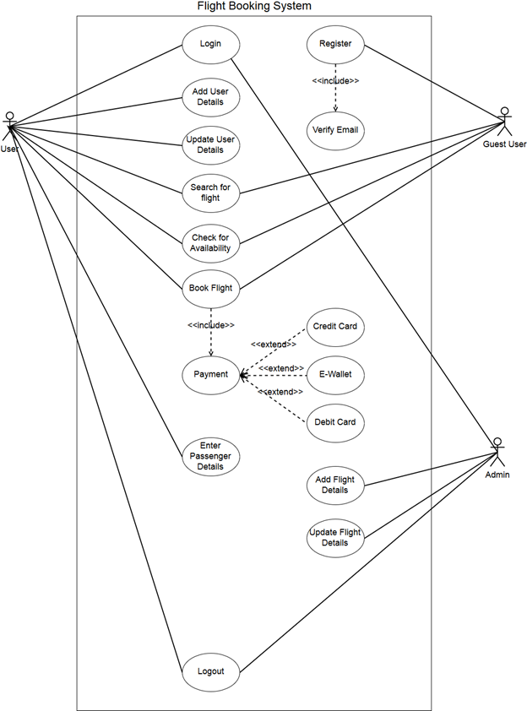

**CHANGE LOG**

|  |  |  |
| --- | --- | --- |
| *Version* | *Date* | *Description* |
| 1.0 | 26/08/2017 | Initial draft of SRS |
|  |  |  |
|  |  |  |