10 PYTHON PROGRAMMING CASE STUDIES
Problem Statement • Objectives • Assumptions • Algorithms • Flowcharts • Pseudocode • Source Code • Tests • Conclusions • Sample Outputs

Prepared from the 10 Python files supplied in this conversation.

Contents
- 1. University Scholarship Allocation
- 2. Employee Payroll and Deduction Analysis
- 3. Examination Result and Grace-Mark Validation
- 4. Password Policy Validation Engine
- 5. Student Feedback Sentiment Scoring
- 6. Sports Tournament Ranking System
- 7. Tuple-Based Transaction Audit
- 8. Nested-List Examination Seating Validation
- 9. Multi-Route Courier Dispatch Planning
- 10. Multi-Branch Retail Inventory Transfer
Flowcharts use a white background with black arrows, outlines, and lettering.

1. University Scholarship Allocation

1. Problem Statement
A university needs to check which students meet scholarship eligibility rules and rank eligible students fairly. Eligibility depends on aggregate percentage, subject marks, attendance, and family income.

2. Objective
Identify eligible students, explain why ineligible students fail the rules, and rank eligible students using the defined tie-break order.

3. Assumptions
- Aggregate and subject marks are percentages on a 0–100 scale.
- A student needs aggregate ≥ 75, every subject mark ≥ 60, attendance ≥ 75, and annual income ≤ Rs. 250,000.
- Ranking is by aggregate descending, attendance descending, income ascending, minimum subject mark descending, then student ID ascending.
- The input student records are already available in the program.

4. Algorithm
- Read each student record.
- Check aggregate, minimum subject mark, attendance, and income rules; collect all failure reasons.
- Add students with no failure reasons to the eligible list; print reasons for others.
- Sort eligible students using the stated ranking and tie-break rules.
- Print the final ranking.

5. Flowchart
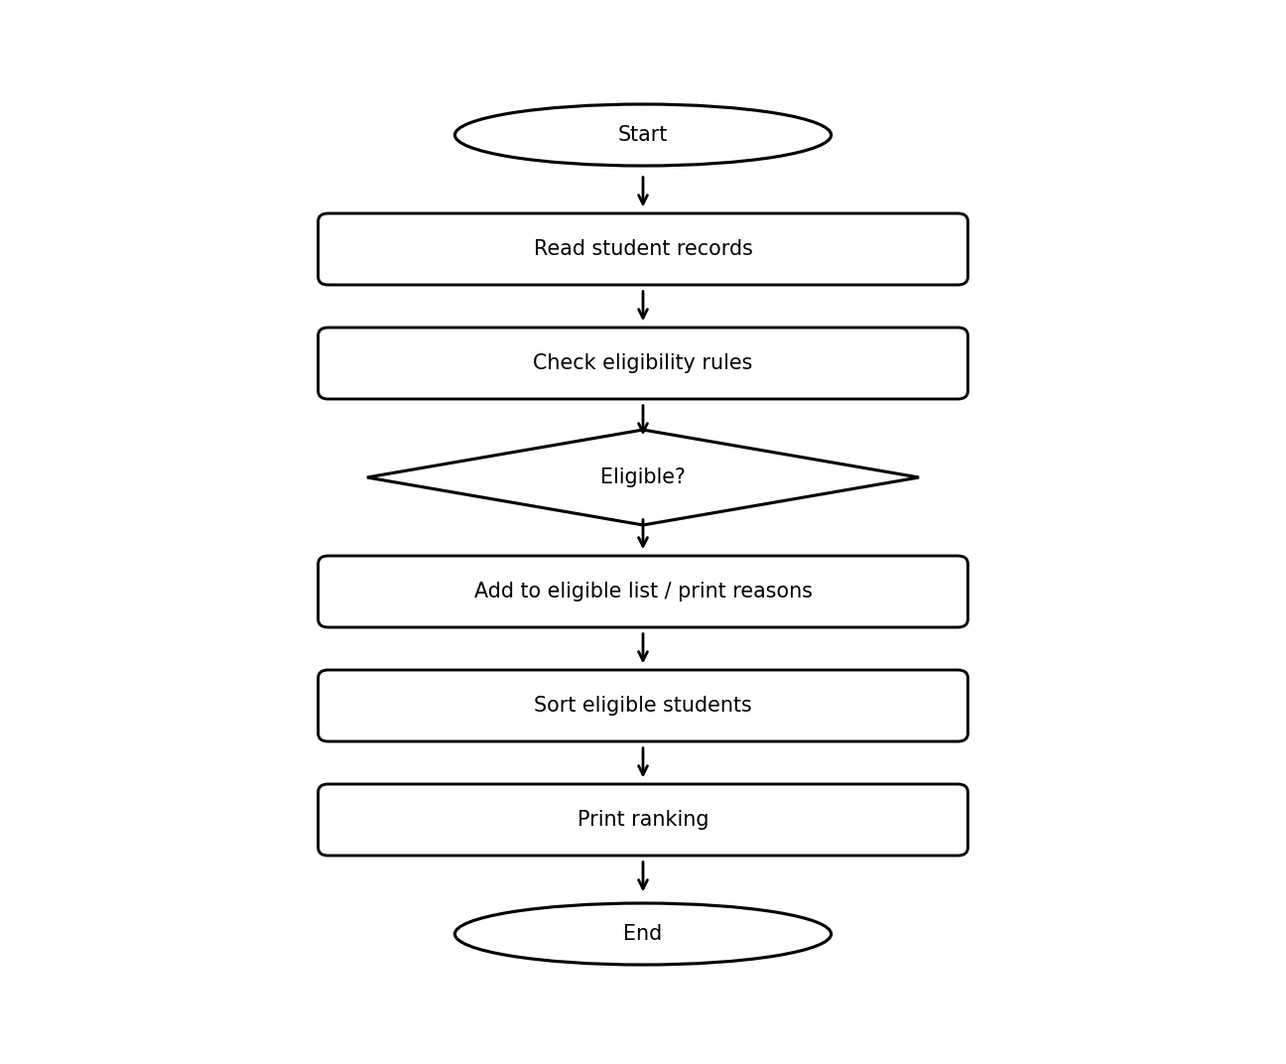
Flowchart convention: Start/End are oval; process steps are rectangular; decision steps are diamond-shaped. All elements are black on white.

6. Pseudocode
BEGIN
eligible ← empty list
FOR each student s
reasons ← empty list
IF s.aggregate < 75: add aggregate reason
IF minimum(s.subjects) < 60: add subject-mark reason
IF s.attendance < 75: add attendance reason
IF s.income > 250000: add income reason
IF reasons is empty: append s to eligible
ELSE: print s and reasons
SORT eligible by aggregate DESC, attendance DESC,
income ASC, minimum subject mark DESC, ID ASC
PRINT ranked eligible students
END

7. Python Source Code

students = [
{
"id": 101,
"name": "Ravi",
"aggregate": 85,
"subjects": [80, 90, 85],
"attendance": 90,
"income": 180000
},
{
"id": 102,
"name": "Sita",
"aggregate": 85,
"subjects": [75, 80, 85],
"attendance": 95,
"income": 200000
},
{
"id": 103,
"name": "Kiran",
"aggregate": 70,
"subjects": [65, 70, 75],
"attendance": 80,
"income": 150000
}
]

eligible = []

for s in students:
reasons = []

if s["aggregate"] < 75:
reasons.append("Aggregate below 75%")

if min(s["subjects"]) < 60:
reasons.append("Subject marks below 60%")

if s["attendance"] < 75:
reasons.append("Attendance below 75%")

if s["income"] > 250000:
reasons.append("Income exceeds limit")

if not reasons:
eligible.append(s)
else:
print(s["name"], "Not eligible:", ", ".join(reasons))

# Ranking and tie-breaking
eligible.sort(
key=lambda s: (
-s["aggregate"],
-s["attendance"],
s["income"],
-min(s["subjects"]),
s["id"]
)
)

print("\nScholarship Ranking:")
for rank, s in enumerate(eligible, start=1):
print(rank, s["name"], s["aggregate"])

8. Test Cases
Test input / condition | Expected result
Ravi: 85 aggregate, 90 attendance, income 180000, subject marks 80/90/85 | Eligible; ranked below Sita due to lower attendance.
Sita: 85 aggregate, 95 attendance, income 200000, subject marks 75/80/85 | Eligible; rank 1.
Kiran: aggregate 70 | Not eligible: Aggregate below 75%

9. Conclusion
The program applies multiple eligibility rules consistently and uses explicit tie-breakers to produce a reproducible scholarship ranking.

10. Sample Output
Kiran Not eligible: Aggregate below 75%

Scholarship Ranking:
1 Sita 85
2 Ravi 85

Explanation: Kiran is not eligible because the aggregate is below 75%. Sita ranks first because both eligible students have 85 aggregate marks, and Sita has higher attendance (95% versus 90%).

2. Employee Payroll and Deduction Analysis

1. Problem Statement
An organization must calculate an employee’s gross salary, progressive deductions, and net salary from basic pay, allowances, overtime, and incentives.

2. Objective
Generate a salary statement with each earning component, gross salary, deduction, and take-home salary.

3. Assumptions
- All entered amounts are non-negative numeric values in Indian rupees.
- Gross salary is the sum of basic salary, allowances, overtime, and incentives.
- The deduction is 5% of the first Rs. 20,000, 10% of the next Rs. 30,000, and 15% of the amount above Rs. 50,000.
- The program does not validate negative values; users are expected to enter valid amounts.

4. Algorithm
- Input employee name and four pay components.
- Calculate gross salary as the sum of all components.
- Calculate progressive deduction using the appropriate salary bracket.
- Subtract deduction from gross salary to get net salary.
- Print a formatted salary statement.

5. Flowchart
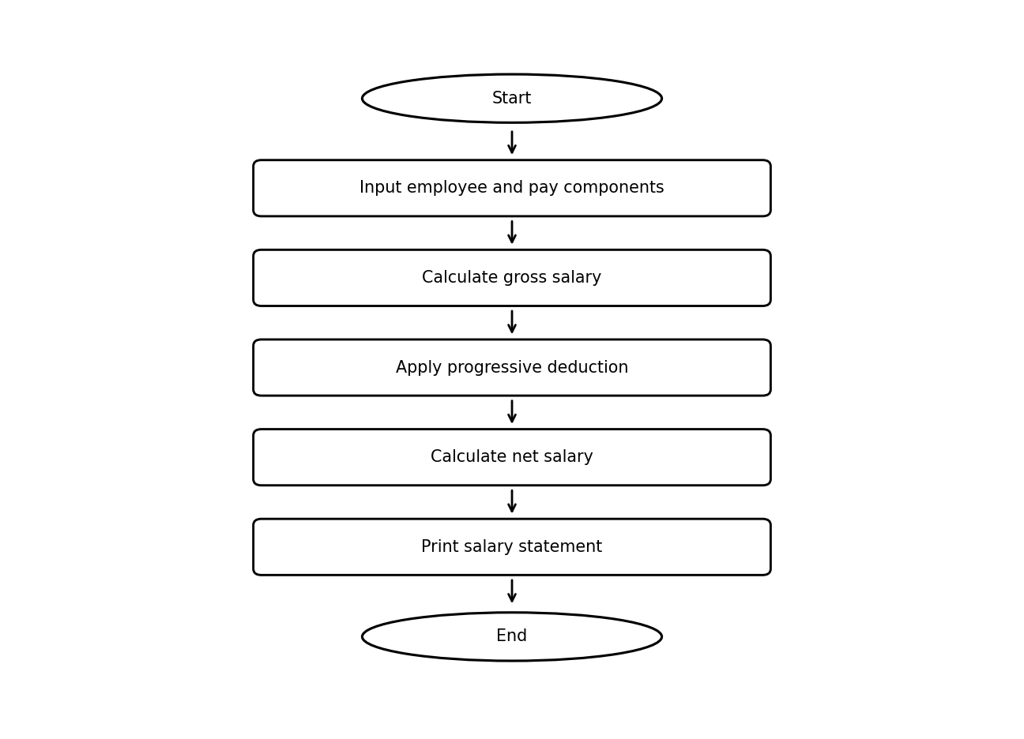
Flowchart convention: Start/End are oval; process steps are rectangular; decision steps are diamond-shaped. All elements are black on white.

6. Pseudocode
BEGIN
INPUT name, basic, allowances, overtime, incentives
gross ← basic + allowances + overtime + incentives
IF gross ≤ 20000: deduction ← gross × 0.05
ELSE IF gross ≤ 50000:
deduction ← 20000 × 0.05 + (gross − 20000) × 0.10
ELSE:
deduction ← 20000 × 0.05 + 30000 × 0.10
+ (gross − 50000) × 0.15
net_salary ← gross − deduction
PRINT salary statement
END

7. Python Source Code

# Employee Payroll and Deduction Analysis

name = input("Enter employee name: ")
basic = float(input("Enter basic salary: "))
allowances = float(input("Enter allowances: "))
overtime = float(input("Enter overtime pay: "))
incentives = float(input("Enter incentives: "))

# Calculate gross salary
gross = basic + allowances + overtime + incentives

# Progressive deduction calculation
if gross <= 20000:
deduction = gross * 0.05
elif gross <= 50000:
deduction = (20000 * 0.05) + ((gross - 20000) * 0.10)
else:
deduction = (20000 * 0.05) + (30000 * 0.10) \
+ ((gross - 50000) * 0.15)

# Calculate net salary
net_salary = gross - deduction

# Display salary statement
print("\n======= SALARY STATEMENT =======")
print("Employee Name :", name)
print("--------------------------------")
print(f"Basic Salary : Rs. {basic:.2f}")
print(f"Allowances : Rs. {allowances:.2f}")
print(f"Overtime Pay : Rs. {overtime:.2f}")
print(f"Incentives : Rs. {incentives:.2f}")
print("--------------------------------")
print(f"Gross Salary : Rs. {gross:.2f}")
print(f"Total Deduction: Rs. {deduction:.2f}")
print("--------------------------------")
print(f"Net Salary : Rs. {net_salary:.2f}")
print("================================")

8. Test Cases
Test input / condition | Expected result
Basic 18000; other components 0 | Gross Rs. 18,000.00; deduction Rs. 900.00; net Rs. 17,100.00
Basic 30000; other components 0 | Gross Rs. 30,000.00; deduction Rs. 2,000.00; net Rs. 28,000.00
Basic 60000; other components 0 | Gross Rs. 60,000.00; deduction Rs. 5,500.00; net Rs. 54,500.00

9. Conclusion
The program automates payroll arithmetic and applies progressive deduction bands. Production use should add validation for negative inputs and confirm that the deduction policy matches current organizational rules.

10. Sample Output
Enter employee name: Anu
Enter basic salary: 60000
Enter allowances: 0
Enter overtime pay: 0
Enter incentives: 0

======= SALARY STATEMENT =======
Employee Name : Anu
--------------------------------
Basic Salary : Rs. 60000.00
Allowances : Rs. 0.00
Overtime Pay : Rs. 0.00
Incentives : Rs. 0.00
--------------------------------
Gross Salary : Rs. 60000.00
Total Deduction: Rs. 5500.00
--------------------------------
Net Salary : Rs. 54500.00
================================

3. Examination Result and Grace-Mark Validation

1. Problem Statement
An examination office needs to validate subject marks, apply a limited grace-mark allowance to narrowly failing subjects, and determine a student’s overall classification.

2. Objective
Calculate total marks and percentage, report each subject’s pass/fail status and grace marks, and assign a final classification.

3. Assumptions
- The grace-mark budget is 5 marks in total across all subjects.
- Grace is applied only when the marks are below the pass mark and the required marks fit within the remaining grace budget.
- Valid marks must be between 0 and the subject maximum; pass marks must be between 0 and the maximum.
- Classification thresholds are 75% Distinction, 60% First Class, 50% Second Class, otherwise Pass Class, provided all subjects are passed.
- Invalid subject entries are skipped by the supplied code; the reported total therefore reflects accepted entries.

4. Algorithm
- Input number of subjects and initialize totals and grace budget.
- For each subject, input maximum, obtained, and pass marks.
- Reject invalid criteria or obtained marks by skipping that subject.
- If the subject is narrowly failed, apply grace if enough grace budget remains.
- Update total and record subject status.
- Calculate percentage and classify the result; if any recorded subject fails, classify as Fail.
- Print subject results and summary.

5. Flowchart
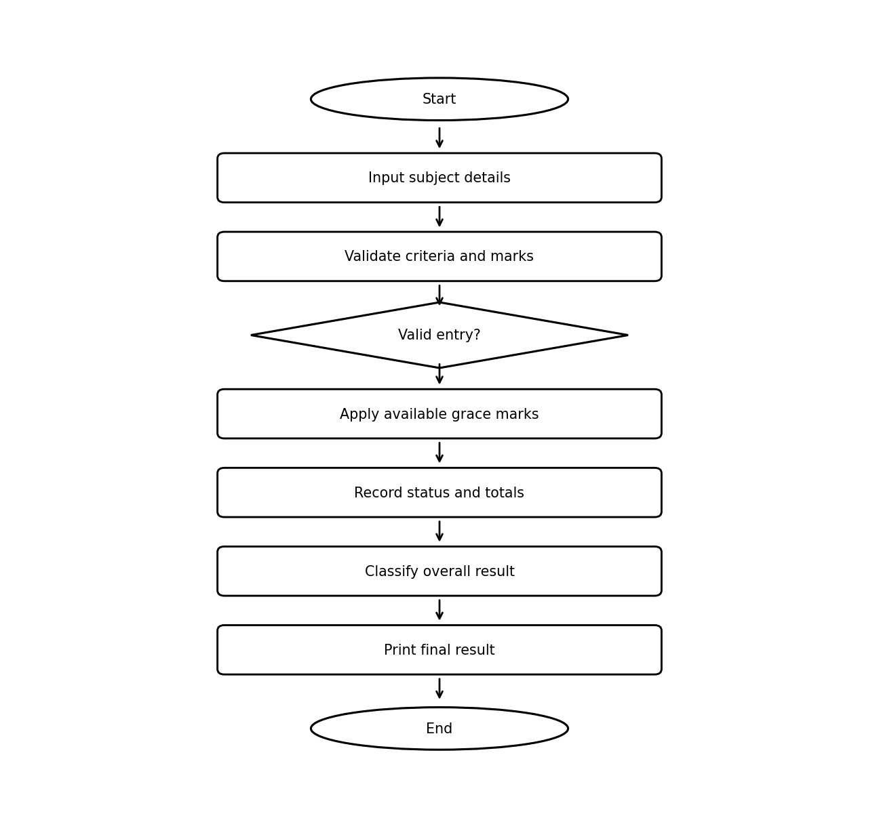
Flowchart convention: Start/End are oval; process steps are rectangular; decision steps are diamond-shaped. All elements are black on white.

6. Pseudocode
BEGIN
INPUT n; total ← 0; grace_used ← 0; subjects ← empty list
REPEAT n times
INPUT subject name, maximum, marks, pass_mark
IF criteria or marks invalid: print error; CONTINUE
grace ← 0
IF marks < pass_mark:
needed ← pass_mark − marks
IF needed ≤ 5 − grace_used:
grace ← needed; grace_used ← grace_used + grace
marks ← marks + grace
status ← PASS if marks ≥ pass_mark else FAIL
total ← total + marks
append subject result
max_total ← sum of accepted subject maxima
percentage ← total / max_total × 100, or 0 if max_total is 0
IF any subject FAIL: classification ← Fail
ELSE classify by percentage thresholds
PRINT result report
END

7. Python Source Code

# Examination Result and Grace-Mark Validation

n = int(input("Enter number of subjects: "))
subjects = []

total = 0
grace_limit = 5
grace_used = 0

for i in range(n):
print("\nSubject", i + 1)

name = input("Enter subject name: ")
maximum = int(input("Enter maximum marks: "))
marks = int(input("Enter obtained marks: "))
pass_mark = int(input("Enter minimum pass marks: "))

if maximum <= 0 or pass_mark < 0 or pass_mark > maximum:
print("Invalid subject criteria!")
continue

if marks < 0 or marks > maximum:
print("Invalid marks! Enter marks within the maximum.")
continue

grace = 0

# Apply grace marks if the student narrowly fails
if marks < pass_mark:
needed = pass_mark - marks

if needed <= grace_limit - grace_used:
grace = needed
grace_used += grace
marks += grace

# Ensure marks never exceed maximum marks
marks = min(marks, maximum)

total += marks

if marks >= pass_mark:
status = "PASS"
else:
status = "FAIL"

subjects.append((name, marks, maximum, status, grace))

print("\n========== FINAL RESULT ==========")

all_pass = True

for name, marks, maximum, status, grace in subjects:
print(f"{name}: {marks}/{maximum} | {status} | Grace: {grace}")
if status == "FAIL":
all_pass = False

max_total = sum(subject[2] for subject in subjects)
percentage = (total / max_total * 100) if max_total > 0 else 0

if all_pass:
if percentage >= 75:
classification = "Distinction"
elif percentage >= 60:
classification = "First Class"
elif percentage >= 50:
classification = "Second Class"
else:
classification = "Pass Class"
else:
classification = "Fail"

print("----------------------------------")
print("Total Marks:", total, "/", max_total)
print("Percentage:", round(percentage, 2), "%")
print("Grace Marks Used:", grace_used)
print("Final Classification:", classification)

8. Test Cases
Test input / condition | Expected result
Subject maximum 100, marks 48, pass mark 50, grace available 5 | 2 grace marks applied; subject passes at 50.
Subject maximum 100, marks 40, pass mark 50 | Needs 10 marks; grace is not applied; subject fails.
Invalid marks 105 out of 100 | Entry is rejected and skipped.

9. Conclusion
The program combines input checks, a shared grace-mark budget, subject-level decisions, and overall classification. A real examination system should also report how many entries were skipped so the final percentage cannot be misunderstood.

10. Sample Output
Enter number of subjects: 2

Subject 1
Enter subject name: Mathematics
Enter maximum marks: 100
Enter obtained marks: 80
Enter minimum pass marks: 50

Subject 2
Enter subject name: Science
Enter maximum marks: 100
Enter obtained marks: 48
Enter minimum pass marks: 50

========== FINAL RESULT ==========
Mathematics: 80/100 | PASS | Grace: 0
Science: 50/100 | PASS | Grace: 2
----------------------------------
Total Marks: 130 / 200
Percentage: 65.0 %
Grace Marks Used: 2
Final Classification: First Class

4. Password Policy Validation Engine

1. Problem Statement
A system needs to evaluate whether a password meets a policy for length, character categories, repeated characters, and prohibited substrings. The uploaded file is named “Passport Policy Validation Engine,” but its Python code validates passwords.

2. Objective
Check each password against all policy rules and print either VALID or INVALID with the detected reasons.

3. Assumptions
- A valid password has at least 8 characters.
- It must include uppercase, lowercase, digit, and special characters.
- Three identical consecutive characters are prohibited.
- The case-insensitive substrings “password”, “admin”, and “123456” are prohibited.
- The program checks sample passwords embedded in the source code.

4. Algorithm
- Define a validation function and an empty error list.
- Check minimum length and required character categories.
- Search for three identical consecutive characters.
- Check whether any prohibited substring appears in the lowercase password.
- Print VALID if no errors exist; otherwise print INVALID and each error.
- Run the function for every sample password.

5. Flowchart
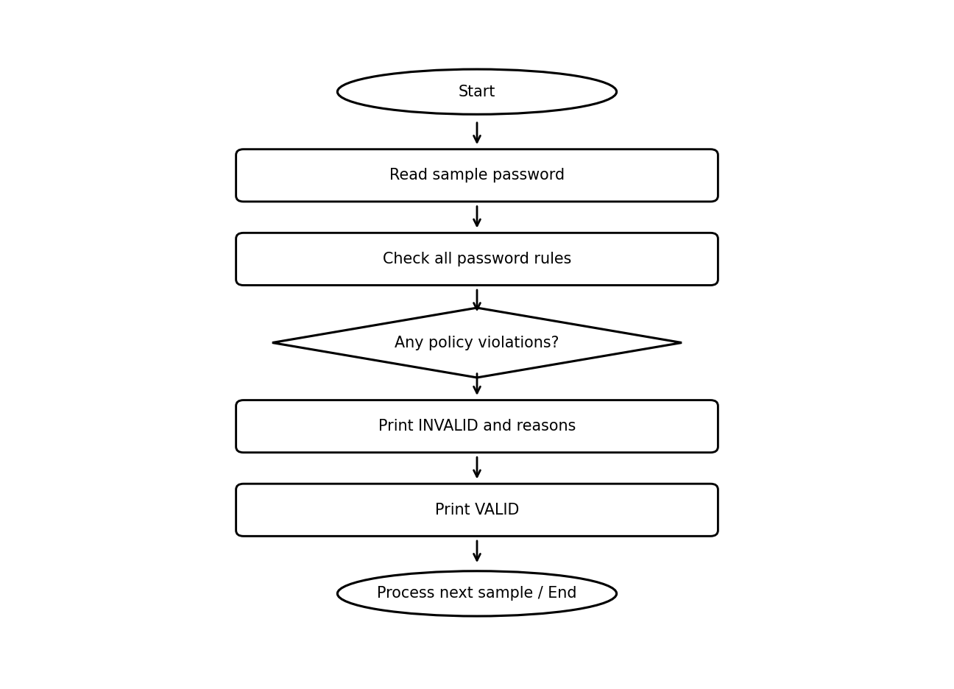
Flowchart convention: Start/End are oval; process steps are rectangular; decision steps are diamond-shaped. All elements are black on white.

6. Pseudocode
FUNCTION validate_password(password)
errors ← empty list
CHECK length ≥ 8
CHECK uppercase, lowercase, digit, special character
CHECK no character repeats 3 times consecutively
CHECK no prohibited substring occurs (case-insensitive)
IF errors empty: PRINT VALID
ELSE: PRINT INVALID and errors
END FUNCTION
FOR each sample password: validate_password(sample)

7. Python Source Code

def validate_password(password):
errors = []

# 1. Minimum length
if len(password) < 8:
errors.append("Password must contain at least 8 characters.")

# 2. Character categories
if not any(c.isupper() for c in password):
errors.append("Add at least one uppercase letter (A-Z).")

if not any(c.islower() for c in password):
errors.append("Add at least one lowercase letter (a-z).")

if not any(c.isdigit() for c in password):
errors.append("Add at least one number (0-9).")

if not any(not c.isalnum() for c in password):
errors.append("Add at least one special character.")

# 3. Repeated characters
for i in range(len(password) - 2):
if password[i] == password[i + 1] == password[i + 2]:
errors.append(
"Do not repeat the same character 3 times consecutively."
)
break

# 4. Prohibited substrings
prohibited = ["password", "admin", "123456"]
lower_password = password.lower()

for word in prohibited:
if word in lower_password:
errors.append(
f"Password must not contain the prohibited substring '{word}'."
)

# 5. Display results
if errors:
print("Password: INVALID")
for error in errors:
print("-", error)
else:
print("Password: VALID")
print("All password policy rules are satisfied.")

# Test sample passwords
samples = [
"Ab@12345",
"hello",
"Abc111@x",
"Admin@1234",
"Good#Pass9"
]

for password in samples:
print("\nChecking:", password)
validate_password(password)

8. Test Cases
Test input / condition | Expected result
Good#Pass9 | VALID under the supplied rules.
hello | INVALID: too short; missing uppercase, digit, and special character.
Abc111@x | INVALID: three consecutive '1' characters.
Admin@1234 | INVALID: contains prohibited substring 'admin'.

9. Conclusion
The validator demonstrates multi-rule input checking and explains failures. It is a simple policy demonstration, not a complete authentication system; secure applications should use established password handling and storage practices.

10. Sample Output
Checking: Ab@12345
Password: VALID
All password policy rules are satisfied.

Checking: hello
Password: INVALID
- Password must contain at least 8 characters.
- Add at least one uppercase letter (A-Z).
- Add at least one number (0-9).
- Add at least one special character.

Checking: Abc111@x
Password: INVALID
- Do not repeat the same character 3 times consecutively.

Checking: Admin@1234
Password: INVALID
- Password must not contain the prohibited substring 'admin'.

Checking: Good#Pass9
Password: VALID
All password policy rules are satisfied.

5. Student Feedback Sentiment Scoring

1. Problem Statement
A school wants a basic way to classify student feedback by counting words that appear in predefined positive and negative word lists.

2. Objective
Calculate positive and negative indicator counts, derive a sentiment score, and label each feedback item Positive, Negative, or Neutral.

3. Assumptions
- Only exact words in the supplied dictionaries count.
- Text is converted to lowercase and common punctuation marks are stripped from each token.
- Score = positive count − negative count.
- Score ≥ 2 is Positive; score ≤ −1 is Negative; all other scores are Neutral.
- The method does not understand context, sarcasm, negation, or synonyms.

4. Algorithm
- Define positive and negative word lists.
- For each feedback sentence, lowercase and split it into words.
- Strip basic punctuation from each word and count dictionary matches.
- Calculate score as positive count minus negative count.
- Apply the score thresholds and print the result.

5. Flowchart
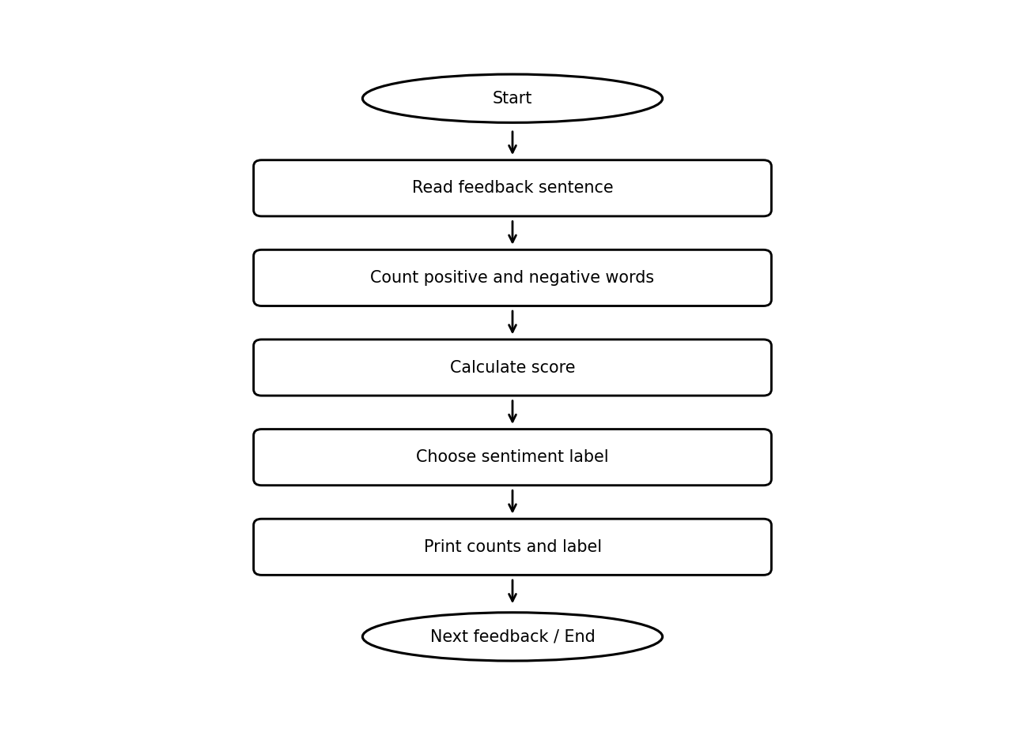
Flowchart convention: Start/End are oval; process steps are rectangular; decision steps are diamond-shaped. All elements are black on white.

6. Pseudocode
BEGIN
FOR each feedback
words ← lowercase(feedback).split()
positive ← 0; negative ← 0
FOR each word in words
remove .,!? from word edges
IF word in positive_words: positive ← positive + 1
ELSE IF word in negative_words: negative ← negative + 1
score ← positive − negative
IF score ≥ 2: sentiment ← Positive
ELSE IF score ≤ −1: sentiment ← Negative
ELSE: sentiment ← Neutral
PRINT counts, score, sentiment
END

7. Python Source Code

# Student Feedback Sentiment Scoring

positive_words = [
"good", "excellent", "helpful", "clear", "interesting",
"best", "easy", "great"
]

negative_words = [
"bad", "poor", "boring", "difficult", "worst",
"unclear", "slow", "confusing"
]

feedback_list = [
"The teacher is good and helpful",
"The explanation is poor and confusing",
"The class is excellent and interesting",
"The subject is difficult",
"The teaching is clear but slow"
]

# Process each feedback
for feedback in feedback_list:
words = feedback.lower().split()

positive_count = 0
negative_count = 0

for word in words:
word = word.strip(".,!?")
if word in positive_words:
positive_count += 1
elif word in negative_words:
negative_count += 1

score = positive_count - negative_count

if score >= 2:
sentiment = "Positive"
elif score <= -1:
sentiment = "Negative"
else:
sentiment = "Neutral"

print("\nFeedback:", feedback)
print("Positive indicators:", positive_count)
print("Negative indicators:", negative_count)
print("Sentiment score:", score)
print("Classification:", sentiment)

8. Test Cases
Test input / condition | Expected result
“The teacher is good and helpful” | Positive count 2, negative count 0, score 2, Positive.
“The subject is difficult” | Positive count 0, negative count 1, score -1, Negative.
“The teaching is clear but slow” | Positive count 1, negative count 1, score 0, Neutral.

9. Conclusion
Dictionary scoring is easy to explain and implement, but the result is only a rough indicator. More advanced systems would be needed for context-aware sentiment analysis.

10. Sample Output
Feedback: The teacher is good and helpful
Positive indicators: 2
Negative indicators: 0
Sentiment score: 2
Classification: Positive

Feedback: The explanation is poor and confusing
Positive indicators: 0
Negative indicators: 2
Sentiment score: -2
Classification: Negative

Feedback: The class is excellent and interesting
Positive indicators: 2
Negative indicators: 0
Sentiment score: 2
Classification: Positive

Feedback: The subject is difficult
Positive indicators: 0
Negative indicators: 1
Sentiment score: -1
Classification: Negative

Feedback: The teaching is clear but slow
Positive indicators: 1
Negative indicators: 1
Sentiment score: 0
Classification: Neutral

6. Sports Tournament Ranking System

1. Problem Statement
A tournament organizer needs to record match scores, update team statistics, award points, and rank teams in a league table.

2. Objective
Produce a final standings table based on points, goal difference, and goals scored.

3. Assumptions
- A win earns 3 points, a draw earns 1 point per team, and a loss earns 0 points.
- Teams must be registered and cannot play themselves.
- Scores must be non-negative integers.
- Ranking priority is points descending, goal difference descending, then goals scored descending.
- The supplied program skips invalid team names or negative scores.

4. Algorithm
- Input team names and initialize each team’s statistics.
- Input each match’s teams and scores.
- Skip invalid matches; otherwise update played, goals for/against, wins/draws/losses, and points.
- Calculate each team’s goal difference.
- Sort teams by points, goal difference, and goals scored, descending.
- Print the ranking table.

5. Flowchart
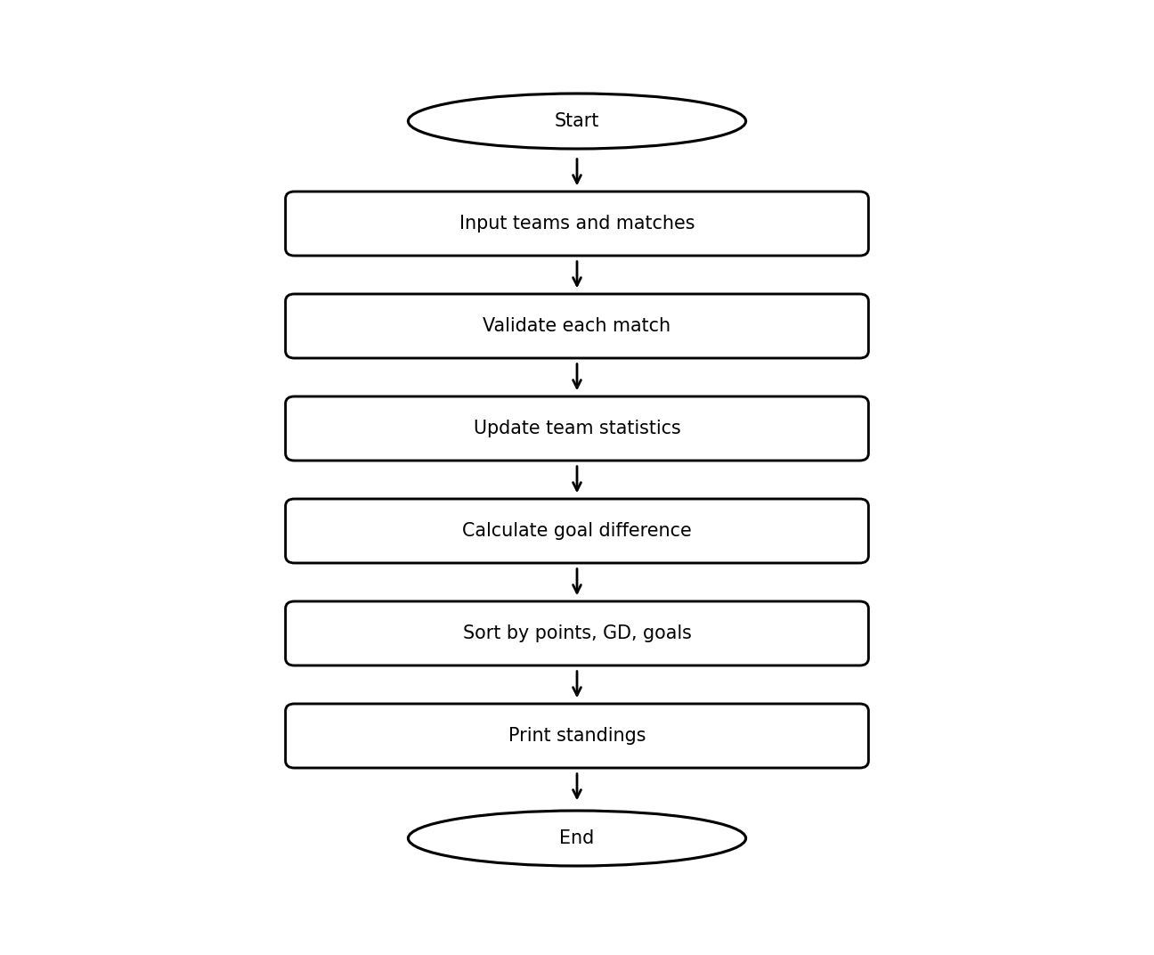
Flowchart convention: Start/End are oval; process steps are rectangular; decision steps are diamond-shaped. All elements are black on white.

6. Pseudocode
BEGIN
INPUT team count and team names
INITIALIZE statistics for each team
INPUT match count
FOR each match
INPUT team1, team2, score1, score2
IF team invalid, same team, or score negative: skip match
UPDATE played and goals for/against
IF score1 > score2: team1 gets 3 points; record win/loss
ELSE IF score2 > score1: team2 gets 3 points; record win/loss
ELSE: each team gets 1 point; record draw
CALCULATE goal difference for each team
SORT by points DESC, goal difference DESC, goals scored DESC
PRINT standings
END

7. Python Source Code

# Sports Tournament Ranking System

teams = {}

n = int(input("Enter number of teams: "))

# Initialize team details
for i in range(n):
name = input(f"Enter team {i + 1} name: ")
teams[name] = {
"played": 0,
"won": 0,
"drawn": 0,
"lost": 0,
"goals_for": 0,
"goals_against": 0,
"points": 0
}

m = int(input("Enter number of matches: "))

# Store and process match results
for i in range(m):
print(f"\nMatch {i + 1}")

team1 = input("Enter first team: ")
team2 = input("Enter second team: ")

if team1 not in teams or team2 not in teams or team1 == team2:
print("Invalid team names. Match skipped.")
continue

score1 = int(input(f"Enter goals scored by {team1}: "))
score2 = int(input(f"Enter goals scored by {team2}: "))

if score1 < 0 or score2 < 0:
print("Invalid scores. Match skipped.")
continue

teams[team1]["played"] += 1
teams[team2]["played"] += 1

teams[team1]["goals_for"] += score1
teams[team1]["goals_against"] += score2

teams[team2]["goals_for"] += score2
teams[team2]["goals_against"] += score1

if score1 > score2:
teams[team1]["won"] += 1
teams[team1]["points"] += 3
teams[team2]["lost"] += 1

elif score2 > score1:
teams[team2]["won"] += 1
teams[team2]["points"] += 3
teams[team1]["lost"] += 1

else:
teams[team1]["drawn"] += 1
teams[team2]["drawn"] += 1
teams[team1]["points"] += 1
teams[team2]["points"] += 1

# Calculate goal difference and ranking
ranking = []

for name, data in teams.items():
goal_difference = data["goals_for"] - data["goals_against"]

ranking.append((
name,
data["played"],
data["won"],
data["drawn"],
data["lost"],
data["points"],
goal_difference,
data["goals_for"]
))

# Ranking policy:
# 1. Highest points
# 2. Highest goal difference
# 3. Highest goals scored
ranking.sort(key=lambda x: (x[5], x[6], x[7]), reverse=True)

# Display final table
print("\n========== TOURNAMENT RANKINGS ==========")
print(f"{'Rank':<6}{'Team':<15}{'P':<5}{'W':<5}"
f"{'D':<5}{'L':<5}{'Pts':<6}{'GD':<6}")

for rank, team in enumerate(ranking, start=1):
name, played, won, drawn, lost, points, gd, goals = team

print(f"{rank:<6}{name:<15}{played:<5}{won:<5}"
f"{drawn:<5}{lost:<5}{points:<6}{gd:<6}")

8. Test Cases
Test input / condition | Expected result
Red 2–0 Blue | Red gets 3 points; Blue records a loss.
Red 1–1 Green | Red and Green each get 1 point.
Unknown team or negative score | Match is skipped.

9. Conclusion
The system turns match results into a consistent league table. If teams tie on all three ranking criteria, the current code preserves the sort’s resulting order rather than applying an additional tie-breaker.

10. Sample Output
========== TOURNAMENT RANKINGS ==========
Rank Team P W D L Pts GD
1 Tigers 2 1 1 0 4 2
2 Eagles 2 1 0 1 3 0
3 Lions 2 0 1 1 1 -2

Note: This illustrative output is retained from the original document; it is not generated by the interactive source code shown above.

7. Tuple-Based Transaction Audit

1. Problem Statement
A finance team wants to screen transaction records for duplicate IDs, invalid amounts, unsupported transaction types, and consecutive debit activity.

2. Objective
Audit a list of transaction tuples and print validation errors for each record.

3. Assumptions
- Each transaction is a tuple of transaction ID, amount, and transaction type.
- Valid amounts must be greater than zero.
- Allowed types are CREDIT and DEBIT.
- A repeated transaction ID is flagged as a duplicate.
- A DEBIT immediately after another DEBIT is flagged as suspicious; this is a simple rule, not proof of fraud.

4. Algorithm
- Initialize a set of seen transaction IDs and no previous transaction type.
- For each tuple, create an empty error list.
- Check duplicate ID, amount, type, and consecutive-debit condition.
- Print Valid transaction if no errors; otherwise print all errors.
- Update previous transaction type and continue.

5. Flowchart
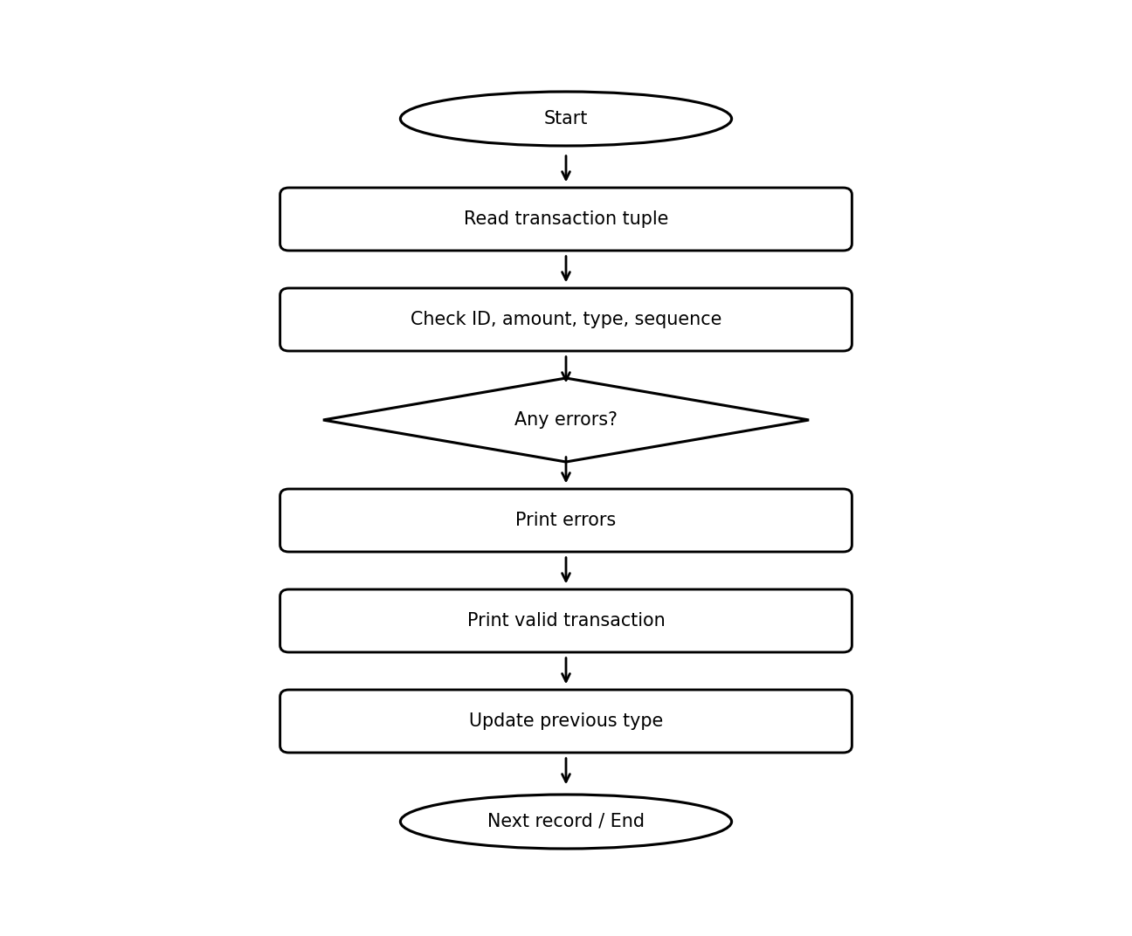
Flowchart convention: Start/End are oval; process steps are rectangular; decision steps are diamond-shaped. All elements are black on white.

6. Pseudocode
BEGIN
seen_ids ← empty set; previous_type ← NONE
FOR each (id, amount, type)
errors ← empty list
IF id in seen_ids: add Duplicate ID
ELSE add id to seen_ids
IF amount ≤ 0: add Invalid amount
IF type not CREDIT or DEBIT: add Invalid transaction type
IF previous_type = DEBIT and type = DEBIT:
add Suspicious consecutive debits
PRINT valid or errors
previous_type ← type
PRINT audit completed
END

7. Python Source Code

# Tuple-Based Transaction Audit

transactions = [
("T101", 500, "CREDIT"),
("T102", 200, "DEBIT"),
("T103", -100, "CREDIT"),
("T101", 300, "DEBIT"),
("T104", 15000, "DEBIT"),
("T105", 0, "CREDIT"),
("T106", 700, "TRANSFER")
]

seen_ids = set()
previous_type = None

print("TRANSACTION AUDIT REPORT")
print("-" * 50)

for transaction in transactions:
trans_id, amount, trans_type = transaction
errors = []

# Check duplicate transaction ID
if trans_id in seen_ids:
errors.append("Duplicate ID")
else:
seen_ids.add(trans_id)

# Check invalid amount
if amount <= 0:
errors.append("Invalid amount")

# Check transaction type
if trans_type not in ("CREDIT", "DEBIT"):
errors.append("Invalid transaction type")

# Check suspicious sequence
if previous_type == "DEBIT" and trans_type == "DEBIT":
errors.append("Suspicious consecutive debits")

# Display result
if errors:
print(trans_id, "->", ", ".join(errors))
else:
print(trans_id, "-> Valid transaction")

previous_type = trans_type

print("-" * 50)
print("Audit completed.")

8. Test Cases
Test input / condition | Expected result
T101, 500, CREDIT (first occurrence) | Valid transaction.
T103, -100, CREDIT | Invalid amount.
T101, 300, DEBIT (second occurrence) | Duplicate ID; the prior record’s type was CREDIT, so no consecutive-debit warning for this record.

9. Conclusion
The audit demonstrates tuple unpacking, sets, and multi-condition validation. Consecutive-debit detection depends on record order, and practical fraud detection requires broader context and review.

10. Sample Output
TRANSACTION AUDIT REPORT
--------------------------------------------------
T101 -> Valid transaction
T102 -> Valid transaction
T103 -> Invalid amount
T101 -> Duplicate ID
T104 -> Suspicious consecutive debits
T105 -> Invalid amount, Suspicious consecutive debits
T106 -> Invalid transaction type
--------------------------------------------------
Audit completed.

8. Nested-List Examination Seating Validation

1. Problem Statement
An examination coordinator needs to validate a seating matrix for empty seats, reserved positions, out-of-range roll numbers, and duplicate roll numbers.

2. Objective
Inspect each cell in a two-dimensional list and determine whether the seating matrix contains validation errors.

3. Assumptions
- The matrix has 3 rows and 4 columns.
- 0 represents an empty seat; -1 represents a reserved position.
- Valid roll numbers range from 1 to 20 inclusive.
- A roll number must not appear more than once.
- The supplied matrix intentionally includes sample errors.

4. Algorithm
- Define matrix dimensions and special values.
- Traverse every row and column.
- Classify each cell as empty, reserved, invalid, duplicate, or valid.
- Track valid roll numbers in a set.
- If any empty, invalid, or duplicate seat is found, mark the matrix invalid.
- Print each seat’s status and the overall result.

5. Flowchart
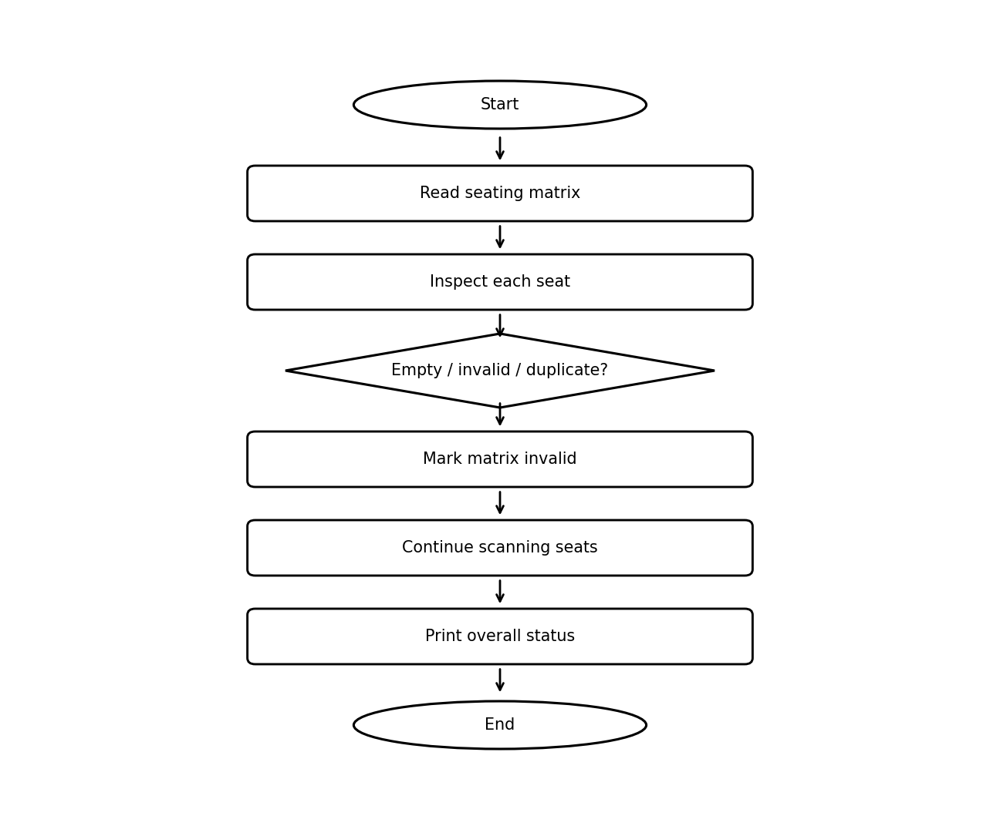
Flowchart convention: Start/End are oval; process steps are rectangular; decision steps are diamond-shaped. All elements are black on white.

6. Pseudocode
BEGIN
valid ← TRUE; seen ← empty set
FOR each row i
FOR each column j
roll ← seats[i][j]
IF roll = 0: print Empty; valid ← FALSE
ELSE IF roll = -1: print Reserved
ELSE IF roll < 1 OR roll > MAX_ROLL:
print Invalid; valid ← FALSE
ELSE IF roll in seen:
print Duplicate; valid ← FALSE
ELSE: print Valid; add roll to seen
IF valid: print matrix valid
ELSE: print validation errors
END

7. Python Source Code
ROWS = 3
COLS = 4
EMPTY = 0
RESERVED = -1
MAX_ROLL = 20

seats = [
[1, 2, 3, 4],
[5, 6, 2, RESERVED],
[9, EMPTY, 11, 25]
]

valid = True
seen = set()

print("Examination Seating Validation\n")

for i in range(ROWS):
for j in range(COLS):
roll = seats[i][j]
print(f"Seat ({i + 1}, {j + 1}): {roll}", end=" -> ")

if roll == EMPTY:
print("Empty seat")
valid = False

elif roll == RESERVED:
print("Reserved position")

elif roll < 1 or roll > MAX_ROLL:
print("Invalid roll number")
valid = False

elif roll in seen:
print("Duplicate roll number")
valid = False

else:
print("Valid allocation")
seen.add(roll)

if valid:
print("\nSeating matrix is valid.")
else:
print("\nSeating matrix has validation errors.")

8. Test Cases
Test input / condition | Expected result
Roll 2 appears twice | Second occurrence is flagged as duplicate.
Seat value 0 | Flagged as empty; matrix invalid.
Seat value 25 when MAX_ROLL=20 | Flagged as invalid roll number.

9. Conclusion
Nested loops and a set provide a straightforward validation method for a seating matrix. Reserved seats are accepted as special positions, while empty seats and allocation errors make the matrix invalid.

10. Sample Output
Examination Seating Validation

Seat (1, 1): 1 -> Valid allocation
Seat (1, 2): 2 -> Valid allocation
Seat (1, 3): 3 -> Valid allocation
Seat (1, 4): 4 -> Valid allocation
Seat (2, 1): 5 -> Valid allocation
Seat (2, 2): 6 -> Valid allocation
Seat (2, 3): 2 -> Duplicate roll number
Seat (2, 4): -1 -> Reserved position
Seat (3, 1): 9 -> Valid allocation
Seat (3, 2): 0 -> Empty seat
Seat (3, 3): 11 -> Valid allocation
Seat (3, 4): 25 -> Invalid roll number

Seating matrix has validation errors.

9. Multi-Route Courier Dispatch Planning

1. Problem Statement
A courier service must allocate packages to vehicles while considering delivery zone, vehicle capacity, and package priority.

2. Objective
Assign high-priority packages first when a compatible vehicle has enough remaining capacity, and report dispatched and undispatched packages.

3. Assumptions
- Each package contains ID, weight, zone, and priority.
- Vehicles have fixed weight capacities and allowed delivery zones.
- Priority order is High, Medium, then Low.
- A package is assigned to the first compatible vehicle in dictionary order with sufficient capacity.
- This is a greedy allocation approach and does not guarantee globally optimal packing.

4. Algorithm
- Define packages, vehicles, capacities, and priority order.
- Sort packages by priority.
- For each package, examine vehicles in order.
- Assign it to the first vehicle that serves its zone and has sufficient capacity.
- If no vehicle fits, mark it undispatched.
- Print vehicle assignments, remaining capacity, and totals.

5. Flowchart
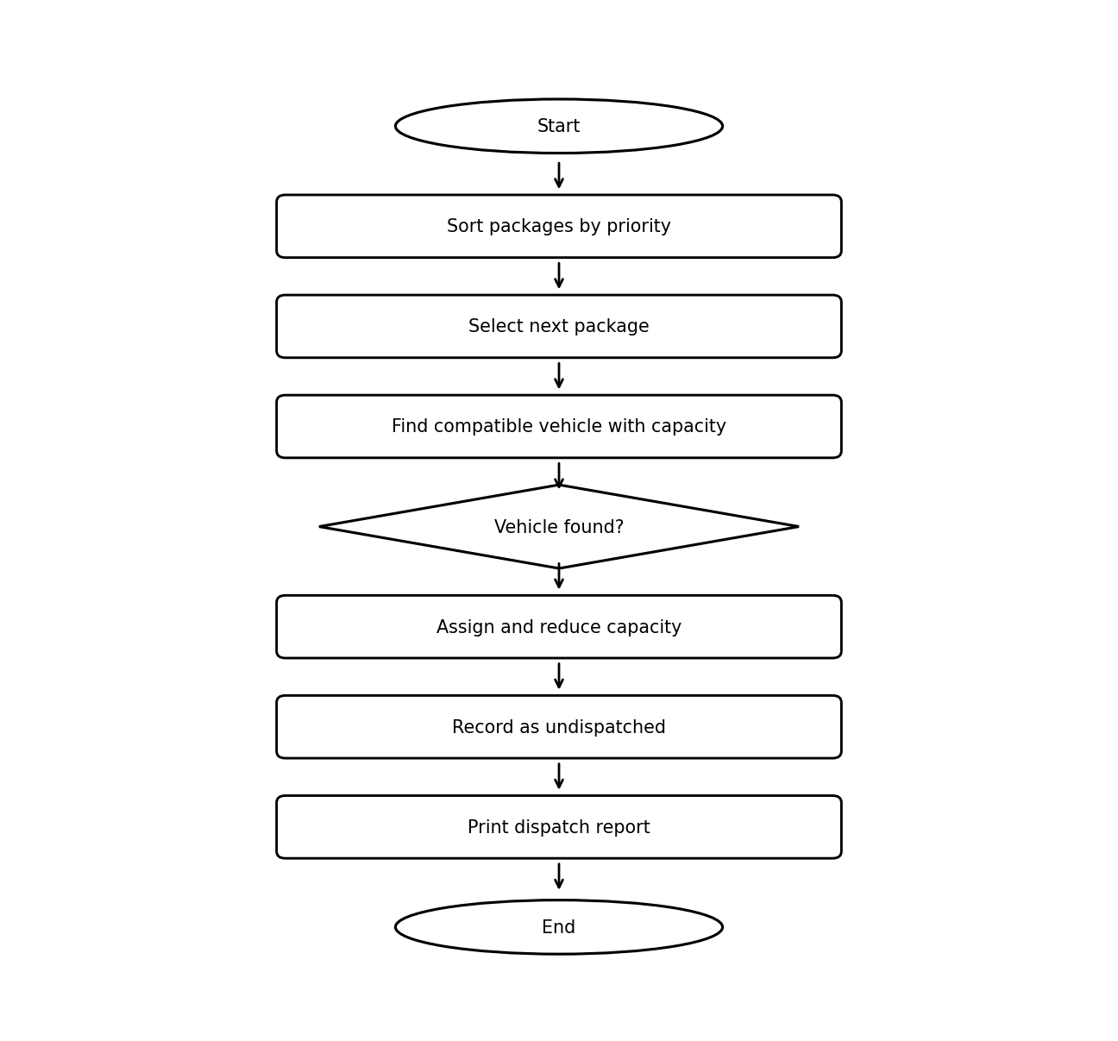
Flowchart convention: Start/End are oval; process steps are rectangular; decision steps are diamond-shaped. All elements are black on white.

6. Pseudocode
BEGIN
SORT packages by priority: High, Medium, Low
INITIALIZE empty dispatch list and remaining capacity per vehicle
undispatched ← empty list
FOR each package p
assigned ← FALSE
FOR each vehicle v
IF p.zone allowed by v AND p.weight ≤ remaining[v]
assign p to v; reduce remaining[v]
assigned ← TRUE; BREAK
IF not assigned: append p to undispatched
PRINT each vehicle's packages and remaining capacity
PRINT undispatched packages and totals
END

7. Python Source Code

# Multi-Route Courier Dispatch Planning

packages = [
[101, 10, "A", "High"],
[102, 20, "B", "Medium"],
[103, 15, "A", "High"],
[104, 30, "C", "Low"],
[105, 25, "B", "High"],
[106, 50, "D", "Medium"]
]

vehicles = {
"V1": {"capacity": 40, "zones": ["A", "B"]},
"V2": {"capacity": 50, "zones": ["B", "C"]},
"V3": {"capacity": 30, "zones": ["A", "C"]}
}

priority = {"High": 1, "Medium": 2, "Low": 3}

packages.sort(key=lambda p: priority[p[3]])

dispatch = {"V1": [], "V2": [], "V3": []}
remaining = {"V1": 40, "V2": 50, "V3": 30}
undispatched = []

for p in packages:
package_id, weight, zone, level = p
assigned = False

for vid in vehicles:
if (zone in vehicles[vid]["zones"]
and weight <= remaining[vid]):

dispatch[vid].append(p)
remaining[vid] -= weight
assigned = True
break

if not assigned:
undispatched.append(p)

print("COURIER DISPATCH REPORT")

for vid in vehicles:
print("\nVehicle:", vid)
print("Packages assigned:")

if len(dispatch[vid]) == 0:
print("No packages")
else:
for p in dispatch[vid]:
print("ID:", p[0], "Weight:", p[1],
"Zone:", p[2], "Priority:", p[3])

print("Remaining capacity:", remaining[vid], "kg")

print("\nUNDISPATCHED PACKAGES")

if len(undispatched) == 0:
print("All packages dispatched")
else:
for p in undispatched:
print("ID:", p[0], "Weight:", p[1],
"Zone:", p[2], "Priority:", p[3])

print("\nTotal packages:", len(packages))
print("Dispatched:", len(packages) - len(undispatched))
print("Undispatched:", len(undispatched))

8. Test Cases
Test input / condition | Expected result
Package 101, 10 kg, zone A, High | Assigned to V1, the first compatible vehicle.
Package 106, 50 kg, zone D, Medium | Undispatched: no vehicle supports zone D and weight capacity combination.
Package heavier than every compatible vehicle’s remaining capacity | Undispatched.

9. Conclusion
The program demonstrates greedy assignment with multiple constraints and a useful dispatch report. Because vehicle order affects assignment, a more advanced optimizer may improve overall utilization.

10. Sample Output
COURIER DISPATCH REPORT

Vehicle: V1
Packages assigned:
ID: 101 Weight: 10 Zone: A Priority: High
ID: 103 Weight: 15 Zone: A Priority: High
Remaining capacity: 15 kg

Vehicle: V2
Packages assigned:
ID: 105 Weight: 25 Zone: B Priority: High
ID: 102 Weight: 20 Zone: B Priority: Medium
Remaining capacity: 5 kg

Vehicle: V3
Packages assigned:
ID: 104 Weight: 30 Zone: C Priority: Low
Remaining capacity: 0 kg

UNDISPATCHED PACKAGES
ID: 106 Weight: 50 Zone: D Priority: Medium

Total packages: 6
Dispatched: 5
Undispatched: 1

10. Multi-Branch Retail Inventory Transfer

1. Problem Statement
A retailer needs to identify products that are above or below target stock at each branch and generate transfers from surplus branches to branches with shortages.

2. Objective
Calculate surplus and shortage, create transfers capped at 10 units per transfer, update branch stocks, and report any shortages left.

3. Assumptions
- Each branch has current stock and a target quantity for each item.
- Surplus is current stock minus target when positive; shortage is target minus current stock when positive.
- A transfer can move stock only between different branches for the same item.
- Each individual transfer is limited to 10 units.
- Transfers follow the order of branches and items in the supplied dictionaries; remaining shortages may exist if surplus is insufficient.

4. Algorithm
- Calculate surplus and shortage for every item at every branch.
- Print the surplus and shortage lists.
- For each shortage, inspect available surplus from other branches.
- Transfer the minimum of shortage, donor surplus, and 10 units.
- Update donor and receiver quantities and branch stock.
- Print remaining shortages and final stock levels.

5. Flowchart
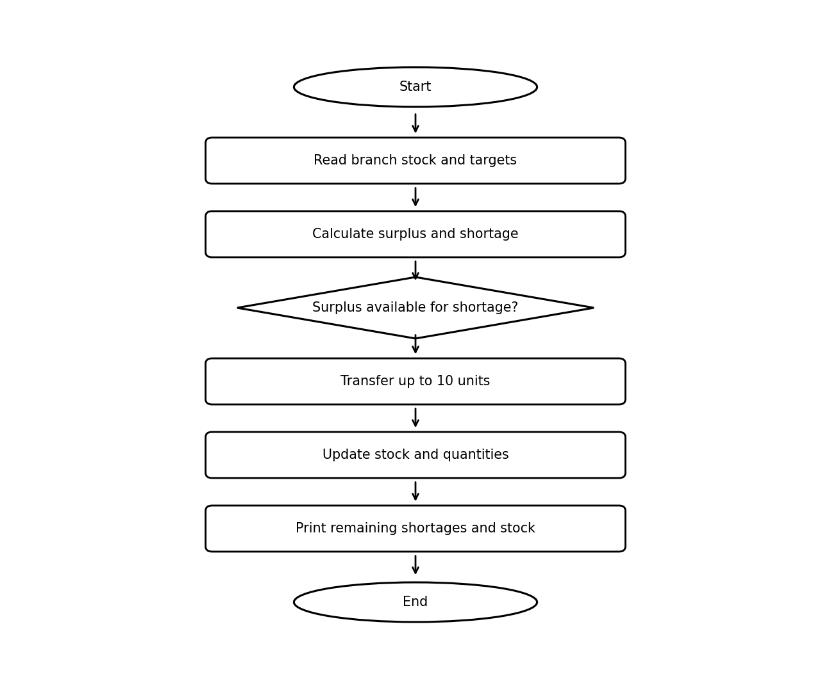
Flowchart convention: Start/End are oval; process steps are rectangular; decision steps are diamond-shaped. All elements are black on white.

6. Pseudocode
BEGIN
surplus ← empty mapping; shortage ← empty mapping
FOR each branch and item
difference ← current stock − target
IF difference > 0: record surplus
ELSE IF difference < 0: record shortage of −difference
FOR each item with shortage
FOR each receiving branch
FOR each donor branch with surplus
IF shortage fulfilled: BREAK
IF donor is receiver OR no surplus: CONTINUE
quantity ← MIN(shortage, surplus, 10)
TRANSFER quantity; update donor, receiver, and stock
PRINT remaining shortages and final stock
END

7. Python Source Code

# Multi-Branch Retail Inventory Transfer

branches = {
"Branch A": {
"stock": {"Laptop": 20, "Mouse": 50, "Keyboard": 15},
"target": {"Laptop": 15, "Mouse": 40, "Keyboard": 25}
},
"Branch B": {
"stock": {"Laptop": 5, "Mouse": 20, "Keyboard": 30},
"target": {"Laptop": 15, "Mouse": 30, "Keyboard": 20}
},
"Branch C": {
"stock": {"Laptop": 10, "Mouse": 35, "Keyboard": 10},
"target": {"Laptop": 10, "Mouse": 25, "Keyboard": 15}
}
}

MAX_TRANSFER = 10

# Step 1: Calculate surplus and shortage
surplus = {}
shortage = {}

for branch, data in branches.items():
for item, target in data["target"].items():
current = data["stock"].get(item, 0)
difference = current - target

if difference > 0:
surplus.setdefault(item, []).append(
[branch, difference]
)
elif difference < 0:
shortage.setdefault(item, []).append(
[branch, -difference]
)

# Step 2: Display surplus and shortage
print("=== SURPLUS STOCK ===")
for item, entries in surplus.items():
for branch, quantity in entries:
print(f"{branch} - {item}: {quantity} units")

print("\n=== SHORTAGE STOCK ===")
for item, entries in shortage.items():
for branch, quantity in entries:
print(f"{branch} - {item}: {quantity} units")

# Step 3: Generate transfers
print("\n=== TRANSFER REPORT ===")
transfers = []

for item in shortage:
available = surplus.get(item, [])
required = shortage[item]

for receiver in required:
receiver_branch, needed = receiver

for donor in available:
donor_branch, extra = donor

if needed <= 0:
break

if extra <= 0 or donor_branch == receiver_branch:
continue

quantity = min(needed, extra, MAX_TRANSFER)

if quantity > 0:
transfers.append(
(item, donor_branch, receiver_branch, quantity)
)

donor[1] -= quantity
receiver[1] -= quantity
needed -= quantity

branches[donor_branch]["stock"][item] -= quantity
branches[receiver_branch]["stock"][item] += quantity

print(
f"{item}: {donor_branch} -> {receiver_branch} "
f"({quantity} units)"
)

# Step 4: Display remaining shortages
print("\n=== REMAINING SHORTAGES ===")
remaining = False

for item, entries in shortage.items():
for branch, quantity in entries:
if quantity > 0:
print(f"{branch} - {item}: {quantity} units")
remaining = True

if not remaining:
print("All shortages have been fulfilled.")

# Step 5: Display final stock
print("\n=== FINAL BRANCH STOCK ===")
for branch, data in branches.items():
print(f"\n{branch}:")
for item, quantity in data["stock"].items():
print(f" {item}: {quantity} units")

8. Test Cases
Test input / condition | Expected result
Branch A has 20 laptops and target 15 | Surplus of 5 laptops.
Branch B has 5 laptops and target 15 | Shortage of 10 laptops; may be supplied from Branch A or C if surplus is available.
Required transfer exceeds 10 units | Transfer occurs in chunks no larger than 10 units.

9. Conclusion
The program coordinates simple stock balancing across branches while enforcing a per-transfer limit. Transfers are greedy and depend on processing order; production systems should also validate stock consistency and generate auditable transfer records.

10. Sample Output
=== SURPLUS STOCK ===
Branch A - Laptop: 5 units
Branch A - Mouse: 10 units

=== SHORTAGE STOCK ===
Branch A - Keyboard: 10 units
Branch B - Laptop: 10 units
Branch B - Mouse: 10 units

=== TRANSFER REPORT ===
Laptop: Branch A -> Branch B (5 units)
Mouse: Branch A -> Branch B (10 units)

=== REMAINING SHORTAGES ===
Branch A - Keyboard: 10 units
Branch B - Laptop: 5 units

=== FINAL BRANCH STOCK ===

Branch A:
Laptop: 15 units
Mouse: 40 units
Keyboard: 15 units

Branch B:
Laptop: 10 units
Mouse: 30 units
Keyboard: 30 units

Branch C:
Laptop: 10 units
Mouse: 35 units
Keyboard: 10 units

