**SECURE CODING (Lab_10)**

Venkata Lokesh

19BCE7776

L23+L24

Crashing the Frigate3_Pro_v36 application and opening calc.exe (Calculator) by triggering it using the above generated payload:

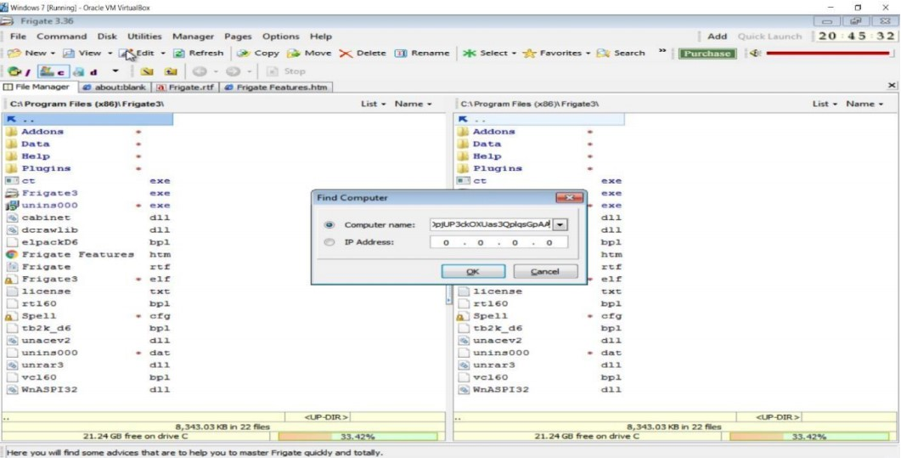

Before Execution (Exploitation): Attaching the debugger (Immunity debugger) to the application Frigate3_Pro_v36 and analysing the address of various registers:

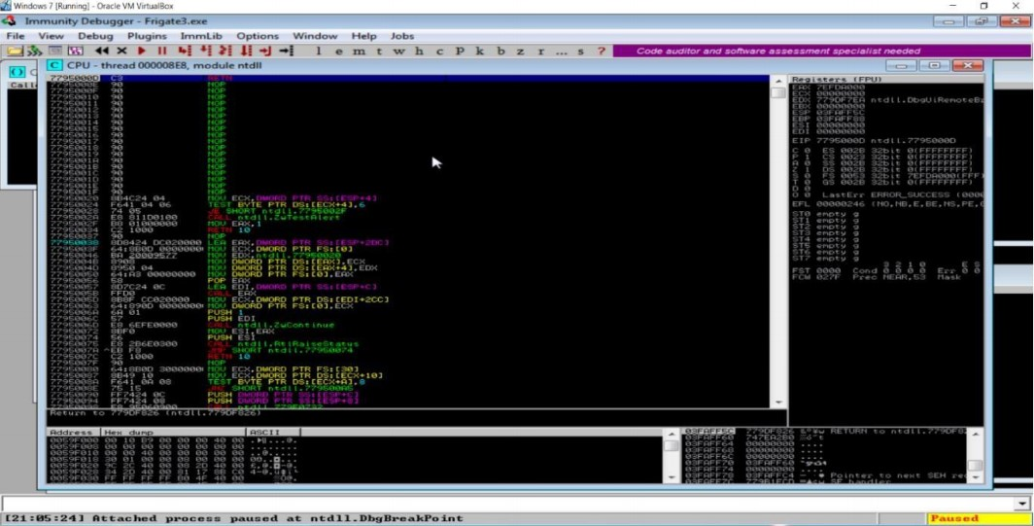

Checking for EIP address:

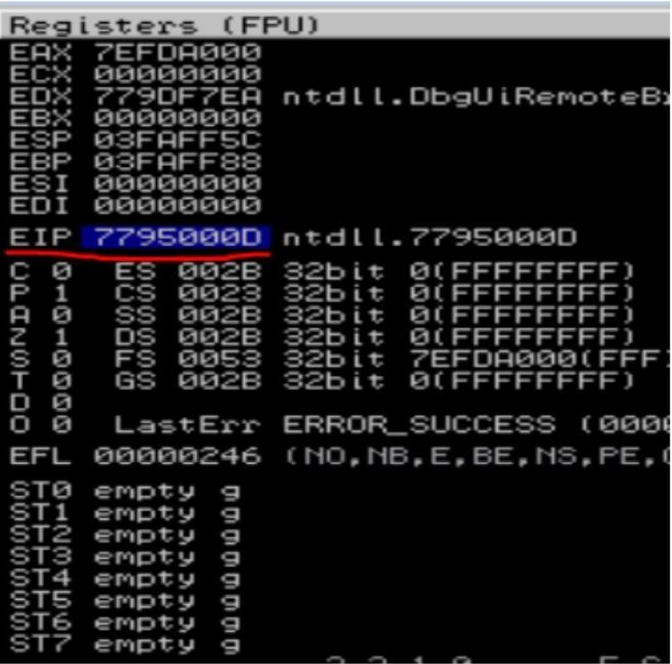

Verifying the SHE chain:

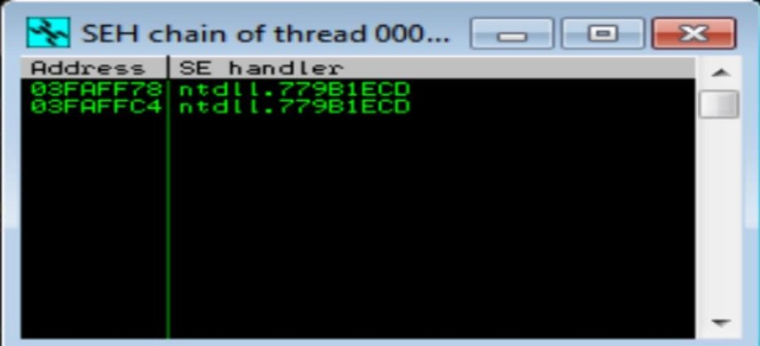

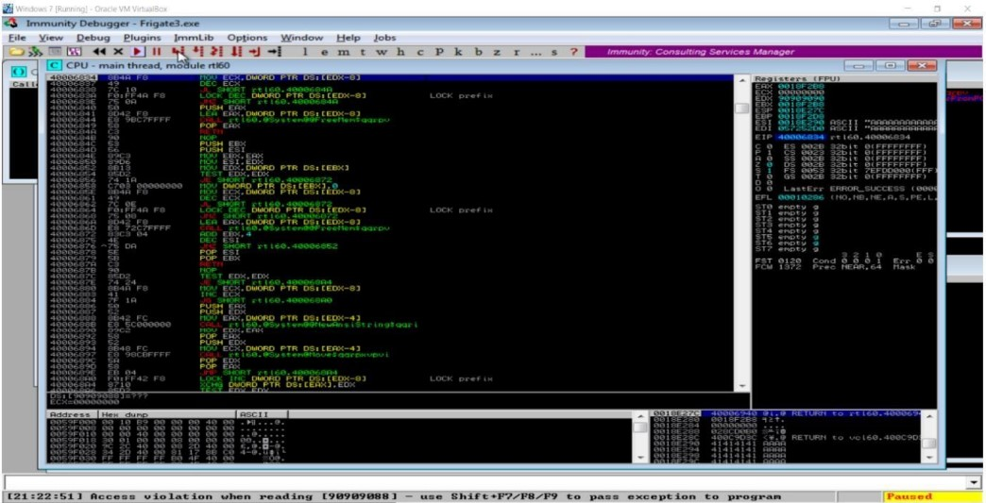

Checkingfor EIP address:

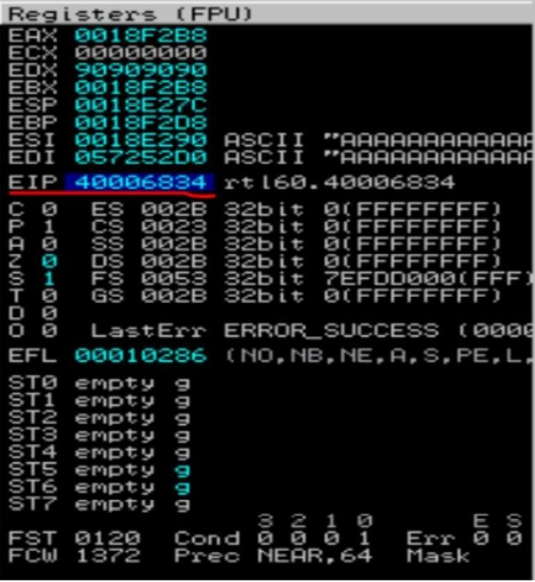

Verifying the SHE chain and reporting the dll loaded along with the addresses:

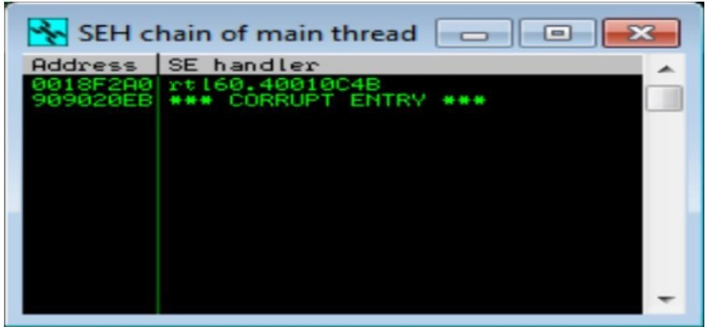

Hence from the above analysis we found that the dll ‘rtl60.40010C4B’iscorruptedandislocatedatthe address ‘0018F2A0’.