**SECURE CODING (Lab_13)**

Venkata Lokesh

19BCE7776

L23+L24

Windows exploit suggester:

This is a tool that helps you to identify the vulnerability in your naïve windows system. Follow the link in github to download the files required….. https://github.com/bitsadmin/wesng

Double click on the **setup.py** to setup windows exploit suggester.

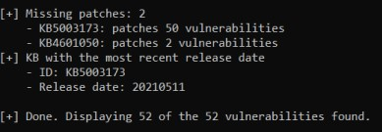Now open command prompt do as follows

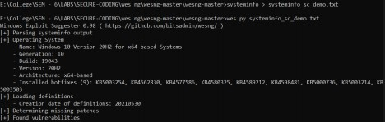

Pipe the systeminfo as a txt file to the wes.py and it will list all the vulnerabilities in the system. At last it will give you all the patches that are required to patch the vulnerabilities as below.

Now go to the Microsoft catalog to download the required hotfixes I will be like below.

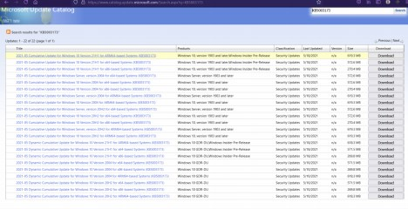

Download the appropriate hotfixes for your pc type **winver** in start to get the version of the pc you are using. Download your hotfixes and fix your vulnerabilities.

