**SECURE CODING (Lab_3)**

Venkata Lokesh

19BCE7776

L23+L24

Microsoft Windows [Version 10.0.19042.804]

(c) 2020 Microsoft Corporation. All rights reserved.

C:\Users\Wreck>where /R C:\ *.exe | findstr firefox.exe

C:\Program Files\Mozilla Firefox\firefox.exe

C:\Program Files\Mozilla Firefox\updated\firefox.exe

C:\Users\Wreck>SCHTASKS /CREATE /SC DAILY /TN "18BCN7084_Task1" /TR "C:\Windows\System32\notepad.exe" /ST 12:15

WARNING: The task name "18BCD7075_Task1" already exists. Do you want to replace it (Y/N)? Y ERROR: Access is denied.

C:\Users\Wreck>SCHTASKS /CREATE /SC DAILY /TN "18BCN7084_Task1" /TR "C:\Windows\System32\notepad.exe" /ST 12:30

WARNING: The task name "18BCD7075_Task1" already exists. Do you want to replace it (Y/N)? y ERROR: Access is denied.

C:\Users\Wreck>SCHTASKS /CREATE /SC DAILY /TN "18BCN7084_Task_1" /TR "C:\Windows\System32\notepad.exe" /ST 12:30

SUCCESS: The scheduled task "18BCD7075_Task_1" has successfully been created.

C:\Users\Wreck>SCHTASKS /CHANGE /TN "18BCD7075_Task_1" /ST 13:00

Please enter the run as password for Wreck: ************

ERROR: The parameter is incorrect.

(22,8):UserId:

C:\Users\Wreck>SCHTASKS /DELETE /TN "18BCD7075_Task_1"

WARNING: Are you sure you want to remove the task "18BCD7075_Task_1" (Y/N)? Y SUCCESS: The scheduled task "18BCD7075_Task_1" was successfully deleted.

C:\Users\Wreck>SCHTASKS /CREATE /SC WEEKLY /D MON,TUE,WED,THU,FRI /TN "18BCD7075_Task_1" /TR "C:\Wondows\System32\notepad.exe" /ST 12:30

SUCCESS: The scheduled task "18BCD7075_Task_1" has successfully been created.

C:\Users\Wreck>SCHTASKS /CREATE /SC WEEKLY /D FRI,SAT /TN "18BCD7075_Task1" /TR "C:\Wondows\System32\notepad.exe" /ST 12:30

WARNING: The task name "18BCD7075_Task1" already exists. Do you want to replace it (Y/N)? Y SUCCESS: The scheduled task "18BCD7075_Task1" has successfully been created.

C:\Users\Wreck> Diskpart

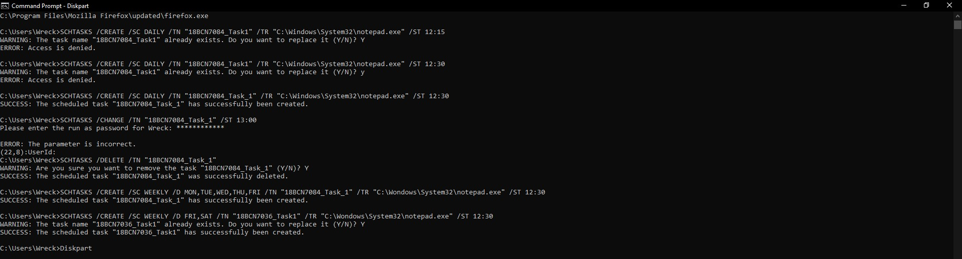

Microsoft DiskPart version 10.0.19041.610

Copyright (C) Microsoft Corporation.

On computer: WRECK

DISKPART> list

Microsoft DiskPart version 10.0.19041.610

DISK - Display a list of disks. For example, LIST DISK.

PARTITION - Display a list of partitions on the selected disk.

For example, LIST PARTITION.

VOLUME - Display a list of volumes. For example, LIST VOLUME.

VDISK - Displays a list of virtual disks.

DISKPART> list disk

Disk ### Status Size Free Dyn Gpt

-------- ------------- ------- ------- --- ---

Disk 0 Online 931 GB 1024 KB *

Disk 1 Online 238 GB 17 MB *

DISKPART> select disk0

Microsoft DiskPart version 10.0.19041.610

DISK - Shift the focus to a disk. For example, SELECT DISK.

PARTITION - Shift the focus to a partition. For example, SELECT PARTITION.

VOLUME - Shift the focus to a volume. For example, SELECT VOLUME.

VDISK - Shift the focus to a virtual disk. For example, SELECT VDISK.

DISKPART> select disk 0

Disk 0 is now the selected disk.

DISKPART> list partition

Partition ### Type Size Offset

------------- ---------------- ------- -------

Partition 1 Reserved 128 MB 1024 KB

Partition 2 Primary 540 GB 129 MB

Partition 3 Primary 390 GB 540 GB

DISKPART> select disk 1

Disk 1 is now the selected disk.

DISKPART> list partition

Partition ### Type Size Offset

------------- ---------------- ------- -------

Partition 1 System 650 MB 1024 KB

Partition 2 Reserved 128 MB 651 MB

Partition 3 Primary 222 GB 779 MB

Partition 4 Recovery 990 MB 223 GB

Partition 5 Recovery 13 GB 224 GB

Partition 6 Recovery 1163 MB 237 GB

DISKPART>

