**SECURE CODING (Lab_4)**

Venkata Lokesh

19BCE7776

L23+L24

1. **Attrib command:**

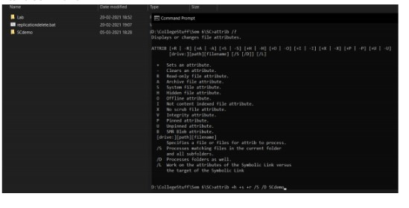

Hiding folder:

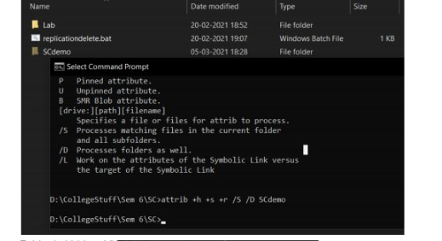

Folder is hidden. Visible due to settings. Reverting hidden attribute:

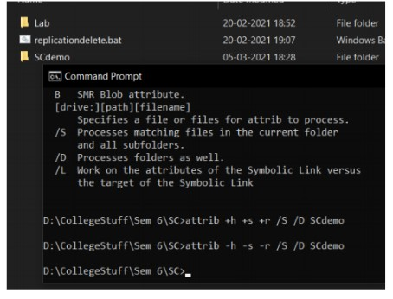

1. **Powercfg command:**

Battery report:

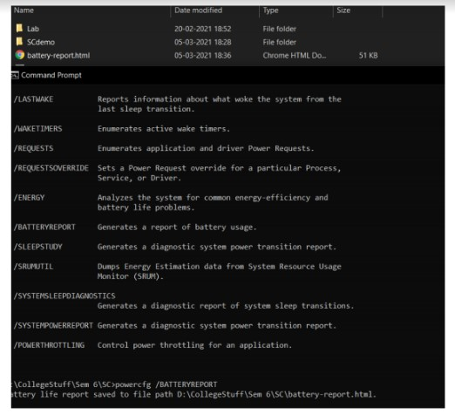

Lastwake:

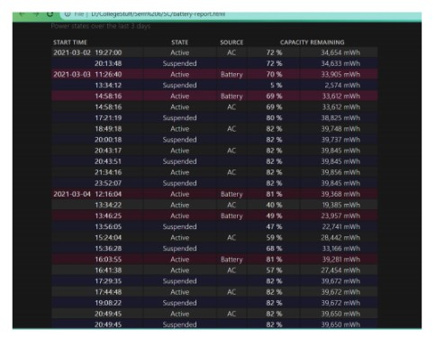

Energy consumption report:

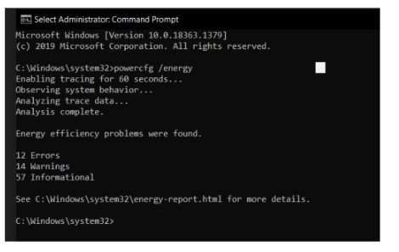

Hibernat

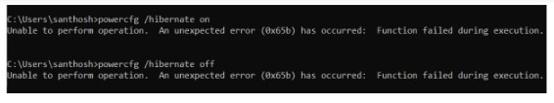

Available sleep states:

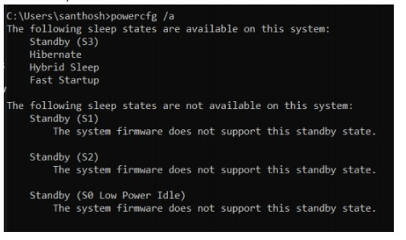

1. **Scheduled Hello world python script:**

Creating exe from python file:

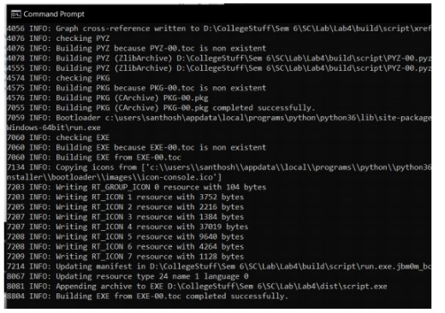

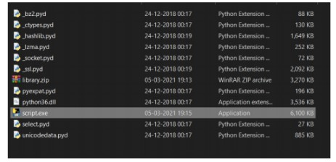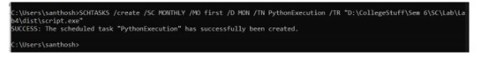

1. **Intermediate tasks: executer1 and executer2 for calculator and notepad:**

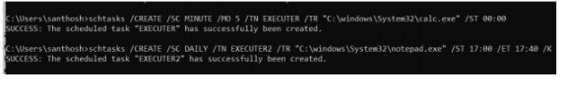

1. **Advanced task: Disk defrag**

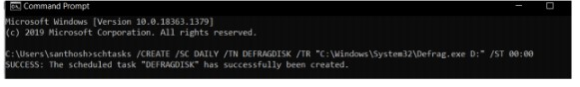

1. **Script to lock the computer:**

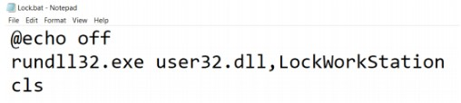

1. **Script to empty recycle bin:**

