**SECURE CODING(Lab_6)**

Venkata Lokesh

19BCE7776

L23+L24

1.

* Write a python script to get all the file names in the current directory 2.
* Write a python script to get all the directory names in the current directory 3
* Write a python script to get all the directory and subdirectory names in the current directory 4
* Write a python script to get all the file name, directory and all the subdirectory names (recursively) in the current directory 5
* Write a python script to get all the file name, directory and all the subdirectory names (recursively) in the current drive and write it to a text file.

6

* Write a python script which creates four new files in the current directory using Powershell.

**1.**

PYTHON SCRIPT :

import os for root, dirs, files in os.walk("."):

for filename in files:

print(filename) OUTPUT :

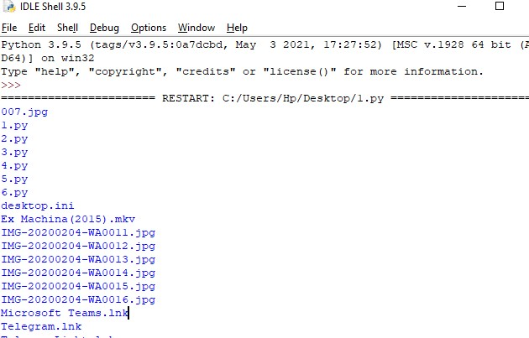

1. Python Script : import os directory_contents = os.listdir(".") for item in directory_contents:

if os.path.isdir(item):

print(item) Output :

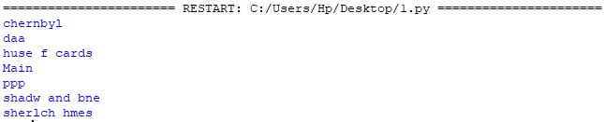

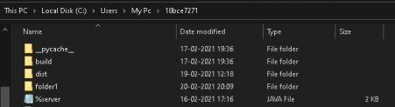

1. Python script :

import os for root, dirs, files in os.walk("."): for name in dirs: print (os.path.join(root, name)) Output :

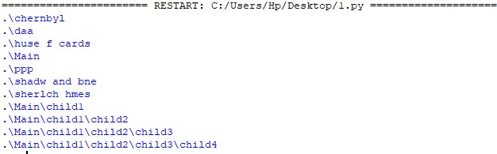

1. Python script :

import os def recursive(dir, ext): subfolders, files = [], [] for f in os.scandir(dir):

if f.is_dir():

subfolders.append(f.path) print(f)

if f.is_file():

files.append(f.path) print(f)

for dir in list(subfolders): sf, f = recursive(dir, ext) subfolders.extend(sf) files.extend(f)

return subfolders, files

subfolders, files = recursive(".", ["."]) Output :

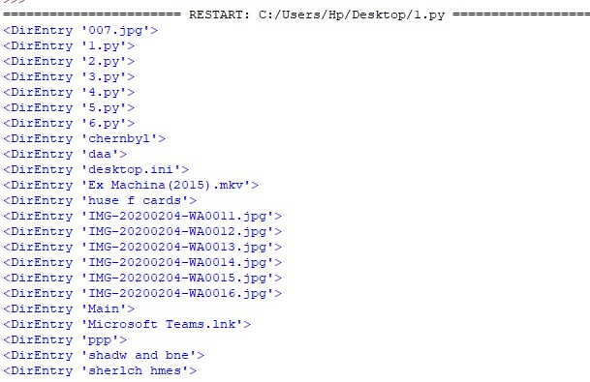

**5.** Python Script: import os def recursive(dir, ext): subfolders, files = [], [] for f in os.scandir(dir):

if f.is_dir():

subfolders.append(f.path) with open('direct.txt', 'a') as g:

print(f,file=g)

if f.is_file():

files.append(f.path) with open('direct.txt', 'a') as g:

print(f,file=g)

for dir in list(subfolders): sf, f = recursive(dir, ext) subfolders.extend(sf) files.extend(f)

return subfolders, files

subfolders, files = recursive(".", ["."]) Output:

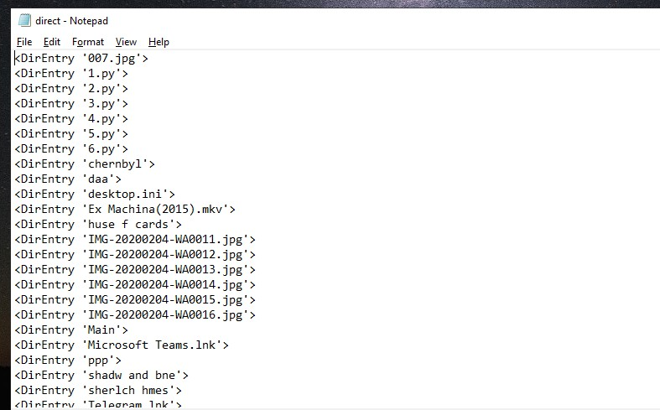

**6.**

(Giving Input in powershell) Python Script :

import os path="." a=int(input("enter how many files :")) for x in range(a):

c=str(x) file ='myfile'+c+'.txt' b=open(os.path.join(path, file), 'w') print(file,"created")

Output :

