**SECURE CODING (Lab_7)**

Venkata Lokesh

19BCE7776

L23+L24

**Working with the memory vulnerabilities**

1) Crashing the StreamRipper32

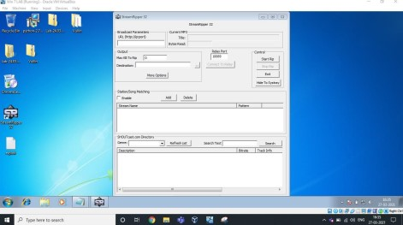

After opening the application, Click on ADD button under the Station/Song Matching Section.

Then, Give some Name in Station Pattern as per your wish and Copy the Exploit text and Paste it in Song Pattern. Now click on Ok, as you can see below.

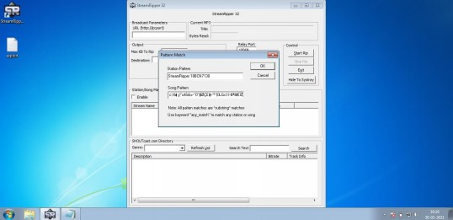

|  |
| --- |
|  |
| Station Pattern  Cancel 18BCD7075  Song Pattern canal o4I e ”0°I I<SEII-"” (0LGc1I-tt°WIb  Note: All patten matches are "substring" matches  Usekeyword"any_match" tomatchany stationor song |

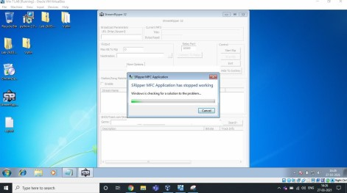

Here is the Exploit used above.

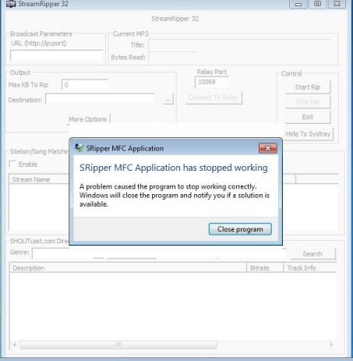

As we can see, it’s crashed. Analysis & Vulnerability :

Buffer Overflow is the Vulnerability in this 32 bit

application. We have inserted an exploit of many characters in the field which overflowed and caused the application to crash itself. It is not capable of handling those many characters given to match/add in the song pattern. That's why it is crashed.