**SECURE CODING (Lab_8)**

Venkata Lokesh

19BCE7776

L23+L24

Script:

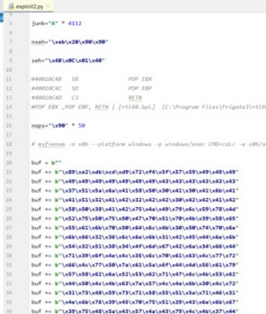

Payload Generated:

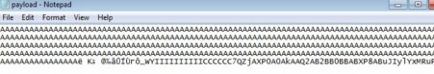

App Crashes:

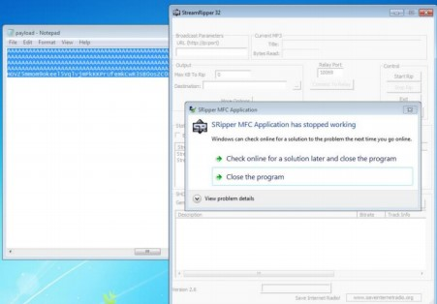

Change the default trigger from cmd.exe to calc.exe:

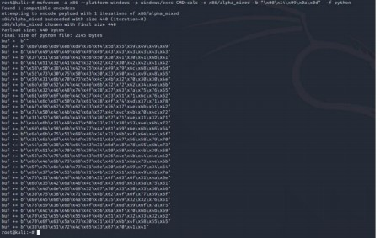

Copy pasting the Generated payload in exploit2.py and then using it in frigate:

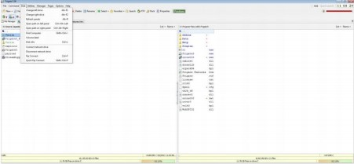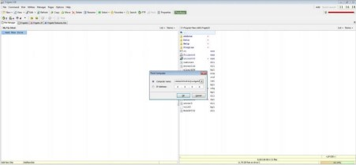

The app crashes and calculator opens:

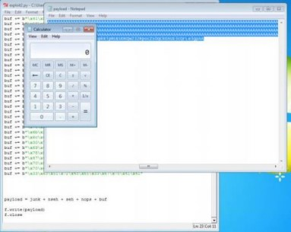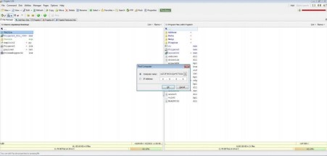

The App crashes and CMD opens:

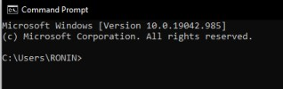

Change the default trigger to open the control panel:

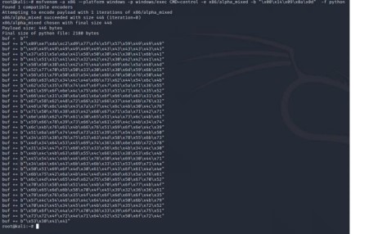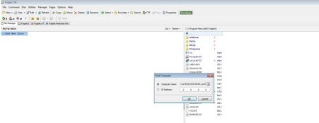

The app crashes and the control panel opens:

