Linux

***Wild cards: (*,?,^,[])***

* * - represents a zero or more characters
* ? – represents a single character
* []- represents a range of characters

touch abcd{1…9}-xyz

ls –l abc*

rm abcd*

rm *xyz

ls –l ?bcd* – anything that has whatever the character is first and other characters is bcd is what I wanted

ls –l *[cd]* - give me anything that has cd

more is for seeing one page at a time

rm *xy* - delete all the fields that have x and y in it

\ = (slash) as an escape character

^= beginning of line

$= end of line

inode- Pointer or a number of a file in hard disk

soft link – link will be removed if a file is removed or renamed- ln -s

hard link - Deleting renaming or removing the original file will not affect the hard link – ln

link is like a shortcut you create in a windows on desktop

ls –li – to get the inode number

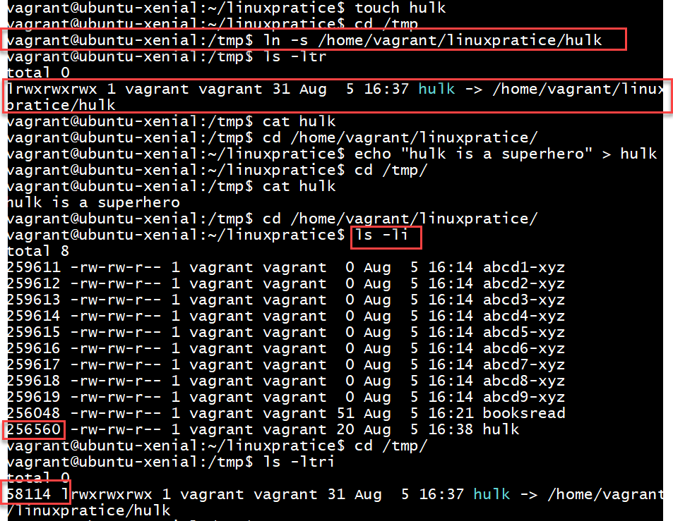

Once I removed the file the link is broken and it no more recognizes the file

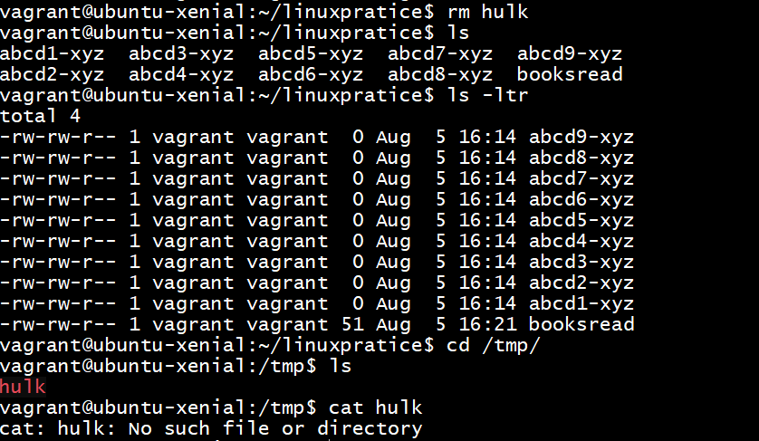

Hard link even we remove source file it doesn’t remove the destination

***Commands option and arguments***

Options modify the way commands

**command option arguments**

ls(command) –ltr(options) Mahesh(argument) only list files with the name “Mahesh”

rm –f sienfeld

chmod – to change permissions

read – 4 , write-2, execute – 1, 0 – no permission

chmod 755

***File ownership commands***

chown – changes ownership of file

chgrp – changes the group ownership of file

-R – recursively changes the ownership of file

1. How to get to the end of line?
2. How to get to the start of line?
3. How to create 10 files abcd1xyz, abcd2xyz……etc?
4. How to search for a files with any starting but have bcd in following letters?
5. What is inode and its significance in soft and hard links?
6. What is soft link and hardlink and its syntax ?
7. What is the command to change permissions?
8. What are the numeric way of representing permissions?