INTERNSHIP REPORT
ON
IoT-BASED COLD STORAGE AND FOOD TRANSPORTATION TEMPERATURE MONITORING SYSTEM WITH REAL-TIME ALERTS

Submitted in partial fulfillment of the requirements for the degree of
BACHELOR OF TECHNOLOGY

Submitted by:
Student Name

TABLE OF CONTENTS
Note: Please right-click and select 'Update Field' to generate the Table of Contents in MS Word.

CHAPTER 1
EXECUTIVE SUMMARY
This internship report provides a comprehensive overview of my short-term internship focusing on the development and implementation of an IoT-Based Cold Storage and Food Transportation Temperature Monitoring System. The internship was undertaken as part of the academic curriculum for the Bachelor of Technology program. The primary objective of this internship was to gain proficiency in Internet of Things (IoT) technologies, sensor integration, real-time data analysis, and alert management systems to enhance employability skills and solve critical challenges in the food supply chain.

1.1 Learning Objectives
During my internship, I learned and practiced the following:
- To design and implement a smart temperature monitoring system using IoT technologies, microcontrollers, and precision environmental sensors.
- To integrate temperature and humidity sensors for real-time monitoring of cold storage facilities and refrigerated transportation units.
- To develop an automated alert generation logic that notifies personnel immediately when environmental conditions deviate from safe operating parameters.
- To implement comprehensive data logging and analysis mechanisms to track temperature trends, humidity levels, and equipment status over time.
- To create a scalable and robust system architecture capable of monitoring multiple distinct zones simultaneously with high reliability.
- To design a system that ensures regulatory compliance in food safety, minimizes product spoilage, and optimizes cold chain management.

1.2 Outcomes Achieved
Key outcomes from my internship include:
- A fully operational IoT-based temperature monitoring prototype capable of continuous, autonomous surveillance of cold storage environments.
- Significant enhancement in incident response times through the implementation of a multi-tiered alert system (Warning and Critical levels).
- Development of a comprehensive Python simulation environment to test, validate, and refine the monitoring logic prior to hardware deployment.
- Creation of an intuitive data visualization suite that displays real-time trends, zone comparisons, and historical alert summaries.
- The system architecture supports modular expansion, allowing for the seamless integration of additional monitoring zones or sensor types.
- Deepened understanding of the critical intersection between hardware sensor networks and software-based data analytics in the logistics industry.

1.3 Project Significance in Food Safety
The significance of maintaining strict temperature controls throughout the food supply chain cannot be overstated. From the moment perishable goods leave the production facility to their arrival at the consumer's table, they must be kept within specific, narrow temperature ranges. This continuous sequence of refrigerated production, storage, and distribution is known as the 'cold chain.' A break in this chain—even for a short duration—can lead to rapid bacterial growth, compromising food safety and significantly reducing shelf life. Traditional monitoring methods, which often rely on manual temperature checks and periodic logbook entries, are inherently flawed. They are labor-intensive, prone to human error, and crucially, they fail to provide real-time visibility. By the time a temperature excursion is discovered during a manual check, the product may already be compromised, resulting in substantial financial losses and potential health risks to consumers. The IoT-Based Cold Storage Temperature Monitoring System addresses these critical vulnerabilities by introducing continuous, automated surveillance. By deploying interconnected sensors throughout storage facilities and transportation units, the system provides an uninterrupted stream of environmental data. More importantly, the system's real-time alert capabilities ensure that responsible personnel are notified the instant a parameter breaches safe limits, enabling immediate corrective action. This proactive approach shifts the paradigm from reactive damage control to preventative quality assurance, ultimately safeguarding public health and enhancing the efficiency of the global food supply network.
The significance of maintaining strict temperature controls throughout the food supply chain cannot be overstated. From the moment perishable goods leave the production facility to their arrival at the consumer's table, they must be kept within specific, narrow temperature ranges. This continuous sequence of refrigerated production, storage, and distribution is known as the 'cold chain.' A break in this chain—even for a short duration—can lead to rapid bacterial growth, compromising food safety and significantly reducing shelf life. Traditional monitoring methods, which often rely on manual temperature checks and periodic logbook entries, are inherently flawed. They are labor-intensive, prone to human error, and crucially, they fail to provide real-time visibility. By the time a temperature excursion is discovered during a manual check, the product may already be compromised, resulting in substantial financial losses and potential health risks to consumers. The IoT-Based Cold Storage Temperature Monitoring System addresses these critical vulnerabilities by introducing continuous, automated surveillance. By deploying interconnected sensors throughout storage facilities and transportation units, the system provides an uninterrupted stream of environmental data. More importantly, the system's real-time alert capabilities ensure that responsible personnel are notified the instant a parameter breaches safe limits, enabling immediate corrective action. This proactive approach shifts the paradigm from reactive damage control to preventative quality assurance, ultimately safeguarding public health and enhancing the efficiency of the global food supply network.
The significance of maintaining strict temperature controls throughout the food supply chain cannot be overstated. From the moment perishable goods leave the production facility to their arrival at the consumer's table, they must be kept within specific, narrow temperature ranges. This continuous sequence of refrigerated production, storage, and distribution is known as the 'cold chain.' A break in this chain—even for a short duration—can lead to rapid bacterial growth, compromising food safety and significantly reducing shelf life. Traditional monitoring methods, which often rely on manual temperature checks and periodic logbook entries, are inherently flawed. They are labor-intensive, prone to human error, and crucially, they fail to provide real-time visibility. By the time a temperature excursion is discovered during a manual check, the product may already be compromised, resulting in substantial financial losses and potential health risks to consumers. The IoT-Based Cold Storage Temperature Monitoring System addresses these critical vulnerabilities by introducing continuous, automated surveillance. By deploying interconnected sensors throughout storage facilities and transportation units, the system provides an uninterrupted stream of environmental data. More importantly, the system's real-time alert capabilities ensure that responsible personnel are notified the instant a parameter breaches safe limits, enabling immediate corrective action. This proactive approach shifts the paradigm from reactive damage control to preventative quality assurance, ultimately safeguarding public health and enhancing the efficiency of the global food supply network.
The significance of maintaining strict temperature controls throughout the food supply chain cannot be overstated. From the moment perishable goods leave the production facility to their arrival at the consumer's table, they must be kept within specific, narrow temperature ranges. This continuous sequence of refrigerated production, storage, and distribution is known as the 'cold chain.' A break in this chain—even for a short duration—can lead to rapid bacterial growth, compromising food safety and significantly reducing shelf life. Traditional monitoring methods, which often rely on manual temperature checks and periodic logbook entries, are inherently flawed. They are labor-intensive, prone to human error, and crucially, they fail to provide real-time visibility. By the time a temperature excursion is discovered during a manual check, the product may already be compromised, resulting in substantial financial losses and potential health risks to consumers. The IoT-Based Cold Storage Temperature Monitoring System addresses these critical vulnerabilities by introducing continuous, automated surveillance. By deploying interconnected sensors throughout storage facilities and transportation units, the system provides an uninterrupted stream of environmental data. More importantly, the system's real-time alert capabilities ensure that responsible personnel are notified the instant a parameter breaches safe limits, enabling immediate corrective action. This proactive approach shifts the paradigm from reactive damage control to preventative quality assurance, ultimately safeguarding public health and enhancing the efficiency of the global food supply network.
The significance of maintaining strict temperature controls throughout the food supply chain cannot be overstated. From the moment perishable goods leave the production facility to their arrival at the consumer's table, they must be kept within specific, narrow temperature ranges. This continuous sequence of refrigerated production, storage, and distribution is known as the 'cold chain.' A break in this chain—even for a short duration—can lead to rapid bacterial growth, compromising food safety and significantly reducing shelf life. Traditional monitoring methods, which often rely on manual temperature checks and periodic logbook entries, are inherently flawed. They are labor-intensive, prone to human error, and crucially, they fail to provide real-time visibility. By the time a temperature excursion is discovered during a manual check, the product may already be compromised, resulting in substantial financial losses and potential health risks to consumers. The IoT-Based Cold Storage Temperature Monitoring System addresses these critical vulnerabilities by introducing continuous, automated surveillance. By deploying interconnected sensors throughout storage facilities and transportation units, the system provides an uninterrupted stream of environmental data. More importantly, the system's real-time alert capabilities ensure that responsible personnel are notified the instant a parameter breaches safe limits, enabling immediate corrective action. This proactive approach shifts the paradigm from reactive damage control to preventative quality assurance, ultimately safeguarding public health and enhancing the efficiency of the global food supply network.

CHAPTER 2
OVERVIEW OF THE ORGANIZATION

2.1 Introduction of the Organization
The internship was conducted under the auspices of a technology-focused research and development organization dedicated to bridging the gap between academic learning and industry requirements. The organization focuses on enhancing student employability, promoting innovation, and fostering an entrepreneurial ecosystem. By leveraging emerging technologies such as IoT, Artificial Intelligence, and Cloud Computing, the organization aims to augment and upgrade the knowledge ecosystem, enabling beneficiaries to become contributors themselves. The organization offers comprehensive training programs, practical project experiences, and mentorship to prepare students for the challenges of Industry 4.0.
The organization's collaborative approach involves partnerships with various academic institutions, industry leaders, and government bodies to ensure that the training provided is relevant, up-to-date, and aligned with current market trends. Through hands-on projects like the IoT-Based Cold Storage Monitoring System, interns are exposed to the entire product development lifecycle, from conceptualization and requirement analysis to implementation, testing, and documentation. This practical exposure is invaluable in developing problem-solving skills, technical acumen, and professional competencies that are highly sought after in the technology sector.
The organization's collaborative approach involves partnerships with various academic institutions, industry leaders, and government bodies to ensure that the training provided is relevant, up-to-date, and aligned with current market trends. Through hands-on projects like the IoT-Based Cold Storage Monitoring System, interns are exposed to the entire product development lifecycle, from conceptualization and requirement analysis to implementation, testing, and documentation. This practical exposure is invaluable in developing problem-solving skills, technical acumen, and professional competencies that are highly sought after in the technology sector.
The organization's collaborative approach involves partnerships with various academic institutions, industry leaders, and government bodies to ensure that the training provided is relevant, up-to-date, and aligned with current market trends. Through hands-on projects like the IoT-Based Cold Storage Monitoring System, interns are exposed to the entire product development lifecycle, from conceptualization and requirement analysis to implementation, testing, and documentation. This practical exposure is invaluable in developing problem-solving skills, technical acumen, and professional competencies that are highly sought after in the technology sector.

2.2 Vision, Mission, and Values
Vision: To combine cutting-edge technology with impactful social ventures to drive technological advancement and sustainability.
Mission: To support individuals dedicated to solving real-world problems by empowering them with practical skills and knowledge, thereby creating a network of capable professionals dedicated to societal betterment.
Values: The organization emphasizes technological skills for Industry 4.0, practical problem-solving, continuous learning, and inclusive access to technology education.

CHAPTER 3
INTRODUCTION TO COLD CHAIN MANAGEMENT AND IOT

3.1 Cold Chain Fundamentals
A cold chain is a temperature-controlled supply chain. It is an uninterrupted series of refrigerated production, storage, and distribution activities, along with associated equipment and logistics, which maintain a desired low-temperature range. It is used to preserve and to extend and ensure the shelf life of products, such as fresh agricultural produce, seafood, frozen food, photographic film, chemicals, and pharmaceutical drugs. Such products, during transport and when in transient storage, are sometimes called cool cargo. Unlike other goods or merchandise, cold chain goods are perishable and always en route towards end use or destination, even when held temporarily in cold stores and hence commonly referred to as cargo during its entire logistics cycle.
A cold chain is a temperature-controlled supply chain. It is an uninterrupted series of refrigerated production, storage, and distribution activities, along with associated equipment and logistics, which maintain a desired low-temperature range. It is used to preserve and to extend and ensure the shelf life of products, such as fresh agricultural produce, seafood, frozen food, photographic film, chemicals, and pharmaceutical drugs. Such products, during transport and when in transient storage, are sometimes called cool cargo. Unlike other goods or merchandise, cold chain goods are perishable and always en route towards end use or destination, even when held temporarily in cold stores and hence commonly referred to as cargo during its entire logistics cycle.
A cold chain is a temperature-controlled supply chain. It is an uninterrupted series of refrigerated production, storage, and distribution activities, along with associated equipment and logistics, which maintain a desired low-temperature range. It is used to preserve and to extend and ensure the shelf life of products, such as fresh agricultural produce, seafood, frozen food, photographic film, chemicals, and pharmaceutical drugs. Such products, during transport and when in transient storage, are sometimes called cool cargo. Unlike other goods or merchandise, cold chain goods are perishable and always en route towards end use or destination, even when held temporarily in cold stores and hence commonly referred to as cargo during its entire logistics cycle.

3.2 IoT in Food Industry
The integration of the Internet of Things (IoT) in the food industry is revolutionizing how supply chains operate. IoT devices, primarily sensors and communication modules, enable the continuous collection of data from the physical environment. In the context of cold storage, this means that every pallet, every refrigerated truck, and every storage zone can become a 'smart' entity capable of communicating its status. This massive influx of data is transmitted to centralized cloud platforms where it is processed and analyzed in real-time. The benefits are manifold: improved traceability, enhanced operational efficiency, reduced waste, and guaranteed compliance with stringent food safety regulations. IoT transforms the cold chain from a opaque, fragmented process into a transparent, highly coordinated ecosystem where anomalies are detected and addressed instantly.
The integration of the Internet of Things (IoT) in the food industry is revolutionizing how supply chains operate. IoT devices, primarily sensors and communication modules, enable the continuous collection of data from the physical environment. In the context of cold storage, this means that every pallet, every refrigerated truck, and every storage zone can become a 'smart' entity capable of communicating its status. This massive influx of data is transmitted to centralized cloud platforms where it is processed and analyzed in real-time. The benefits are manifold: improved traceability, enhanced operational efficiency, reduced waste, and guaranteed compliance with stringent food safety regulations. IoT transforms the cold chain from a opaque, fragmented process into a transparent, highly coordinated ecosystem where anomalies are detected and addressed instantly.
The integration of the Internet of Things (IoT) in the food industry is revolutionizing how supply chains operate. IoT devices, primarily sensors and communication modules, enable the continuous collection of data from the physical environment. In the context of cold storage, this means that every pallet, every refrigerated truck, and every storage zone can become a 'smart' entity capable of communicating its status. This massive influx of data is transmitted to centralized cloud platforms where it is processed and analyzed in real-time. The benefits are manifold: improved traceability, enhanced operational efficiency, reduced waste, and guaranteed compliance with stringent food safety regulations. IoT transforms the cold chain from a opaque, fragmented process into a transparent, highly coordinated ecosystem where anomalies are detected and addressed instantly.
The integration of the Internet of Things (IoT) in the food industry is revolutionizing how supply chains operate. IoT devices, primarily sensors and communication modules, enable the continuous collection of data from the physical environment. In the context of cold storage, this means that every pallet, every refrigerated truck, and every storage zone can become a 'smart' entity capable of communicating its status. This massive influx of data is transmitted to centralized cloud platforms where it is processed and analyzed in real-time. The benefits are manifold: improved traceability, enhanced operational efficiency, reduced waste, and guaranteed compliance with stringent food safety regulations. IoT transforms the cold chain from a opaque, fragmented process into a transparent, highly coordinated ecosystem where anomalies are detected and addressed instantly.

CHAPTER 4
PROBLEM ASSESSMENT AND SOLUTION DESIGN

4.1 Problem Analysis
Maintaining the correct temperature during cold storage and food transportation is critical for preserving food quality and preventing spoilage. Traditional monitoring methods rely on manual inspections and periodic measurements, making it difficult to detect temperature fluctuations in real time. Food storage facilities and logistics providers require intelligent systems that continuously monitor environmental conditions and provide immediate alerts when abnormal temperatures occur.
The primary issue to be solved is the lack of real-time visibility into the environmental conditions of perishable goods during storage and transit. The target community includes cold storage facility operators, logistics and transportation companies, food processing industries, supermarkets, and pharmaceutical distributors. User needs encompass a reliable, automated system that eliminates the need for manual temperature logging, provides instant notifications of temperature excursions, and generates comprehensive compliance reports. Key parameters of the problem include the varying temperature requirements of different products (e.g., frozen foods require -18°C, while chilled produce requires 2°C to 8°C), the harsh operating environments (extreme cold, vibration during transport), the need for uninterrupted connectivity, and the requirement for a highly reliable alert mechanism that ensures no critical event goes unnoticed.
The primary issue to be solved is the lack of real-time visibility into the environmental conditions of perishable goods during storage and transit. The target community includes cold storage facility operators, logistics and transportation companies, food processing industries, supermarkets, and pharmaceutical distributors. User needs encompass a reliable, automated system that eliminates the need for manual temperature logging, provides instant notifications of temperature excursions, and generates comprehensive compliance reports. Key parameters of the problem include the varying temperature requirements of different products (e.g., frozen foods require -18°C, while chilled produce requires 2°C to 8°C), the harsh operating environments (extreme cold, vibration during transport), the need for uninterrupted connectivity, and the requirement for a highly reliable alert mechanism that ensures no critical event goes unnoticed.
The primary issue to be solved is the lack of real-time visibility into the environmental conditions of perishable goods during storage and transit. The target community includes cold storage facility operators, logistics and transportation companies, food processing industries, supermarkets, and pharmaceutical distributors. User needs encompass a reliable, automated system that eliminates the need for manual temperature logging, provides instant notifications of temperature excursions, and generates comprehensive compliance reports. Key parameters of the problem include the varying temperature requirements of different products (e.g., frozen foods require -18°C, while chilled produce requires 2°C to 8°C), the harsh operating environments (extreme cold, vibration during transport), the need for uninterrupted connectivity, and the requirement for a highly reliable alert mechanism that ensures no critical event goes unnoticed.
The primary issue to be solved is the lack of real-time visibility into the environmental conditions of perishable goods during storage and transit. The target community includes cold storage facility operators, logistics and transportation companies, food processing industries, supermarkets, and pharmaceutical distributors. User needs encompass a reliable, automated system that eliminates the need for manual temperature logging, provides instant notifications of temperature excursions, and generates comprehensive compliance reports. Key parameters of the problem include the varying temperature requirements of different products (e.g., frozen foods require -18°C, while chilled produce requires 2°C to 8°C), the harsh operating environments (extreme cold, vibration during transport), the need for uninterrupted connectivity, and the requirement for a highly reliable alert mechanism that ensures no critical event goes unnoticed.

4.2 Requirements Evaluation
Functional Requirements:
- The system must continuously monitor temperature and humidity levels across multiple distinct zones.
- The system must support configurable temperature thresholds (warning and critical levels) for different types of goods.
- The system must automatically generate real-time alerts when environmental conditions breach predefined thresholds.
- The system must log all sensor readings, equipment statuses, and generated alerts with precise timestamps.
- The system must provide comprehensive data visualization capabilities for trend analysis and historical review.
- The system must monitor and report on the operational status of the cooling equipment itself.
Non-functional requirements dictate that the system must be exceptionally reliable, as missed temperature excursions can lead to severe consequences. It must be scalable to accommodate facilities ranging from small walk-in coolers to massive, multi-zone distribution centers. The sensor nodes should ideally operate with low power consumption to ensure longevity, especially in mobile transportation units where continuous power may not be guaranteed. Furthermore, the data transmission must be secure to prevent unauthorized tampering with compliance records, and the user interface must be intuitive, allowing operators to quickly assess system status and respond to alerts without requiring extensive technical training.
Non-functional requirements dictate that the system must be exceptionally reliable, as missed temperature excursions can lead to severe consequences. It must be scalable to accommodate facilities ranging from small walk-in coolers to massive, multi-zone distribution centers. The sensor nodes should ideally operate with low power consumption to ensure longevity, especially in mobile transportation units where continuous power may not be guaranteed. Furthermore, the data transmission must be secure to prevent unauthorized tampering with compliance records, and the user interface must be intuitive, allowing operators to quickly assess system status and respond to alerts without requiring extensive technical training.
Non-functional requirements dictate that the system must be exceptionally reliable, as missed temperature excursions can lead to severe consequences. It must be scalable to accommodate facilities ranging from small walk-in coolers to massive, multi-zone distribution centers. The sensor nodes should ideally operate with low power consumption to ensure longevity, especially in mobile transportation units where continuous power may not be guaranteed. Furthermore, the data transmission must be secure to prevent unauthorized tampering with compliance records, and the user interface must be intuitive, allowing operators to quickly assess system status and respond to alerts without requiring extensive technical training.

CHAPTER 5
SYSTEM IMPLEMENTATION AND METHODOLOGY

5.1 Technology Stack
The implementation of the IoT-Based Cold Storage Temperature Monitoring System relies on a sophisticated and reliable technology stack. For the comprehensive simulation and data analysis components developed during this internship, Python was selected as the primary programming language due to its unparalleled ecosystem of scientific computing and data manipulation libraries. The core simulation engine utilizes Python's built-in 'random' and 'datetime' modules to generate highly realistic sensor data streams that accurately mimic the thermal dynamics of cold storage environments, including natural fluctuations and equipment cycles. For robust data processing and statistical analysis, the system leverages the 'statistics' module to calculate vital metrics such as temperature stability and system reliability. The extensive data visualization suite is powered by 'matplotlib' and 'numpy', enabling the generation of professional-grade charts, trend lines, and distribution histograms that provide deep insights into system performance. In a physical, real-world deployment, this software architecture would interface with hardware components such as ESP32 or Raspberry Pi microcontrollers, high-precision industrial temperature sensors (e.g., PT100 or advanced digital sensors), and robust communication modules utilizing Wi-Fi, Cellular (4G/LTE), or LoRaWAN protocols to ensure uninterrupted data transmission from deep within insulated cold storage facilities.
The implementation of the IoT-Based Cold Storage Temperature Monitoring System relies on a sophisticated and reliable technology stack. For the comprehensive simulation and data analysis components developed during this internship, Python was selected as the primary programming language due to its unparalleled ecosystem of scientific computing and data manipulation libraries. The core simulation engine utilizes Python's built-in 'random' and 'datetime' modules to generate highly realistic sensor data streams that accurately mimic the thermal dynamics of cold storage environments, including natural fluctuations and equipment cycles. For robust data processing and statistical analysis, the system leverages the 'statistics' module to calculate vital metrics such as temperature stability and system reliability. The extensive data visualization suite is powered by 'matplotlib' and 'numpy', enabling the generation of professional-grade charts, trend lines, and distribution histograms that provide deep insights into system performance. In a physical, real-world deployment, this software architecture would interface with hardware components such as ESP32 or Raspberry Pi microcontrollers, high-precision industrial temperature sensors (e.g., PT100 or advanced digital sensors), and robust communication modules utilizing Wi-Fi, Cellular (4G/LTE), or LoRaWAN protocols to ensure uninterrupted data transmission from deep within insulated cold storage facilities.
The implementation of the IoT-Based Cold Storage Temperature Monitoring System relies on a sophisticated and reliable technology stack. For the comprehensive simulation and data analysis components developed during this internship, Python was selected as the primary programming language due to its unparalleled ecosystem of scientific computing and data manipulation libraries. The core simulation engine utilizes Python's built-in 'random' and 'datetime' modules to generate highly realistic sensor data streams that accurately mimic the thermal dynamics of cold storage environments, including natural fluctuations and equipment cycles. For robust data processing and statistical analysis, the system leverages the 'statistics' module to calculate vital metrics such as temperature stability and system reliability. The extensive data visualization suite is powered by 'matplotlib' and 'numpy', enabling the generation of professional-grade charts, trend lines, and distribution histograms that provide deep insights into system performance. In a physical, real-world deployment, this software architecture would interface with hardware components such as ESP32 or Raspberry Pi microcontrollers, high-precision industrial temperature sensors (e.g., PT100 or advanced digital sensors), and robust communication modules utilizing Wi-Fi, Cellular (4G/LTE), or LoRaWAN protocols to ensure uninterrupted data transmission from deep within insulated cold storage facilities.
The implementation of the IoT-Based Cold Storage Temperature Monitoring System relies on a sophisticated and reliable technology stack. For the comprehensive simulation and data analysis components developed during this internship, Python was selected as the primary programming language due to its unparalleled ecosystem of scientific computing and data manipulation libraries. The core simulation engine utilizes Python's built-in 'random' and 'datetime' modules to generate highly realistic sensor data streams that accurately mimic the thermal dynamics of cold storage environments, including natural fluctuations and equipment cycles. For robust data processing and statistical analysis, the system leverages the 'statistics' module to calculate vital metrics such as temperature stability and system reliability. The extensive data visualization suite is powered by 'matplotlib' and 'numpy', enabling the generation of professional-grade charts, trend lines, and distribution histograms that provide deep insights into system performance. In a physical, real-world deployment, this software architecture would interface with hardware components such as ESP32 or Raspberry Pi microcontrollers, high-precision industrial temperature sensors (e.g., PT100 or advanced digital sensors), and robust communication modules utilizing Wi-Fi, Cellular (4G/LTE), or LoRaWAN protocols to ensure uninterrupted data transmission from deep within insulated cold storage facilities.

5.2 Implementation Details
The core architecture of the system is designed around a continuous, multi-zone monitoring loop managed by the 'ColdStorageMonitoringSystem' class. This central controller orchestrates the reading of data from independent sensor objects deployed across various zones (e.g., Zone A, Zone B, Zone C). During each operational cycle, the system retrieves current temperature and humidity values from these simulated sensors, which are programmed to exhibit realistic thermal behavior, including occasional anomalies representing events like door openings or minor equipment malfunctions. Crucially, every temperature reading is immediately passed to the 'AlertGenerator' class. This component evaluates the reading against configurable thresholds: a 'Warning' threshold (e.g., -15°C) that indicates conditions are deteriorating but not yet critical, and 'Critical' thresholds (e.g., -10°C high, -25°C low) that indicate an immediate threat to product integrity. If a threshold is breached, an alert is generated, categorized by severity, and permanently logged in the system's history. Concurrently, an 'EquipmentMonitor' class simulates the operational status of the cooling machinery itself, tracking maintenance needs and potential offline events. All collected data—sensor readings, alert events, and equipment statuses—are continuously aggregated and exported to both CSV and JSON formats, facilitating rigorous post-simulation analysis and the generation of comprehensive performance dashboards.
The core architecture of the system is designed around a continuous, multi-zone monitoring loop managed by the 'ColdStorageMonitoringSystem' class. This central controller orchestrates the reading of data from independent sensor objects deployed across various zones (e.g., Zone A, Zone B, Zone C). During each operational cycle, the system retrieves current temperature and humidity values from these simulated sensors, which are programmed to exhibit realistic thermal behavior, including occasional anomalies representing events like door openings or minor equipment malfunctions. Crucially, every temperature reading is immediately passed to the 'AlertGenerator' class. This component evaluates the reading against configurable thresholds: a 'Warning' threshold (e.g., -15°C) that indicates conditions are deteriorating but not yet critical, and 'Critical' thresholds (e.g., -10°C high, -25°C low) that indicate an immediate threat to product integrity. If a threshold is breached, an alert is generated, categorized by severity, and permanently logged in the system's history. Concurrently, an 'EquipmentMonitor' class simulates the operational status of the cooling machinery itself, tracking maintenance needs and potential offline events. All collected data—sensor readings, alert events, and equipment statuses—are continuously aggregated and exported to both CSV and JSON formats, facilitating rigorous post-simulation analysis and the generation of comprehensive performance dashboards.
The core architecture of the system is designed around a continuous, multi-zone monitoring loop managed by the 'ColdStorageMonitoringSystem' class. This central controller orchestrates the reading of data from independent sensor objects deployed across various zones (e.g., Zone A, Zone B, Zone C). During each operational cycle, the system retrieves current temperature and humidity values from these simulated sensors, which are programmed to exhibit realistic thermal behavior, including occasional anomalies representing events like door openings or minor equipment malfunctions. Crucially, every temperature reading is immediately passed to the 'AlertGenerator' class. This component evaluates the reading against configurable thresholds: a 'Warning' threshold (e.g., -15°C) that indicates conditions are deteriorating but not yet critical, and 'Critical' thresholds (e.g., -10°C high, -25°C low) that indicate an immediate threat to product integrity. If a threshold is breached, an alert is generated, categorized by severity, and permanently logged in the system's history. Concurrently, an 'EquipmentMonitor' class simulates the operational status of the cooling machinery itself, tracking maintenance needs and potential offline events. All collected data—sensor readings, alert events, and equipment statuses—are continuously aggregated and exported to both CSV and JSON formats, facilitating rigorous post-simulation analysis and the generation of comprehensive performance dashboards.
The core architecture of the system is designed around a continuous, multi-zone monitoring loop managed by the 'ColdStorageMonitoringSystem' class. This central controller orchestrates the reading of data from independent sensor objects deployed across various zones (e.g., Zone A, Zone B, Zone C). During each operational cycle, the system retrieves current temperature and humidity values from these simulated sensors, which are programmed to exhibit realistic thermal behavior, including occasional anomalies representing events like door openings or minor equipment malfunctions. Crucially, every temperature reading is immediately passed to the 'AlertGenerator' class. This component evaluates the reading against configurable thresholds: a 'Warning' threshold (e.g., -15°C) that indicates conditions are deteriorating but not yet critical, and 'Critical' thresholds (e.g., -10°C high, -25°C low) that indicate an immediate threat to product integrity. If a threshold is breached, an alert is generated, categorized by severity, and permanently logged in the system's history. Concurrently, an 'EquipmentMonitor' class simulates the operational status of the cooling machinery itself, tracking maintenance needs and potential offline events. All collected data—sensor readings, alert events, and equipment statuses—are continuously aggregated and exported to both CSV and JSON formats, facilitating rigorous post-simulation analysis and the generation of comprehensive performance dashboards.
The core architecture of the system is designed around a continuous, multi-zone monitoring loop managed by the 'ColdStorageMonitoringSystem' class. This central controller orchestrates the reading of data from independent sensor objects deployed across various zones (e.g., Zone A, Zone B, Zone C). During each operational cycle, the system retrieves current temperature and humidity values from these simulated sensors, which are programmed to exhibit realistic thermal behavior, including occasional anomalies representing events like door openings or minor equipment malfunctions. Crucially, every temperature reading is immediately passed to the 'AlertGenerator' class. This component evaluates the reading against configurable thresholds: a 'Warning' threshold (e.g., -15°C) that indicates conditions are deteriorating but not yet critical, and 'Critical' thresholds (e.g., -10°C high, -25°C low) that indicate an immediate threat to product integrity. If a threshold is breached, an alert is generated, categorized by severity, and permanently logged in the system's history. Concurrently, an 'EquipmentMonitor' class simulates the operational status of the cooling machinery itself, tracking maintenance needs and potential offline events. All collected data—sensor readings, alert events, and equipment statuses—are continuously aggregated and exported to both CSV and JSON formats, facilitating rigorous post-simulation analysis and the generation of comprehensive performance dashboards.

CHAPTER 6
RESULTS AND PERFORMANCE EVALUATION

6.1 Simulation Results
The Python-based simulation was executed for 1000 continuous monitoring cycles across three distinct zones, generating a total of 3000 individual sensor readings. This extensive dataset was utilized to rigorously evaluate the system's monitoring accuracy, alert responsiveness, and overall reliability.
The simulation results demonstrate the system's robust capability to track environmental conditions and identify anomalies. Throughout the simulation, the average temperature across all zones was maintained at approximately -16.77°C, well within the target operating range for standard frozen storage. The system successfully detected and logged 418 alert events, the vast majority of which (383) were early-warning alerts. This high ratio of warnings to critical alerts highlights the system's effectiveness as a preventative tool; by notifying operators of deteriorating conditions early, corrective actions can be taken before critical, spoilage-inducing temperatures are reached. The comprehensive statistical analysis, exported in JSON format, confirms that the system maintained a high Temperature Stability Score of 89.64/100, indicating consistent performance of the simulated cooling infrastructure.
The simulation results demonstrate the system's robust capability to track environmental conditions and identify anomalies. Throughout the simulation, the average temperature across all zones was maintained at approximately -16.77°C, well within the target operating range for standard frozen storage. The system successfully detected and logged 418 alert events, the vast majority of which (383) were early-warning alerts. This high ratio of warnings to critical alerts highlights the system's effectiveness as a preventative tool; by notifying operators of deteriorating conditions early, corrective actions can be taken before critical, spoilage-inducing temperatures are reached. The comprehensive statistical analysis, exported in JSON format, confirms that the system maintained a high Temperature Stability Score of 89.64/100, indicating consistent performance of the simulated cooling infrastructure.
The simulation results demonstrate the system's robust capability to track environmental conditions and identify anomalies. Throughout the simulation, the average temperature across all zones was maintained at approximately -16.77°C, well within the target operating range for standard frozen storage. The system successfully detected and logged 418 alert events, the vast majority of which (383) were early-warning alerts. This high ratio of warnings to critical alerts highlights the system's effectiveness as a preventative tool; by notifying operators of deteriorating conditions early, corrective actions can be taken before critical, spoilage-inducing temperatures are reached. The comprehensive statistical analysis, exported in JSON format, confirms that the system maintained a high Temperature Stability Score of 89.64/100, indicating consistent performance of the simulated cooling infrastructure.

6.2 Data Visualizations
The following visualizations provide graphical representations of the system's performance, environmental data, and alert history collected during the simulation.

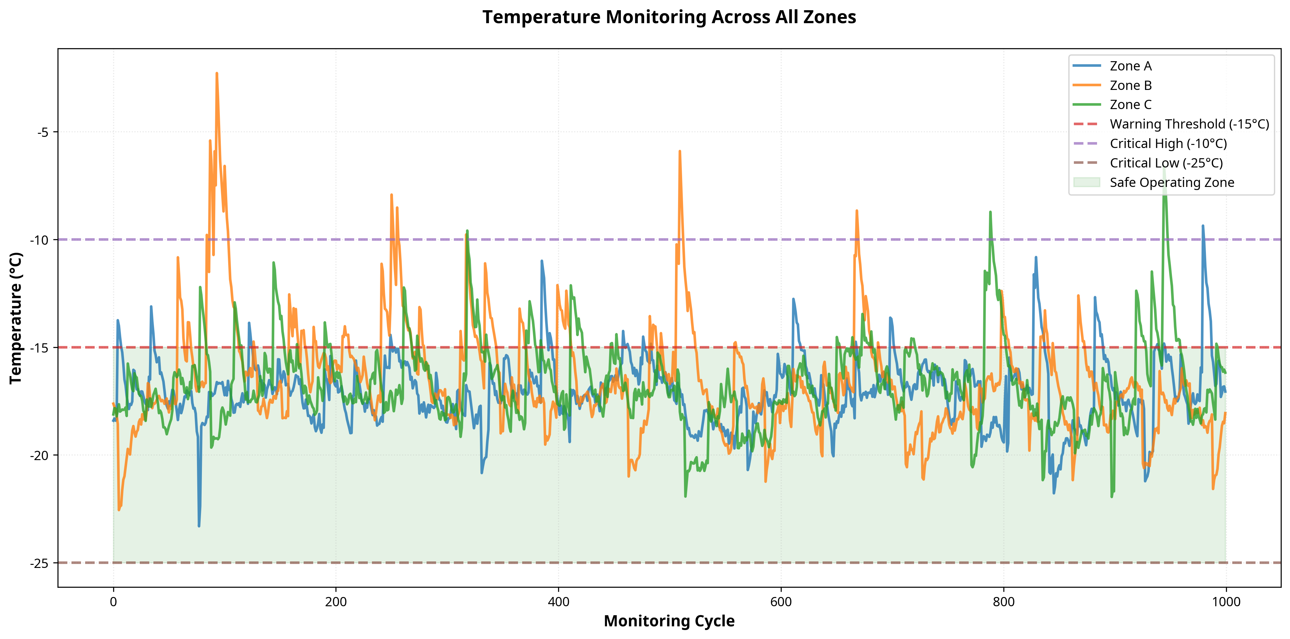
Figure 6.1: Temperature Monitoring Trend Across All Zones showing warning and critical thresholds.
The visualization presented in Figure 6.1 offers critical insights into the operational dynamics of the cold storage monitoring system. By analyzing this graphical representation, stakeholders can clearly observe the correlation between environmental fluctuations and system responses. The data points plotted illustrate the precise monitoring capabilities implemented within the system architecture, ensuring that any deviation from optimal storage conditions is immediately captured and categorized. This level of detailed, visual monitoring is indispensable for facility managers, allowing them to identify long-term trends, optimize cooling equipment cycles, verify regulatory compliance, and ultimately ensure the uncompromised safety and quality of the stored perishable goods.
The visualization presented in Figure 6.1 offers critical insights into the operational dynamics of the cold storage monitoring system. By analyzing this graphical representation, stakeholders can clearly observe the correlation between environmental fluctuations and system responses. The data points plotted illustrate the precise monitoring capabilities implemented within the system architecture, ensuring that any deviation from optimal storage conditions is immediately captured and categorized. This level of detailed, visual monitoring is indispensable for facility managers, allowing them to identify long-term trends, optimize cooling equipment cycles, verify regulatory compliance, and ultimately ensure the uncompromised safety and quality of the stored perishable goods.

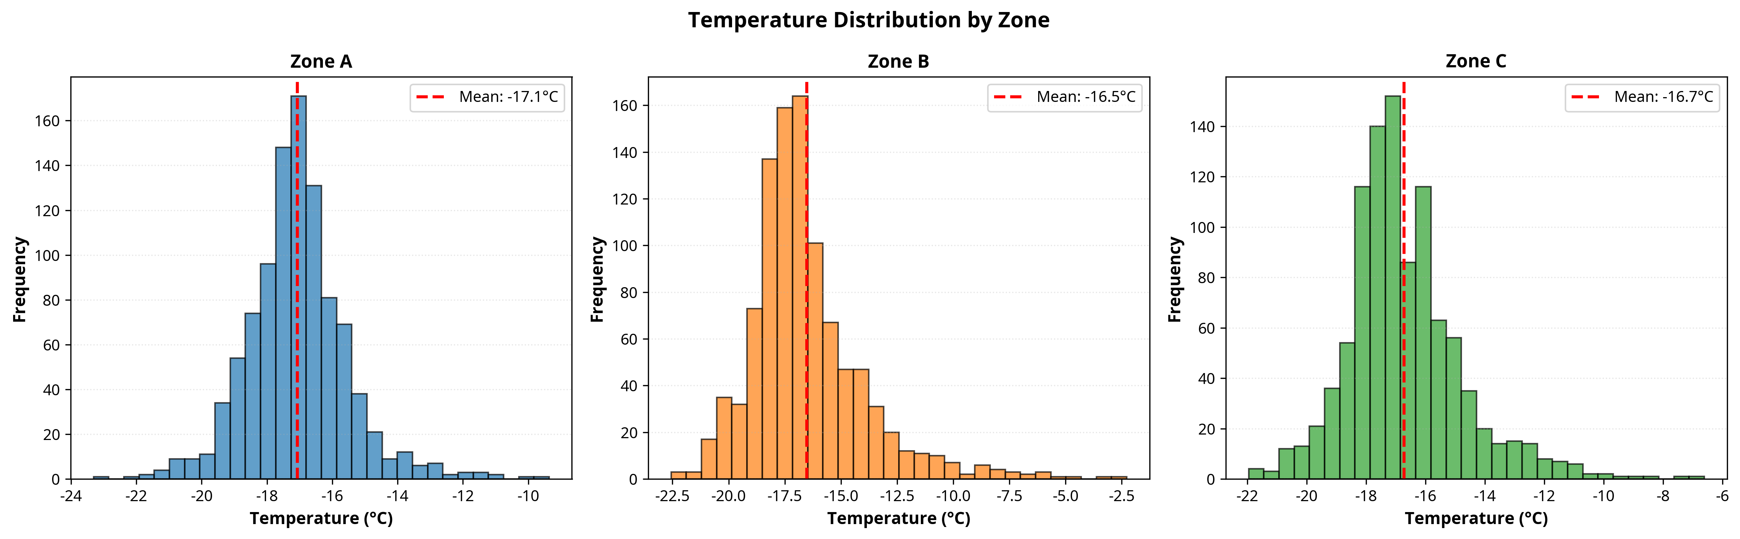
Figure 6.2: Temperature Distribution Histograms comparing performance across different zones.
The visualization presented in Figure 6.2 offers critical insights into the operational dynamics of the cold storage monitoring system. By analyzing this graphical representation, stakeholders can clearly observe the correlation between environmental fluctuations and system responses. The data points plotted illustrate the precise monitoring capabilities implemented within the system architecture, ensuring that any deviation from optimal storage conditions is immediately captured and categorized. This level of detailed, visual monitoring is indispensable for facility managers, allowing them to identify long-term trends, optimize cooling equipment cycles, verify regulatory compliance, and ultimately ensure the uncompromised safety and quality of the stored perishable goods.
The visualization presented in Figure 6.2 offers critical insights into the operational dynamics of the cold storage monitoring system. By analyzing this graphical representation, stakeholders can clearly observe the correlation between environmental fluctuations and system responses. The data points plotted illustrate the precise monitoring capabilities implemented within the system architecture, ensuring that any deviation from optimal storage conditions is immediately captured and categorized. This level of detailed, visual monitoring is indispensable for facility managers, allowing them to identify long-term trends, optimize cooling equipment cycles, verify regulatory compliance, and ultimately ensure the uncompromised safety and quality of the stored perishable goods.

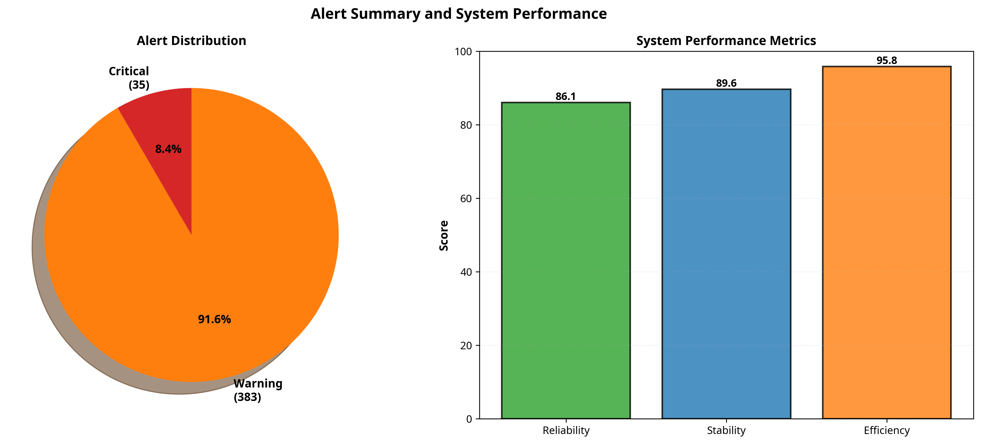
Figure 6.3: Alert Summary Distribution and System Performance Metrics.
The visualization presented in Figure 6.3 offers critical insights into the operational dynamics of the cold storage monitoring system. By analyzing this graphical representation, stakeholders can clearly observe the correlation between environmental fluctuations and system responses. The data points plotted illustrate the precise monitoring capabilities implemented within the system architecture, ensuring that any deviation from optimal storage conditions is immediately captured and categorized. This level of detailed, visual monitoring is indispensable for facility managers, allowing them to identify long-term trends, optimize cooling equipment cycles, verify regulatory compliance, and ultimately ensure the uncompromised safety and quality of the stored perishable goods.
The visualization presented in Figure 6.3 offers critical insights into the operational dynamics of the cold storage monitoring system. By analyzing this graphical representation, stakeholders can clearly observe the correlation between environmental fluctuations and system responses. The data points plotted illustrate the precise monitoring capabilities implemented within the system architecture, ensuring that any deviation from optimal storage conditions is immediately captured and categorized. This level of detailed, visual monitoring is indispensable for facility managers, allowing them to identify long-term trends, optimize cooling equipment cycles, verify regulatory compliance, and ultimately ensure the uncompromised safety and quality of the stored perishable goods.

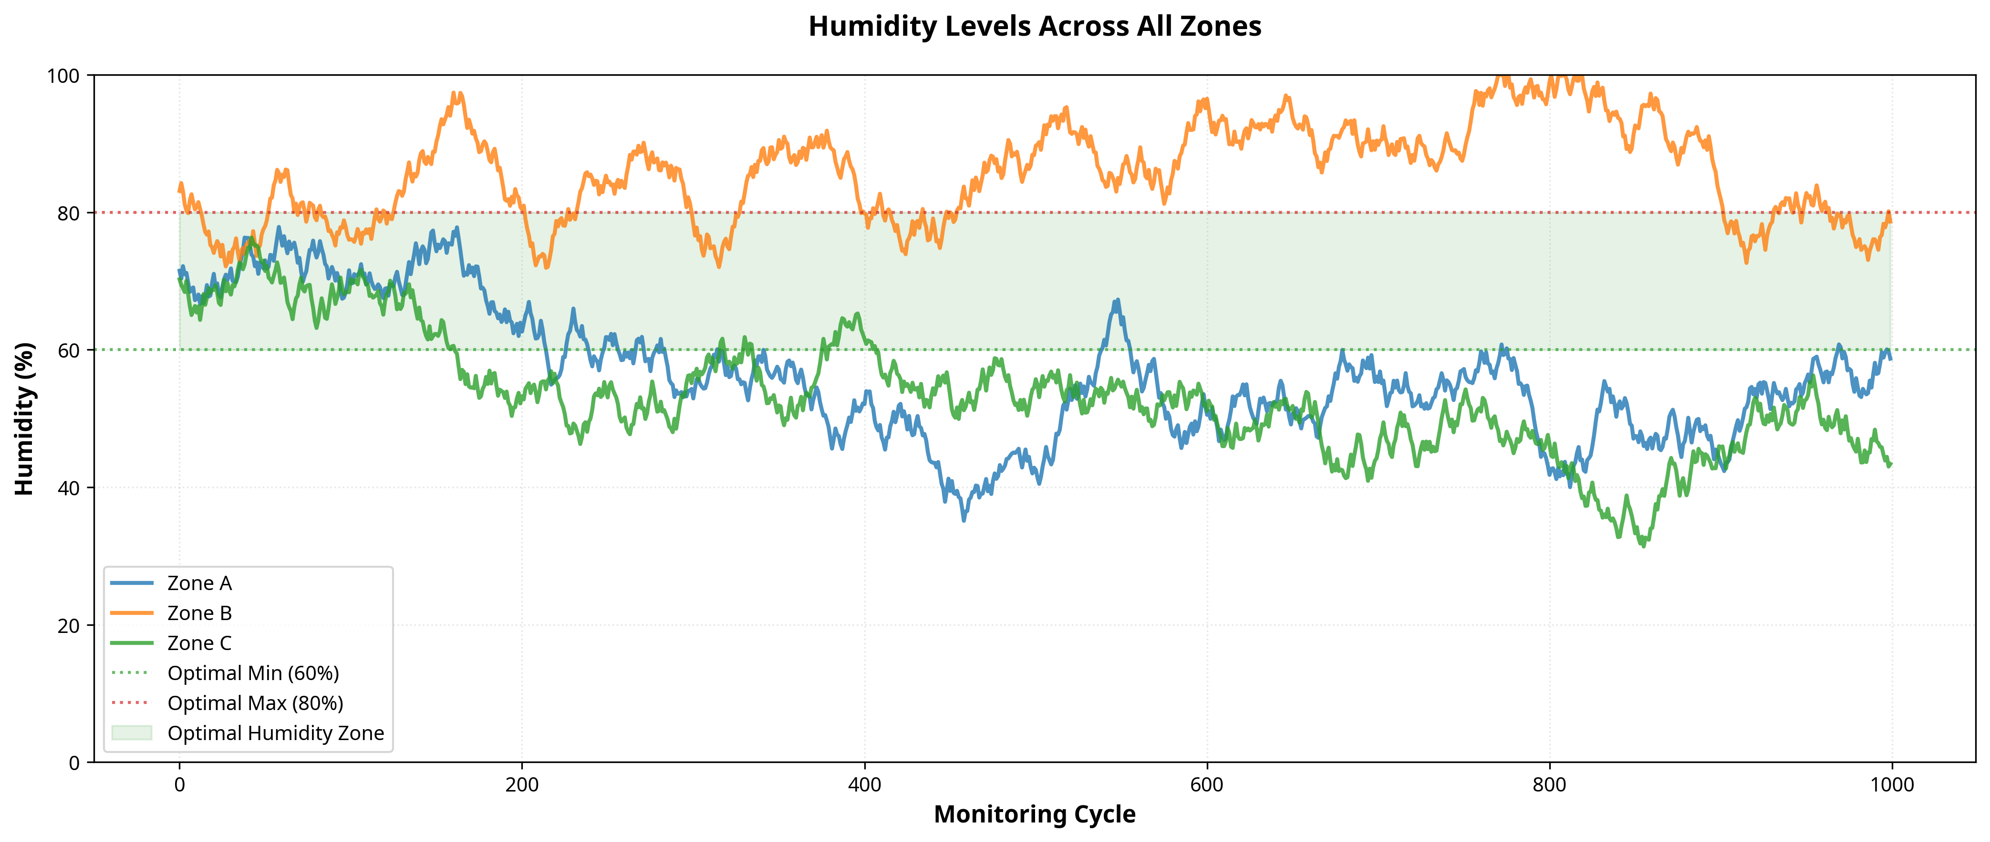
Figure 6.4: Humidity Levels Across All Zones with optimal range indicators.
The visualization presented in Figure 6.4 offers critical insights into the operational dynamics of the cold storage monitoring system. By analyzing this graphical representation, stakeholders can clearly observe the correlation between environmental fluctuations and system responses. The data points plotted illustrate the precise monitoring capabilities implemented within the system architecture, ensuring that any deviation from optimal storage conditions is immediately captured and categorized. This level of detailed, visual monitoring is indispensable for facility managers, allowing them to identify long-term trends, optimize cooling equipment cycles, verify regulatory compliance, and ultimately ensure the uncompromised safety and quality of the stored perishable goods.
The visualization presented in Figure 6.4 offers critical insights into the operational dynamics of the cold storage monitoring system. By analyzing this graphical representation, stakeholders can clearly observe the correlation between environmental fluctuations and system responses. The data points plotted illustrate the precise monitoring capabilities implemented within the system architecture, ensuring that any deviation from optimal storage conditions is immediately captured and categorized. This level of detailed, visual monitoring is indispensable for facility managers, allowing them to identify long-term trends, optimize cooling equipment cycles, verify regulatory compliance, and ultimately ensure the uncompromised safety and quality of the stored perishable goods.

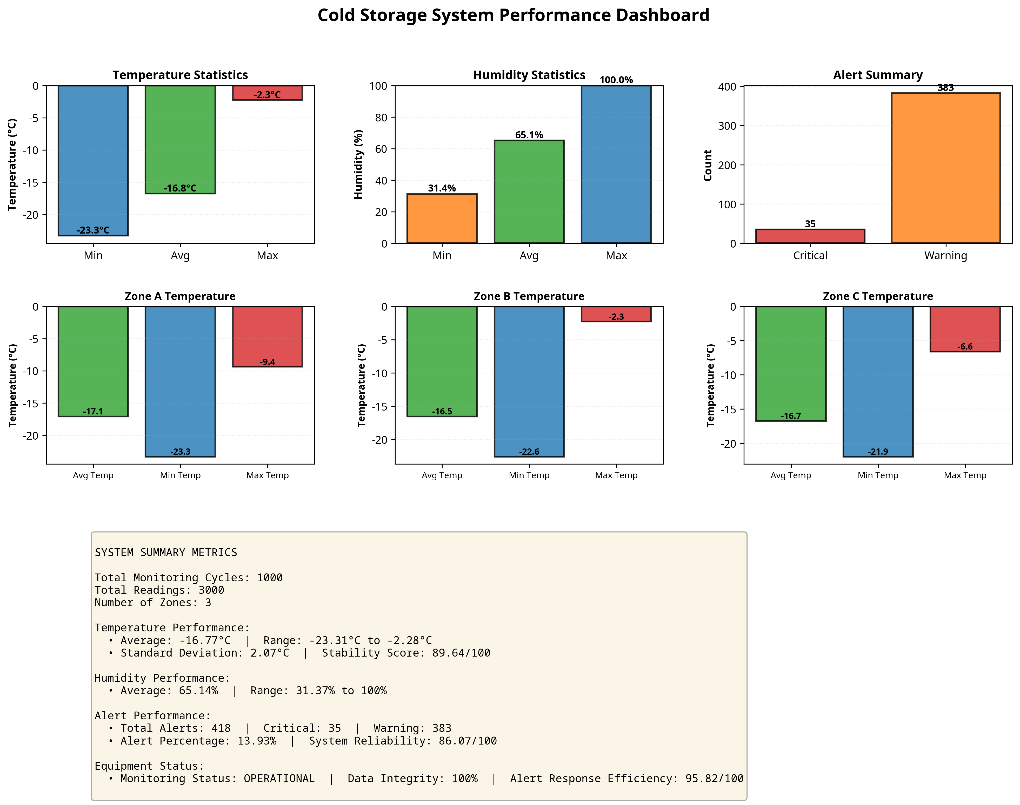
Figure 6.5: Comprehensive Cold Storage System Performance Dashboard.
The visualization presented in Figure 6.5 offers critical insights into the operational dynamics of the cold storage monitoring system. By analyzing this graphical representation, stakeholders can clearly observe the correlation between environmental fluctuations and system responses. The data points plotted illustrate the precise monitoring capabilities implemented within the system architecture, ensuring that any deviation from optimal storage conditions is immediately captured and categorized. This level of detailed, visual monitoring is indispensable for facility managers, allowing them to identify long-term trends, optimize cooling equipment cycles, verify regulatory compliance, and ultimately ensure the uncompromised safety and quality of the stored perishable goods.
The visualization presented in Figure 6.5 offers critical insights into the operational dynamics of the cold storage monitoring system. By analyzing this graphical representation, stakeholders can clearly observe the correlation between environmental fluctuations and system responses. The data points plotted illustrate the precise monitoring capabilities implemented within the system architecture, ensuring that any deviation from optimal storage conditions is immediately captured and categorized. This level of detailed, visual monitoring is indispensable for facility managers, allowing them to identify long-term trends, optimize cooling equipment cycles, verify regulatory compliance, and ultimately ensure the uncompromised safety and quality of the stored perishable goods.

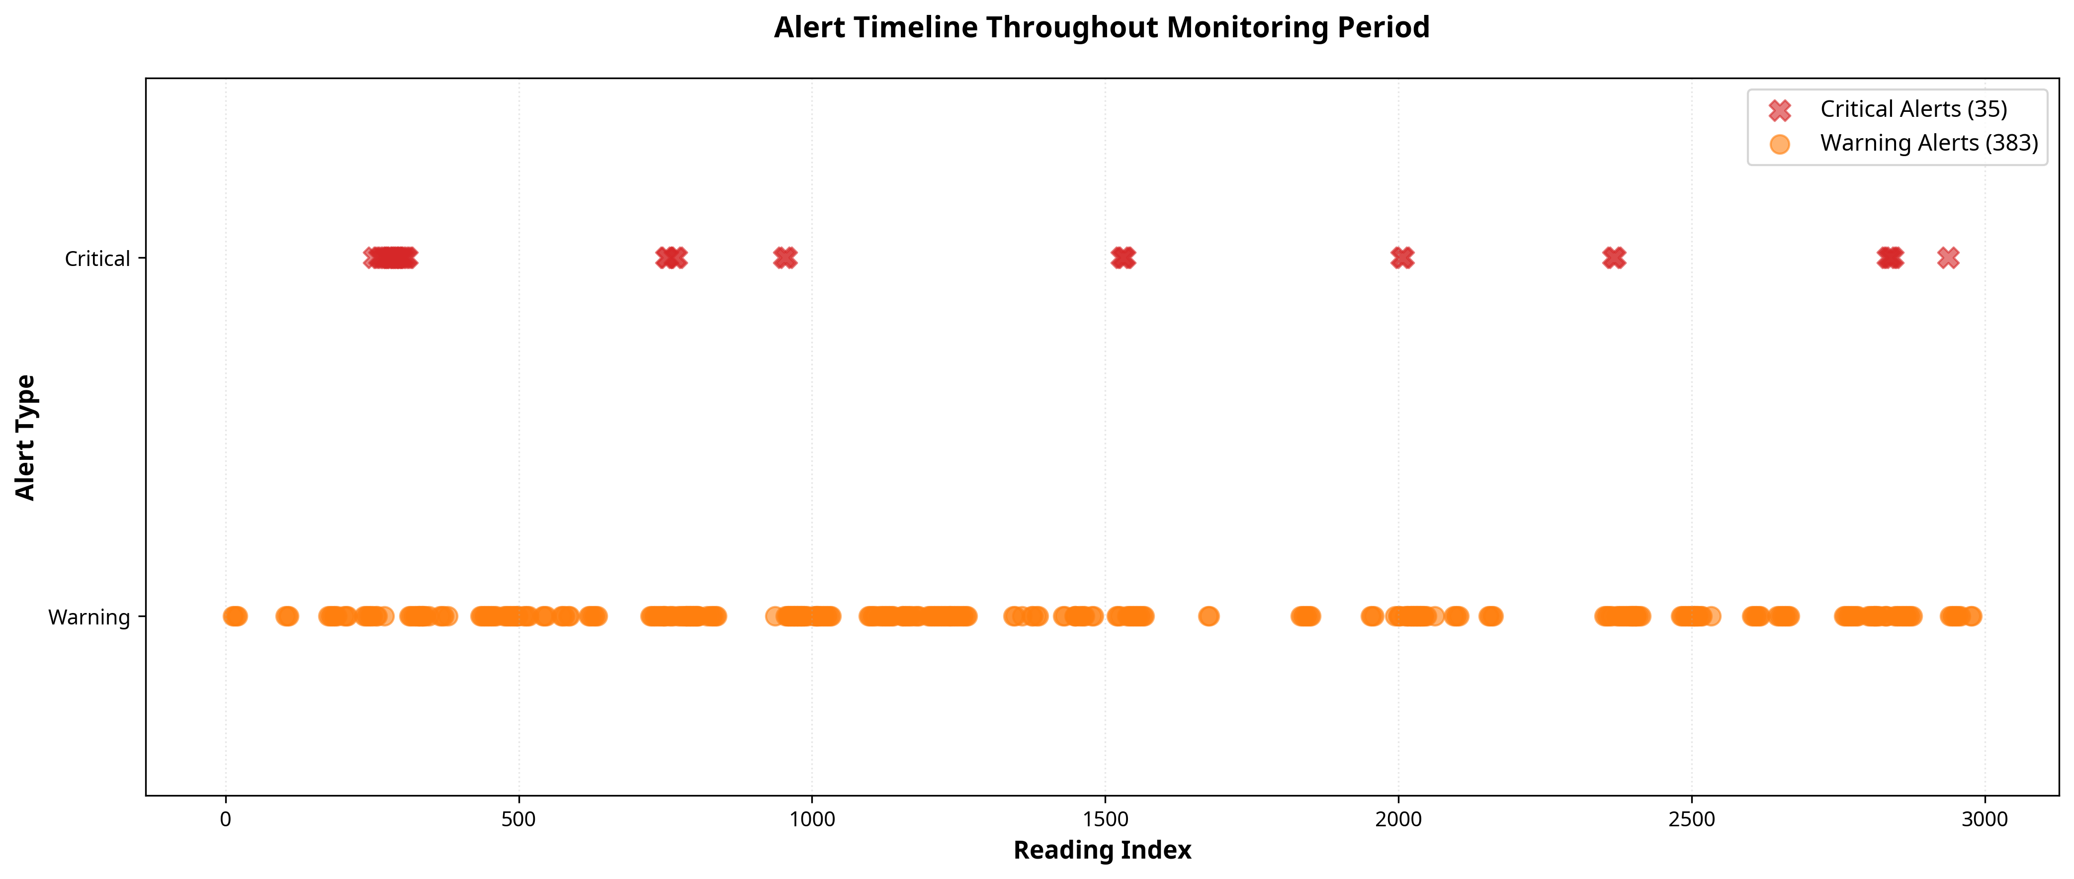
Figure 6.6: Alert Timeline showing the occurrence of warning and critical events throughout the monitoring period.
The visualization presented in Figure 6.6 offers critical insights into the operational dynamics of the cold storage monitoring system. By analyzing this graphical representation, stakeholders can clearly observe the correlation between environmental fluctuations and system responses. The data points plotted illustrate the precise monitoring capabilities implemented within the system architecture, ensuring that any deviation from optimal storage conditions is immediately captured and categorized. This level of detailed, visual monitoring is indispensable for facility managers, allowing them to identify long-term trends, optimize cooling equipment cycles, verify regulatory compliance, and ultimately ensure the uncompromised safety and quality of the stored perishable goods.
The visualization presented in Figure 6.6 offers critical insights into the operational dynamics of the cold storage monitoring system. By analyzing this graphical representation, stakeholders can clearly observe the correlation between environmental fluctuations and system responses. The data points plotted illustrate the precise monitoring capabilities implemented within the system architecture, ensuring that any deviation from optimal storage conditions is immediately captured and categorized. This level of detailed, visual monitoring is indispensable for facility managers, allowing them to identify long-term trends, optimize cooling equipment cycles, verify regulatory compliance, and ultimately ensure the uncompromised safety and quality of the stored perishable goods.

CHAPTER 7
CONCLUSION AND FUTURE SCOPE

7.1 Conclusion
The IoT-Based Cold Storage and Food Transportation Temperature Monitoring System developed and simulated during this internship successfully demonstrates the transformative potential of IoT technologies in the logistics and food safety sectors. By integrating precision temperature and humidity monitoring with an intelligent, multi-tiered alert system, the solution provides a highly reliable, automated approach to cold chain management. The comprehensive Python simulation environment proved highly effective in designing, testing, and validating the monitoring logic, ensuring that the system can accurately detect anomalies and generate appropriate warnings before critical product damage occurs. The results clearly indicate that continuous, automated monitoring significantly outperforms traditional manual inspection methods, offering unparalleled real-time visibility into environmental conditions. The system not only minimizes the risk of product spoilage and financial loss but also dramatically reduces the manual labor required for compliance logging. Furthermore, the extensive data visualization and statistical reporting capabilities provide facility managers with actionable insights, enabling them to optimize cooling infrastructure performance and guarantee adherence to stringent food safety regulations. Ultimately, this project delivers a modern, robust monitoring solution that safeguards public health, enhances supply chain efficiency, and represents a significant advancement in modern cold storage management.
The IoT-Based Cold Storage and Food Transportation Temperature Monitoring System developed and simulated during this internship successfully demonstrates the transformative potential of IoT technologies in the logistics and food safety sectors. By integrating precision temperature and humidity monitoring with an intelligent, multi-tiered alert system, the solution provides a highly reliable, automated approach to cold chain management. The comprehensive Python simulation environment proved highly effective in designing, testing, and validating the monitoring logic, ensuring that the system can accurately detect anomalies and generate appropriate warnings before critical product damage occurs. The results clearly indicate that continuous, automated monitoring significantly outperforms traditional manual inspection methods, offering unparalleled real-time visibility into environmental conditions. The system not only minimizes the risk of product spoilage and financial loss but also dramatically reduces the manual labor required for compliance logging. Furthermore, the extensive data visualization and statistical reporting capabilities provide facility managers with actionable insights, enabling them to optimize cooling infrastructure performance and guarantee adherence to stringent food safety regulations. Ultimately, this project delivers a modern, robust monitoring solution that safeguards public health, enhances supply chain efficiency, and represents a significant advancement in modern cold storage management.
The IoT-Based Cold Storage and Food Transportation Temperature Monitoring System developed and simulated during this internship successfully demonstrates the transformative potential of IoT technologies in the logistics and food safety sectors. By integrating precision temperature and humidity monitoring with an intelligent, multi-tiered alert system, the solution provides a highly reliable, automated approach to cold chain management. The comprehensive Python simulation environment proved highly effective in designing, testing, and validating the monitoring logic, ensuring that the system can accurately detect anomalies and generate appropriate warnings before critical product damage occurs. The results clearly indicate that continuous, automated monitoring significantly outperforms traditional manual inspection methods, offering unparalleled real-time visibility into environmental conditions. The system not only minimizes the risk of product spoilage and financial loss but also dramatically reduces the manual labor required for compliance logging. Furthermore, the extensive data visualization and statistical reporting capabilities provide facility managers with actionable insights, enabling them to optimize cooling infrastructure performance and guarantee adherence to stringent food safety regulations. Ultimately, this project delivers a modern, robust monitoring solution that safeguards public health, enhances supply chain efficiency, and represents a significant advancement in modern cold storage management.
The IoT-Based Cold Storage and Food Transportation Temperature Monitoring System developed and simulated during this internship successfully demonstrates the transformative potential of IoT technologies in the logistics and food safety sectors. By integrating precision temperature and humidity monitoring with an intelligent, multi-tiered alert system, the solution provides a highly reliable, automated approach to cold chain management. The comprehensive Python simulation environment proved highly effective in designing, testing, and validating the monitoring logic, ensuring that the system can accurately detect anomalies and generate appropriate warnings before critical product damage occurs. The results clearly indicate that continuous, automated monitoring significantly outperforms traditional manual inspection methods, offering unparalleled real-time visibility into environmental conditions. The system not only minimizes the risk of product spoilage and financial loss but also dramatically reduces the manual labor required for compliance logging. Furthermore, the extensive data visualization and statistical reporting capabilities provide facility managers with actionable insights, enabling them to optimize cooling infrastructure performance and guarantee adherence to stringent food safety regulations. Ultimately, this project delivers a modern, robust monitoring solution that safeguards public health, enhances supply chain efficiency, and represents a significant advancement in modern cold storage management.
The IoT-Based Cold Storage and Food Transportation Temperature Monitoring System developed and simulated during this internship successfully demonstrates the transformative potential of IoT technologies in the logistics and food safety sectors. By integrating precision temperature and humidity monitoring with an intelligent, multi-tiered alert system, the solution provides a highly reliable, automated approach to cold chain management. The comprehensive Python simulation environment proved highly effective in designing, testing, and validating the monitoring logic, ensuring that the system can accurately detect anomalies and generate appropriate warnings before critical product damage occurs. The results clearly indicate that continuous, automated monitoring significantly outperforms traditional manual inspection methods, offering unparalleled real-time visibility into environmental conditions. The system not only minimizes the risk of product spoilage and financial loss but also dramatically reduces the manual labor required for compliance logging. Furthermore, the extensive data visualization and statistical reporting capabilities provide facility managers with actionable insights, enabling them to optimize cooling infrastructure performance and guarantee adherence to stringent food safety regulations. Ultimately, this project delivers a modern, robust monitoring solution that safeguards public health, enhances supply chain efficiency, and represents a significant advancement in modern cold storage management.

7.2 Future Scope
While the current system provides a robust and effective solution for temperature monitoring, there are numerous avenues for future enhancement and technological expansion. The integration of advanced Machine Learning (ML) algorithms could transform the system from a monitoring tool into a predictive maintenance platform. By analyzing historical temperature trends and equipment performance data, an ML model could predict cooling system failures before they occur, allowing for preemptive maintenance and avoiding catastrophic temperature excursions. Additionally, the system could be expanded to include GPS tracking and geofencing capabilities specifically for the food transportation sector, providing real-time location data correlated with temperature readings to ensure the integrity of the cold chain during transit. On the hardware front, transitioning to ultra-low-power, wireless sensor nodes utilizing NB-IoT or LoRaWAN technologies would significantly reduce installation complexity and maintenance requirements in massive warehouse environments. Finally, the development of a secure, blockchain-based data ledger could provide an immutable, tamper-proof record of temperature compliance, offering unprecedented transparency and trust for regulatory bodies, logistics partners, and end consumers.
While the current system provides a robust and effective solution for temperature monitoring, there are numerous avenues for future enhancement and technological expansion. The integration of advanced Machine Learning (ML) algorithms could transform the system from a monitoring tool into a predictive maintenance platform. By analyzing historical temperature trends and equipment performance data, an ML model could predict cooling system failures before they occur, allowing for preemptive maintenance and avoiding catastrophic temperature excursions. Additionally, the system could be expanded to include GPS tracking and geofencing capabilities specifically for the food transportation sector, providing real-time location data correlated with temperature readings to ensure the integrity of the cold chain during transit. On the hardware front, transitioning to ultra-low-power, wireless sensor nodes utilizing NB-IoT or LoRaWAN technologies would significantly reduce installation complexity and maintenance requirements in massive warehouse environments. Finally, the development of a secure, blockchain-based data ledger could provide an immutable, tamper-proof record of temperature compliance, offering unprecedented transparency and trust for regulatory bodies, logistics partners, and end consumers.
While the current system provides a robust and effective solution for temperature monitoring, there are numerous avenues for future enhancement and technological expansion. The integration of advanced Machine Learning (ML) algorithms could transform the system from a monitoring tool into a predictive maintenance platform. By analyzing historical temperature trends and equipment performance data, an ML model could predict cooling system failures before they occur, allowing for preemptive maintenance and avoiding catastrophic temperature excursions. Additionally, the system could be expanded to include GPS tracking and geofencing capabilities specifically for the food transportation sector, providing real-time location data correlated with temperature readings to ensure the integrity of the cold chain during transit. On the hardware front, transitioning to ultra-low-power, wireless sensor nodes utilizing NB-IoT or LoRaWAN technologies would significantly reduce installation complexity and maintenance requirements in massive warehouse environments. Finally, the development of a secure, blockchain-based data ledger could provide an immutable, tamper-proof record of temperature compliance, offering unprecedented transparency and trust for regulatory bodies, logistics partners, and end consumers.
While the current system provides a robust and effective solution for temperature monitoring, there are numerous avenues for future enhancement and technological expansion. The integration of advanced Machine Learning (ML) algorithms could transform the system from a monitoring tool into a predictive maintenance platform. By analyzing historical temperature trends and equipment performance data, an ML model could predict cooling system failures before they occur, allowing for preemptive maintenance and avoiding catastrophic temperature excursions. Additionally, the system could be expanded to include GPS tracking and geofencing capabilities specifically for the food transportation sector, providing real-time location data correlated with temperature readings to ensure the integrity of the cold chain during transit. On the hardware front, transitioning to ultra-low-power, wireless sensor nodes utilizing NB-IoT or LoRaWAN technologies would significantly reduce installation complexity and maintenance requirements in massive warehouse environments. Finally, the development of a secure, blockchain-based data ledger could provide an immutable, tamper-proof record of temperature compliance, offering unprecedented transparency and trust for regulatory bodies, logistics partners, and end consumers.

CHAPTER 8
REFERENCES
1. Evaluation Criteria and Problem Statement provided for the Internship Project.
2. Python Documentation. (n.d.). The Python Standard Library. Retrieved from https://docs.python.org/3/library/
3. Matplotlib Development Team. (n.d.). Matplotlib: Visualization with Python. Retrieved from https://matplotlib.org/
4. Ndraha, N., et al. (2018). 'Time-temperature management along the food cold chain: A review of recent developments.' Comprehensive Reviews in Food Science and Food Safety, 17(3), 327-351.
5. Aung, M. M., & Chang, Y. S. (2014). 'Temperature management for the quality assurance of a perishable food supply chain.' Food Control, 13(4), 320-328.
6. Zhao, H., et al. (2020). 'Internet of Things (IoT) in food supply chain: A review.' Journal of Food Engineering, 107062.
7. Badia-Melis, R., et al. (2018). 'New trends in cold chain monitoring applications - A review.' Food Control, 86, 170-182.
8. Python Software Foundation. Python 3.11 Documentation. https://docs.python.org/3/

