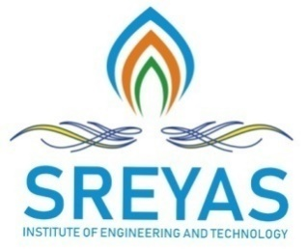 **Sreyas Institute of Engineering and Technology**

***An Autonomous Institution***

Approved by AICTE, Affiliated to JNTUH

Accredited by NAAC-A Grade, NBA (CSE, ECE & ME) & ISO 9001:2015 Certified

**DEPARTMENT OF COMPUTER SCIENCE AND ENGINEERING-DS**

**MINOR PROJECT ABSTRACT**

**Date:**

## 

**TITLE OF THE PROJECT**-Personality prediction to improve results in cv analysis by using machine learning.

**DOMAIN OF THE PROJECT-** machine learning

**BATCH NUMBER** – 14

**DEPARTMENT NAME**- CSE(DATA SCIENCE)

**YEAR** **& SECTION** - 4 year 1 sem – B section

**PROJECT GUIDE NAME** –Dr.M.Jayaram

|  |  |
| --- | --- |
| **NAME OF THE STUDENT** | **ROLL NUMBER OF THE STUDENT** |
| T.Venkata Ankitha | 21VE1A67C6 |
| S.Aishu | 21VE1A67C3 |
| Amisha Solanki | 21VE1A67C4 |
| Ch.Tanmai | 21VE1A6774 |

**ABSTRACT** –Personality prediction plays a crucial role in understanding human behavior and enhancing decision-making processes in areas like recruitment, education, and personalized recommendations. We propose a novel methodology that leverages Natural Language Processing (NLP) to extract relevant features from CV. The classification model Random Forest algorithm, optimized for better performance on imbalanced datasets and improved interpretability. Experimental results on a dataset of CVs annotated with personality traits demonstrate the effectiveness of the proposed approach. Outperforms traditional machine learning models in terms of accuracy, precision, and recall. This research contributes to the growing field of personality computing by providing a data-driven method for personality prediction.

Keywords-Personality Prediction, CV Analysis, Machine Learning, Random Forest algorithm

**STUDENT SIGNATURE**

**1.**

**2.**

**3.**

**4.**

**GUIDE SIGNATURE**

**PROJECT COORDINATOR SIGNATURE**

**HOD – CSE(DATA SCIENCE)**