This documents contain some mock screens and its description for a BPMLS architecture.

Below contains Mockscreen of Execution of a BPMLSfrom a Learner Perspective.

- User Login page:
Here the Learner has to Login

- Once the User logs in, he/she can access the Learner’s Home Page:
This page gives information about:
I. Current Learning paths in progress
II. All available Learning paths
III. Completed Learning paths (and if possible some learning analytics based on KPIs?)
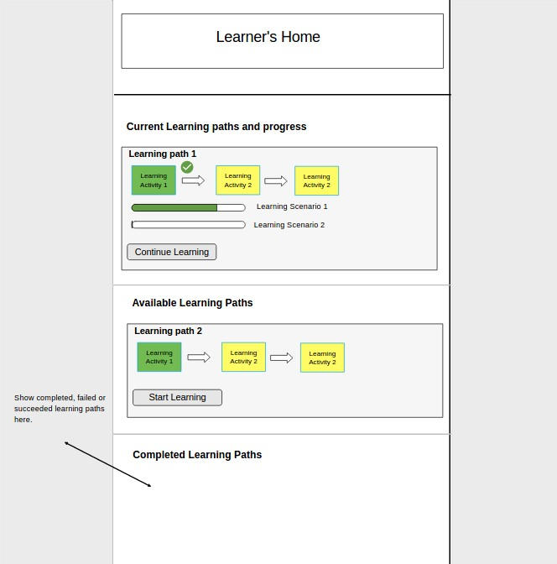

- When the learner initiates or continues a given learning path he/she will be taken to Learning Portal:
This window displays information about a given learning path which includes:
I. Learning Activities of the path with hints to completed, currently progressing and yet to be completed Learning Activities
II. Progress of the current Learning Scenario
III. A sub-window that can be switched to display:
- The simulation if it not a learning activity or the expected user inputs fields with guides and hints if it is a learning activity
- BPMN diagram with current activity progress, for reference and understanding
- The set of target KPIs to be completed and its current update
