Application load balancing Step_1

* Wehave to launch two instances
* Inthat we have to allow all the traffic
* And we have to give userdata
* Then launch

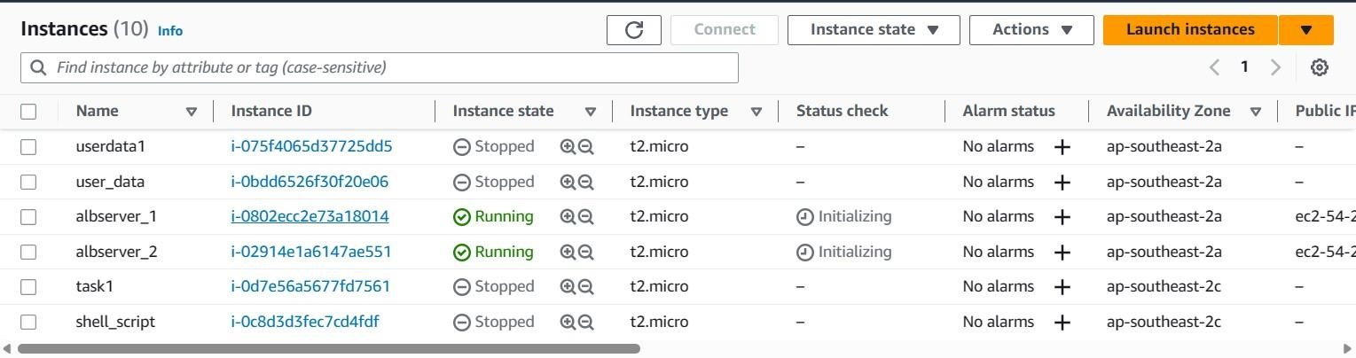

Step2

* In step2 we have to click on security group
* And click on create security group
* Give security group name and description
* Next go to inbound rules in that you have to give HTTP type and destination we have to select anywhere
* And add click on add rule in that you will give HTTPS type and destination anywhere
* In outbound rules you will repeat same as inbound rules
* And click on create security group

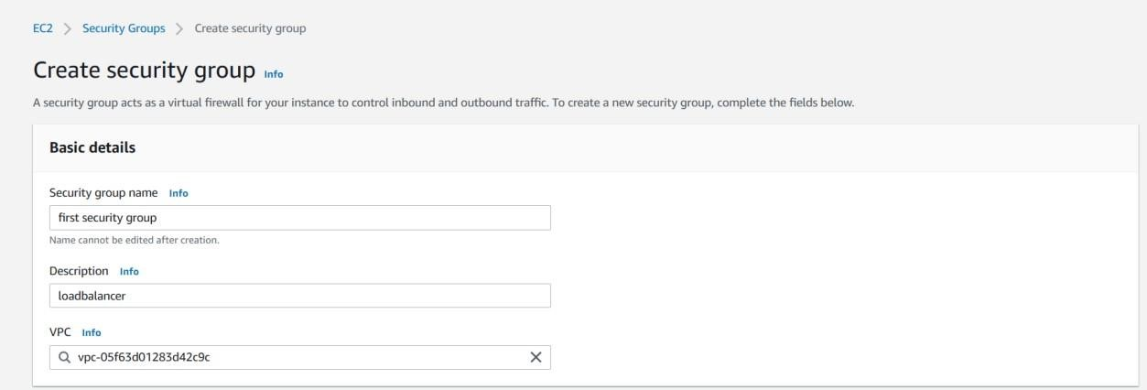

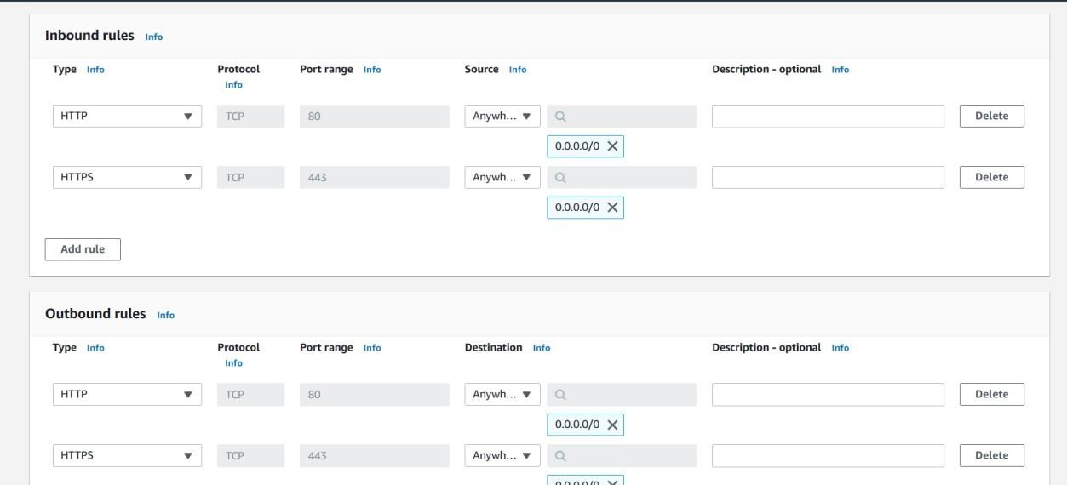

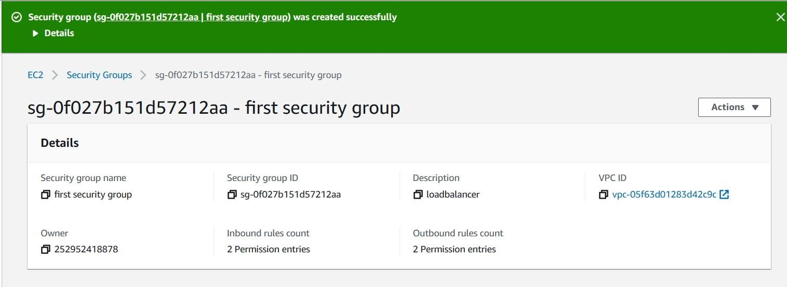

Step3

* After creating security group we have to create target group
* Click on targetgroup
* Scroll down and give name for target group name
* And scrolldown and click on next
* After click on next we can see our two serveres are running
* And select both servers click on include as below option
* Then the servers will add to target group
* Then click on create target group
* Now you are completed with target group creation

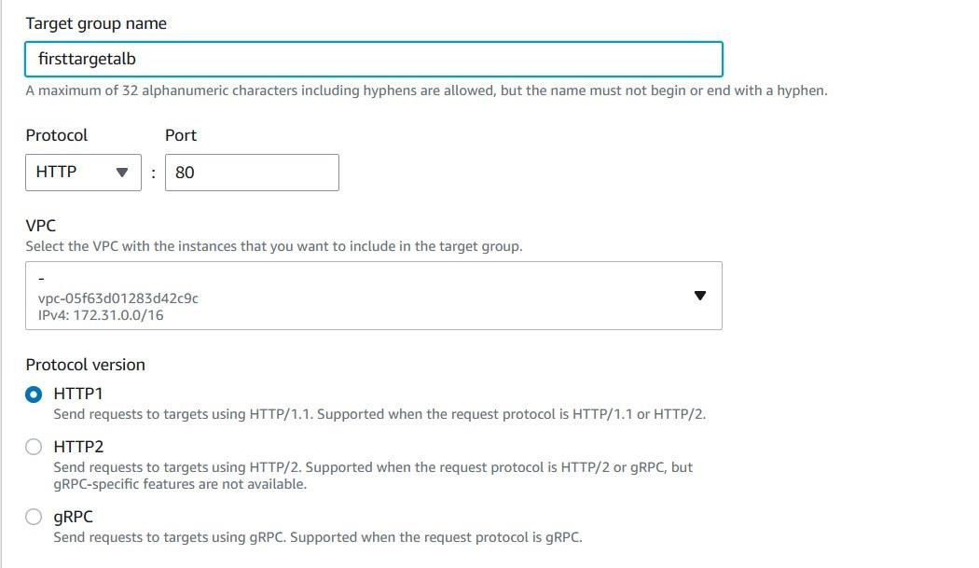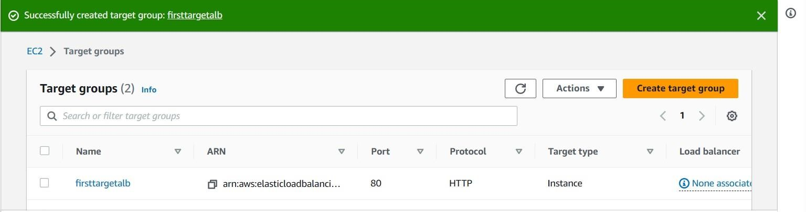

Step4

* After creating target group we have to create loadbalancer
* Click on load balancers
* Next click on create load balancer
* And go for application loadbalancer and clickon create
* Ater that you will give name for loadbalancer
* Then scroll down you will see network mapping in that select all available zones
* Next scroll down go for security group search for security group that you have already created and select it
* Next scroll down go for listeners and routing here we have to give target group that we have already created
* Next scrolldown click on create load balancer

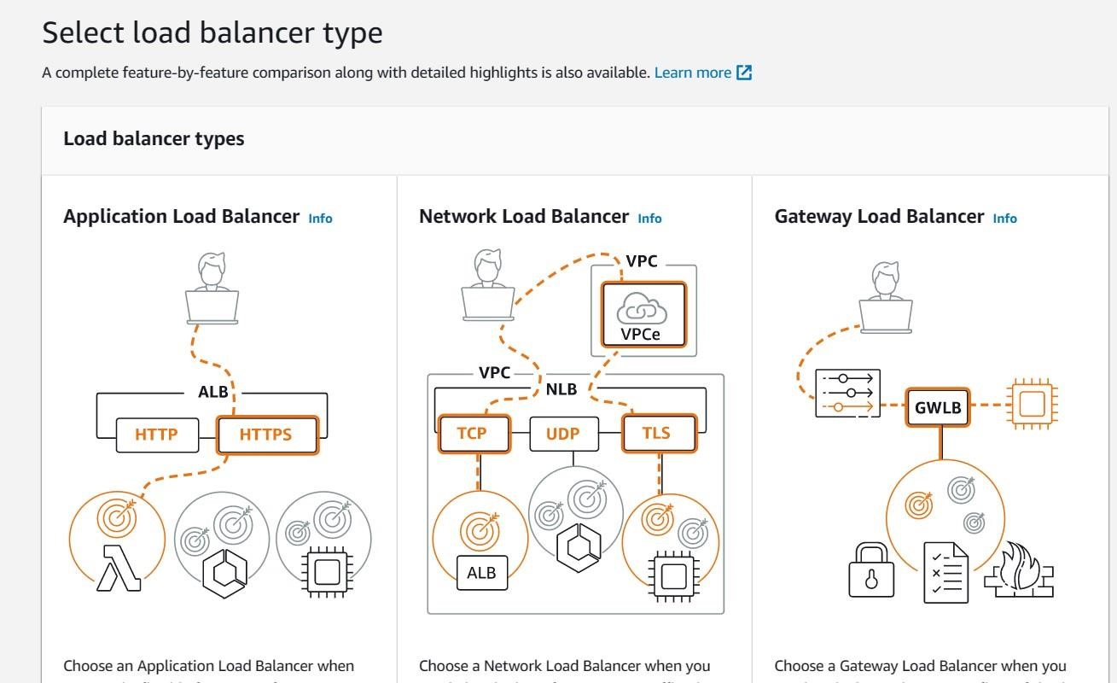

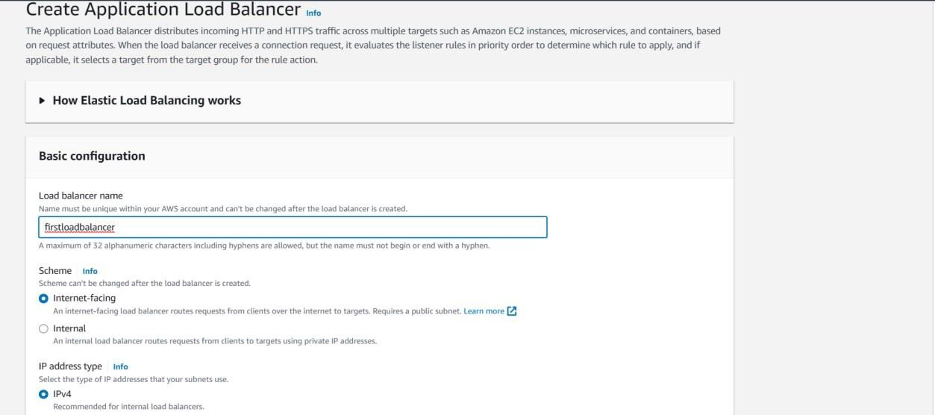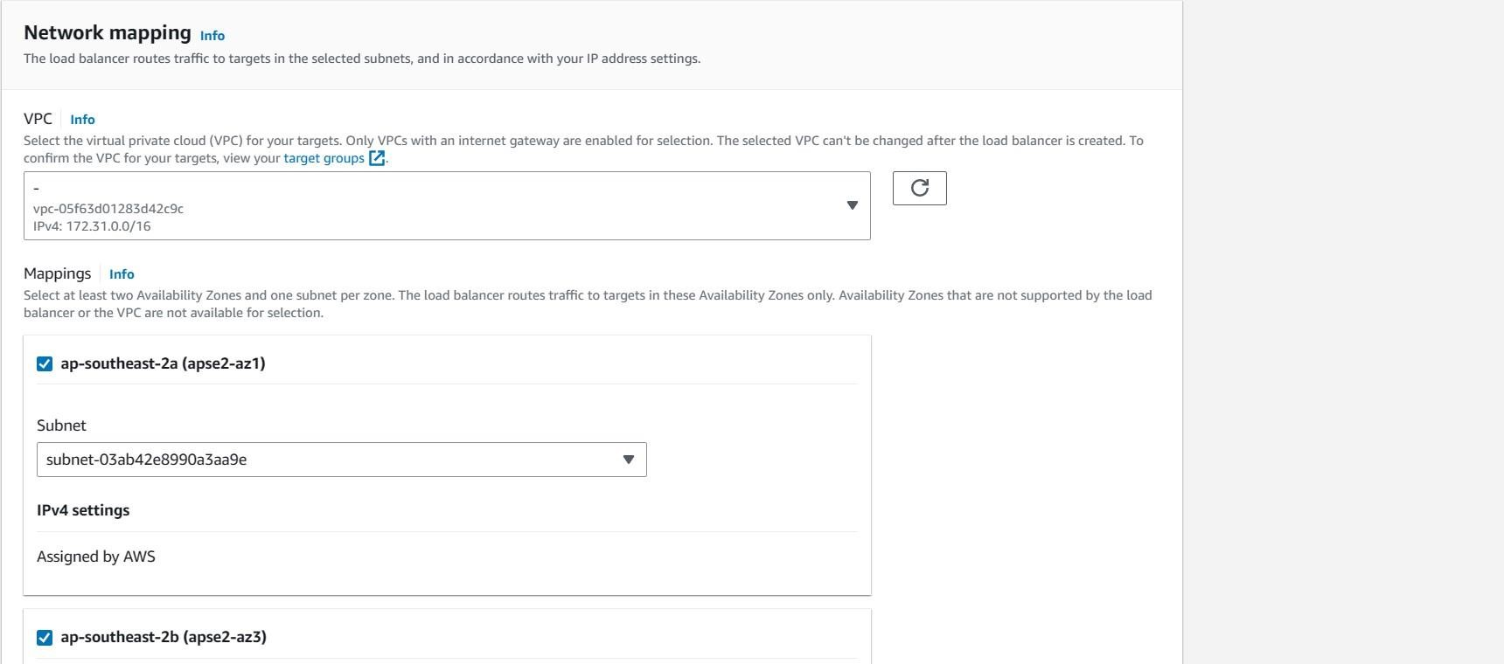

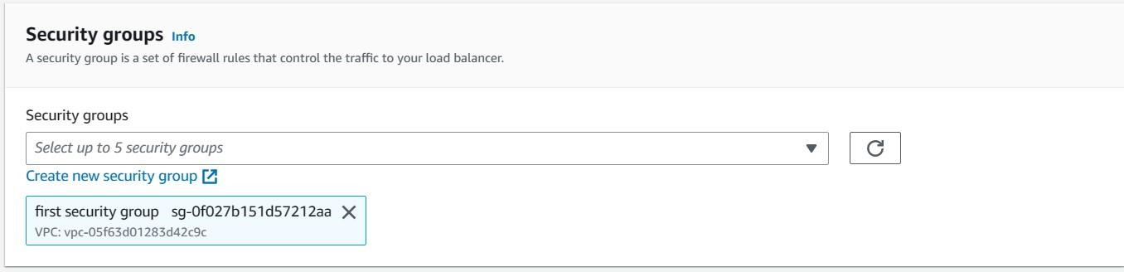

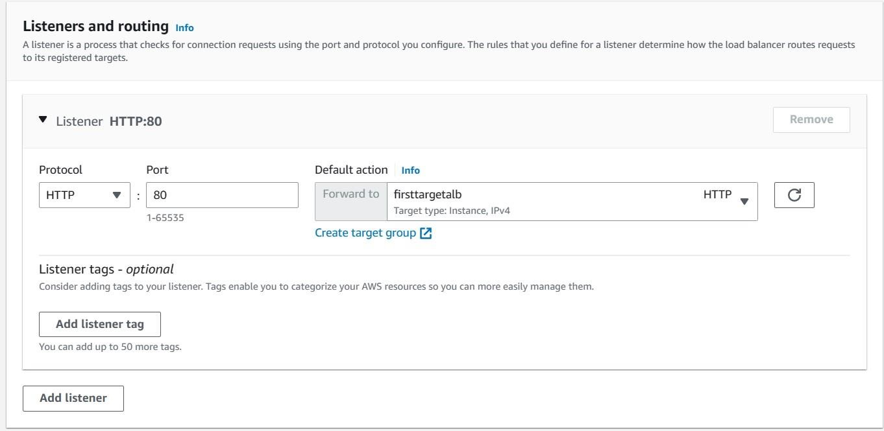

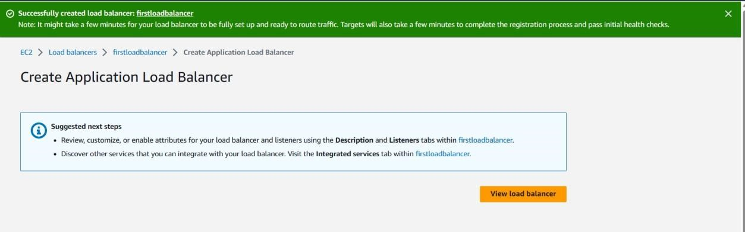

Step5

* After creating all these (instances and security groups and target groups and loadbalancer)
* Click on load balancers
* Next select the load balancer that you have created
* Next scroll down where you can see details of your load balancer
* In detals you have to copy DNS name
* And paste it in the browser you will see output as shown in the picture below and refresh it and you will get another server user data

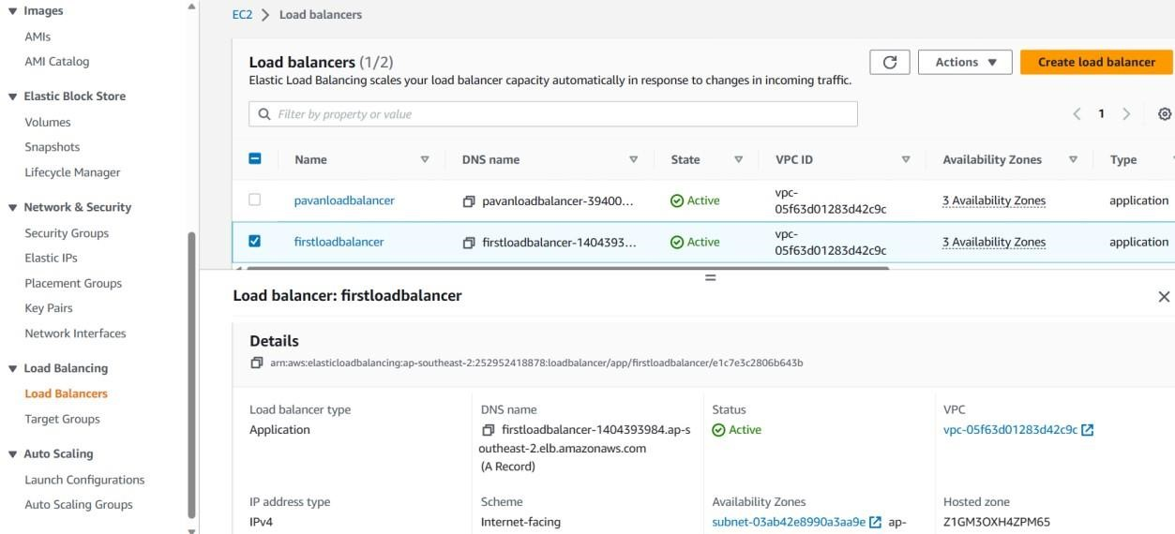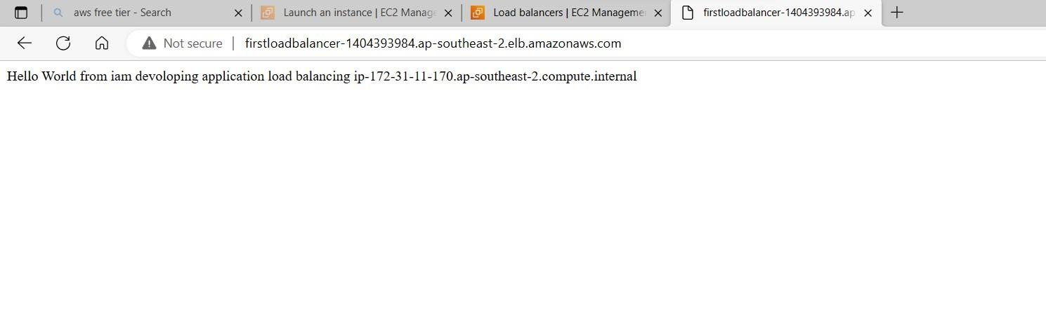

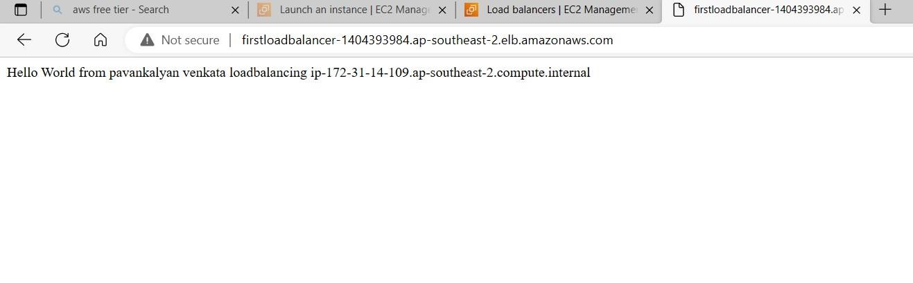

➢ If you want to chek the health status go for target groups select target group name and scroll down you can see health status ofyour servers

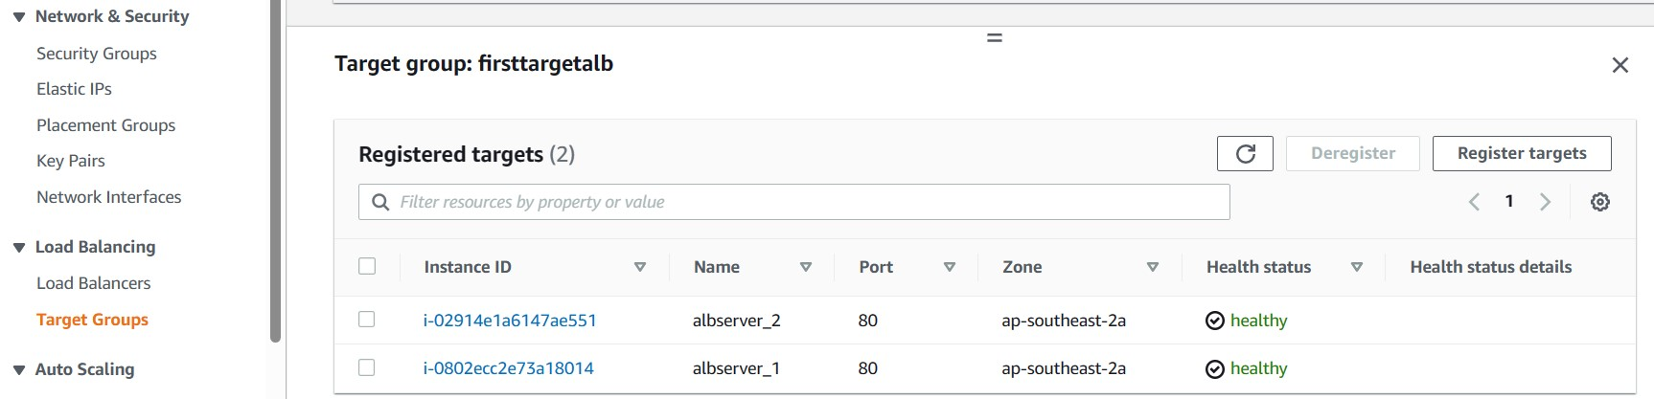

DONE

Network load balancer

# Step 1

We have to create two ec2 instances with userdata



# Step 2

In this we have to create one target group

We have to select both servers and click on include as pending below And click on crete target group

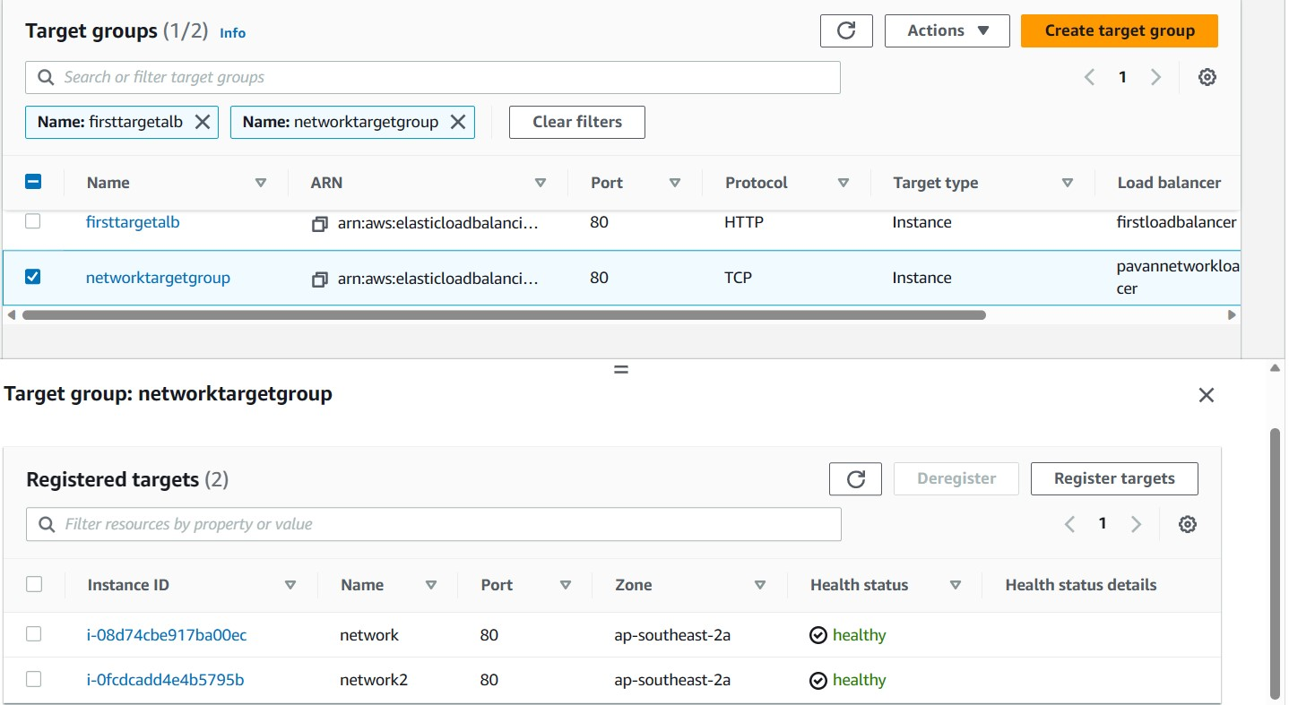

# Step 3

Go for load balancer

Click on create load balancer

Select networkload balancer we will give name there

And no need of security group

Then we have to give targetgroup

Then click on create load balancer

Wait until its get active

After that copy the DNS name of network load balancer

Paste it in browser

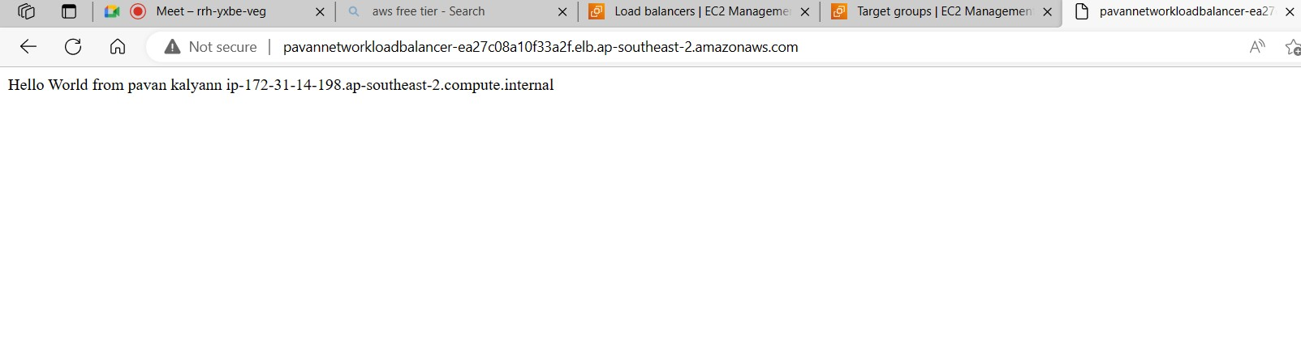

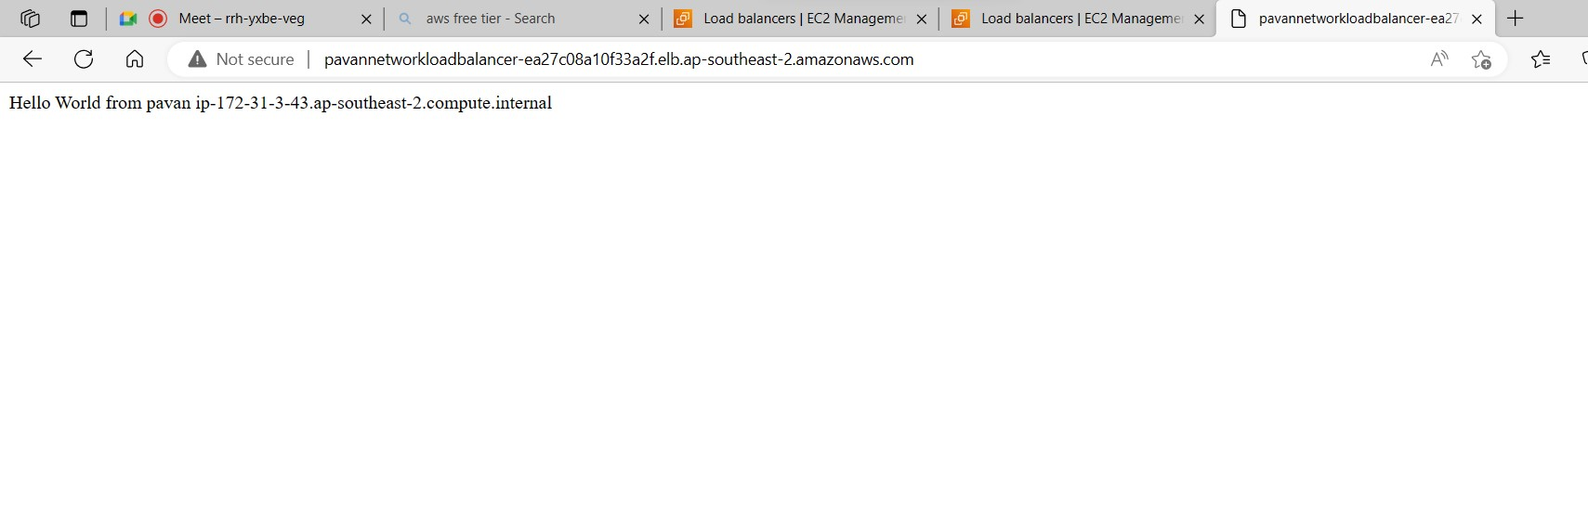

# For health check

Go for target group select network target group

And u can see both servers are healthy

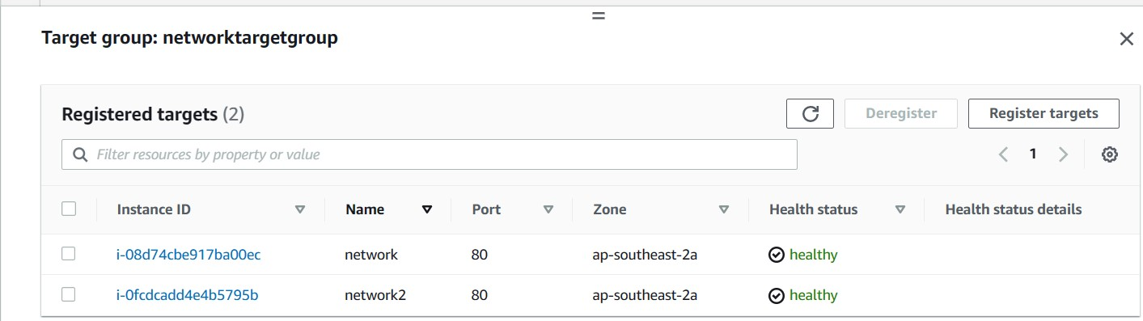

Done