
Final Insight Summary & Project Report
RLS-Enabled Regional Sales & Profit Analytics
Power BI Project

1. Project Objective
The main objective of this project is to develop an interactive Power BI dashboard for analyzing sales and profit performance across categories, customers, products, and regions. The report is designed to help users understand sales trends, customer and product performance, discount impact, delivery performance, and regional results. Row-Level Security (RLS) is also used to restrict regional information according to the assigned manager.

2. Dashboard Overview
The completed report contains separate views for Sales Overview, Customer Insights, Customer Profile, Product & Discount Impact, and Region & Manager analysis. The visuals provide an interactive way to explore the retail dataset.

3. Sales Overview – Key Insights
The Sales Overview page reports total sales of approximately 1.05 billion, total profit of 121.80 million, a profit percentage of 11.61%, and approximately 51K orders. The category chart shows Technology with the highest sales among the three displayed categories, followed by Office Supplies and Furniture.
The dashboard also includes sales by state, a monthly sales and profit trend, and top and bottom product tables. These visuals provide a quick view of overall business performance and product-level contribution.
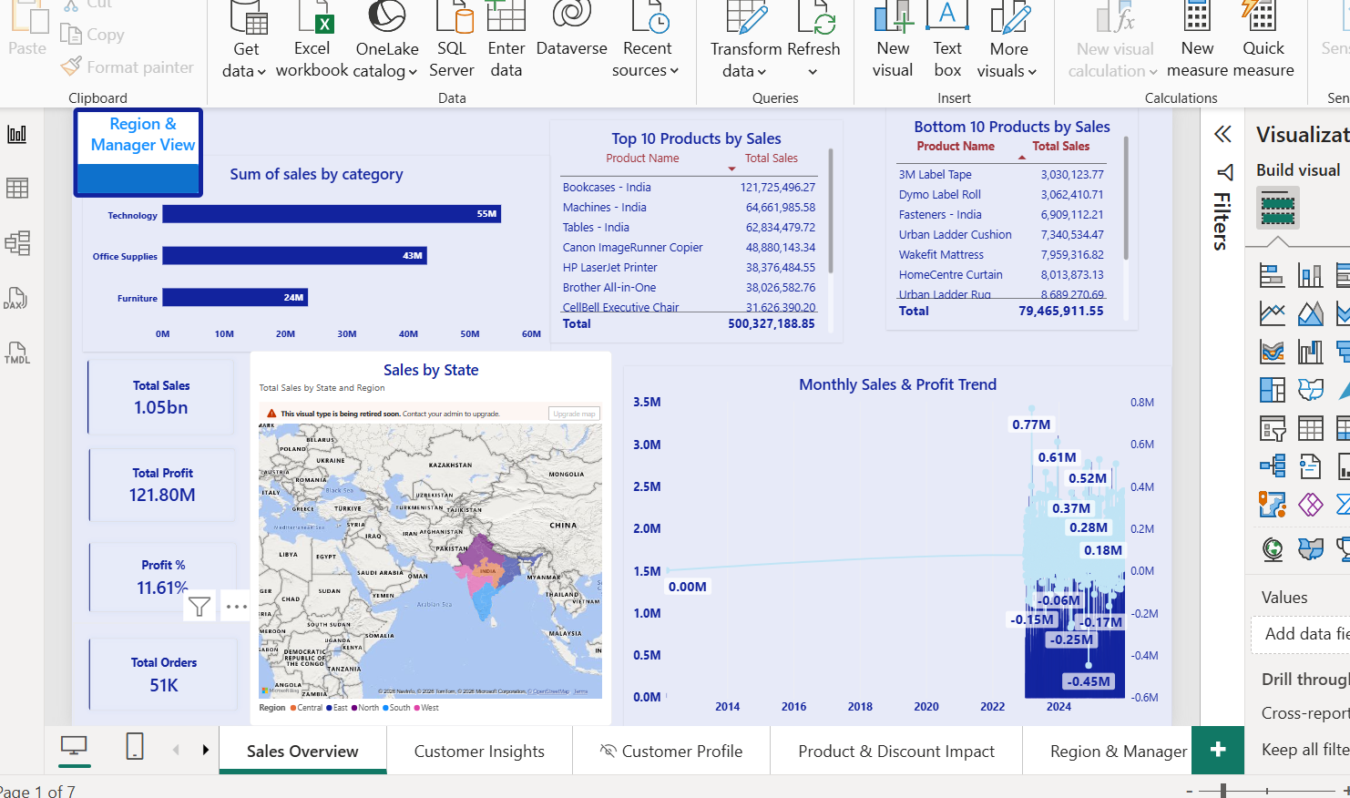
Figure 1. Sales Overview dashboard

4. Customer Insights – Key Insights
The Customer Insights page shows the contribution of the three customer segments. Consumer customers contribute about 540.16 million (51.48%) of sales, Corporate customers contribute about 317.45 million (30.25%), and Home Office contributes about 191.72 million (18.27%).
The page also provides top and bottom customer tables and a Region vs Customer Sales comparison. These visuals help identify important customers and compare segment contributions across regions.
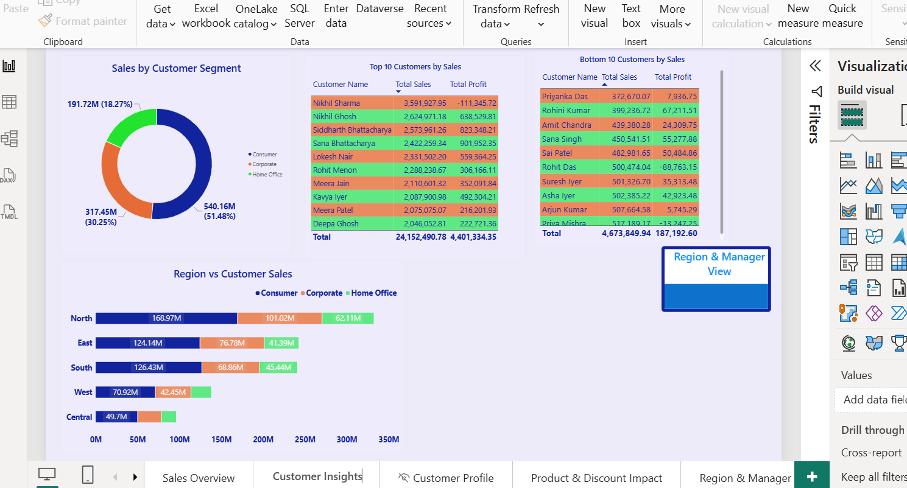
Figure 2. Customer Insights dashboard

5. Customer Profile – Drill-through Example
The Customer Profile page demonstrates drill-through functionality. In the displayed example, the selected customer has sales of approximately 3.59 million and 58 orders. The displayed total profit is approximately -111.35K, with a profit percentage of -3.10%. The order-history table provides product, category, sub-category, quantity, and profit information for the selected customer.
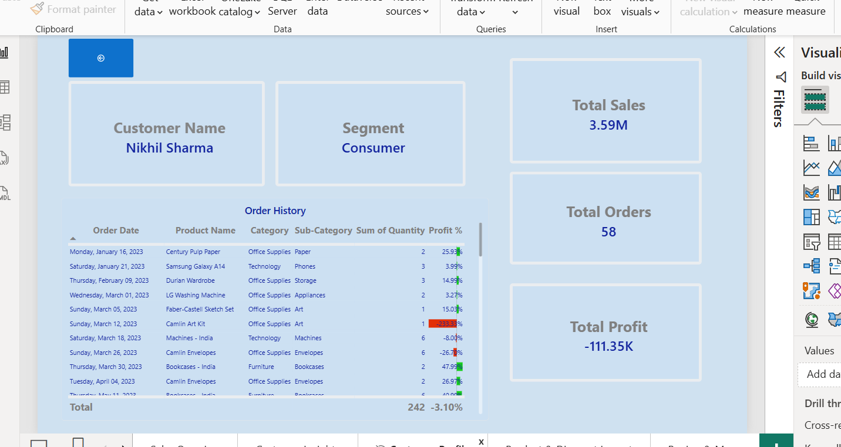
Figure 3. Customer Profile drill-through page

6. Product & Discount Impact – Key Insights
The Product & Discount Impact page compares discount percentage with profit using a scatter plot and separates profit and loss observations. The product table provides sales, profit, and profit percentage for individual products.
The report also shows an example of a product with negative profitability: Tables - India has sales of approximately 62.83 million and profit of about -5.32 million, corresponding to a profit percentage of -8.46%. This illustrates why discount and product-level profitability should be monitored together.
Average delivery days are also displayed by shipping mode. The values shown are close to 17.4–17.5 days across the four displayed shipping modes.
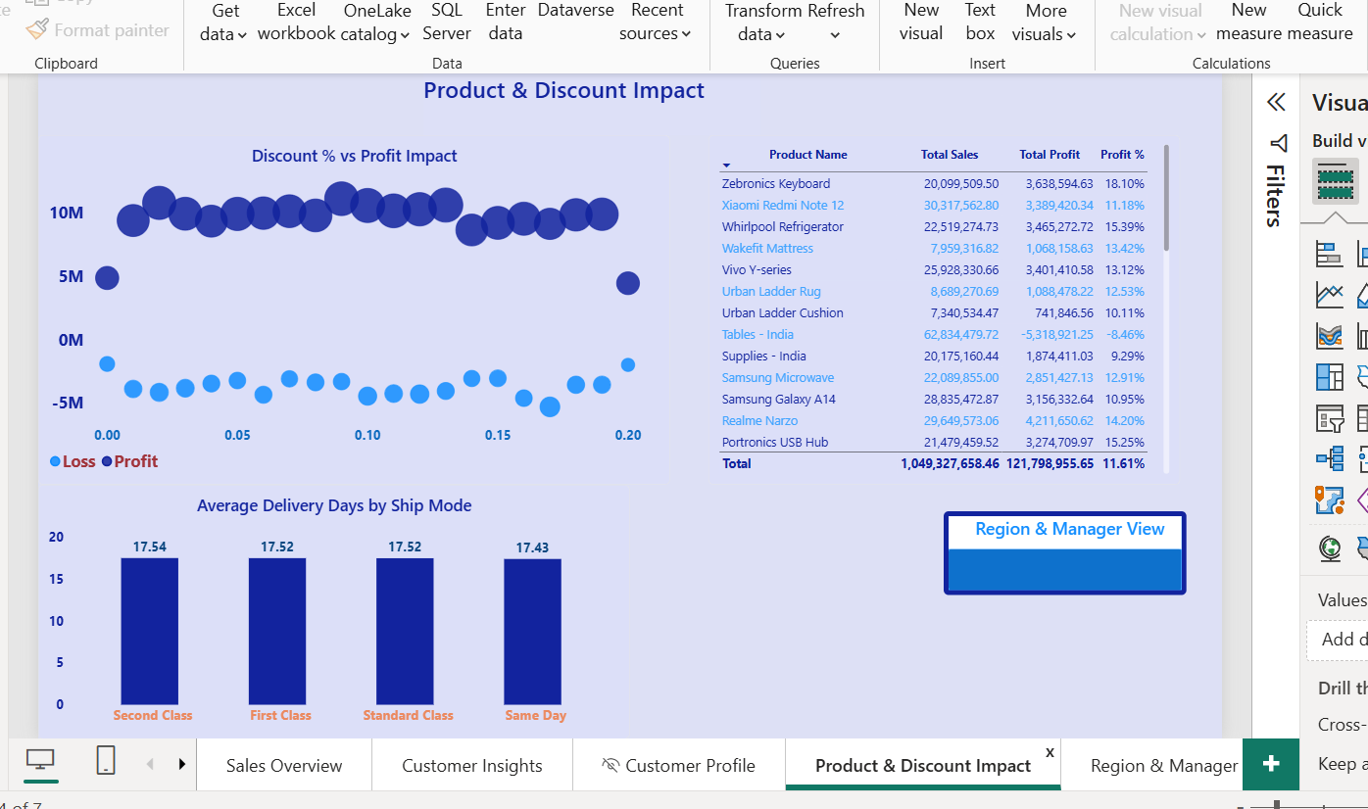
Figure 4. Product & Discount Impact dashboard

7. Region & Manager View – Key Insights
The Region & Manager page provides a regional comparison and supports a Region → State → City sales breakdown. In the displayed report, North has approximately 332 million in sales, followed by East at 242 million, South at 241 million, West at 138 million, and Central at 96 million.
The regional profit comparison shows approximately 37 million for North, 29 million for East, 28 million for South, 16 million for West, and 12 million for Central. The page also includes a monthly sales trend by region and navigation buttons for moving between report sections.
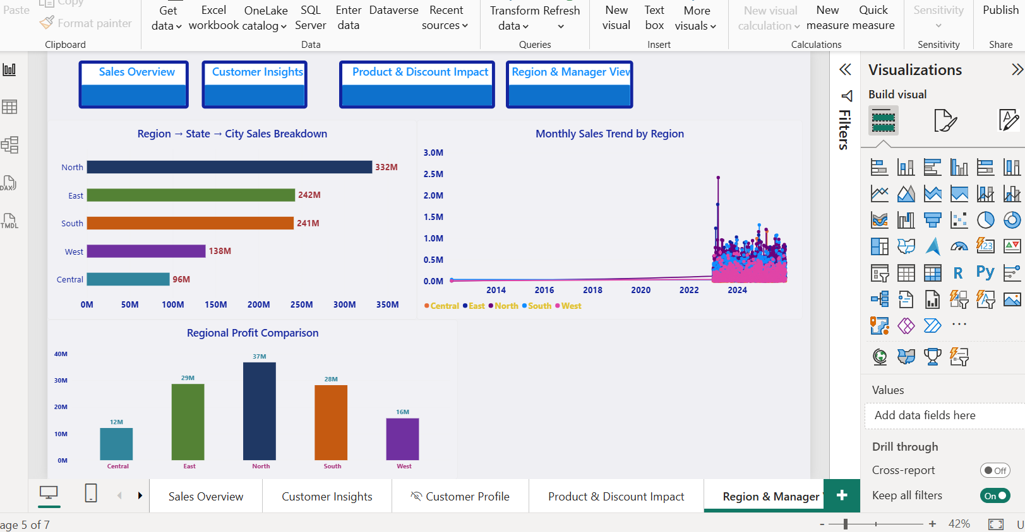
Figure 5. Region & Manager View

8. Row-Level Security (RLS)
Row-Level Security was configured to restrict data according to regional manager roles. The report contains separate security roles for Aniket Sharma, Harish Deshmukh, Nithin Chaturvedi, Pragya Rathi, and Yash Srivastava.
The 'View as roles' feature was used to test the role-based view. In the displayed test, the report was viewed as Aniket Sharma and the regional visuals were filtered to the corresponding region. This demonstrates the intended regional data restriction.
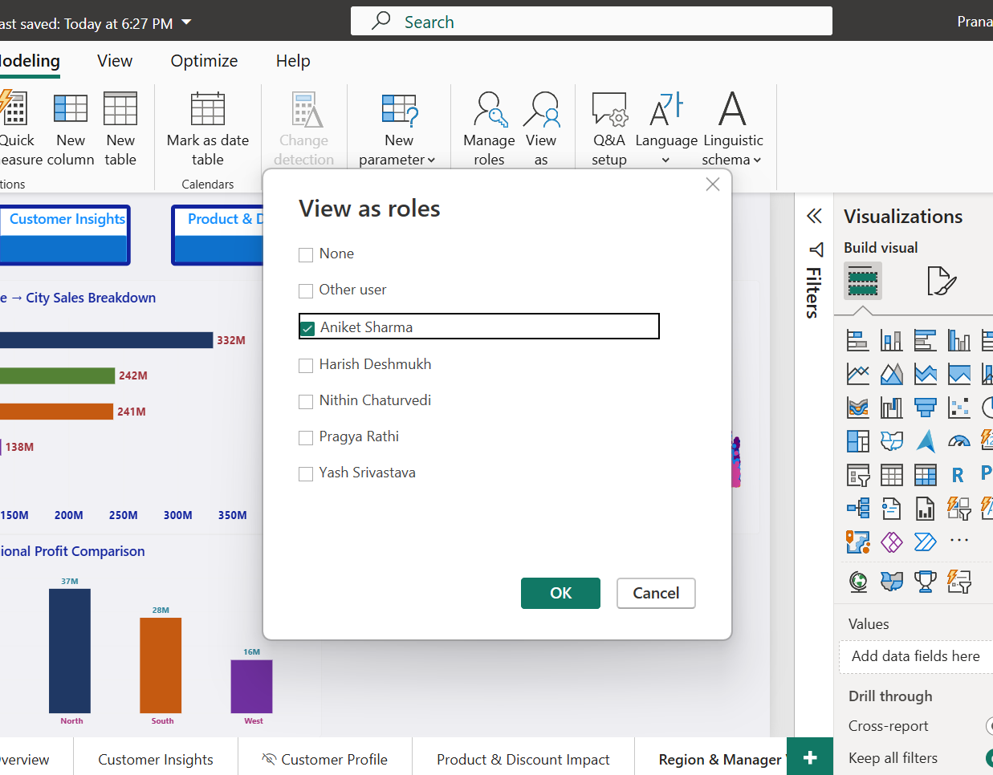
Figure 6. RLS role testing using View as roles
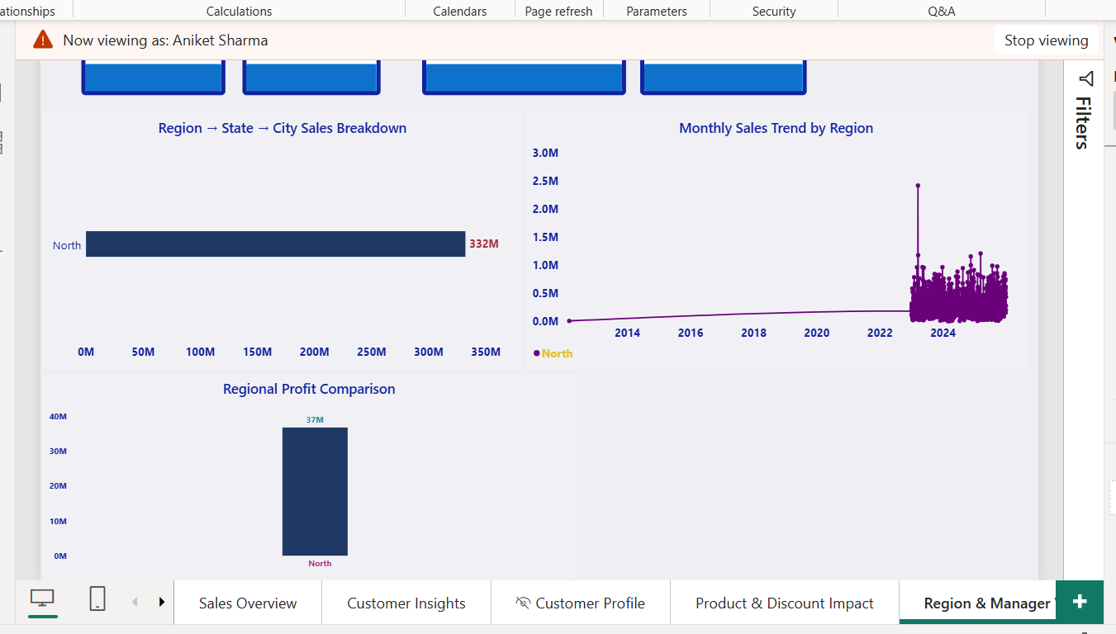
Figure 7. Configured regional manager security roles
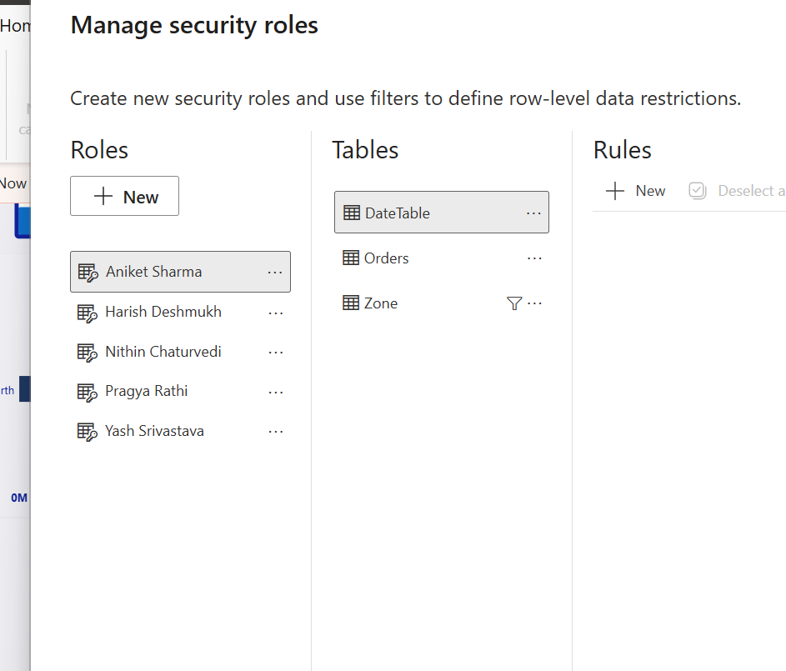
Figure 8. Example regional view under RLS

9. Interactive Features
Feature | Purpose
Row-Level Security (RLS) | Restricts regional data according to the configured manager role.
Bookmarks | Supports navigation and switching between report views.
Drill-through | Allows users to move from summary information to a detailed customer profile.
Customized Tooltips | Provides additional detail when users interact with report visuals.
Navigation Buttons | Makes movement between the main report pages easier.

10. Final Insight Summary
The Power BI dashboard provides a consolidated view of sales and profit performance across categories, customers, products, and regions. The report shows overall sales of approximately 1.05 billion and profit of approximately 121.80 million, with a profit percentage of 11.61%.
The analysis shows that Consumer customers contribute the largest share of sales among the displayed customer segments. The regional analysis shows North with the highest displayed sales and regional profit, while the product analysis highlights that some products can generate negative profit even with substantial sales.
The dashboard's interactive capabilities make it easier to explore information at different levels of detail. RLS supports secure regional access, while drill-through, bookmarks, customized tooltips, and navigation buttons improve the overall usability of the report.

11. Conclusion
The RLS-Enabled Regional Sales & Profit Analytics project demonstrates how Power BI can transform retail data into an interactive and understandable business reporting solution. The completed dashboard combines sales, profit, customer, product, discount, delivery, and regional analysis in one report.
The project also demonstrates the use of advanced Power BI features, particularly RLS, drill-through, bookmarks, customized tooltips, and navigation. These features help users explore the report efficiently while supporting secure regional analysis.
Overall, the report provides a practical way to monitor business performance, identify important trends and profitability issues, and support data-driven decision-making.

12. Published Power BI Report
Published report link: Open Power BI Report
The report has been published to Power BI Service. The shared link is configured for the applicable organization/access environment.

13. Submission Checklist
- Power BI report file (.pbix)
- Published Power BI report
- Client-style PPT presentation
- Final Insight Summary / project report
- RLS configured and tested
- Bookmarks, drill-through and customized tooltips implemented

Final Submission Package
- Power BI report file (.pbix)
- Published Power BI report link
- Client-style PPT presentation
- Final Insight Summary / project report
- RLS configured and tested
- Bookmarks, drill-through, customized tooltips, and navigation implemented
Published Power BI link: https://app.powerbi.com/links/Qprz8AK6pb

