COMPUTER NETWORKS

SKILL – 1
ENCAPSULATION BUILDER
Analyze protocol-header overhead and network efficiency

Student Details | Information
Name | Vinay Bandla
Roll Number | 2520030437
Cluster | 1
Section | 2

Practical record

1. Aim
To capture network packets using Wireshark, examine the Ethernet, IP and TCP/UDP headers, calculate the header overhead, and understand how encapsulation affects network efficiency.

2. Tools Required
- Wireshark installed on a computer.
- An active Wi-Fi or Ethernet network connection.
- A web browser to generate network traffic.

3. Short Explanation
Encapsulation is the process of adding protocol information to data as it moves down the network layers. Each layer adds its own header. These headers help deliver data to the correct device and application, but they also add extra bytes called overhead.
Layer / Protocol | What its header does
Ethernet | Carries source and destination MAC addresses on the local network.
IP | Carries source and destination IP addresses and information needed to route packets.
TCP | Provides reliable, ordered delivery and uses port numbers, sequence numbers and acknowledgements.
UDP | Provides a simpler transport header with port numbers and length information.

4. Procedure
- Open Wireshark and choose the active Wi-Fi or Ethernet interface.
- Double-click the interface to start packet capture.
- While capturing, open a browser and visit a few websites. Wait for about 30 seconds.
- Return to Wireshark and click the red Stop button.
- Enter the display filter tcp to view TCP packets. Then enter udp to view UDP packets.
- Select a packet. In the Packet Details pane, expand Frame, Ethernet II, Internet Protocol, and Transmission Control Protocol or User Datagram Protocol.
- Note the frame length and the header and payload lengths shown by Wireshark.
- Save the capture using File → Save As and keep the .pcapng format.

5. Filters Used
Display Filter | Purpose
tcp | Displays TCP packets.
udp | Displays UDP packets.
icmp | Displays ICMP packets.
tcp.len > 0 | Displays TCP packets carrying data.

6. Packet Observations
The following values are taken from the supplied Wireshark screenshots. The selected TCP and UDP packets use IPv6, while the example calculation in the original handout uses IPv4. Therefore, the observation table below records the actual IPv6 captures.

A. TCP Packet
Selected packet: No. 48755. Wireshark shows a frame length of 1414 bytes, an IPv6 packet, and a TCP segment carrying 1340 bytes of data.
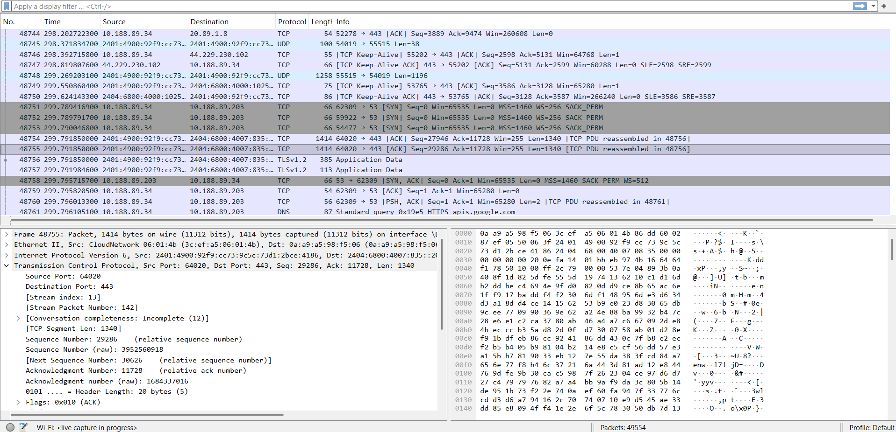
Figure 1. TCP packet selected in Wireshark; packet details show TCP segment length 1340 bytes.
Parameter | TCP observation
Frame Length | 1414 bytes
Ethernet Header Length | 14 bytes
IP Version / Header Length | IPv6 / 40 bytes
Transport Protocol | TCP
TCP Header Length | 20 bytes
IP Total Length | 1400 bytes
TCP Payload Length | 1340 bytes
Source Port | 64020
Destination Port | 443

B. UDP Packet
The selected UDP packet is shown as Frame 1 in the packet-details pane. It has a frame length of 100 bytes and contains 38 bytes of UDP data.
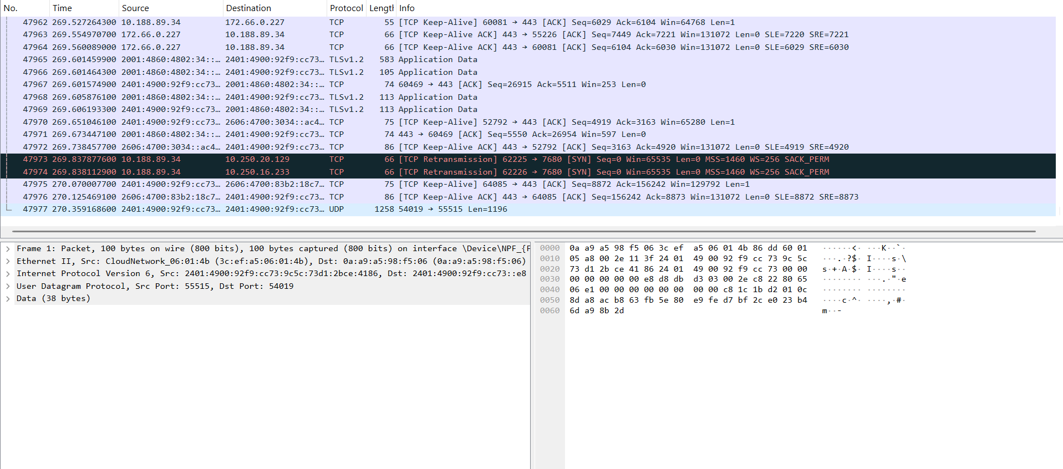
Figure 2. UDP packet details showing IPv6, UDP ports 55515 and 54019, and 38 bytes of data.
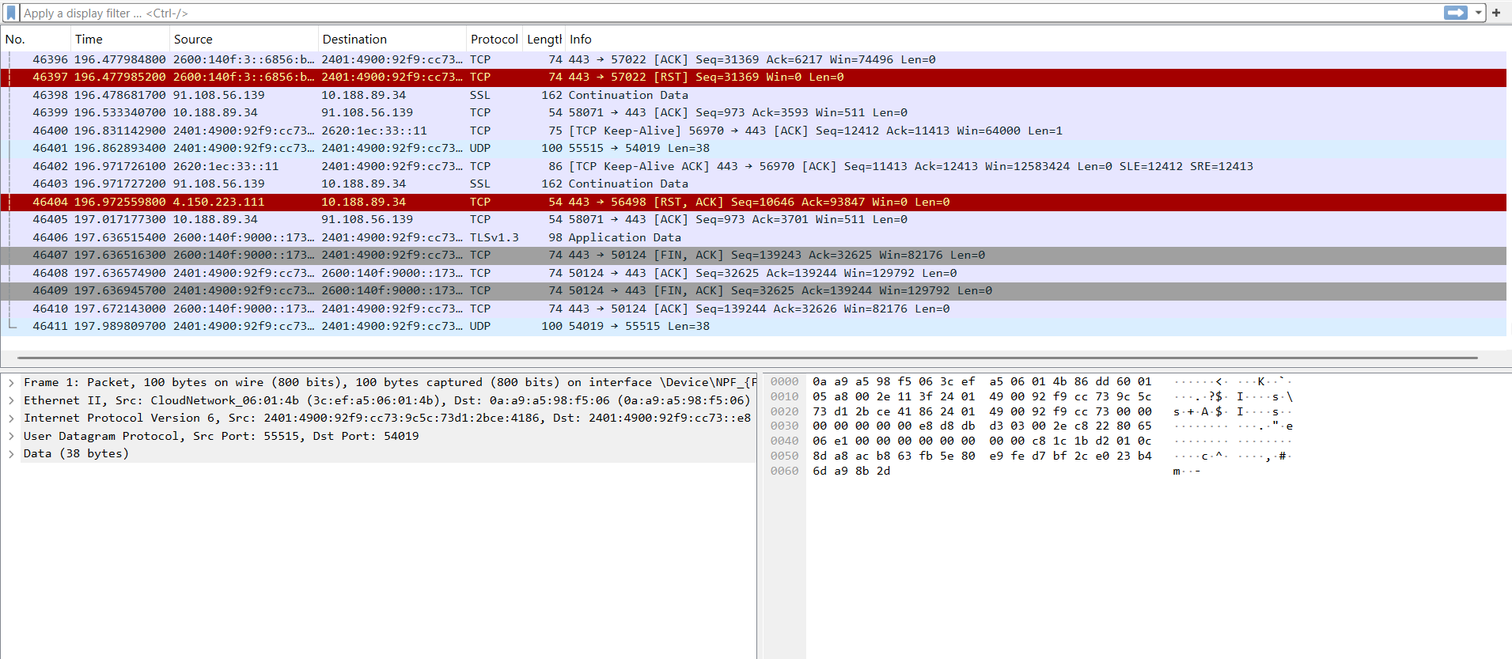
Figure 3. Wireshark packet list showing captured TCP and UDP traffic.
Parameter | UDP observation
Frame Length | 100 bytes
Ethernet Header Length | 14 bytes
IP Version / Header Length | IPv6 / 40 bytes
Transport Protocol | UDP
UDP Header Length | 8 bytes
IP Total Length | 86 bytes
UDP Payload Length | 38 bytes
Source Port | 55515
Destination Port | 54019

7. Header Overhead Calculations
For these captured packets, overhead is calculated as the Ethernet header + IP header + transport header. The captured frame lengths do not show an Ethernet FCS, so FCS is not added.

A. TCP Packet
Total overhead = 14 + 40 + 20 = 74 bytes
Payload efficiency = (Payload Length ÷ Frame Length) × 100
= (1340 ÷ 1414) × 100 = 94.76%

B. UDP Packet
Total overhead = 14 + 40 + 8 = 62 bytes
Payload efficiency = (Payload Length ÷ Frame Length) × 100
= (38 ÷ 100) × 100 = 38%

8. Final Observation Table
Parameter | TCP Packet | UDP Packet
Frame Length | 1414 bytes | 100 bytes
Ethernet Header | 14 bytes | 14 bytes
IP Header | 40 bytes (IPv6) | 40 bytes (IPv6)
Transport Header | 20 bytes (TCP) | 8 bytes (UDP)
IP Total Length | 1400 bytes | 86 bytes
Payload Length | 1340 bytes | 38 bytes
Total Header Overhead | 74 bytes | 62 bytes
Payload Efficiency | 94.76% | 38%

9. Result
Network packets were captured successfully using Wireshark. Ethernet, IPv6, TCP and UDP headers were inspected, and the overhead and payload efficiency were calculated. The captured TCP packet had 74 bytes of header overhead, while the UDP packet had 62 bytes. The results show that protocol headers take up part of each transmitted frame, reducing the space available for application data.

10. Answers to Questions in the Handout
1. What is encapsulation?
Encapsulation is the process of adding protocol headers to data as it moves through network layers.
2. What is the purpose of the Ethernet header?
It contains source and destination MAC addresses and helps deliver a frame across a local network.
3. What information is stored in the IP header?
It contains source and destination IP addresses and control information used to route the packet.
4. What is the difference between TCP and UDP headers?
TCP has fields such as sequence and acknowledgement numbers for reliable communication. UDP has a smaller, simpler header with source port, destination port, length and checksum.
5. Why does each protocol add a header?
Each protocol adds information needed to perform its own task, such as addressing, routing or delivery.
6. What is packet overhead?
Packet overhead is the extra header and control information added to the actual application data.
7. How does header overhead affect network efficiency?
More overhead means a smaller portion of the transmitted bytes carries application data, which reduces payload efficiency.

11. Conclusion
This practical helped me understand how encapsulation works and how Ethernet, IP and transport headers are added to network data. By inspecting real TCP and UDP packets in Wireshark, I learned how to identify header sizes, calculate packet overhead and compare payload efficiency.

