CDIS – EXPERIMENT 2
AWS MFA Creation and EC2 Instance Launch
Name: Vinay Bandla | Roll No.: 2520030437
Cluster: 1 | Section: 3

Aim
To secure an AWS account using Multi-Factor Authentication (MFA) and create a virtual server using Amazon EC2.

2.a – Creating Multi-Factor Authentication (MFA)
Step 1: Open IAM
Sign in to the AWS Console and open the IAM service. The dashboard provides access to account identity and security settings.
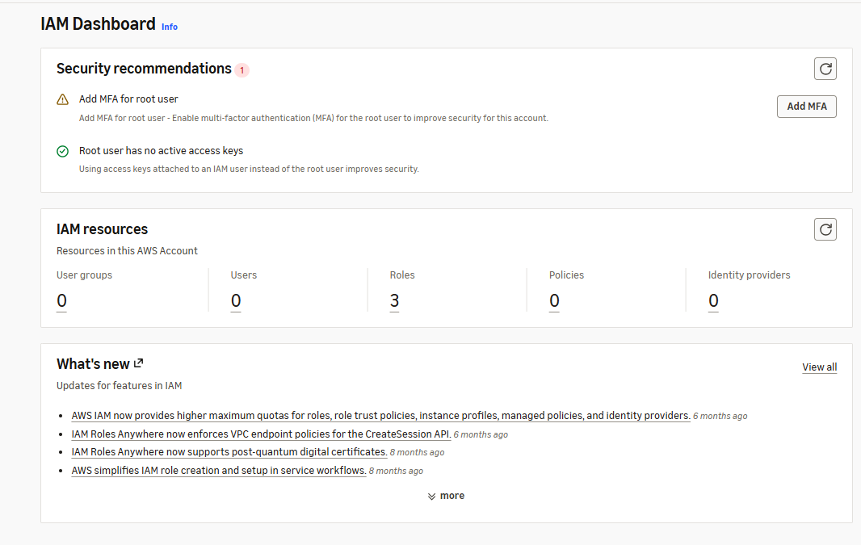
Screenshot 1: IAM dashboard.
Step 2: Choose an MFA device
Open Security credentials and select Assign MFA device. Enter a device name and choose the Authenticator app option.
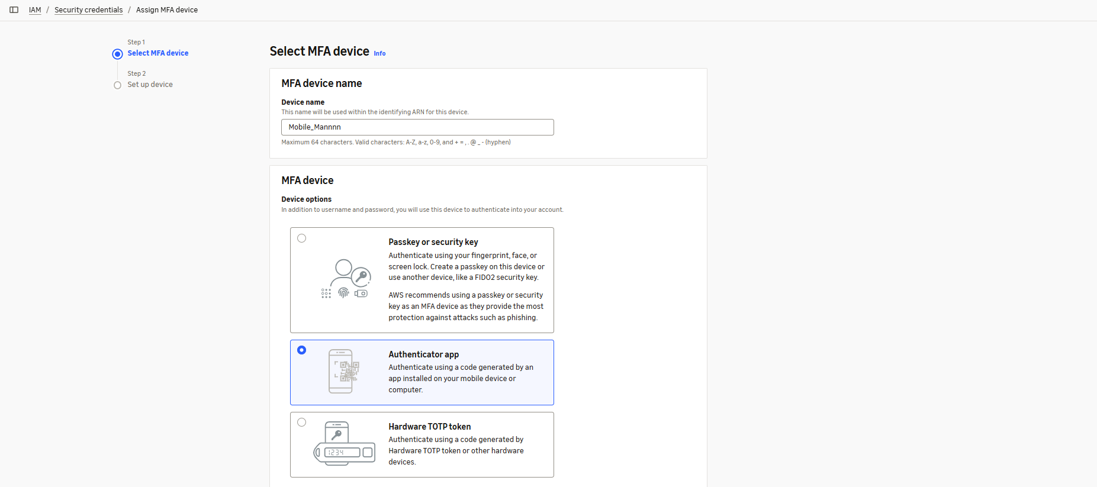
Screenshot 2: Selecting the authenticator app for MFA.
Step 3: Confirm MFA registration
Scan the QR code using an authenticator app and enter the verification codes requested by AWS. After setup, the registered device appears in the MFA list.
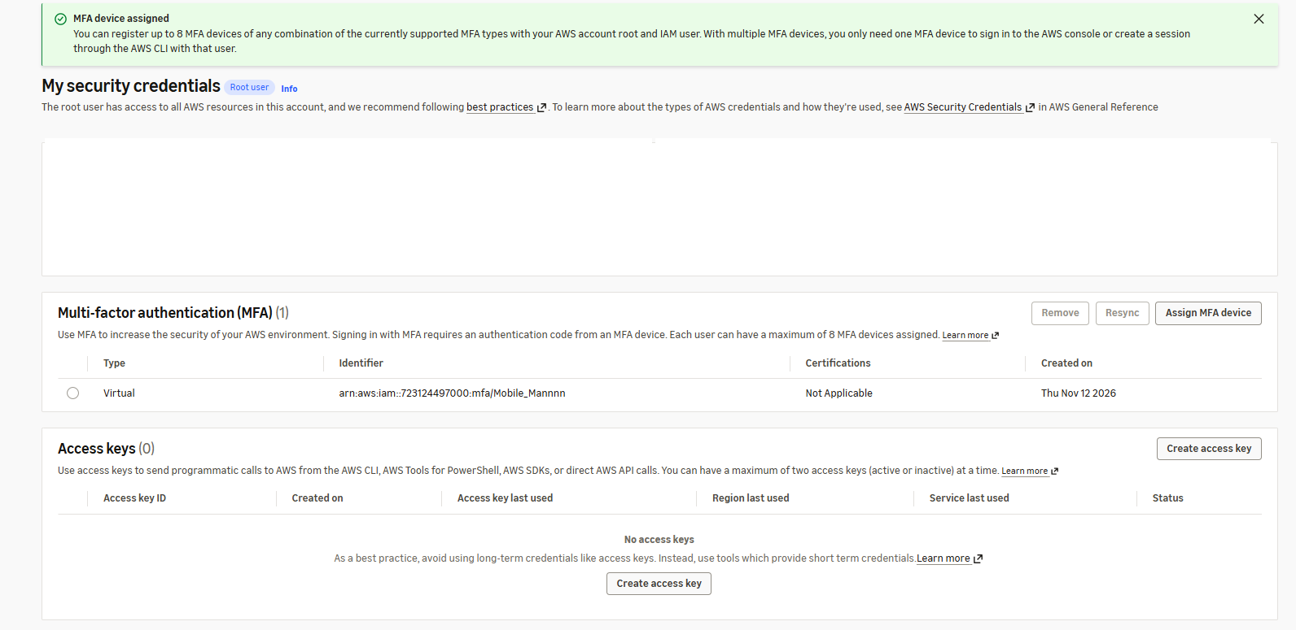
Screenshot 3: MFA device successfully assigned.

2.b – Launching an Amazon EC2 Instance
Step 4: Open EC2
Open the EC2 service from the AWS Console and select Launch instance to begin creating a virtual machine.
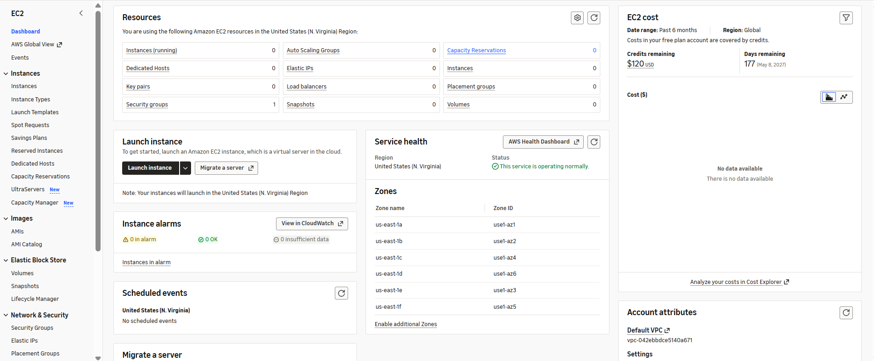
Screenshot 4: EC2 dashboard and Launch instance option.
Step 5: Choose the operating system
Give the instance a name and select an Amazon Machine Image (AMI). Amazon Linux 2023 was selected for this experiment.
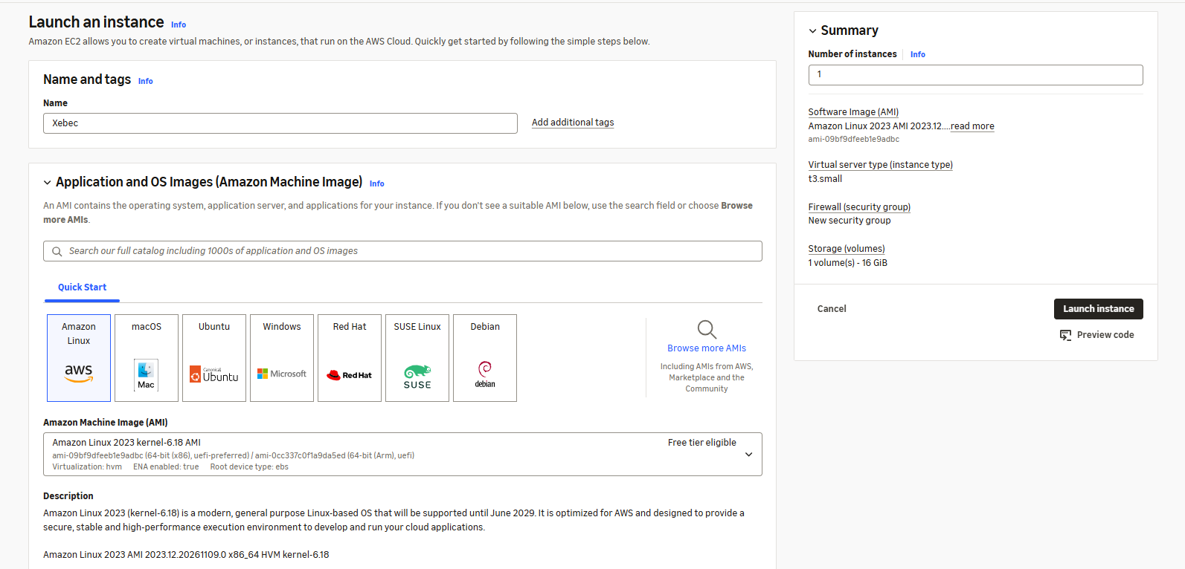
Screenshot 5: Instance name and Amazon Linux 2023 selection.
Step 6: Select instance type and key pair
Choose the t3.small instance type and select the existing key pair named “Teach”. The key pair is used for secure connection to the instance.
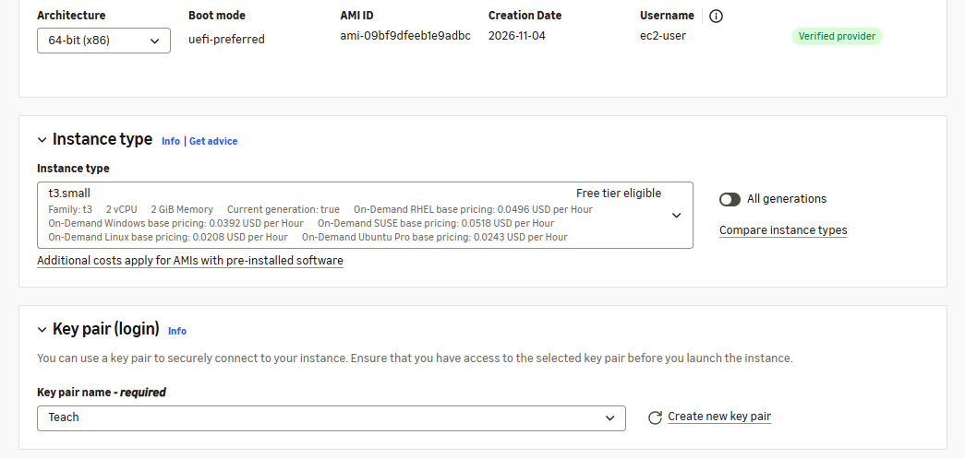
Screenshot 6: Instance type and key pair settings.
Step 7: Configure network and storage
Keep the selected VPC, enable public IP assignment and configure the security group. SSH access was enabled; restricting its source to a known IP is safer than allowing all IPs.
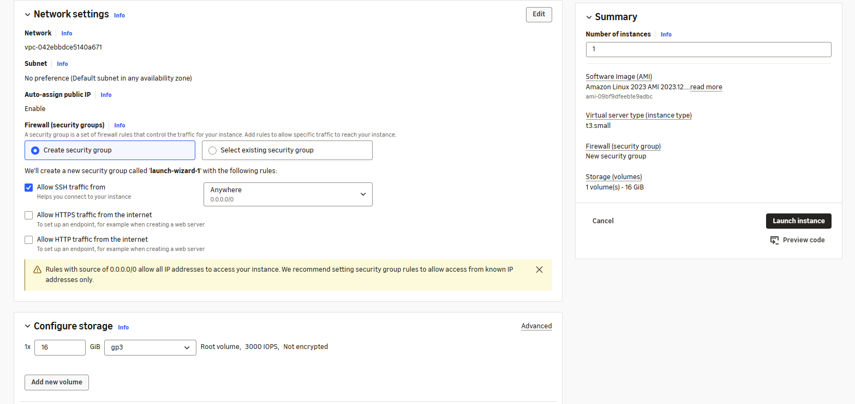
Screenshot 7: Network settings and 16 GiB storage configuration.
Step 8: Verify the instance
Review the settings and launch the instance. Open the Instances page and check that its state is Running.
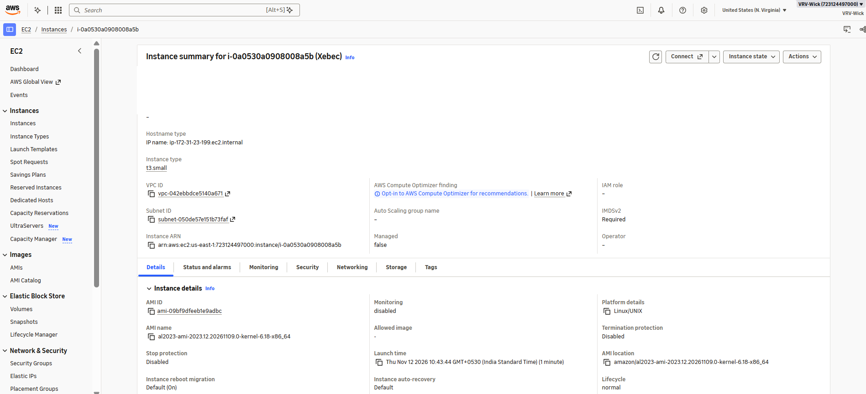
Screenshot 8: EC2 instance summary showing Running status.

Result
MFA was enabled using an authenticator app, and an Amazon EC2 instance was launched successfully. The instance status was verified as Running.

