CDIS – EXPERIMENT 2.c
Creation of an Amazon S3 Bucket
Name: Vinay Bandla | Roll No.: 2520030437
Cluster: 1 | Section: 3

Aim
To create an Amazon Simple Storage Service (S3) bucket for storing files and objects in AWS.

Procedure
Step 1: Configure bucket access and versioning
Open Amazon S3 and choose Create bucket. Keep ACLs disabled and Block all public access enabled for safer access control. Enable bucket versioning to keep and recover earlier versions of objects.
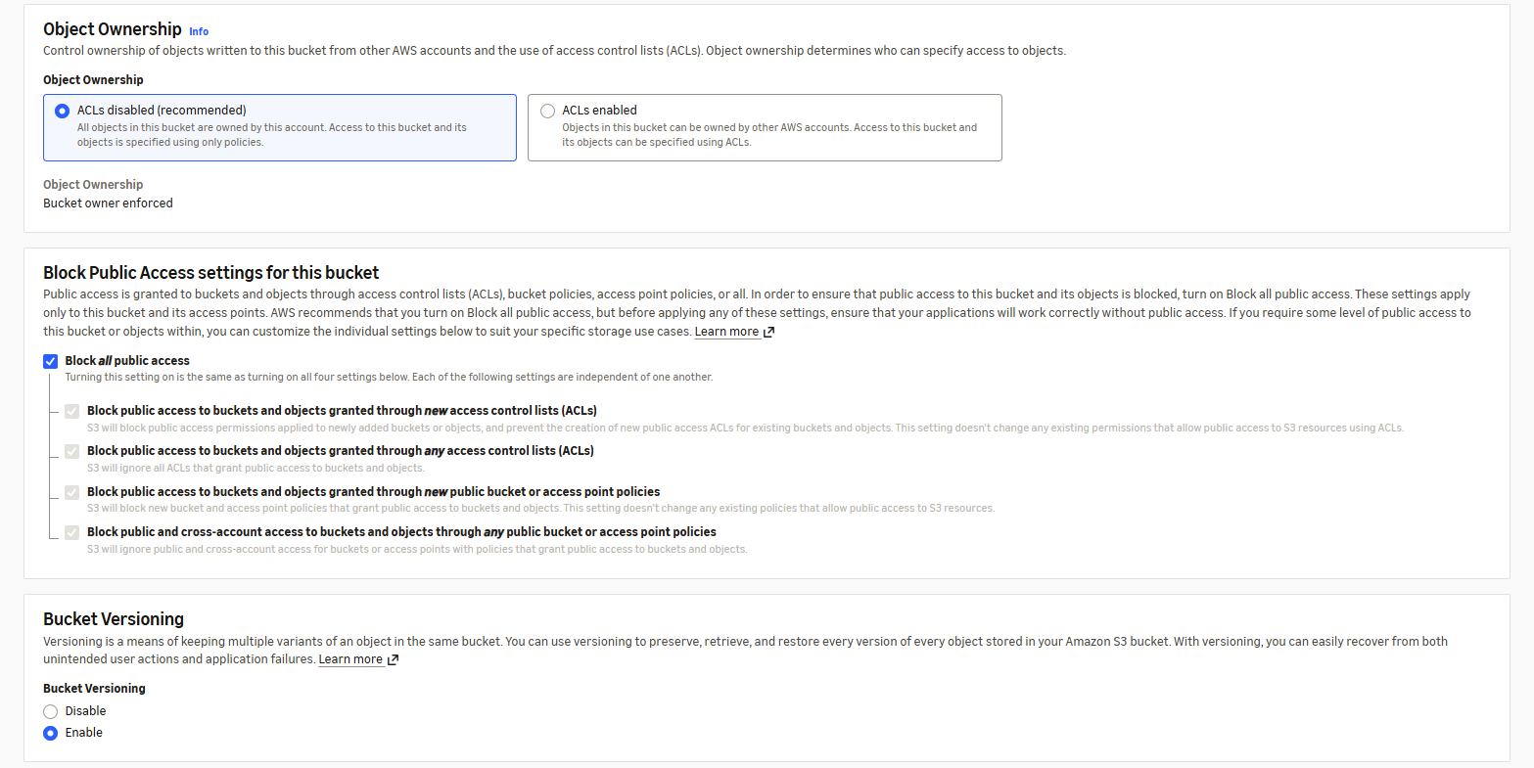
Screenshot 1: Object ownership, public access and versioning settings.
Step 2: Set encryption and create the bucket
Enter a globally unique bucket name. Keep the default server-side encryption option selected and review the settings. Select Create bucket to finish the setup.
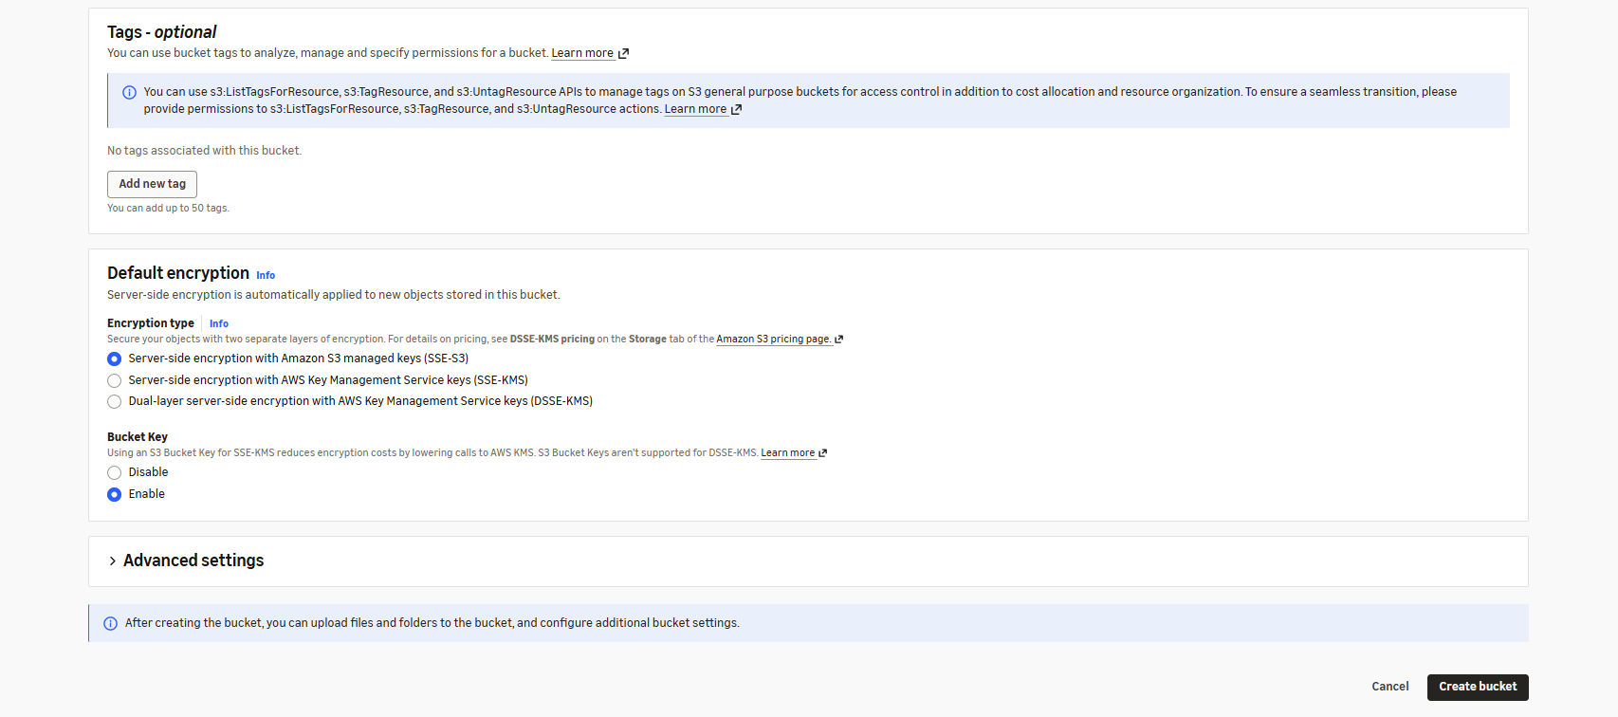
Screenshot 2: Encryption settings and Create bucket option.
Step 3: Verify bucket creation
Open the bucket from the S3 console. The Objects tab displays the bucket name and shows that it is empty, confirming that the bucket has been created successfully.
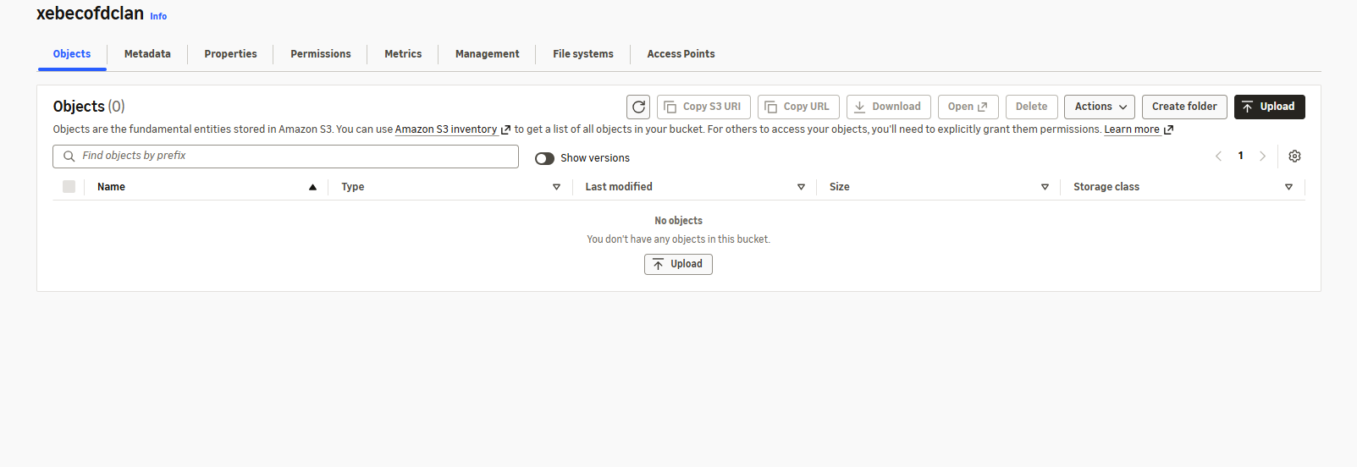
Screenshot 3: Newly created S3 bucket with no objects.

Result
The S3 bucket named “xebecofdclan” was created successfully. Public access blocking, default encryption and bucket versioning settings were configured.

