SQL CONCEPTS — DDL / DML / DQL / TCL / DCL
Bandla Vinay
Roll No: 2520030437

Step 1 — DDL: Schema Evolution & Initial DML
Used ALTER TABLE to add a column and modify a default, then inserted the first rows into agents and clients.
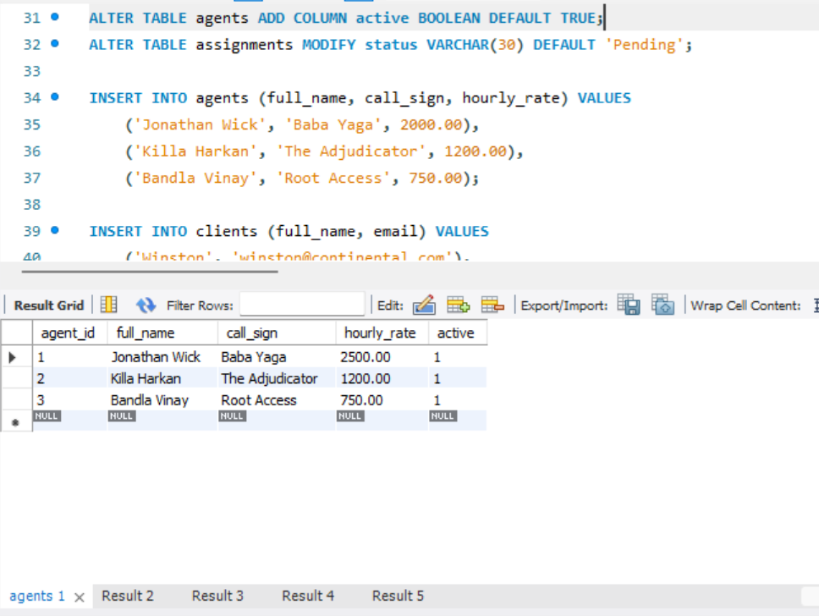

Step 2 — DML: Insert & Update
Inserted assignment records linking agents to clients, then updated an agent's hourly rate and a task's status.
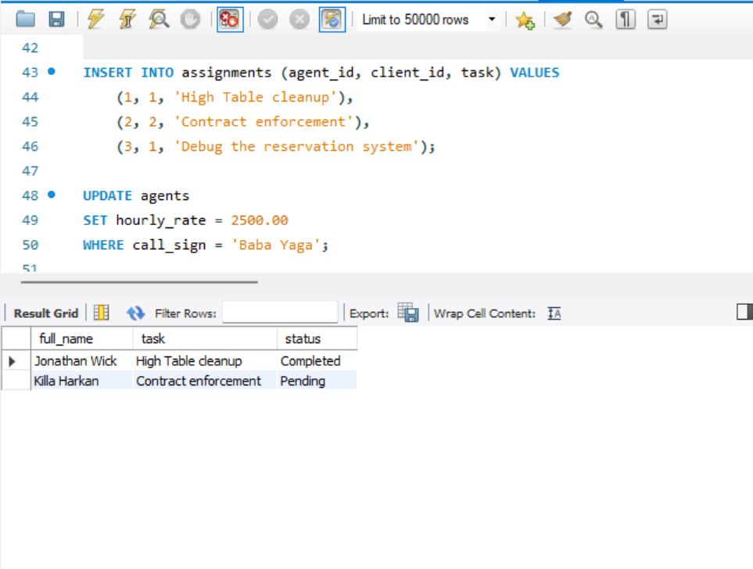

Step 3 — DQL: Grouped Query & Start of Transaction
Used JOIN, GROUP BY, HAVING, and ORDER BY to count tasks per agent, then kicked off a transaction block.
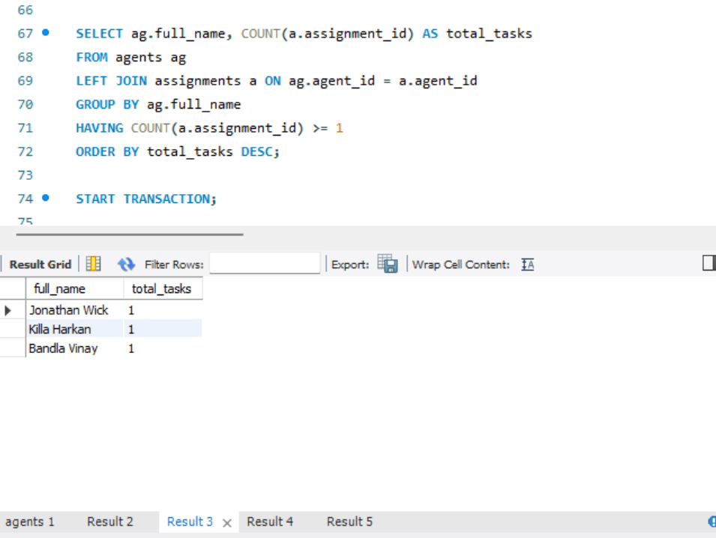

Step 4 — TCL: Savepoint, Rollback & Commit
Action log showing SAVEPOINT, a partial ROLLBACK TO SAVEPOINT, COMMIT, and a second transaction fully rolled back after a foreign key error.
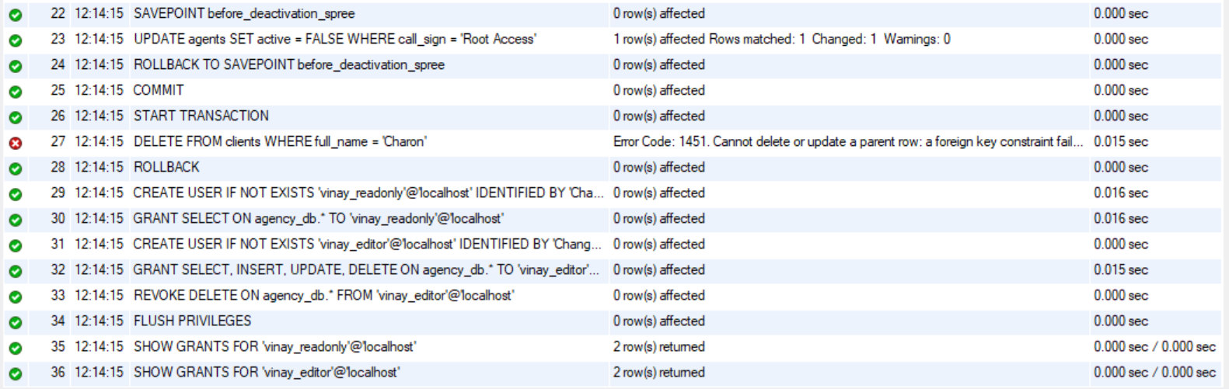

Step 5 — DCL: Create Users & Grant Privileges
Created two database users and granted read-only access to one, broader DML access to the other.
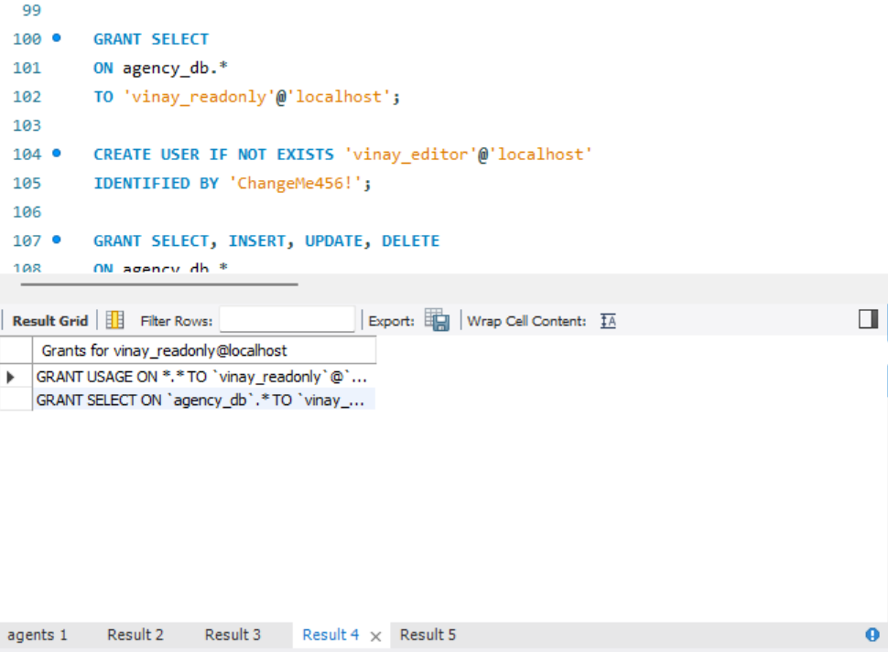

Step 6 — DCL: Revoke & Verify Grants
Revoked DELETE from the editor account, flushed privileges, and confirmed each user's exact grants.
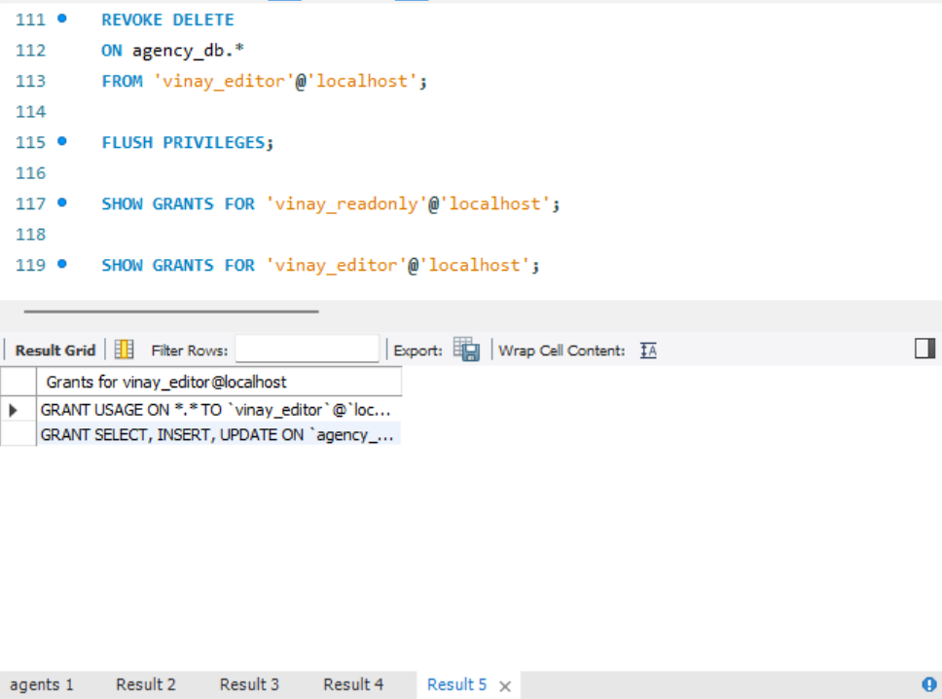

Step 7 — Full Execution Log
Consolidated action log confirming the complete run from database creation through the start of the transaction block.
