WEEK-1.1
Bandla Vinay
Roll No: 2520030437

Step 1 — Create Database & Books Table
Created the bookflow_db database (guarded with IF NOT EXISTS), dropped any pre-existing books/members tables, then created the books table with an auto-incrementing primary key, a unique ISBN constraint, and DESCRIBE books to confirm the schema.
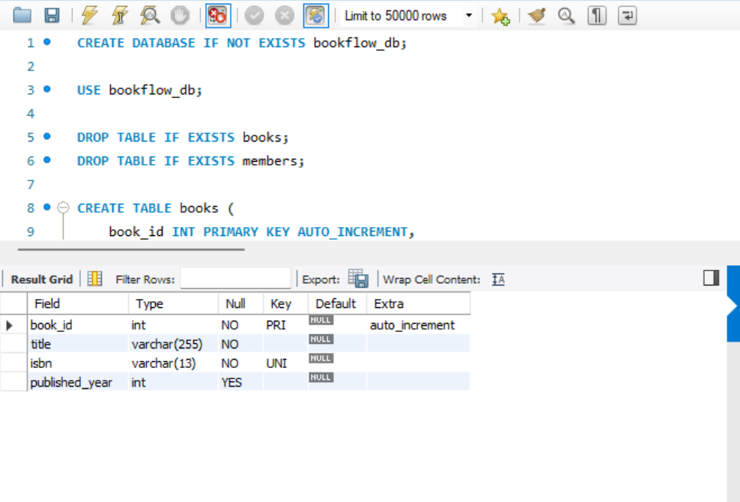

Step 2 — Create Members Table
Created the members table with member_id as an auto-incrementing primary key, and full_name, email, and PhNo all set NOT NULL (email and PhNo also UNIQUE). Verified the structure with DESCRIBE members.
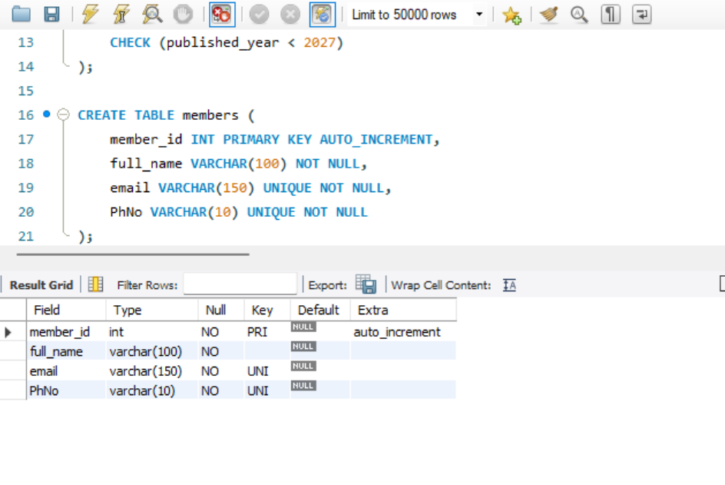

Step 3 — Insert Records into Books
Inserted 3 sample rows into books (title, isbn, published_year) and confirmed the data with the result grid.
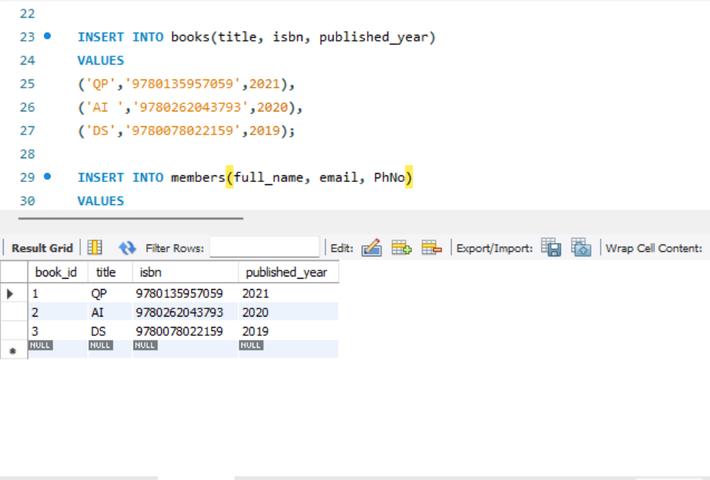

Step 4 — Insert Records into Members
Inserted 3 sample rows into members (full_name, email, PhNo) and confirmed the data with the result grid.
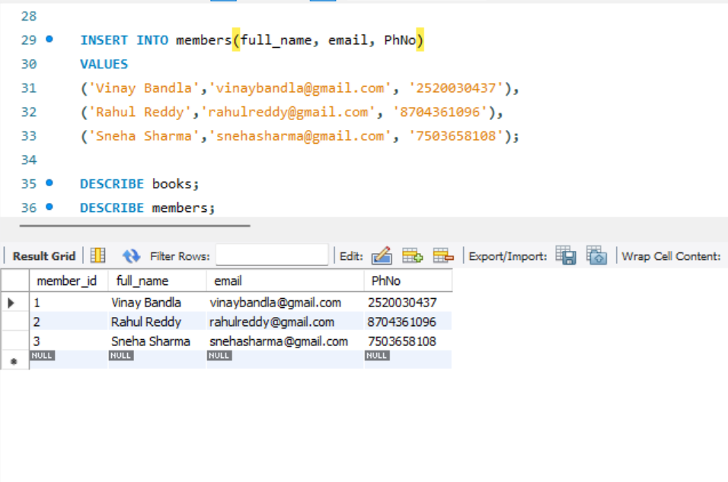

Step 5 — Full Execution Log
Consolidated action log showing the complete run in order: database creation, table drops, table creation for books and members, data inserts, and the DESCRIBE / SELECT verification queries.
