WEEK-1.2
Bandla Vinay
Roll No: 2520030437

Step 1 — Create Table & Insert Records
Created the student_marks table (roll_no, name, subject, marks) and inserted the initial 9 student records.
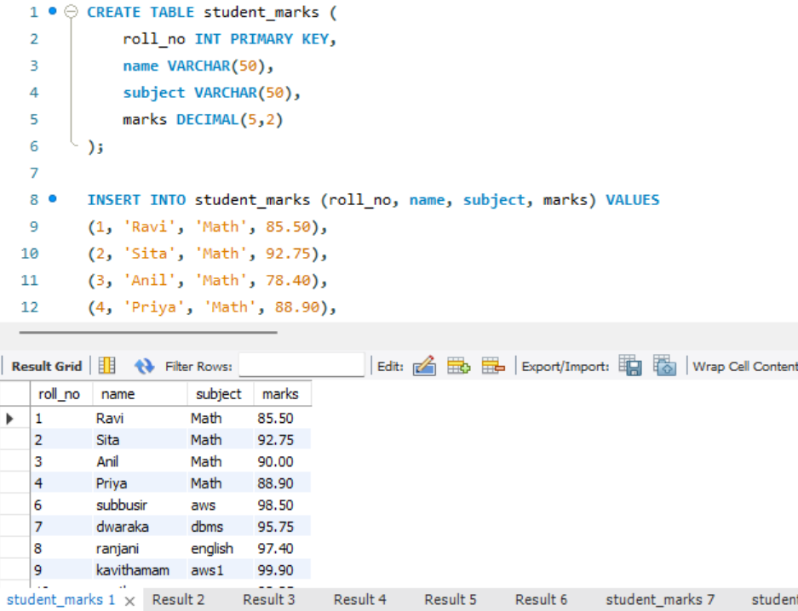

Step 2 — Aggregate Functions
Ran the five core aggregate functions against the marks column to summarize the whole table.
COUNT(*) → total_students = 9
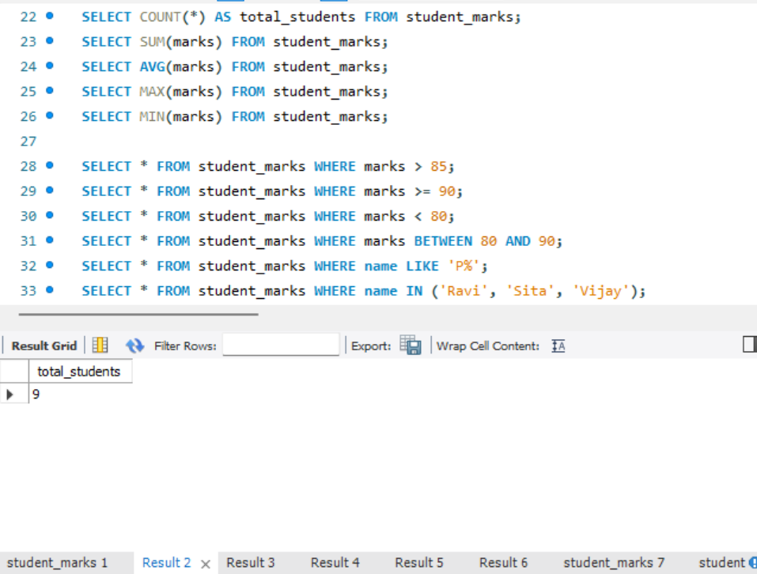
SUM(marks) = 830.95
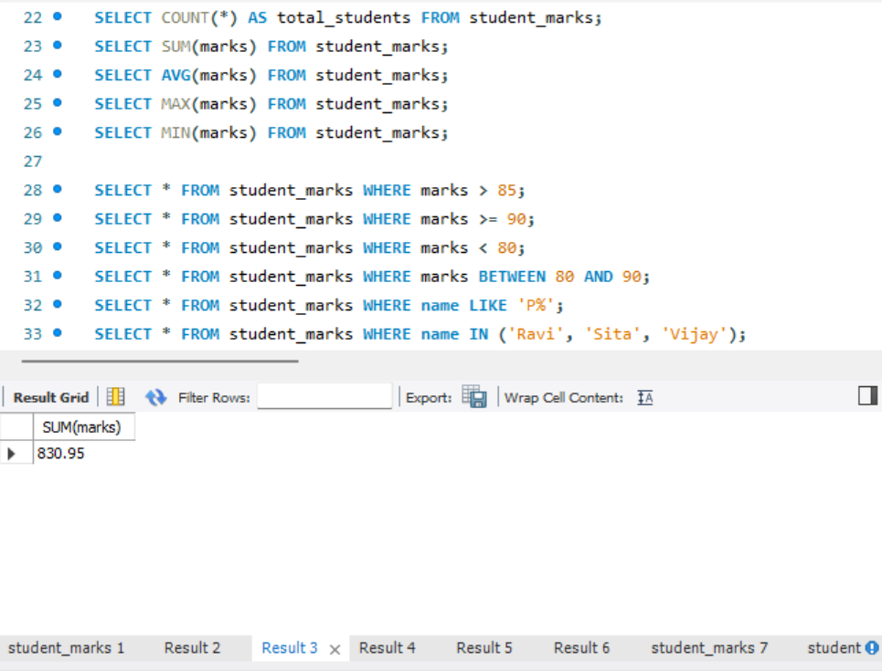
AVG(marks) = 92.327778
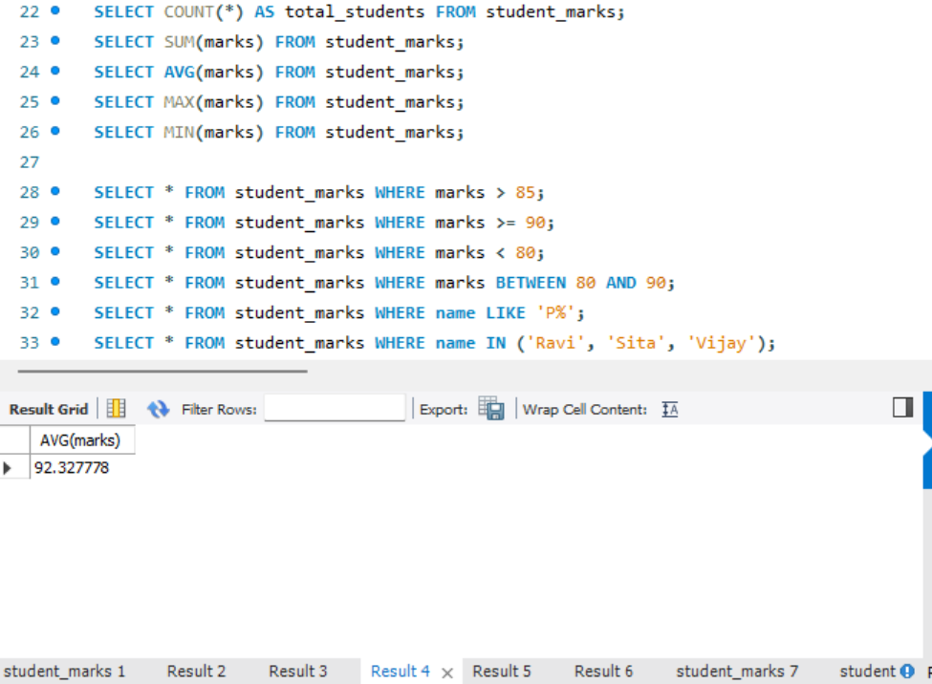
MAX(marks) = 99.90
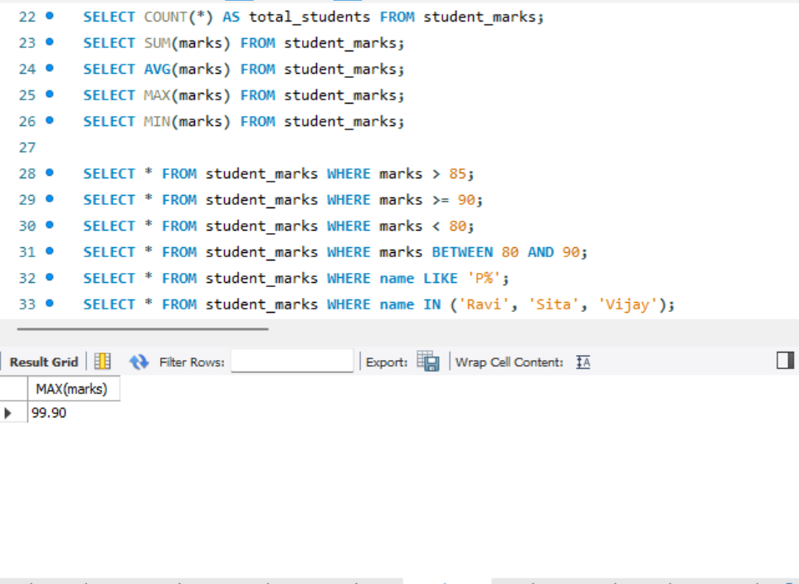
MIN(marks) = 82.25
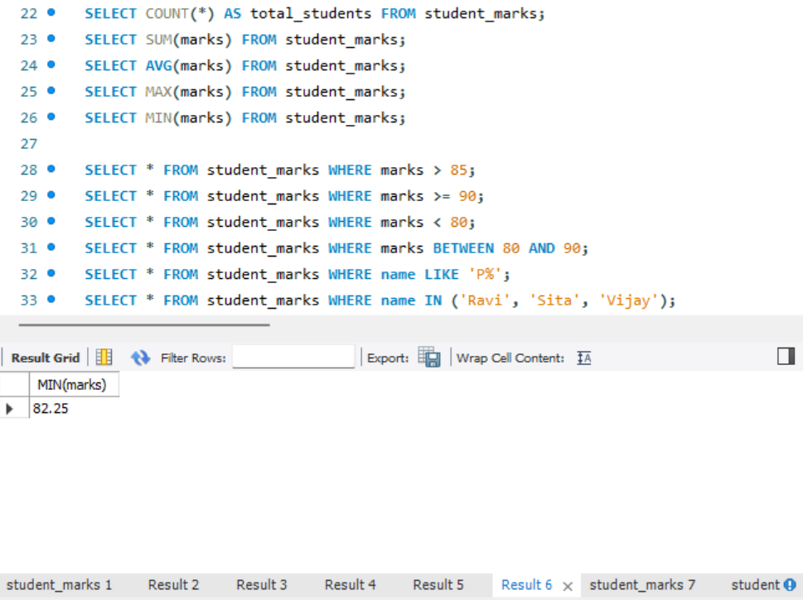

Step 3 — Filtering with WHERE
Filtered rows using comparison, range, pattern-match, and set-membership conditions.
marks > 85
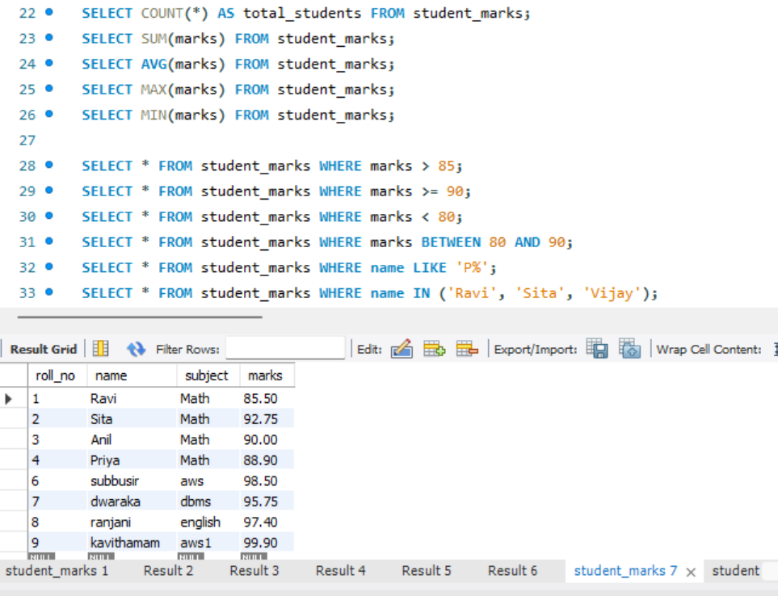
marks >= 90
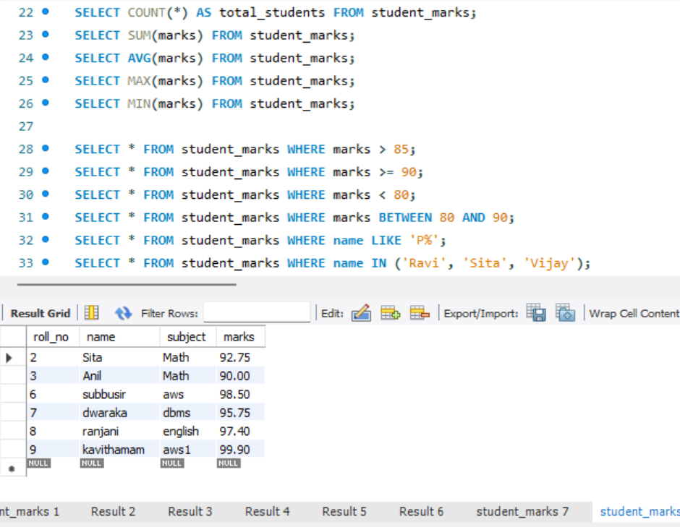
marks < 80
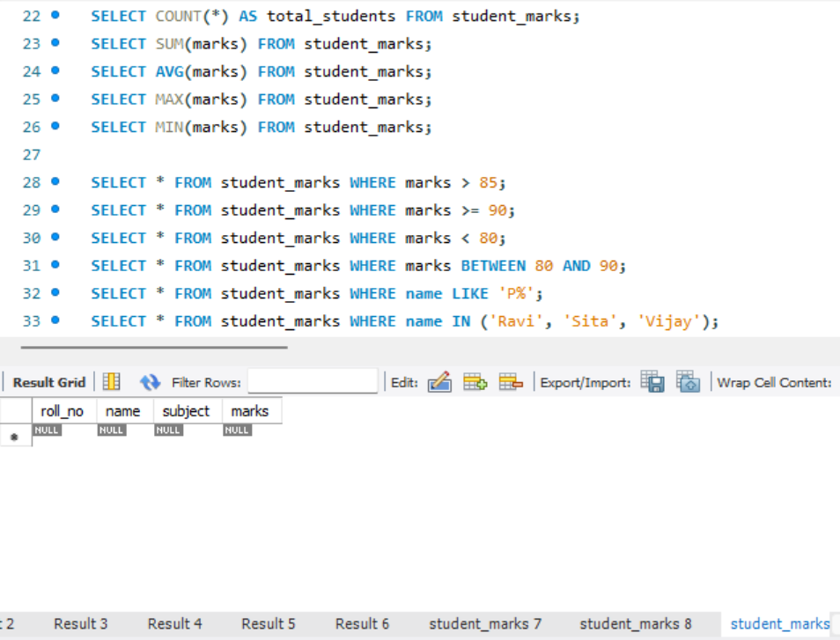
marks BETWEEN 80 AND 90
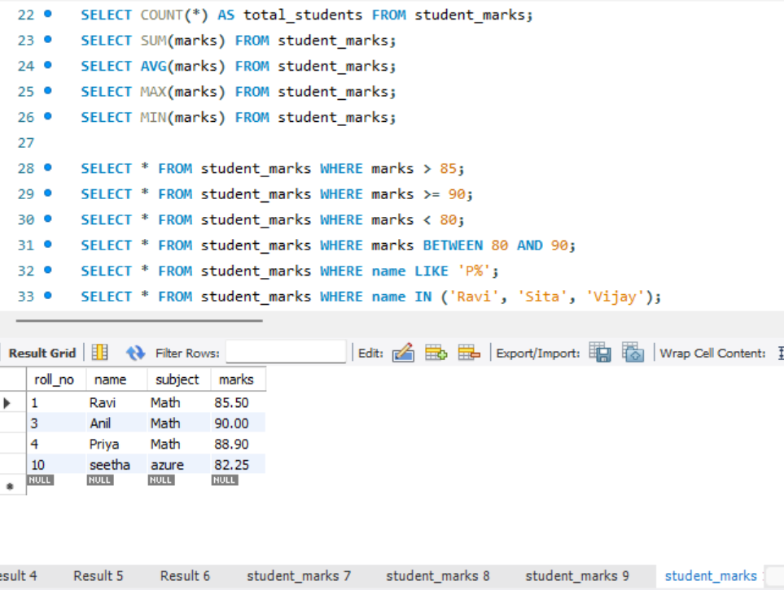
name LIKE 'P%'
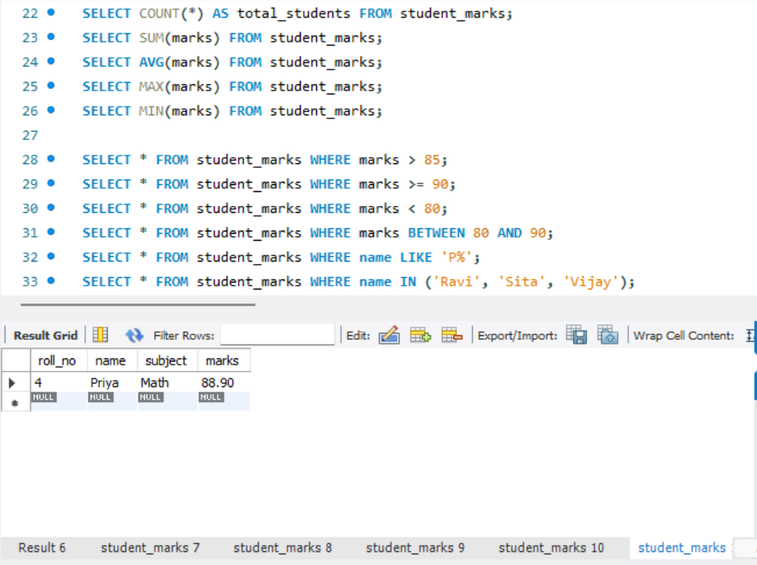
name IN ('Ravi', 'Sita', 'Vijay')
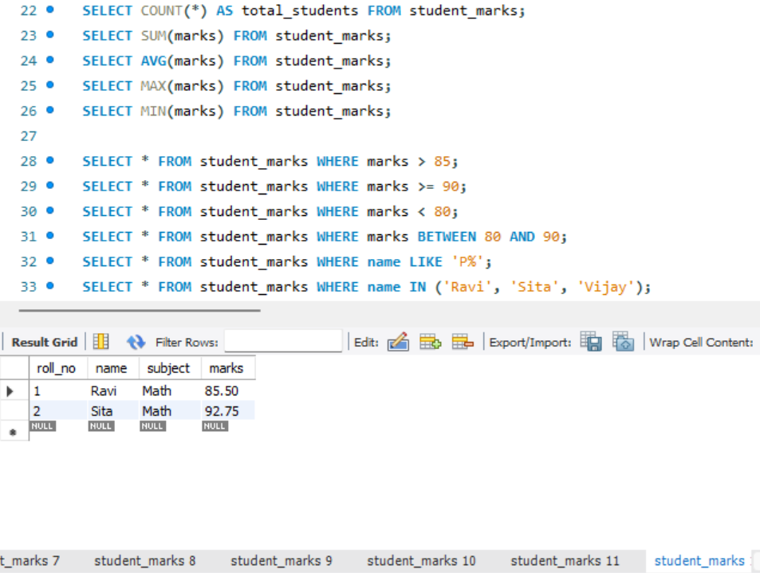

Step 4 — Grouped Aggregates by Subject
Used GROUP BY subject to roll aggregate functions up per subject instead of across the whole table.
SUM(marks) per subject
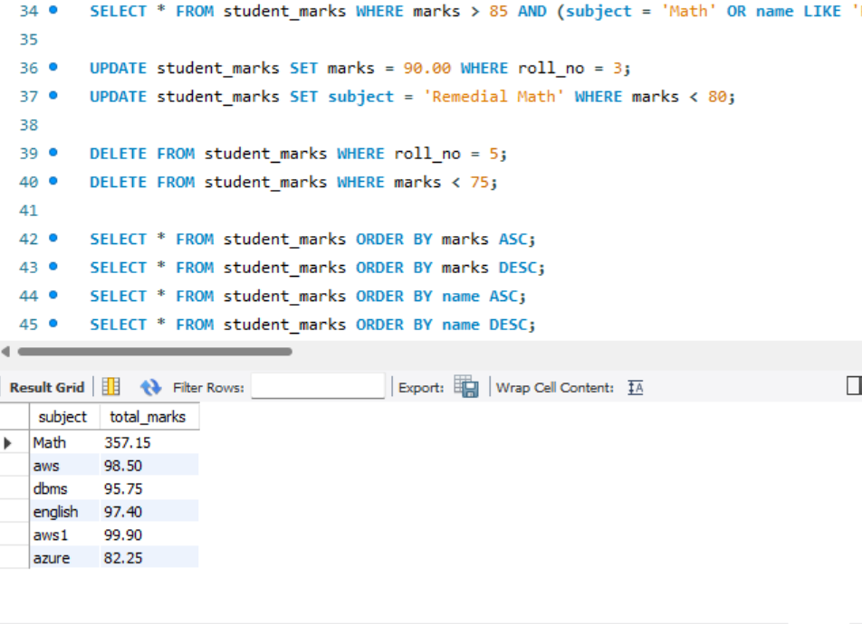
AVG(marks) per subject
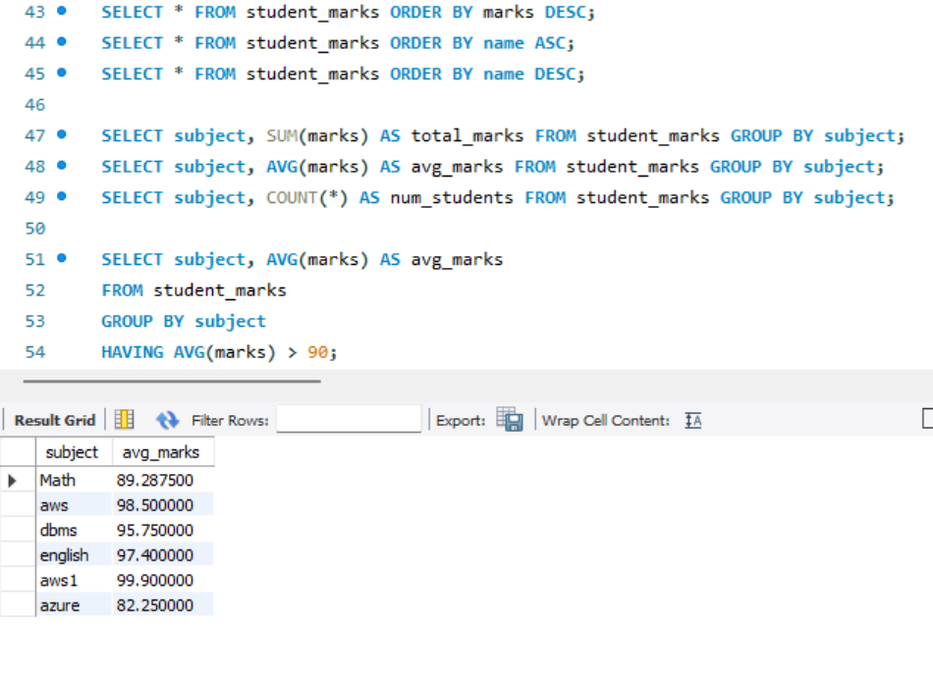
COUNT(*) per subject
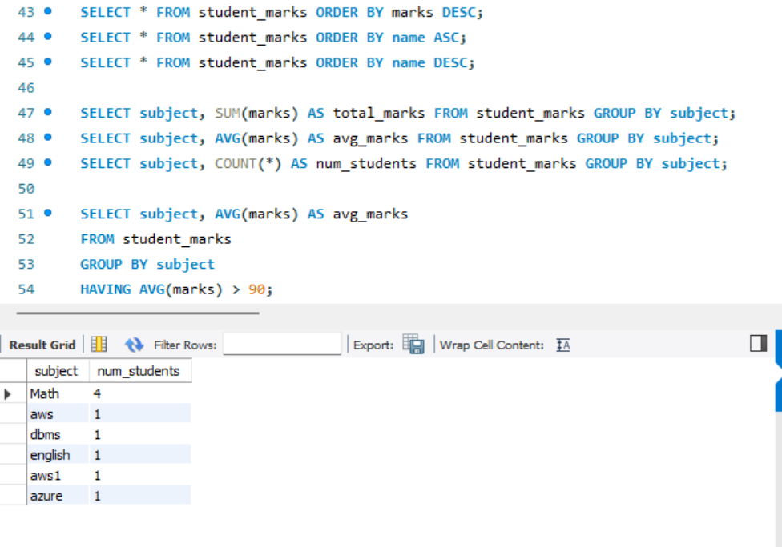

Step 5 — Filtering Groups with HAVING
Applied HAVING to keep only subject groups whose average crosses a threshold, since WHERE can't filter on an aggregate.
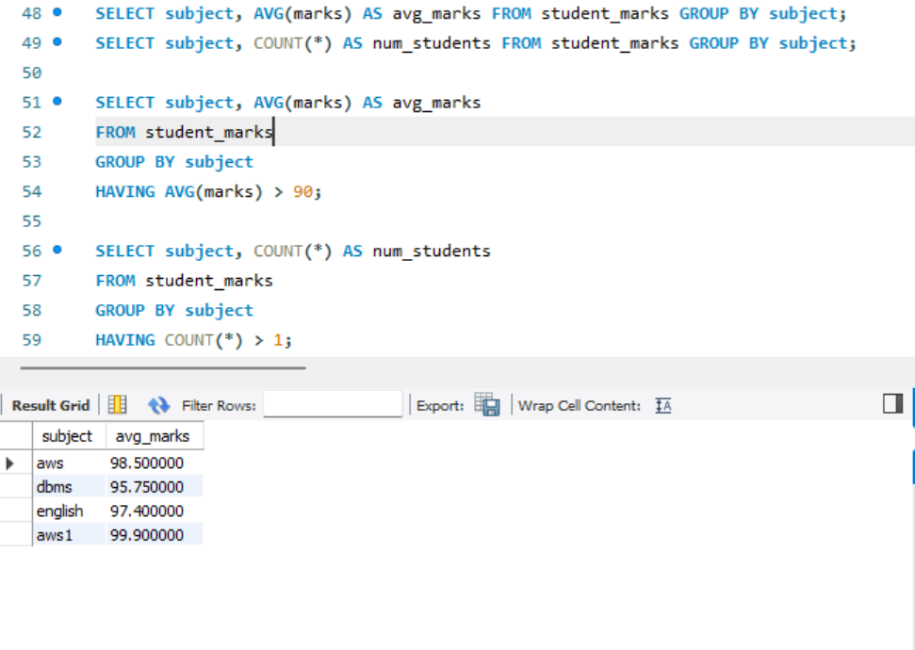

Step 6 — Sorting with ORDER BY
Sorted the result set by marks and by name, in both ascending and descending order.
ORDER BY marks ASC
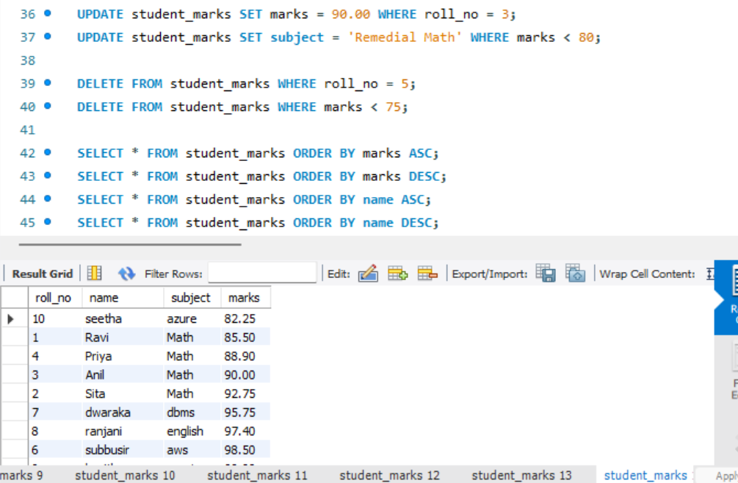
ORDER BY marks DESC
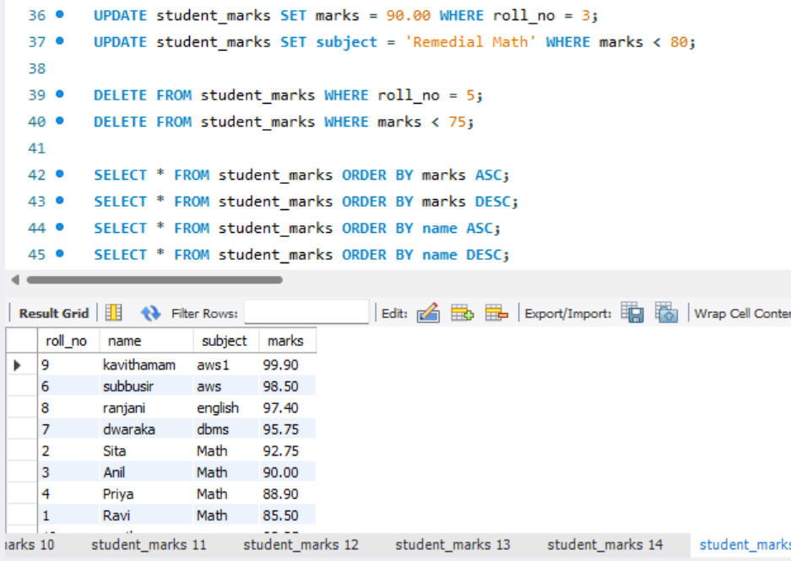
ORDER BY name ASC
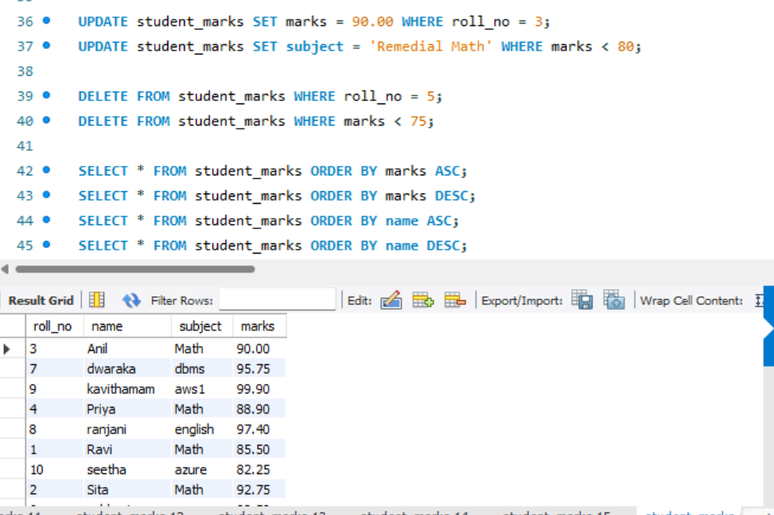
ORDER BY name DESC
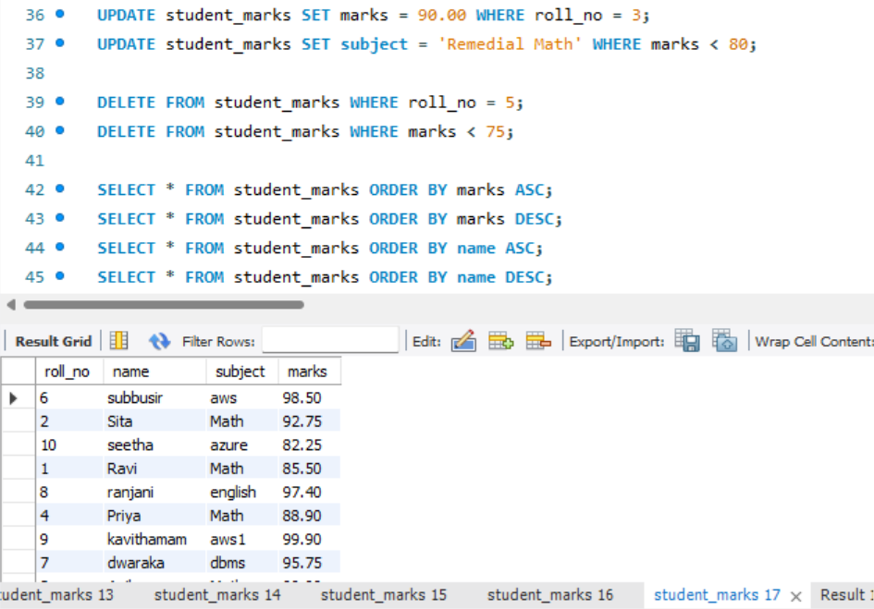

Step 7 — Execution Log Summary
Consolidated action log confirming the GROUP BY and ORDER BY statements executed successfully in sequence.
