CO-4 PROJECT – 2
Student Records REST API
Spring Boot • MongoDB • Spring Security • JWT • Postman

PROJECT DOCUMENTATION
A practical verification record of registration, authentication,
JWT-protected CRUD operations, and deletion validation.

1. Project Overview
The Student Records project implements a RESTful backend for managing student records. The application uses Spring Boot for the web layer, MongoDB for persistence, Spring Data MongoDB for database access, and Spring Security with JWT-based authentication for protected student endpoints.
The application was run locally on port 8080 and tested through Postman. The testing sequence covered user registration, authentication, student creation and retrieval, update handling, deletion, and post-deletion verification.

2. Objectives
- Build and run a Spring Boot REST API for student records.
- Connect the application to a local MongoDB database.
- Provide registration and login endpoints.
- Generate and use a Bearer JWT for protected student operations.
- Verify CRUD operations through Postman.
- Confirm that a deleted student can no longer be retrieved.

3. Technology Stack
Component | Technology / Configuration
Language | Java 17
Framework | Spring Boot 3.4.5
Build | Maven Wrapper (mvnw.cmd)
Database | MongoDB — localhost:27017
Security | Spring Security + JWT
API Testing | Postman
Server | Embedded Tomcat — port 8080

4. API Endpoints Tested
Method | Endpoint | Purpose | Expected Result
POST | /auth/register | Register a user | 201 Created
POST | /auth/login | Authenticate and receive JWT | 200 OK
POST | /students | Create a student | 201 Created
GET | /students | Retrieve all students | 200 OK
GET | /students/{id} | Retrieve one student | 200 OK / 404 after deletion
PUT | /students/{id} | Update an existing student | 200 OK
DELETE | /students/{id} | Delete a student | 204 No Content

5. Student Data Used for Testing
The CRUD test used a temporary student record. The record was created, read, updated, and finally deleted.
{
"name": "John",
"age": 21,
"course": "Computer Science",
"email": "john@example.com"
}

6. Postman Testing Evidence

6.1 Workspace and API Test Setup
The captured workspace shows the Student Records API being tested locally in Postman. The Postman collection/workspace and local API requests are visible in the testing environment.
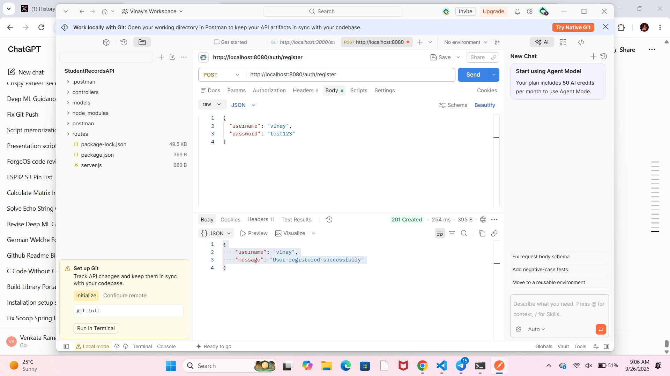
Figure 1 — Postman workspace and local Student Records API testing.

6.2 User Registration
A POST request was sent to /auth/register with the username 'vinay' and the test password. The API returned HTTP 201 Created with the message 'User registered successfully'.
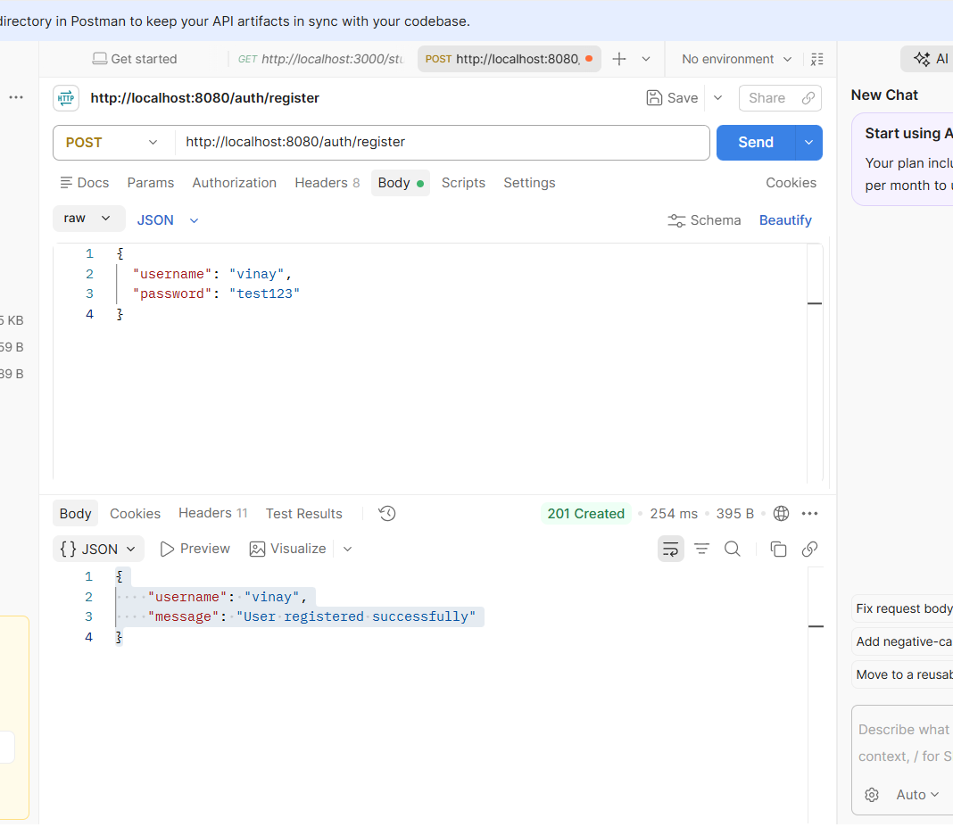
Figure 2 — Successful user registration: HTTP 201 Created.

6.3 Retrieve All Students
The protected GET /students endpoint returned HTTP 200 OK and displayed the created student record.
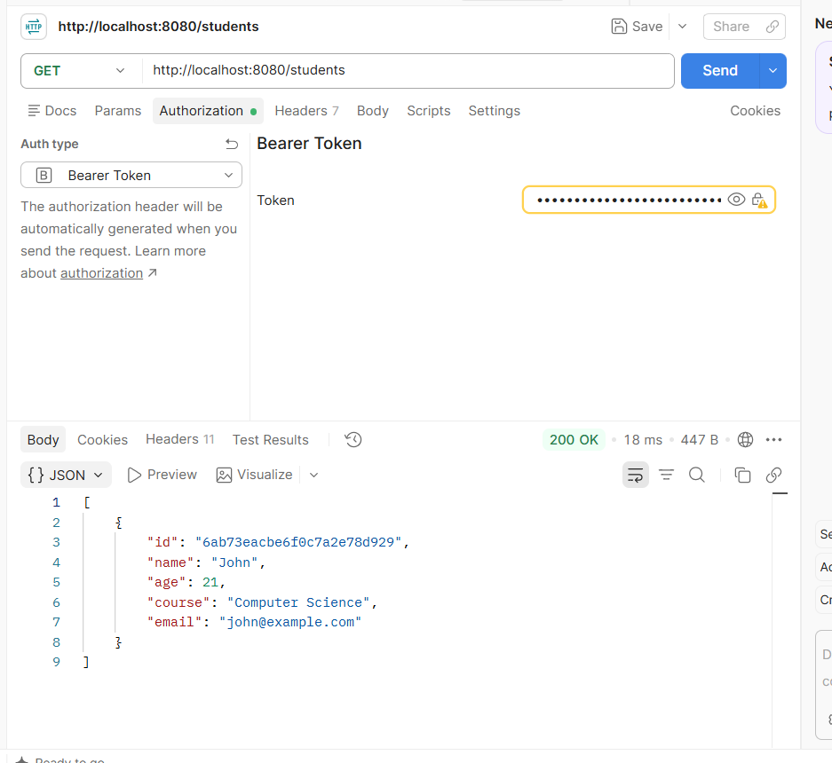
Figure 3 — GET /students returning the student record.

6.4 Retrieve a Student by ID
The GET /students/{id} request returned HTTP 200 OK for the created MongoDB document.
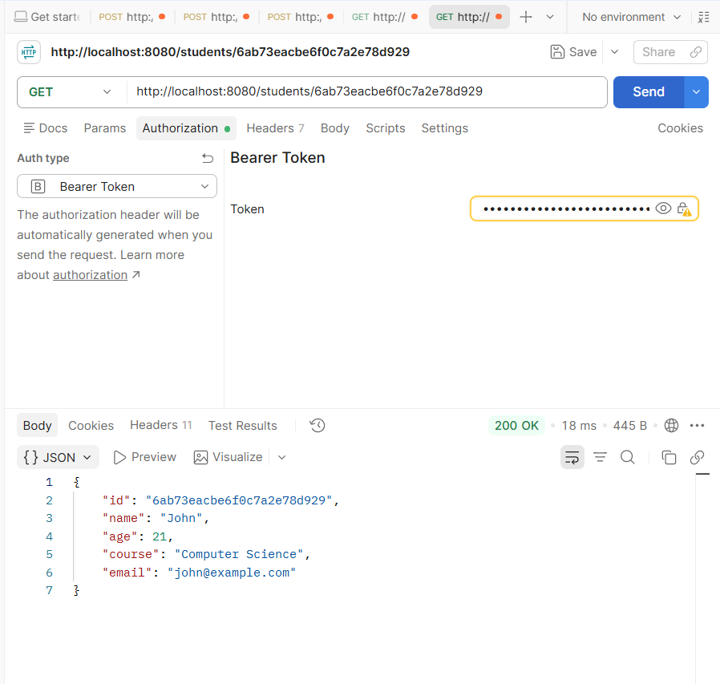
Figure 4 — GET /students/{id} returning the requested student.

6.5 Authentication Handling During Update
One PUT attempt returned HTTP 401 Unauthorized because authentication was not supplied correctly. The API response explicitly indicated that authentication was required. This provided a useful negative test of the protected endpoint.
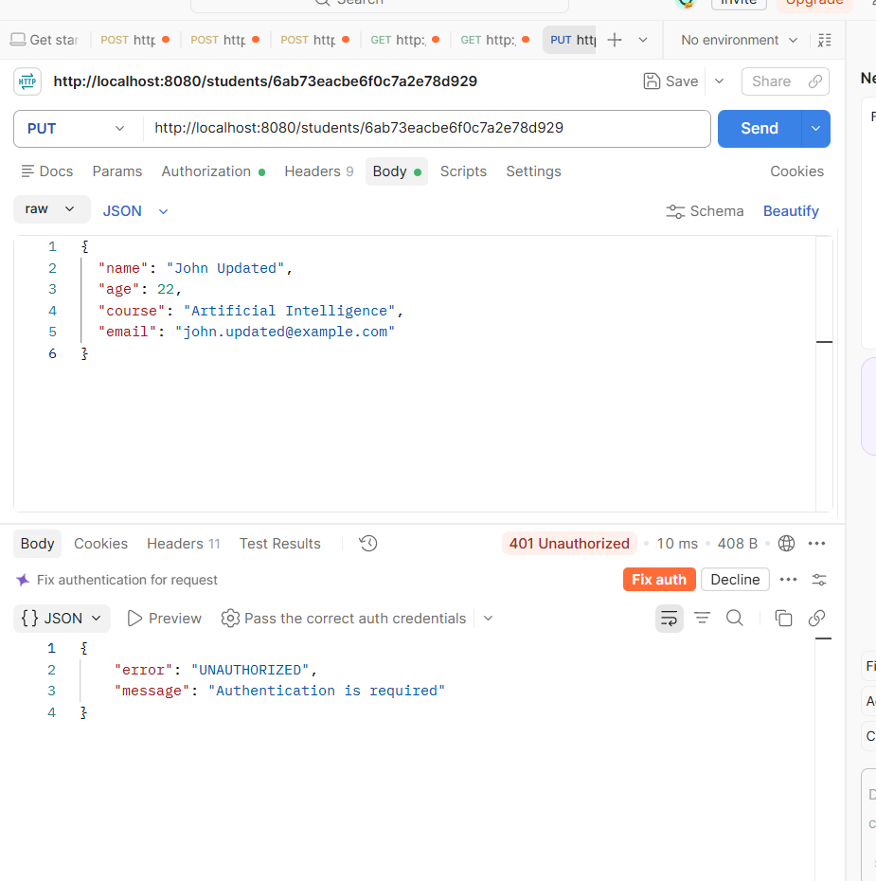
Figure 5 — Negative security test: PUT request rejected with HTTP 401 Unauthorized.

6.6 Successful Student Update
After supplying the Bearer JWT correctly, the same PUT request returned HTTP 200 OK. The response showed the same student ID with the updated name, age, course, and email.
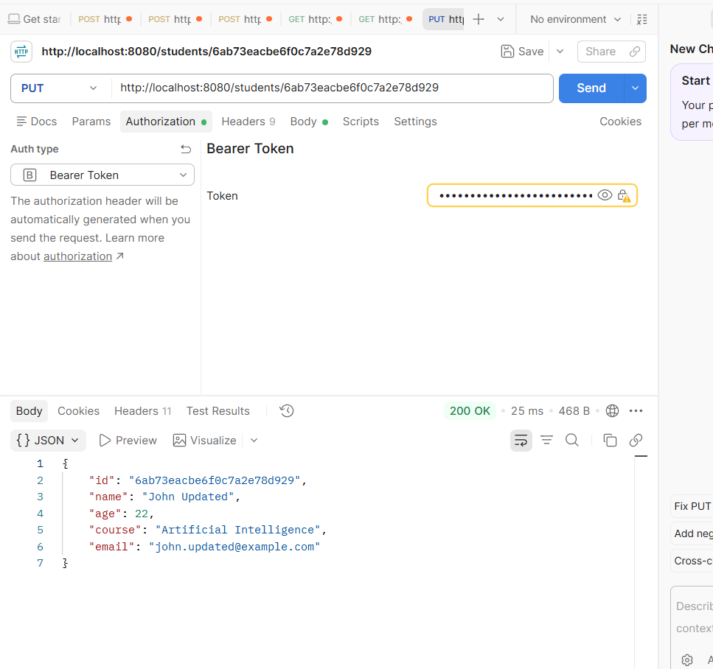
Figure 6 — Successful student update: HTTP 200 OK.

6.7 Student Deletion
The DELETE /students/{id} request returned HTTP 204 No Content, indicating successful deletion.
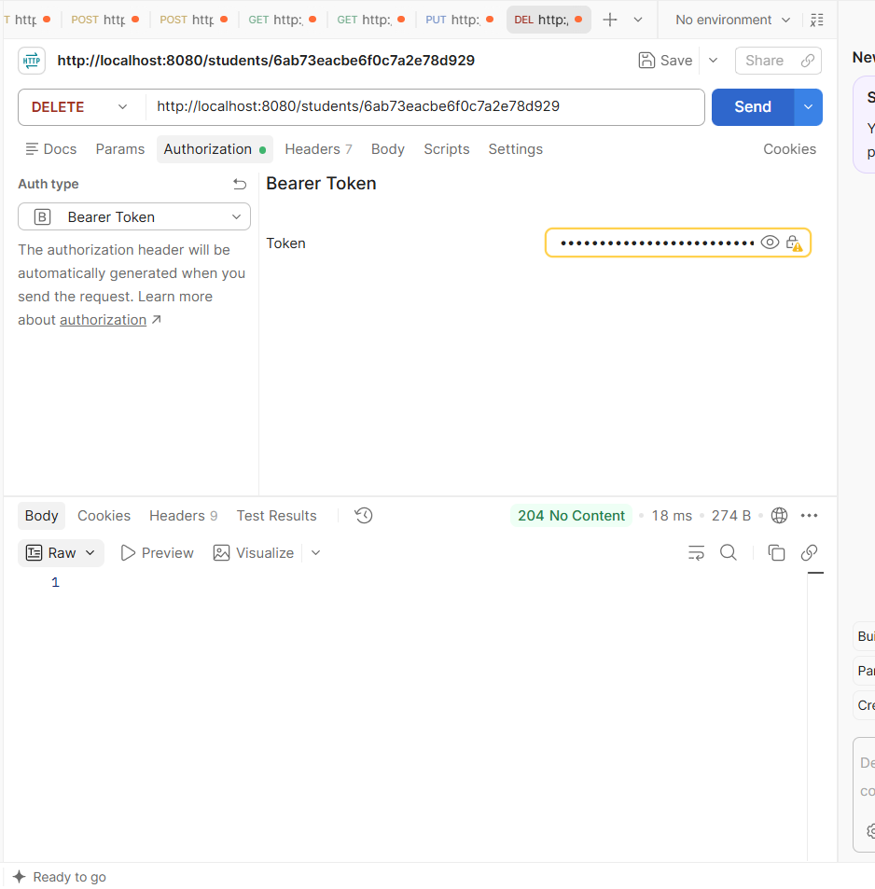
Figure 7 — Successful deletion: HTTP 204 No Content.

6.8 Post-Deletion Verification
A final GET request was sent using the deleted student ID. The API returned HTTP 404 Not Found with 'Student not found', confirming that the record was no longer available.
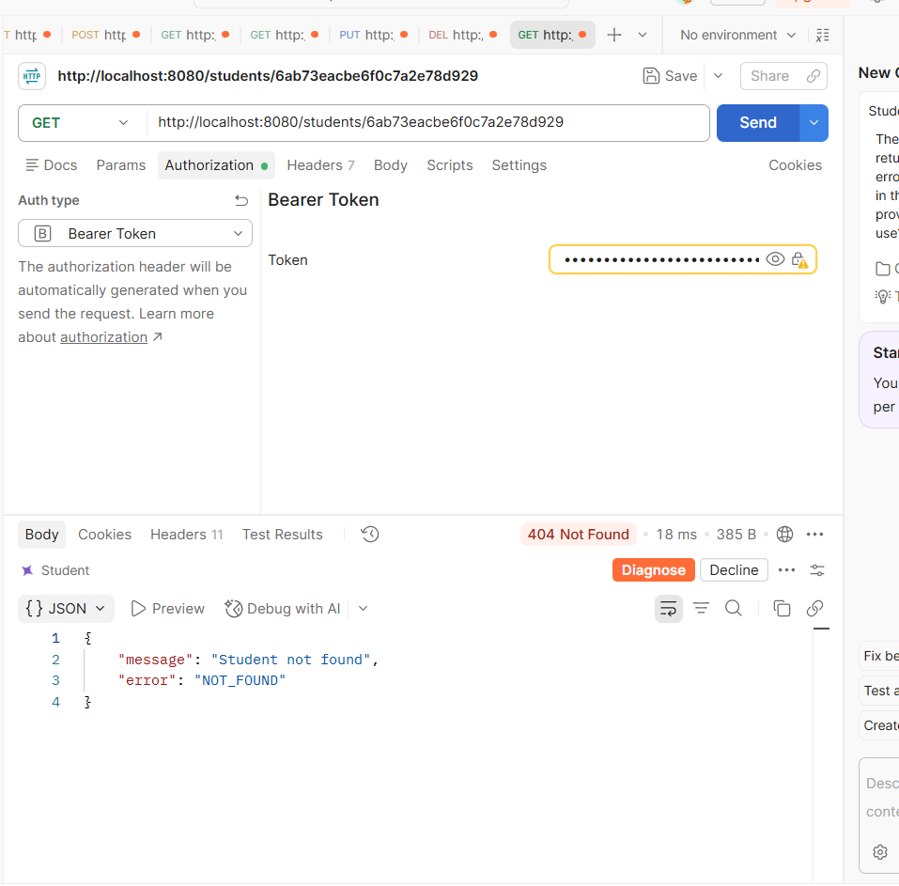
Figure 8 — Post-deletion verification: HTTP 404 Not Found.

7. Test Results Summary
Test | Observed Status | Result
User registration | 201 Created | Passed
User login / JWT generation | 200 OK | Passed
Create student | 201 Created | Passed
Get all students | 200 OK | Passed
Get student by ID | 200 OK | Passed
Unauthenticated PUT attempt | 401 Unauthorized | Expected security behavior
Authenticated student update | 200 OK | Passed
Delete student | 204 No Content | Passed
GET deleted student | 404 Not Found | Passed

8. Conclusion
The Student Records REST API was successfully exercised through Postman. Registration and authentication were verified, a JWT was used to access protected student endpoints, and the complete CRUD lifecycle was tested. The update endpoint correctly rejected a request without valid authentication and succeeded after the Bearer token was supplied. The final 404 response after deletion confirmed that the test student was removed.

9. Final Verification Checklist
- Spring Boot application launched successfully on port 8080.
- MongoDB connectivity was established.
- Registration endpoint returned 201 Created.
- Login returned a Bearer JWT.
- Protected student endpoints accepted the JWT.
- Create, read, update, and delete operations were verified.
- Unauthorized access was rejected with HTTP 401.
- Deleted student lookup returned HTTP 404 Not Found.

