WEEK 3 PRACTICAL
MongoDB – Book Metadata

Database: bookflow
Collection: book_metadata

Practical record

1. Aim
To work with MongoDB documents and try out different queries, aggregation stages, embedded data, text search and indexes using the book_metadata collection.

2. What I did
- Created/used the book_metadata collection in the bookflow database.
- Checked the documents and their different fields.
- Used $gt and $in queries on reviews.rating.
- Used a regular expression query on format.
- Created an aggregation using $match, $unwind, $group and $sort.
- Created a text index for reviews.comments.
- Tested text search and phrase search.
- Checked the query using explain().

3. Collection
use bookflow
db.book_metadata.find()
The collection contains 5 documents. The documents are not exactly the same, which shows the flexible nature of MongoDB. Some documents have fields/arrays that are not present in the others.
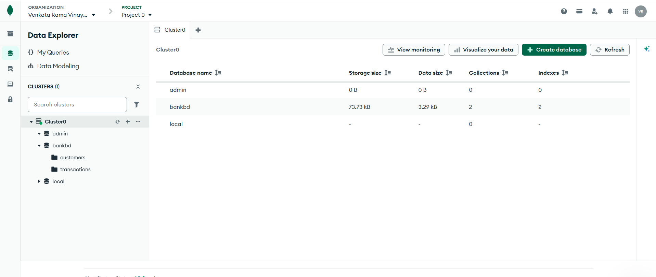
MongoDB Atlas showing the book_metadata collection and its documents.

4. Document Structure
The books have normal fields like title, author, published_year, category and format. There are also nested/array fields such as reviews, combat_style and weapons.
"member_id": 101
"reviews": [ ... ]
Here reviews is embedded inside the book document. member_id can be used as a reference to member data.
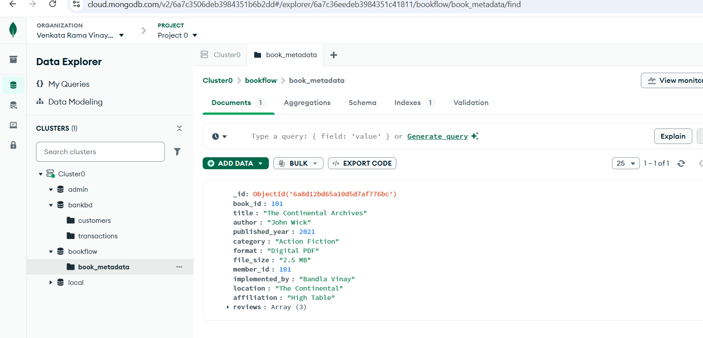
Example document with reviews and other book metadata.
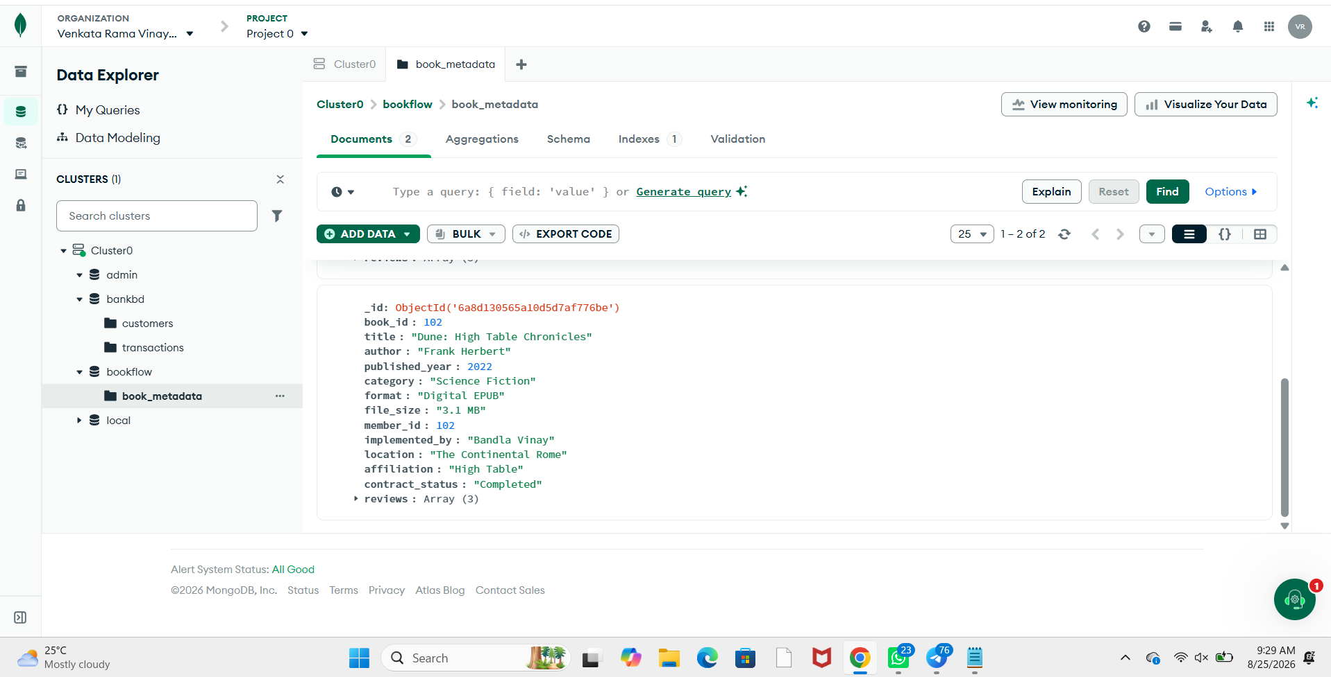
Another document showing different fields and arrays.

5. Queries

5.1 $gt
{
"reviews.rating": {
"$gt": 4
}
}
This checks for books having a review rating greater than 4. The result showed 5 documents.
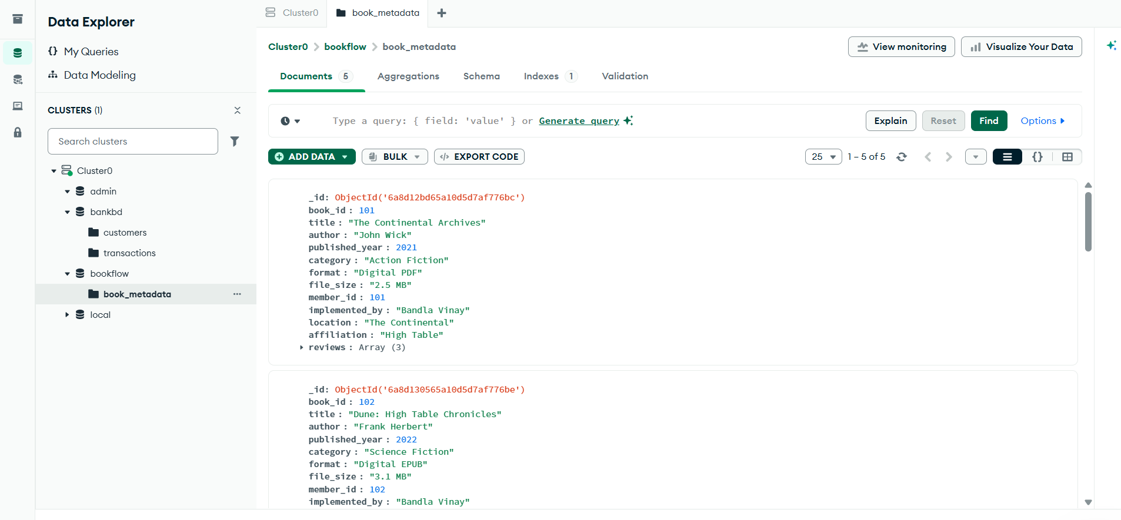
Result of the $gt query.

5.2 $in
{
"reviews.rating": {
"$in": [4, 5]
}
}
This checks for ratings that are either 4 or 5. The result showed 5 documents.
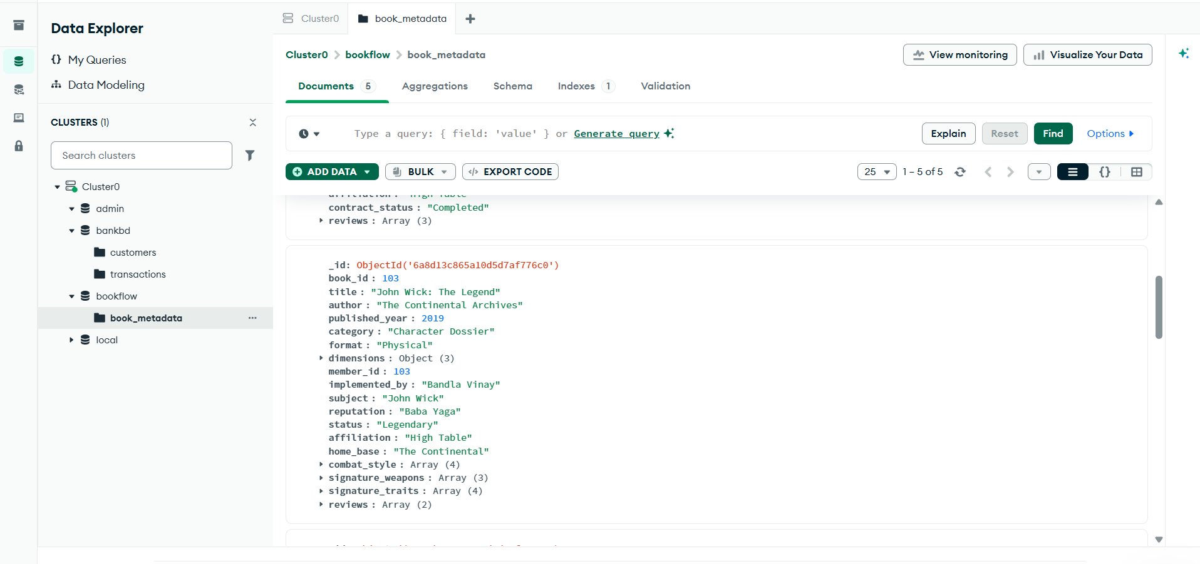
Result of the $in query.

5.3 Regex
{
"format": {
"$regex": "Digital",
"$options": "i"
}
}
This searches for Digital in the format field without worrying about uppercase/lowercase. 4 documents were returned.
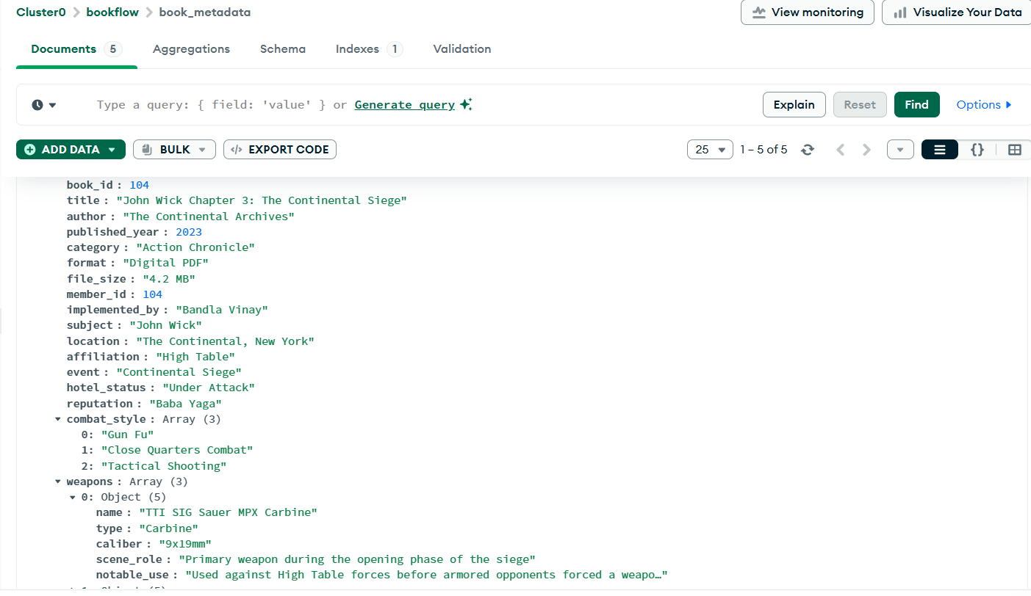
Regex search for Digital formats.

6. Aggregation
I used the aggregation builder in Atlas and made the stages one by one.

Stage 1 – $match
{
"published_year": {
"$gt": 2020
}
}
This filters the books published after 2020. The preview showed 4 documents.
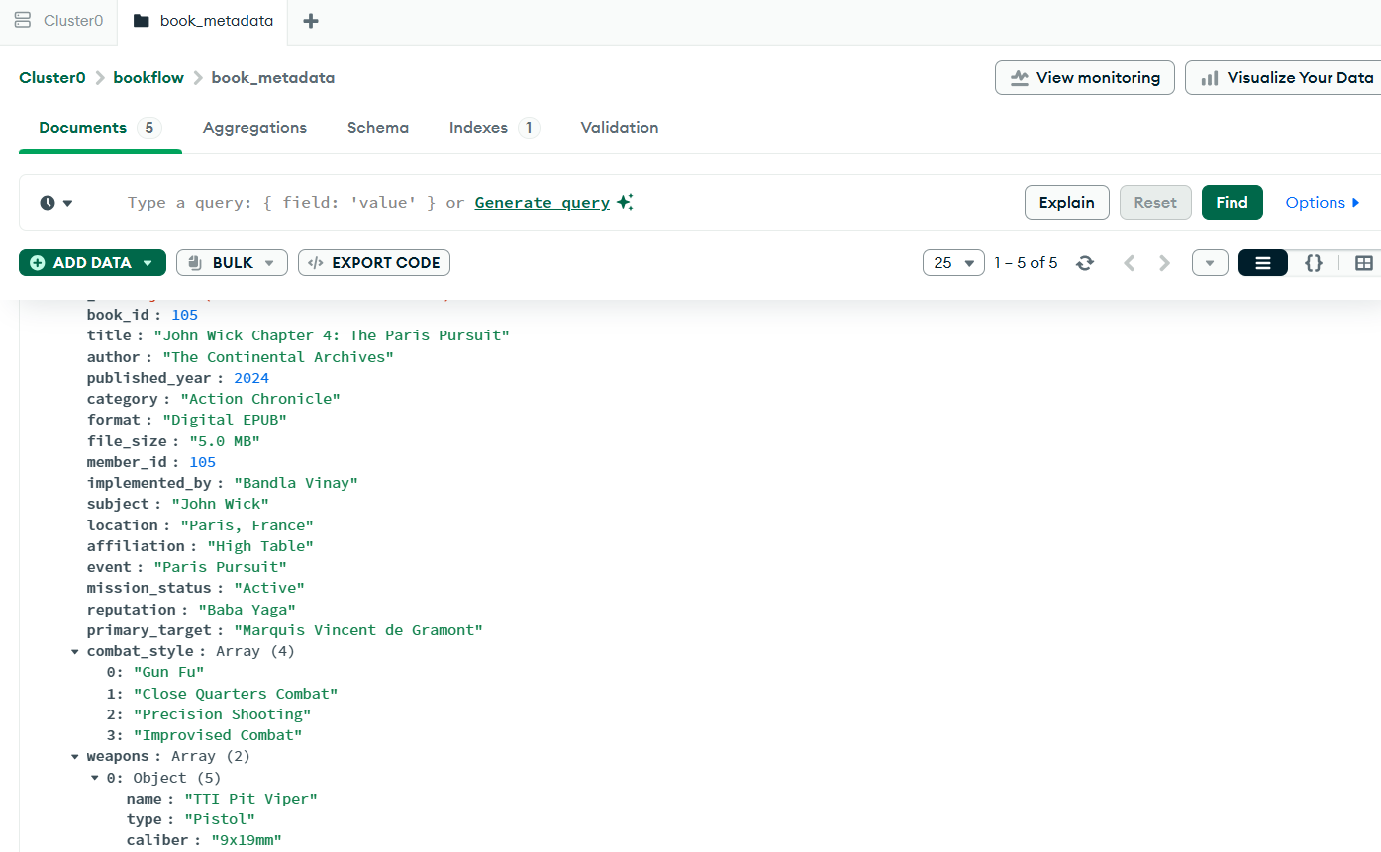
The $match stage.

Stage 2 – $unwind
"$reviews"
This expands the reviews array so that each review can be handled separately.
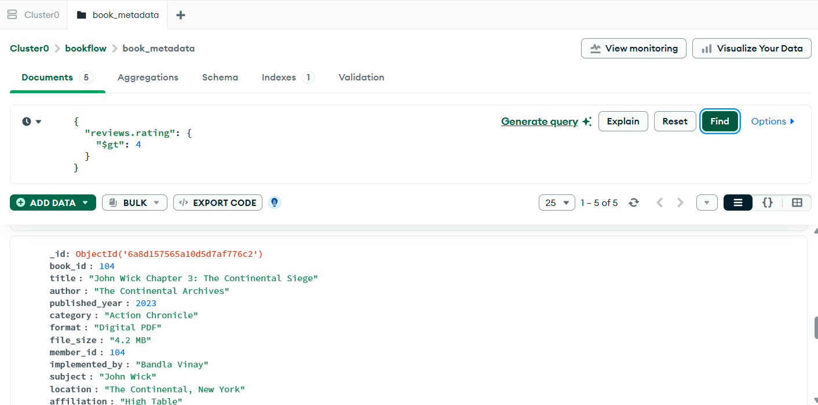
The $unwind stage.

Stage 3 – $group
{
"_id": "$title",
"average_rating": {
"$avg": "$reviews.rating"
},
"total_reviews": {
"$sum": 1
}
}
This groups the reviews by book title and calculates the average rating and number of reviews.
Note: when I previewed this stage separately in Atlas, average_rating appeared as null because the $unwind stage was not before it in that separate preview. The stage itself is meant to be used after $unwind.
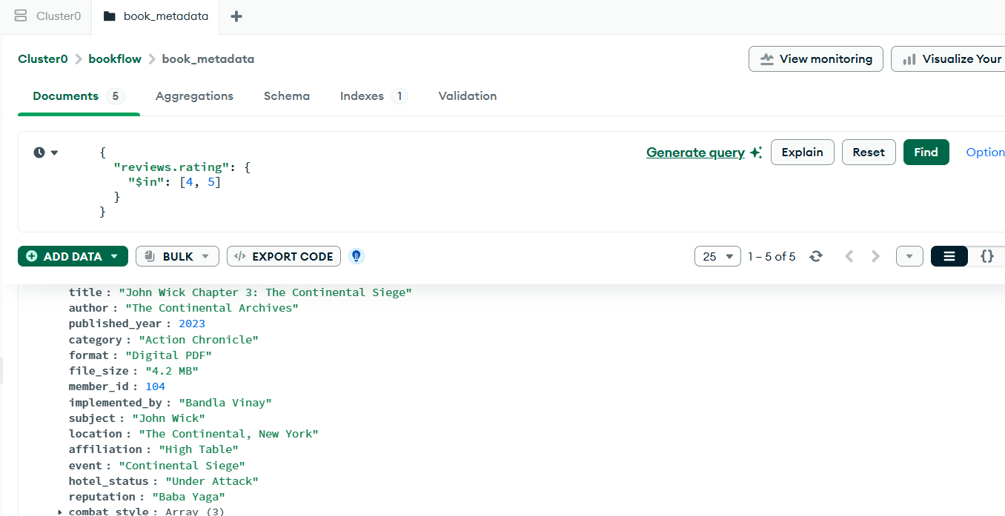
The $group stage in Atlas.

Stage 4 – $sort
{
"average_rating": -1
}
This sorts the average ratings from highest to lowest.
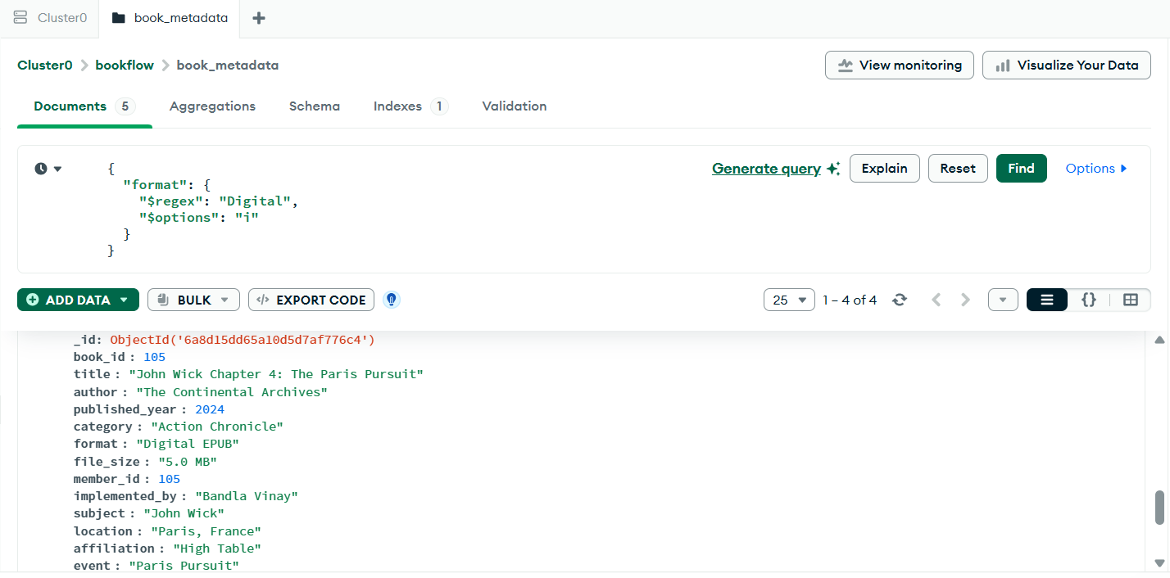
The $sort stage.

7. Full Aggregation Command
db.book_metadata.aggregate([
{
"$match": {
"published_year": { "$gt": 2020 }
}
},
{
"$unwind": "$reviews"
},
{
"$group": {
"_id": "$title",
"average_rating": { "$avg": "$reviews.rating" },
"total_reviews": { "$sum": 1 }
}
},
{
"$sort": {
"average_rating": -1
}
}
])
So the order of the stages is: $match → $unwind → $group → $sort.
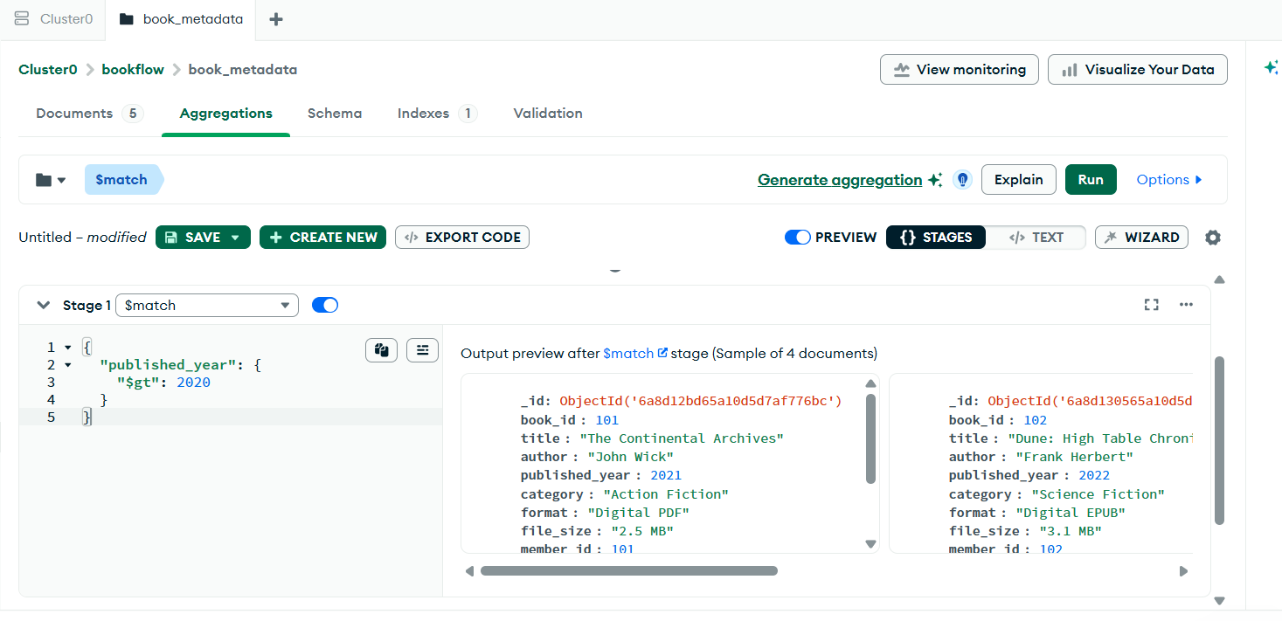
Aggregation work done in Atlas.

8. Text Index
db.book_metadata.createIndex({
"reviews.comments": "text"
})
I created a text index on reviews.comments. In Atlas the index is shown as TEXT and its status is READY.
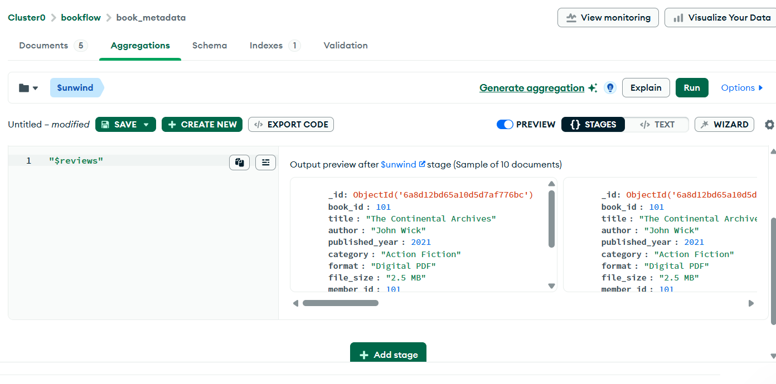
Text index on reviews.comments.

9. Text Search
db.book_metadata.find({
"$text": {
"$search": "excellent"
}
})
The text search for excellent returned 5 documents in the collection.
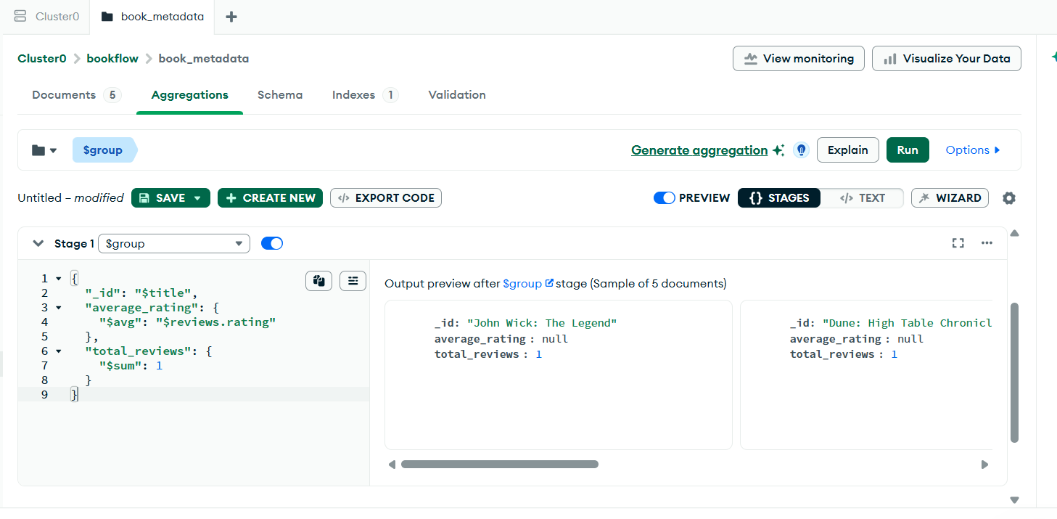
Text search for excellent.

10. Phrase Search
db.book_metadata.find({
"$text": {
"$search": "\"science fiction\""
}
})
The phrase search for science fiction returned 1 document.
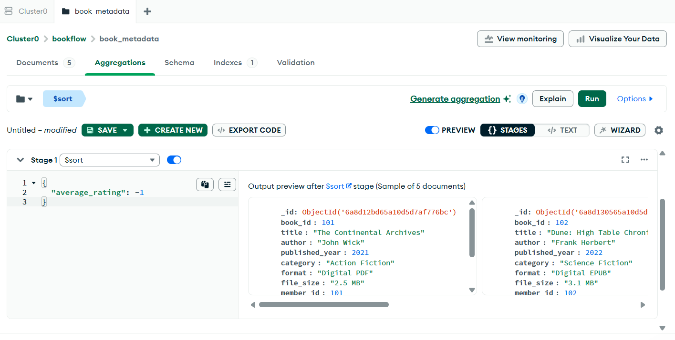
Phrase search for science fiction.

11. More Screenshots / Output
These are the other screenshots from the practical showing the collection and the stored documents.
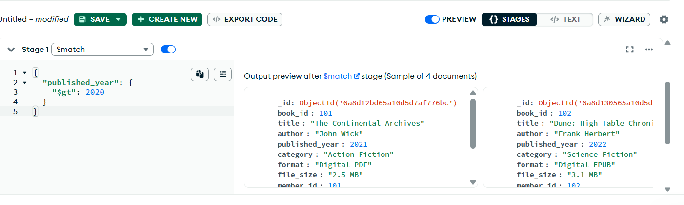
Collection document with nested arrays.
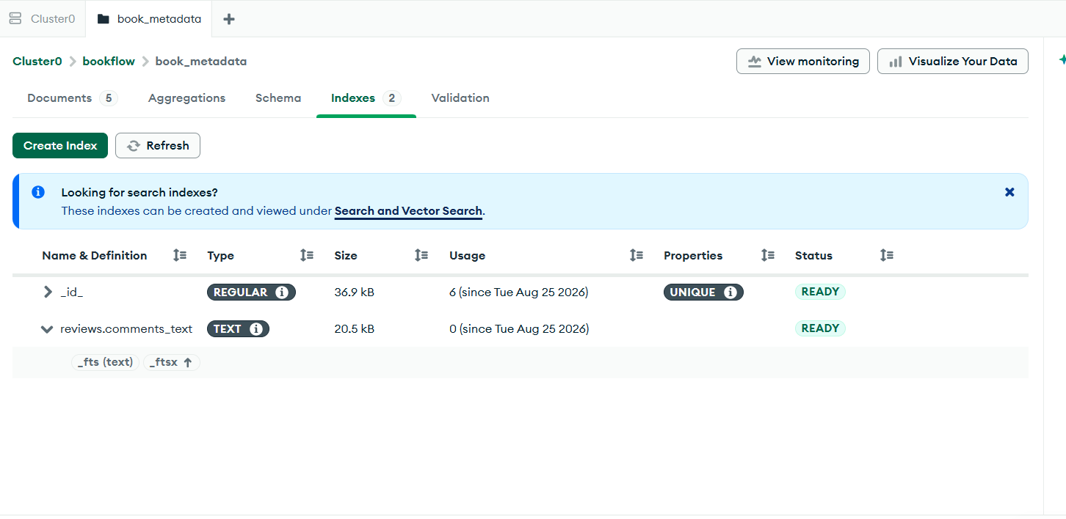
Document showing combat_style and weapons.
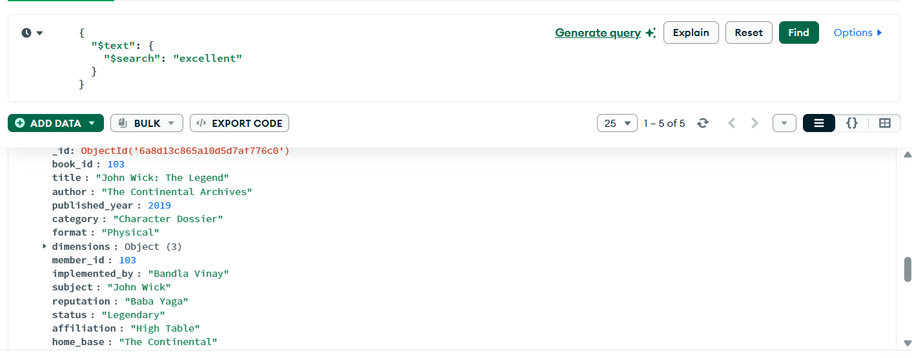
Book metadata document in Atlas.
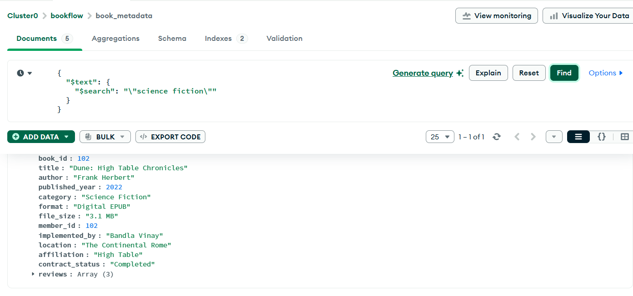
Another view of the collection.
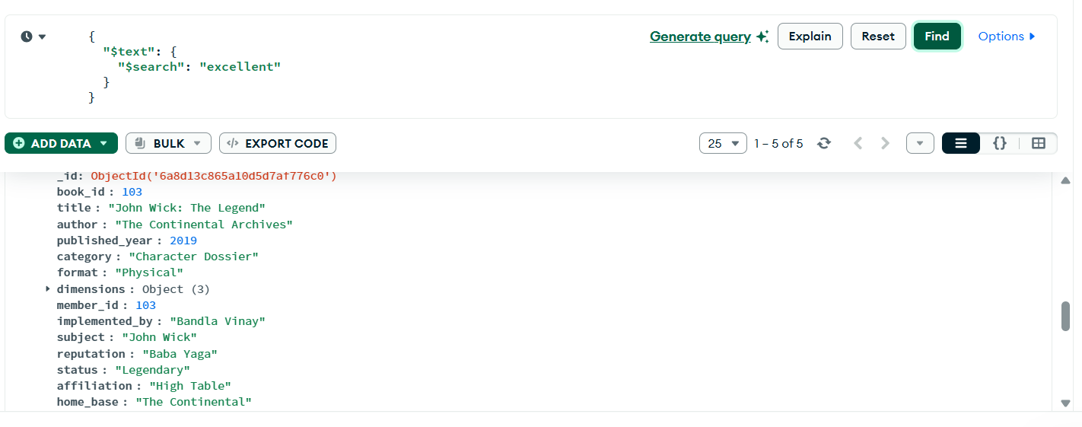
Collection and document view.

12. explain()
I also checked how MongoDB can show the query execution plan. The command used for the text search is:
db.book_metadata.find({
"$text": { "$search": "excellent" }
}).explain("executionStats")
The main things to look for in the execution plan are IXSCAN, which means an index scan, and COLLSCAN, which means a collection scan.

13. Result
The MongoDB practical was completed using the book_metadata collection. I was able to perform the required queries, aggregation stages, text indexing and text searches in MongoDB Atlas.

14. Conclusion
This practical helped me understand how MongoDB stores flexible documents and how queries and aggregation can be applied to them. I also got to see how nested arrays can be searched and expanded using $unwind, and how a text index can be used for searching review comments.

